# MODEL TASK[1] FOR ASSIGNMENT 2.1 – PHONON

**Language:** Phonon

**Team -** Isaac Ribeiro - Id: 040957075 **/** Hilary Johnson - Id: 040980317

### **PART 1: RE – Regular Expression (1.5 mark)**

**Lexeme Classes:** Define the classes to be used in your regular expression:

**(0)L** = [A-Za-z] (Letters)

**(1)D** = [0-9] (Digits)

**(2)U** = _ (Underscore)

**(3)M** = . (Method delimiter)

**(4)Q** = " (String Literal delimiter)

**(5)O** = [^**LDUMQ**] (Other chars)

**(6)N** = \n (New Line)

**MNID** = **L**(**L**|**D**|**U**)\***M** (Method ID)

**SL** = (?<=**Q**)([^\\**QN**]|\\.)*(?=**Q**) (String literal)

**NL** = (?<=**O**)**D**+(?=**O**) (Number Literal)

**KEY** = { while, if, else, return, void, out, in, float, int, bool }

Define the RE to be used for: variables, literals and keywords:

**\* Comments:** (\/\/.*)|(\/\*(.|**N**)*\*\/)

**\* Variables: L**(**L**|**D**|**U**)*

first char must be a letter; the rest can be any number of letters, numbers, and underscores

**\* Methods: L**(**L**|**D**|**U**)\***M**

**\* Literals:**

**- Numbers:** (?<=**O**)**D**+(?=**O**)

**- Strings:** (?<=**Q**)([^\\**QN**]|\\.)*(?=**Q**)

**\* Keywords:** (?<=[^**LDU**])(**KEY**)(?=[^**LDU**])

### **PART 2: TD – Transition Diagram (1.5 marks)**

**Activity:** Starting from the previous lexeme classes and obeying the RE, it is possible to define the automata for your language:

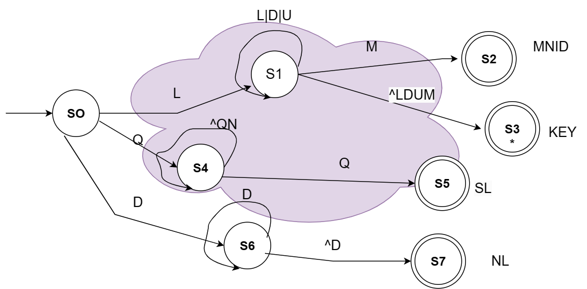

### **PART 3: TT – Transition Table (2 marks)**

**Activity:** Now, it is possible to define the TT for these lexemes:

| Input | Input Symbol | | | | | | Output |
| --- | --- | --- | --- | --- | --- | --- | --- |
| STATE/CLASSES | 0 | 1 | 2 | 3 | 4 | 5 | TYPE |
|  | L = [A-Za-z] | D = [0-9] | U = _ | M = . | Q = “ | O = [^LDUMQ] | - |
| S0 | 1 | ESNR | ESNR | ESNR | 4 | ESNR | NOAS [0] |
| S1 | 1 | 1 | 1 | 2 | 3 | 3 | NOAS [1] |
| S2 | FS | FS | FS | FS | FS | FS | ASNR (MNID) [2] |
| S3 | FS | FS | FS | FS | FS | FS | ASWR (KEY) [3] |
| S4 | 4 | 4 | 4 | 4 | 5 | 4 | NOAS [4] |
| S5 | FS | FS | FS | FS | FS | FS | ASNR (SL) [5] |
| S6 | 6 | 6 | 6 | 6 | 6 | 7 | NOAS [6] |
| S7 | FS | FS | FS | FS | FS | FS | ASNR (NL) [7] |

1. Adapted from resources developed by Prof. Svillen Ranev (Algonquin College, 2019)