冒泡排序

#include <iostream>

using namespace std;

int main()

{

//排序总轮数=元素个数-1

//每轮对比次数=元素个数-排序轮数-1;

int arr[9] = { 4,2,8,0,5,7,1,3,9 };

cout << "排序前为 ";

for (int i = 0; i < 9; i++)

{

cout << arr[i];

}

//外层循环，排序轮数

for (int i = 0; i < 9 - 1; i++)

{

//内层循环 对比次数

for (int j = 0; j < 9 - 1 - 1; j++)

{

if (arr[j]>arr[j+1])

{

int temp = arr[j];

arr[j] = arr[j + 1];

arr[j + 1] = temp;

}

}

}

cout << "排序后为 ";

for (int i = 0; i < 9; i++)

{

cout << arr[i];

}

system("pause");

return 0;

}计算三个人各自总成绩

#include <iostream>

using namespace std;

int main()

{

//100 100 100

//90 50 100

//60 70 80

//创建二维数组

int scores[3][3] =

{

{100,100,100},

{90,50,100},

{60,70,80}

};

cout << "三个人的成绩分别为 ";

for (int i = 0; i < 3; i++)

{

int sum = 0;

for (int j = 0; j < 3; j++)

{

sum += scores[i][j];

}

cout << sum << " ";

}

system("pause");

return 0;

}

函数的值传递

#include <iostream>

using namespace std;

void swap(int num1, int num2)

{

cout << "交换前";

cout << "num1= " << num1;

cout << "num2= " << num2 << endl;

int temp = num1;

num1 = num2;

num2 = temp;

cout << "交换后";

cout << "num1= " << num1;

cout << "num2= " << num2;

}

int main()

{

int a = 10;

int b = 20;

swap(a, b);

system("pause");

return 0;

}

函数的分文件编写

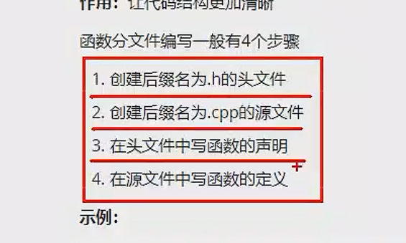

指针

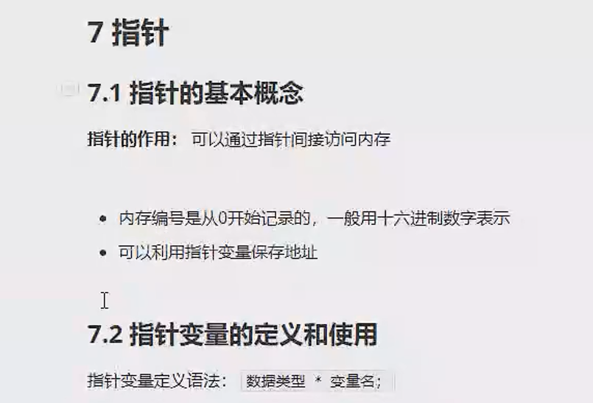

、

指针是一个地址