**논문 읽기**



**Morphological features**



Using the QRS summits (after normalization), the maximum of cross-correlation function between each detected beat and the following beat was calculated, as well as the maximum of cross-correlation between the current beat and the previous beat detected, called respectively Corr1 and Corr2 [[17](https://journalofbigdata.springeropen.com/articles/10.1186/s40537-019-0244-x#ref-CR17)]. Another feature was the maximum of cross-correlation between a template of normal beat, with each QRS complex detected, called CxyCxy, was computed. For each record, the template was calculated as the averaged beat of a sequence of many normal sinus beats.



**Cross Correlation**



➡ 신호가 비슷하다면 큰 값!

ex)

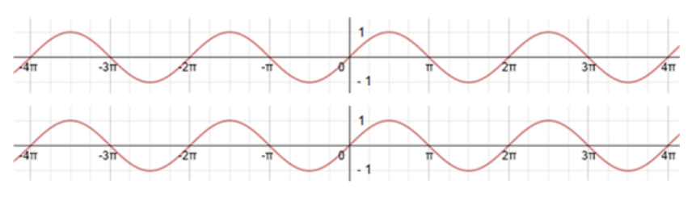

위 그림과 같이 동일한 sine함수이면 CorrCoef(상관계수) = 1

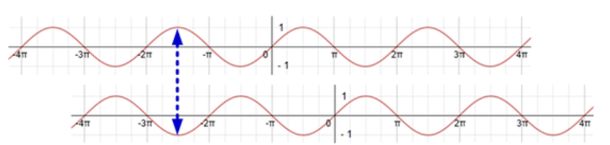

위 그림과 같이 정 반대인 경우 CorrCoef = -1