**UniPlanner**

**College Event Management Platform**



**UNIVERSITY OF ENGINEERING**

**&**

**MANAGEMENT, JAIPUR**

**UniPlanner: College Event Management Platform**

Submitted in the partial fulfillment of the degree of

**BACHELOR OF TECHNOLOGY**

In

**COMPUTER SCIENCE & ENGINEERING**

Under

**UNIVERSITY OF ENGINEERING & MANAGEMENT, JAIPUR**

BY

**Biswanath Mukherjee  
University Roll no: 12022002026009  
University Registration no: 204202200200122**

**Piyush Kumar Rai  
University Roll no: 12022002001099  
University Registration no: 204202200200142**

**Arunava Pari  
University Roll no: 12022002001014  
University Registration no: 204202200200019**

UNDER THE GUIDANCE OF

**PROF. DIPTA MUKHERJEE**

COMPUTER SCIENCE & ENGINEERING



UNIVERSITY OF ENGINEERING & MANAGEMENT, JAIPUR

**Approval Certificate**

This is to certify that the project report entitled “**UniPlanner: College Event Management Platform**” submitted by **Piyush Kumar Rai** (Roll No. - 12022002001099), **Biswanath Mukherjee** (Roll No. - 12022002026009) and **Arunava Pari** (Roll No. - 12022002001014) in partial fulfillment of the requirements of the degree of **Bachelor of Technology** in **Computer Science & Engineering** from University **of Engineering and Management, Jaipur** was carried out in a systematic and procedural manner to the best of our knowledge. It is a bona fide work of the candidate and was carried out under our supervision and guidance during the academic session of 2022-2026.

_______________________

**Prof. Dipta Mukherjee**

Project Guide, Assistant Professor (CSE)

UEM, JAIPUR

_______________________

**Prof. Dr. G Uma Devi**

Associate Dean of Engineering

Head of the Department (CSE)

UEM, JAIPUR

**ACKNOWLEDGEMENT**

The endless thanks go to Lord Almighty for all the blessings he has showered onto us, which has enabled us to write this last note in our research work. During the period of our research, as in the rest of our life, We have been blessed by Almighty with some extraordinary people who have spun a web of support around us. Words can never be enough in expressing how grateful we are to those incredible people in our life who made this thesis possible. We would like an attempt to thank them for making our time during our research in the Institute a period we will treasure. We are deeply indebted to our research supervisor, Professor Dipta Mukherjee for giving us such an interesting thesis topic. Each meeting with him added in valuable aspects to the implementation and broadened our perspective. He has guided us with his invaluable suggestions, lightened up the way in our darkest times and encouraged us a lot in the academic life.

Biswanath Mukherjee

Piyush Kumar Rai

Arunava Pari

**ABSTRACT**

Managing events in a college setting often involves challenges such as miscommunication, scheduling conflicts, and time-consuming coordination. To address these issues, this project introduces a web-based event management application that streamlines the planning and organization of campus events. Built using React.js for frontend development, MongoDB, ExpressJS, React, NodeJS. The application offers a centralized platform tailored to the needs of students and administrators. A key feature of the system is its calendar-based interface, providing a clear overview of all scheduled events. Students can easily propose new events by submitting details such as the name, date, venue, description, poster, and registration link. Administrators have the ability to approve, decline, reschedule events, or allocate new venues as necessary, ensuring optimal resource management. The application also facilitates account management, allowing students to request user access and receive timely notifications about event requests and approvals. By automating traditionally manual processes, this platform minimizes errors, improves efficiency, and enhances communication, ultimately creating a more vibrant and connected campus environment. Future enhancements for the application include adding analytics for participation trends, developing a mobile version for broader accessibility, and scaling the platform to support multi-campus operations. This application exemplifies an innovative approach to modernizing event management in academic institutions, fostering greater engagement, and streamlining organizational processes.

# Table of Contents

Table of Contents 1

List of Figures 2

1. CHAPTER 3

INTRODUCTION 3

1.1 What is the College Event Management Platform 3

1.2 What is the need of a College Event Management Platform 3

1.3 What will be the usage of a Event Management Platform ? 4

2. CHAPTER 5

2.1 Literature Review 5

2.2 Objectives of the application 7

2.3 Features of the Application 7

3. CHAPTER 8

3.1 Proposed Model 8

3.2 Experimental Setup 9

RESULTS & DISCUSSION 10

Results and Screenshots 10

Future Scope 14

CONCLUSION 15

APPENDIX 16

REFERENCES 17

# List of Figures

Figure 1: Proposed Model 8

Figure 2: Dashboard seen after login 10

Figure 3: Calendar View of all the events 10

Figure 4: Sign Up Page 11

Figure 5: Sign In Page 11

Figure 6: Detailed View of an Event – 1 12

Figure 7: Detailed View of an Event - 2 12

Figure 8: Registration Page for an Event 13

Figure 9: Ticket for an Event after Registration 13

# CHAPTER

## INTRODUCTION

### What is the College Event Management Platform

The college event management web application is an integrated platform that has been developed to ease the entire process of planning, scheduling, and coordination of events within the college environment. It employs some modern web technologies called the Mern Stack which consists of MongoDB, ExpressJS, ReactJS, Node.js It includes a calendar-based UI that can present events that are scheduled to help users and administrators see central views of all the activities scheduled. Thus, the system empowers the student and faculty by simplifying the process of event creation, approvals, and management, thereby ensuring good communication is done in real-time.

### What is the need of a College Event Management Platform

Organizing college events tends to be challenging: such activities involve working out schedules, finding vacant venues, and ensuring that all stakeholders are informed at the correct time. Methods such as noticeboards or broken digital tools do not make the cut; this application streamlines an event-related activity by centralizing all activities. It minimizes communication barriers, ensures that venue conflicts are avoided, and reduces the administrative load from hand tracking event requests. Moreover, it offers students a structured platform by which one may stay updated about events happening around college time and participate actively in college activities, engaging more and collaborating better.

### What will be the usage of a Event Management Platform ?

The application is a comprehensive tool for both students and college administrations. Students can request the creation of events with specific details such as name for events, dates, venue, description, a poster, and registration link. Additionally, students can view a calendar of upcoming events and are notified about the status of their event requests. Administrators can get more advanced features, through which they can approve or decline or reschedule events to even the venue in case it is needed. In addition, admins can manage user accounts with approval of new registrations. The app automates such processes to enhance the efficiency of organizing an event and promote an interactive, dynamic campus environment.

.

# CHAPTER

### Literature Review

Event organizers create schedules for events using android app interface and assign student volunteers at the time of schedule creation. The students register with the site and some of them register as coordinators. Only event organizers and volunteers can upload event content to the site. College Event Organizer also provide facility to provide all information about all events which are being conducted. So, every student should get proper knowledge about events and he can participate if he wants. College Event Organizer can be extended to organize the events conducted in a city so that this will be an online portal for any type of event conducted in a city. [1]

Event is organized in almost all the colleges but all the work done is manually. The events are decided and then asked to students whether they will coordinate or not then all the details are maintained in files manually. Many colleges have websites for events that they organize but this website is used for displaying the various events details that are going to be conduct in those colleges for informing the other college students. Students also not get the proper platform for finding events which helps to build their resume. There is no such android application or web application for Event management or organization by which automatic record will maintain, also show all events to participants by which they can apply online and event can be organized. [1]

The College activity management system is used to maintain college activities like fest, farewell and annual day celebrations, workshops etc. it provides information on placements, maintains student attendance, provides information on faculty, it also provides college information, and it maintains, branch details, sports details, also provides college achievements. Notification on exams and results, and it takes complaints and some other college activities. The core idea of this project is to implement android based Mobile Campus application for advancement of institution and educational system .The application will be used by students, teachers and parents. In the

previous system, all the information has to view in a hard file, or in website. At the same time while searching any information it is too difficult to access and takes a lot of time to search the particular website. Hence, in order to overcome this problem a smart phone based application using Android can be used to make this process easier, secure and less error prone. More efficient information’s will be achieved through this system.[2]

The paper discusses the method of the management information in higher education. On the basis of a comprehensive investigation and analysis on the student management in higher education, we establish the models of the college students’ management information by adopting the advanced information technology, and construct the student management information platform. Moreover, we analyze the characteristics of the information management in higher education, and elaborate the methods to solve the difficulties confronting in the students management of the higher education. Finally, the key method and technology to carry out the information management platform are presented.[3]

Event Management Solution for EINS Consultancy focuses on creating, updating, deleting and viewing of events including seminars, trainings, or workshops through the website. It also includes Content Management System (CMS) which allows both the System Manager and Administrators to modify the website’s content, both graphical and textual content, through the website. The website has three users namely end-users, administrators, and System Manager. First, an end-user is a person usually a customer, client, or consumer that a software program or hardware device is designed for. Second, an Administrator is a person who has a privilege to perform tasks other than viewing the website. An Administrator facilitates the website’s activities including creating, updating, deleting events and announcements. An Administrator could also view reports of all the events. Last is the System Manager. There is only one System Manager of the website. A System Manager could perform all the privileges of an end-user and an administrator. However, a System Manager has a higher privilege than an administrator. A System Manager oversees all the activities proceeding on the website. The difference between the System Manager and an Administrator is that the former could create an Administrator account that could help facilitate the website. Also, the System Manager is enabled to view an audit trail which provides a set of records that serve as an evidence of changes attempted or applied on the website by the System Manager himself or a particular administrator.[4]

.

### Objectives of the application

**Simplify Event Management:** Provide a centralized platform to manage event-related tasks, from creation to scheduling and approval, reduce the manual effort involved with those processes.

**Enhance Communication:** Effective real-time notification helps keep abreast, including all stakeholders, of event requests, approvals, and changes.

**Promote Collaboration:** Foster an environment where students can actively participate in organizing and attending events, contributing to a more vibrant campus life.

**Prevent Schedule Conflicts:** Ensure proper tracking and allocation of venues to avoid double-booking and scheduling issues.

**Streamline User Access:** Provide an easy access request mechanism for students to request access and apply for participation in events.

### Features of the Application

**Calendar-Based UI:** The application provides a visually appealing calendar interface that displays all scheduled events on their respective dates, making it easy for users to navigate.

**Event Creation and Approval Workflow:** Users can propose events with detailed information, while admins can review and approve or decline requests efficiently.

**Venue Management:** Admins can allocate or change venues for events, ensuring optimal utilization of available spaces.

**User Account Management:** Students can request user access, and admins have the authority to approve these accounts, maintaining a secure and streamlined user base.

**Event Participation Tracking:** Students can view event details and register for events through links provided, encouraging active involvement.

# CHAPTER

### Proposed Model

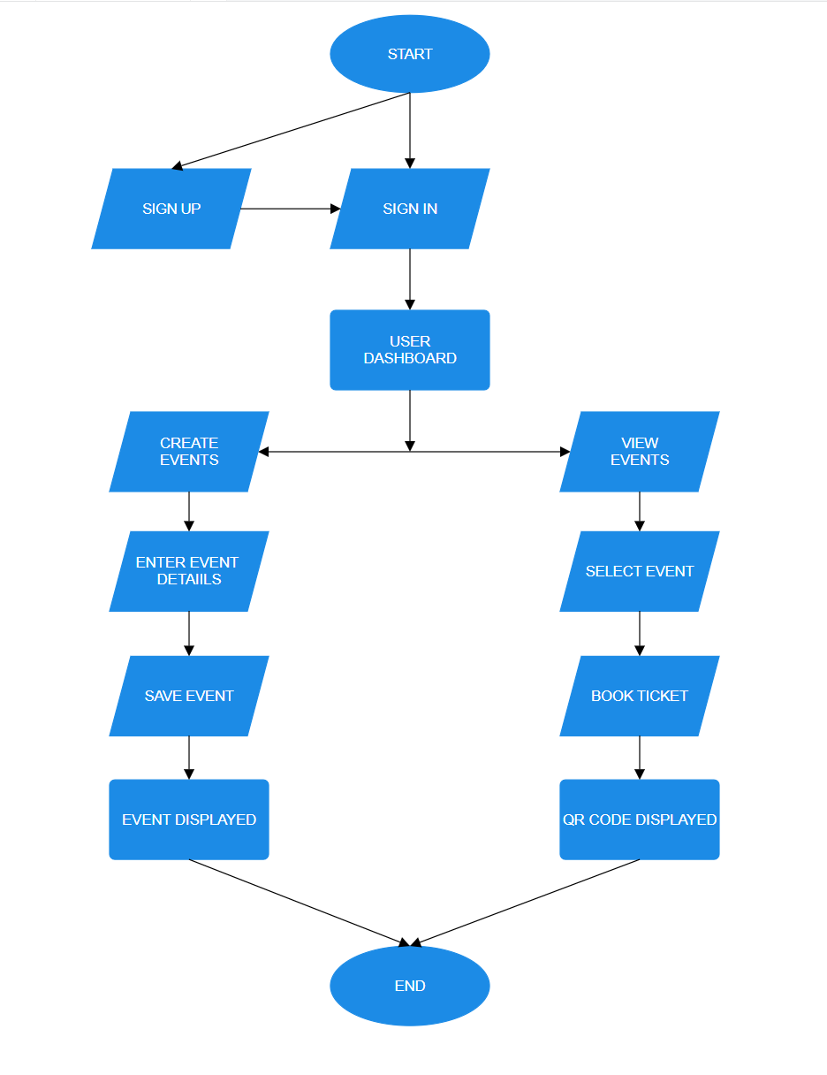

Figure : Proposed Model

### Experimental Setup

Experimental Setup for the Event Management Platform

**Step 1:** Clone the frontend repository from GitHub onto your local machine:

https://github.com/i0am0arunava/uemEvent_fe.git

**Step 2:** Navigate to the project folder and install the necessary dependencies:

cd uemEvent_fe

**Step 3:** Run the development server locally:

npm run dev -- --host

**Step 4:** Clone the backend repository from GitHub onto your local machine:

https://github.com/i0am0arunava/uemEv_backend.git

**Step 5:** Navigate to the backend folder and install the required packages:

cd uemEv_backend

npm install

**Step 6:** Start the backend server:

npm run start

**Conclusion:** By following these steps, the frontend and backend servers will be set up locally, enabling you to run and test the event management application.

# RESULTS & DISCUSSION

### Results and Screenshots

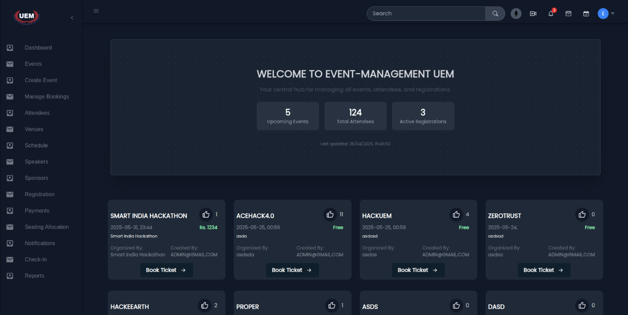

Figure 1: Dashboard seen after login

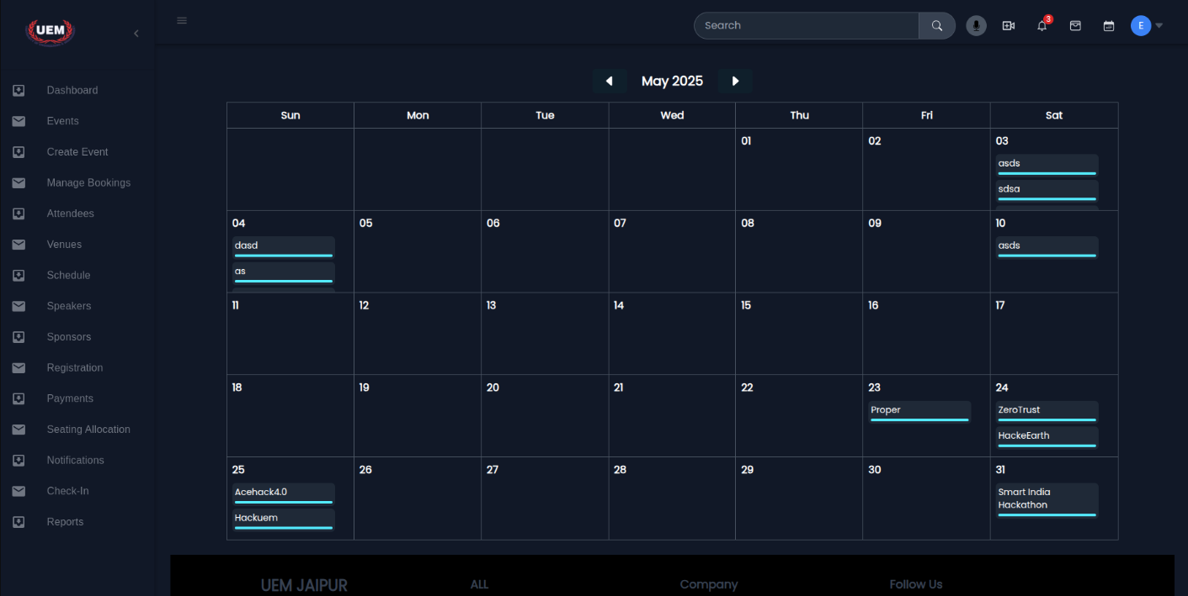

Figure 2: Calendar View of all the events

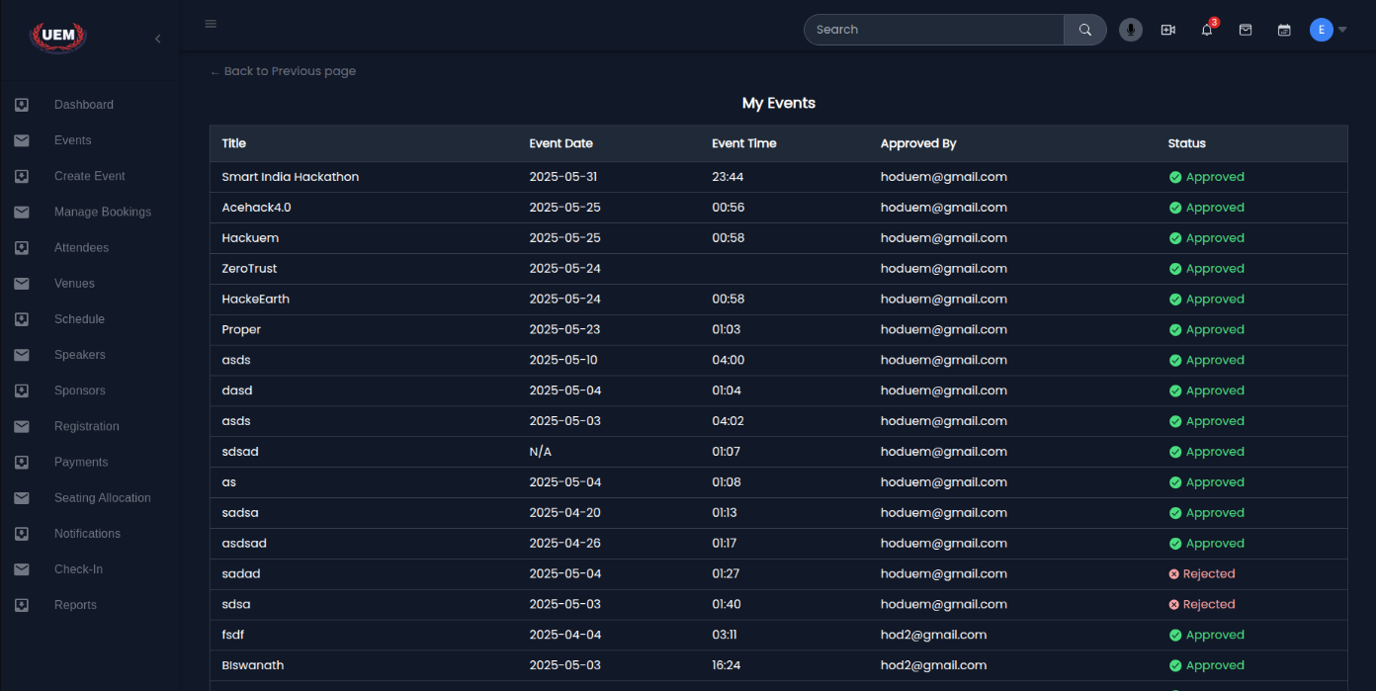

Figure 3: Event list view

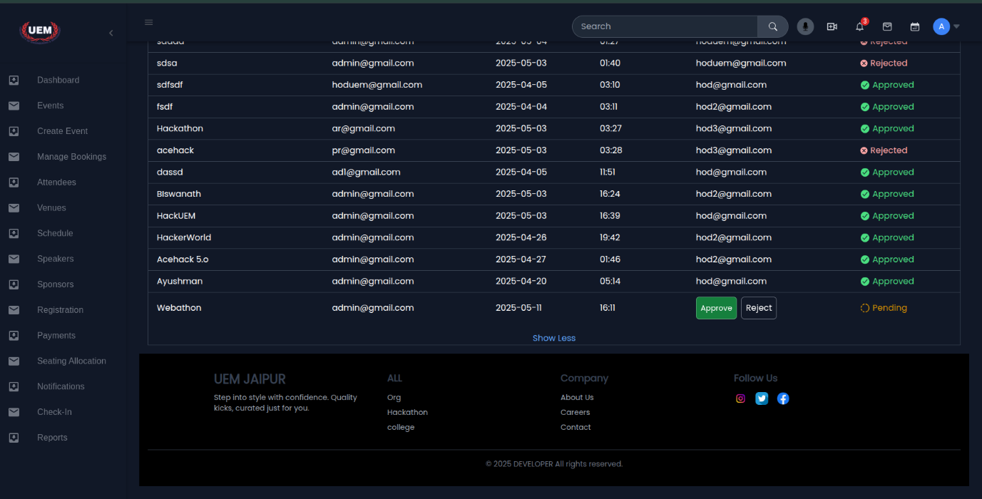

Figure 4: Event Approval view

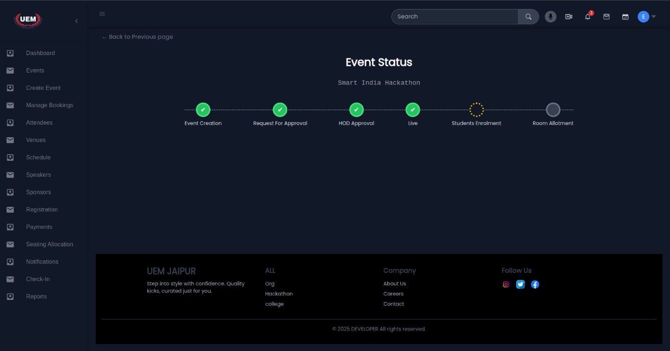

Figure 5: Event approval status

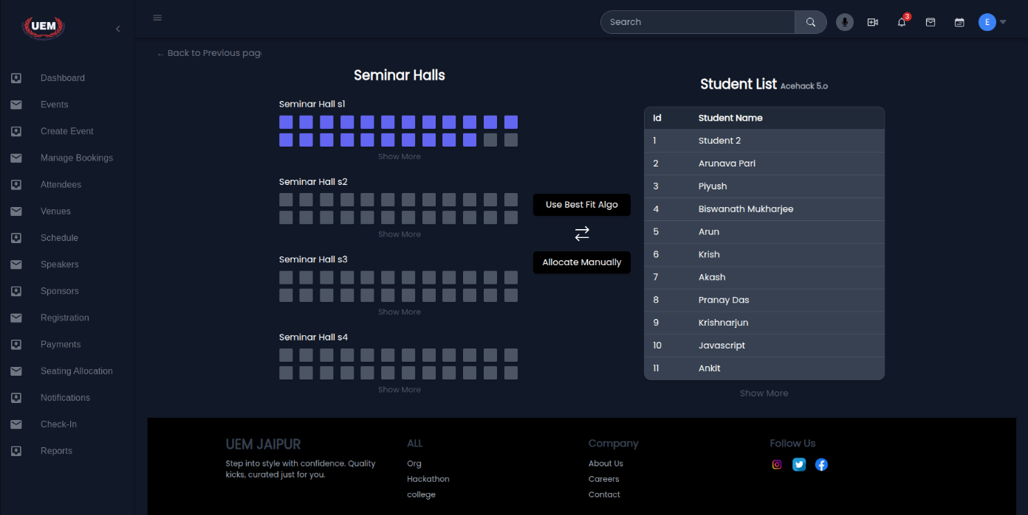

Figure 6: Seminar Hall allotment

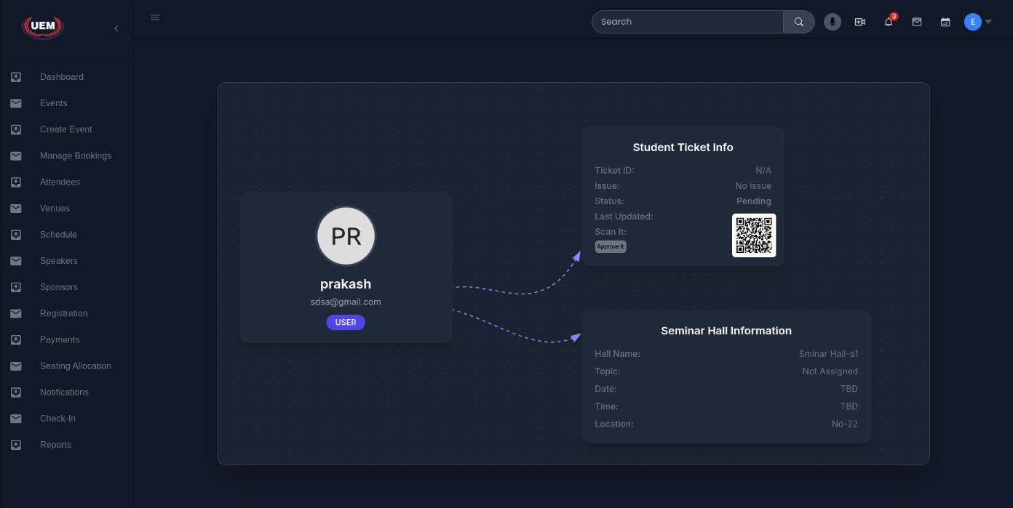

Figure 7: Qr Code Generation

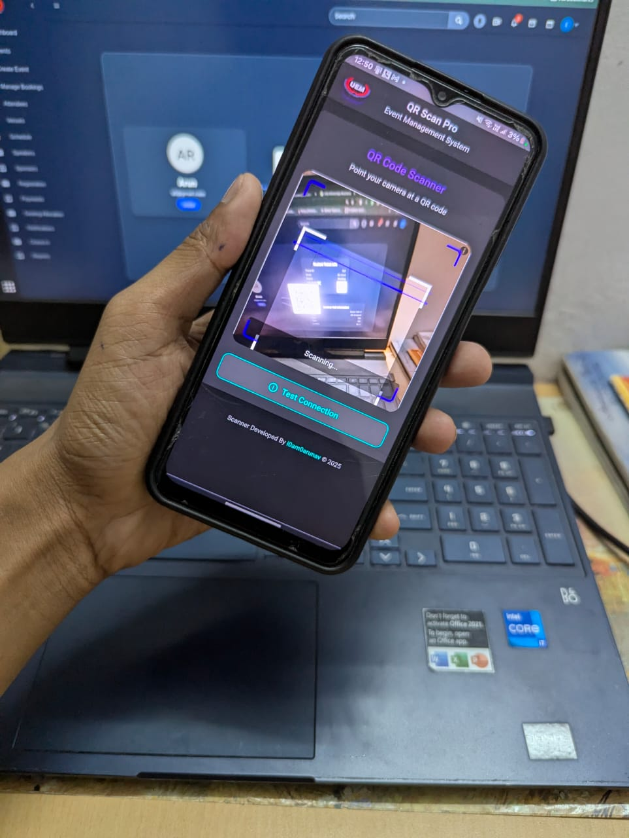

Figure 8: QR Code Scanner

### Future Scope

* **Inter-integration with College systems:** The application can be integrated with the existing college management systems, which may improvise functionality and data sharing.
* **Analytics and insights**: Addition of features for the analysis of trends in participation by users in events will help in better planning and decision making.
* **Mobile application:** Scaling up the project to a mobile app version so that the users access the portal from the phone for comfort and ease.
* **Automated Reminders:** Adding reminders for upcoming events can enhance user experience and user engagement further.
* **Third Party Integrations:** The support of integrating popular tools such as Google Calendar or Microsoft Teams would make it more usable.
* **Scalability for Multi-Campus Usage:** The application can be scaled up for managing events across multiple campuses or institutions to cater to a larger audience.

# CONCLUSION

The UniPlanner application demonstrates a transformative approach to managing college events by integrating modern technologies to create a centralized, efficient, and user-friendly platform. By addressing common challenges such as miscommunication, scheduling conflicts, and administrative overload, the system simplifies event planning and enhances the overall campus experience. Its calendar-based interface, real-time notifications, and robust user and event management workflows empower both students and administrators, ensuring seamless coordination and active participation.

The application’s design not only automates manual processes but also promotes collaboration and engagement among stakeholders. Additionally, its scalability and potential for future enhancements—such as analytics, mobile access, and third-party integrations—underscore its long-term viability and adaptability. UniPlanner is not just a tool for event organization but a stepping stone towards creating a more connected and dynamic academic community, setting a benchmark for modernizing administrative processes in educational institutions.

# APPENDIX

* **MongoDB:** MongoDB is a popular NoSQL database that ditches the rigid tables of traditional databases. Instead, it stores information in flexible JSON-like documents. These documents can hold various data types and structures, making them perfect for constantly evolving data. Unlike relational databases where you define everything upfront, MongoDB offers a schema-less design. This allows you to add new fields or change existing ones on the fly, giving you more freedom and agility. MongoDB excels at handling massive datasets and scales horizontally by distributing data across multiple servers. This makes it ideal for real-time applications where you need fast performance and high availability.
* **ReactJS:** ReactJS, often shortened to React, is a popular JavaScript library for building dynamic user interfaces (UIs). It uses a component-based approach, where complex UIs are broken down into smaller, reusable components. These components are written in JSX (JavaScript XML), a syntax extension that makes writing UI code more readable. React also employs a virtual DOM, which efficiently updates the real DOM (Document Object Model) of the browser, leading to smooth performance and fast rendering. This makes React ideal for building interactive and responsive web applications.
* **NodeJS:** Node.js is an open-source, cross-platform JavaScript runtime environment that allows you to run JavaScript code outside of a web browser. It excels at handling eventdriven, asynchronous tasks, making it ideal for building real-time applications, APIs, and I/O intensive applications. Node.js leverages Google's V8 JavaScript engine, known for its speed and efficiency, for code execution. Unlike traditional web servers that create a new thread for each request, Node.js uses a single-threaded model with an event loop. This allows it to handle a high volume of concurrent connections efficiently without overloading the server.

# REFERENCES

[1] Misal, Sandeep, et al. "Review on college event organizer." International Research Journal of Engineering and Technology (IRJET) 4.3 (2017): 416-418.

[2] Kumar, M. Ashok, et al. "College Activity Management System." 2018 Second International Conference on Intelligent Computing and Control Systems (ICICCS). IEEE, 2018.

[3] Yue, Zhi-gang, and You-wei Jin. "The development and design of the student management system based on the network environment." 2010 International conference on multimedia communications. IEEE, 2010.

[4] Perez, Maria Rona L., Ace C. Lagman, and Rossana T. Adao. "Event management solution using web application platform." Proceedings of the 2017 International Conference on Information Technology. 2017.