**APPENDICES**

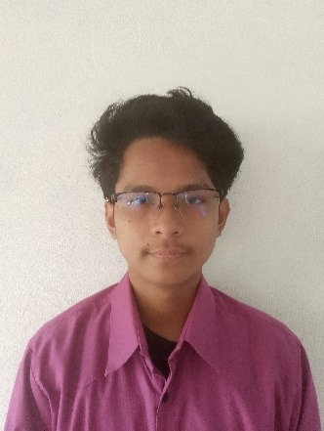Resume of the Researcher

Kent Andrei Tyler Ancheta

Centro-2 Claveria, Cagayan

0928199636

andreiclass101@gmail.com

***Personal Data***

|  |  |  |
| --- | --- | --- |
| **Age** | **:** | 17 |
| **Date of Birth** | **:** | October 10, 2006 |
| **Sex** | **:** | Male |
| **Place of Birth** | **:** | Claveria, Cagayan |
| **Civil Status** | **:** | Single |
| **Height** | **:** | 170 cm |
| **Nationality** | **:** | Filipino |
| **Religion** | **:** | N/A |
| **Mother’s Name** | **:** | Mayvee Lynne Ancheta |
| **Occupation** | **:** | N/A |
| **Father’s Name** | **:** | Diomedes Ancheta |
| **Occupation** | **:** | Police |

***Educational Background***

|  |  |  |
| --- | --- | --- |
| * ELEMENTARY | Claveria West Central School | 2013-2019 |
| * JUNIOR HIGH SCHOOL | Academy of St. Joseph | 2019- 2023 |
| * SENIOR HIGH SCHOOL | Academy of St. Joseph | 2023-2025 |

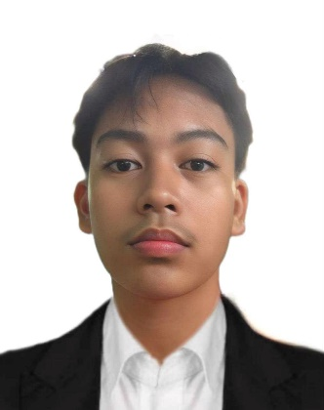

Aedrian Clyde Aridao

Centro-1 Claveria, Cagayan

09077375270

aedrian.clyde@gmail.com

***Personal Data***

|  |  |  |
| --- | --- | --- |
| **Age** | **:** | 17 |
| **Date of Birth** | **:** | November 30, 2006 |
| **Sex** | **:** | Male |
| **Place of Birth** | **:** | Mariano Marcos Memorial Hospital |
| **Civil Status** | **:** | Single |
| **Height** | **:** | 167 cm |
| **Nationality** | **:** | Filipino |
| **Religion** | **:** | Roman Catholic |
| **Mother’s Name** | **:** | Eden Chona Aridao |
| **Occupation** | **:** | Teacher |
| **Father’s Name** | **:** | Dick Aridao |
| **Occupation** | **:** | Forest Technician |

***Educational Background***

|  |  |  |
| --- | --- | --- |
| * ELEMENTARY | Claveria West Central School | 2013-2019 |
| * JUNIOR HIGH SCHOOL | Academy of St. Joseph | 2019- 2023 |
| * SENIOR HIGH SCHOOL | Academy of St. Joseph | 2023-2025 |

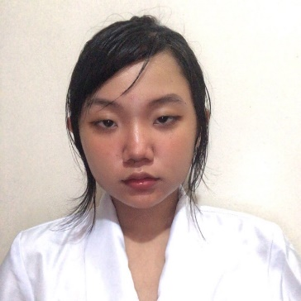

Irish Keira Icat

Centro-7 Claveria, Cagayan

09077375270

irishkeiraicat1@gmail.com

***Personal Data***

|  |  |  |
| --- | --- | --- |
| **Age** | **:** | 17 |
| **Date of Birth** | **:** | March 5, 2007 |
| **Sex** | **:** | Female |
| **Place of Birth** | **:** | Claveria, Cagayan |
| **Civil Status** | **:** | Single |
| **Height** | **:** | 152 cm |
| **Nationality** | **:** | Filipino |
| **Religion** | **:** | Roman Catholic |
| **Mother’s Name** | **:** | Irene Icat |
| **Occupation** | **:** | N/A |
| **Father’s Name** | **:** | Edison Icat |
| **Occupation** | **:** | Marine Engineer |

***Educational Background***

|  |  |  |
| --- | --- | --- |
| * ELEMENTARY | Claveria West Central School | 2013-2019 |
| * JUNIOR HIGH SCHOOL | Academy of St. Joseph | 2019- 2023 |
| * SENIOR HIGH SCHOOL | Academy of St. Joseph | 2023-2025 |



Jakielyn Silvano Oandasan

Sta. Filomena, Calanasan, Apayao

09701941313

oandasanjakie22@gmail.com

***Personal Data***

|  |  |  |
| --- | --- | --- |
| **Age** | **:** | 17 |
| **Date of Birth** | **:** | July 22, 2006 |
| **Sex** | **:** | Female |
| **Place of Birth** | **:** | Sta. Filomena, Calanasan, Apayao |
| **Civil Status** | **:** | Single |
| **Height** | **:** | 144 cm |
| **Nationality** | **:** | Filipino |
| **Religion** | **:** | Roman Catholic |
| **Mother’s Name** | **:** | Analyn Silvano Oandasan |
| **Occupation** | **:** | Vendor |
| **Father’s Name** | **:** | Rodolfo Corpuz Oandasan Jr. |
| **Occupation** | **:** | Tricycle Driver |

***Educational Background***

|  |  |  |
| --- | --- | --- |
| * ELEMENTARY | Sta. Filomena Elementary School | 2013-2019 |
| * JUNIOR HIGH SCHOOL | Academy of St. Joseph | 2019- 2023 |
| * SENIOR HIGH SCHOOL | Academy of St. Joseph | 2023-2025 |

Christinah M. Rillon

Centro-3 Claveria, Cagayan

09563818987

Tinahrillon1203mail.com

***Personal Data***

|  |  |  |
| --- | --- | --- |
| **Age** | **:** | 17 |
| **Date of Birth** | **:** | December 3, 2006 |
| **Sex** | **:** | Female |
| **Place of Birth** | **:** | Claveria, Cagayan |
| **Civil Status** | **:** | Single |
| **Height** | **:** | 154.94 cm |
| **Nationality** | **:** | Filipino |
| **Religion** | **:** | Roman Catholic |
| **Mother’s Name** | **:** | Jeralyn Maglacion |
| **Occupation** | **:** | N/A |
| **Father’s Name** | **:** | Warren Rillon |
| **Occupation** | **:** | Tricycle Driver |

***Educational Background***

|  |  |  |
| --- | --- | --- |
| * ELEMENTARY | Claveria West Central School | 2013-2019 |
| * JUNIOR HIGH SCHOOL | Academy of St. Joseph | 2019- 2023 |
| * SENIOR HIGH SCHOOL | Academy of St. Joseph | 2023-2025 |