

MyHEP User Manual
Student and Administrator Guide
A practical, step-by-step guide to the MyHEP student portal and staff work areas
What this guide covers
How students use their portal, submit scholarship and welfare details, join programs, use Food Bank services, and check student-affairs information. Staff sections explain the matching review, record, reporting, and poster workflows. Menu items depend on each account’s assigned role.

Politeknik Besut Terengganu | September 2026

Read this first
MyHEP provides separate student and staff work areas. Sign in with the account issued to you, then use the navigation menu to open the service you need. Students enter or review their own information. Administrators review records and manage only the modules permitted for their role.

How to use this manual
1 | Find your role: use the Student Portal chapters if you are a student, or the Administrator chapters if you manage records.
2 | Follow the numbered steps in order. Required fields are marked on screen; optional fields can be left blank.
3 | After saving, check the success notice or updated record. If a page is unavailable, your account may not have access to that module.

Navigation and account basics
- Open the sidebar menu and choose the page name. On a phone, open the menu or use the bottom navigation where it appears.
- Use search and filters to narrow long lists. Choose Reset to clear a filter, and Export when a report file is available.
- Use Profile or Settings to maintain the details and preferences available to your account. Sign out when you finish on a shared device.
- Use the support or bug-report link to describe a problem. Include the page name and what you expected to happen; never send your password.
Access note
Staff menus vary by assigned role and enabled features. A missing menu item usually means that the account does not have that permission or the feature is currently unavailable.

Student portal
The student dashboard is the starting point for campus services. Review your profile summary and alerts, then open the relevant menu for programs, scholarship information, Food Bank, discipline, documents, or account settings.

Sign in and find a service
1 | Open the MyHEP website and choose the student sign-in option.
2 | Enter your student account credentials and complete any verification shown on screen.
3 | On the dashboard, use the sidebar or mobile navigation to open the service. The page title confirms where you are.
4 | Use the account menu to update your profile or sign out when finished.

Keep your student information current
Open Profile and review your contact, program, and other editable details. Save any changes and check the confirmation message. Some identity and enrolment fields are supplied by the institution and may be read-only.

View notices and personal records
Scholarship and discipline announcement pages show notices published by staff. Student record pages display information linked to your account, such as scholarship status, offenses, Food Bank activity, or documents. Contact the relevant office if a record appears incorrect; do not create a duplicate record to correct it.
Protect your account
Use your own account, keep your sign-in details private, and sign out on shared computers. Upload only documents requested by the form.

Submit scholarship or welfare details
Use Scholarship → Status Form to tell Student Affairs whether you receive external scholarship support, need welfare assistance, or have no scholarship. The form can be updated later; a new submission updates your saved form rather than creating another form for the same student.
1 | Open Scholarship, then choose Status Form (the menu label may be “Borang Status Biasiswa”).
2 | Check the read-only student name, matric number, and program shown at the top.
3 | Choose one status: Scholarship / Sponsorship, Welfare Assistance, or No Scholarship.
4 | Complete the fields shown for that choice. Scholarship recipients enter the sponsor and monthly amount, then attach the offer letter. Welfare applicants enter guardian, household, category, and situation details, then attach supporting proof.
5 | Add an optional note if needed. Review the information and submit the form.
6 | Read the confirmation message. Return to the form later to update details if your status changes.

Before submitting
Use a clear PDF or image for supporting documents. The upload limit shown by the form applies. If you replace a document, verify that the new file is attached before submitting.

Scholarship notices and record history
Open Scholarship Announcements to read current notices. Open Scholarship Records to review aid records displayed for your account. The status form is where you report your current scholarship or welfare details; it is different from the record list managed by staff.

Programs and attendance
The Programs page lists activities and any participation actions enabled for students. Attendance rules can differ by program, so follow the instructions displayed on that program’s page.
1 | Open Program Activities and select a program to read its date, venue, description, and participation status.
2 | If registration or attendance is open, use the action shown on screen and provide the requested information.
3 | When attendance requires a QR code, open the attendance scanner and scan the code displayed by the organizer. Some programs require the dynamic on-screen QR rather than a static poster.
4 | Wait for a successful confirmation before closing the page. If the scan fails, check camera permission, network access, and the program instructions, then try again.
5 | Return to the program page to review participation or merit information when that feature is enabled.

AI Helper
If AI Helper is available to your account, enter a question or select a suggested action and review the response. Treat generated guidance as a starting point and verify important policy or scholarship decisions with Student Affairs.
QR safety
Scan the QR shown by the official program organizer. The QR may change while attendance is open; a screenshot of an old code may not work.

Food Bank for students
Students may use the Food Bank poster QR without signing in. The QR opens a public form that records the claim time automatically.
1 | At the Food Bank counter, scan the official poster QR with your phone camera. If scanning does not open it, ask staff for the public Food Bank form link.
2 | Enter your full name and matric or registration number.
3 | Enter the number of food items received and choose whether you are B40.
4 | Submit the form. The system records the date and time; you do not enter these manually.
5 | Show the success receipt to the counter staff. Check the name, matric number, item count, B40 choice, and recorded time.

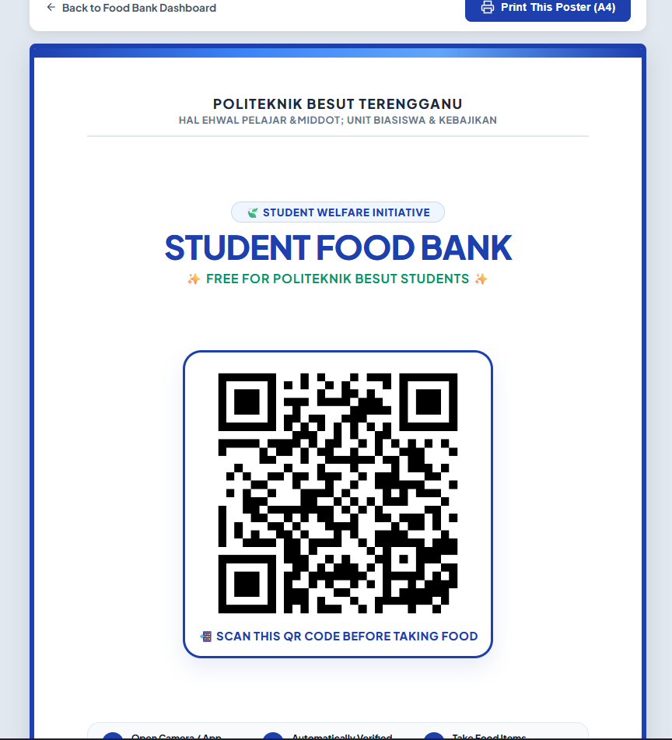
Food Bank poster example. Scan its QR to open the public claim form.

Review your Food Bank history
Sign in to MyHEP and open Food Bank Siswa to view your claim totals and the actions available to students. The public QR form itself does not require a MyHEP login.

Food Bank for staff
Staff with Food Bank access can review claim totals and records, search by student, apply date or program filters, export the report, and prepare the poster QR.

Review claims and export a report
1 | Open Student Food Bank from the Scholarship or Student Affairs menu.
2 | Review the total claims, unique student count, claims today, and claims this month cards.
3 | Use the search box and filters to narrow records by student or the available program, semester, and date fields.
4 | Choose Export Client Format Excel Report to download a spreadsheet for the selected records. Review the filters and exported rows before sharing.
5 | Use the delete action only when an authorized correction is needed and confirm the target record carefully.

Place the QR on a client poster
1 | Open Print QR Poster from the Food Bank dashboard.
2 | Choose Upload Client Poster and select a PNG, JPG, WebP, or PDF file no larger than 20 MB. For a PDF, the first page is used.
3 | Wait while MyHEP looks for a blank square. Check the preview before using the poster.
4 | If the QR is misplaced, drag it on the preview or adjust horizontal position, vertical position, and size.
5 | Choose Download Poster With QR to save a PNG, or choose Print Poster to print the current preview.

Poster file privacy
Poster processing takes place in the browser. The upload is not saved to MyHEP. If automatic detection is uncertain, the QR is placed in a fallback position; adjust it manually and confirm that it does not cover poster text or artwork.

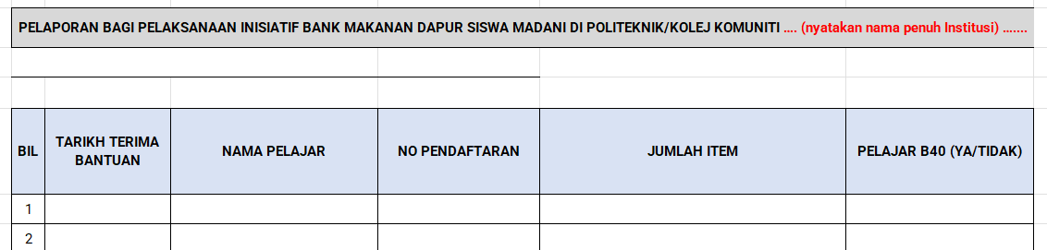
Client-provided example of the expected Food Bank report layout.

Scholarship administration
The Scholarship area includes the student form submissions, scholarship records, welfare cases, B40 TVET imports, and announcements. Use the page that matches the work you are doing; a saved student status form and a managed aid record are different records.

Review student status forms
1 | Open Scholarship Status Data to list students who submitted the status form.
2 | Search by student or matric number and review the selected submission.
3 | Open the supporting document link when one is attached. Check the file and the student details before making a decision.
4 | Use the available review or download actions on the page. Follow the office process for contacting the student or recording an outcome.

Use Scholarship Records
Open Scholarship Records to search, filter, export, add, edit, or delete managed aid records. The card above the list shows the number of distinct students who submitted the scholarship status form. It counts each student once, including students who reported “No Scholarship” or selected welfare assistance; it is not a count of active awards.
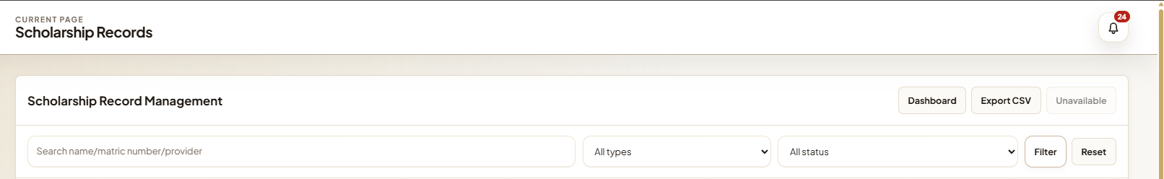
Scholarship Records page example. The search and filters narrow the list; student details are omitted from this illustration.

Manage notices and welfare
Use Scholarship Announcements to create, edit, or remove notices for students. Use Student Welfare to review welfare records and the available status and group filters. Check the selected student and record before editing or deleting.

Discipline and campus services

Student actions
- My Offenses: review offense records and any payment or appeal actions shown for your account.
- Vehicle Sticker: submit vehicle details and documents requested by the application form, then check the displayed decision status.
- Student Movement: use the movement QR or form available to your account and review your movement history or status.
- Rules and Announcements: read current campus rules and notices published by the office.
- Documents: download documents available to your account and check their status if review is shown.

Staff actions
Authorized staff can manage offense records, decisions, rules, discipline notices, vehicle stickers, insurance receipts, and student movement settings. Use search and filters first. Open a record before changing it, verify the student identifier, save the decision, and check that the updated status appears in the list.
Keep decisions traceable
Use the record’s built-in status or decision action. Avoid changing a student’s underlying profile to represent a separate discipline or payment decision.

Campus movement and Guard House
Students scan the official Guard House QR to open a short one-time movement pass. Check your displayed student details and current inside/outside status, choose the movement action, complete the requested details, and submit before the pass expires. Staff with Guard House access can display or refresh the checkpoint QR, review movement and outside-campus lists, and check recorded violations.

Laptop loans and program merit
Authorized staff open Laptop Management to search assets, filter by available or borrowed status, print QR labels, and review loan history. Use Scan a Laptop QR to record a borrow or return, then confirm that the result message shows the correct laptop and action. Students can review merit totals from Program Activities when the feature is enabled. Program staff set merit values in the program settings; the system awards points for valid internal attendance.

Programs and reports for staff

Create and manage a program
1 | Open Program Management and choose the create or add action.
2 | Enter the program title, dates, venue, description, and any other required fields.
3 | Choose the attendance method and participation settings. Review the displayed mode before opening attendance.
4 | Save the program and open it from the program list to verify its details.
5 | When the activity is running, display the current QR if the program requires scanning. Close attendance when the session ends.
6 | Review attendance and questionnaire data. Use the available report or export action to prepare the record.

Monthly reports and exports
Open Monthly Report to choose the reporting period and review the available summary cards and charts. Export only the required date range and check the file before sending it outside the institution. Some roles see only reports for their assigned scope.
Report figures
Confirm the selected program or date range before interpreting totals. A report export reflects its current filters and the data saved in MyHEP.

Student records and account administration

Maintain student records
1 | Open Student List and search by name or matric number before adding a new record.
2 | Open the student profile to review the current details and linked records.
3 | Use Edit for permitted corrections. Save and confirm the updated values.
4 | For bulk imports, use the provided import template and review the import summary for created, updated, skipped, or invalid rows.
5 | Use export for an authorized reporting purpose. Handle exported personal data securely.

Manage staff and access
Administrators with account-management access can add or edit staff accounts and assign the permitted role or scope. Give each person only the access needed for their work. When a staff member changes duties or leaves, update or disable the account promptly according to institutional procedure.

Settings, support, and maintenance
- Profile and Settings: maintain your own account information and available preferences.
- Feature Management and Maintenance: system administrators can manage feature availability and maintenance notices.
- Active Visitors and Bug Reports: authorized staff can review current visits or resolve submitted issue reports.
- AI Helper and paperwork: use available prompts or templates, review generated content, and download the chosen output format.

Troubleshooting and quick reference

Common issues
I cannot see a menu item. Your role may not include that module, or the feature may be disabled. Ask your system administrator to verify your access.
A form will not submit. Look for required fields or validation messages, check that uploaded files match the allowed type and size, and submit again.
A QR code will not scan. Use the official current QR, allow camera access, improve lighting, and check the network connection. For attendance, ask staff to confirm that attendance is still open.
The poster QR is in the wrong place. Use the preview controls to drag or resize the QR. Leave a clear quiet zone around the code and test-scan the downloaded poster before printing copies.
An exported file looks incomplete. Return to the source page, clear unintended filters, confirm the date range, and export again. Check that the export completed before closing the page.
A record looks incorrect. Capture the page name and record identifier, then contact the office responsible for that module. Do not share passwords or sensitive documents in a general support message.

At a glance
Need to… | Open…
Submit scholarship or welfare details | Student Portal → Scholarship → Status Form
Claim Food Bank items | Scan the official Food Bank QR; no login is needed
Review student aid submissions | Admin → Scholarship → Scholarship Status Data
Prepare a client Food Bank poster | Admin → Student Food Bank → Print QR Poster
Manage programs and attendance | Admin → Program Management
Check student discipline records | Student Portal → Discipline, or the authorized admin area

Need help?
Use the MyHEP support or bug-report option if it is available to your account. Include the page, the action you took, and the message shown so staff can investigate.

