# Homework: Bugs and Bug Tracking

## Bug Hunting: Google Home Page

|  |  |
| --- | --- |
| **Bug** | **Description** |
| **Bug #1** | The page has no title.  **Actual:** |
| **Bug #2** | The colors of the logo are changed:  **Actual:** |
| **Bug #3** | The places of Images and Gmail are not correct  **Actual:** |
| **Bug #4** | The number of dots in the app form are 8, instead of 9.  **Actual:** |
| **Bug #5** | The sign Bulgaria should be not in italic  **Actual:** |
| **Bug #6** | The field How search works is repeated twice:  **Actual:** |
| **Bug #7** | The magnified glass should be oriented on the other side  **Actual:** |
| **Bug #8** | The microphone field is not correct  **Actual:** |
| **Bug #9** | Privacy button is missing  **Actual:** |
| **Bug #10** | The search on images button is missing:  **Actual:**    **Should be like this:** |
| **Bug#11** | **I am Felling Lucky** sign is not correct. It has a typo:  **Actual:** |
| **Bug#12** | Business link is missing  **Actual:** |
| **Bug#13** | Advertising link is missing  **Actual:** |

## Bug Hunting: Notepad Application

|  |  |
| --- | --- |
| **Bug #1** | There is no title |
| **Bug #2** | The menu is not correct. Is like this:    Should be: |
| **Bug #3** | The close button is not correctly displayed |
| **Bug #4** | There is forward and back function which is not correct |
| **Bug #5** | Open function is not displayed correctly: |
| **Bug #6** | There should be not dots after the Save as function and **As** should be with small letter **as**: |
| **Bug #7** | There should be no dots after Page setup and **Setup** should be with small letter **setup** |
| **Bug #8** | Print is not displayed correctly |
| **Bug #9** | The settings button is missing: |
| **Bug #10** | The Notepad sign should be not there |
| **Bug #11** | The + button is missing |
| **Bug #12** | After the Print function there shoud be not empty field |

## Bug Reporting: Gmail

|  |  |
| --- | --- |
| **Bug ID** | SB-21 |
| **Priority** | High |
| **Severity** | High |
| **Assigned to** | empty |
| **Reported by** | Ivan Georgiev |
| **Reported on** | 15.03.2023 |
| **Status** | new |
| **Environment** | Google Chrome Version 111.0.5563.65 (Official Build) (64-bit) |
| **Summary** | After logging into Gmail, it navigates to Google.co |
| **Description** | When I try to log in Gmail.com -http://gmail.com with username and password the browser opens Google.com page instead of my Gmail inbox. |
| **Expected behavior** | Open my Gmail inbox |
| **Actual behavior** | Open <http://google.com> page |
| **Steps to reproduce** | Open un anonymous (incognito) browser [Shift+Ctrl+N]Open the <http://gmail.com> page  Fill in your usernameFill in your passwordThe log in could require a two steps verificationAfter successful log in it should open my Gmail inboxInstead of my Gmail.com inbox account it open google.com |

## Bug Reporting: Reset Password

|  |  |
| --- | --- |
| **Bug ID** | SA-35 |
| **Priority** | Medium |
| **Severity** | Medium |
| **Assign to** | Empty |
| **Reported by** | Ivan Georgiev |
| **Reported on** | 18.03.2023 |
| **Status** | New |
| **Environment** | Google Chrome Mobile |
| **Summary** | New user who registers via mobile on a website, receives twice an conformation e-mail |
| **Description** | When a new user is register for the first time on a webpage – samplepage.com via mobile phone, he/she received an e-mail containing the link to reset the initial (default) password two times.  If the user is register on PC/laptop everything is working properly |
| **Expected Behavior** | When the user is register to the website it should received conformation e-mail only once |
| **Actual Behavior** | The registration e-mail is received twice, when the user is register via a mobile application |
| **Steps to reproduce** | 1. Open the website samplepage.com on a mobile device 2. Open the registration form 3. Fill in the user name 4. Fill in the password 5. Check your e-mail for a link to reset the initial password 6. The e-mail is received twice |

## Register in Atlassian Jira Cloud

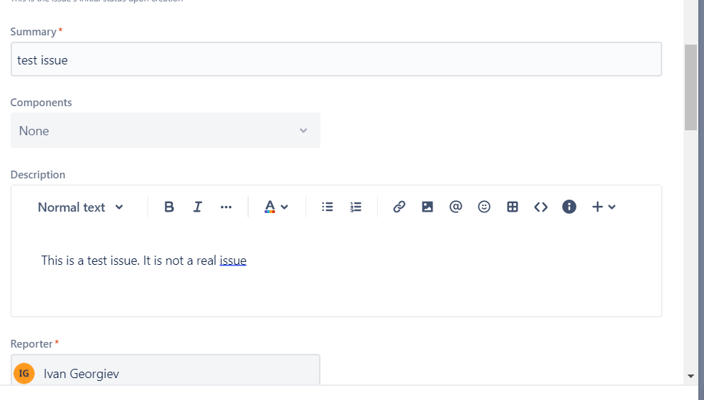

## Bug Reporting: Registration Form

Briefly describe all bugs you have found in the table below. You may add screenshots where it is relevant.

|  |  |
| --- | --- |
| **Bug** | **Description** |
| **Bug #1** | The username cannot be 4 or 5 alphanumerical chars. But username **gosho** or gosh are working correctly |
| **Bug #2** | **Clear Form** button is not working |
| **Bug #3** | When the page is redirect to another page the **“You are now logged in.”** message didn’t appear.  Instead, we have a message: |
| **Bug #4** | The field **Create Your Account** has a typo:  **Actual:**    **Expected:**  **Create Your Account** |
| **Bug #5** | The name of field **Confirm Email** is not correct. It should be **Confirm Password**  **Actual:**    **Expected:**  **Confirm Password** |
| **Bug #6** | Incorrect punctuation after the test labels. There should be no spaces after the Username, Email, Password, Confirm Email and **“:”**  **Actual:**    **Expected:**  Username:  Email:  Password:  Confirm Password:  Type: **Enchantment** |
| **Bug #7** | If you register once and go back you can register again by clicking on forwards button and without fill in the password’s fields |
| **Bug #8** | The password with 11 alphanumerical chars should be invalid but **GOsho123!12** is valid |
| **Bug #9** | The message **Redirecting** is not needed |
| **Bug #10** | A password with 4 and 5 alphanumerical chars should be not valid but password **GOs!1** is valid |
| **Bug #11** | Username should have a limit of characters - e.g. 50 chars  Type: **Enchantment** |
| **Bug#12** | Duplicated username should be not allowed.  You can log in with the same username more than once |
| **Bug#13** | Checkbox **Terms and Conditions** is missing  Type: **Enchantment** |
| **Bug#14** | **Usability issue:** The validations errors should be displayed in red before or after the incorrectly filled filed  **Actual/Bad usability**    **Expected/Better usability**    Type: **Enchantment** |

**Report all bugs** found in your **Jira** project.

