To Install the tool

1.Clone the tool to a folder: <tool-folder>

Command: git clone "https://github.com/JulianHayward/Azure-MG-Sub-Governance-Reporting.git"

2.Create output folder.

3.Execute the tool

Command: <tool-folder>\Azure-MG-Sub-Governance-Reporting\pwsh\AzGovVizParallel.ps1 -ManagementGroupId <target Management Group Id> -OutputPath "c:\AzGovViz-Output"

To view the html report in Azure portal, copy the report to a web container.

A) To create a web container:

1. Create a resource of type Storage account

2. Click on the 'Static website' under 'Data management'

3. Enter a file name in 'Index document name’. Example: report.html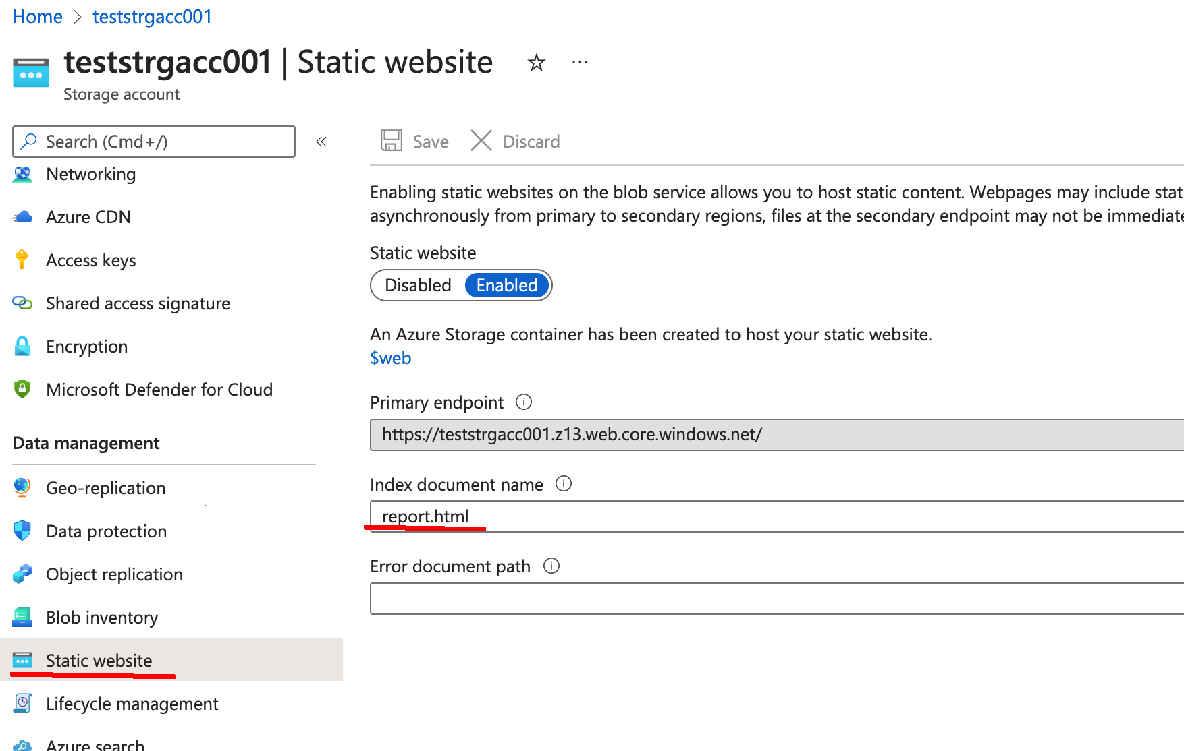

B) Copy the generated report to the web container created above:

Powershell command: *Get-AzStorageAccount -Name <storage account> -ResourceGroupName <resource group> | Get-AzStorageContainer -Name $web | Set-AzStorageBlobContent -File <source-file> -Blob <target-file>*

Example: *Get-AzStorageAccount -Name teststrgacc001 -ResourceGroupName rg-governance-eng-eastus | Get-AzStorageContainer -Name $web | Set-AzStorageBlobContent -File ./report.html -Blob report.html*

C) To create a secure shared access signature (SAS) URI:

1.Click on the '$web' container from the list of containers

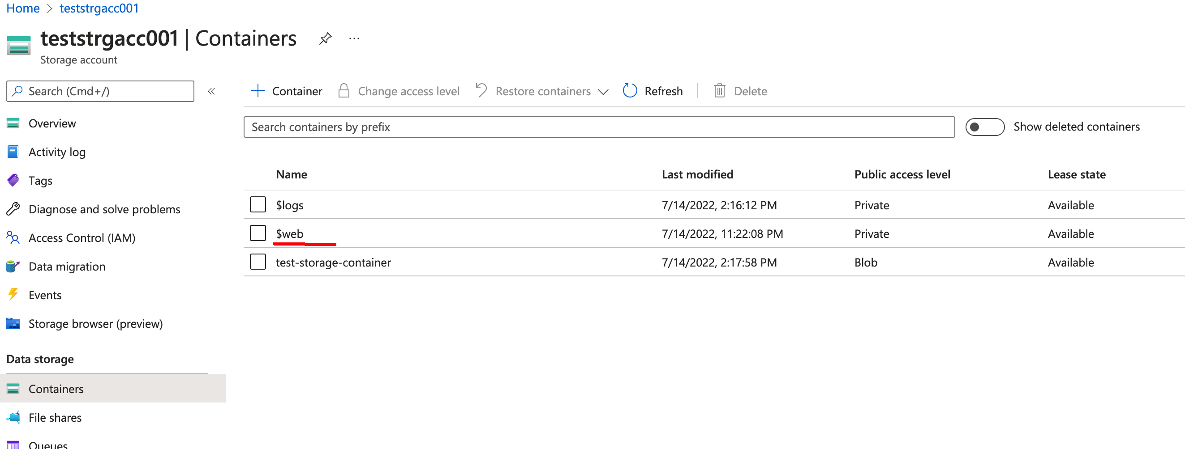

2.Click on the file(report.html) copied by the above step

3.In the overview tab make sure CONTENT-TYPE is set to ‘text/html’

4.Click on the 'Generate SAS' tab

5.Click on 'Generate SaS token and URL’ button.

6.Use the generated link to share/view the report

