KSU CSC 113 Project - Phase 2 Report
Project Title: King Saud Hotel Management System
Course: CSC 113

Team Members:
- Mustafa Alalami - ID: 446106513
- Mohammed Alhatam- ID: 446108828

1. Introduction
This Phase 2 report details the substantial enhancements made to the King Saud Hotel System. The primary objective was to transition the application from a basic console-based tool to a robust Graphical User Interface (GUI) system while optimizing data structures and reliability.

Key Enhancements:

- Data Structure Migration: Replaced fixed-size arrays with a custom Generic Linked List (MyLinkedList) to allow dynamic memory management and overcome capacity limitations.

- Persistent Storage: Integrated Object Serialization to save and load the entire HotelSystem state, ensuring data persistence across sessions.

- Event-Driven Interface: Developed a multi-frame GUI using Java Swing to handle user interactions and display real-time results.

2. Exception Handling Details
Our system implements a comprehensive error-handling strategy to ensure stability:

- User-Defined & Checked Exception: InvalidDateException is thrown when illogical dates are entered. This exception is propagated from constructors and caught in the GUI layer to notify the user via dialog boxes.

- Unchecked Exception: NumberFormatException is handled during input parsing to prevent crashes from non-numeric entries. Additionally, IllegalArgumentException is utilized within the ResultFrame to validate search queries.

- File I/O Exceptions: IOException is handled during file operations to manage potential read/write errors.

3. GUI Implementation & Logic
The system's interface is designed across two primary frames for better user experience:
- Main Input Frame (inputgui): Handles customer registration and reservation creation. It features dynamic visibility logic where components (like "Nights" or "Stage") appear only when relevant to the selected reservation type.

- Display & Search Frame (ResultFrame): Dedicated to querying the Linked List. It allows users to search for specific reservations by ID or view the entire sequence of active bookings.

- Screenshots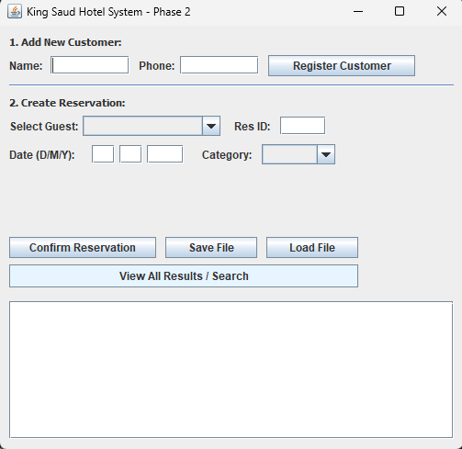
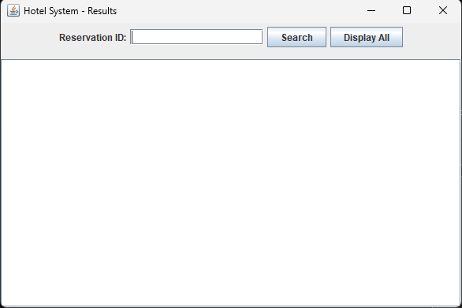
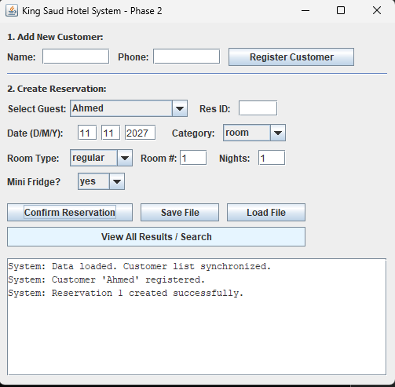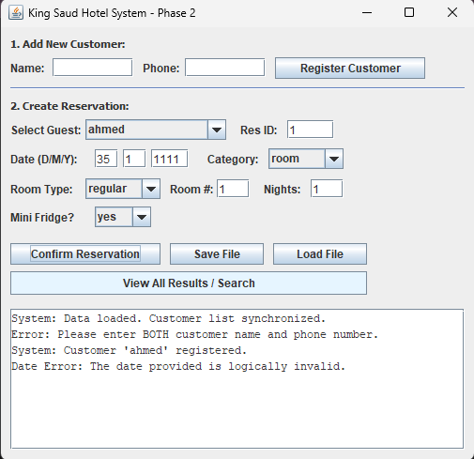
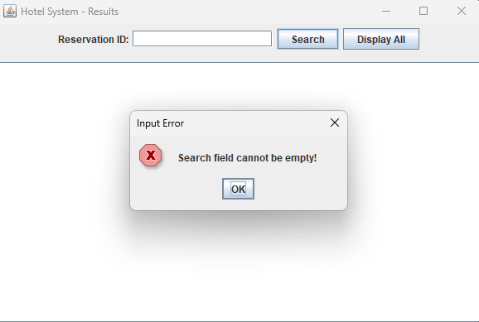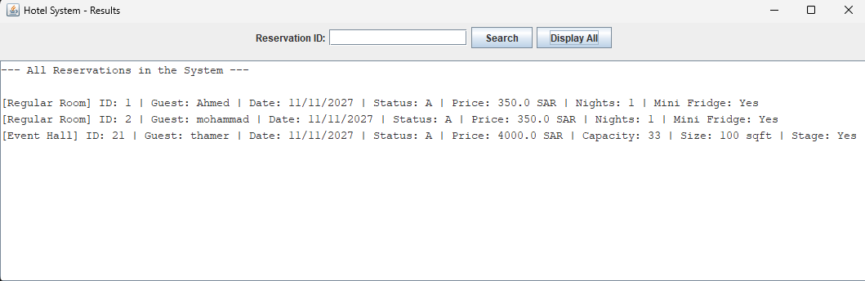
- Screenshot 1: The main inputgui frame showing the customer registration and reservation fields.
- Screenshot 2: An example of a successful save operation with the success message in the text area.
- Screenshot 3 & 4: An example of Exception Handling (e.g., the popup dialog showing the date error or empty search field).
- Screenshot 5: The ResultFrame displaying a search result or all current reservations.

