SE Assignment 3

Group Members
Roll Number | Name
22i-0983 | Muhammad Taha
22i-0878 | Muhammad Ibrahim Awais
22i-8223 | Sameed Ahmed

Project Repository
GitHub Link:
https://github.com/i220878/SE_PCPartVisualizer

User Stories

Completed User Stories
- US1: Users can search for PC components by category and brand.
- US2: Users can add components to a build list.
- US3: Users receive compatibility warnings if selected parts are not compatible.
- US4: Users can see price comparisons from different retailers.
- US5: Users can save multiple builds.
- US6: Users can see a 3D model of their selected components.
- US7: Users can rotate, zoom, and inspect their PC build in the 3D viewer.
- US8: The 3D viewer highlights potential compatibility issues.
- US9: Users can toggle between different case side panels.
- US10: Users can change lighting and color schemes in the 3D viewer.
- US16: Users can export their build as a detailed PDF.
- US17: Users can filter component search results by power consumption.
- US18: The system recommends a power supply based on selected components.
- US25: Users can see estimated shipping times for each component.

In Progress User Stories
- US11: Users can generate a shareable link to their PC build.
- US20: Users can generate a step-by-step build guide.

Remaining User Stories (Product Backlog)
- US12: Leave reviews on specific components.
- US13: View user-submitted builds with photos/specs.
- US14: Comment/discuss other users' builds.
- US15: Follow builders, notifications of new builds.
- US19: Simulate airflow in 3D viewer.
- US21: Manage/access builds from mobile device.
- US22: Mobile-optimized interface.
- US23: Notifications for price drops.
- US24: Checkout from integrated online stores.

Gantt Chart
The Gantt chart below illustrates the timeline and distribution of tasks among team members for the SE_PCPartVisualizer project. Each phase, from requirements gathering to testing and deployment, is mapped with estimated start and end dates, ensuring clear visibility of project progress and deadlines.
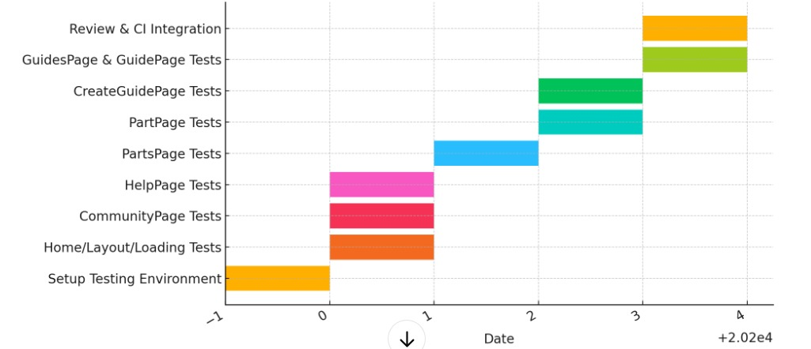

Burndown Chart
The burndown chart tracks the remaining work in the sprint backlog over time. It helps visualize the team's progress and ensures that the project is on track to meet its deadlines. The chart is updated daily to reflect completed tasks and remaining workload.
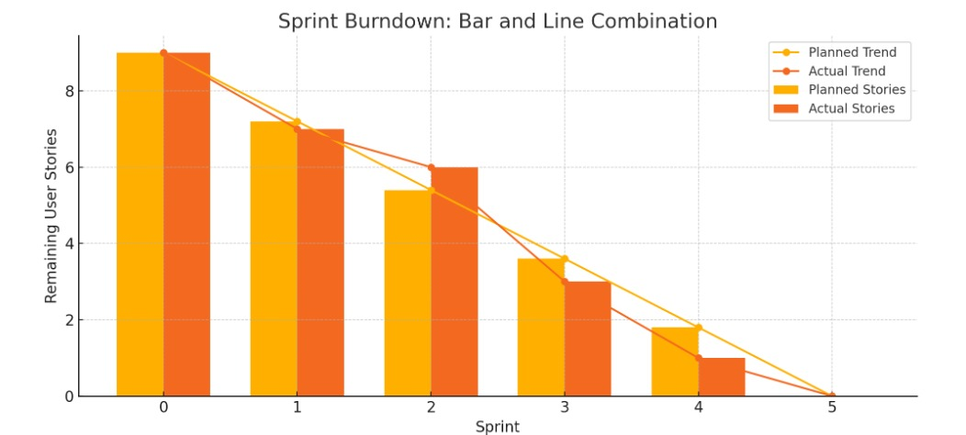

Sprint Snapshots
First snapshot:
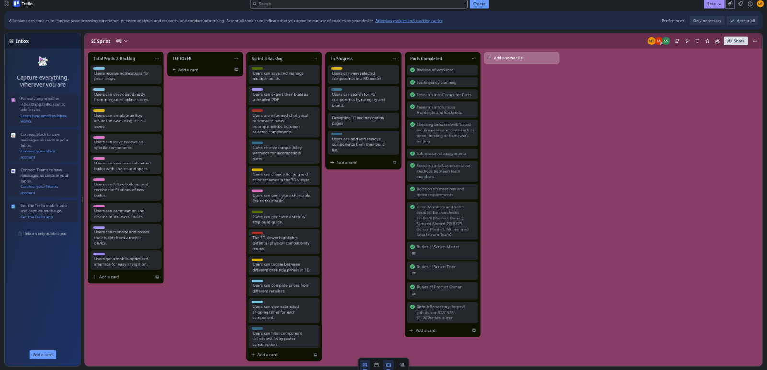

Second Snapshot:
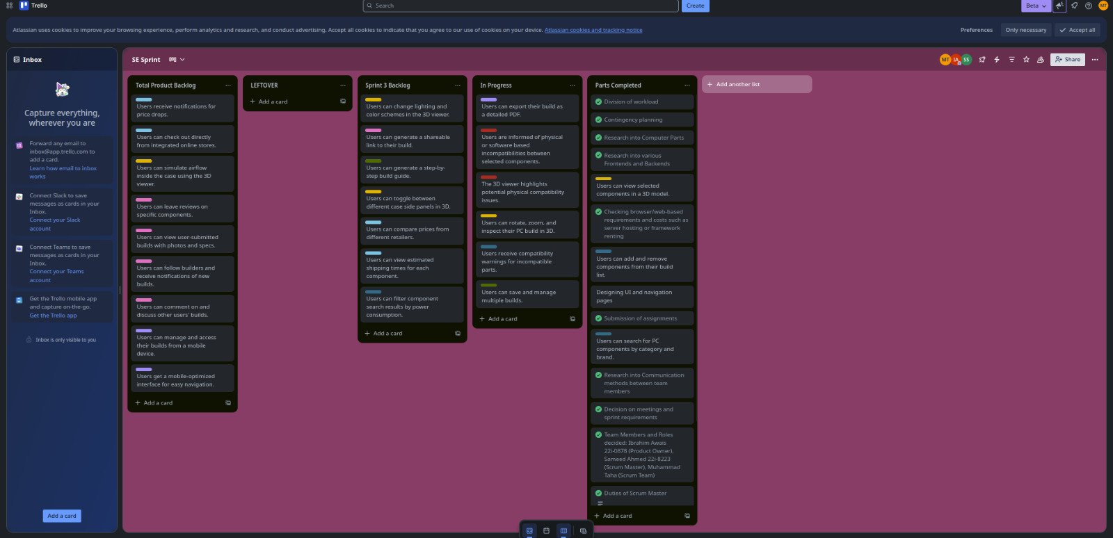
Third snapshot:
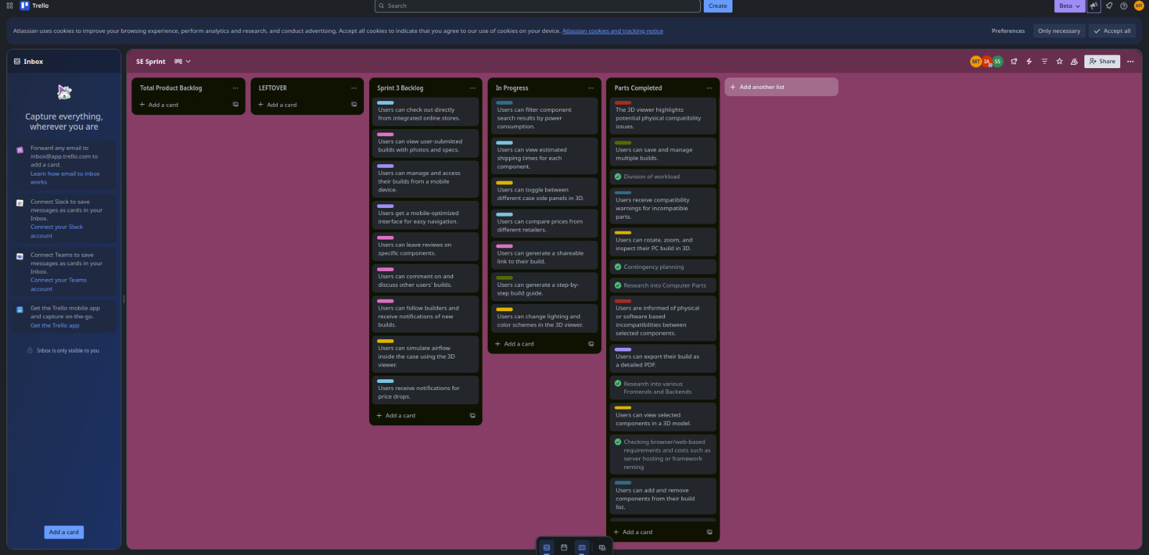

Fourth Snapshot:
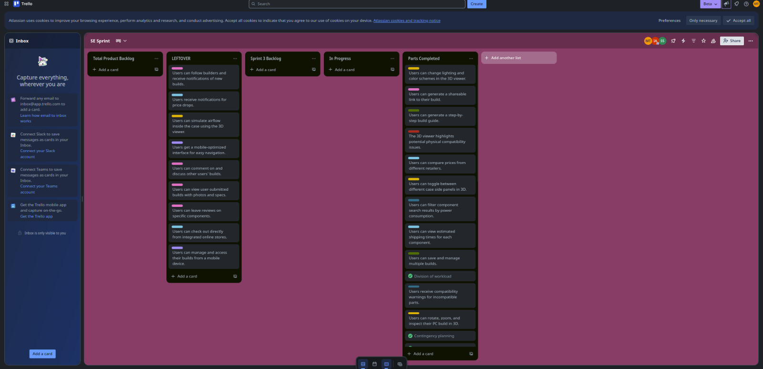

Equivalence Classes Partitioning
The image below demonstrates the equivalence class partitioning applied to the input validation module of the PC Part Visualizer. It categorizes valid and invalid input ranges, ensuring comprehensive test coverage and robust validation logic.
