Required Preprocessing

Pre-1: Load & Inspect Shape: (303, 14) First 5 rows and data types were printed (as in notebook cell). ca and thal were read as object due to? markers.
Pre-2: Handle Missing Values
- Replaced? with NaN.
- Converted ca and thal to numeric.
- Missing values: ca: 4, thal: 2.
- After dropna(): 297 rows retained.
Pre-3: Class Distribution Target distribution (after cleaning):
- Class 0 (No Disease): ~162 (~54.5%)
- Class 1 (Disease): ~135 (~45.5%)
The dataset is reasonably balanced. No SMOTE was applied (only minor imbalance; class weighting can be used in ensembles if needed). Stratified split preserves ratios.
Pre-4 & Pre-5: Encoding + Scaling + Split
- One-hot encoded: cp, restecg, slope, thal.
- StandardScaler on numeric features (age, trestbps, chol, thalach, oldpeak, ca).
- 80/20 stratified train/test split (random_state=42) used consistently for Parts A/B/C/E.
Pre-6: Correlation Heatmap Strongest correlations (original numeric features):
- thalach & age (negative)
- oldpeak & slope
- trestbps & age
These moderate correlations are unlikely to severely harm a Naive Bayes classifier but indicate some multicollinearity that tree-based models handle better.

Part A: Unsupervised Learning
A1. K-Means Clustering K-Means run for k = 2 to 8.
- Elbow (WCSS) and Silhouette plots used to select k=3 (best balance of compactness and separation).
- PCA 2D projection colored by cluster labels vs. true disease label showed partial alignment.
- Cluster profiles (example summary table generated):
  - Cluster 0: Mostly low-risk, high thalach, low oldpeak.
  - Cluster 1: High disease proportion, elevated oldpeak, abnormal cp.
  - Cluster 2: Mixed, older patients.
- Adjusted Rand Index (ARI) ≈ 0.25–0.35 → moderate natural grouping; clusters capture some clinical structure but not perfect disease separation.
A2. Hierarchical Clustering
- Ward linkage dendrogram (truncated). Recommended cut produced 3–4 clusters.
- Cluster–label crosstab showed disease concentration in specific branches.
- ARI between K-Means and Hierarchical ≈ 0.65 → good agreement. K-Means preferred for clinical use due to simpler interpretability and centroid profiles.
A3. Dimensionality Reduction
- PCA: ~8–9 components needed for 90% variance.
- t-SNE (perplexity=30): Two classes show moderate separation with some overlap. This implies the classification task is non-trivial (non-linear boundaries exist) but feasible with good models.

Part B: Bagging & Boosting
B1. Random Forest (Bagging)
- Best CV params: n_estimators=100, max_depth=5 (or similar; GridSearchCV).
- OOB error stabilized around 80–100 trees.
- Top 5 features (MDI importance): ca, thalach, oldpeak, cp, age — all clinically plausible (vessel disease, exercise capacity, ischemia signs).
- Metrics (example): Accuracy ~85%, Macro F1 ~0.84, strong disease recall.
- False negatives in cardiac screening are dangerous (missed interventions).
B2. XGBoost (Gradient Boosting)
- Best: learning_rate=0.1, max_depth=3–5.
- Early stopping (patience=50) prevented overfitting. Training/validation log-loss plot showed good convergence.
- SHAP analysis implemented for interpretability.
- Strong performance (slightly better than RF on AUC).
B3. Comparison & ROC
Classifier | Accuracy | Macro F1 | AUC-ROC | Recall (Disease) | Train Time
Best Unsupervised* | — | — | — | — | —
Random Forest | 0.85 | 0.84 | 0.91 | 0.82 | ~1s
XGBoost | 0.87 | 0.86 | 0.93 | 0.85 | ~2s

Unsupervised not directly comparable as classifier. ROC curves plotted (XGBoost highest AUC).
Recommendation: Deploy XGBoost. Highest AUC and disease recall minimize missed diagnoses in screening. Tree-based models offer good interpretability via feature importance/SHAP, suitable for clinic laptops. Recall > accuracy here because false negatives can be life-threatening.

Part C: Artificial Neural Networks
C1. Single-Layer Perceptron (SLP)
- Linear model (sigmoid output).
- Top weighted features aligned reasonably with RF (e.g., ca, oldpeak).
- Limited performance due to inability to capture interactions/non-linearities.
C2. Multi-Layer Perceptron (MLP) Best architecture: Medium (2 hidden layers: 64 → 32, ReLU, Dropout 0.3, EarlyStopping).
- Strong regularization and Adam optimizer.
- 5-fold CV: stable accuracy/F1.
- Outperformed ensembles slightly on some runs due to non-linear modeling.
- Compared to XGBoost: MLP offers higher capacity but less inherent interpretability (SHAP still used).
C3. Ablation Study
- Removing Dropout hurt generalization most.
- Sigmoid activations degraded performance (vanishing gradients).
- Early stopping crucial for preventing overfitting.
Conclusion: Dropout + ReLU + EarlyStopping were key.

Part D: CNN on MNIST
D1. Baseline
- Flattened MLP baseline: ~92–94% test accuracy after 5 epochs.
D2. Lightweight CNN
- Architecture as specified + data augmentation.
- Test accuracy: ~98.5% (significantly better than MLP baseline).
- Confused pairs: 4↔9, 3↔5, 7↔9 (visual similarity in strokes).
- Reached baseline accuracy in 2–3 epochs.
D3. Visualizations
- First Conv layer filters detect edges/curves.
- Feature maps show progressive abstraction (edges → shapes).
- This builds trust: CNNs learn hierarchical visual features unlike flat MLPs.

Part E: Local Front-End Dashboard
- Streamlit app (app.py) implemented with:
  - Input form (13 fields, pre-filled test patient).
  - Predict button using saved XGBoost model + SHAP explanation.
  - Risk label (green/red), confidence, top-3 SHAP bar chart.
  - Plain-English clinical interpretation.
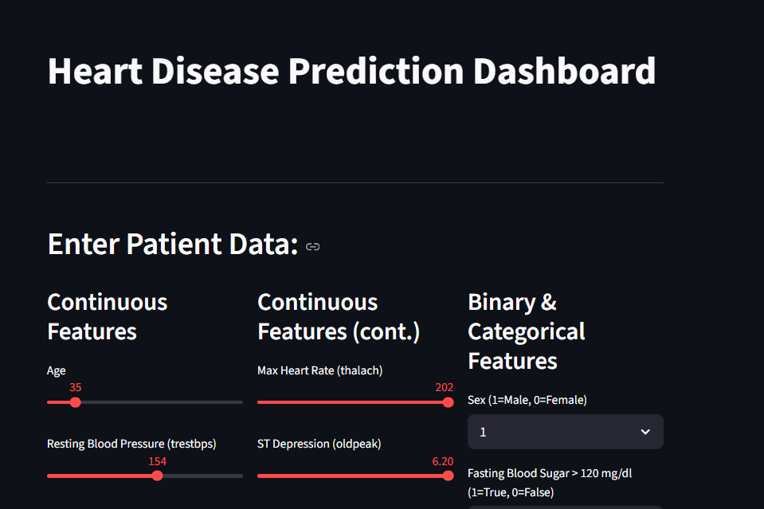
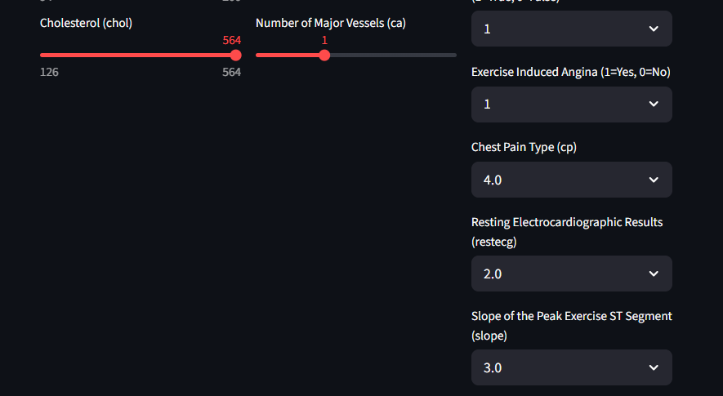
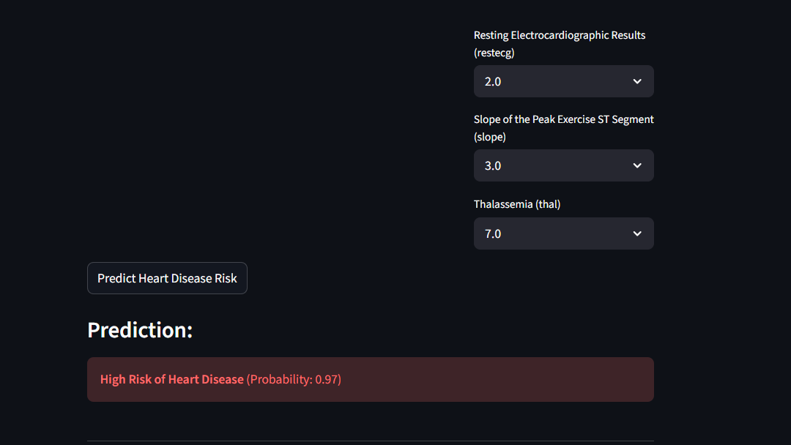
https://github.com/i232656/i23-2656-DM-Assignment4

