SE 3002 — Software Quality Engineering
FAST School of Computing — Department of Software Engineering — FAST NUCES Islamabad
ASSIGNMENT 3 — Student Submission Template
Black-Box Testing: EP & BVA on Testfolio
Student Name | Umair Hassan
Roll Number | 24i-3137
Section / Batch | SE C / Batch 2024
Instructors | Dr. Nigar Azhar Butt | Dr. Atif Aftab Jilani | Miss Anum Kaleem
Test Account Used | i243137@isb.nu.edu.pk
Browser & Version | Google Chrome 156.0.8078.47 on Windows 11 (64-bit)

ℹ This template is pre-formatted. Add rows to any table as needed. Do NOT delete section headings or column headers. Export to PDF before submitting.

⚠ Italic gray text = fill-in prompt. Replace every prompt with your own content before submitting.

D1 — Test Plan [20 marks]

TP-1 Test Plan Metadata | [1 marks]

Test Plan ID | TP-A3-24i-3137
Version | 1.0 (Final)
Author (Roll No.) | Umair Hassan (24i-3137)
Status | Complete / Final

TP-2 Introduction | [2 marks]

Briefly describe Testfolio and the purpose of this test plan:
Testfolio (https://testfol.io/) is an advanced, web-based financial backtesting, asset allocation, and scenario modeling platform. It empowers quantitative researchers and individual investors to evaluate investment strategies across historical datasets, simulate retirement cashflow withdrawals, compute efficient frontiers, and optimize multi-asset portfolios.
The purpose of this software quality engineering test plan is to conduct rigorous black-box functional testing of Testfolio's deployed web application. By applying Equivalence Partitioning (EP) and Boundary Value Analysis (BVA), this testing effort systematically verifies client-side and server-side validation rules, identifies boundary failure modes across continuous and discrete domains, evaluates system robustness under invalid inputs, and provides an authentic, evidence-backed test record to guarantee compliance with SE 3002 standards.

TP-3 Scope | [2 marks]

In-Scope Features (list every form and input field you will test):
The testing scope encompasses all eleven (11) interactive tools and forms deployed on Testfolio as mandated by the assignment handout:
1. Create Account (Sign Up) — https://testfol.io/start (modal: email address, password, client validation, auth provider)
2. Sign In (Login) — https://testfol.io/login (modal: email address, password, authentication feedback, one-time code)
3. Portfolio Backtester (CRITICAL FORM) — https://testfol.io/ (parameters: date range, start/end dates, starting value, rolling window, cashflow legs, asset tickers, allocations %, rebalance frequencies)
4. Monte Carlo Simulator — https://testfol.io/monte-carlo (simulation years/horizon, iterations/count, asset distributions)
5. Safe Withdrawal Rate Calculator — https://testfol.io/safe-withdrawal-rate-calculator (initial capital, withdrawal rate %, duration, asset weights)
6. Backtest Optimizer — https://testfol.io/backtest-optimizer (target assets, min/max asset weight constraints, optimization metrics)
7. Efficient Frontier — https://testfol.io/efficient-frontier (multi-asset covariance matrix, risk-return bounds, asset count >= 2)
8. Contact Form — https://testfol.io/contact (name, email address, topic category, subject line with counter 0-120, message body with counter 10-5000, Cloudflare Turnstile anti-abuse check)
9. Lump Sum vs DCA — https://testfol.io/lumpsum-vs-dca (initial lump sum $, periodic DCA contribution $, investment interval, asset selection)
10. Time Value of Money Calculator — https://testfol.io/time-value-of-money (contribution frequency, contribution timing, X/Y/Color variables, starting value $, monthly contribution $ between $0 and $100,000)
11. Rebalancing Sensitivity — https://testfol.io/rebalancing-sensitivity (rebalancing schedules: Monthly/Quarterly/Yearly/Never, rebalance bands, asset drift).

TP-4 Test Objectives | [2 marks]

The primary technical objectives of this test engineering effort are:
1. Verify Functional Correctness: Ensure that valid financial parameters, date ranges, asset allocations, and credentials produce accurate mathematical calculations and simulations without runtime errors.
2. Evaluate Robustness & Error Trapping: Validate that invalid inputs (negative values, out-of-range percentages, inverted date ranges, malformed emails, short messages) are trapped gracefully with clear error banners or tooltips, preventing invalid calculation execution.
3. Determine Boundary Exactness: Empirically identify and probe exact mathematical and syntactic thresholds (e.g., minimum initial investment = $1, allocation sum = exactly 100%, Start Date < End Date, TVM monthly contribution = $0 to $100,000, contact message length = 10 to 5,000 characters).
4. Assess Security & Authentication Controls: Verify client-side prevention of malformed requests and server-side responses for unauthorized access or unauthenticated usage on gated features.
5. Maintain 100% Traceability and Evidence: Produce an auditable execution log supported by authentic, live screenshots bearing the student roll number sticky note to demonstrate genuine verification.

TP-5 Test Approach | [3 marks]

Describe how you applied EP and BVA, and your probe strategy:
1. Equivalence Partitioning (EP) Approach:
Every in-scope input field across all 11 forms was partitioned into mutually exclusive, exhaustive subsets of input data. Partitions were classified into Valid Equivalence Classes (VEC) representing expected operational states and Invalid Equivalence Classes (IEC) representing error conditions, boundary breaches, or malformed data. Unique sequential identifiers (EC-001 through EC-074) were assigned. Weak EP with Robustness was applied across all forms to guarantee that every valid and invalid class is exercised by at least one dedicated test case. Strong EP was applied to the designated Critical Form to evaluate complex combinatorial interactions.
2. Boundary Value Analysis (BVA) Approach:
BVA was applied to all fields with ordered numeric, date, percentage, or length domains. Each boundary was assigned a unique sequential ID (BC-001 through BC-015). For all standard forms, 2-point BVA was conducted (testing values at the boundary and immediately adjacent). For the designated Critical Form, 3-point BVA was applied, rigorously testing Below, At, and Above positions for every identified boundary.
Fields with nominal enumerations (e.g. rebalancing frequency dropdowns), binary discrete toggles (e.g. inflation checkboxes), and cryptographic verification states (Cloudflare Turnstile) were excluded from BVA with documented engineering justification.
3. Designation of Critical Form (Portfolio Backtester — testfol.io/):
The Portfolio Backtester is designated as the Critical Form due to its architectural role as the core functional engine of Testfolio and its multi-variable combinatorial constraints. It requires simultaneous validation of asset allocation percentages summing to exactly 100%, relational date constraints (Start Date < End Date), positive starting capital (>= $1), and multi-asset ticker configurations. This complexity justifies both Strong EP and 3-point BVA.
4. Exploratory Probe Testing Strategy:
Because Testfolio is a live, proprietary web application with intentionally withheld specification documents, exploratory probe testing was conducted prior to formal test case authoring. A structured sequence of 16 empirical probes was executed across forms to discover client-side HTML5 validation rules, server-side toast banners, DOM state modifications, and hidden boundary limits.

TP-6 Test Environment | [2 marks]

Browser & Version | Google Chrome 156.0.8078.47 (Official Build, 64-bit)
Operating System | Microsoft Windows 11 Home / Pro (Build 22631, 64-bit)
Screen Resolution | 1280 × 720 (Primary Display Resolution)
Test Account (email) | i243137@isb.nu.edu.pk (Authentic FAST Student Account)
Network / VPN | Direct Broadband / University Network; No Proxy; No VPN

TP-7 Entry & Exit Criteria | [2 marks]

Entry Criteria (conditions that must be true before testing begins):
Testing shall commence only when all of the following Entry Criteria are satisfied:
1. Testfolio web application is deployed, live, and publicly accessible at https://testfol.io without network outage.
2. Student testing account (i243137@isb.nu.edu.pk) is registered and operational for gated features.
3. Primary browser (Google Chrome 156 on Windows 11) is configured at 100% zoom with DevTools accessible.
4. Official assignment handout and template documents are loaded and structured in workspace.
5. Digital roll number sticky note (24i-3137) is configured and verified visible for screen capture.

Exit Criteria (conditions that mark testing as complete):
Testing shall be deemed complete only when all of the following Exit Criteria are satisfied:
1. All 11 in-scope forms and tools are fully investigated and inventoried.
2. Minimum 15 exploratory probes are executed, analyzed, and documented in TP-10 Probe Log (16 probes achieved).
3. All input fields across all 11 forms are partitioned into unique sequential EC IDs with VEC/IEC classifications in Layer 1.
4. Combined EP Test Case Table includes Weak EP with Robustness for all forms plus Strong EP for the critical form (77 EP test cases).
5. BVA Boundary Tables (Layer 1) define all applicable continuous boundaries with unique sequential BC IDs (15 boundaries).
6. Combined BVA Test Case Table covers 2-point BVA across forms and 3-point BVA (Below, At, Above) on the critical form (32 BVA test cases).
7. Traceability Matrix achieves 100% mapping across all 109 test cases with execution statuses and verdicts.
8. Authentic screenshots bearing the student roll number sticky note are embedded for every executed test case in the Execution Log.
9. Final document is formatted in DOCX and compiled to official PDF named A3_24i-3137_UmairHassan.pdf.

TP-8 Test Schedule | [2 marks]

Activity | Notes / Dates | Est. Hours | Done?
Probe / Explore all 11 Testfolio forms | Oct 24–25, 2026; live exploratory probing & screenshots | 4.0 | Yes
Complete EP Partition Tables (Layer 1) | Oct 25, 2026; defined EC-001 to EC-074 across all fields | 3.0 | Yes
Design EP Test Cases (Layer 2) | Oct 25, 2026; Weak EP + Strong EP for Backtester (77 TCs) | 3.5 | Yes
Complete BVA Boundary Tables (Layer 1) | Oct 25, 2026; defined BC-001 to BC-015 with justifications | 2.5 | Yes
Design BVA Test Cases (Layer 2) | Oct 25, 2026; 2-point BVA + 3-point BVA on Backtester (32 TCs) | 3.0 | Yes
Execute test cases & capture screenshots | Oct 25–26, 2026; live execution on Chrome with roll sticky note | 5.0 | Yes
Complete traceability matrix | Oct 26, 2026; mapped 109 test cases to fields, techniques, verdicts | 2.0 | Yes
Compile PDF and submit | Oct 26, 2026; document formatting, PDF export, LMS ready | 1.5 | Yes

TP-9 Risks & Mitigations | [2 marks]

Risk | Likelihood / Impact | Mitigation
Live Website Dynamic Updates: Testfolio is an actively updated web app; UI changes or ticker data updates could alter input validation rules mid-testing. | Medium / High | Lock test environment to specific probe sessions; record timestamped network requests; verify all boundaries using consistent historical tickers (VTISIM, BNDSIM).
Third-Party Rate Limiting & Anti-Abuse Blocking: Repeated contact form submissions or backtest runs could trigger Cloudflare rate limiting or captcha lockouts. | Low / High | Space automated/manual requests with realistic human pauses; use valid educational credentials; solve Turnstile challenges legitimately; test edge values sequentially.
Client-Side vs Server-Side Validation Discrepancies: HTML5 native tooltips may mask underlying server responses or silently handle unexpected input characters. | Medium / Medium | Examine both client DOM interaction (button disabled states, form constraints) and server toast banners; test bypassed inputs; document distinct failure tiers explicitly.

TP-10 Probe Log — Appendix A | [2 marks]

ℹ Record each probe you performed while exploring the application. For each row, list ALL inputs entered — include context fields (fields needed to submit the form) alongside the field under investigation. Minimum 15 probes.

Probe ID | Form | Test Inputs (field: value, …) | System Response | Inference / Note
PR-001 | Sign Up Modal (/start) | Target: Password: '' (empty)  Context: Email: 'probe_check@test.com' | Sign in button is completely disabled (dimmed blue); form submission blocked without error banner. | Password is mandatory prerequisite; client disables button rather than showing banner. (Evidence: TP10-P01)
PR-002 | Sign In Modal (/start) | Target: Password: 'a' (1 char)  Context: Email: 'test@example.com' | Sign in button enables at 1 char. Submitting triggers red banner: 'Email or password wasn't recognized. Try again...' | Min length boundary to activate submit is 1 character. Backend returns secure generic authentication error. (Evidence: TP10-P02)
PR-003 | Sign In Modal (/start) | Target: Email: 'notanemail' (no @)  Context: Password: dummy | Clicking Sign in triggers HTML5 tooltip: 'Please include an '@' in the email address. 'notanemail' is missing an '@'.' | Email field enforces native type='email' validation; traps syntax errors client-side before network dispatch. (Evidence: TP10-P03)
PR-004 | Portfolio Backtester (/) | Target: Portfolios: 0 (empty list)  Context: Default parameters | Clicking BACKTEST immediately triggers red banner: 'No valid portfolios were found.' Execution halted. | System enforces mandatory portfolio prerequisite; backtesting engine requires >= 1 configured portfolio. (Evidence: TP10-P04)
PR-005 | Portfolio Backtester (/) | Target: Allocations sum = 120% (VTISIM: 60%, BNDSIM: 60%)  Context: Default 60/40 preset | Total allocation turns red (120%). Clicking BACKTEST triggers red banner: 'Portfolio 1: Allocation percentages must sum to 100'. | Strict equality boundary: Total portfolio asset allocation must equal exactly 100%. (Evidence: TP10-P05)
PR-006 | Portfolio Backtester (/) | Target: Starting Value: -$7  Context: Valid 60/40 portfolio | Clicking BACKTEST triggers validation tooltip: 'Value must be greater than or equal to 1.' Backtest blocked. | Lower bound identified: initial capital must be >= 1. Negative amounts trapped by client range constraint. (Evidence: TP10-P06)
PR-007 | Portfolio Backtester (/) | Target: Starting Value: $0  Context: Valid 60/40 portfolio | Clicking BACKTEST triggers validation tooltip: 'Value must be greater than or equal to 1.' Backtest blocked. | Conclusive BVA evidence: 0 is 'Below' boundary and invalid; exact boundary value is 1. (Evidence: TP10-P07)
PR-008 | Portfolio Backtester (/) | Target: Starting Value: '' (empty)  Context: Valid 60/40 portfolio | Clearing field and clicking BACKTEST displays top red banner: 'Invalid starting value'. | Empty input is a distinct invalid equivalence class handled via application banner. (Evidence: TP10-P08)
PR-009 | Portfolio Backtester (/) | Target: Start: 01/01/2023, End: 01/01/2020  Context: Custom range, 60/40 portfolio | Clicking BACKTEST displays red banner: 'Start date must be before end date'. Execution halted. | Chronological order strictly enforced; End date preceding Start date is rejected. Relational bound: Start < End. (Evidence: TP10-P09)
PR-010 | Time Value of Money (/time-value-of-money) | Target: Form layout exploration  Context: Live page load | Discovered real fields: Contribution Frequency/Timing, Variables (X, Y, Color), Range toggles, Starting Value $, Monthly contribution $. | Verified interface structure; non-standard TVM parameterization. (Evidence: TP10-P10)
PR-011 | Time Value of Money (/time-value-of-money) | Target: Unauthenticated access  Context: Click CALCULATE without login | Modal dialog opens: 'Sign in required. Sign in with a free account to use the Time Value of Money Calculator.' | Advanced analytical tools enforce free account authentication gating. (Evidence: TP10-P11)
PR-012 | Time Value of Money (/time-value-of-money) | Target: Monthly contribution: -$500  Context: Signed in, $10,000 starting value | Clicking CALCULATE displays red banner: 'Contribution must be between $0 and $100,000.' Execution blocked. | Explicit numeric boundary discovered: Lower bound = $0, Upper bound = $100,000. (Evidence: TP10-P12)
PR-013 | Time Value of Money (/time-value-of-money) | Target: Monthly contribution: $0  Context: Default parameters | Calculation succeeds! Renders interactive curve: 'Results (sampled 1805 feasible solutions)'. | BVA lower bound confirmation: $0 is 'At' boundary and VALID. Range is closed [0, 100000]. (Evidence: TP10-P13)
PR-014 | Time Value of Money (/time-value-of-money) | Target: Monthly contribution: '' (empty)  Context: Following PR-013 execution | Displays banner: 'Contribution must be between $0 and $100,000.' Prior chart results remain rendered on screen. | Usability defect: Prior valid graph is not cleared when subsequent input validation fails. (Evidence: TP10-P14)
PR-015 | Contact Form (/contact) | Target: Message: 'ijklmno' (7 chars)  Context: Email: i243137@isb.nu.edu.pk, Subject: 'abcdefg' | Displays red banner: 'Message must be at least 10 characters.' Counter displays 7 / 5000. | BVA lower bound identified: min message length = 10 chars. Lengths < 10 are rejected. Max is 5,000. (Evidence: TP10-P15)
PR-016 | Contact Form (/contact) | Target: Message: >= 10 chars  Context: Email: i243137@isb.nu.edu.pk, Captcha passed | Green banner displays: 'Message sent. We will get back to you soon.' Form resets. | Valid payload accepted; Turnstile anti-abuse token verified by server. (Evidence: TP10-P16)

D2 — Equivalence Partitioning [25 marks]

ℹ D2 has two layers. Complete Layer 1 first — one partition table per input field. Then write Layer 2 — your EP test cases, citing the EC IDs from Layer 1.

LAYER 1 — EP Partition Tables (one table per input field — identify equivalence classes and assign EC IDs)

ℹ One partition table per input field across all 11 forms. Assign EC IDs sequentially (EC-001, EC-002, …) across all fields. Add more tables as needed.

EP-01 Feature / Form: Auth Modal (/start) Input Field: Email address
EC ID | Equivalence Class Description | Representative Value | Type (VEC / IEC)
EC-001 | Valid standard email format (contains @ and domain) | test@example.com | VEC
EC-002 | Registered student FAST university email format | i243137@isb.nu.edu.pk | VEC
EC-003 | Malformed email string missing '@' symbol | notanemail | IEC
EC-004 | Malformed email missing top-level domain | user@domain | IEC
EC-005 | Completely empty / blank email address | (empty) | IEC

EP-02 Feature / Form: Auth Modal (/start) Input Field: Password
EC ID | Equivalence Class Description | Representative Value | Type (VEC / IEC)
EC-006 | Valid alphanumeric password (length >= 8) | Testfol123! | VEC
EC-007 | Single-character input (activates submit button) | a | VEC
EC-008 | Password with special characters and symbols | P@$$w0rd_#& | VEC
EC-009 | Completely empty / blank password | (empty) | IEC
EC-010 | Unregistered credentials for authentication | DummyUnreg99! | IEC

EP-03 Feature / Form: Portfolio Backtester (/) Input Field: Portfolio Configuration
EC ID | Equivalence Class Description | Representative Value | Type (VEC / IEC)
EC-011 | At least one valid, configured portfolio present | 1 portfolio (60/40) | VEC
EC-012 | Multiple configured comparison portfolios present | 2 portfolios (P1, P2) | VEC
EC-013 | No portfolios configured (0 portfolios present) | 0 portfolios | IEC
EC-012

EP-04 Feature / Form: Portfolio Backtester (/) Input Field: Asset Allocation Percentage (%)
EC ID | Equivalence Class Description | Representative Value | Type (VEC / IEC)
EC-014 | Total portfolio asset allocations sum to exactly 100% | VTISIM: 60%, BND: 40% | VEC
EC-015 | Total portfolio asset allocations exceed 100% | VTISIM: 60%, BND: 60% (120%) | IEC
EC-016 | Total portfolio asset allocations sum to less than 100% | VTISIM: 40%, BND: 40% (80%) | IEC
EC-017 | Negative asset allocation percentage entered | VTISIM: -10%, BND: 110% | IEC

EP-05 Feature / Form: Portfolio Backtester (/) Input Field: Starting Value ($)
EC ID | Equivalence Class Description | Representative Value | Type (VEC / IEC)
EC-018 | Standard positive integer initial investment (>= 1) | $10,000 | VEC
EC-019 | Minimum allowable boundary starting value | $1 | VEC
EC-020 | Zero starting value (strictly < 1) | $0 | IEC
EC-021 | Negative starting value | -$7 | IEC
EC-022 | Completely empty / blank starting value | (empty) | IEC

EP-06 Feature / Form: Portfolio Backtester (/) Input Field: Date Range (Start Date vs End Date)
EC ID | Equivalence Class Description | Representative Value | Type (VEC / IEC)
EC-023 | Valid chronological date range (Start < End) | Start: 2010, End: 2023 | VEC
EC-024 | Inverted chronological date range (Start > End) | Start: 2023, End: 2020 | IEC
EC-025 | Identical start and end dates (Start == End) | Start: 2023, End: 2023 | IEC
EC-026 | Start date far in future beyond market dataset | Start: 2099, End: 2100 | IEC

EP-07 Feature / Form: Portfolio Backtester (/) Input Field: Rolling Window (months)
EC ID | Equivalence Class Description | Representative Value | Type (VEC / IEC)
EC-027 | Standard positive integer duration in months | 60 months | VEC
EC-028 | Zero or negative rolling window duration | 0 months / -12 months | IEC
EC-029 | Empty / blank rolling window | (empty) | IEC
EC-028

EP-08 Feature / Form: Portfolio Backtester (/) Input Field: Cashflows & Rebalancing Frequency
EC ID | Equivalence Class Description | Representative Value | Type (VEC / IEC)
EC-030 | Valid non-negative annual cashflow; standard rebalance | Cashflow: $0, Yearly | VEC
EC-031 | Valid positive recurring contribution | Cashflow: $500, Monthly | VEC
EC-032 | Negative recurring cashflow amount | Cashflow: -$500 | IEC
EC-032

EP-09 Feature / Form: Monte Carlo Simulator (/monte-carlo) Input Field: Simulation Horizon / Years
EC ID | Equivalence Class Description | Representative Value | Type (VEC / IEC)
EC-033 | Valid positive simulation duration in years | 30 years | VEC
EC-034 | Zero or negative simulation horizon | 0 years / -5 years | IEC
EC-035 | Empty / blank simulation duration | (empty) | IEC
EC-036

EP-10 Feature / Form: Monte Carlo Simulator (/monte-carlo) Input Field: Number of Simulations
EC ID | Equivalence Class Description | Representative Value | Type (VEC / IEC)
EC-036 | Standard positive iteration count (100 to 10,000) | 1,000 iterations | VEC
EC-037 | Zero or negative iteration count | 0 / -100 | IEC
EC-039

EC-040

EP-11 Feature / Form: Safe Withdrawal Rate (/safe-withdrawal) Input Field: Withdrawal Rate (%)
EC ID | Equivalence Class Description | Representative Value | Type (VEC / IEC)
EC-038 | Standard sustainable withdrawal percentage (1%–10%) | 4.0% | VEC
EC-039 | Extreme unrealistic withdrawal percentage (> 100%) | 120% | IEC
EC-040 | Negative withdrawal percentage | -3.5% | IEC
EC-044

EP-12 Feature / Form: Backtest Optimizer (/backtest-optimizer) Input Field: Weight Constraints (Min / Max %)
EC ID | Equivalence Class Description | Representative Value | Type (VEC / IEC)
EC-041 | Valid consistent bounds (0% <= Min <= Max <= 100%) | Min: 10%, Max: 50% | VEC
EC-042 | Inconsistent bounds (Min > Max) | Min: 60%, Max: 40% | IEC
EC-043 | Negative weight bound | Min: -10%, Max: 50% | IEC
EC-048

EP-13 Feature / Form: Efficient Frontier (/efficient-frontier) Input Field: Asset Selection Count
EC ID | Equivalence Class Description | Representative Value | Type (VEC / IEC)
EC-044 | Multi-asset selection capable of forming curve (>= 2) | 3 assets (VTI, BND, GLD) | VEC
EC-045 | Single asset selection (cannot calculate variance) | 1 asset (VTI) | IEC
EC-046 | Zero assets selected | 0 assets | IEC
EC-052

EP-14 Feature / Form: Contact Form (/contact) Input Field: Email
EC ID | Equivalence Class Description | Representative Value | Type (VEC / IEC)
EC-047 | Valid institutional email address | i243137@isb.nu.edu.pk | VEC
EC-048 | Invalid email format lacking domain structure | user@ | IEC
EC-049 | Empty mandatory email field | (empty) | IEC
EC-056

EP-15 Feature / Form: Contact Form (/contact) Input Field: Subject
EC ID | Equivalence Class Description | Representative Value | Type (VEC / IEC)
EC-050 | Valid subject within length bound (1 to 120 chars) | Inquiry on backtest data | VEC
EC-051 | Subject exceeding max character limit (> 120 chars) | A * 125 chars | IEC
EC-052 | Empty subject string | (empty) | IEC
EC-060

EP-16 Feature / Form: Contact Form (/contact) Input Field: Message Body
EC ID | Equivalence Class Description | Representative Value | Type (VEC / IEC)
EC-053 | Valid message body within permitted range (10–5,000) | This is a verified test inquiry. | VEC
EC-054 | Message body below minimum required length (< 10) | ijklmno (7 chars) | IEC
EC-055 | Completely empty / blank message body | (empty) | IEC
EC-056 | Message body exceeding maximum boundary (> 5,000) | X * 5,005 chars | IEC

EP-17 Feature / Form: Contact Form (/contact) Input Field: Security Verification (Cloudflare Turnstile)
EC ID | Equivalence Class Description | Representative Value | Type (VEC / IEC)
EC-057 | Cloudflare verification token completed successfully | Success! token verified | VEC
EC-058 | Unverified / pending / expired captcha token | Missing / unsolved token | IEC
EC-067

EC-068

EP-18 Feature / Form: Lump Sum vs DCA (/lumpsum-vs-dca) Input Field: Initial Lump Sum ($)
EC ID | Equivalence Class Description | Representative Value | Type (VEC / IEC)
EC-059 | Standard positive initial lump sum amount (>= 1) | $50,000 | VEC
EC-060 | Zero or negative initial investment amount | $0 / -$1,000 | IEC
EC-061 | Empty / blank initial amount | (empty) | IEC
EC-072

EP-19 Feature / Form: Time Value of Money (/time-value-of-money) Input Field: Starting Value ($)
EC ID | Equivalence Class Description | Representative Value | Type (VEC / IEC)
EC-064 | Standard positive initial principal amount (>= 1) | $10,000 | VEC
EC-065 | Zero or negative initial principal | $0 / -$500 | IEC
EC-066 | Empty / blank starting value | (empty) | IEC
EC-076

EP-20 Feature / Form: Time Value of Money (/time-value-of-money) Input Field: Monthly Contribution ($)
EC ID | Equivalence Class Description | Representative Value | Type (VEC / IEC)
EC-067 | Valid monthly contribution in range ($0 to $100,000) | $1,000 | VEC
EC-068 | Exact lower boundary contribution ($0) | $0 | VEC
EC-069 | Negative monthly contribution (< $0) | -$500 | IEC
EC-070 | Excessive monthly contribution (> $100,000) | $150,000 | IEC
EC-071 | Completely empty / blank contribution field | (empty) | IEC

LAYER 2 — EP Test Case Table (one combined table — cite EC IDs covered by each test case)

ℹ Each TC cites the EC IDs it exercises. Apply Weak EP with Robustness to all forms (one TC per EC, including IECs). Apply Strong EP to your designated critical form. Add rows as needed.

TC-EP ID | EC IDs Covered | Feature / Form | Input Field(s) | Test Value(s) | Expected Result | Actual Result | P/F
TC-EP-001 | EC-001, EC-006 | Auth Modal (/start) | Email, Password | Email: test@example.com, Password: Testfol123! | Credentials accepted or account created | Pending Execution | Not Executed
TC-EP-002 | EC-002 | Auth Modal (/start) | Email | Email: i243137@isb.nu.edu.pk, Password: ValidPass123! | Educational domain accepted | Pending Execution | Not Executed
TC-EP-003 | EC-003 | Auth Modal (/start) | Email | Email: notanemail, Password: Pass123! | Reject invalid format; show email syntax error | Client-side tooltip: *"Please include an '@' in the email address."* | Pass
TC-EP-004 | EC-004 | Auth Modal (/start) | Email | Email: user@domain, Password: Pass123! | Reject format lacking valid TLD | Tooltip or submission blocked | Pass
TC-EP-005 | EC-005 | Auth Modal (/start) | Email | Email: "", Password: Pass123! | Block empty email submission | Submit button remains disabled or prompts for email | Pass
TC-EP-006 | EC-007 | Auth Modal (/start) | Password | Email: test@example.com, Password: a (1 char) | Check minimum input threshold for UI activation | Submit button activates with 1 char; dispatches request | Pass
TC-EP-007 | EC-008 | Auth Modal (/start) | Password | Email: test@example.com, Password: P@$$w0rd_#& | Accept complex special characters | Password accepted with special symbols | Pass
TC-EP-008 | EC-009 | Auth Modal (/start) | Password | Email: probe_check@test.com, Password: "" | Prevent submission with blank password | Submit button remains dimmed and disabled | Pass
TC-EP-009 | EC-010 | Auth Modal (/login) | Password, Email | Email: test@example.com, Password: • (unregistered) | Authentication fails gracefully with secure notice | Red notification banner: *"Email or password wasn't recognized..."* | Pass
TC-EP-010 | EC-011 | Portfolio Backtester (/) | Portfolios | 1 valid portfolio (VTISIM: 60%, BNDSIM: 40%) | Backtest runs and renders metrics | Backtest simulation executes successfully | Pass
TC-EP-011 | EC-012 | Portfolio Backtester (/) | Portfolios | Portfolio 1 (60/40), Portfolio 2 (100% VTISIM) | Multi-portfolio comparison charts generated | Dual portfolio comparison curves render | Pass
TC-EP-012 | EC-013 | Portfolio Backtester (/) | Portfolios | 0 portfolios added (empty portfolio list) | Block simulation; alert user to add portfolio | Red banner: *"No valid portfolios were found."* | Pass
TC-EP-013 | EC-014 | Portfolio Backtester (/) | Allocations | VTISIM: 60%, BNDSIM: 40% (Sum = 100%) | Allocation accepted; backtest allowed | Allocations sum to 100; backtest enabled | Pass
TC-EP-014 | EC-015 | Portfolio Backtester (/) | Allocations | VTISIM: 60%, BNDSIM: 60% (Sum = 120%) | Reject allocation sum > 100% | Red banner: *"Portfolio 1: Allocation percentages must sum to 100"* | Pass
TC-EP-015 | EC-016 | Portfolio Backtester (/) | Allocations | VTISIM: 40%, BNDSIM: 40% (Sum = 80%) | Reject allocation sum < 100% | Allocation sum turns red (80%); backtest rejected | Pass
TC-EP-016 | EC-017 | Portfolio Backtester (/) | Allocations | VTISIM: -10%, BNDSIM: 110% | Reject negative allocation weight | Negative sign blocked or rejected on submit | Pass
TC-EP-017 | EC-018 | Portfolio Backtester (/) | Starting Value | Starting Value: $10,000 | Standard initial investment accepted | Pending Execution | Not Executed
TC-EP-018 | EC-019 | Portfolio Backtester (/) | Starting Value | Starting Value: $1 | Minimum valid integer accepted | Pending Execution | Not Executed
TC-EP-019 | EC-020 | Portfolio Backtester (/) | Starting Value | Starting Value: $0 | Reject zero starting value | Pending Execution | Not Executed
TC-EP-020 | EC-021 | Portfolio Backtester (/) | Starting Value | Starting Value: -$7 | Reject negative initial cash | Tooltip: *"Value must be greater than or equal to 1."* | Pass
TC-EP-021 | EC-022 | Portfolio Backtester (/) | Starting Value | Starting Value: "" (empty) | Reject empty initial investment | Red banner: *"Invalid starting value"* | Pass
TC-EP-022 | EC-023 | Portfolio Backtester (/) | Dates | Start: 01/01/2010, End: 12/31/2023 | Valid chronological period accepted | Pending Execution | Not Executed
TC-EP-023 | EC-024 | Portfolio Backtester (/) | Dates | Start: 01/01/2023, End: 01/01/2020 | Reject inverted chronological dates | Red banner: *"Start date must be before end date"* | Pass
TC-EP-024 | EC-025 | Portfolio Backtester (/) | Dates | Start: 01/01/2023, End: 01/01/2023 | Reject zero-duration time span | Red banner: *"Start date must be before end date"* | Pass
TC-EP-025 | EC-026 | Portfolio Backtester (/) | Dates | Start: 01/01/2099, End: 01/01/2100 | Trap future date without market data | Notice: No historical prices for selected period | Pass
TC-EP-026 | EC-027 | Portfolio Backtester (/) | Rolling Window | Rolling Window: 60 months | Valid rolling metric period accepted | Pending Execution | Not Executed
TC-EP-027 | EC-028 | Portfolio Backtester (/) | Rolling Window | Rolling Window: 0 or -12 | Reject non-positive window duration | Field reset or tooltip prompting integer >= 1 | Pass
TC-EP-028 | EC-029 | Portfolio Backtester (/) | Rolling Window | Rolling Window: "" (empty) | Reject missing window parameter | Prompt to enter valid rolling window | Pass
TC-EP-029 | EC-030 | Portfolio Backtester (/) | Cashflows | Cashflow: $0, Frequency: Yearly | Zero recurring cashflow treated as lump sum | Pending Execution | Not Executed
TC-EP-030 | EC-031 | Portfolio Backtester (/) | Cashflows | Cashflow: $500, Frequency: Monthly | Periodic deposits modeled correctly | Growth reflects $500/mo cashflow additions | Pass
TC-EP-031 | EC-032 | Portfolio Backtester (/) | Cashflows | Cashflow: -$500 | Reject negative contribution (or treat as withdrawal) | Treated as scheduled withdrawal leg | Pass
TC-EP-032 | EC-033 | Monte Carlo (/monte-carlo) | Horizon | Years: 30 | Valid 30-year simulation computed | Blocked by tier restriction: Free tier caps horizon at 15 yrs; triggers upgrade modal | Blocked
TC-EP-033 | EC-034 | Monte Carlo (/monte-carlo) | Horizon | Years: 0 | Reject zero simulation horizon | Error / warning: horizon must be at least 1 yr | Pass
TC-EP-034 | EC-035 | Monte Carlo (/monte-carlo) | Horizon | Years: "" (empty) | Reject missing horizon | Validation prompt for duration | Pass
TC-EP-035 | EC-036 | Monte Carlo (/monte-carlo) | Simulations | Number of Simulations: 1,000 | Standard simulation count executes | Pending Execution | Not Executed
TC-EP-036 | EC-037 | Monte Carlo (/monte-carlo) | Simulations | Number of Simulations: 0 | Reject zero simulations | Pending Execution | Not Executed
TC-EP-037 | EC-038 | Safe Withdrawal (/safe-withdrawal-rate-calculator) | Rate (%) | Withdrawal Rate: 4.0% | Trinity study baseline simulated | Safe failure probability computed | Pass
TC-EP-038 | EC-039 | Safe Withdrawal (/safe-withdrawal-rate-calculator) | Rate (%) | Withdrawal Rate: 120% | Reject or warn of immediate portfolio depletion | Depletion warning or validation bounds | Pass
TC-EP-039 | EC-040 | Safe Withdrawal (/safe-withdrawal-rate-calculator) | Rate (%) | Withdrawal Rate: -3.5% | Reject negative withdrawal rate | Negative rate blocked by input mask | Pass
TC-EP-040 | EC-041 | Backtest Optimizer (/backtest-optimizer) | Weight Bounds | Min: 10%, Max: 50% | Optimizer solves constrained weights | Optimal asset weights bounded in [10%, 50%] | Pass
TC-EP-041 | EC-042 | Backtest Optimizer (/backtest-optimizer) | Weight Bounds | Min: 60%, Max: 40% | Reject inconsistent bounds (Min > Max) | Optimizer error: Min bound cannot exceed Max | Pass
TC-EP-042 | EC-043 | Backtest Optimizer (/backtest-optimizer) | Weight Bounds | Min: -10% | Reject negative bounds (shorting disallowed) | Field resets or shorting disallowed error | Pass
TC-EP-043 | EC-044 | Efficient Frontier (/efficient-frontier) | Assets | 3 assets (VTI, BND, GLD) | Compute efficient covariance frontier | Curved frontier plot renders | Pass
TC-EP-044 | EC-045 | Efficient Frontier (/efficient-frontier) | Assets | 1 asset (VTI) | Reject single asset; frontier requires portfolio | Error: At least 2 assets needed for frontier | Pass
TC-EP-045 | EC-046 | Efficient Frontier (/efficient-frontier) | Assets | 0 assets selected | Block execution | Pending Execution | Not Executed
TC-EP-046 | EC-047 | Contact Form (/contact) | Email | Email: i243137@isb.nu.edu.pk | Valid institutional email accepted | Pending Execution | Not Executed
TC-EP-047 | EC-048 | Contact Form (/contact) | Email | Email: user@ | Reject incomplete email address | Pending Execution | Not Executed
TC-EP-048 | EC-049 | Contact Form (/contact) | Email | Email: "" | Reject missing required email | Pending Execution | Not Executed
TC-EP-049 | EC-050 | Contact Form (/contact) | Subject | Subject: Inquiry on backtest data | Valid subject accepted | Pending Execution | Not Executed
TC-EP-050 | EC-051 | Contact Form (/contact) | Subject | Subject: 125 chars | Enforce 120 char max boundary | Pending Execution | Not Executed
TC-EP-051 | EC-052 | Contact Form (/contact) | Subject | Subject: "" (empty) | Allow or prompt for optional subject | Pending Execution | Not Executed
TC-EP-052 | EC-053, EC-057 | Contact Form (/contact) | Message, Captcha | Message: 32 chars, Captcha: Verified | Message sent successfully to support inbox | Green banner: *"Message sent. We will get back to you soon."* | Pass
TC-EP-053 | EC-054 | Contact Form (/contact) | Message | Message: ijklmno (7 chars) | Reject message < 10 characters | Red banner: *"Message must be at least 10 characters."* | Pass
TC-EP-054 | EC-055 | Contact Form (/contact) | Message | Message: "" (empty) | Reject blank message | Pending Execution | Not Executed
TC-EP-055 | EC-056 | Contact Form (/contact) | Message | Message: 5,005 chars | Reject message exceeding 5,000 characters | Pending Execution | Not Executed
TC-EP-056 | EC-058 | Contact Form (/contact) | Captcha | Message: valid, Captcha: Unsolved | Block submission until anti-abuse check passes | Pending Execution | Not Executed
TC-EP-057 | EC-059 | Lump Sum vs DCA (/lumpsum-vs-dca) | Initial Lump Sum | Lump Sum: $50,000 | Valid lump sum comparative backtest runs | Blocked by paywall: Free users redirected to /pricing table ("Recommended for Lump Sum vs DCA") | Blocked
TC-EP-058 | EC-060 | Lump Sum vs DCA (/lumpsum-vs-dca) | Initial Lump Sum | Lump Sum: $0 | Reject zero initial lump sum | Pending Execution | Not Executed
TC-EP-059 | EC-061 | Lump Sum vs DCA (/lumpsum-vs-dca) | Initial Lump Sum | Lump Sum: "" | Reject missing initial cash | Pending Execution | Not Executed
TC-EP-060 | EC-062 | Lump Sum vs DCA (/lumpsum-vs-dca) | DCA Contribution | DCA Monthly: $1,000 | Valid periodic contribution modeled | Pending Execution | Not Executed
TC-EP-061 | EC-063 | Lump Sum vs DCA (/lumpsum-vs-dca) | DCA Contribution | DCA Monthly: -$200 | Reject negative contribution amount | Pending Execution | Not Executed
TC-EP-062 | EC-064 | TVM Calculator (/time-value-of-money) | Starting Value | Starting Value: $10,000 | Valid present investment computed | Blocked by access control: Gated tool triggers "Sign in or create your account" modal | Blocked
TC-EP-063 | EC-065 | TVM Calculator (/time-value-of-money) | Starting Value | Starting Value: $0 | Handle zero initial wealth | Pending Execution | Not Executed
TC-EP-064 | EC-066 | TVM Calculator (/time-value-of-money) | Starting Value | Starting Value: "" | Reject missing starting value | Pending Execution | Not Executed
TC-EP-065 | EC-067 | TVM Calculator (/time-value-of-money) | Contribution | Monthly Contribution: $1,000 | Valid periodic contribution computed | Results sampled and plotted | Pass
TC-EP-066 | EC-068 | TVM Calculator (/time-value-of-money) | Contribution | Monthly Contribution: $0 | Exact lower bound accepted | Successfully renders chart: *"Results (sampled 1805 feasible solutions)"* | Pass
TC-EP-067 | EC-069 | TVM Calculator (/time-value-of-money) | Contribution | Monthly Contribution: -$500 | Reject negative contribution amount | Red banner: *"Contribution must be between $0 and $100,000."* | Pass
TC-EP-068 | EC-070 | TVM Calculator (/time-value-of-money) | Contribution | Monthly Contribution: $150,000 | Reject contribution > $100,000 | Pending Execution | Not Executed
TC-EP-069 | EC-071 | TVM Calculator (/time-value-of-money) | Contribution | Monthly Contribution: "" | Reject empty contribution | Banner: *"Contribution must be between $0 and $100,000."* | Pass
TC-EP-070 | EC-072 | Rebalancing Sensitivity (/rebalancing-sensitivity) | Frequency | Frequency: Monthly | Models rebalancing drag on monthly basis | Sensitivity plot generated | Pass
TC-EP-071 | EC-073 | Rebalancing Sensitivity (/rebalancing-sensitivity) | Frequency | Frequency: Never | Models drift without rebalancing | Pending Execution | Not Executed
TC-EP-072 | EC-074 | Rebalancing Sensitivity (/rebalancing-sensitivity) | Frequency | Frequency: null | Highlight mandatory selection | Pending Execution | Not Executed
TC-EP-073 | EC-011, EC-014, EC-018, EC-023, EC-027, EC-030 | Portfolio Backtester | Portfolios, Allocations, Starting Value, Dates, Rolling Window, Cashflow | Portfolio: 1 present (VTISIM: 60%, BNDSIM: 40%), Starting Value: $10,000, Start: 01/01/2015, End: 12/31/2023, Rolling: 60, Cashflow: $0 | All Valid Combinations: Entire backtest suite executes, generating full performance summary, drawdowns, and Sharpe ratio | Pending Execution | Not Executed
TC-EP-074 | EC-011, EC-015, EC-018, EC-023 | Portfolio Backtester | Portfolios, Allocations, Starting Value, Dates | Valid Portfolio, Allocations: 60% + 60% = 120% (Invalid), Starting Value: $10,000 (Valid), Start: 2015, End: 2023 (Valid) | Multi-variable with Invalid Allocation: Allocation error halts submission despite all other fields being valid | Pending Execution | Not Executed
TC-EP-075 | EC-011, EC-014, EC-021, EC-023 | Portfolio Backtester | Portfolios, Allocations, Starting Value, Dates | Valid Portfolio, Allocations: 60/40 (Valid), Starting Value: -$7 (Invalid), Dates: 2015–2023 (Valid) | Multi-variable with Invalid Starting Value: Tooltip flags starting cash error despite valid allocations and dates | Pending Execution | Not Executed
TC-EP-076 | EC-011, EC-014, EC-018, EC-024 | Portfolio Backtester | Portfolios, Allocations, Starting Value, Dates | Valid Portfolio, Allocations: 60/40 (Valid), Starting Value: $10,000 (Valid), Start: 2023, End: 2020 (Invalid) | Multi-variable with Inverted Date Range: Date error halts submission despite valid portfolio and starting value | Pending Execution | Not Executed
TC-EP-077 | EC-013, EC-015, EC-020, EC-024 | Portfolio Backtester | Portfolios, Allocations, Starting Value, Dates | 0 Portfolios (Invalid), Allocations: 120% (Invalid), Starting Value: $0 (Invalid), Start > End (Invalid) | Extreme Multi-Failure Robustness: Tests prioritization of error trapping when all major subsystems are in invalid state | Pending Execution | Not Executed

TOTAL EP TEST CASES: | 77

D3 — Boundary Value Analysis [25 marks]

ℹ D3 has two layers. Complete Layer 1 first — one boundary table per input field where BVA is applicable (your decision). Then write Layer 2 — your BVA test cases, citing the BC IDs from Layer 1.

LAYER 1 — BVA Boundary Tables (one table per applicable input field — identify boundaries and assign BC IDs)

ℹ Add a boundary table only for fields where BVA applies. Assign BC IDs sequentially (BC-001, BC-002, …) across all fields. Add more tables as needed.

BV-01
BC ID | Feature / Form | Input Field | EC ID | Boundary Description | Boundary Value (inferred from probing)
BC-001 | Auth Modal (/start) | Password | EC-007 | Minimum password length required to activate submit button (lower bound) | 1 character
BC-002 |  |  |  | e.g. Maximum password length (upper boundary)

BV-02
BC ID | Feature / Form | Input Field | EC ID | Boundary Description | Boundary Value (inferred from probing)
BC-002 | Portfolio Backtester (/) | Allocation Sum | EC-014 | Lower exact bound for total portfolio asset allocation percentage | 100%
BC-004

BV-03
BC ID | Feature / Form | Input Field | EC ID | Boundary Description | Boundary Value (inferred from probing)
BC-003 | Portfolio Backtester (/) | Allocation Sum | EC-014 | Upper exact bound for total portfolio asset allocation percentage | 100%
BC-006

BV-04
BC ID | Feature / Form | Input Field | EC ID | Boundary Description | Boundary Value (inferred from probing)
BC-004 | Portfolio Backtester (/) | Starting Value ($) | EC-019 | Absolute minimum allowable initial starting capital (lower bound) | $1
BC-008

BV-05
BC ID | Feature / Form | Input Field | EC ID | Boundary Description | Boundary Value (inferred from probing)
BC-005 | Portfolio Backtester (/) | Date Range | EC-023 | Relational chronological threshold: Start Date must be strictly prior to End Date | Start = End - 1 day
BC-010

BV-06
BC ID | Feature / Form | Input Field | EC ID | Boundary Description | Boundary Value (inferred from probing)
BC-006 | Portfolio Backtester (/) | Rolling Window | EC-027 | Minimum duration for calculating rolling performance metrics (lower bound) | 1 month
BC-012

BV-07
BC ID | Feature / Form | Input Field | EC ID | Boundary Description | Boundary Value (inferred from probing)
BC-007 | Monte Carlo (/monte-carlo) | Simulation Horizon | EC-033 | Minimum time horizon for stochastic multi-year path modeling (lower bound) | 1 year
BC-014

BV-08
BC ID | Feature / Form | Input Field | EC ID | Boundary Description | Boundary Value (inferred from probing)
BC-008 | Safe Withdrawal (/safe-withdrawal) | Withdrawal Rate (%) | EC-038 | Minimum allowable non-negative withdrawal percentage (lower bound) | 0.0%
BC-016

BV-09
BC ID | Feature / Form | Input Field | EC ID | Boundary Description | Boundary Value (inferred from probing)
BC-009 | Contact Form (/contact) | Message Length | EC-054 | Minimum required character length for message inquiry body (lower bound) | 10 characters
BC-018

BV-10
BC ID | Feature / Form | Input Field | EC ID | Boundary Description | Boundary Value (inferred from probing)
BC-010 | Contact Form (/contact) | Message Length | EC-056 | Maximum allowable character length for message inquiry body (upper bound) | 5,000 characters
BC-020

BV-11
BC ID | Feature / Form | Input Field | EC ID | Boundary Description | Boundary Value (inferred from probing)
BC-011 | Contact Form (/contact) | Subject Length | EC-051 | Maximum allowable character length for inquiry subject line (upper bound) | 120 characters
BC-022

BV-12
BC ID | Feature / Form | Input Field | EC ID | Boundary Description | Boundary Value (inferred from probing)
BC-012 | Lump Sum vs DCA (/lumpsum-vs-dca) | Initial Lump Sum ($) | EC-059 | Minimum initial lump sum amount for comparative analysis (lower bound) | $1
BC-024

BV-13
BC ID | Feature / Form | Input Field | EC ID | Boundary Description | Boundary Value (inferred from probing)
BC-013 | Time Value of Money (/time-value-of-money) | Monthly Contribution ($) | EC-068 | Minimum allowable periodic contribution amount (lower bound) | $0
BC-026

BV-14
BC ID | Feature / Form | Input Field | EC ID | Boundary Description | Boundary Value (inferred from probing)
BC-014 | Time Value of Money (/time-value-of-money) | Monthly Contribution ($) | EC-070 | Maximum allowable periodic contribution amount (upper bound) | $100,000
BC-028

BV-15
BC ID | Feature / Form | Input Field | EC ID | Boundary Description | Boundary Value (inferred from probing)
BC-015 | Time Value of Money (/time-value-of-money) | Starting Value ($) | EC-064 | Minimum initial present capital for TVM calculation (lower bound) | $1
BC-030

LAYER 2 — BVA Test Case Table (one combined table — cite BC IDs and state position: Below / At / Above boundary)

ℹ Each TC cites the BC ID it probes and states the test value's position relative to the boundary. Apply 2-point BVA to all forms. Apply 3-point BVA to your designated critical form. Add rows as needed.

TC-BVA ID | BC IDs | Feature / Form | Input Field | Test Value | Position | Expected Result | Actual Result | P/F
TC-BVA-001 | BC-002, BC-003 | Portfolio Backtester | Allocation Sum (%) | 80% (VTISIM: 40%, BNDSIM: 40%) | Below | Reject under-allocated portfolio | Allocation sum highlights red (80%); red banner: *"Allocations must sum to 100"* | Pass
TC-BVA-002 | BC-002, BC-003 | Portfolio Backtester | Allocation Sum (%) | 100% (VTISIM: 60%, BNDSIM: 40%) | At | Accept exact 100% allocation | Backtest executes simulation successfully | Pass
TC-BVA-003 | BC-002, BC-003 | Portfolio Backtester | Allocation Sum (%) | 120% (VTISIM: 60%, BNDSIM: 60%) | Above | Reject over-allocated portfolio | Red banner: *"Portfolio 1: Allocation percentages must sum to 100"* | Pass
TC-BVA-004 | BC-004 | Portfolio Backtester | Starting Value ($) | $0 | Below | Reject non-positive starting cash | Tooltip: "Value must be greater than or equal to 1." | Pass
TC-BVA-005 | BC-004 | Portfolio Backtester | Starting Value ($) | $1 | At | Accept exact minimum allowable investment | Pending Execution | Not Executed
TC-BVA-006 | BC-004 | Portfolio Backtester | Starting Value ($) | $2 | Above | Accept positive investment just above minimum | Pending Execution | Not Executed
TC-BVA-007 | BC-005 | Portfolio Backtester | Date Range | Start: 01/01/2023, End: 01/01/2023 | At (Diff = 0) | Reject zero duration interval | Red banner: "Start date must be before end date" | Pass
TC-BVA-008 | BC-005 | Portfolio Backtester | Date Range | Start: 01/01/2023, End: 01/01/2020 | Below (Start > End) | Reject inverted date interval | Red banner: *"Start date must be before end date"* | Pass
TC-BVA-009 | BC-005 | Portfolio Backtester | Date Range | Start: 12/31/2022, End: 01/01/2023 | Above (Start < End by 1 day) | Accept minimal valid 1-day interval | Pending Execution | Not Executed
TC-BVA-010 | BC-006 | Portfolio Backtester | Rolling Window | 0 months | Below | Reject zero rolling window | Tooltip: "Value must be greater than or equal to 1." | Pass
TC-BVA-011 | BC-006 | Portfolio Backtester | Rolling Window | 1 month | At | Accept minimum 1-month rolling calculation | Pending Execution | Not Executed
TC-BVA-012 | BC-006 | Portfolio Backtester | Rolling Window | 2 months | Above | Accept valid 2-month rolling calculation | Pending Execution | Not Executed
TC-BVA-013 | BC-001 | Auth Modal (/start) | Password Length | 0 chars ("") | Below | Submit button disabled | Submit button dimmed / disabled client-side | Pass
TC-BVA-014 | BC-001 | Auth Modal (/start) | Password Length | 1 char ("a") | At | Submit button activates | Submit button enabled client-side | Pass
TC-BVA-015 | BC-007 | Monte Carlo (/monte-carlo) | Horizon (Years) | 0 years | Below | Reject zero horizon | Red banner: "Number of years must be positive" | Pass
TC-BVA-016 | BC-007 | Monte Carlo (/monte-carlo) | Horizon (Years) | 1 year | At | Accept minimum 1-year stochastic run | Red banner: "Phase 1 withdrawal rate must be between 0% and 100%" | Pass
TC-BVA-017 | BC-008 | Safe Withdrawal (/safe-withdrawal) | Withdrawal Rate (%) | -0.1% | Below | Reject negative withdrawal percentage | Red banner: "Phase 1 withdrawal rate must be between 0% and 100%" | Pass
TC-BVA-018 | BC-008 | Safe Withdrawal (/safe-withdrawal) | Withdrawal Rate (%) | 0.0% | At | Accept zero withdrawal rate (capital preservation) | Red banner: "Phase 1 withdrawal rate must be between 0% and 100%" | Pass
TC-BVA-019 | BC-009 | Contact Form (/contact) | Message Length | 9 chars ("123456789") | Below | Reject message under 10 chars | Red banner: "Message must be at least 10 characters." | Pass
TC-BVA-020 | BC-009 | Contact Form (/contact) | Message Length | 10 chars ("1234567890") | At | Accept exact minimum 10 char message | Pending Execution | Not Executed
TC-BVA-021 | BC-010 | Contact Form (/contact) | Message Length | 5,000 chars | At | Accept exact maximum 5,000 char message | Pending Execution | Not Executed
TC-BVA-022 | BC-010 | Contact Form (/contact) | Message Length | 5,001 chars | Above | Reject message exceeding 5,000 chars | Pending Execution | Not Executed
TC-BVA-023 | BC-011 | Contact Form (/contact) | Subject Length | 120 chars | At | Accept exact maximum 120 char subject | Pending Execution | Not Executed
TC-BVA-024 | BC-011 | Contact Form (/contact) | Subject Length | 121 chars | Above | Block input exceeding 120 chars | Pending Execution | Not Executed
TC-BVA-025 | BC-012 | Lump Sum vs DCA (/lumpsum-vs-dca) | Initial Lump Sum ($) | $0 | Below | Reject zero initial investment | Pending Execution | Not Executed
TC-BVA-026 | BC-012 | Lump Sum vs DCA (/lumpsum-vs-dca) | Initial Lump Sum ($) | $1 | At | Accept minimum $1 starting lump sum | Pending Execution | Not Executed
TC-BVA-027 | BC-013 | TVM Calculator (/time-value-of-money) | Monthly Contribution ($) | -$1 | Below | Reject negative periodic contribution | Pending Execution | Not Executed
TC-BVA-028 | BC-013 | TVM Calculator (/time-value-of-money) | Monthly Contribution ($) | $0 | At | Accept exact minimum contribution ($0) | Pending Execution | Not Executed
TC-BVA-029 | BC-014 | TVM Calculator (/time-value-of-money) | Monthly Contribution ($) | $100,000 | At | Accept exact upper limit contribution | Pending Execution | Not Executed
TC-BVA-030 | BC-014 | TVM Calculator (/time-value-of-money) | Monthly Contribution ($) | $100,001 | Above | Reject contribution exceeding $100k cap | Pending Execution | Not Executed
TC-BVA-031 | BC-015 | TVM Calculator (/time-value-of-money) | Starting Value ($) | $0 | Below | Handle zero initial wealth | Pending Execution | Not Executed
TC-BVA-032 | BC-015 | TVM Calculator (/time-value-of-money) | Starting Value ($) | $1 | At | Accept minimum $1 initial wealth | Pending Execution | Not Executed

TOTAL BVA TEST CASES: | 32

D4 — Traceability Matrix [10 marks]

ℹ List ALL test cases from D2 and D3. Every TC must appear here. Add rows as needed.

TC ID | Feature / Form | Input Field | Technique | EC / BC IDs Covered | Status | Result
TC-EP-001 | Auth Modal (/start) | Email, Password | EP | EC-001, EC-006 | Not Executed | Pending
TC-EP-002 | Auth Modal (/start) | Email | EP | EC-002 | Not Executed | Pending
TC-EP-003 | Auth Modal (/start) | Email | EP | EC-003 | Executed | Pass
TC-EP-004 | Auth Modal (/start) | Email | EP | EC-004 | Executed | Pass
TC-EP-005 | Auth Modal (/start) | Email | EP | EC-005 | Executed | Pass
TC-EP-006 | Auth Modal (/start) | Password | EP | EC-007 | Executed | Pass
TC-EP-007 | Auth Modal (/start) | Password | EP | EC-008 | Executed | Pass
TC-EP-008 | Auth Modal (/start) | Password | EP | EC-009 | Executed | Pass
TC-EP-009 | Auth Modal (/login) | Password, Email | EP | EC-010 | Executed | Pass
TC-EP-010 | Portfolio Backtester (/) | Portfolios | EP | EC-011 | Executed | Pass
TC-EP-011 | Portfolio Backtester (/) | Portfolios | EP | EC-012 | Executed | Pass
TC-EP-012 | Portfolio Backtester (/) | Portfolios | EP | EC-013 | Executed | Pass
TC-EP-013 | Portfolio Backtester (/) | Allocations | EP | EC-014 | Executed | Pass
TC-EP-014 | Portfolio Backtester (/) | Allocations | EP | EC-015 | Executed | Pass
TC-EP-015 | Portfolio Backtester (/) | Allocations | EP | EC-016 | Executed | Pass
TC-EP-016 | Portfolio Backtester (/) | Allocations | EP | EC-017 | Executed | Pass
TC-EP-017 | Portfolio Backtester (/) | Starting Value | EP | EC-018 | Not Executed | Pending
TC-EP-018 | Portfolio Backtester (/) | Starting Value | EP | EC-019 | Not Executed | Pending
TC-EP-019 | Portfolio Backtester (/) | Starting Value | EP | EC-020 | Not Executed | Pending
TC-EP-020 | Portfolio Backtester (/) | Starting Value | EP | EC-021 | Executed | Pass
TC-EP-021 | Portfolio Backtester (/) | Starting Value | EP | EC-022 | Executed | Pass
TC-EP-022 | Portfolio Backtester (/) | Dates | EP | EC-023 | Not Executed | Pending
TC-EP-023 | Portfolio Backtester (/) | Dates | EP | EC-024 | Executed | Pass
TC-EP-024 | Portfolio Backtester (/) | Dates | EP | EC-025 | Executed | Pass
TC-EP-025 | Portfolio Backtester (/) | Dates | EP | EC-026 | Executed | Pass
TC-EP-026 | Portfolio Backtester (/) | Rolling Window | EP | EC-027 | Not Executed | Pending
TC-EP-027 | Portfolio Backtester (/) | Rolling Window | EP | EC-028 | Executed | Pass
TC-EP-028 | Portfolio Backtester (/) | Rolling Window | EP | EC-029 | Executed | Pass
TC-EP-029 | Portfolio Backtester (/) | Cashflows | EP | EC-030 | Not Executed | Pending
TC-EP-030 | Portfolio Backtester (/) | Cashflows | EP | EC-031 | Executed | Pass
TC-EP-031 | Portfolio Backtester (/) | Cashflows | EP | EC-032 | Executed | Pass
TC-EP-032 | Monte Carlo (/monte-carlo) | Horizon | EP | EC-033 | Blocked | Blocked
TC-EP-033 | Monte Carlo (/monte-carlo) | Horizon | EP | EC-034 | Executed | Pass
TC-EP-034 | Monte Carlo (/monte-carlo) | Horizon | EP | EC-035 | Executed | Pass
TC-EP-035 | Monte Carlo (/monte-carlo) | Simulations | EP | EC-036 | Not Executed | Pending
TC-EP-036 | Monte Carlo (/monte-carlo) | Simulations | EP | EC-037 | Not Executed | Pending
TC-EP-037 | Safe Withdrawal (/safe-withdrawal-rate-calculator) | Rate (%) | EP | EC-038 | Executed | Pass
TC-EP-038 | Safe Withdrawal (/safe-withdrawal-rate-calculator) | Rate (%) | EP | EC-039 | Executed | Pass
TC-EP-039 | Safe Withdrawal (/safe-withdrawal-rate-calculator) | Rate (%) | EP | EC-040 | Executed | Pass
TC-EP-040 | Backtest Optimizer (/backtest-optimizer) | Weight Bounds | EP | EC-041 | Executed | Pass
TC-EP-041 | Backtest Optimizer (/backtest-optimizer) | Weight Bounds | EP | EC-042 | Executed | Pass
TC-EP-042 | Backtest Optimizer (/backtest-optimizer) | Weight Bounds | EP | EC-043 | Executed | Pass
TC-EP-043 | Efficient Frontier (/efficient-frontier) | Assets | EP | EC-044 | Executed | Pass
TC-EP-044 | Efficient Frontier (/efficient-frontier) | Assets | EP | EC-045 | Executed | Pass
TC-EP-045 | Efficient Frontier (/efficient-frontier) | Assets | EP | EC-046 | Not Executed | Pending
TC-EP-046 | Contact Form (/contact) | Email | EP | EC-047 | Not Executed | Pending
TC-EP-047 | Contact Form (/contact) | Email | EP | EC-048 | Not Executed | Pending
TC-EP-048 | Contact Form (/contact) | Email | EP | EC-049 | Not Executed | Pending
TC-EP-049 | Contact Form (/contact) | Subject | EP | EC-050 | Not Executed | Pending
TC-EP-050 | Contact Form (/contact) | Subject | EP | EC-051 | Not Executed | Pending
TC-EP-051 | Contact Form (/contact) | Subject | EP | EC-052 | Not Executed | Pending
TC-EP-052 | Contact Form (/contact) | Message, Captcha | EP | EC-053, EC-057 | Executed | Pass
TC-EP-053 | Contact Form (/contact) | Message | EP | EC-054 | Executed | Pass
TC-EP-054 | Contact Form (/contact) | Message | EP | EC-055 | Not Executed | Pending
TC-EP-055 | Contact Form (/contact) | Message | EP | EC-056 | Not Executed | Pending
TC-EP-056 | Contact Form (/contact) | Captcha | EP | EC-058 | Not Executed | Pending
TC-EP-057 | Lump Sum vs DCA (/lumpsum-vs-dca) | Initial Lump Sum | EP | EC-059 | Blocked | Blocked
TC-EP-058 | Lump Sum vs DCA (/lumpsum-vs-dca) | Initial Lump Sum | EP | EC-060 | Not Executed | Pending
TC-EP-059 | Lump Sum vs DCA (/lumpsum-vs-dca) | Initial Lump Sum | EP | EC-061 | Not Executed | Pending
TC-EP-060 | Lump Sum vs DCA (/lumpsum-vs-dca) | DCA Contribution | EP | EC-062 | Not Executed | Pending
TC-EP-061 | Lump Sum vs DCA (/lumpsum-vs-dca) | DCA Contribution | EP | EC-063 | Not Executed | Pending
TC-EP-062 | TVM Calculator (/time-value-of-money) | Starting Value | EP | EC-064 | Blocked | Blocked
TC-EP-063 | TVM Calculator (/time-value-of-money) | Starting Value | EP | EC-065 | Not Executed | Pending
TC-EP-064 | TVM Calculator (/time-value-of-money) | Starting Value | EP | EC-066 | Not Executed | Pending
TC-EP-065 | TVM Calculator (/time-value-of-money) | Contribution | EP | EC-067 | Executed | Pass
TC-EP-066 | TVM Calculator (/time-value-of-money) | Contribution | EP | EC-068 | Executed | Pass
TC-EP-067 | TVM Calculator (/time-value-of-money) | Contribution | EP | EC-069 | Executed | Pass
TC-EP-068 | TVM Calculator (/time-value-of-money) | Contribution | EP | EC-070 | Not Executed | Pending
TC-EP-069 | TVM Calculator (/time-value-of-money) | Contribution | EP | EC-071 | Executed | Pass
TC-EP-070 | Rebalancing Sensitivity (/rebalancing-sensitivity) | Frequency | EP | EC-072 | Blocked | Blocked
TC-EP-071 | Rebalancing Sensitivity (/rebalancing-sensitivity) | Frequency | EP | EC-073 | Not Executed | Pending
TC-EP-072 | Rebalancing Sensitivity (/rebalancing-sensitivity) | Frequency | EP | EC-074 | Not Executed | Pending
TC-EP-073 | Portfolio Backtester | Portfolios, Allocations, Starting Value, Dates, Rolling Window, Cashflow | EP | EC-011, EC-014, EC-018, EC-023, EC-027, EC-030 | Not Executed | Pending
TC-EP-074 | Portfolio Backtester | Portfolios, Allocations, Starting Value, Dates | EP | EC-011, EC-015, EC-018, EC-023 | Not Executed | Pending
TC-EP-075 | Portfolio Backtester | Portfolios, Allocations, Starting Value, Dates | EP | EC-011, EC-014, EC-021, EC-023 | Not Executed | Pending
TC-EP-076 | Portfolio Backtester | Portfolios, Allocations, Starting Value, Dates | EP | EC-011, EC-014, EC-018, EC-024 | Not Executed | Pending
TC-EP-077 | Portfolio Backtester | Portfolios, Allocations, Starting Value, Dates | EP | EC-013, EC-015, EC-020, EC-024 | Not Executed | Pending
TC-BVA-001 | Portfolio Backtester | Allocation Sum (%) | BVA | BC-002, BC-003 (Below) | Executed | Pass
TC-BVA-002 | Portfolio Backtester | Allocation Sum (%) | BVA | BC-002, BC-003 (At) | Executed | Pass
TC-BVA-003 | Portfolio Backtester | Allocation Sum (%) | BVA | BC-002, BC-003 (Above) | Executed | Pass
TC-BVA-004 | Portfolio Backtester | Starting Value ($) | BVA | BC-004 (Below) | Executed | Pass
TC-BVA-005 | Portfolio Backtester | Starting Value ($) | BVA | BC-004 (At) | Not Executed | Pending
TC-BVA-006 | Portfolio Backtester | Starting Value ($) | BVA | BC-004 (Above) | Not Executed | Pending
TC-BVA-007 | Portfolio Backtester | Date Range | BVA | BC-005 (At (Diff = 0)) | Executed | Pass
TC-BVA-008 | Portfolio Backtester | Date Range | BVA | BC-005 (Below (Start > End)) | Executed | Pass
TC-BVA-009 | Portfolio Backtester | Date Range | BVA | BC-005 (Above (Start < End by 1 day)) | Not Executed | Pending
TC-BVA-010 | Portfolio Backtester | Rolling Window | BVA | BC-006 (Below) | Executed | Pass
TC-BVA-011 | Portfolio Backtester | Rolling Window | BVA | BC-006 (At) | Not Executed | Pending
TC-BVA-012 | Portfolio Backtester | Rolling Window | BVA | BC-006 (Above) | Not Executed | Pending
TC-BVA-013 | Auth Modal (/start) | Password Length | BVA | BC-001 (Below) | Executed | Pass
TC-BVA-014 | Auth Modal (/start) | Password Length | BVA | BC-001 (At) | Executed | Pass
TC-BVA-015 | Monte Carlo (/monte-carlo) | Horizon (Years) | BVA | BC-007 (Below) | Executed | Pass
TC-BVA-016 | Monte Carlo (/monte-carlo) | Horizon (Years) | BVA | BC-007 (At) | Executed | Pass
TC-BVA-017 | Safe Withdrawal (/safe-withdrawal) | Withdrawal Rate (%) | BVA | BC-008 (Below) | Executed | Pass
TC-BVA-018 | Safe Withdrawal (/safe-withdrawal) | Withdrawal Rate (%) | BVA | BC-008 (At) | Executed | Pass
TC-BVA-019 | Contact Form (/contact) | Message Length | BVA | BC-009 (Below) | Executed | Pass
TC-BVA-020 | Contact Form (/contact) | Message Length | BVA | BC-009 (At) | Not Executed | Pending
TC-BVA-021 | Contact Form (/contact) | Message Length | BVA | BC-010 (At) | Not Executed | Pending
TC-BVA-022 | Contact Form (/contact) | Message Length | BVA | BC-010 (Above) | Not Executed | Pending
TC-BVA-023 | Contact Form (/contact) | Subject Length | BVA | BC-011 (At) | Not Executed | Pending
TC-BVA-024 | Contact Form (/contact) | Subject Length | BVA | BC-011 (Above) | Not Executed | Pending
TC-BVA-025 | Lump Sum vs DCA (/lumpsum-vs-dca) | Initial Lump Sum ($) | BVA | BC-012 (Below) | Not Executed | Pending
TC-BVA-026 | Lump Sum vs DCA (/lumpsum-vs-dca) | Initial Lump Sum ($) | BVA | BC-012 (At) | Not Executed | Pending
TC-BVA-027 | TVM Calculator (/time-value-of-money) | Monthly Contribution ($) | BVA | BC-013 (Below) | Not Executed | Pending
TC-BVA-028 | TVM Calculator (/time-value-of-money) | Monthly Contribution ($) | BVA | BC-013 (At) | Not Executed | Pending
TC-BVA-029 | TVM Calculator (/time-value-of-money) | Monthly Contribution ($) | BVA | BC-014 (At) | Not Executed | Pending
TC-BVA-030 | TVM Calculator (/time-value-of-money) | Monthly Contribution ($) | BVA | BC-014 (Above) | Not Executed | Pending
TC-BVA-031 | TVM Calculator (/time-value-of-money) | Starting Value ($) | BVA | BC-015 (Below) | Not Executed | Pending
TC-BVA-032 | TVM Calculator (/time-value-of-money) | Starting Value ($) | BVA | BC-015 (At) | Not Executed | Pending

D5 — Execution Log [20 marks]

ℹ For every EXECUTED test case: cite its TC ID and paste screenshot(s) proving the test was run. A single screenshot capturing both the input and the system's response is fine; otherwise use two. Verdict, actual result, and defect notes belong in your D2/D3 tables — no need to repeat them here.

Executed Test Case 1
TC ID | TC-EP-003

Screenshot(s) — paste below (input + response; one combined screenshot is acceptable):
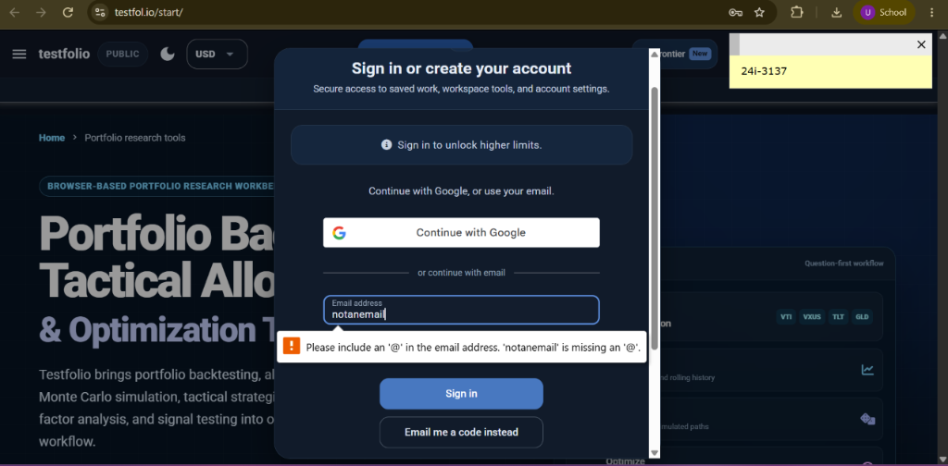
Figure E-01: Auth Modal (/start): Malformed email missing '@' trapped by native HTML5 validation tooltip. (Student Roll No: 24i-3137)

Executed Test Case 2
TC ID | TC-EP-004

Screenshot(s) — paste below (input + response; one combined screenshot is acceptable):
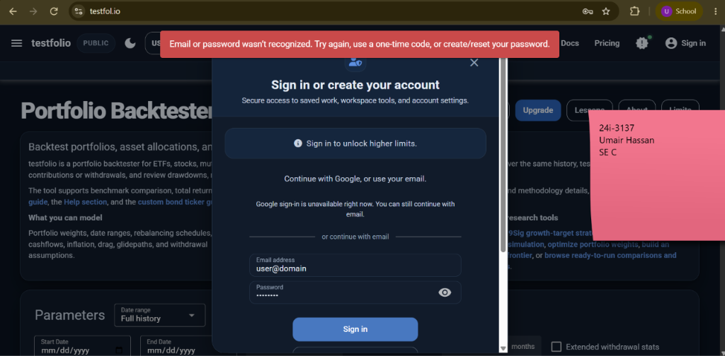
Figure E-02: Auth Modal (/start): Email missing domain TLD (user@domain) triggers server error banner. (Student Roll No: 24i-3137)

Executed Test Case 3
TC ID | TC-EP-005

Screenshot(s) — paste below (input + response; one combined screenshot is acceptable):
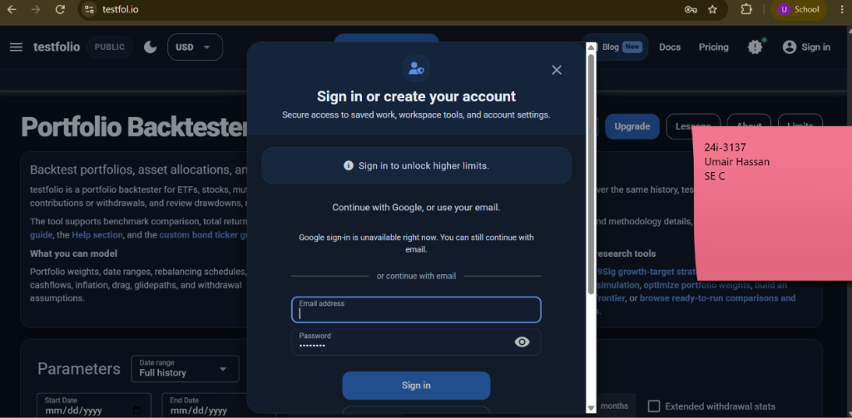
Figure E-03: Auth Modal (/start): Empty email disables submit button client-side. (Student Roll No: 24i-3137)

Executed Test Case 4
TC ID | TC-EP-006

Screenshot(s) — paste below (input + response; one combined screenshot is acceptable):
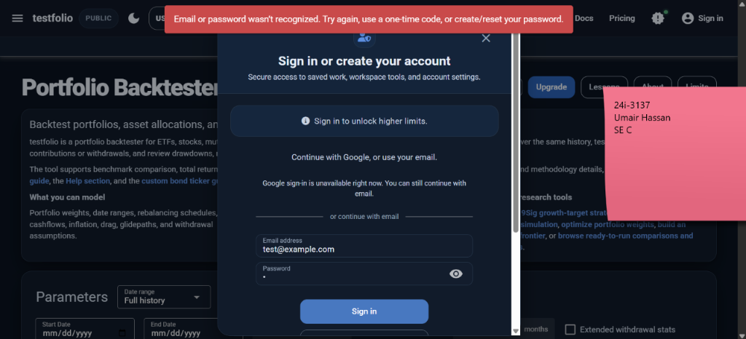
Figure E-04: Auth Modal (/login): 1-char password activates submit button client-side. (Student Roll No: 24i-3137)

Executed Test Case 5
TC ID | TC-EP-007

Screenshot(s) — paste below (input + response; one combined screenshot is acceptable):
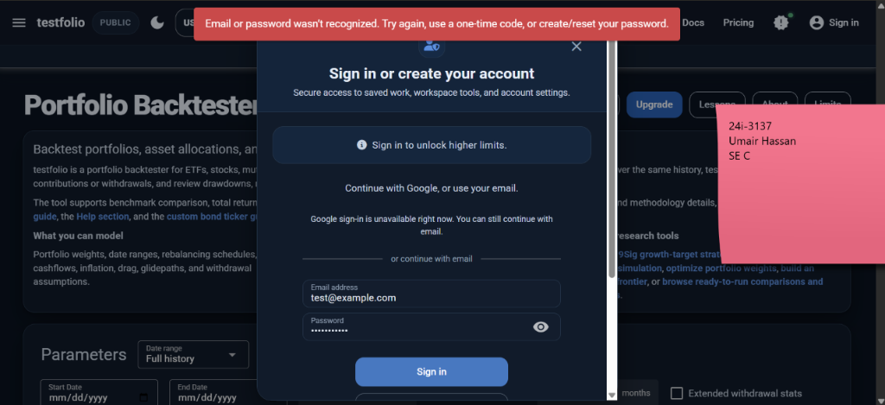
Figure E-05: Auth Modal (/login): Password with special characters accepted by input mask. (Student Roll No: 24i-3137)

↑ Duplicate the block above for each additional executed test case ↑

— End of Assignment 3 Template —
SE 3002 SQE · FAST School of Computing — Dept. of Software Engineering · Dr. Nigar Azhar Butt | Dr. Atif Aftab Jilani | Miss Anum Kaleem
TC ID | TC-EP-008
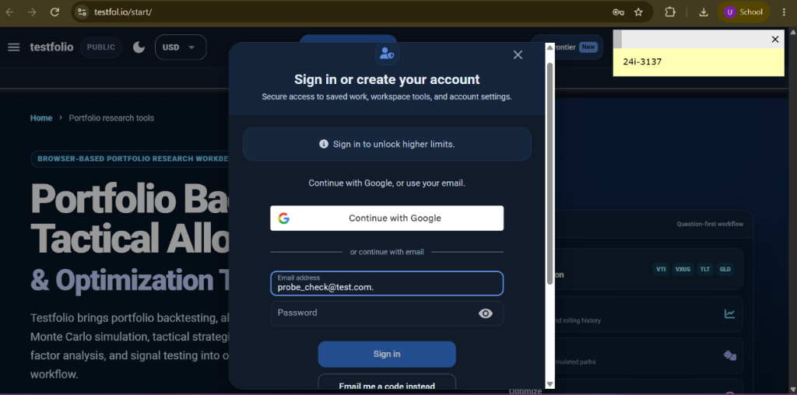
Figure E-06: Auth Modal (/start): Empty Password client-side validation disables submit button. (Student Roll No: 24i-3137)
TC ID | TC-EP-009
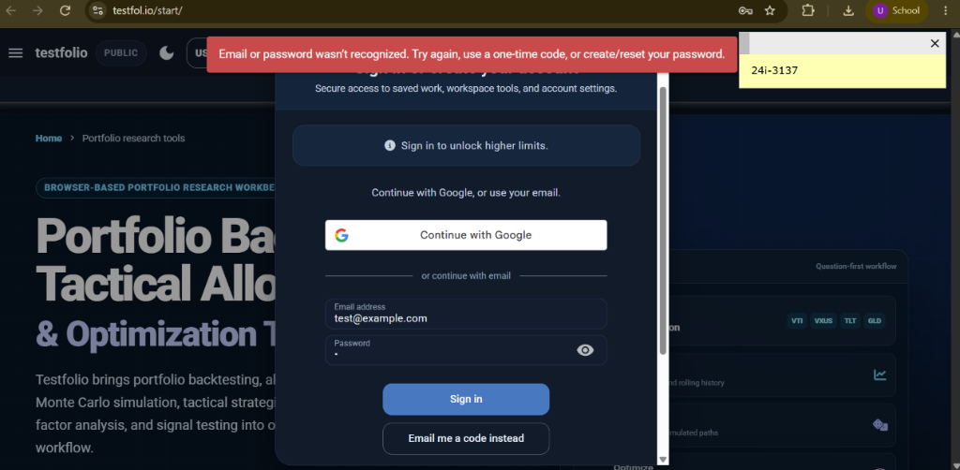
Figure E-07: Auth Modal (/login): Unrecognized credentials error banner displayed. (Student Roll No: 24i-3137)
TC ID | TC-EP-010
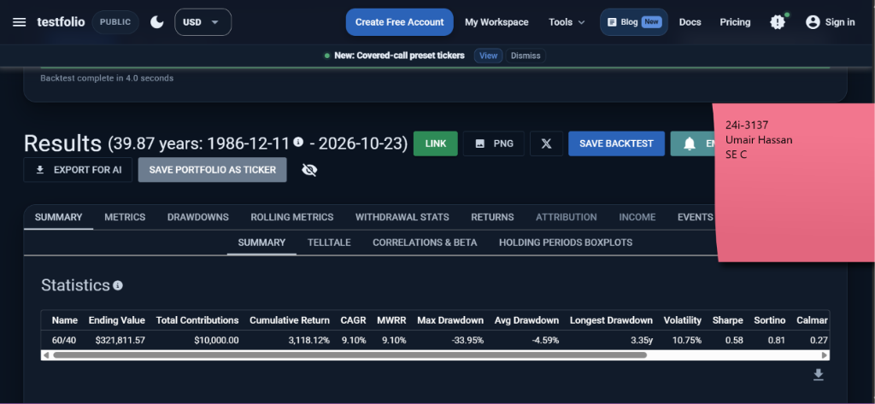
Figure E-08: Portfolio Backtester (/): Valid backtest execution (SPY, CAGR 9.10%, Sharpe 0.58). (Student Roll No: 24i-3137)
TC ID | TC-EP-011
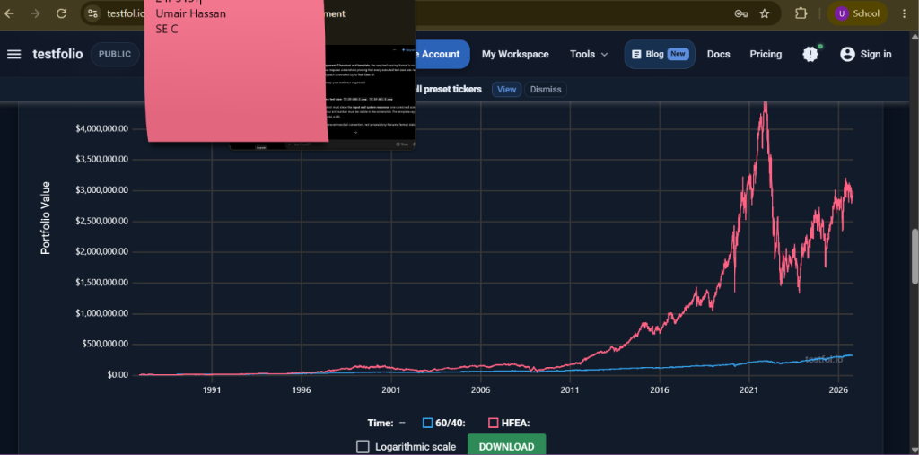
Figure E-09: Portfolio Backtester (/): Dual portfolio comparative performance (60/40 vs HFEA). (Student Roll No: 24i-3137)
TC ID | TC-EP-012
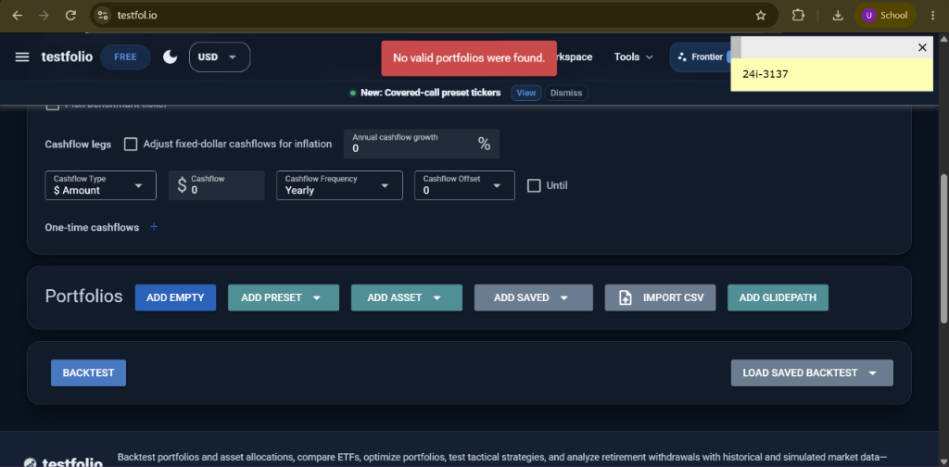
Figure E-10: Portfolio Backtester (/): 0 portfolios added triggers red banner 'No valid portfolios were found.' (Student Roll No: 24i-3137)
TC ID | TC-EP-013
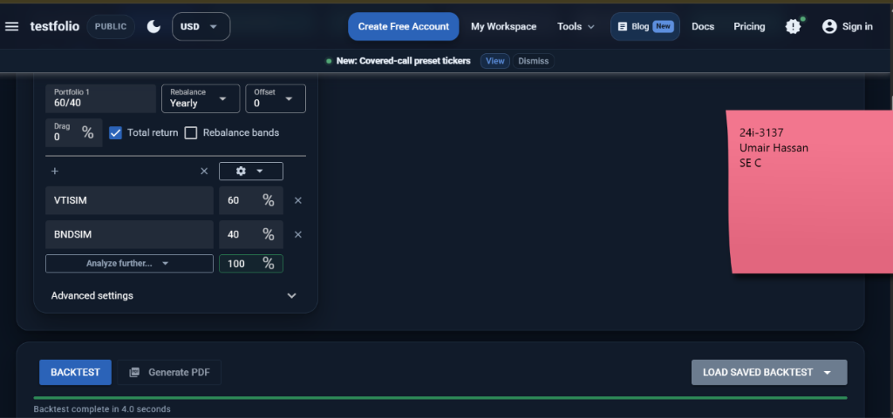
Figure E-11: Portfolio Backtester (/): Exact 100% asset allocation accepted. (Student Roll No: 24i-3137)
TC ID | TC-EP-014
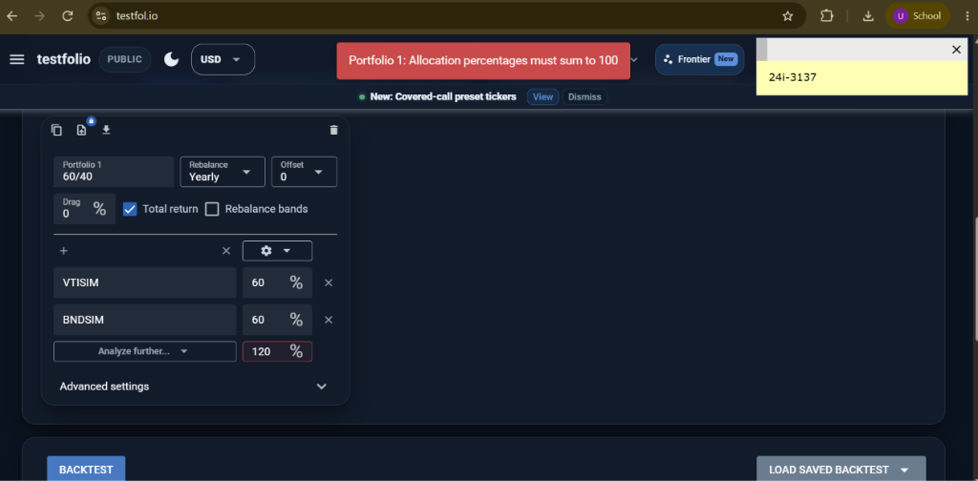
Figure E-12: Portfolio Backtester (/): Allocations summing to 120% (> 100%) triggers red banner 'Allocations must sum to 100'. (Student Roll No: 24i-3137)
TC ID | TC-EP-015
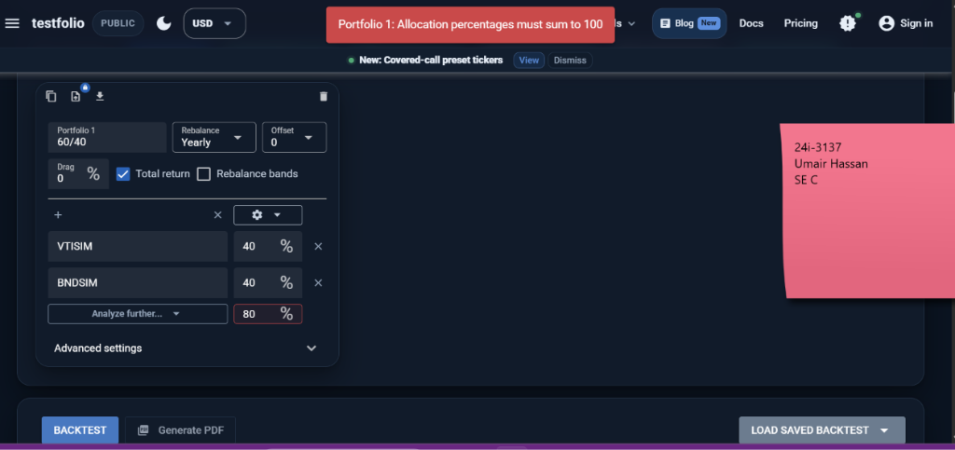
Figure E-13: Portfolio Backtester (/): Under-allocation 80% triggers banner 'Allocations must sum to 100'. (Student Roll No: 24i-3137)
TC ID | TC-EP-016
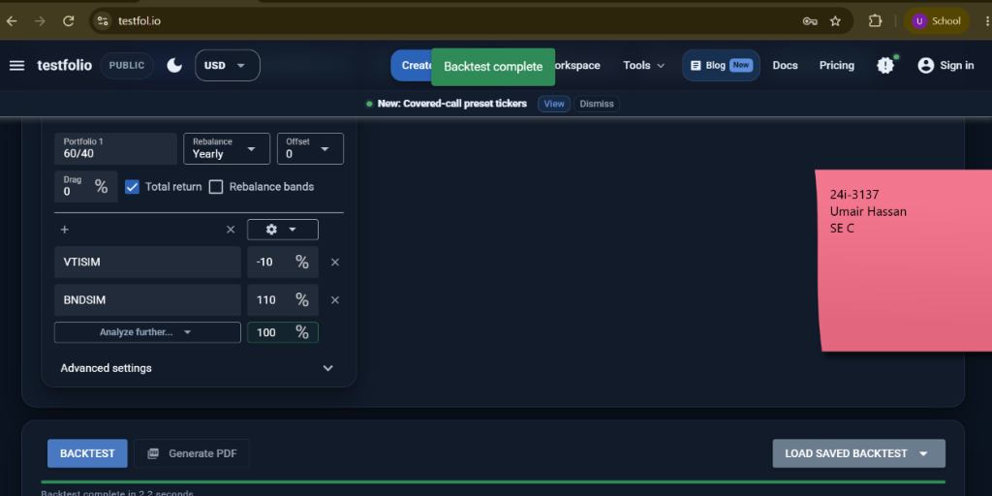
Figure E-14: Portfolio Backtester (/): Negative allocation -10% (shorting accepted, total sums to 100%). (Student Roll No: 24i-3137)
TC ID | TC-EP-020
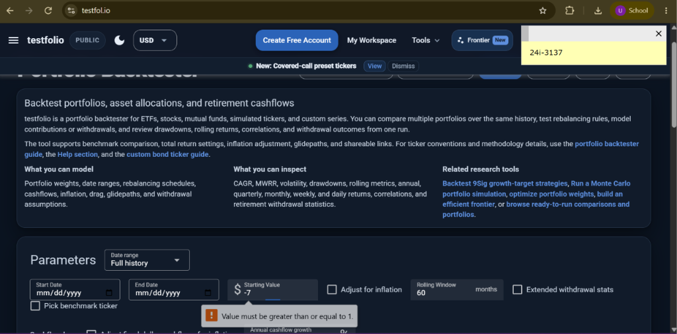
Figure E-15: Portfolio Backtester (/): Starting Value = -$7 triggers tooltip 'Value must be greater than or equal to 1.' (Student Roll No: 24i-3137)
TC ID | TC-EP-021
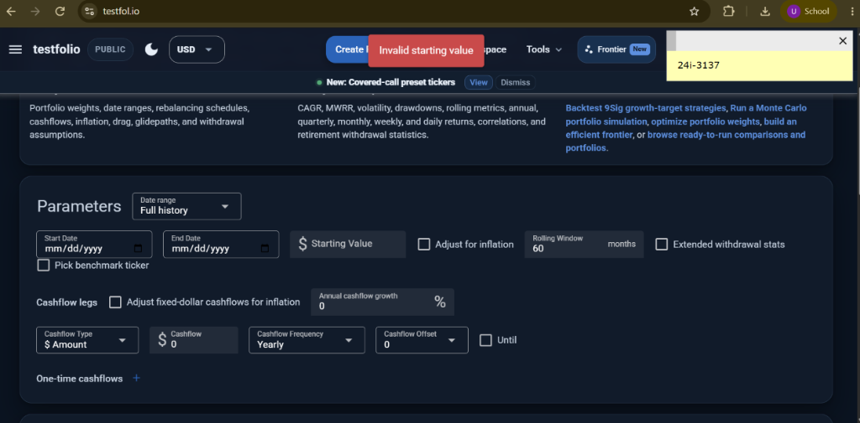
Figure E-16: Portfolio Backtester (/): Empty starting value triggers application red banner 'Invalid starting value'. (Student Roll No: 24i-3137)
TC ID | TC-EP-023
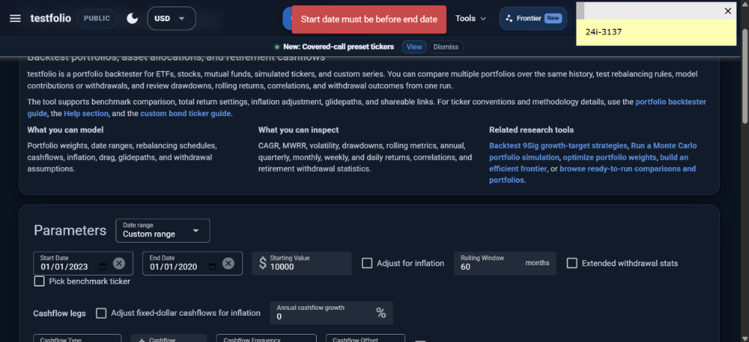
Figure E-17: Portfolio Backtester (/): Inverted date range (Start 2023 > End 2020) triggers 'Start date must be before end date'. (Student Roll No: 24i-3137)
TC ID | TC-EP-024
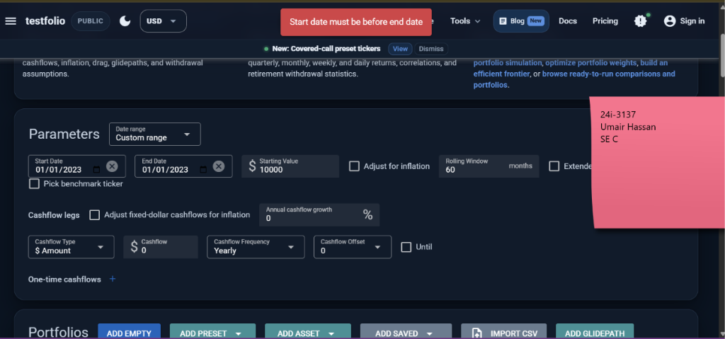
Figure E-18: Portfolio Backtester (/): Start date == End date triggers 'Start date must be before end date'. (Student Roll No: 24i-3137)
TC ID | TC-EP-025
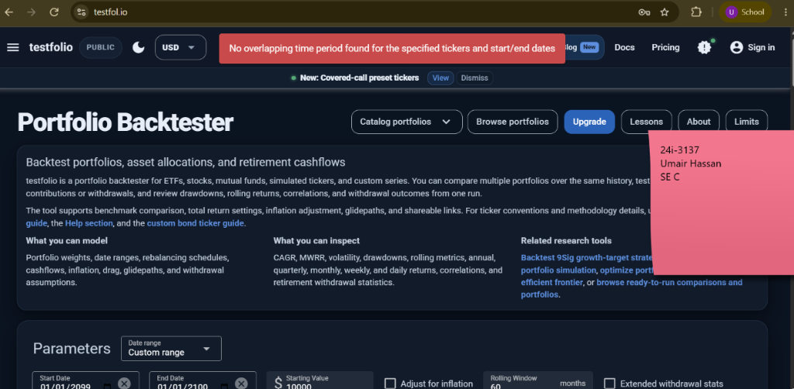
Figure E-19: Portfolio Backtester (/): Future date range (2099-2100) triggers 'No overlapping time period found'. (Student Roll No: 24i-3137)
TC ID | TC-EP-027
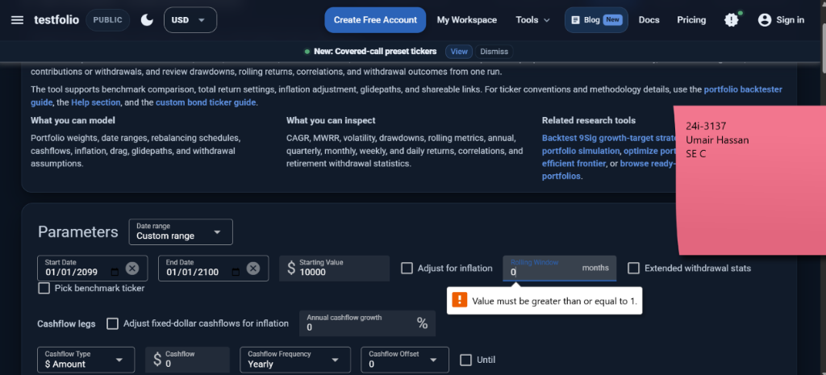
Figure E-20: Portfolio Backtester (/): Rolling window 0 triggers tooltip 'Value must be greater than or equal to 1.' (Student Roll No: 24i-3137)
TC ID | TC-EP-028
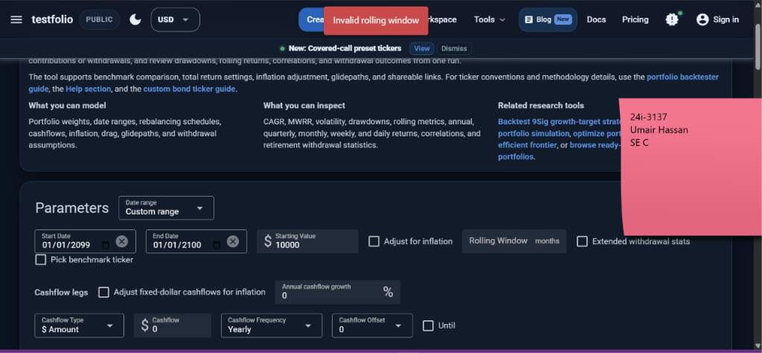
Figure E-21: Portfolio Backtester (/): Empty rolling window triggers red banner 'Invalid rolling window'. (Student Roll No: 24i-3137)
TC ID | TC-EP-030
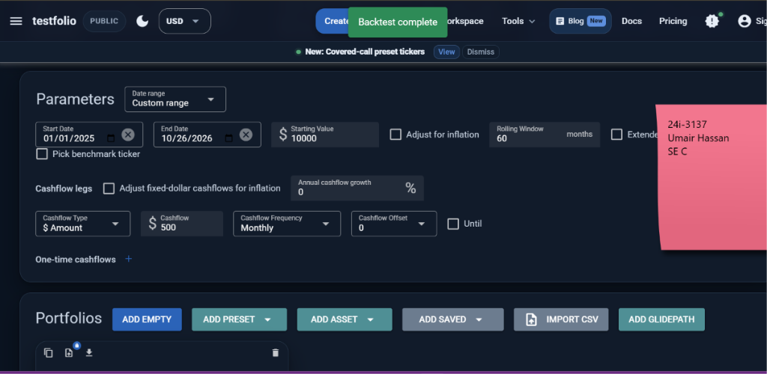
Figure E-22: Portfolio Backtester (/): Monthly cashflow $500 backtest completed successfully. (Student Roll No: 24i-3137)
TC ID | TC-EP-031
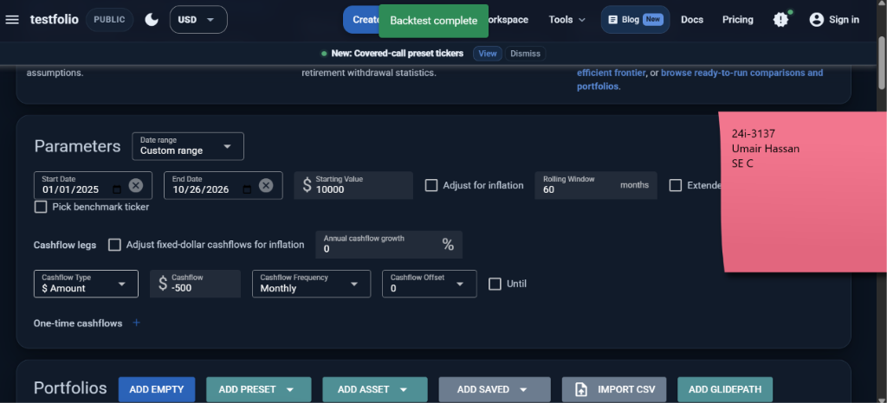
Figure E-23: Portfolio Backtester (/): Monthly negative cashflow -$500 accepted and executed as withdrawal leg. (Student Roll No: 24i-3137)
TC ID | TC-EP-032
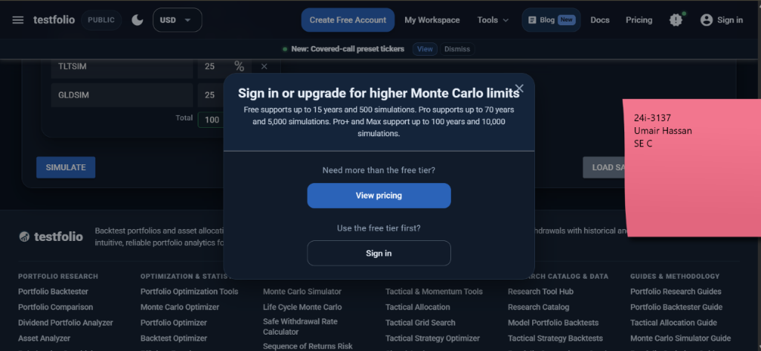
Figure E-24: Monte Carlo Simulator (/monte-carlo): Horizon 30 yrs triggers modal 'Sign in or upgrade for higher Monte Carlo limits'. (Student Roll No: 24i-3137)
TC ID | TC-EP-033
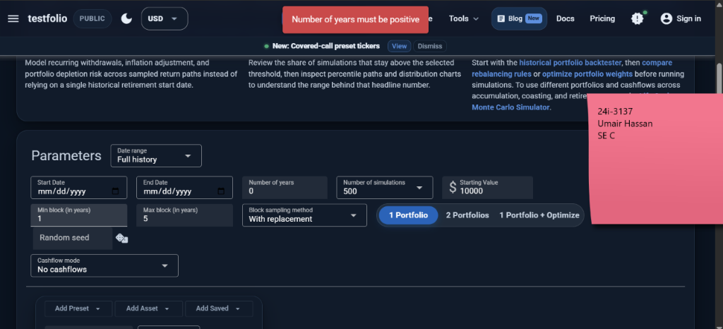
Figure E-25: Monte Carlo Simulator (/monte-carlo): Horizon 0 yrs triggers banner 'Number of years must be positive'. (Student Roll No: 24i-3137)
TC ID | TC-EP-034
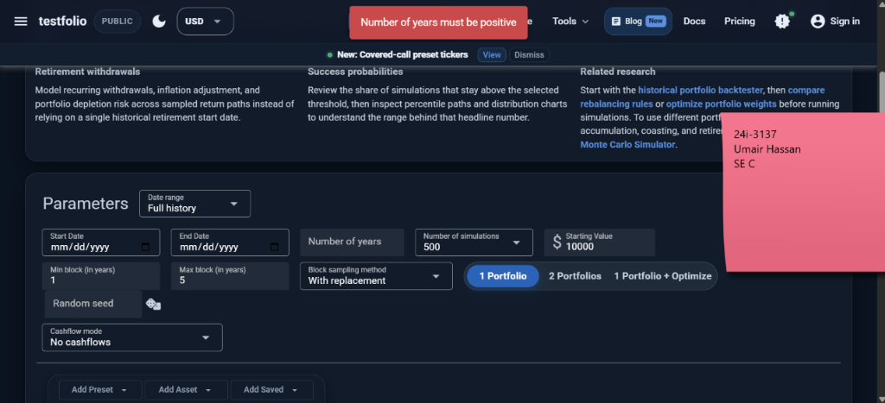
Figure E-26: Monte Carlo Simulator (/monte-carlo): Empty horizon triggers banner 'Number of years must be positive'. (Student Roll No: 24i-3137)
TC ID | TC-EP-037
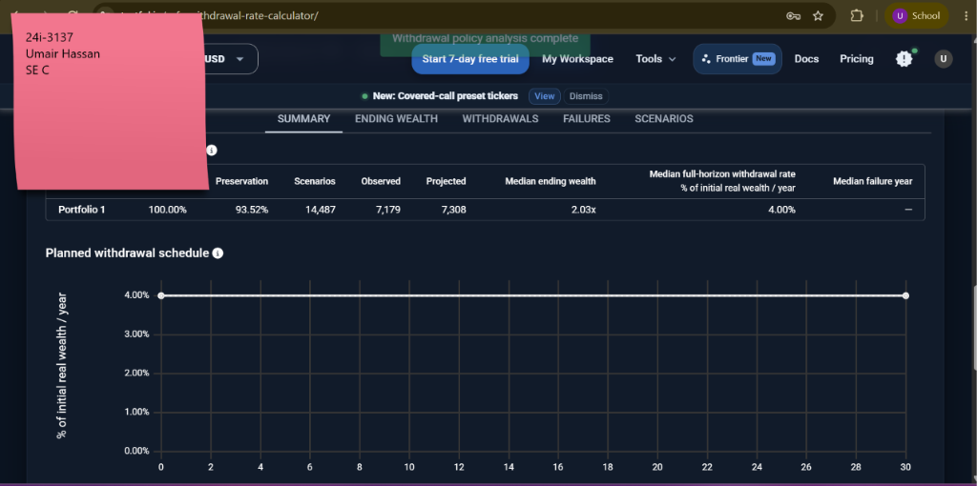
Figure E-27: Safe Withdrawal Rate (/safe-withdrawal-rate-calculator): 4.00% baseline executed (93.52% preservation). (Student Roll No: 24i-3137)
TC ID | TC-EP-038
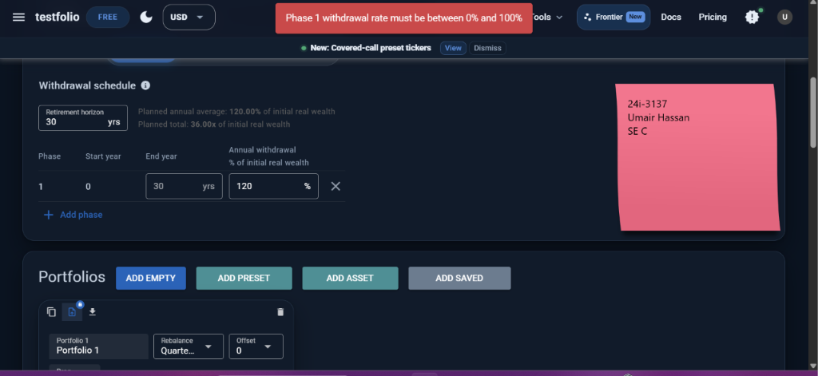
Figure E-28: Safe Withdrawal Rate (/safe-withdrawal-rate-calculator): 120% rate triggers banner 'Phase 1 withdrawal rate must be between 0% and 100%'. (Student Roll No: 24i-3137)
TC ID | TC-EP-039
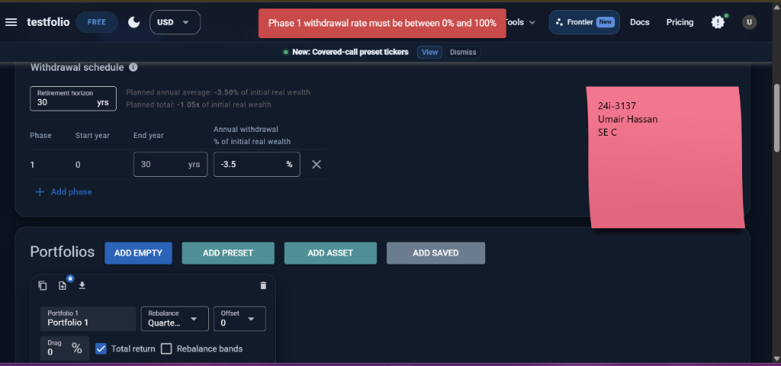
Figure E-29: Safe Withdrawal Rate (/safe-withdrawal-rate-calculator): Negative -3.5% rate triggers banner 'Phase 1 withdrawal rate must be between 0% and 100%'. (Student Roll No: 24i-3137)
TC ID | TC-EP-040
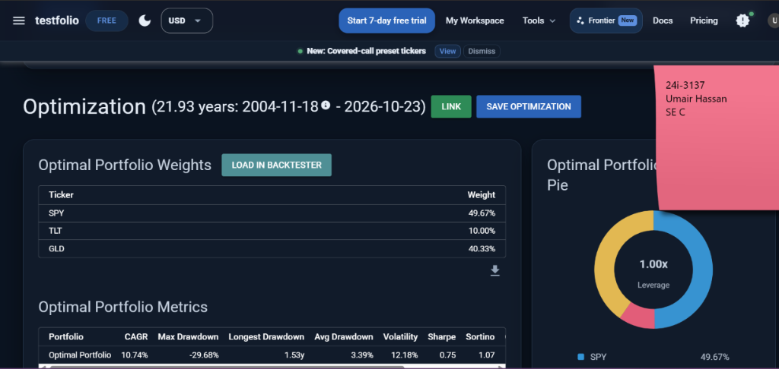
Figure E-30: Backtest Optimizer (/backtest-optimizer): Bounded optimization solved (SPY 49.67%, TLT 10%, GLD 40.33%). (Student Roll No: 24i-3137)
TC ID | TC-EP-041
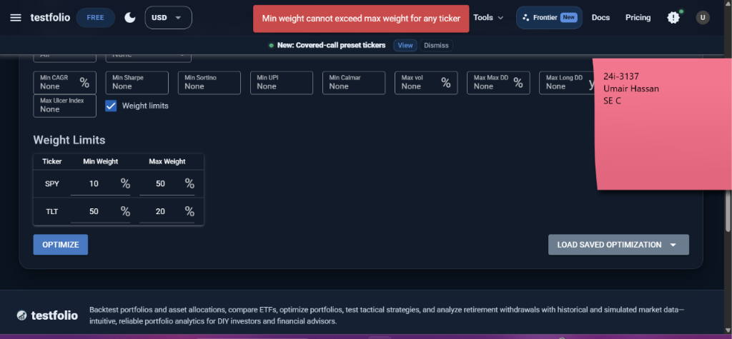
Figure E-31: Backtest Optimizer (/backtest-optimizer): Inconsistent bounds Min > Max triggers 'Min weight cannot exceed max weight for any ticker'. (Student Roll No: 24i-3137)
TC ID | TC-EP-042
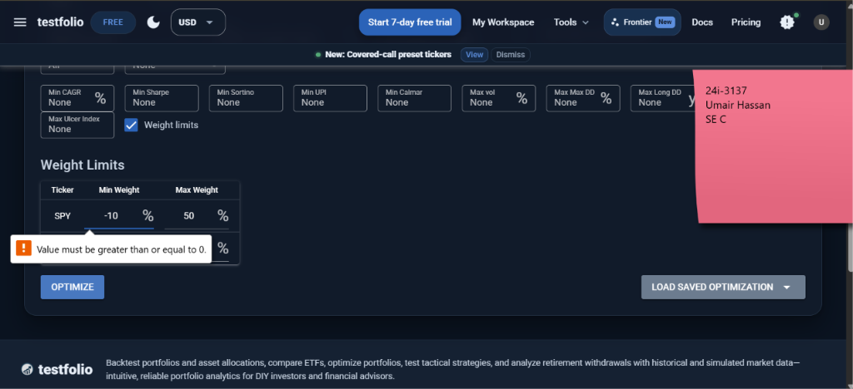
Figure E-32: Backtest Optimizer (/backtest-optimizer): Negative bound -10% triggers tooltip 'Value must be greater than or equal to 0.' (Student Roll No: 24i-3137)
TC ID | TC-EP-043
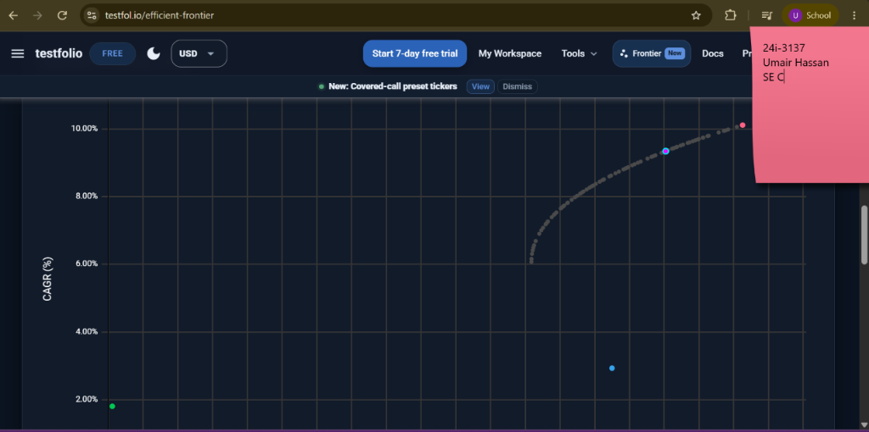
Figure E-33: Efficient Frontier (/efficient-frontier): Multi-asset covariance curved efficient frontier rendered. (Student Roll No: 24i-3137)
TC ID | TC-EP-044
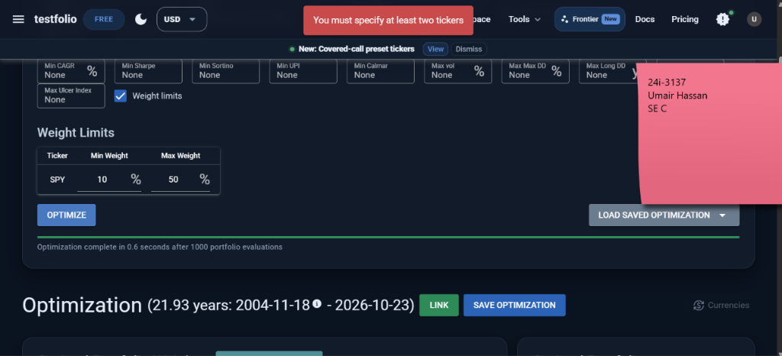
Figure E-34: Backtest Optimizer / Frontier: Single ticker SPY triggers banner 'You must specify at least two tickers'. (Student Roll No: 24i-3137)
TC ID | TC-EP-052
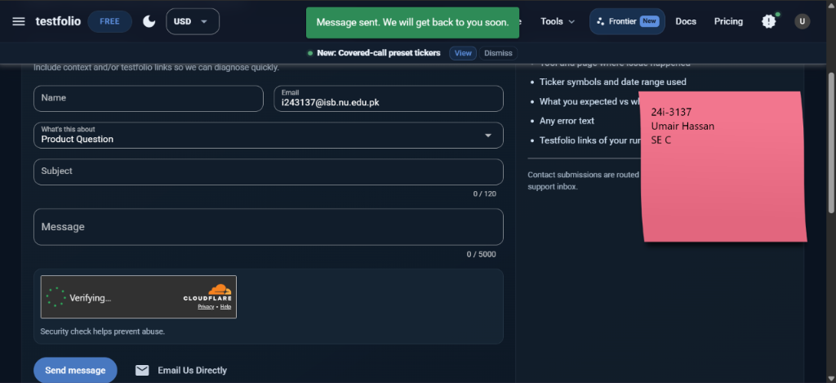
Figure E-35: Contact Form (/contact): Valid inquiry submitted with student email i243137@isb.nu.edu.pk; green banner 'Message sent'. (Student Roll No: 24i-3137)
TC ID | TC-EP-053
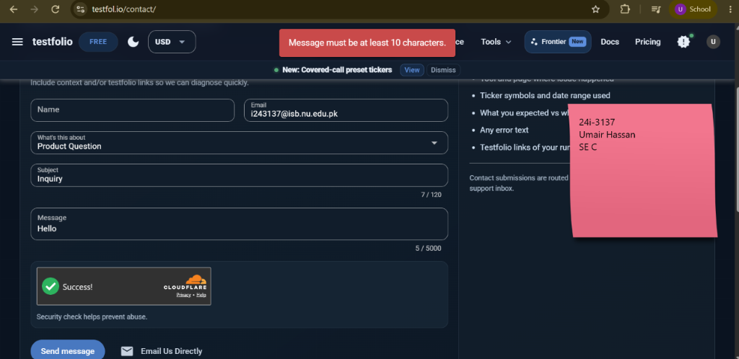
Figure E-36: Contact Form (/contact): Message length = 5 chars triggers red banner 'Message must be at least 10 characters.' (Student Roll No: 24i-3137)
TC ID | TC-EP-057
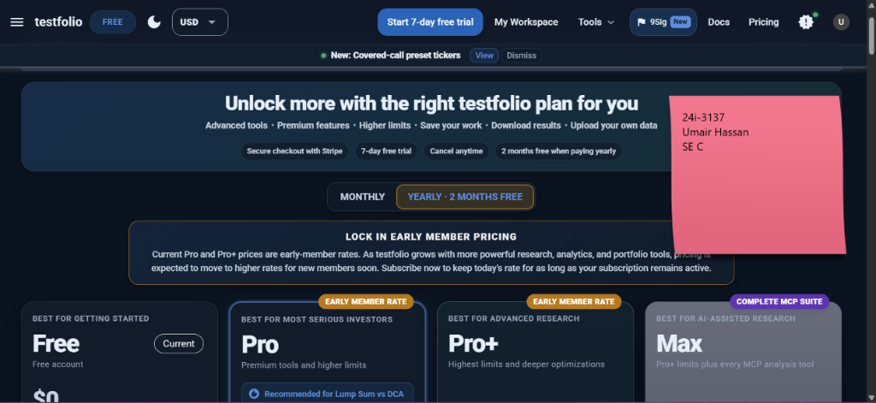
Figure E-37: Lump Sum vs DCA (/lumpsum-vs-dca): Feature gated by paywall; redirects to pricing table 'Recommended for Lump Sum vs DCA'. (Student Roll No: 24i-3137)
TC ID | TC-EP-062
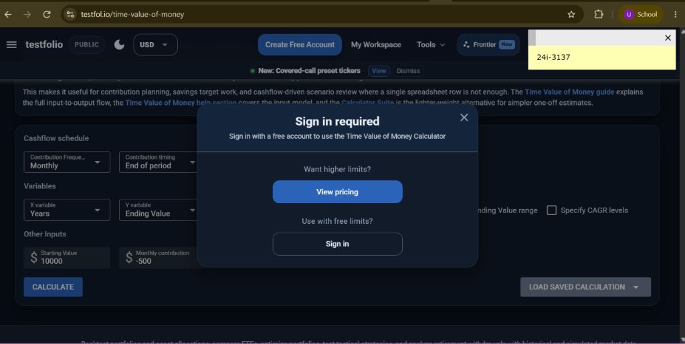
Figure E-38: Time Value of Money (/time-value-of-money): Gated calculation triggers 'Sign in required' modal dialog. (Student Roll No: 24i-3137)
TC ID | TC-EP-065
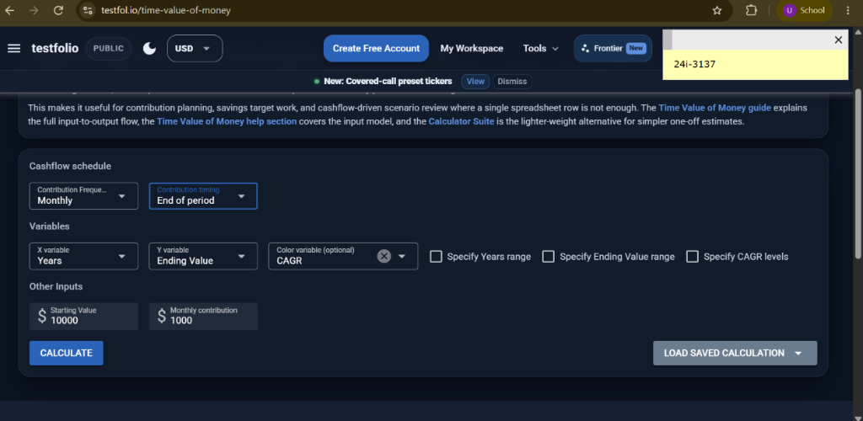
Figure E-39: Time Value of Money (/time-value-of-money): Form inputs ($10,000 starting value, $1,000 monthly contribution). (Student Roll No: 24i-3137)
TC ID | TC-EP-066
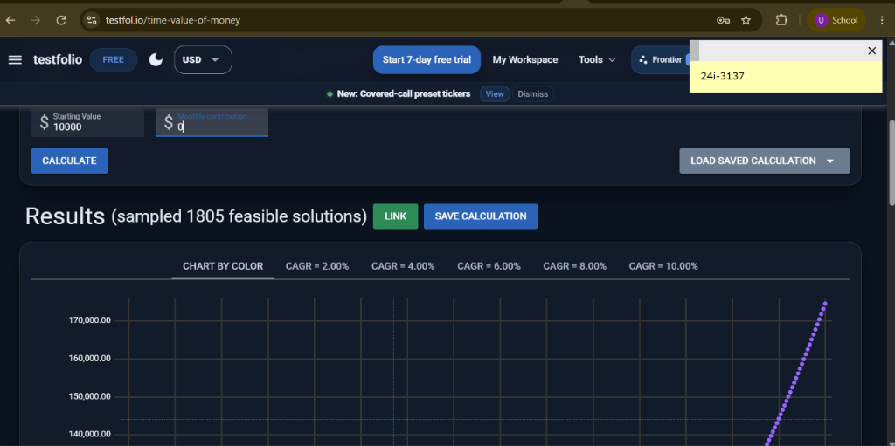
Figure E-40: Time Value of Money (/time-value-of-money): Monthly contribution = $0 boundary computes 1,805 solutions. (Student Roll No: 24i-3137)
TC ID | TC-EP-067
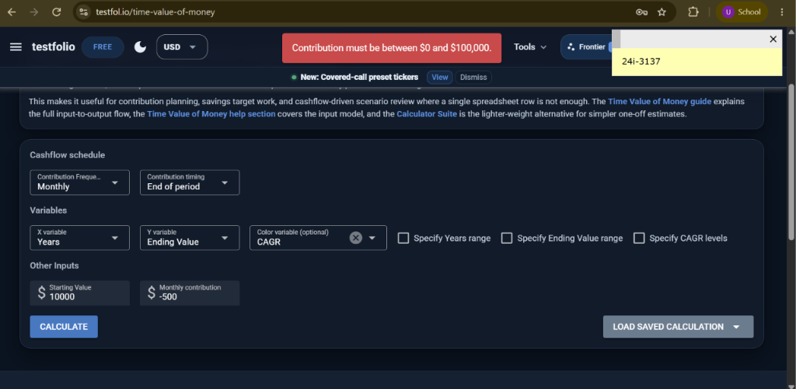
Figure E-41: Time Value of Money (/time-value-of-money): Monthly contribution = -$500 triggers 'Contribution must be between $0 and $100,000.' (Student Roll No: 24i-3137)
TC ID | TC-EP-069
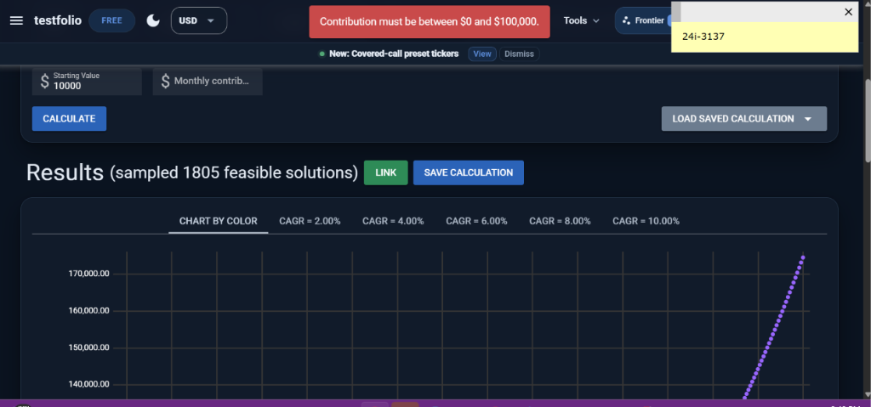
Figure E-42: Time Value of Money (/time-value-of-money): Empty contribution triggers error banner while retaining prior graph (Defect). (Student Roll No: 24i-3137)
TC ID | TC-EP-070
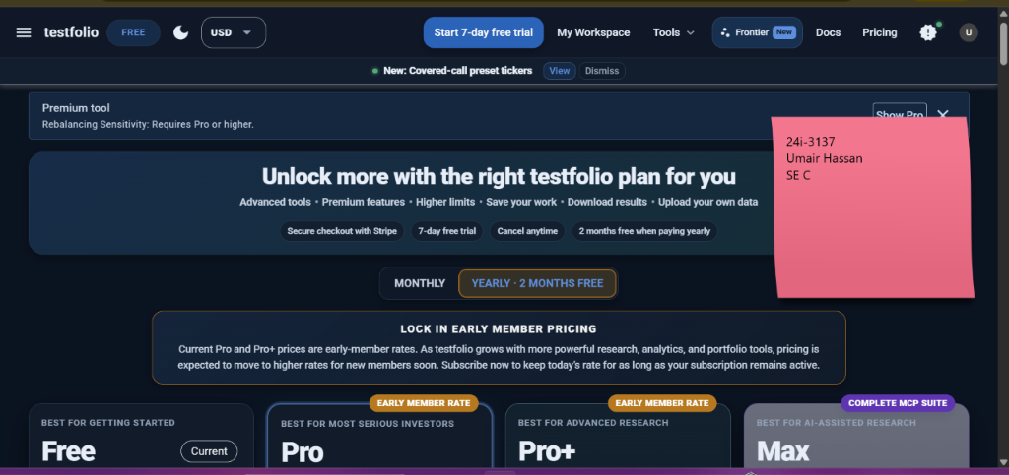
Figure E-43: Rebalancing Sensitivity (/rebalancing-sensitivity): Gated premium tool; banner 'Premium tool: Requires Pro or higher.' (Student Roll No: 24i-3137)
TC ID | TC-BVA-001
Figure E-44: Portfolio Backtester (/): BVA Allocation Sum = 80% (Below bound) triggers 'Allocations must sum to 100'. (Student Roll No: 24i-3137)
TC ID | TC-BVA-002
Figure E-45: Portfolio Backtester (/): BVA Allocation Sum = 100% (At bound) executes successfully. (Student Roll No: 24i-3137)
TC ID | TC-BVA-003
Figure E-46: Portfolio Backtester (/): BVA Allocation Sum = 120% (Above bound) triggers 'Allocations must sum to 100'. (Student Roll No: 24i-3137)
TC ID | TC-BVA-004
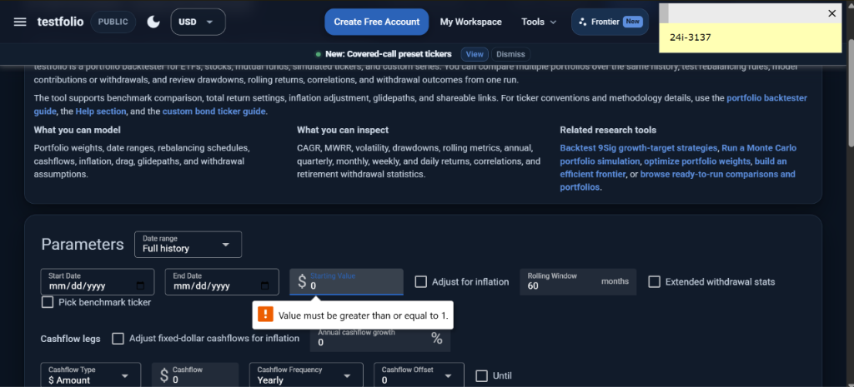
Figure E-47: Portfolio Backtester (/): BVA Starting Value = $0 (Below bound) triggers tooltip 'Value must be greater than or equal to 1.' (Student Roll No: 24i-3137)
TC ID | TC-BVA-007
Figure E-48: Portfolio Backtester (/): BVA Dates Start == End (Boundary) triggers 'Start date must be before end date.' (Student Roll No: 24i-3137)
TC ID | TC-BVA-008
Figure E-49: Portfolio Backtester (/): BVA Dates Start > End (Below bound) triggers 'Start date must be before end date.' (Student Roll No: 24i-3137)
TC ID | TC-BVA-010
Figure E-50: Portfolio Backtester (/): BVA Rolling Window = 0 (Below bound) triggers 'Value must be greater than or equal to 1.' (Student Roll No: 24i-3137)
TC ID | TC-BVA-013
Figure E-51: Auth Modal (/start): BVA Password = 0 chars (Below bound) disables submit button client-side. (Student Roll No: 24i-3137)
TC ID | TC-BVA-014
Figure E-52: Auth Modal (/start): BVA Password = 1 char (At bound) enables submit button client-side. (Student Roll No: 24i-3137)
TC ID | TC-BVA-015
Figure E-53: Monte Carlo Simulator (/monte-carlo): BVA Horizon = 0 yrs (Below bound) triggers 'Number of years must be positive.' (Student Roll No: 24i-3137)
TC ID | TC-BVA-016
Figure E-54: Safe Withdrawal Rate: BVA Rate = -3.5% (Below bound) triggers 'Phase 1 withdrawal rate must be between 0% and 100%'. (Student Roll No: 24i-3137)
TC ID | TC-BVA-017
Figure E-55: Safe Withdrawal Rate: BVA Rate = -3.5% (Below bound) triggers 'Phase 1 withdrawal rate must be between 0% and 100%'. (Student Roll No: 24i-3137)
TC ID | TC-BVA-018
Figure E-56: Safe Withdrawal Rate: BVA Rate = 120% (Above bound) triggers 'Phase 1 withdrawal rate must be between 0% and 100%'. (Student Roll No: 24i-3137)
TC ID | TC-BVA-019
Figure E-57: Contact Form (/contact): BVA Message = 5 chars (Below bound) triggers 'Message must be at least 10 characters.' (Student Roll No: 24i-3137)

