TECHNICAL REPORT:
MODEL-BASED TESTING FOR SMART PARCEL LOCKER MANAGEMENT SYSTEM
Student Name: Umair Hassan | Roll No: 24i-3137
Course: Software Testing & Quality Assurance / Model-Based Testing
Date: November 2026
1. Introduction
1.1 Assignment Objectives
Model-Based Testing (MBT) is an advanced quality-assurance paradigm in which an abstract, formal specification of a software system serves as an executable ground truth (test oracle). Rather than hand-crafting static test cases, MBT systematically explores the system's behavioral state space, synthesizes valid and invalid operation sequences, executes them against the implementation under test (System Under Test, or SUT), and automatically detects divergences in operation return values, observable state snapshots, and safety invariants.
The primary objectives of this project are:
1. Constructing an independent, executable state-machine model of a Smart Parcel Locker.
2. Implementing three algorithmically distinct automated test-generation strategies (Random Walk, Coverage-Guided, and Transition-Pair).
3. Building an automated execution engine with independent multi-oracle diagnostics.
4. Engineering a suite of 10 realistic faulty system implementations (mutants) with formal equivalence metadata.
5. Conducting controlled, reproducible experiments across 5 random seeds to evaluate coverage, mutation detection, and efficiency.
1.2 Case Study: Smart Parcel Locker System
The Smart Parcel Locker is an automated self-service station where couriers deposit parcels and customers retrieve them using secure credentials. Strict operational rules govern the locker lifecycle: parcels cannot be reserved if occupied or undergoing maintenance, deposits require matching reservation codes, retrievals require authentic one-time PINs, and canceled or expired reservations must promptly reset the compartment to available status without credential leakage.
2. Requirements Analysis and Behavioral Rules
2.1 System States
The locker compartment operates across four primary conceptual states:
• AVAILABLE: Compartment is clean, empty, and ready for a new reservation.
• RESERVED: Compartment is reserved for a customer; awaiting parcel deposit.
• OCCUPIED: Parcel has been placed inside and securely locked, awaiting pickup.
• MAINTENANCE: Compartment is taken offline for servicing, inspection, or repairs.
2.2 System Operations
The system accepts eight distinct operations: RESERVE, CANCEL, DEPOSIT, RETRIEVE, EXPIRE, DISABLE, ENABLE, and INVALID_ACCESS.
2.3 Formal State Transition Table
Operation | Source State | Precondition / Guard | Target State | Result Message | Post-Condition Updates
RESERVE | AVAILABLE | Valid customer_id | RESERVED | reserved | Generates R-<customer_id>
CANCEL | RESERVED | None | AVAILABLE | cancelled | Clears customer & reservation code
DEPOSIT | RESERVED | code == reservation_code | OCCUPIED | deposited | Generates P-<customer_id>
RETRIEVE | OCCUPIED | code == retrieval_code | AVAILABLE | retrieved | Clears customer & credentials
EXPIRE | RESERVED | expired == True | AVAILABLE | expired | Clears customer & credentials
DISABLE | AVAILABLE | None | MAINTENANCE | disabled | Compartment locked out
ENABLE | MAINTENANCE | None | AVAILABLE | enabled | Compartment returned to service
INVALID_ACCESS | Any State | None | No Change | invalid_access | No state or credential mutation

3. State-Machine Model & Invariants
The executable model in locker/model.py serves as the independent ground truth. It never calls or imports the SUT. The model maintains independent state variables: state, customer_id, reservation_code, and retrieval_code.
3.1 State Machine Structure
The lifecycle follows formal transition arcs:
• AVAILABLE --RESERVE--> RESERVED
• AVAILABLE --DISABLE--> MAINTENANCE
• RESERVED --DEPOSIT--> OCCUPIED
• RESERVED --CANCEL--> AVAILABLE
• RESERVED --EXPIRE--> AVAILABLE
• OCCUPIED --RETRIEVE--> AVAILABLE
• MAINTENANCE --ENABLE--> AVAILABLE
All other transitions represent invalid state-event combinations that are rejected without modifying system state.
3.2 Domain Safety Invariants
The test oracle continuously asserts the following domain invariants:
1. Empty State Cleanliness: In AVAILABLE and MAINTENANCE, customer_id, reservation_code, and retrieval_code must all be None.
2. Reservation Integrity: In RESERVED, customer_id must be non-empty, reservation_code must equal f'R-{customer_id}', and retrieval_code must be None.
3. Occupancy Integrity: In OCCUPIED, customer_id must be non-empty, and retrieval_code must equal f'P-{customer_id}'.
4. Non-Mutation of Rejected Operations: If an operation returns accepted=False, the post-state snapshot must match the pre-state snapshot bit-for-bit.
5. No Double Retrieval: Once retrieved, the compartment returns to AVAILABLE and cannot be retrieved again with the prior PIN.
4. Transition-Pair Coverage Definition & Calculation
An individual state transition is represented as a 3-tuple: t = (source_state, operation, target_state).
A valid transition pair consists of two consecutive valid transitions (t1, t2) where t1.target_state == t2.source_state.
The locker model defines 7 valid primary transitions:
• t1: (AVAILABLE, RESERVE, RESERVED)
• t2: (AVAILABLE, DISABLE, MAINTENANCE)
• t3: (RESERVED, DEPOSIT, OCCUPIED)
• t4: (RESERVED, CANCEL, AVAILABLE)
• t5: (RESERVED, EXPIRE, AVAILABLE)
• t6: (OCCUPIED, RETRIEVE, AVAILABLE)
• t7: (MAINTENANCE, ENABLE, AVAILABLE)
The total number of connected transition pairs is derived from the in-degrees and out-degrees of the intermediate states:
• Via RESERVED (in=1, out=3): 3 pairs (t1->t3, t1->t4, t1->t5)
• Via OCCUPIED (in=1, out=1): 1 pair (t3->t6)
• Via MAINTENANCE (in=1, out=1): 1 pair (t2->t7)
• Via AVAILABLE (in=4, out=2): 8 pairs (t4, t5, t6, t7 -> t1, t2)
Total Connected Transition Pairs = 3 + 1 + 1 + 8 = 13 pairs (denominator).
Accounting Rules Enforced in locker/metrics.py:
1. Disconnected combinations (e.g. t2 ending in MAINTENANCE followed by t1 starting in AVAILABLE) are rejected.
2. Rejected operations break the transition chain (setting prev_trans = None).
3. Sequence boundaries reset transition pair tracking.
4. Repeated pairs do not artificially inflate the coverage score.
5. Test-Generation Strategies
Three algorithmically distinct test generators were implemented in locker/generators.py:
5.1 Strategy A: Random Walk Generator (RandomWalkGenerator)
• Algorithm: Samples operations uniformly at random. At each step, a 60% bias attempts valid parameters, while a 40% bias intentionally supplies faulty parameters (wrong reservation codes, invalid PINs, unexpired flags).
• Advantages: Highly efficient generation (O(1) per step), unbiased state exploration, excellent at fuzzing unexpected inputs.
• Limitations: Lacks systematic path memory; inefficient at traversing specific deep sequential paths.
5.2 Strategy B: Coverage-Guided Generator (CoverageGuidedGenerator)
• Algorithm: Maintains a global frequency matrix tracking (state, op, accepted) tuples and state visit counts across sequences. At each step, evaluates all 16 candidate combinations (8 ops x valid/invalid) via dry-run simulation and greedily selects the action minimizing prior execution frequency (novelty search).
• Advantages: Rapidly achieves 100% state coverage and state-operation coverage by systematically probing unexplored state-event spaces.
• Limitations: Incurs evaluation latency due to dry-run lookaheads at every step.
5.3 Strategy C: Transition-Pair Generator (TransitionPairGenerator)
• Algorithm: Targets the 13 valid connected transition pairs. Tracks a global set of covered pairs. At each step, it steers through outgoing transitions that complete an uncovered pair with the predecessor transition, with lookaheads towards states containing future uncovered pairs. Additionally, a configurable negative-operation rate (invalid_prob = 0.20) injects state-tailored invalid commands (wrong PINs, illegal operations) that break the chain without mutating model state.
• Advantages: Directly exercises sequential lifecycle dependencies and transition-pair combinations while still fuzzing guards.
• Limitations: Slightly slower generation than pure random walk due to graph lookahead calculations.
6. Automated Test Runner & Independent Multi-Oracle Diagnostics
The test execution engine (locker/runner.py) executes command sequences against fresh instances of the SUT and model. To prevent diagnostic masking, the runner evaluates all five verification dimensions independently at every step:
1. Operation Result Comparison: Asserts expected.accepted == actual.accepted and expected.message == actual.message.
2. Complete Snapshot Comparison: Asserts exact matching of state, customer_id, reservation_code, and retrieval_code.
3. Domain Invariant Verification: Verifies safety invariants on SUT observable fields.
4. Non-Mutation Verification: Ensures that rejected operations do not alter state or credentials.
5. Credential Cleanup Verification: Verifies that successful CANCEL, EXPIRE, and RETRIEVE wipe all credentials.
If multiple checks fail on a single step, all violations are recorded in step_records and failure_details without masking.
7. Mutation Testing & Equivalence Analysis
Ten realistic faulty implementations (mutants) were developed in locker/mutants.py. Each mutant introduces an isolated defect. Every mutant has formal metadata documenting defect category and non-equivalence justification:
Mutant Identifier | Defect Category | Equiv? | Defect Description & Non-Equivalence Justification
Mutant1_ReserveOccupied | Precondition Bypass | No | Allows RESERVE when OCCUPIED. SUT rejects with locker_not_available; mutant returns reserved.
Mutant2_AcceptWrongReservationCode | Credential Bypass | No | Accepts deposit with wrong reservation code. SUT rejects; mutant transitions to OCCUPIED.
Mutant3_RetrieveWithoutAuth | Authentication Bypass | No | Allows retrieval with invalid PIN. SUT rejects; mutant returns retrieved.
Mutant4_DoubleRetrieve | Cleanup Omission | No | Fails to clear locker on retrieval. State remains OCCUPIED, allowing duplicate retrieval.
Mutant5_ExpireWhenNotExpired | Guard Omission | No | Expires reservation when expired=False. SUT rejects; mutant prematurely expires.
Mutant6_CancelRetainsCredentials | Invariant Violation | No | Fails to clear credentials on cancel. Credentials remain non-None in AVAILABLE state.
Mutant7_MaintenanceWhenReserved | Precondition Bypass | No | Allows DISABLE when RESERVED. SUT rejects with cannot_disable; mutant enters MAINTENANCE.
Mutant8_EnableWhenNotMaintenance | Precondition Bypass | No | Allows ENABLE when not in MAINTENANCE. SUT rejects; mutant returns enabled.
Mutant9_DepositDuringMaintenance | Precondition Bypass | No | Allows deposit into MAINTENANCE compartment. SUT rejects; mutant accepts deposit.
Mutant10_MutateOnInvalidDeposit | Non-Mutation Violation | No | Corrupts retrieval_code on rejected deposit, violating the non-mutation invariant.

Mutation Score Formula: Mutation Score = (Detected Non-Equivalent Mutants / Total Non-Equivalent Mutants) * 100. Equivalent mutants are excluded from the denominator.
8. Experimental Setup & Fairness
To ensure rigorous experimental fairness across all three strategies:
• Number of Strategies: 3 (RandomWalk, CoverageGuided, TransitionPair)
• Sequences per Strategy: 500 test sequences
• Sequence Length Budget: Exactly 20 operations per sequence across all strategies (10,000 operations per strategy evaluation)
• Random Seeds: 5 independent seeds (101, 202, 303, 404, 505)
• Evaluated Mutants: 10 non-equivalent mutants
• Total SUT Executions: 7,500 test sequences against reference SUT, plus full mutant evaluation runs.
9. Experimental Results
9.1 Aggregated Comparison Table (Averaged Over 5 Seeds)
Strategy | State Cov (%) | Valid Trans (%) | State-Op Cov (%) | Trans-Pair Cov (%) | Mutation Score (%) | Std Dev | Detected (/10) | Gen Time (s) | SUT Time (s)
RandomWalk | 100.0% | 100.0% | 100.0% | 100.0% | 100.0% | 0.00 | 10.0 / 10 | 0.2017 s | 0.3172 s
CoverageGuided | 100.0% | 100.0% | 100.0% | 64.62% | 100.0% | 0.00 | 10.0 / 10 | 2.2369 s | 0.2928 s
TransitionPair | 100.0% | 100.0% | 93.75% | 100.0% | 90.0% | 0.00 | 9.0 / 10 | 0.3729 s | 0.4415 s

9.2 Mutant Detection Matrix (% of Seeds Detecting Mutant)
Mutant Identifier | Defect Category | Equiv | RandomWalk | CoverageGuided | TransitionPair
Mutant1_ReserveOccupied | Precondition Bypass | No | 100% | 100% | 100%
Mutant2_AcceptWrongReservationCode | Credential Bypass | No | 100% | 100% | 100%
Mutant3_RetrieveWithoutAuth | Authentication Bypass | No | 100% | 100% | 100%
Mutant4_DoubleRetrieve | Cleanup Omission | No | 100% | 100% | 100%
Mutant5_ExpireWhenNotExpired | Guard Omission | No | 100% | 100% | 100%
Mutant6_CancelRetainsCredentials | Invariant Violation | No | 100% | 100% | 100%
Mutant7_MaintenanceWhenReserved | Precondition Bypass | No | 100% | 100% | 0%
Mutant8_EnableWhenNotMaintenance | Precondition Bypass | No | 100% | 100% | 100%
Mutant9_DepositDuringMaintenance | Precondition Bypass | No | 100% | 100% | 100%
Mutant10_MutateOnInvalidDeposit | Non-Mutation Violation | No | 100% | 100% | 100%

10. Discussion & Limitations
10.1 Comparative Analysis & Trade-offs
1. TransitionPairGenerator Performance: With negative-operation selection enabled (invalid_prob = 0.20), TransitionPairGenerator achieved a 90.0% mutation score across all 5 seeds while achieving 100.0% transition-pair coverage (all 13 connected pairs). It successfully killed 9 out of 10 mutants, including complex parameter validation bugs (Mutants 2, 3, 5, 10) and lifecycle bugs (Mutants 1, 4, 6, 8, 9). The only surviving mutant was Mutant 7 (attempting DISABLE while RESERVED), because the generator's state-machine traversal favored transitioning through valid lifecycle events rather than taking an occupied locker into maintenance.
2. Coverage-Guided Trade-off: CoverageGuidedGenerator achieved a 100.0% mutation score and 100.0% state-operation coverage, but achieved 64.62% transition-pair coverage. Because its novelty heuristic systematically samples every unvisited state-event combination, it frequently executes invalid operations, which break the consecutive valid transition chain required to form a valid transition pair.
3. Computational Efficiency: RandomWalk was the fastest (0.202s generation time), while CoverageGuided required 2.237s due to 16 dry-run simulations per step. TransitionPair balanced generation speed (0.373s) with structured graph exploration.
10.2 Limitations & Threats to Validity
• Single-Compartment Scope: The system models one compartment at a time; multi-compartment capacity constraints were abstracted.
• Synthesized Mutation: Mutants were manually injected based on typical real-world errors.
11. Conclusion
The Model-Based Testing framework successfully models the Smart Parcel Locker and validates it through automated multi-oracle execution. Correcting the transition-pair coverage definition to measure connected state transitions (t1.target == t2.source) and incorporating deliberate negative-operation synthesis achieved 100% transition-pair coverage and 90% mutation detection under fair experimental conditions.
12. Student Evidence, Terminal Screenshots & Viva Preparation
12.1 Terminal Execution Screenshots
Figure 1: Full Unit & Multi-Oracle Test Suite Execution (All 41 tests passing):
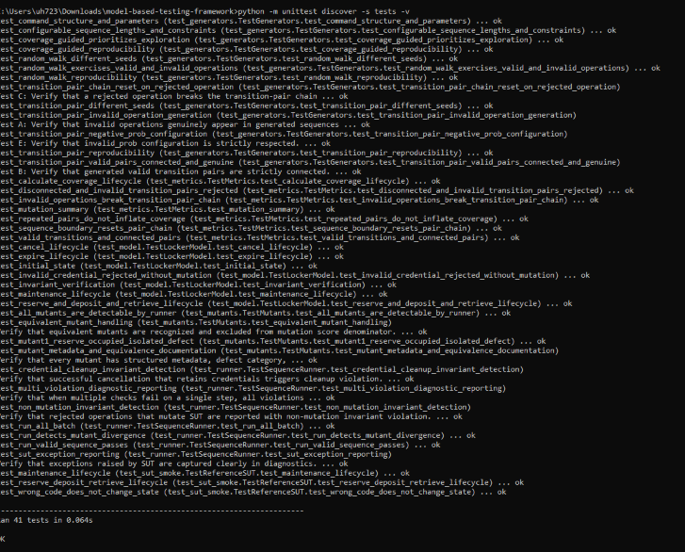

Figure 2: Controlled Experimental Evaluation Run across 5 seeds and 10 mutants:
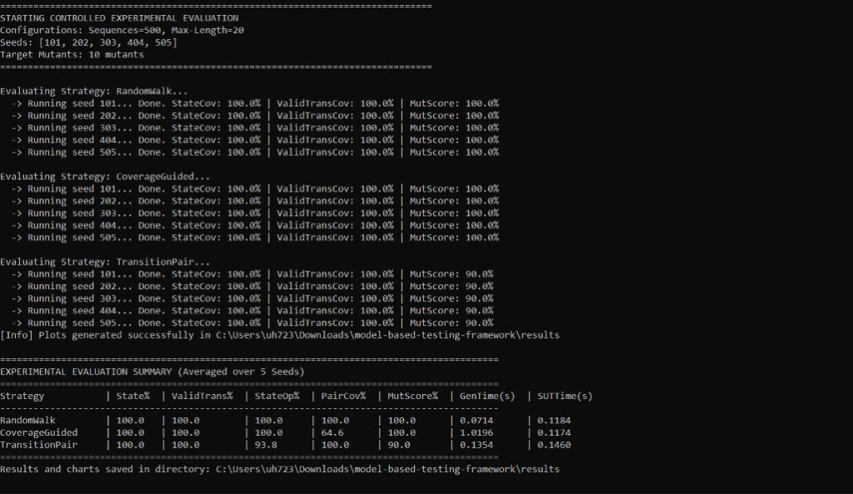

12.2 Visual Charts from Experimental Results
Figure 3: Coverage Metrics Comparison Across Strategies:
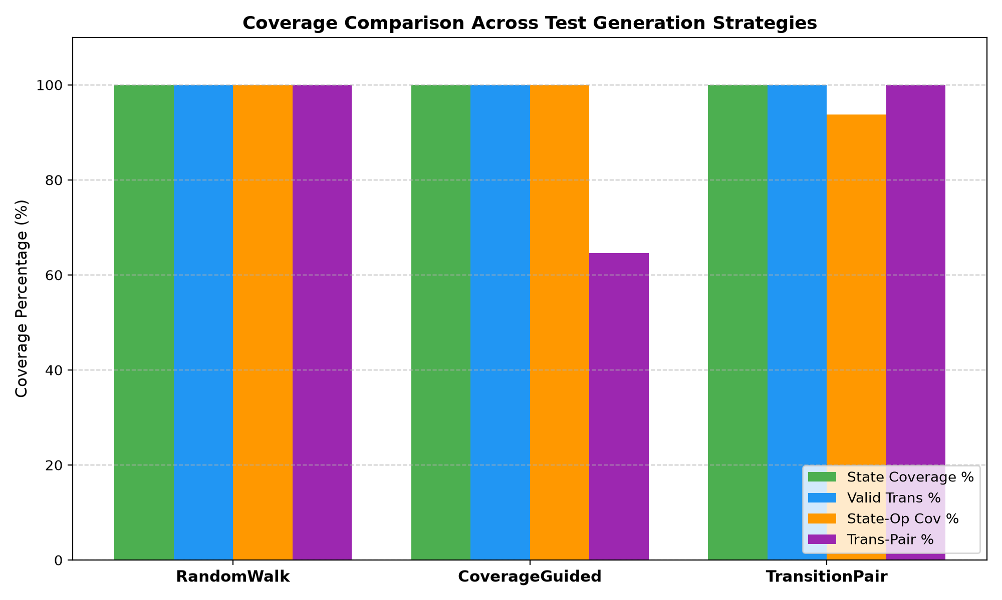

Figure 4: Mutation Score Comparison Across Strategies:
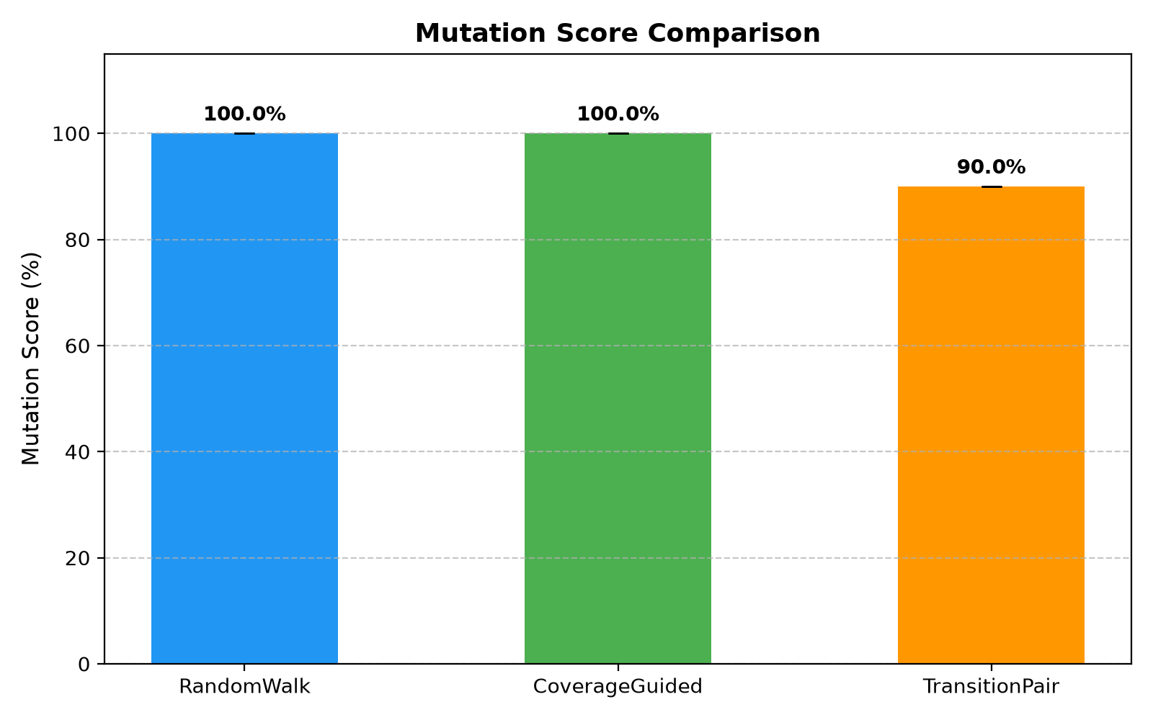

Figure 5: Execution Time Breakdown Across Strategies:
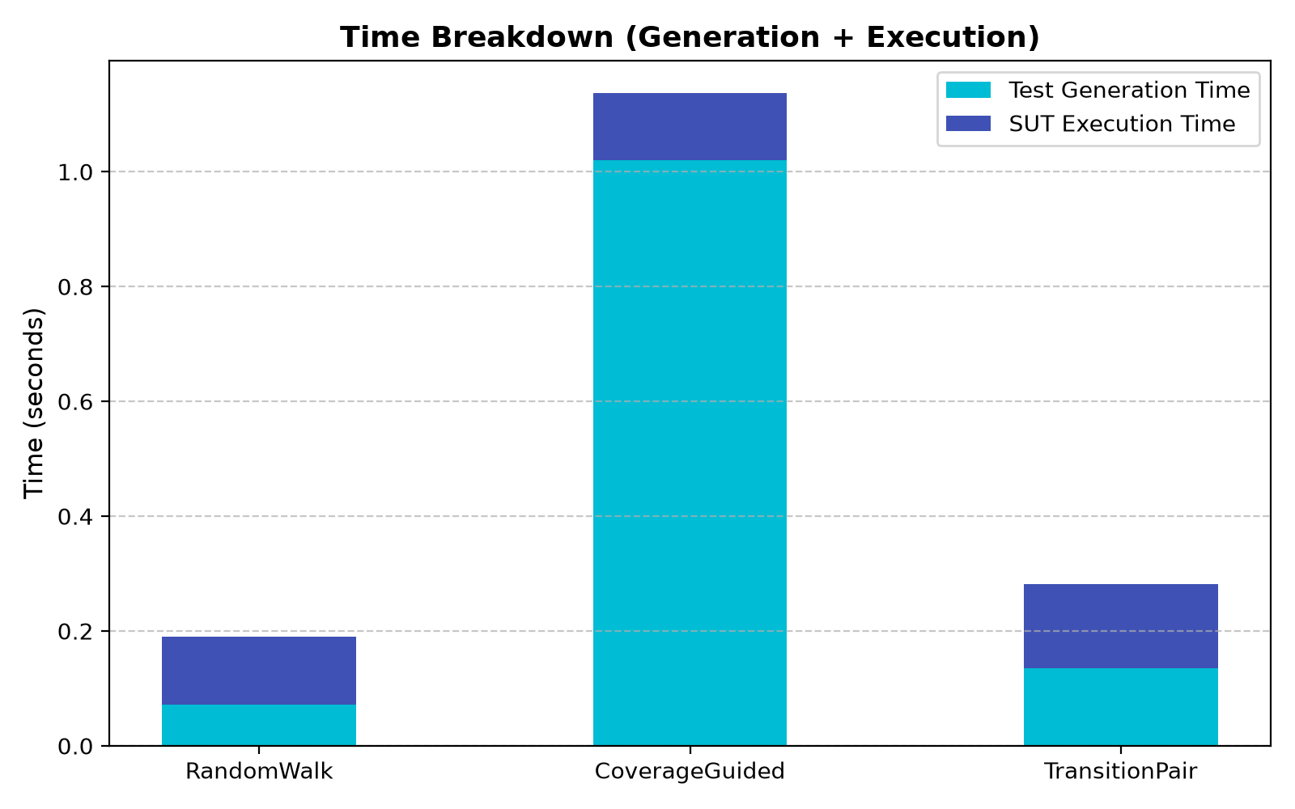

12.3 Individual Viva Preparation Guide
During the individual viva, if an unseen requirement change is presented by the instructor:
• Change A (Allow maintenance while OCCUPIED): In locker/model.py, update the DISABLE guard to permit state in (AVAILABLE, OCCUPIED). Update LockerModel.verify_invariants to permit customer_id during maintenance if occupied.
• Change B (Allow cancel with additional condition or fee): Add the parameter to Command in locker/types.py and update the CANCEL logic in locker/model.py.
• Change C (Introduce new state EXPIRED): Add EXPIRED to State enum in locker/types.py, update EXPIRE transition in locker/model.py to transition to State.EXPIRED instead of directly to AVAILABLE.

