SPRING IOC

ClassPathXmlApplicationContext

代码入口
ApplicationContext xmlcontext = new ClassPathXmlApplicationContext("classpath:applicationContext.xml");
Aoo aoo = (Aoo) xmlcontext.getBean("Aoo");

ClassPathXmlApplicationContext继承类图
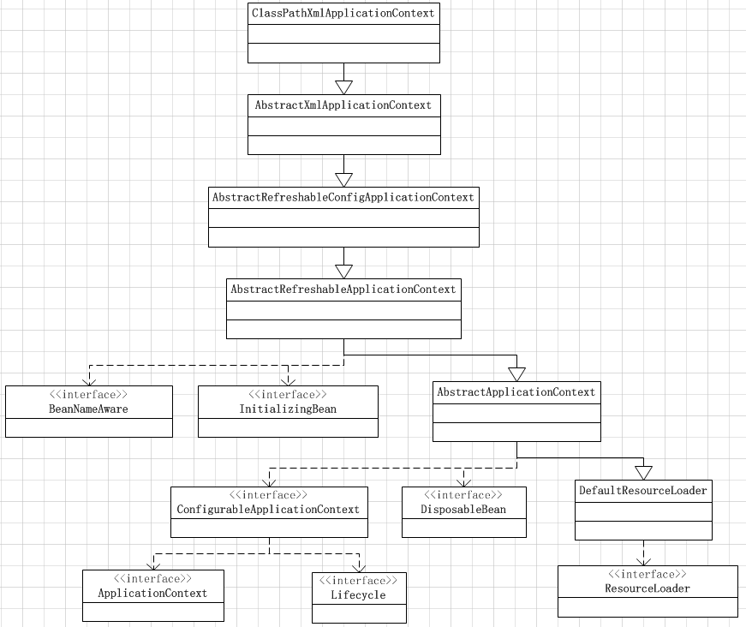

ClassPathXmlApplicationContext存储内容
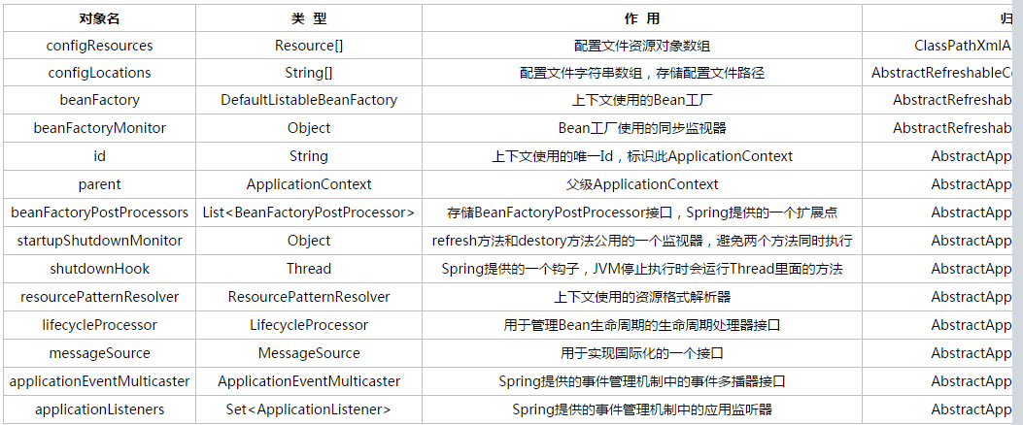

/**
* Create a new ClassPathXmlApplicationContext with the given parent,
* loading the definitions from the given XML files.
* @param configLocations array of resource locations
* @param refresh whether to automatically refresh the context,
* loading all bean definitions and creating all singletons.
* Alternatively, call refresh manually after further configuring the context.
* @param parent the parent context
* @throws BeansException if context creation failed
* @see #refresh()
*/
public ClassPathXmlApplicationContext(String[] configLocations, boolean refresh, ApplicationContext parent) throws BeansException {
super(parent);
setConfigLocations(configLocations);
if (refresh) {
refresh();
}
}

refresh
public void refresh() throws BeansException, IllegalStateException {
synchronized (this.startupShutdownMonitor) {
// Prepare this context for refreshing.
prepareRefresh();

// Tell the subclass to refresh the internal bean factory.
ConfigurableListableBeanFactory beanFactory = obtainFreshBeanFactory();

// Prepare the bean factory for use in this context.
prepareBeanFactory(beanFactory);

try {
// Allows post-processing of the bean factory in context subclasses.
postProcessBeanFactory(beanFactory);

// Invoke factory processors registered as beans in the context.
invokeBeanFactoryPostProcessors(beanFactory);

// Register bean processors that intercept bean creation.
registerBeanPostProcessors(beanFactory);

// Initialize message source for this context.
initMessageSource();

// Initialize event multicaster for this context.
initApplicationEventMulticaster();

// Initialize other special beans in specific context subclasses.
onRefresh();

// Check for listener beans and register them.
registerListeners();

// Instantiate all remaining (non-lazy-init) singletons.
finishBeanFactoryInitialization(beanFactory);

// Last step: publish corresponding event.
finishRefresh();
}

catch (BeansException ex) {
// Destroy already created singletons to avoid dangling resources.
destroyBeans();

// Reset 'active' flag.
cancelRefresh(ex);

// Propagate exception to caller.
throw ex;
}
}
}

// Prepare this context for refreshing.

prepareRefresh();

// Tell the subclass to refresh the internal bean factory.

ConfigurableListableBeanFactory beanFactory = obtainFreshBeanFactory();
protected ConfigurableListableBeanFactory obtainFreshBeanFactory() {
refreshBeanFactory();
ConfigurableListableBeanFactory beanFactory = getBeanFactory();
if (logger.isDebugEnabled()) {
logger.debug("Bean factory for " + getDisplayName() + ": " + beanFactory);
}
return beanFactory;
}
protected final void refreshBeanFactory() throws BeansException {
if (hasBeanFactory()) {
destroyBeans();
closeBeanFactory();
}
try {
DefaultListableBeanFactory beanFactory = createBeanFactory();
beanFactory.setSerializationId(getId());
customizeBeanFactory(beanFactory);
loadBeanDefinitions(beanFactory);
synchronized (this.beanFactoryMonitor) {
this.beanFactory = beanFactory;
}
}
catch (IOException ex) {
throw new ApplicationContextException("I/O error parsing bean definition source for " + getDisplayName(), ex);
}
}
DefaultListableBeanFactory
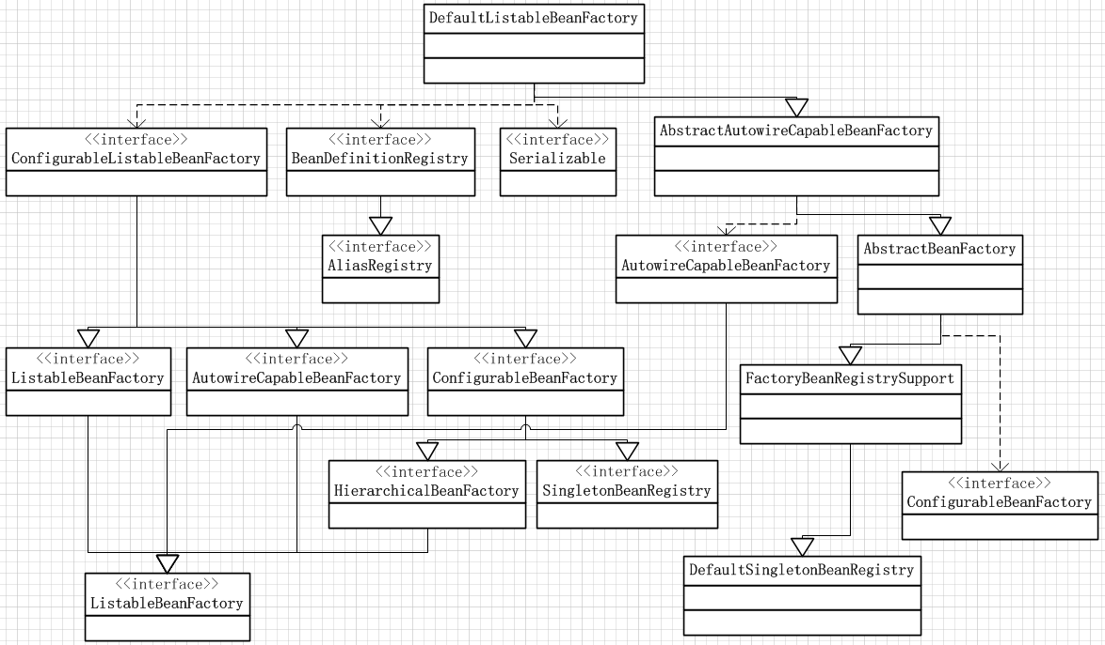
DefaultListableBeanFactory
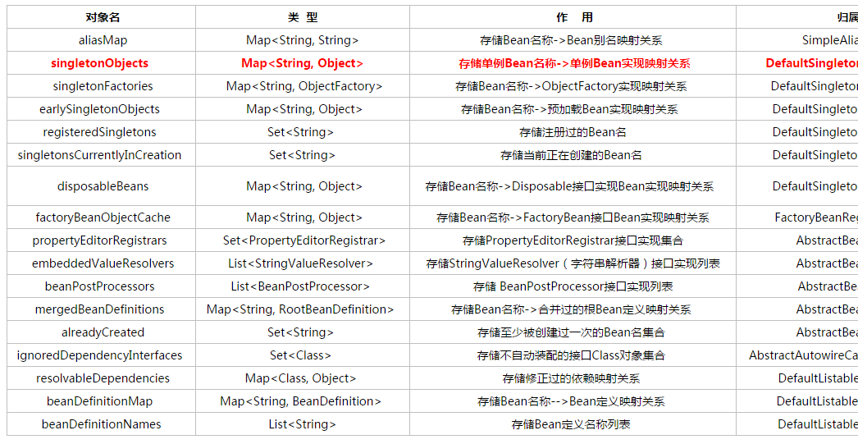

SPRING MVC

SPRING IOC与WEB
在Web.xml中通过org.springframework.web.context.ContextLoaderListener启动IOC
public void contextInitialized(ServletContextEvent event) {
initWebApplicationContext(event.getServletContext());
}
public void contextDestroyed(ServletContextEvent event) {
closeWebApplicationContext(event.getServletContext());
ContextCleanupListener.cleanupAttributes(event.getServletContext());
}
createWebApplicationContext(servletContext)
org.springframework.context.support.AbstractApplicationContext.refresh()

SPRING IOC-DispatcherServlet执行流程
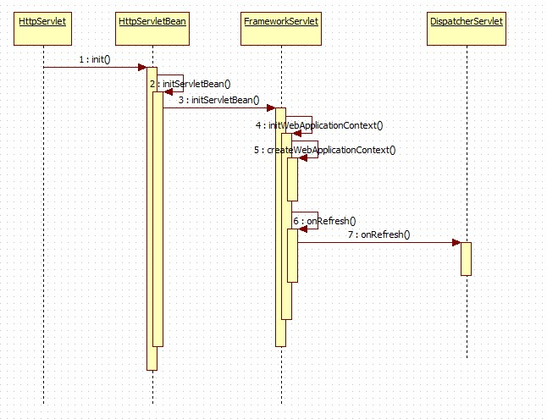

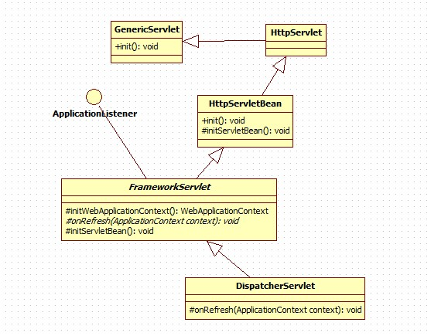
CommonsMultipartResolver

