AI Image Report
homepage_01.jpeg
Tool: Ideogram
Number of Attempts: 1
Modifications: None
Prompt:
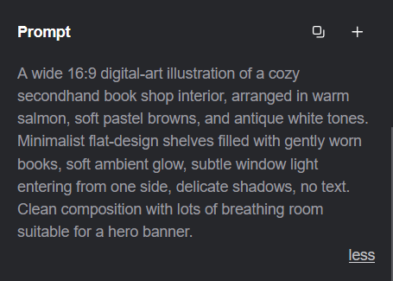
aboutus_page_01.jpeg
Tool: Gemini NanoBanana
Number of Attempts: 2
Modifications: None
Prompt:
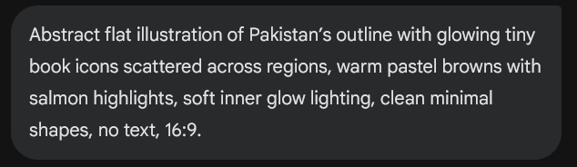

aboutus_page_02.jpeg
Tool: Gemini NanoBanana
Number of Attempts: 5
Modifications: None
Prompt:
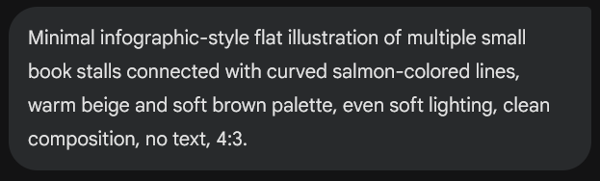
checkout_page_01.jpeg
Tool: Gemini NanoBanana
Number of Attempts: 1
Modifications: None
Prompt:
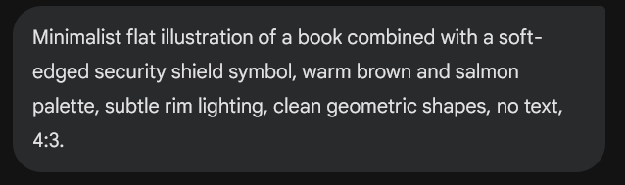
contactus_page_01.jpeg
Tool: Gemini NanoBanana
Number of Attempts: 1
Modifications: None
Prompt:
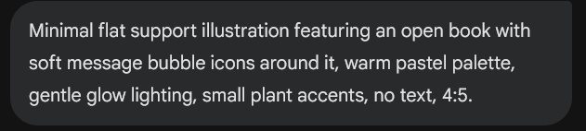

login_page_01.jpeg
Tool: Gemini NanoBanana
Number of Attempts: 1
Modifications: None
Prompt:
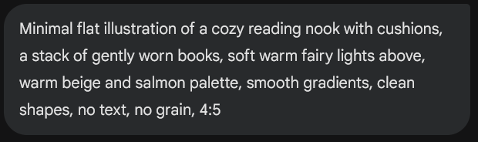
login_page_02.jpeg
Tool: Gemini NanoBanana
Number of Attempts: 1
Modifications: None
Prompt: 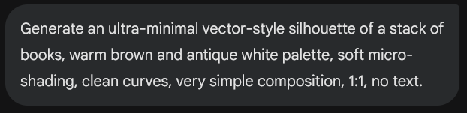

productlisting_page_01:
Tool: Gemini NanoBanana
Number of Attempts: 1
Modifications: None
Prompt:
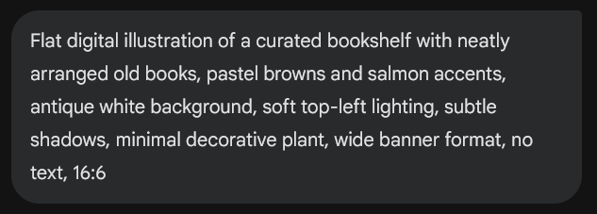
productlisting_page_02:
Tool: Gemini NanoBanana
Number of Attempts: 1
Modifications: None
Prompt:
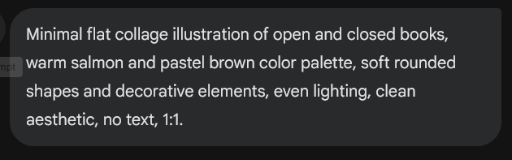
profile_page_01:
Tool: Gemini NanoBanana
Number of Attempts: 1
Modifications: None
Prompt: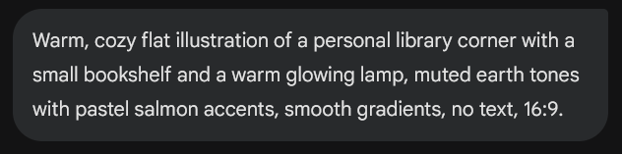

shoppingcart_page_01:
Tool: Gemini NanoBanana
Number of Attempts: 1
Modifications: None
Prompt:
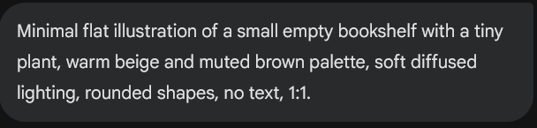

shoppingcart_page_02:
Tool: Gemini NanoBanana
Number of Attempts: 1
Modifications: None
Prompt:
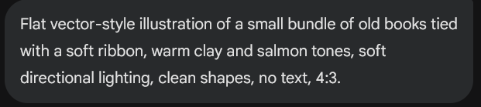

Reflection:
AI generated images are suitable for our theme as they allow us to create highly specialized, minimalist, digital art which is in line with our original vision of the website.
A major challenge we faced was consistency, which we were able to overcome by using extremely detailed prompts which contained all the stylistic information.
We will clearly mark all photos as AI to maintain our ethical code. Not only that, but we have attempted to make sure that our art is not copied from some other website or online source.

