Smart University Lab Management System

Project Title: Automated Priority and Timeout Lab Controller

Student's Names: [Mahad Waqas, Saif Ali, Tallal Khurram]

Instructor's Name: [Arige Anjum]

Course Name and Code: [DLD Lab]

University Name: [Fast NUCES Islamabad]

Date of Submission: [10/05/2026]

2. Abstract of the Project
This project is a smart control system for a university computer lab. In this lab, four student computers share one very fast supercomputer. To be fair, the system gives each student a turn one by one. But, if a teacher needs the supercomputer right away, they can press an emergency button to lock it. To stop people from hogging the computer, the system watches what they do. If the teacher stops working, the system automatically kicks them off and gives the computer back to the students. This makes sure the supercomputer is always busy.

3. Introduction
Project Overview
In many schools, students have to share expensive equipment. In our project, four workstations (named W0, W1, W2, and W3) need to use one main supercomputer. We built a digital circuit to control who gets to use the connection.

Objective
The goals of this project are:
- To make a system that naturally rotates access fairly for everyone.
- To allow important users to skip the line.
- To build a timeout rule that kicks a user off if they stop sending data.

Importance of the Project
Without this smart system, students would have to plug and unplug cables by hand. Also, one person could leave their computer on and block everyone else all day. This automated system saves time, stops long lines, and keeps things fair.

4. Design and Methodology
Design Process (Truth Tables and K-Maps)
To build the circuit, we first had to write down the rules using Truth Tables and Karnaugh Maps.
This helps us figure out the exact wiring.
Truth Table:
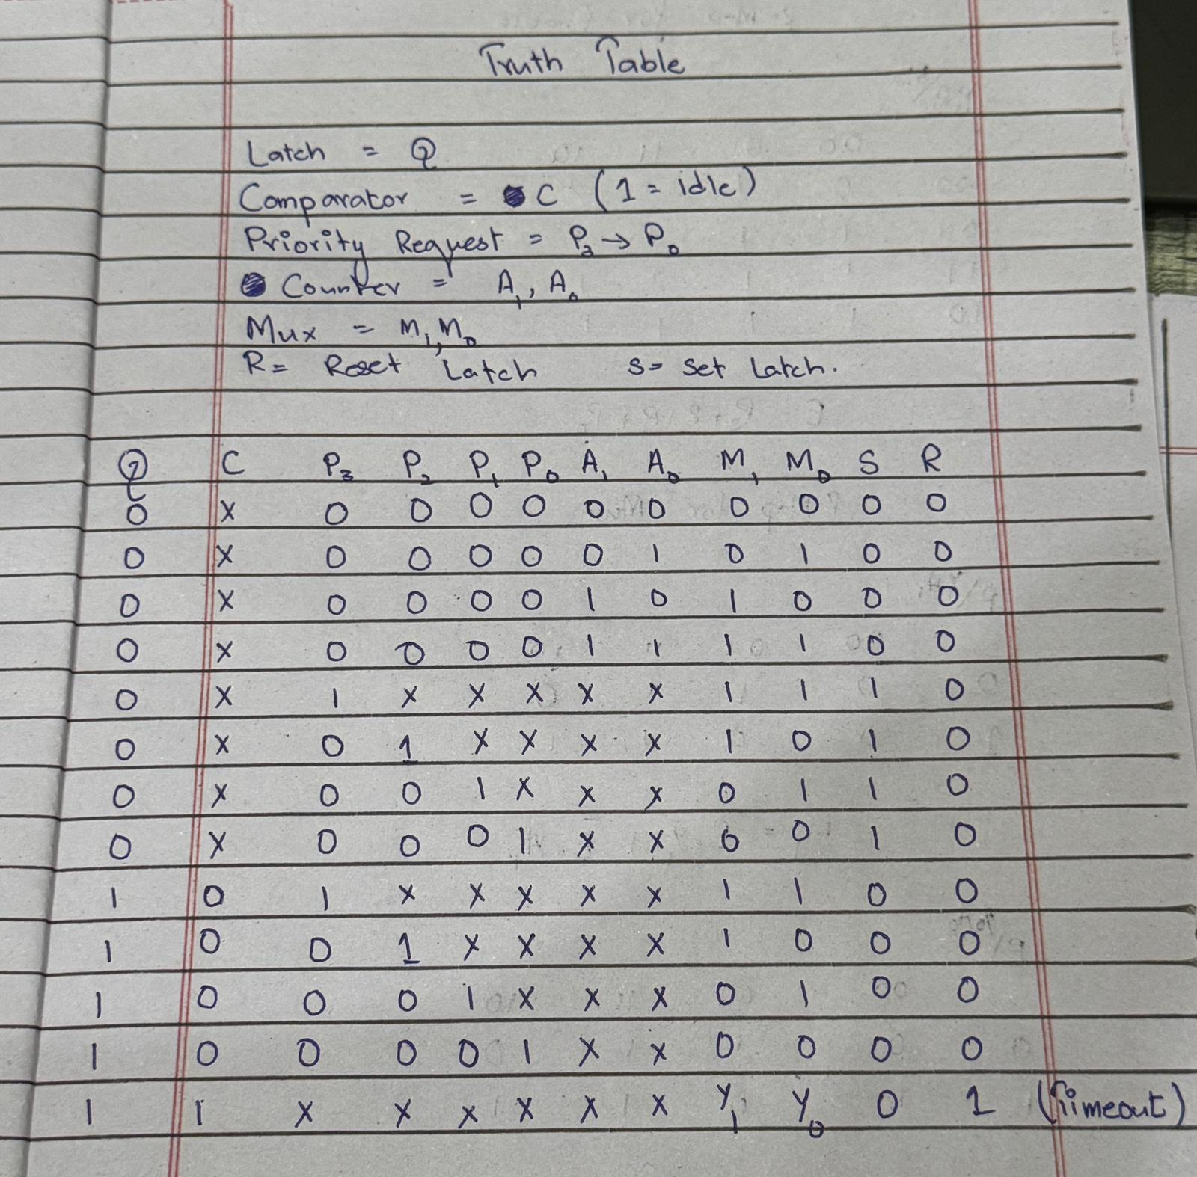
K-Maps:
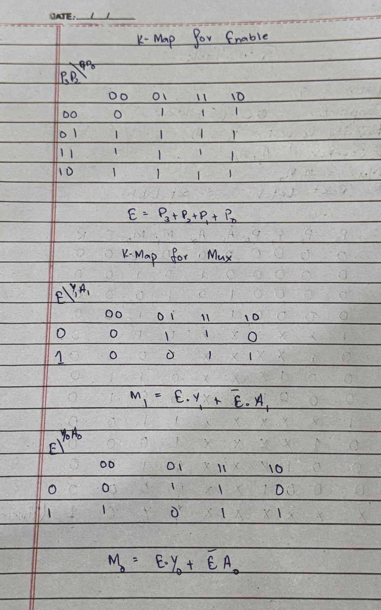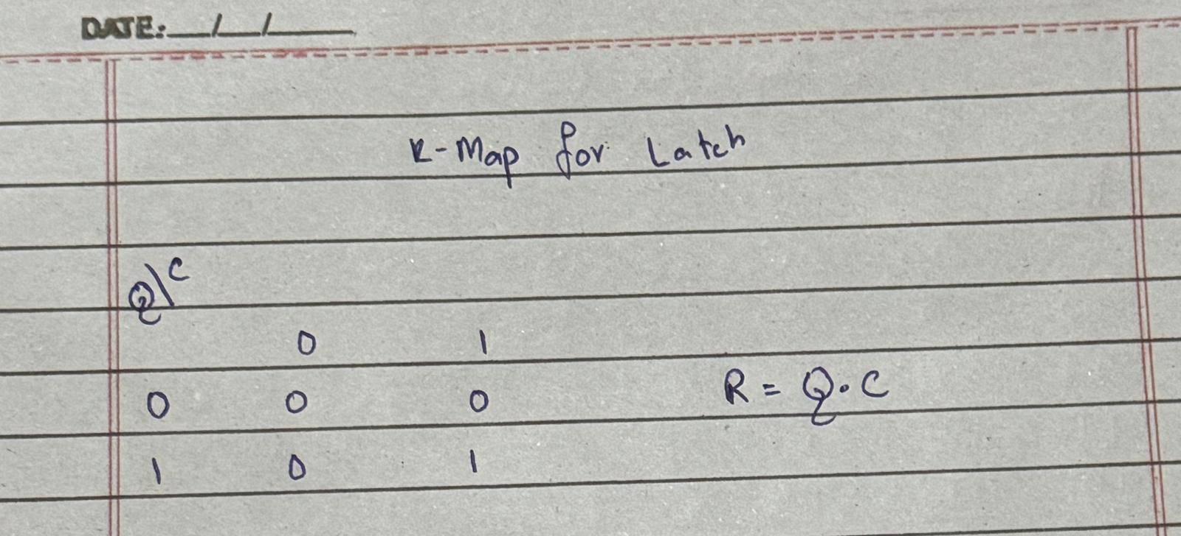

Circuit Diagram
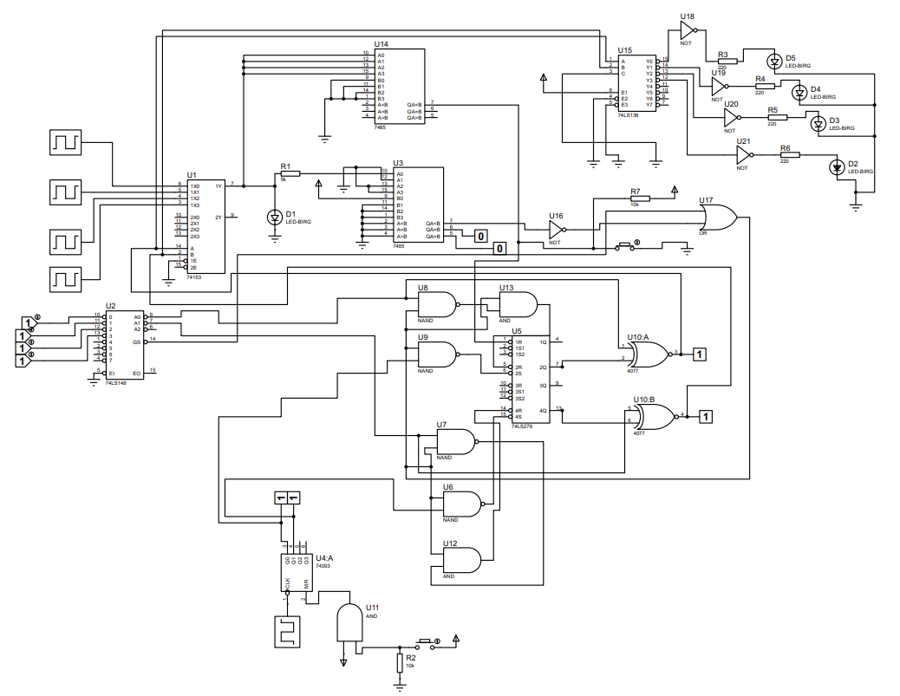
Logic Design
Our logic has three main jobs:
- A counter goes from 0 to 3 over and over. This gives everyone a turn.
- If a VIP presses a button, the system stops the carousel. A memory chip holds the lock so they don't lose their turn even if they let go of the button.
- Another chip watches the VIP's data. If the data drops to 0, it sends a signal to unlock the memory and start again.

Hardware Components
We used these main parts to build it:
- 555 Timer & 74393 Counter: These act like a clock to keep the turns moving.
- 74153 Multiplexer (MUX): This acts like a train switch to pick which student gets to talk to the computer.
- 74LS148 Priority Encoder: This chip decides who is the most important if two people press buttons at the exact same time.
- 7485 Comparator: This acts as the "idle detector". It compares the student's data to a set limit.
- 74LS279 SR Latch: This acts as memory to hold the lock.
- 74LS138 Demultiplexer: This sends the computer's answer back to the correct student's screen.

Software Tools
We used the Proteus Design Suite software to draw and test the circuit.

Simulation
We ran the simulation by turning on the clock and using virtual switches to act like students pressing buttons and typing data.

5. Testing and Results
Testing Procedure
The system was simulated using the Proteus Design Suite. To prove that the logic design works correctly, we tested the circuit in four specific stages, monitoring the logic probes and LED outputs (D2-D5) at each step.

Test 1: Normal Rotation
- Action: The simulation was started with no priority buttons pressed.
- Observation: The 555 Timer successfully provided clock pulses to the 74393 Counter (U4). The 2-bit output from the counter successfully drove the selection pins of both the 74153 Multiplexer (U1) and the 74LS138 Demultiplexer (U15).
- Result: We observed the output LEDs (D2, D3, D4, and D5) turning on one by one in a continuous cycle, proving the system was sharing access fairly.

Test 2: Emergency Priority Lock
- Action: We pressed the highest priority input button attached to the 74LS148 Priority Encoder (U2).
- Observation: The encoder instantly output the binary address for that button. This triggered the 74LS279 SR Latch (U5) to enter the "SET" state. The latch overrode the counter's selection lines.
- Result: The system successfully stopped scanning. The LED cycle froze, locking onto LED D5. Even when the virtual button was released, the latch held the connection open, proving the priority memory works.

Test 3: Idle Detection and Timeout
- Action: While the system was locked onto the priority user (LED D5), we dropped the student's simulated data input to 0.
- Observation: The 7485 Magnitude Comparator (U3) immediately detected that the data input (A) was less than the power-tied threshold (B). Pin 7 (A < B) went HIGH (1). This signal passed through the NOT gate (U16) and OR gate (U17).
- Result: The OR gate (U17) successfully sent a LOW (0) pulse down the Reset. This cleared the SR Latch (U5), erasing the priority lock. The 74153 MUX and 74LS138 DEMUX immediately started listening to the 74393 Counter again, and the LEDs resumed their normal rotation.

Test 4: Master Clear
- Action: During an active priority lock, we pressed the manual Master Reset button located at the bottom of the schematic.
- Observation: This forced a LOW (0) signal directly into the OR gate (U17), bypassing the comparator entirely.
- Result: All active pins on the SR Latch (U5) were cleared simultaneously, proving the lab manager can manually restart the system at any time.

Discussion of Results
The simulation behaved exactly as predicted by the truth tables and Karnaugh Maps. During initial testing, a logic contention error occurred because the Priority Encoder (U2, Pin 14) and the Timeout AND gate (U17) were both attempting to drive the reset at the same time. This was resolved by rerouting the logic to ensure U17 acted as the sole master control for the reset, allowing the simulation to run without short circuits.

