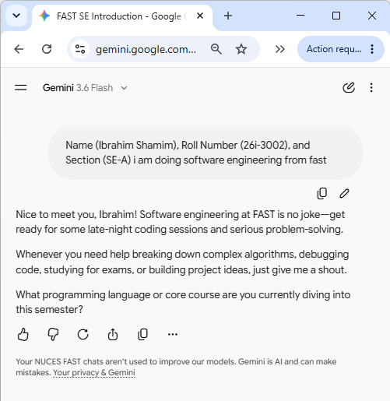

Student Name: Ibrahim Shamim
Roll Number: 26i-3002
Section: SE-A

## Prompt 1: Initial Context & Setup
Prompt: Uploaded index.html and style.css files from Lab 11 and described the wedding invitation theme.
Result: AI confirmed understanding of the theme, colors, and layout.

## Prompt 2: Venue Page (venue.html)
Prompt: Asked AI to create venue.html with venue details, location table, navigation bar, and directions alert button using style.css.
Result: venue.html was generated and added to main branch.

## Prompt 3: RSVP Page (rsvp.html)
Prompt: Asked AI to generate rsvp.html with guest confirmation form, navigation bar, and confirmation popup alert.
Result: rsvp.html was created on feature-rsvp branch and merged into main.

