Lab 12 – AI Prompt Log
Student: Muhammad Jawad Ahmad | Roll No: 26i-3028 | Section: SE-A
Theme: Spring Festival Event Invitation (continued from Lab 11). AI tool: ChatGPT.
Important: Keep this log consistent with the prompts you actually used. Capture screenshots of the real ChatGPT conversation interface, including the initial prompt with your name, roll number and background.

Prompt 1 Initial context and page planning
Prompt:
I am Muhammad Jawad Ahmad, roll number 26i-3028, Section SE-A, a Software Engineering student at FAST-NUCES Islamabad. I am completing Lab 12 and continuing my approved Lab 11 website. My theme is an Event Invitation for a Spring Festival. My existing Lab 11 page is titled Event Invitation / Spring Festival. It has a maroon background, white text, centered headings, an event venue photo, event details in a table, and an RSVP button that displays a JavaScript alert. My uploaded style.css sets body background-color to maroon and all text to white. Please keep the same event theme, maroon and white colour scheme, and simple student-level HTML, CSS and JavaScript. Suggest suitable pages for a multi-page event invitation website.
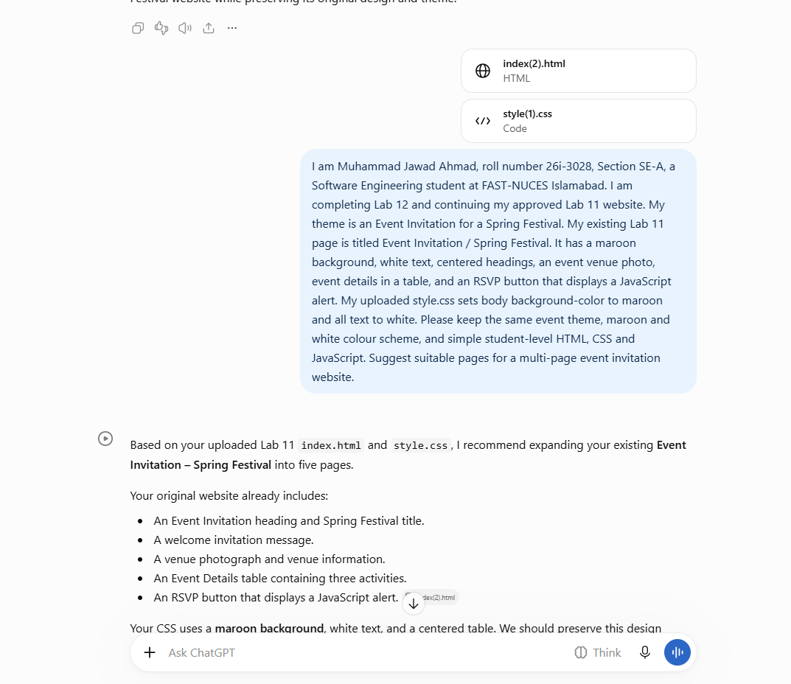

Prompt 2 Schedule page
Prompt:
Create schedule.html for my Spring Festival event invitation website. Keep the same maroon background, white text, heading style, and overall visual theme as my Lab 11 index.html and style.css. Add a shared navigation bar linking Home, Schedule, Venue and RSVP. Add an event schedule table with these activities from my original page: Concerts and tableaus; Meals and bonfire; Winner announcements and prize distribution. You may include a talent competitions row because the invitation paragraph mentions talent competitions. Add the same footer and link to the shared style.css and script.js.
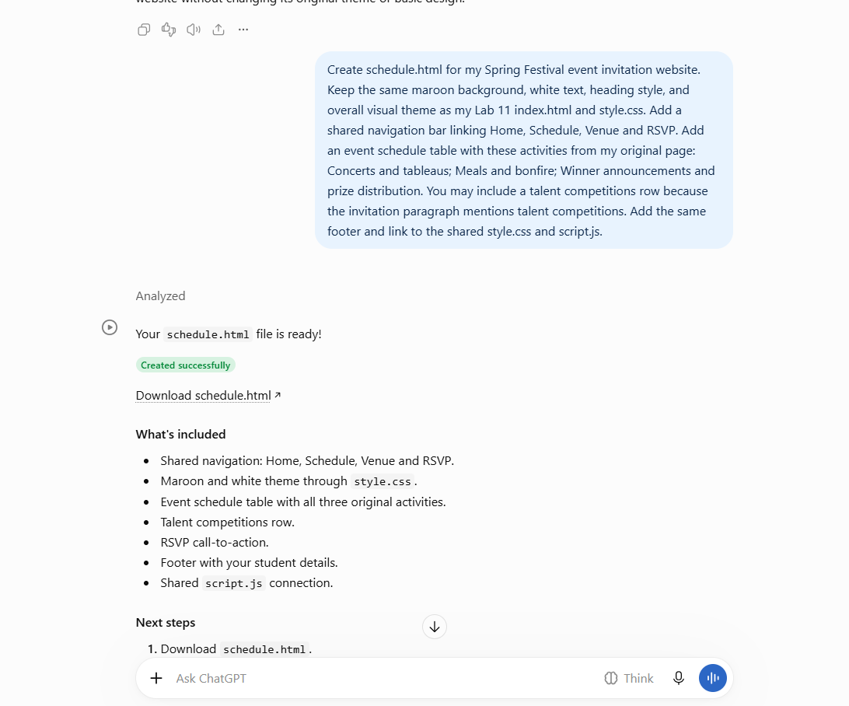
Result:
Result: The Schedule page was created with a table based on the activities in Lab 11. Verify the activity wording against the original assignment and adjust if needed.

Prompt 3 Venue and Directions page
Prompt:
Create venue.html for my Spring Festival website. Use the same maroon and white theme, shared navigation bar, footer, style.css and script.js. Show the venue name Continental Lake View and the address text from my Lab 11 file: Wulfruna Street, West Midlands, right in the heart of city centre, Postel Code: WV1 1LY, Pakistan. Use my supplied venue photograph from images/festival-venue.jpg. Do not invent a map pin or new address.

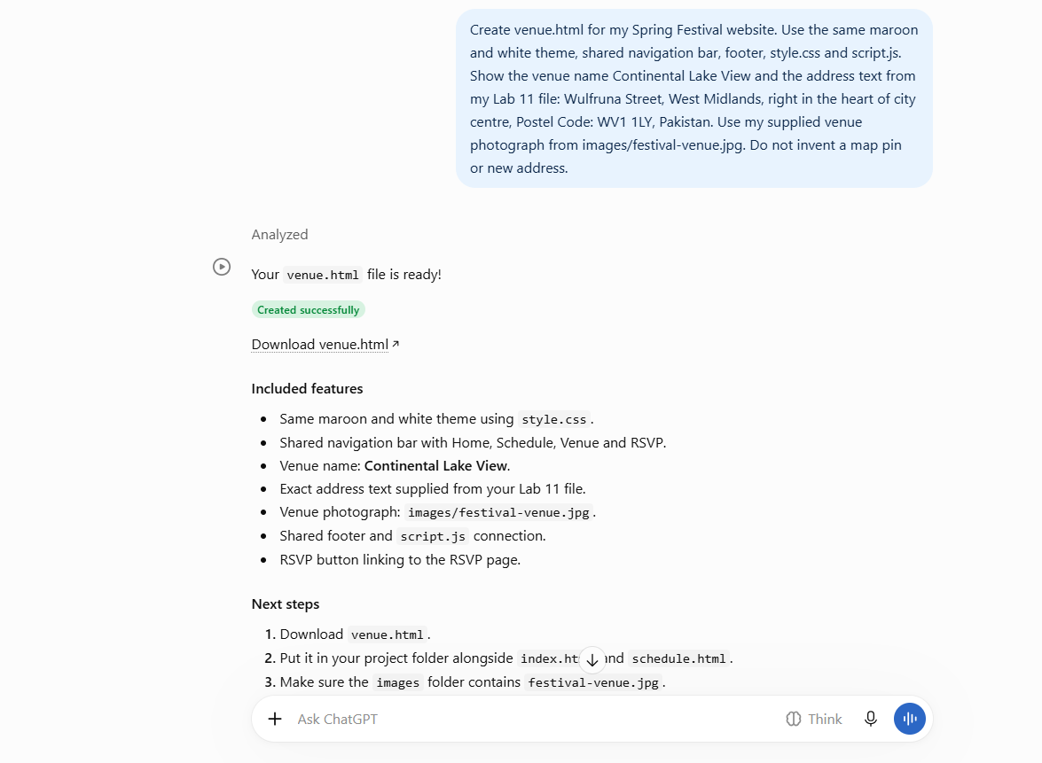
Result:
Result: Venue page created using the uploaded photograph and the venue/address text supplied in Lab 11. Note that the original address wording should be checked for accuracy before final submission.

Prompt 4 RSVP page and JavaScript
Prompt:
Create rsvp.html for my Spring Festival event invitation website. Maintain the same maroon and white design and shared navigation/footer. Add a form for full name, email address, number of attendees, interest in competitions, and optional message. Use required validation for name and email. In the shared script.js, add a submit event listener that prevents a real server submission, displays a window.alert thank-you message, writes a console.log message, and resets the form. Do not claim that this demonstration form sends data online.
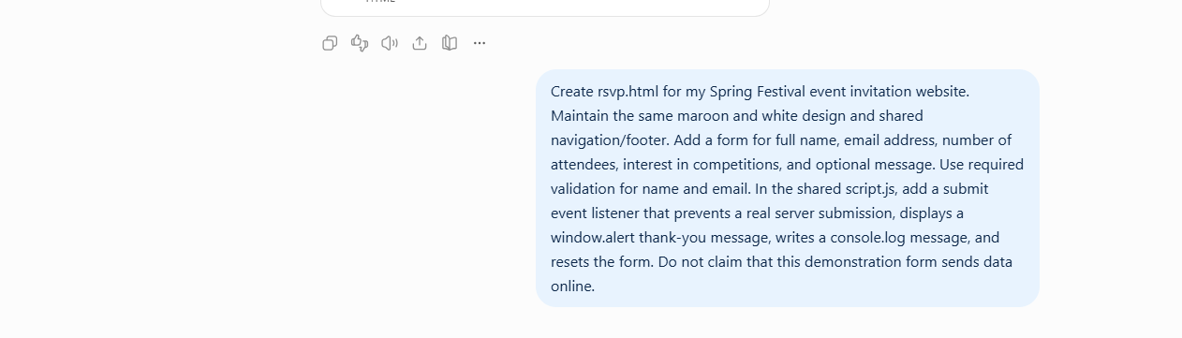
Result:
Result: RSVP form created with browser validation and a JavaScript confirmation alert. Test the required fields, alert and reset in your browser.

Prompt 5 Check navigation and consistency
Prompt:
Review all four pages (index.html, schedule.html, venue.html and rsvp.html) for consistent navigation, footer, maroon and white colour theme, and correct links. Confirm that all pages use the same style.css and script.js. Check image paths and filenames. Fix any broken links or missing navigation items without changing my event invitation theme.
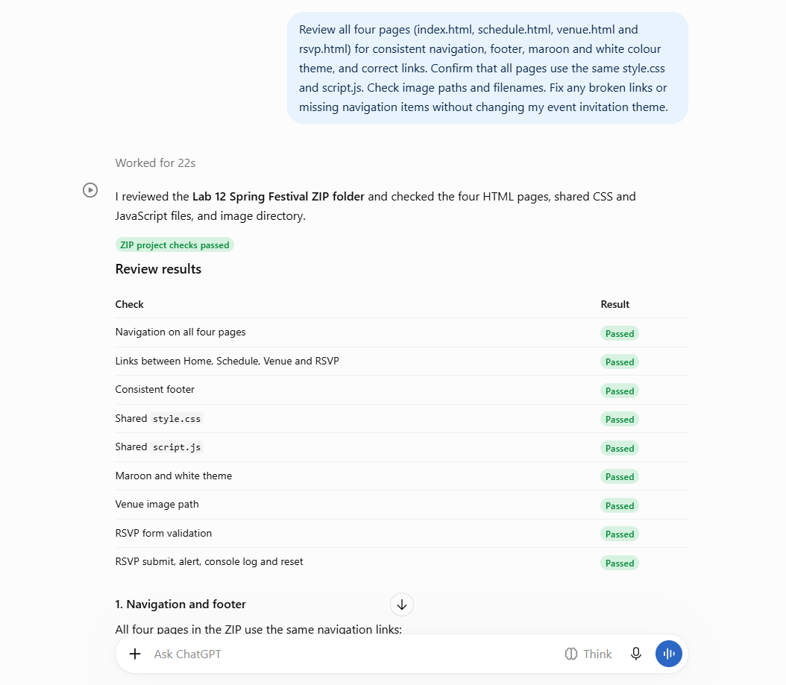

Result:
Result: All four pages were built to use shared CSS/JS and the same navigation. Click every navigation link and test the RSVP form locally; record any actual fixes made.

Prompt 6 README
Prompt:
Write a concise README.md for my Lab 12 Spring Festival Event Invitation website. Include my name Muhammad Jawad Ahmad, roll number 26i-3028, section SE-A, theme, one-line description, page list, technologies HTML CSS JavaScript, AI tool ChatGPT, and placeholders for my actual GitHub repository URL and GitHub Pages live URL. Do not invent a GitHub username or URL.

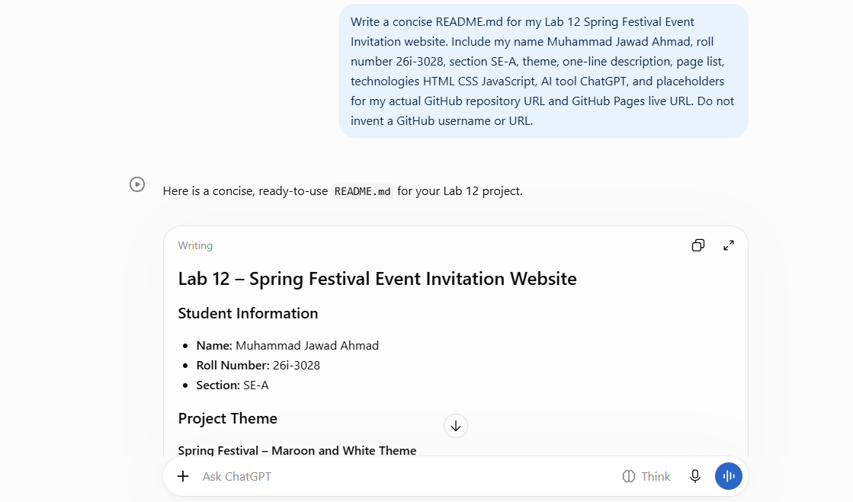
Result:
Result: README includes the project details and URL placeholders. Replace the placeholders after publishing.

