Name: Muhammad Aliyan
Roll No. 26I-3030
Lab. 12-IICT
Screenshots of my Prompts


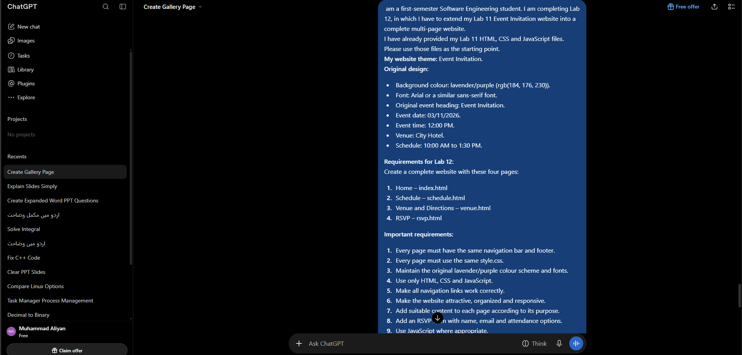
Screenshots of his answer



