Prompt 1: My name is Hamza Taqvim, my roll number is 26i3054, and my section is SE-B. I am a Software Engineering student at FAST-NUCES Islamabad, currently completing CL1000 Introduction to Information & Communication Technologies Lab 12.
I previously created a website in Lab 11 with the theme "Dhaba Menu".
I have uploaded my existing index.html file. Please carefully analyze it before suggesting any changes.
My existing website has:
- A traditional Dhaba Menu theme.
- Brown (#8b4513), dark brown (#4a2c11), and white (#ffffff) color scheme.
- Arial font.
- A menu table containing Paratha, Fried Egg, Chai, Lassi and Channay.
- An Order Now button with a JavaScript alert.
- A food image in the header.
I want to extend this existing website into a professional-looking, multi-page Dhaba website for Lab 12.
Important requirements:
- Preserve my original design, theme, colors and fonts.
- Use only HTML, CSS and JavaScript.
- Keep the website simple and suitable for a beginner-level university lab.
- All pages must have a consistent navigation bar, footer and styling.
- Do not introduce unnecessary frameworks or libraries.
- Do not remove my existing content or functionality without explaining why.
For now, do not generate any code. First, analyze my existing website and suggest the best additional pages for this Dhaba website. Explain what each page should contain.
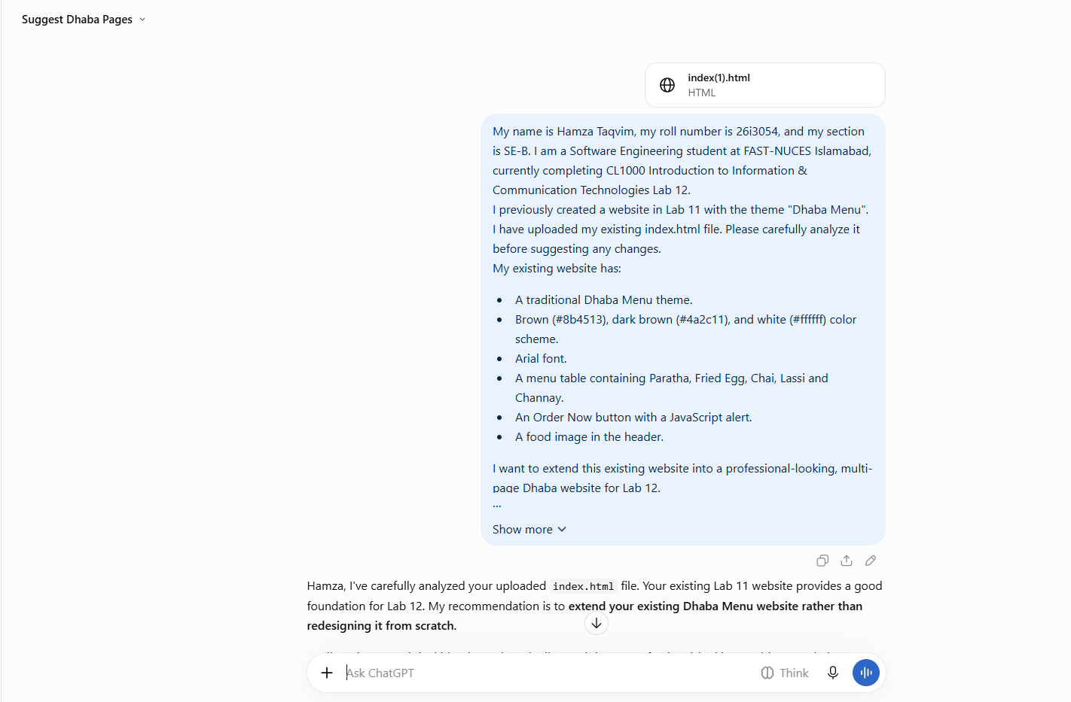
Prompt 2:
Now create the updated Home Page (index.html) for my Dhaba Menu website.
Use my existing Lab 11 index.html as the starting point. Do not redesign it from scratch. Preserve its original theme, layout, colors, font, food image, menu-related content, and Order Now button.
Requirements:
- Keep all CSS inside the HTML file using the <style> tag. Do not create a separate CSS file.
- Use the same brown (#8b4513), dark brown (#4a2c11), and white (#ffffff) color scheme.
- Continue using Arial as the font.
- Add a navigation bar with links to index.html, menu.html, and gallery.html.
- Add a welcoming introduction to the Dhaba website.
- Keep the existing Dhaba food image and its original path: images/dhaba_menu.webp.
- Keep the existing Order Now button and its JavaScript alert functionality.
- Add a consistent footer.
- Make the page clean, attractive, beginner-friendly, and suitable for my CL1000 Lab 12 assignment.
- Make sure the HTML is complete and works correctly.
Provide the complete updated index.html code, not just snippets. Do not create the other pages yet. 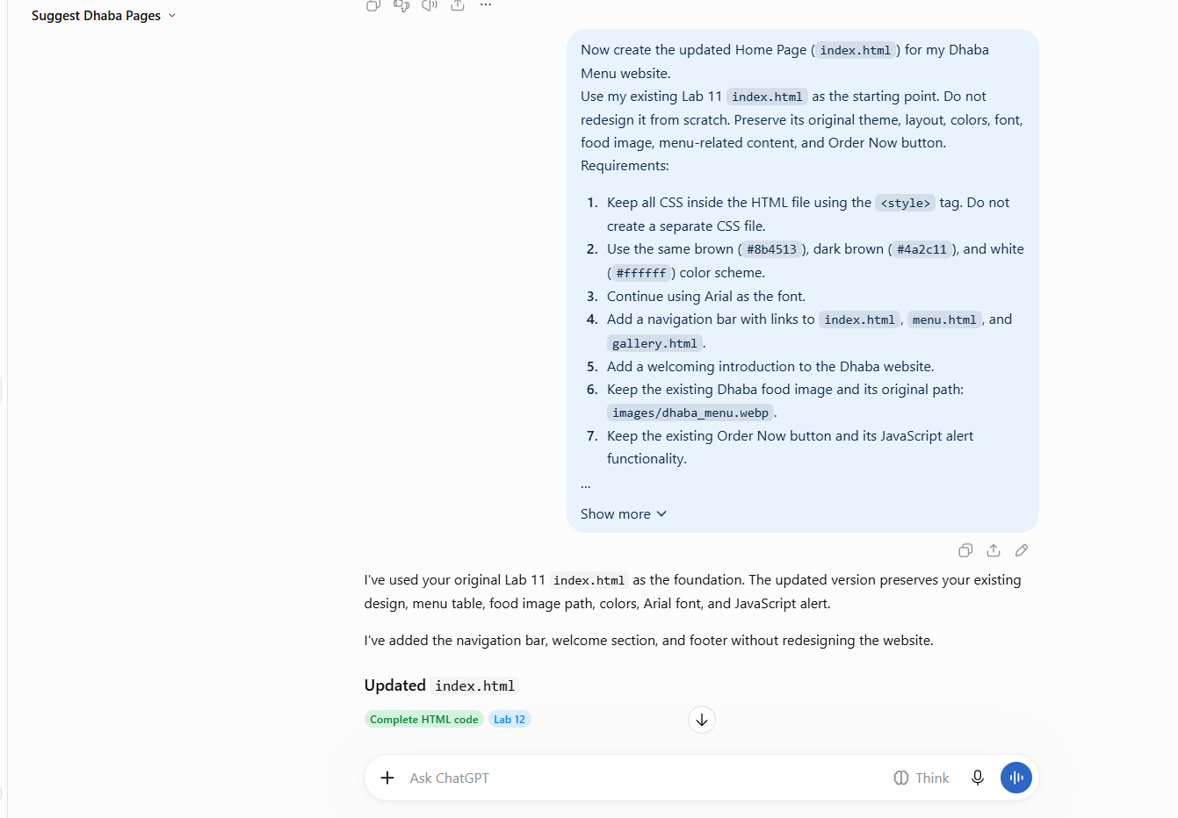

Prompt 3 – Create the Menu Page (menu.html)
Prompt:
Create a complete Menu Page (menu.html) for my existing Dhaba Menu website.
Requirements:
- Follow the same design and theme as my existing index.html.
- Use the same brown (#8b4513), dark brown (#4a2c11), and white (#ffffff) color scheme.
- Use Arial as the font.
- Keep all CSS inside the HTML file using the <style> tag. Do not create a separate CSS file.
- Add a navigation bar with working links to index.html, menu.html, and gallery.html.
- Add a heading and introduction for the food menu.
- Include a food table with these items and prices:
  - Paratha – Rs 70
  - Fried Egg – Rs 80
  - Chai – Rs 60
  - Lassi – Rs 100
  - Channay – Rs 150
- Add an Order Now button with JavaScript alert functionality.
- Add a footer consistent with the Home Page.
- Make the page responsive and beginner-friendly.
Provide the complete HTML code. Do not create a separate CSS file.
Result:
ChatGPT generated a complete menu.html page containing a navigation bar, food menu table, prices, Order Now button, and footer. The original Dhaba theme was maintained using the same brown-and-white colors and Arial font. All CSS was included internally using the <style> tag. 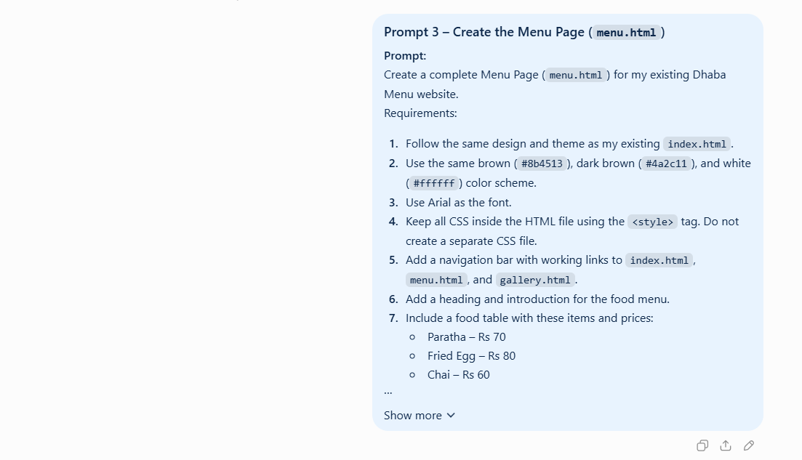

Prompt 4 – Create the Gallery Page (gallery.html)
Prompt:
Create a complete Gallery Page (gallery.html) for my existing Dhaba Menu website.
Requirements:
- Maintain the same theme, layout style, and colors as my Home and Menu pages.
- Use brown (#8b4513), dark brown (#4a2c11), and white (#ffffff).
- Use Arial as the font.
- Keep all CSS inside the HTML file using the <style> tag. Do not create a separate CSS file.
- Add a navigation bar with working links to index.html, menu.html, and gallery.html.
- Add a heading and introduction for the food gallery.
- Create a gallery section with multiple food image cards.
- Use the existing image path images/dhaba_menu.webp because it is currently available in my project.
- Add suitable titles and descriptions for the gallery items.
- Add a footer consistent with the other pages.
- Make the gallery responsive and beginner-friendly.
Provide the complete HTML code. Do not create a separate CSS file.
Result:
ChatGPT generated a complete gallery.html page with a navigation bar, introduction, and food gallery containing three image cards with titles and descriptions. The page maintained the original Dhaba website's color scheme, Arial font, and consistent footer. Internal CSS was used instead of a separate CSS file. 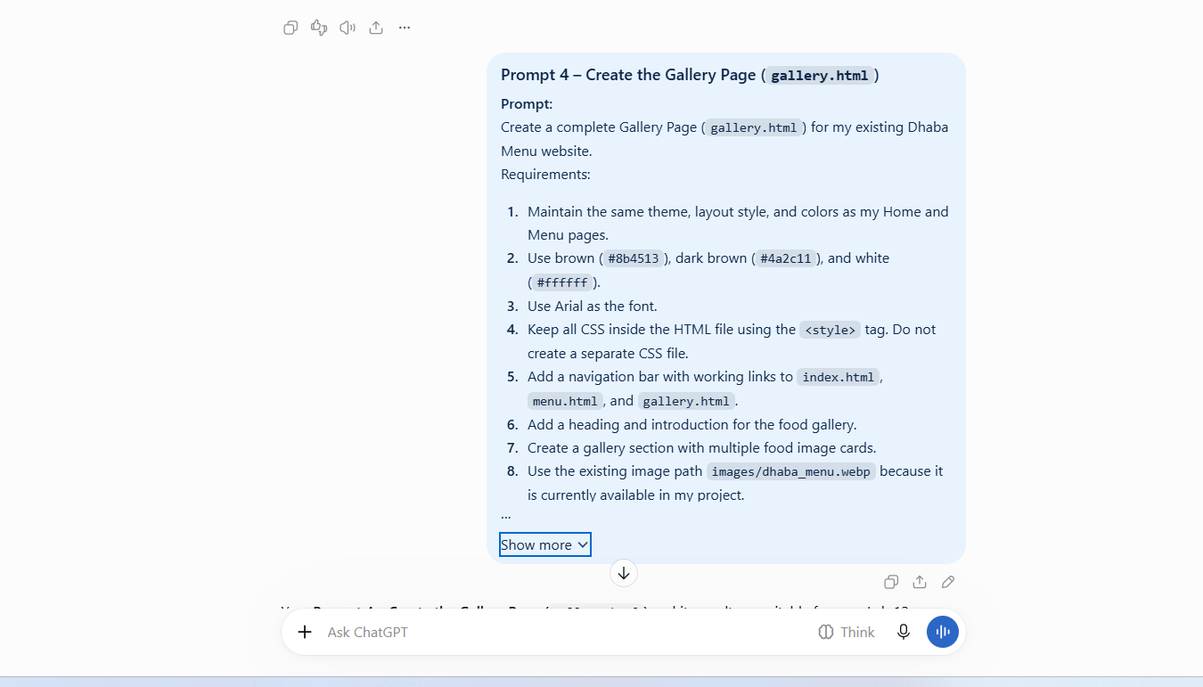

Prompt 5 – Navigation Accessibility Improvement
Prompt:
Improve the accessibility of the navigation bars across my Dhaba Menu website. Keep the existing design and functionality unchanged. Add an appropriate accessible label to the navigation element on all three pages.
Result:
The navigation elements were updated with the aria-label="Main navigation" attribute. This provides a descriptive label for assistive technologies while preserving the existing navigation design and links. 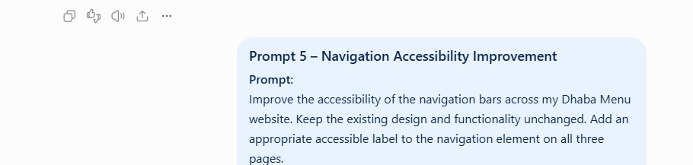

Manual Code Modification
Change made:
I manually modified the welcome heading in index.html.
Original heading:
Welcome to Our Dhaba!
Updated heading:
Welcome to Our Traditional Pakistani Dhaba!
Result:
The Home Page welcome heading was improved to provide a more descriptive introduction to the traditional Pakistani Dhaba. This change was made manually without using an AI tool.
Git Commit Message:
Manual: Improve home page welcome heading

Summary:
The AI updated my existing Lab 11 Dhaba Menu website to create an improved Home Page. It preserved the original design, brown-and-white color scheme, Arial font, food image, menu-related content, and Order Now button.
A navigation bar was added to connect the Home, Menu, and Gallery pages. A welcoming introduction and footer were also included. All CSS was kept inside the HTML file using the <style> tag, without creating a separate CSS file.
The updated page maintains the original Lab 11 theme while adding features required for Lab 12. 

