Prompts

1st prompt:
Hi! My name is Abdul Sami, roll number i263077, Section B. I am a first-year Software Engineering student (Batch 2026) at FAST NUCES Islamabad, and I am working on my ICT lab (CL1000 Lab 12). I am a beginner in web development, so please keep the code simple, clean and easy to explain.
Project: I am turning my Lab 11 page into a multi-page "Pet Adoption" website using ONLY HTML, CSS and JavaScript (no frameworks, no libraries, no build tools). It will be hosted on GitHub Pages, so all links must be relative and file names must be lowercase.
I have attached my Lab 11 files. Please note these problems in them:
- style.css is empty and index.html links to "styles.css" (wrong name). All styling is inline in index.html.
- The Google Fonts/icons link is broken (https://googleapis.com).
- script.js contains <script> tags inside it, which is invalid.
My theme (must stay identical on every page):
- Black navigation bar (#000) with white text
- Blue headings: rgb(0, 162, 255)
- Font: Nunito (Google Fonts), with sans-serif fallback
- Friendly, clean pet-adoption feel
- Pets table with borders, and an "Adopt" button that shows console.log("Adopt button was clicked") and window.alert("Thanks for adopting")
My planned pages (all files in the main folder, lowercase names):
index.html (Home), pets.html (Our Pets), adopt.html (How to Adopt), contact.html (Contact), about.html (Success Stories / About)
Rules for everything you generate:
- ONE shared style.css for all pages (no inline <style>), and ONE shared script.js (no <script> tags inside it)
- The same navbar (linking to all 5 pages) and the same footer on every page
- Do not add features I did not ask for
- Images are in an "image" folder and I will add my own, so use clear placeholder file names and tell me what to name them
Do NOT write any page yet. First, reply with: (a) the fixed style.css and script.js for my existing index.html, (b) an updated index.html that uses them, and (c) a one-line summary of what you changed.

Screenshots:
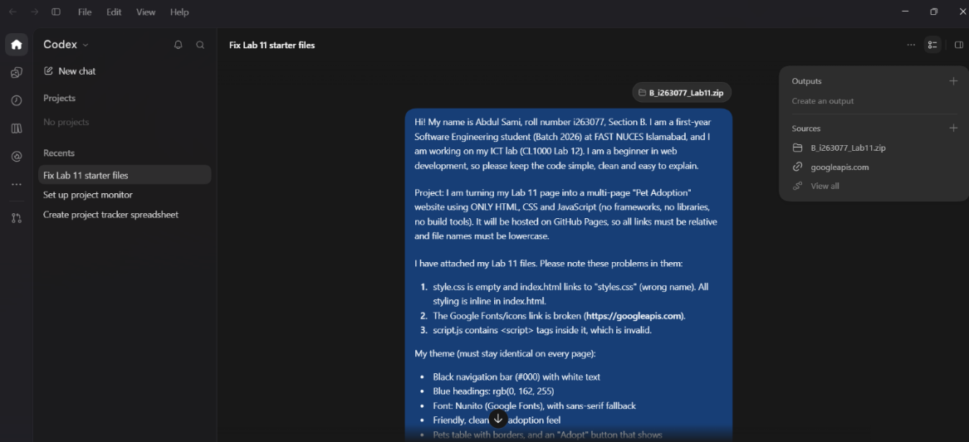

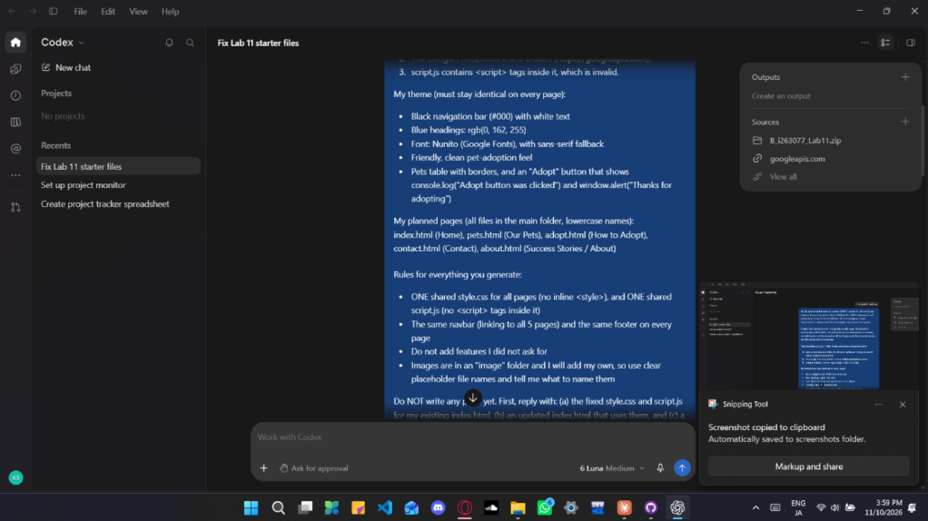

Results:
It improved my website to some extend.

2nd prompt:
Please suggest suitable pages for this website and what content each could have. I am planning these 5 pages: index.html (Home), pets.html (Our Pets), adopt.html (How to Adopt), contact.html (Contact) and about.html (Success Stories / About). Give 3–4 short content ideas per page. Keep the file names lowercase and do not generate code yet.

Screenshots:
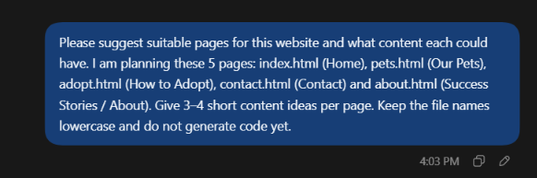

Results:
It gave me some suggestion, and I choose some of them.

Prompt 3:
for index (home): A brief welcome to the pet adoption site.A short note about giving pets a loving home. for pets.html: An Adopt button for each pet.A short note about each pet’s needs or ideal home. for adopt.html: A simple overview of the adoption steps.
- What visitors should consider before adopting.
- What information to prepare when contacting you.
- A reminder that adoption is a long-term commitment. for contact.html:An email address or other contact details.
- A simple contact form layout idea, if your lab allows it.
- The days and times when you are available.
- A short invitation to ask about a pet or the adoption process. for about.html: A short introduction to the site’s purpose.
- A few brief stories about pets finding homes.
- A note about the people or group helping the pets.
- A message about responsible pet adoption.

Screenshots:
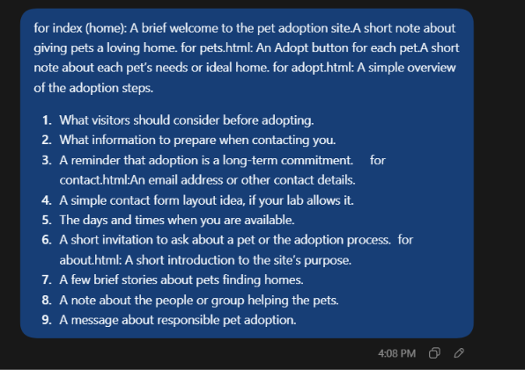

Results:
I approved of some of his suggestions and it nodded.

Prompt 4:
Now please fix my existing files. Give me: (a) a complete style.css containing all the styling currently inline in index.html, using Nunito and my theme colours, with a shared navbar and footer style; (b) a complete script.js with a say() function that does console.log("Adopt button was clicked") and window.alert("Thanks for adopting"), with no <script> tags inside it; (c) an updated index.html that links style.css, script.js and the Nunito Google Font correctly (fix the broken link), and has a navbar linking to index.html, pets.html, adopt.html, contact.html and about.html, plus a footer. Keep my pets table and image. Tell me in one line what you changed. also move the adopt button in the center.

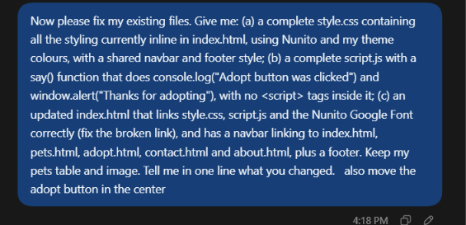
Screenshot:

Results:
It improved the website a lot but messed up the readability of the adopt button. So I ask it to improve it.

Prompt 5:
Create pets.html (Our Pets). Use the exact same navbar, footer, style.css and script.js as index.html. Show 6 pet cards in a responsive grid, each with an image (image/pet1.jpg to image/pet6.jpg), name, type, age, a one-line description and an "Adopt" button that uses console.log and window.alert and includes the pet's name in the alert. Give me only the new CSS lines to add to style.css.

Screenshots:
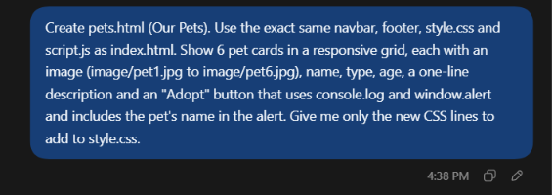

Result:
It messed up the animals and their description but I fixed it.

