Lab 12: Prompt Log
Name: Mansoor Ashiq
Roll Number: 26i-3078
Section: B
Course: CL1000 - Introduction to ICT
This document records the AI prompts used to create the Chai Corner website.

1. AI Prompts

Prompt 1: Initial Planning
- Prompt: Hi! My name is Mansoor Ashiq, roll number 26i-3078. Here are my Lab 11 files for Chai Corner. Suggest a 3-page layout.
- Result: The AI suggested creating a Home page, a Menu page, and a Contact Us page.
- Fixes: None, the suggestion was good.
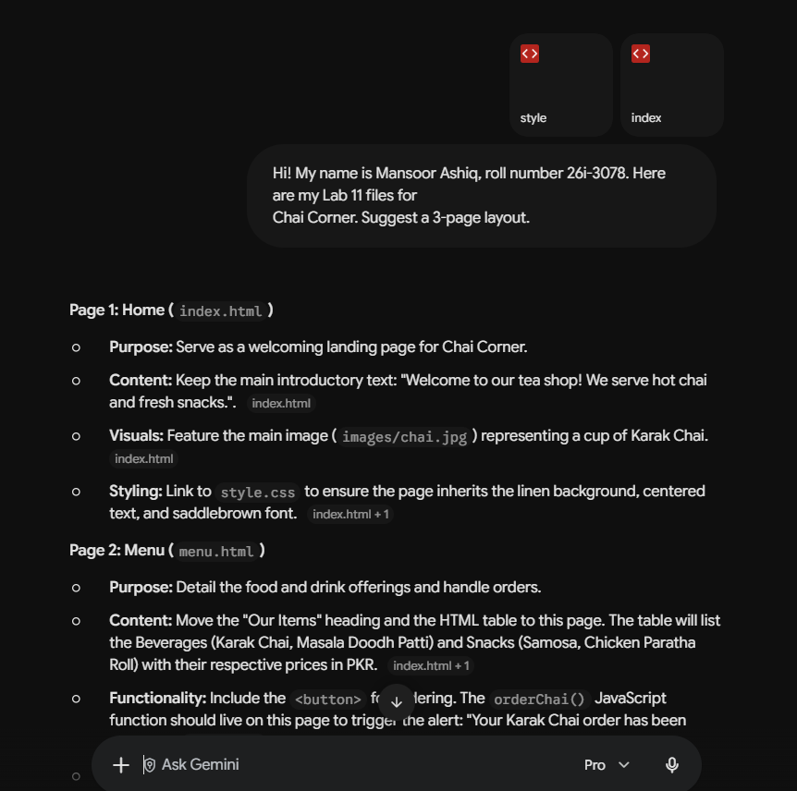

Prompt 2: Generating the Pages
- Prompt: Write the code for index.html and style.css. Keep my colors: linen background and chocolate headings. Add a navigation bar.
- Result: The AI wrote the HTML code and the CSS file to match my theme.
- Fixes: I had to fix the padding on the container manually so it looked better.
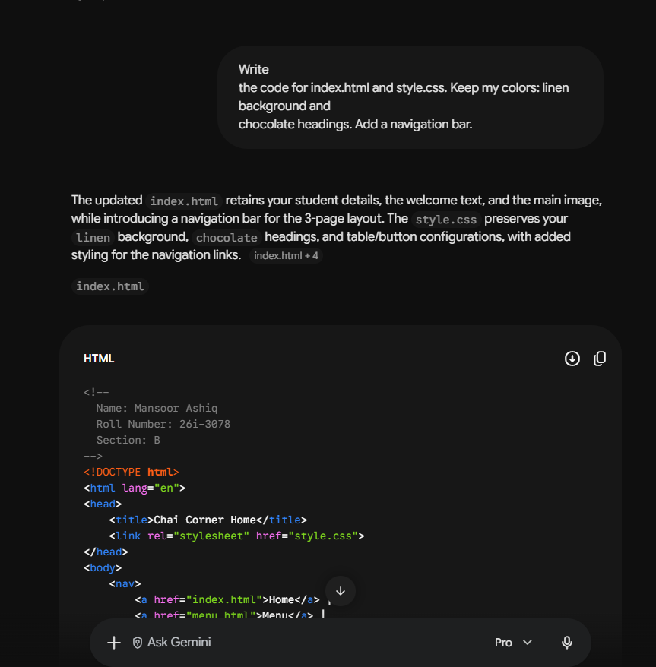]

Prompt 3: Menu & Contact Form
- Prompt: Create menu.html with a table, and contact.html with a form. Add a Javascript alert when I click submit.
- Result: AI gave me the form code and the script for the alert.
- Fixes: I had to change the Javascript slightly because it was not clearing the form after submit.
[ 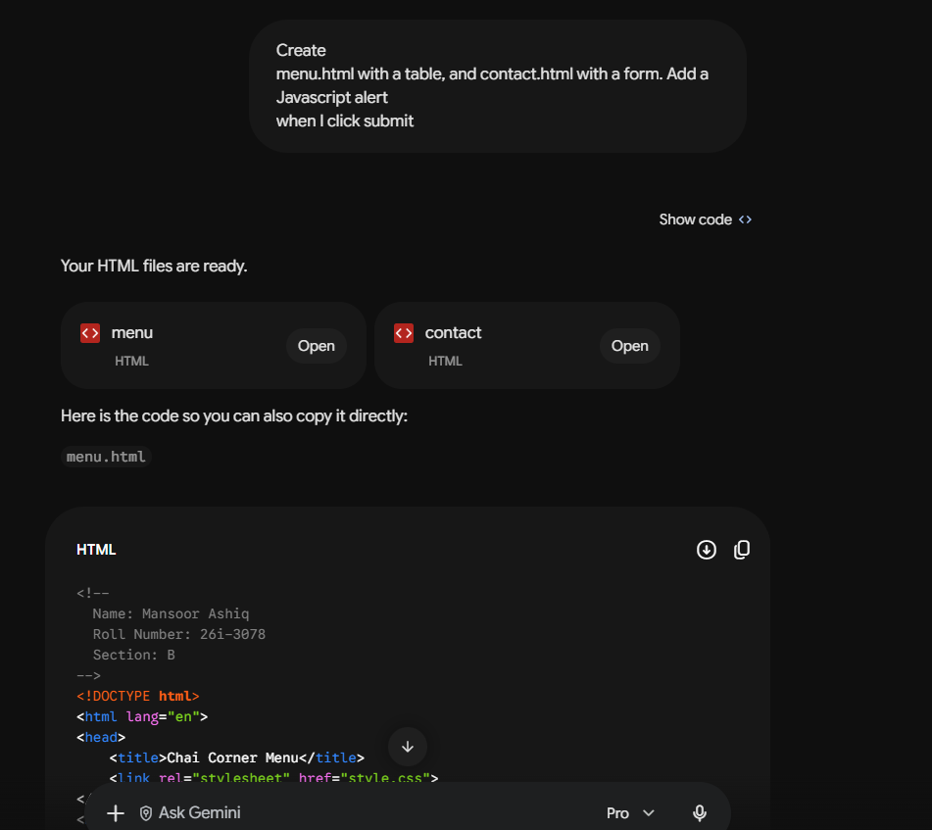

2. Git Commit History
Here is the list of my commits for Lab 12:
- 1. Add Lab 11 files (main branch)
- 2. Add Home and Menu page (main branch)
- 3. Add Contact page with form (feature-contact branch)
- 4. Merge feature-contact into main (main branch)
- 5. Manual: change button color (main branch)
- 6. Add prompts log (main branch)

