Prompt 1

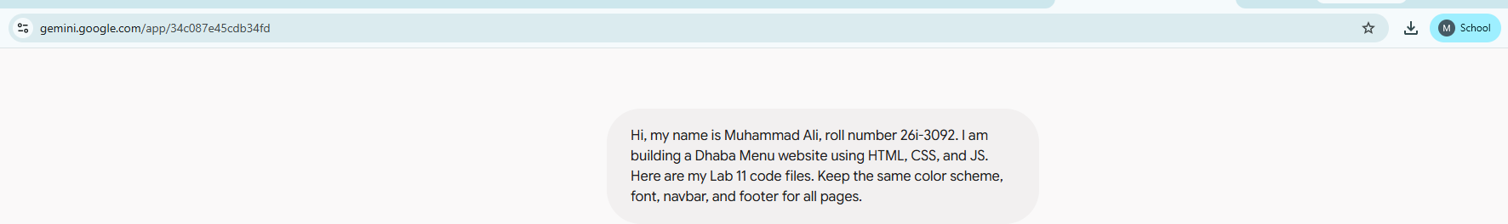

Prompt 2
Create menu.html for my dhaba website using the same navigation bar, footer, and style.css as index.html. Add menu categories like Desi Karahi, BBQ, and Drinks with prices
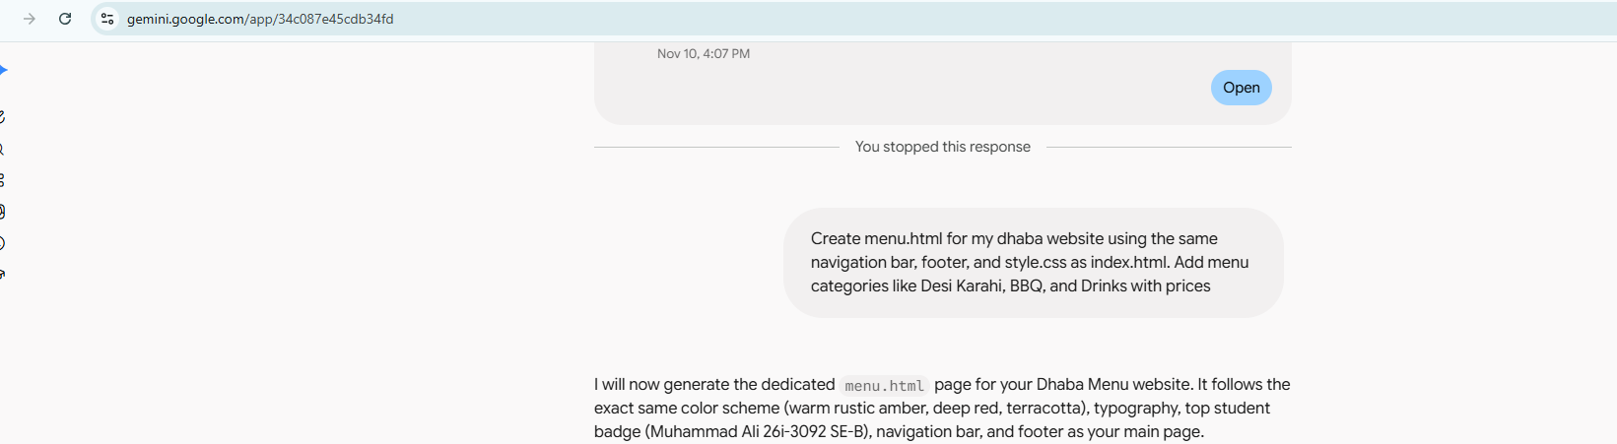

Result:
The prompt generated the page correctly
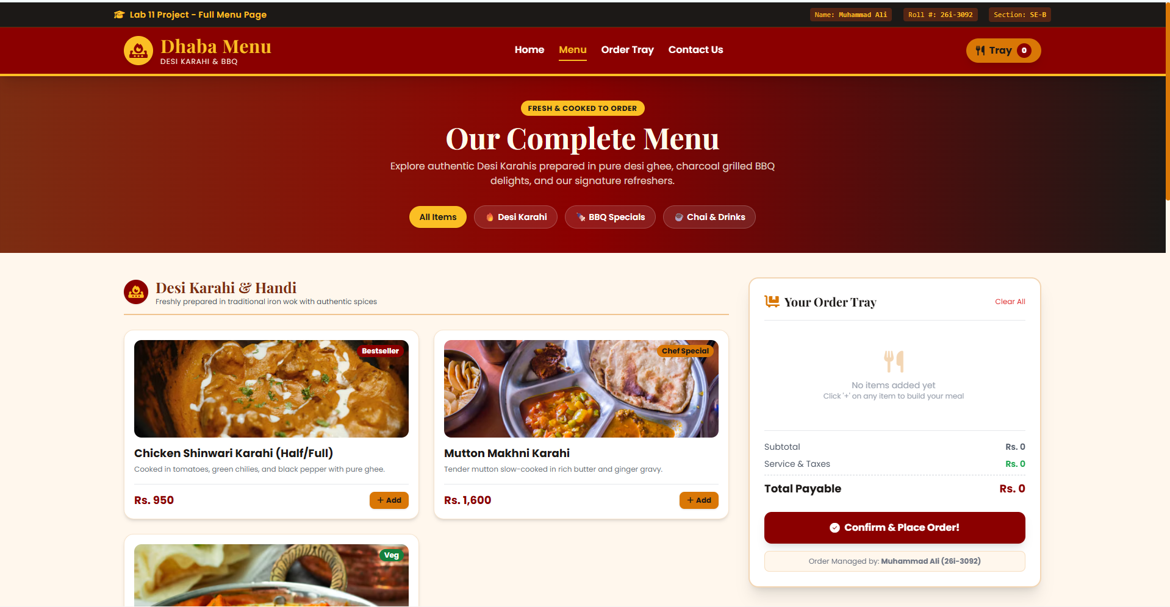

Prompt 3
Create contact.html using the same header, navbar, footer, and style.css. Include a contact form (Name, Phone, Order Note), dhaba timing, address, and Google Maps placeholder



Result:
Contact page was created successfully.
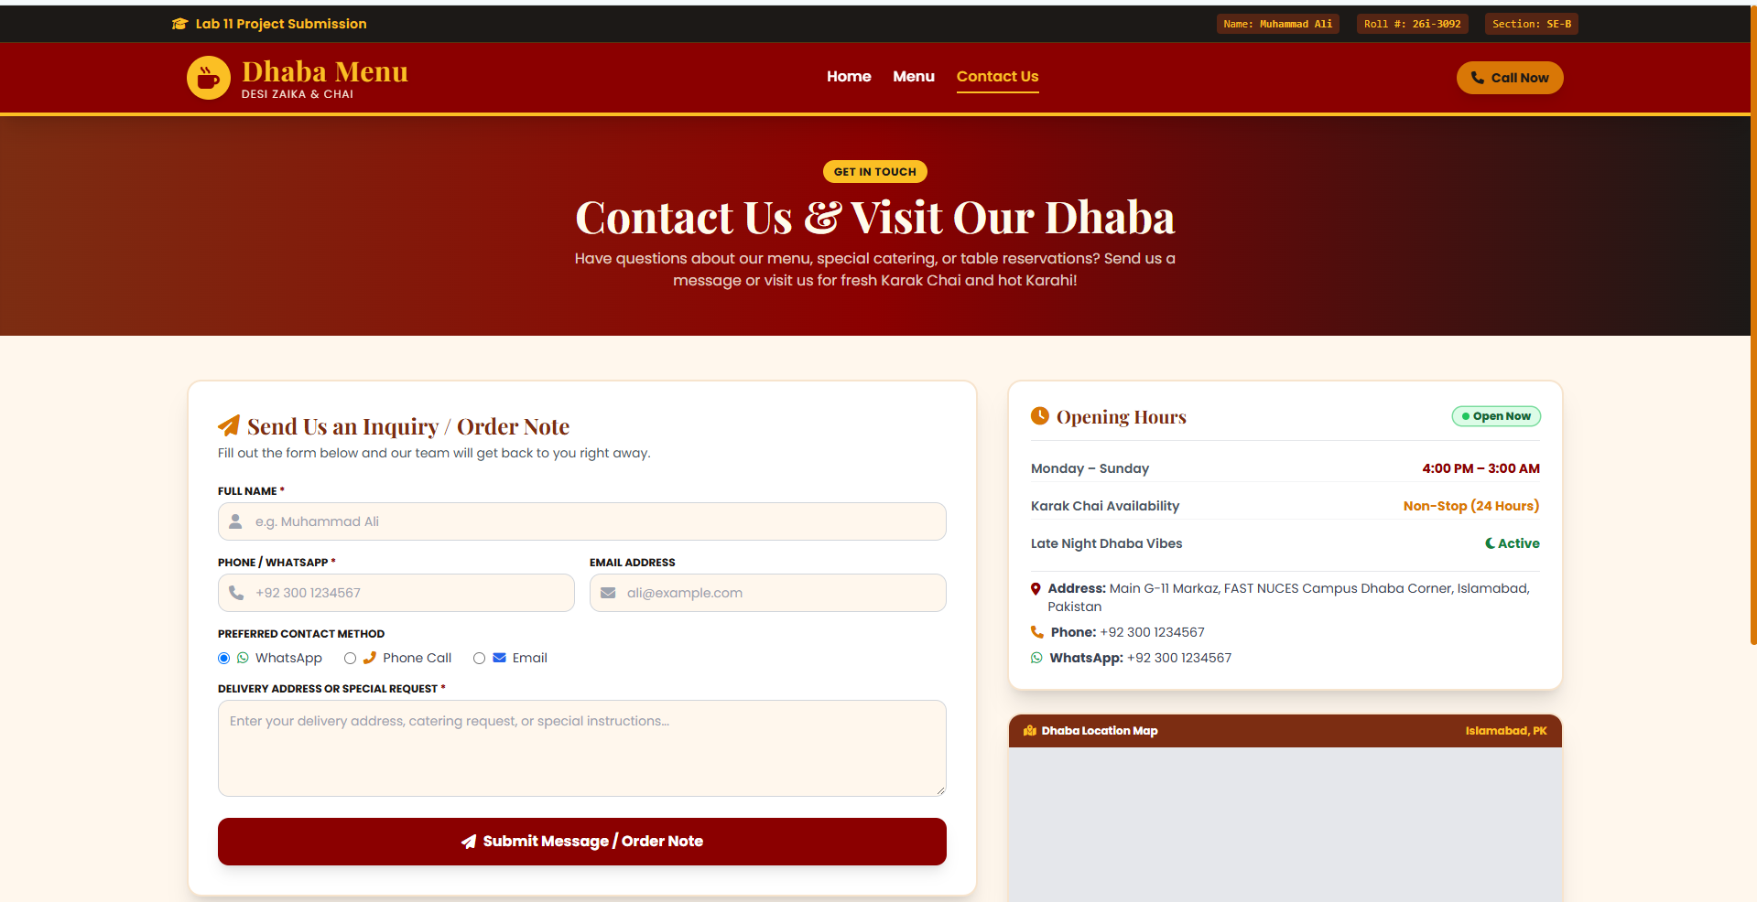

History Tab:


