Aiman Zahid
26i-3221
SE-A

Lab 12

## Prompt 1: Introduction

Prompt: My roll number is i263221.i am doing an iict lab where i've to create the website on the theme of cafe menu . i,ve already created a menu option in previous lab . help me add more pages to create a website

Result: I gave the AI intro of what I want

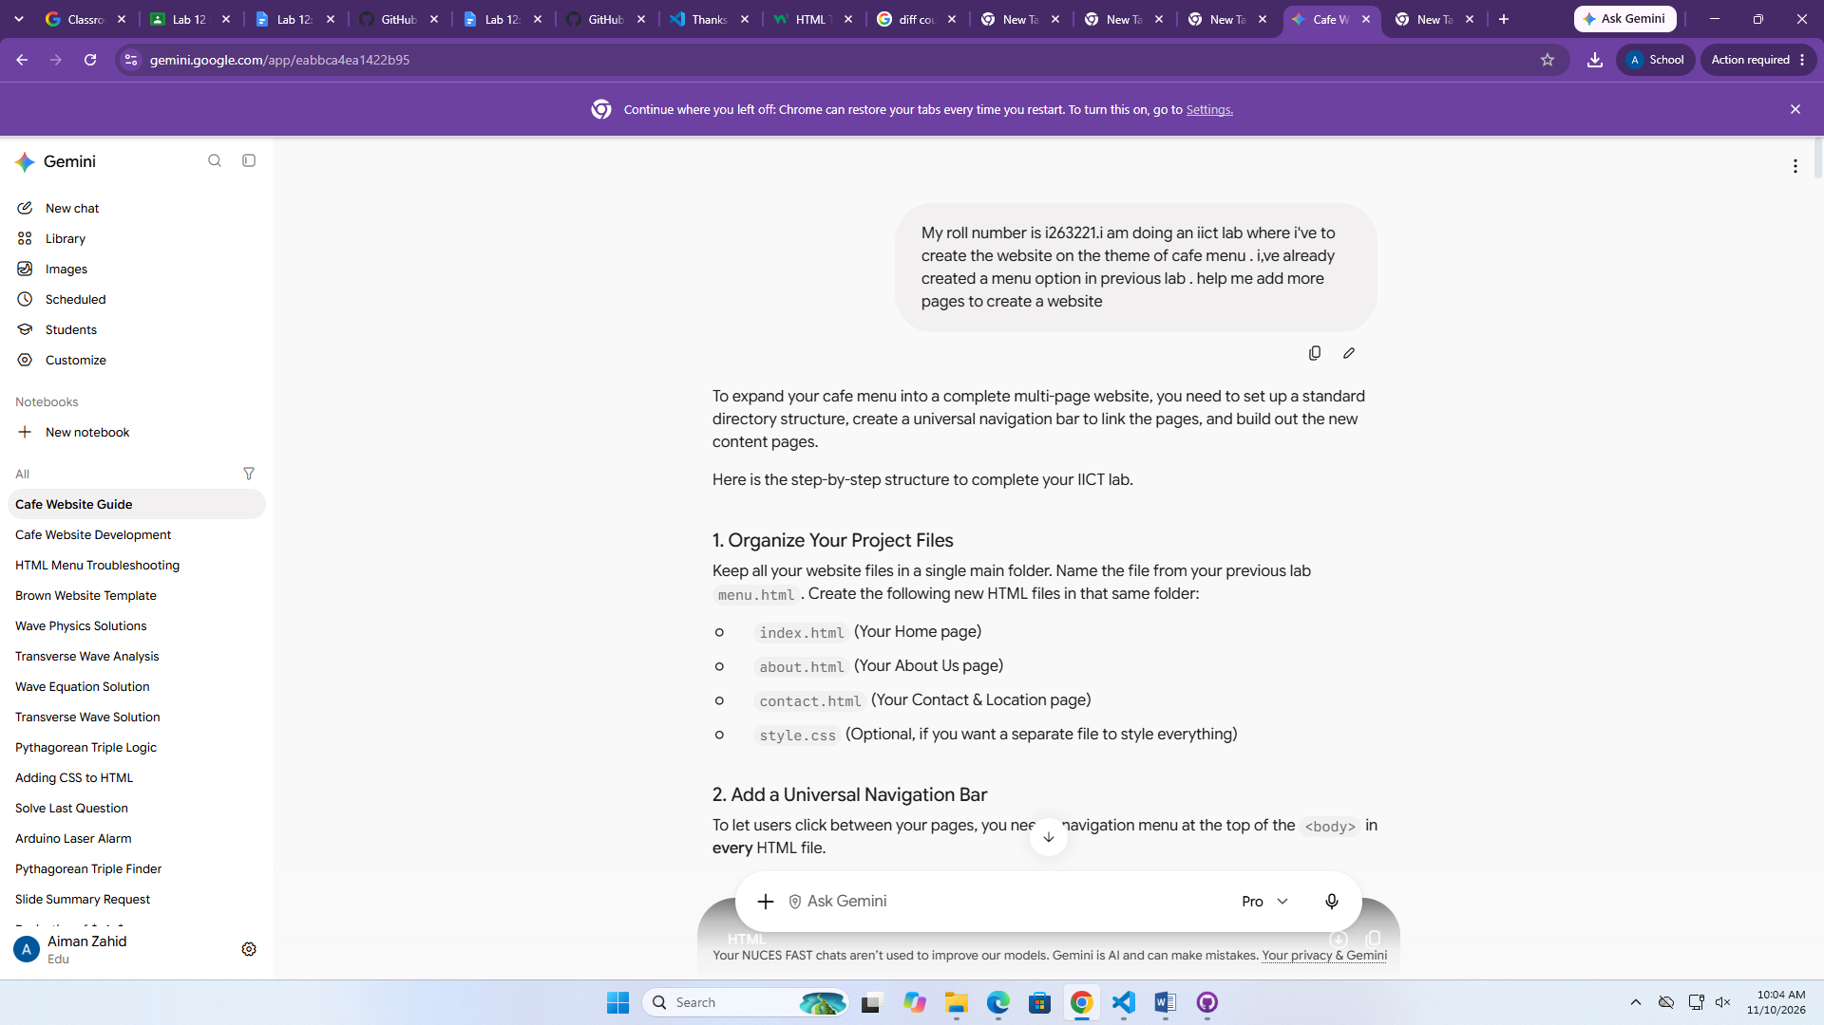
## Prompt 2: create website and add pages

Prompt: here are the html css and java files . i've created a web page using them . now i want to add a homepage , menu page ,total billing page and then a thankyou nd contact page . keep the theme as in the files given . also change the font for the home page and keep the name of restaurant

Result: AI created me the code of the website

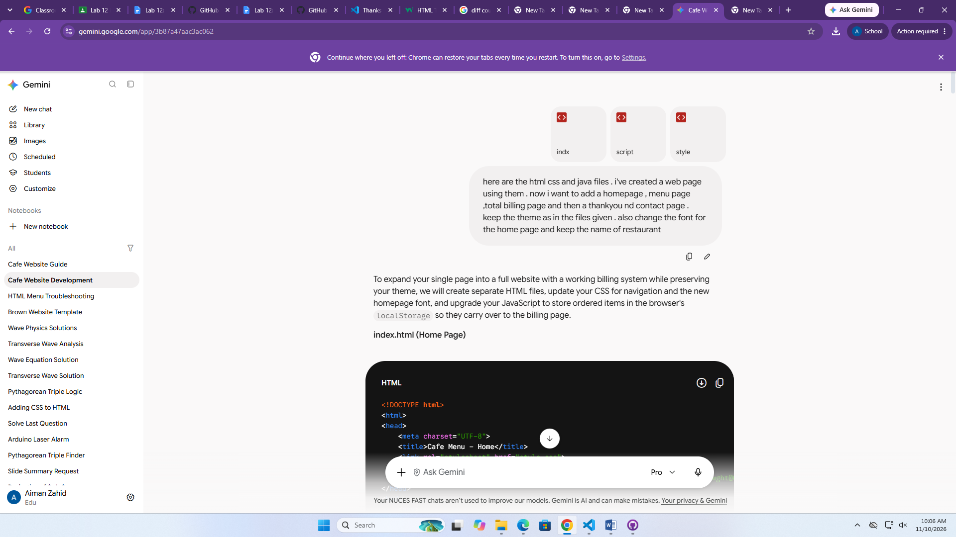

## Prompt 3: Add total bill

Prompt: in java script add the total billing calculation on the basis of users choice and display total bill as a proper receipt

Result: The code was perfect but there was not an option for total bill so I asked AI to add it .

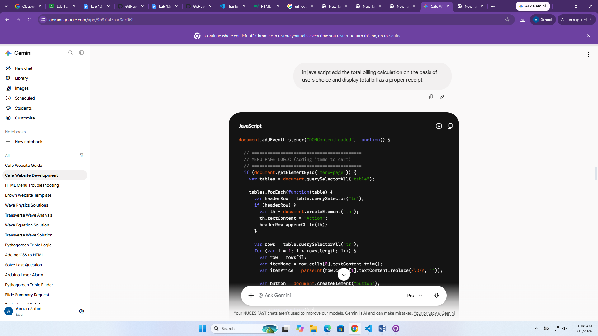

## Prompt 4: Open menu option

Prompt: create the site in such a manner that on menu page there should be an option/button of menu when user clicks it .

Result: AI added a button in homepage that leads to menu option.



