Vibe Coding Prompts Log & AI Documentation
Student Name: Huma Yaseen
Roll Number: 26i-3222
Section: BS SE A
Project: FoldiGo Shopping Bag Website (HTML/CSS/JS)
Prompt 1: Initial Prompt and Extra Page Ideas
Main Prompt: “Hi, I’m Huma Yaseen, roll number 26i-3222, a BS Software Engineering student in Section A. I’m building a simple website using only HTML, CSS and JavaScript. Here are my Lab 11 files [index.html and style.css]. My theme is FoldiGo (Foldable Keychain Shopping Bag), colours are Pink and Blanchedalmond, font style is oblique. Suggest 2-3 extra pages that suit this theme.”
What AI Gave Me: Gemini looked through my index.html and style.css files and suggested three page ideas that fit my FoldiGo shopping bag theme: a How It Works page, an About Us page focusing on plastic waste, and a Contact/Order page.
What I Fixed: I took the header navigation bar and footer code and added them to all the new pages so visitors can easily click around the website without getting stuck on one page.

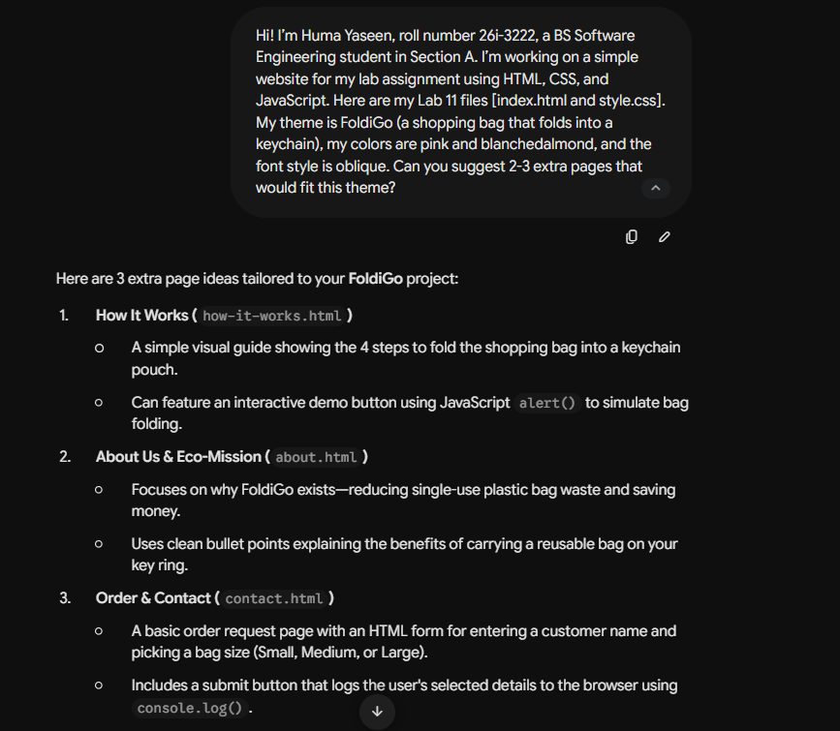

Prompt 2: Creating the How It Works Page
Main Prompt: “Create how-it-works.html using the same navbar, footer and style.css as index.html. Include step-by-step instructions on folding the bag into a keychain and an interactive button using alert().”
What AI Gave Me: It wrote the HTML for how-it-works.html with a 4-step list explaining how to fold the shopping bag into a keychain pouch, along with a demo button that pops up an alert.
What I Fixed: The original alert text was a bit plain, so I edited the JavaScript code to show a custom message: “Simulation: Bag Folded into Keychain Successfully!” when the button is clicked.
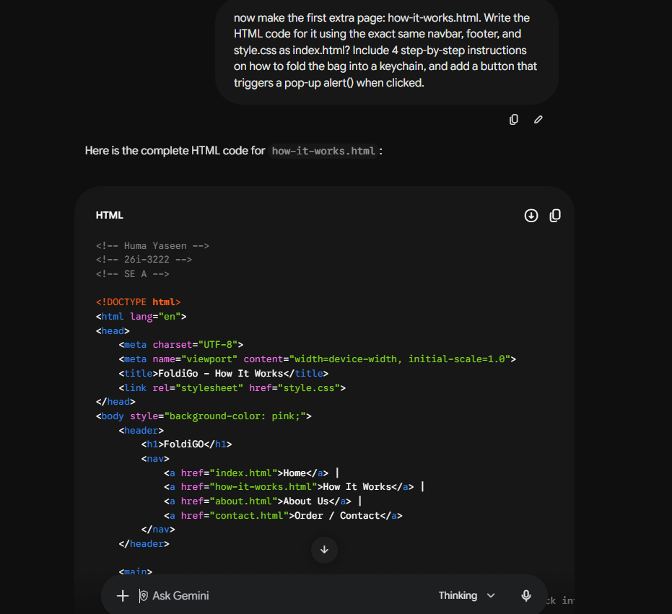

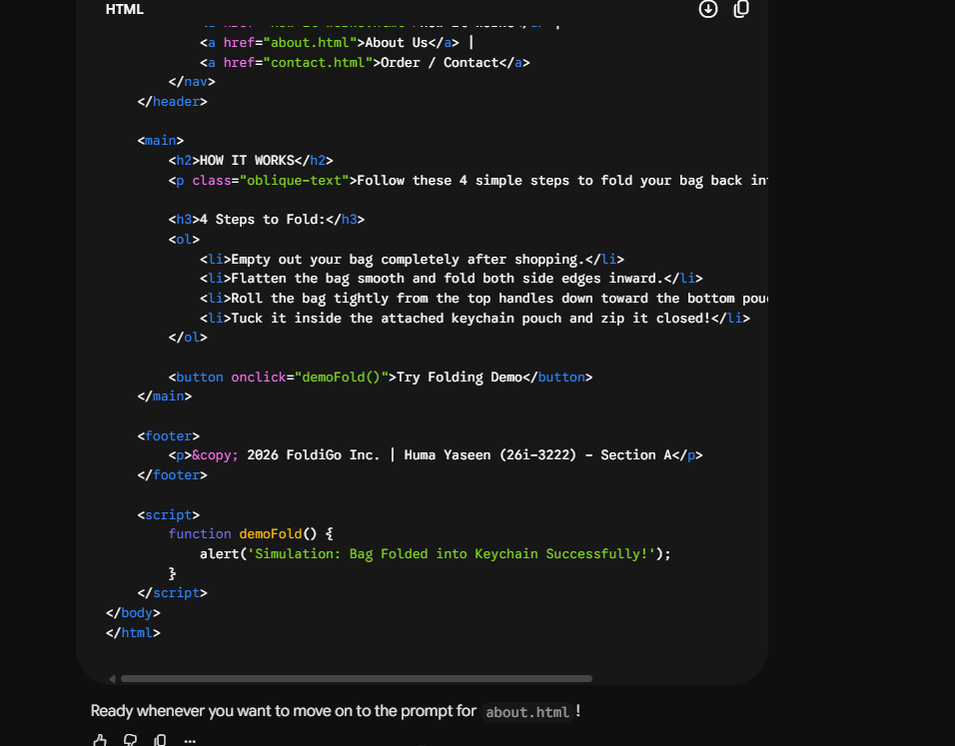

Prompt 3: Creating the About Us Page
Main Prompt: “Create about.html using the same navbar, footer and style.css as index.html. Focus on the eco-mission of reducing plastic bag waste.”
What AI Gave Me: It gave me the code for about.html with bullet points explaining the eco-mission behind FoldiGo and how using reusable bags helps reduce plastic waste.
What I Fixed: One of the navigation links had a typo in the file path which broke the page link, so I manually fixed the href link in VS Code.
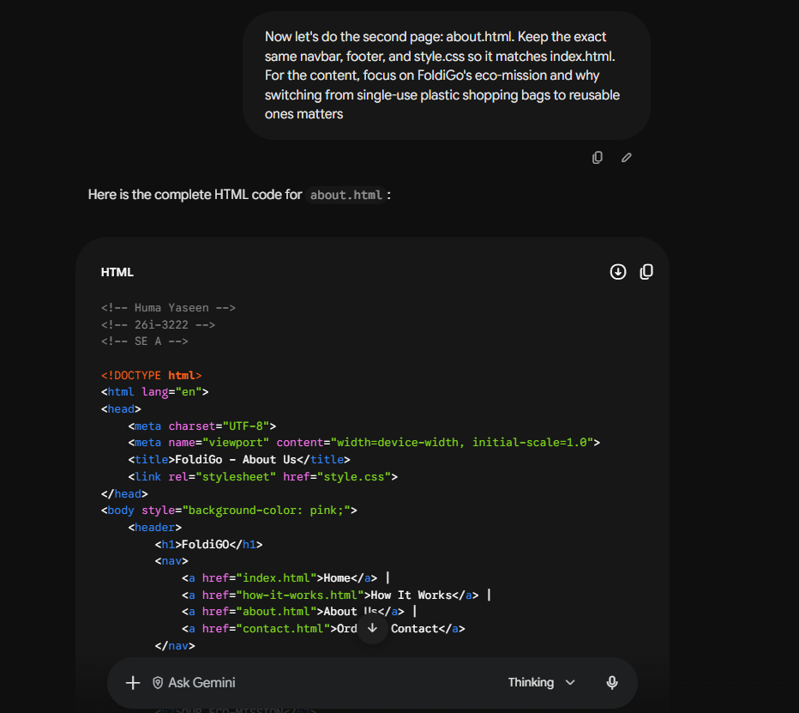
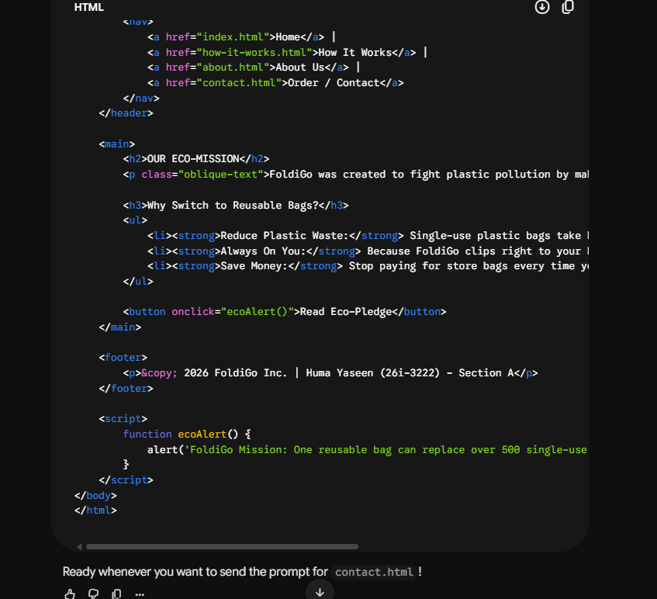

Prompt 4: Creating the Contact & Order Page
Main Prompt: “Create contact.html using the same navbar, footer and style.css as index.html. Include an order request form and a submit button with console.log().”
What AI Gave Me: It generated contact.html with a simple customer order form that includes a name text box and a dropdown menu to select bag sizes (Small, Medium, Large).
What I Fixed: I updated the JavaScript function attached to the form submit button so it outputs the customer's name and selected size directly into the browser console using console.log().
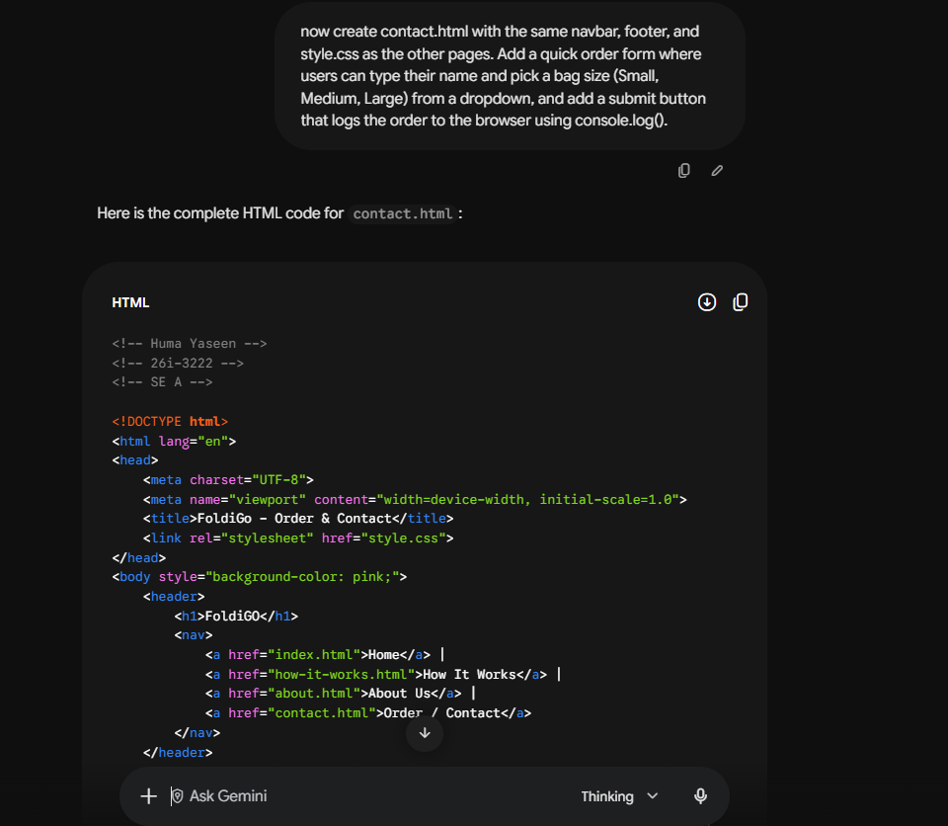
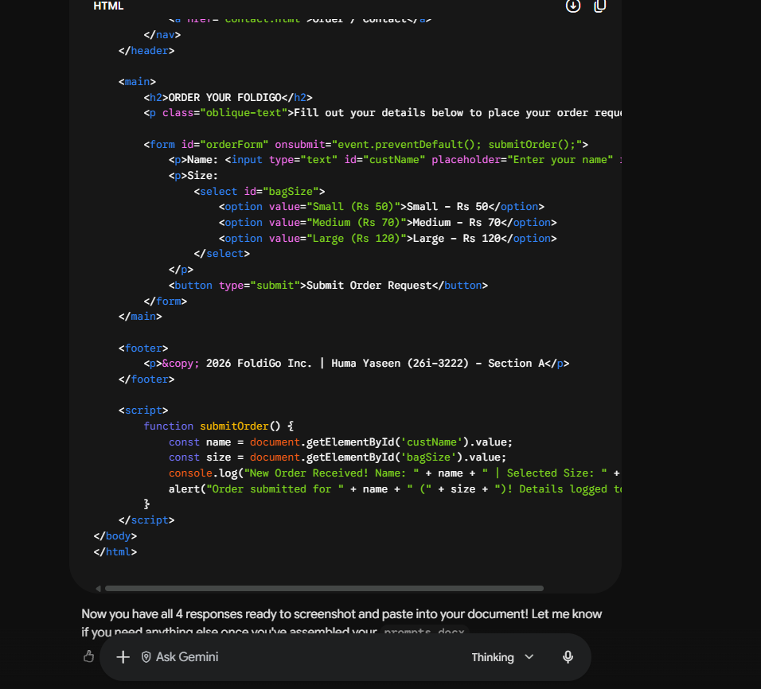

Summary of Git Workflow & Manual Edits
1. Feature Branching: I created a new branch called feature-contact using git checkout -b feature-contact to build the contact page. After committing the changes on that branch, I switched back to main and merged feature-contact into main.
2. Manual Code Edits: I opened VS Code directly and updated style.css on my own. I tweaked the button hover background color and added rounded corners with border-radius to make the buttons look better.
3. Commit Messages: I made sure to write clear and descriptive commit messages (such as “Add contact page with order form” and “Manual: update button hover style”) instead of generic messages like “update”.

