Prompts I gave to chatgpt to make changes:
Prompt 1 for the page 1
this is an html file i made for a website that basically gives a online kiosk type order menu for chaaye khaana in which there is an image used at first for the logo of the cafe and then in the home page 1 it says welcome to chaaye khaana and i want a theme of orange and white and i also this image center aligned. this will be the first page out of the 3 of my website


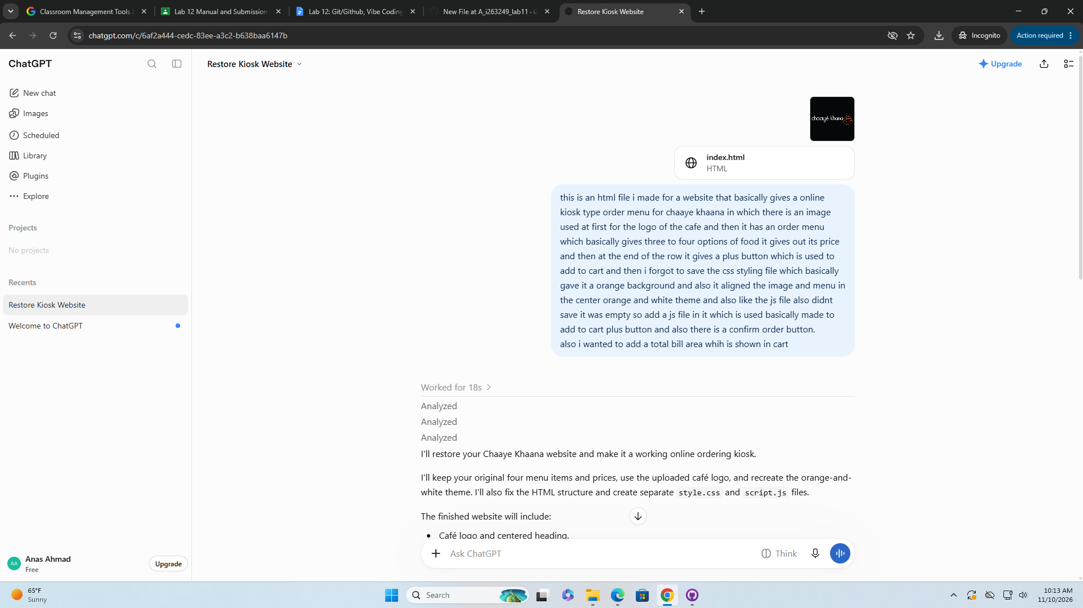
The page worked and it was static then I added an explore menu button which takes you to the 2nd page which is menu page.

Prompt 2:

make a new page 3 in which it says contact us for help type but make it the same theme give me another file for this with css html and js.

Result
I've created Page 3 – Contact Us for Help using the same orange-and-white Chaaye Khaana theme as your first two pages.
Page 3 created

What's included?
Matching design
Orange headings, white background, rounded sections and buttons.
Contact form
Name, email address and message fields.
JavaScript
Validates the form and displays a thank-you message.
Back to Menu
Button to return to page 2.

Prompt 3:

why whenenver i open a page it works but when i change the change it says file not found so change that file and merge all 3 pages file into 1.
Result:
Gpt gave a fully merged file which was overall connected with all three of the files.

