Zainab Abbasi
26i-3268
SE-A
Theme: PET-adoption website
Planned Pages: index.html, pets.html, contact.html

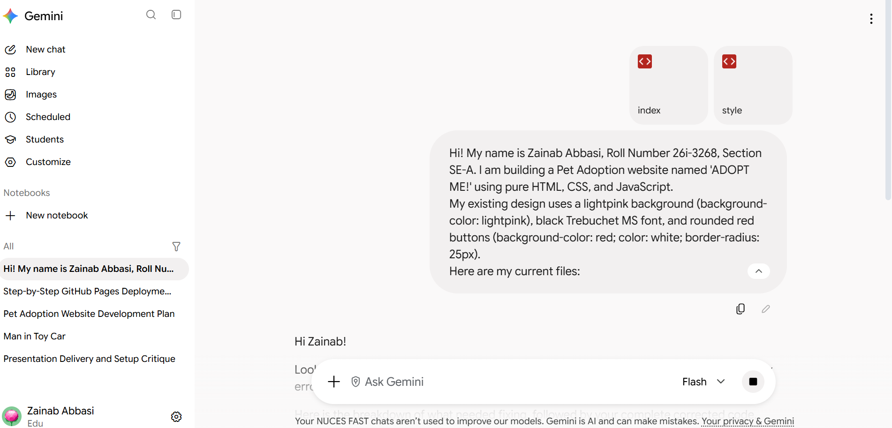

Prompt 1: Update my index.html file to add a top navigation bar (<nav>) below the <h1> title that links to three pages: Home (index.html), Our Pets (pets.html), and Contact Us (contact.html). Ensure the navbar uses the existing style.css styles so it matches the lightpink theme.

Result: The AI generated the navigation bar. The links worked, but I had to adjust the margin spacing in CSS to center it nicely.

Prompt 2: Create a new page called pets.html for my Pet Adoption site. Use the exact same <nav> header, background color (lightpink), fonts (Trebuchet MS), and footer as index.html. Show four pets with image placeholders, age, breed, and a red button that triggers alert('Thank you for inquiring about adopting!') when clicked.

Result: The page rendered correctly with all 4 pets. I updated the src paths in the <img> tags to point to my local /images/ folder.

Prompt 3: Create a contact.html page using the same header, navbar, and lightpink theme. Include a contact form with fields for Name, Email, Pet Name interested in, and a Message. Include a Submit button that triggers alert('Your adoption inquiry has been submitted!')

Result: Built on branch feature-contact. The form rendered properly, but the text fields were unstyled, so I asked the AI to add basic CSS for form inputs.

