Lab 12: Documenting Prompts.

Name: Ahmer Abdullah Roll NO: 26I-3289

PROMPT 2:

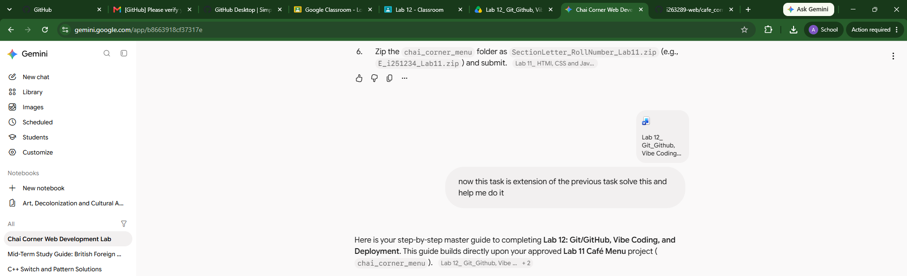

I gave Gemini this prompt just to get the understanding of all the steps to solve this. It gave me the steps to solve this.

