DSP Notch Filter

- A 2nd order notch-filter is designed in the z-domain. It has conjugate complex zeros on the unit circle – corresponding to frequency 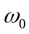 that should be suppressed. It also has poles at the same phase angle as the zeros and is marginal inside the unit circle. The zeros and poles can be represented as: zeros: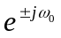; poles: 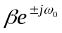.
  - Write a Matlab function notchdesign( ) to calculate the filter coefficients 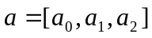 and 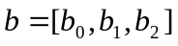. This function uses the normalized frequency and  as input parameters. The coefficients can be calculated by using either analytical methods or using the Matlab function poly( ).
  - Plot the frequency response (in dB) of a notch filter 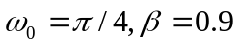 using function freqz( ). What will the frequency response change if is increased to 0.9999? Verify your guess using Matlab.
  - The music clip music_distorted.wav contains a single frequency jamming tone. Use Matlab to analyze the spectrum of the music clip and find the frequency of the jamming tone.
  - Design a notch filter in Matlab to suppress the jamming tone. Hear the result of the filtered signal, and only the noise should remain. (Using filter( ) to perform filtering operation.)
  - Repeat the above step by using 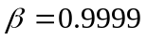. What are the difference between the output signal from the previous step? Why? Check the observed behavior by plotting the impulse response of the two notch filters. (Using impz( ) ).
  - Once the filter is verified in Matlab, implement it on the DSP board.

