**GUIDELINES**

**Development tools:**

1. Web-ide for Application creation and development

**How to Run?**

1. Import the Github2.zip file in web-ide
2. Run the application

**The GitHub application:**

**I** have used UI5 Master detail approach for this application

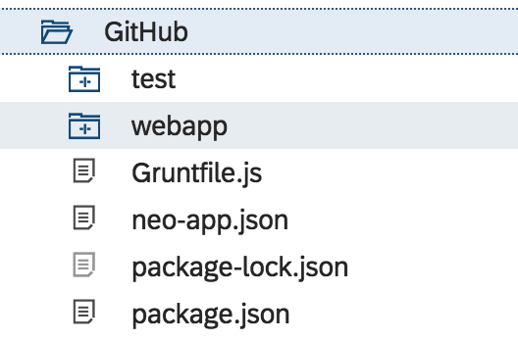

**We have a folder called test in my application where I have mentioned the unit test case which can be executed by running this file in unit test mode**

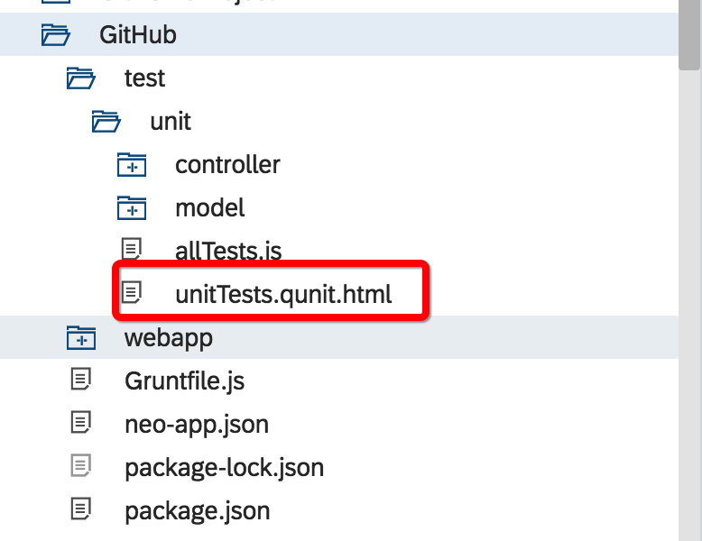

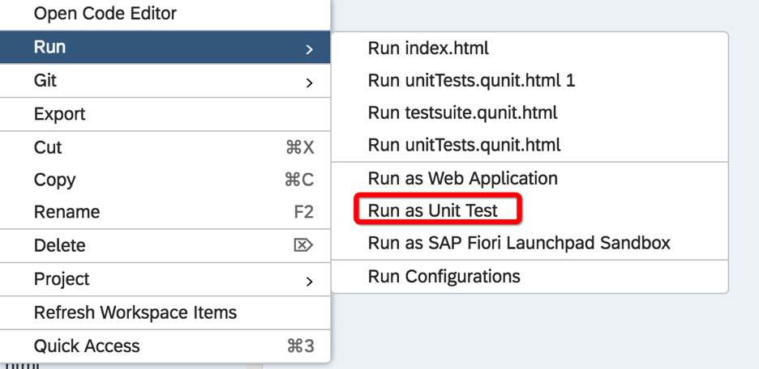

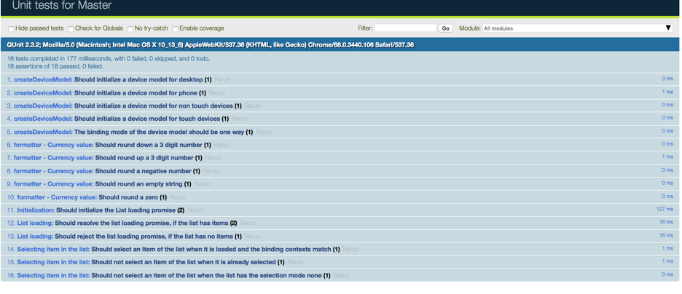

**When you execute the ui5 application this is the main master detail screen**

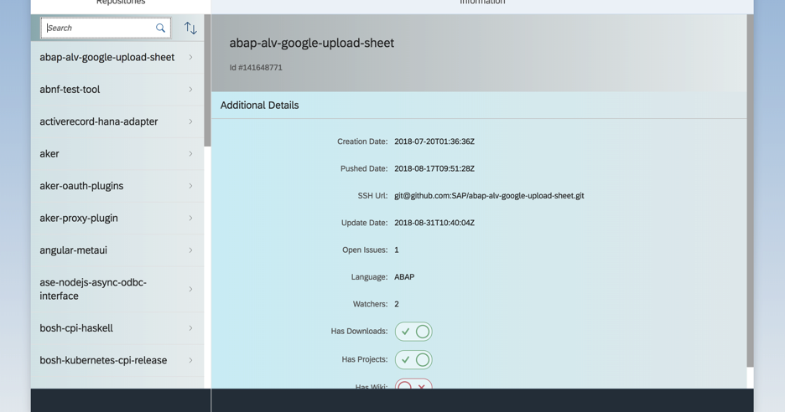

**The search criteria**

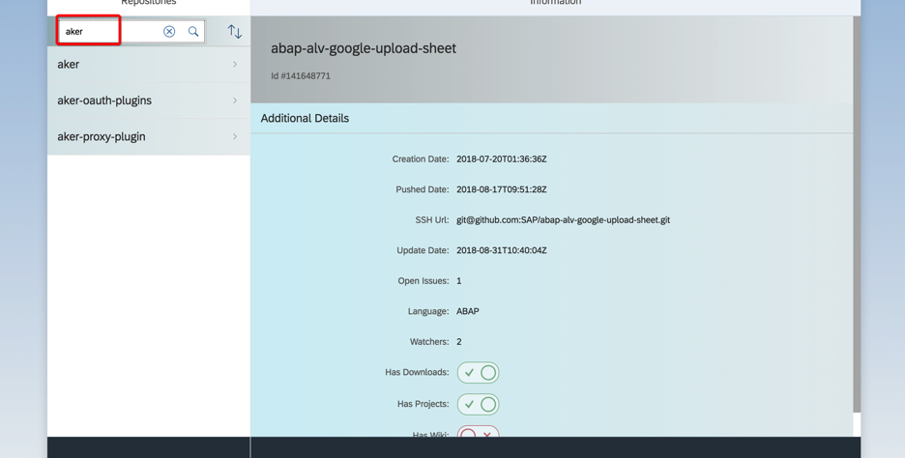

**The sorting button**

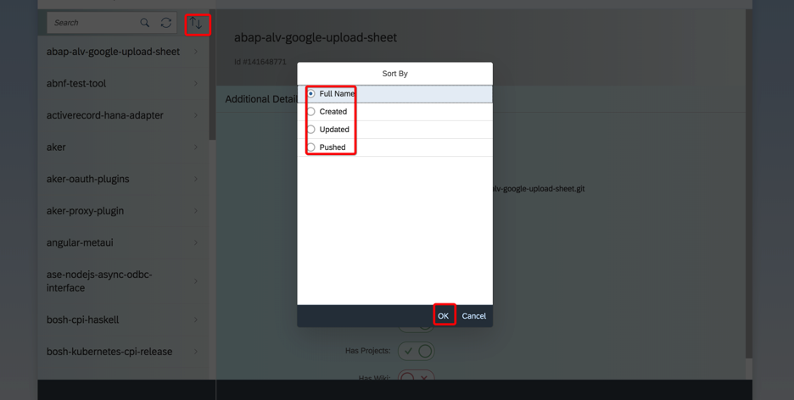

**Click on the items in the left list**

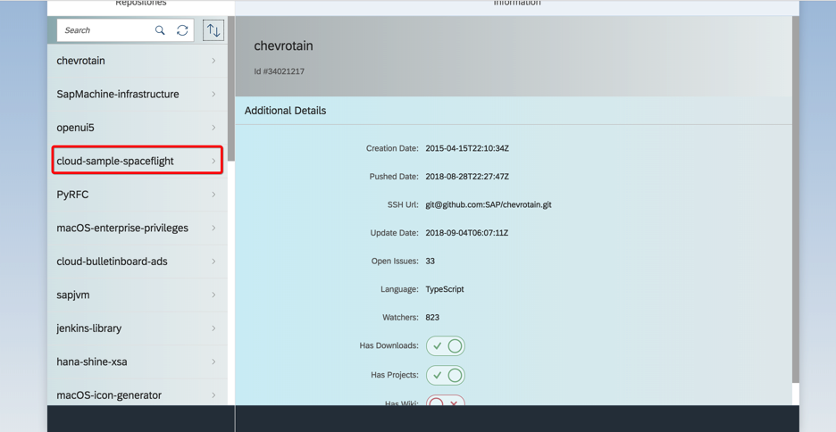

**The detail is loaded in right and the master list on the list navigates to the contributer details for that list item.**

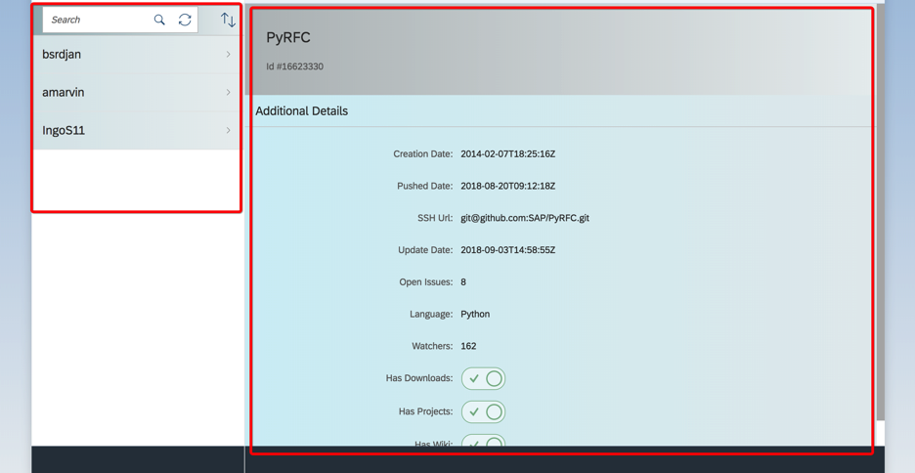

**Now click on the contributer list item**

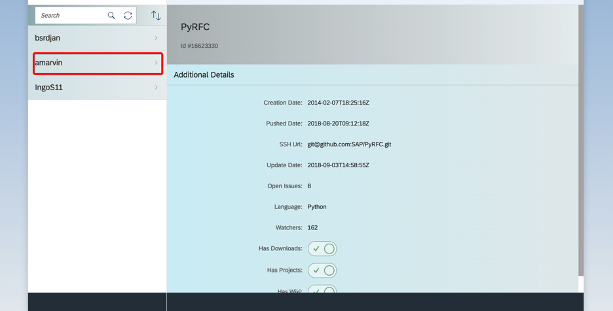

**You can see the details on the left.**

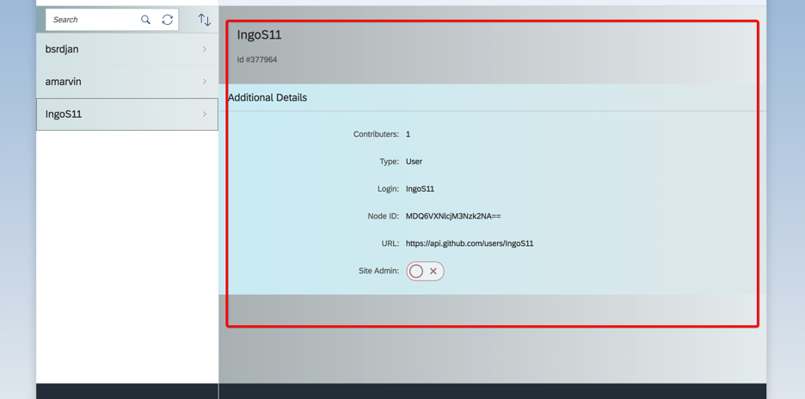

**Click on back button to go back to the main page.**

