IT8520 - Digital Transformation

Course Coordinator:

Section: 12

Group Members:

Salman Almomani 202301225
Abdulrahman Altairey 202304613
Abdulla Alfetaini 202203262
Abdulla Almutawa 202203316
Bader Aamer 202203053

Table of Contents
IT8520 - Digital Transformation 1
Table of Contents 2
Introduction 3
Lab Design and Network Topology: 4
Network Diagram: 5
Justification of Topology: 5
Roles of Virtual Machines: 6
Tools Used for Virtualization and Network Configuration: 6
Creating the Isolated Lab Environment and Assigning the IP’s to Each Server: 7
Network Traffic Generation: 18
Flow feature columns 34
Training ML Models & Evaluation: 35
Training ML Models and Evaluation Report 35
Dataset Loading and Initial Analysis 35
Feature Selection Strategy 36
Data Splitting 37
Data Preprocessing 37
Machine Learning Models Used 38
Model Training Process 40
Results Comparison 41
Accuracy Visualization 41
Result Interpretation 41
IDS: 42
AI-Based Countermeasures for Smart City Networks 57
Conclusion 58
Group Reflection & Peer Review Table 60

Introduction

With the quick development of smart city technologies, there is now a need for interconnection of systems, IoT devices, cloud services, and network communication. Though those tools increase the level of efficiency and automate numerous processes in different sectors, including transportation, healthcare, energy, and public safety, they bring a lot of cybersecurity challenges in terms of network intrusion, denial-of-service attacks, and other forms of network exploitation. As traditional ways of securing networks may not be enough to protect them from advanced and evolving threats, IDS should be implemented to detect any abnormal activity.

This project aims at creating an Intelligent Intrusion Detection System in a simulated environment of a smart city. First, a virtual lab was created with VirtualBox, and four virtual machines were configured to perform different functions, like being an attacker, monitoring system, target server, and normal client. Different types of traffic were simulated, including both normal activities and malicious attacks, like SYN Flood, UDP Flood, and HTTP Flood attacks. The traffic was captured, and its conversion to the structured data was performed.

In order to classify traffic as normal or malicious, several machine learning models were built, and their performance was estimated using the dataset.

Lab Design and Network Topology:

A custom dataset was created to train and evaluate the ML models for detecting threats in a segment of smart city network traffic. In order to achieve this goal, an isolated secure virtual lab environment has been designed and implemented to simulate the action using Oracle VM VirtualBox.
The virtual lab environment contains four virtual machines: normal client/user , a target server , an attacker machine , and a monitoring node. By implementing this topology, both of the normal and malicious traffic will be generated in a secure and controlled environment without impacting the physical network nor systems.
The four virtual machines are connected by a shared VirtualBox internal network called: IT8520_SmartCityLab.
This allows to separate the curated lab environment from the actual physical network and internet. This method ensures that the lab is secure and can be used to collect data and showcase how normal and attack traffic such as SYN Flood, UDP Flood, and HTTP Flood are carried out.
Once all the VMs are connected together through an internal network; a private IP subnet has been provided: 192.168.82.0/24.
The subnet has enough addresses to assign to all utilized virtual machines.

Network Diagram:
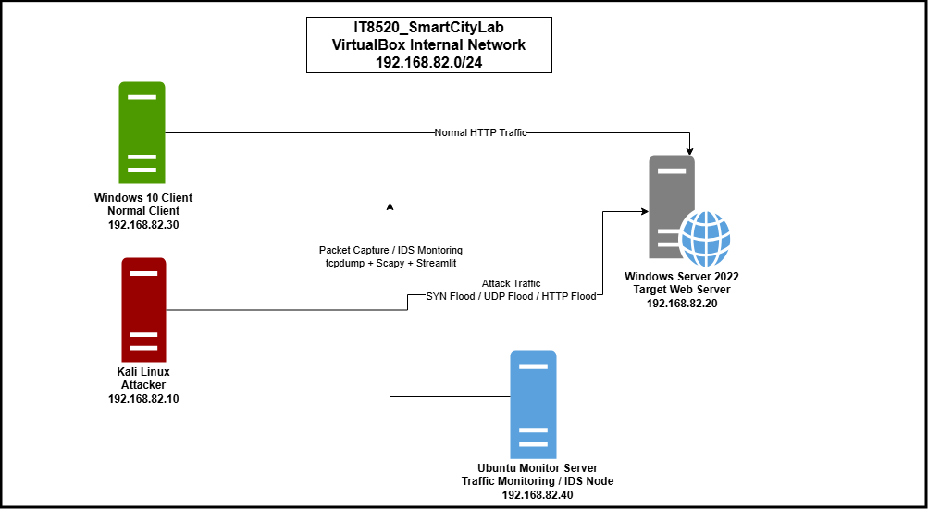
Figure 1: Network topology Diagram using the IT8520_SmartCityLab internal network and 192.168.82.0/24 subnet.

Justification of Topology:
The topology was designed with four virtual machines. Each machine had a clear, concise, and separated role. This segmentation helped in troubleshooting and making the process of generating the traffic easier and more organized.

IP Addressing Scheme:
The following table demonstrate the assignment of IP address pool for each server along with their role in the network:
Server | IP Address | Role
Kali Linux | 192.168.82.10 | Attacker
Windows Server 2022 | 192.168.82.20 | Target (Web Server)
Windows 10 Client | 192.168.82.30 | Normal client
Ubuntu Monitor Server | 192.168.82.40 | Traffic Capture/monitor

Due to the nature of the task the lab is isolated and only the virtual servers are required to communicate, the DNS and gateway are left empty.

Roles of Virtual Machines:
- Kali linux (Attacker):
Assumes the role of the attacker. It sends malicious attacks to the Windows Server 2022 (Target Server) including SYN Flood, UDP Flood, and HTTP Flood. Its role is crucial in the lab since it allows controlled and sophisticated traffic to be created and later utilized to generate the dataset for training and IDS testing.
It has been assigned the IP: 192.168.82.10

- Windows Server 2022 (Target Server):
Used as the target/victim machine. It is set to be as a web server (IIS). The server receives two kinds of traffic normal from the Windows Client and attack from Kali Linux.
It has been assigned the IP: 192.168.82.20

- Windows 10 Client (Normal Client):
It acts as the normal client machine. It produces normal traffic by sending HTTP requests to the web server (Windows Server 2022).
It has been assigned the IP: 192.168.82.30

- Ubuntu Monitoring Server (Monitoring Point):
Employed as the monitoring and traffic capturing node. It uses tcpdump to collect the network traffic and later to run the IDS application for testing. It is a critical part in the topology as it allows the capture of the packets that act as the raw data to be analyzed, converted into a dataset, and classified using the trained machine learning model.
It has been assigned the IP: 192.168.82.40

Tools Used for Virtualization and Network Configuration:
The project was developed using the following tools:

Tool | Purpose
Oracle VirtualBox | Import/add and runs all used virtual machines
VirtualBox Internal Network | Connects all virtual machines under an internal network and Isolates them from the external network
Windows Server 2022 | Hosts the IIS Web Server (target)
Windows 10 | Produces normal client traffic
Kali Linux | Generate attacks on the target server
Ubuntu server | Capture traffic (normal, attack) and run the IDS app
Ip command | Assigns IP address on Linux Machines (Ubuntu, Kali Linux)
Windows network settings | Assigns static IP address on Windows Machines (Windows 10, Windows Server 2022)
tcpdump | Command used to listen and capture traffic into PCAP files

Creating the Isolated Lab Environment and Assigning the IP’s to Each Server:

The four virtual machines have been imported\added in Oracle Virtualbox:
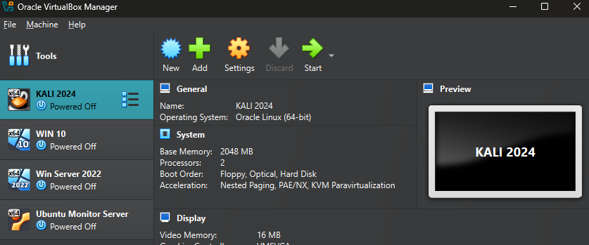
Figure 2: The Four Virtual Machines Added Successfully in Oracle VirtualBox

To establish the isolated network, each virtual machine was configured in Oracle VirtualBox as mentioned below:
All the virtual machines network name was set to: IT8520_SmartCityLab
This step guarantees all virtual machines are connected to the same isolated virtual network.
Oracle VirtualBox VM Setting Network Adapter Attached to: Internal Network

Following the configuration of the internal network, each machine was given a static IP address based on the IP addressing table. HTTP requests and ping were used to test the machines' connectivity and make sure the virtual lab was functioning properly.
The pictures below demonstrated the process of configuring network and ip assignment for each virtual server:

Kali Linux (Attack server):
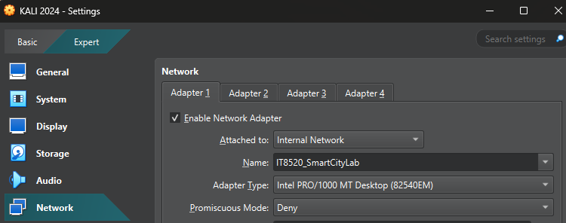
Figure 3: Kali Linux VM connected to IT8520_SmartCityLab the internal network
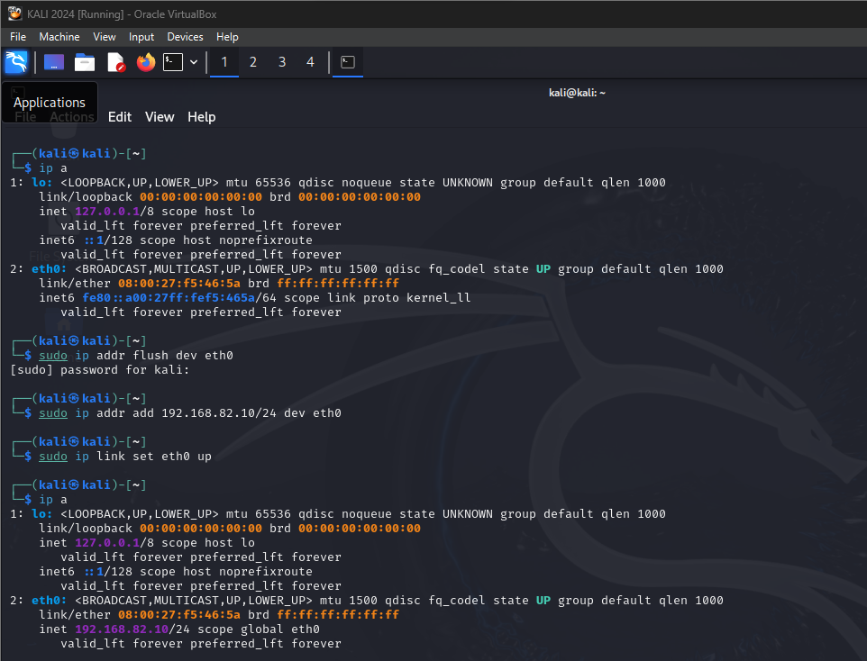
Figure 4: Set Kali Linux Ip address to 192.168.82.10
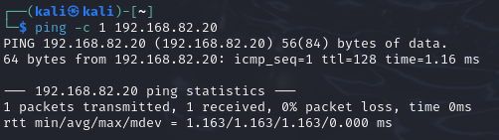
Figure 5: Kali Linux 192.168.82.10 can reach Windows Server 192.168.82.20

Windows Server 2022: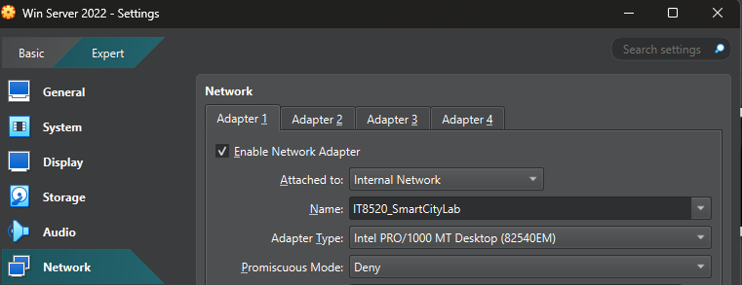
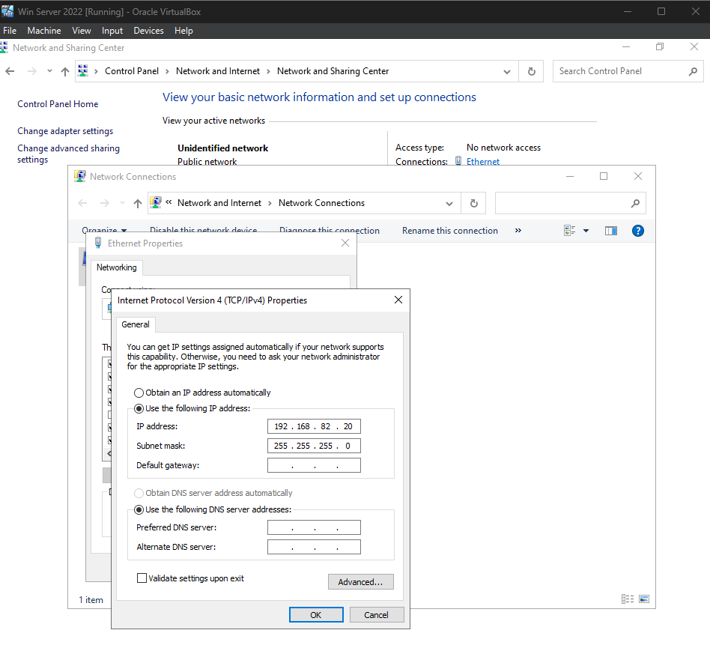
Figure 6: Windows Server 2022 VM connected to IT8520_SmartCityLab the internal network

Figure 7: Set Windows Server 2022 Ip address to 192.168.82.20
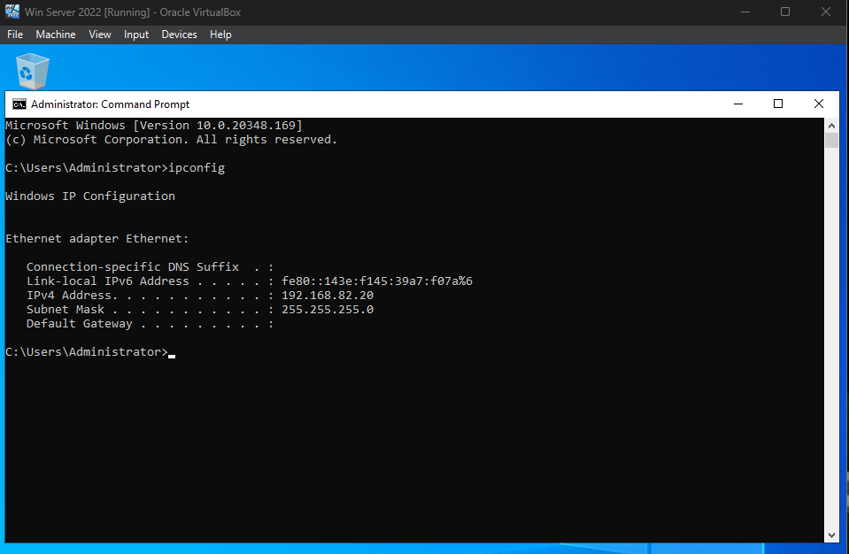
Figure 8: Verifying Windows Server 2022 static IP address using ipconfig

Windows Server 2022 is hosting IIS Web Server
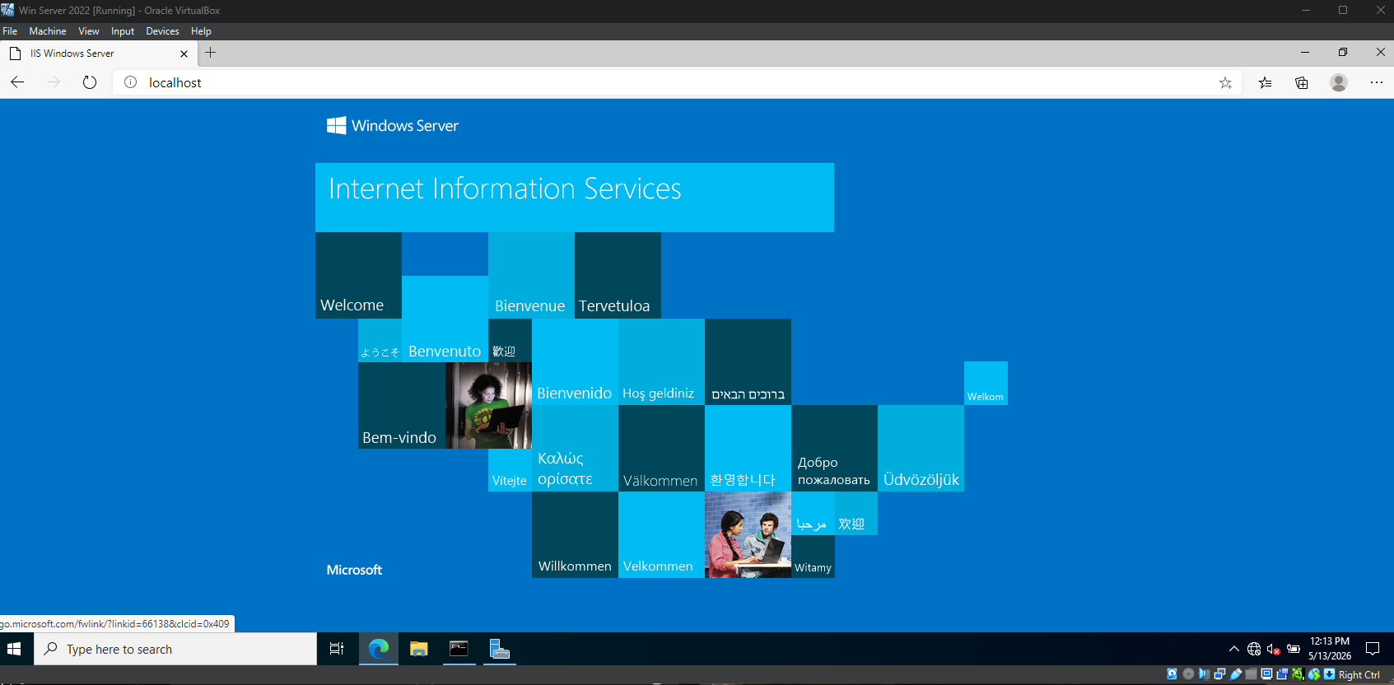
Figure 9: Windows Server 2022 successfully hosting the IIS web server

Windows 10 Client:
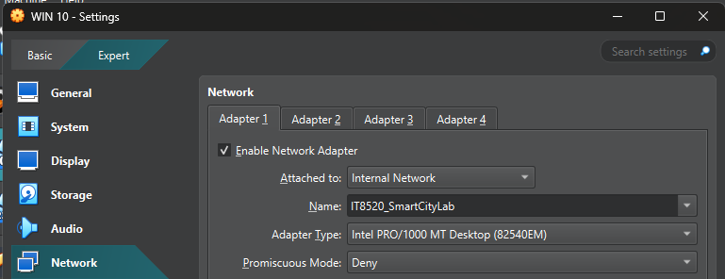
Figure 10: Windows 10 Client VM connected to IT8520_SmartCityLab the internal network
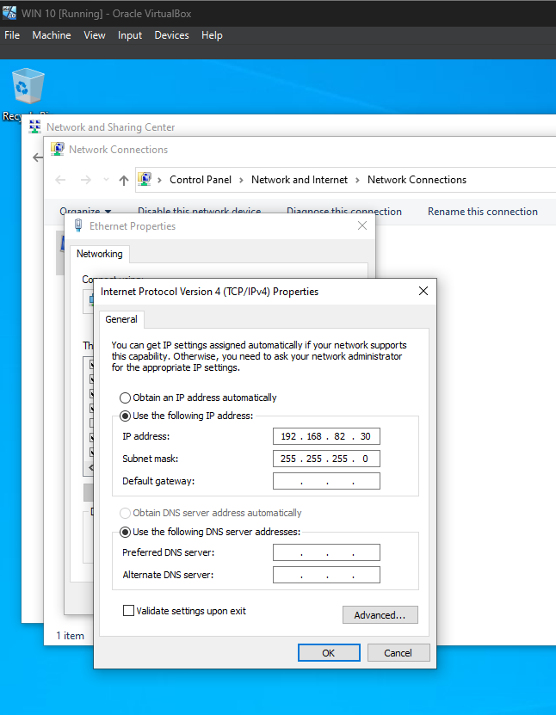

Figure 11: Set Windows 10 Client Ip address to 192.168.82.30

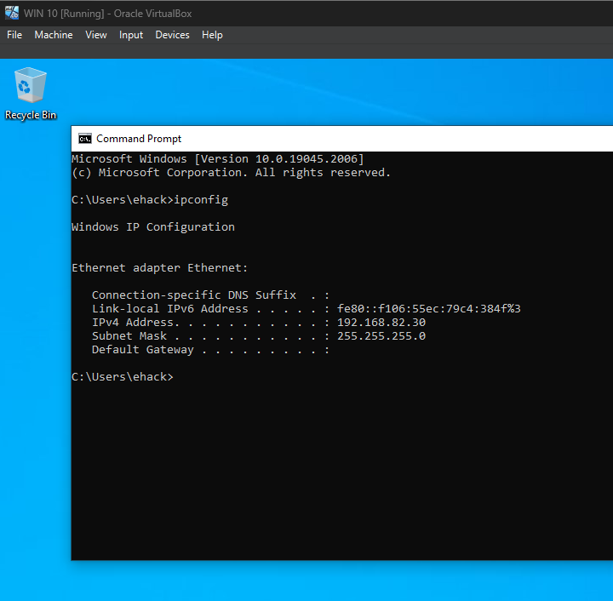

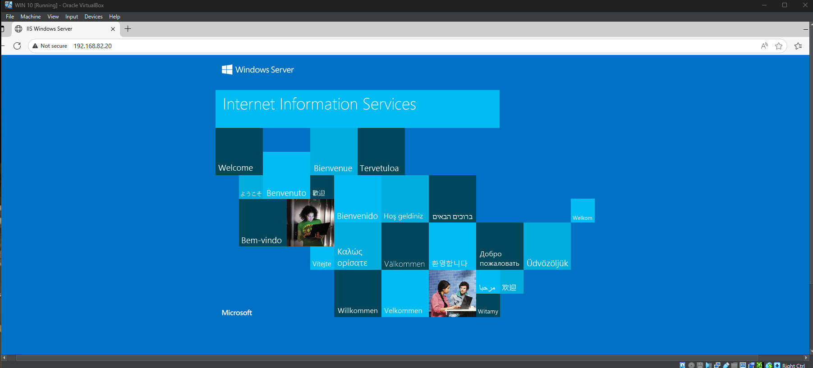
Figure 12: Verifying Windows 10 Client static IP address using ipconfig
Figure 13: Windows Client accessing Windows Server (IIS web server) at https://192.168.82.20 successfully

Ubuntu Monitoring Server:
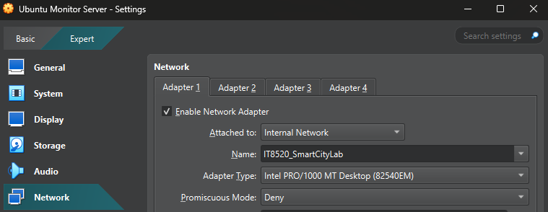
Figure 14: Ubuntu VM connected to IT8520_SmartCityLab the internal network

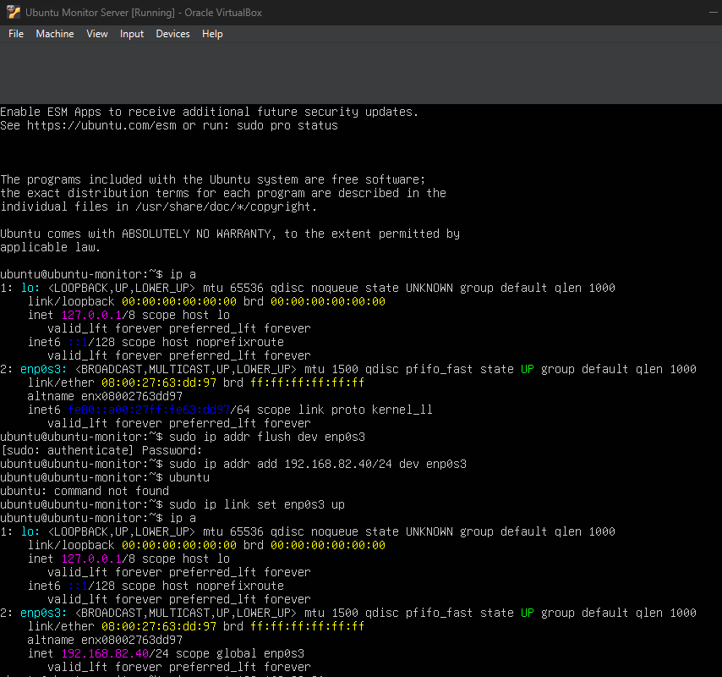
Figure 15: Set Ubuntu Server Ip address to 192.168.82.40
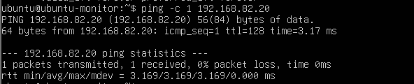
Figure 16: Ubuntu Server 192.168.82.40 can reach Windows Server 192.168.82.20

Network Traffic Generation:

Traffic generation is required to build the custom dataset used to train the machine learning models. The traffic is produced inside an isolated lab environment. It uses all virtual machines mentioned above in the report. The output of this step is to generate 100,000 packet records. A decision was made to divide the packets equally between the two types: normal and attack.
The CSV file contains around 1000 rows of engineered samples for the Moodle assignment, whereas the PCAP file includes raw samples. The experimental data contains around 100,000 packet samples in total.

The following table below shows how the packets are divided:
Traffic Type | Number of packets
Normal Traffic | 50,000
SYN Flood attack | 17,000
UDP Flood attack | 17,000
HTTP Flood attack | 16,000
Total | 100,000

Traffic capture using Ubuntu:
All the traffic is collected and captured using tcpdump on the ubuntu server, as the ubuntu server is used as the monitoring mode in the suggested topology mentioned above.
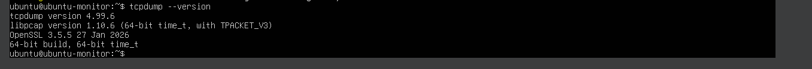
Figure 17: tcpdump version check on Ubuntu Server

Normal Traffic Generation:
The following servers are running to generate normal traffic:
1- Windows 10 Client (normal client)
2- Windows Server 2022 (IIIS Web Server - target)
3- Ubuntu Monitoring Server (capture packets)
The network interface used to capture traffic enp0s3 which is connected to the ip 192.168.82.40

The code that is used to run the tcpdump command:
Sudo tcpdump -i enp0s3 -c 500 -w normal_traffic_gen.pcap host 192.168.82.30 and host 192.168.82.20 and tcp port 80
Basically this line of code calls tcpdump to capture the network packets from the isolated lab interface (-i enp0s3) and stops when file has 500 packets -c 500 and then store the data in a PCAP file called -w normal_traffic_gen.pcap and only collect the traffic between the windows client server and target server 192.168.82.30 and host 192.168.82.20
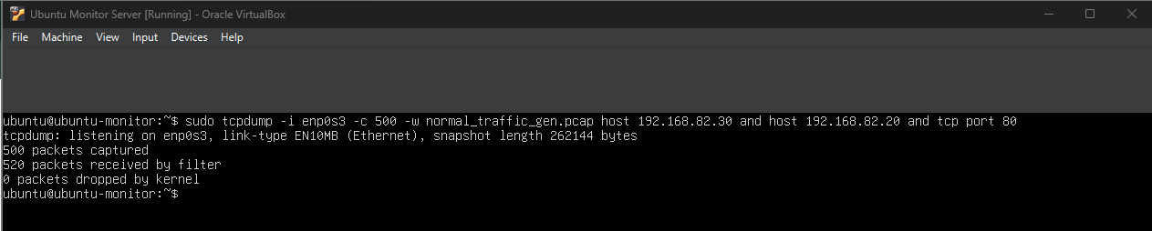
Figure 18: tcpdump command used to capture between 192.168.82.30 and host 192.168.82.20 into a pcap

This method ensures that the data that has been captured is concise and clean to train the model as accurately as possible.

For the actual normal traffic, it will be generated from a Windows 10 client sent to the Windows Server 2022 (Target server). Since the target server is a web server then it will be hosted in port 80.

The command below is executed in the CMD on the windows 10 client to simulate normal traffic by automating the process of accessing the web page 500 times through a curl loop:

For /L %i in (1,1,500) do curl -s -o NUL http://192.168.82.20/

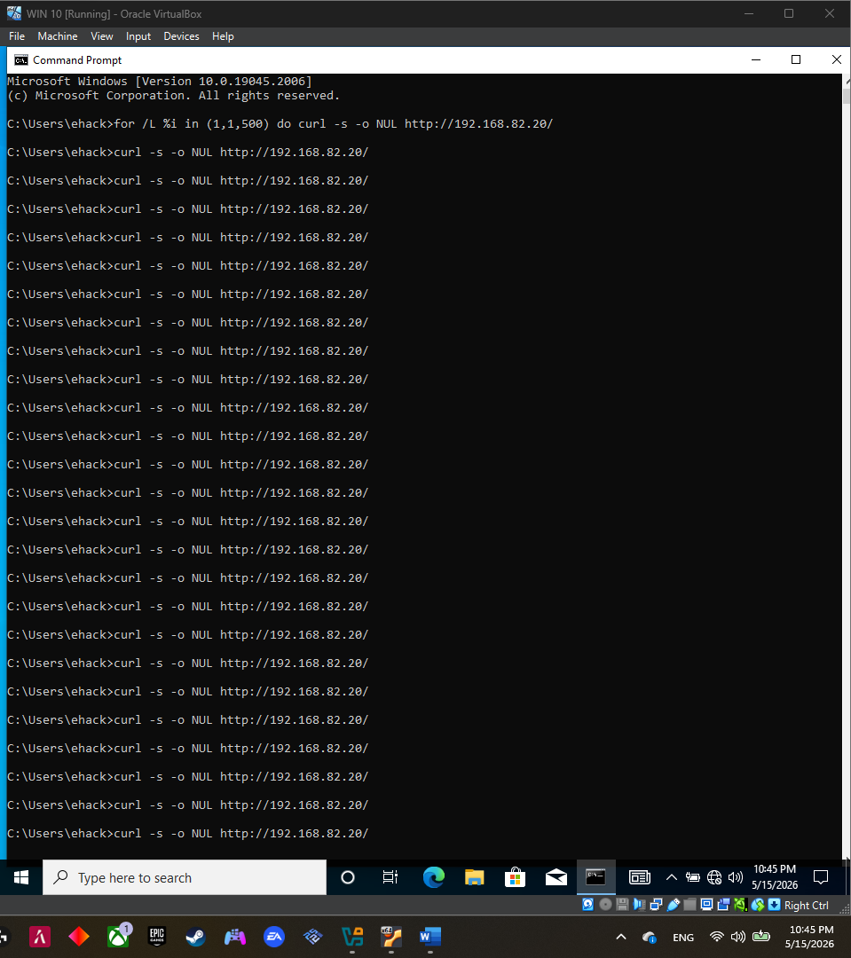
Figure 19: Automated HTTP traffic generation using a curl loop in Windows CMD

Malicious Traffic Generation:
The below servers are running to generate attack traffic:
1- Kali Linux (attacker)
2- Windows Server 2022 (IIIS Web Server - target)
3- Ubuntu Monitoring Server (capture packets)
The network interface used to capture traffic enp0s3 which is connected to the ip 192.168.82.40
Three different attack types are used to conduct malicious attacks, this will provide more diversity in the dataset. And thus, widen the detection rate of the ML models.
1. SYN Flood (170 packet):
The code below is used to conduct the SYN Flood attack:
sudo hping3 -I eth0 -S -c 170 -p 80 192.168.82.20
Hping3 is the tool to generate packets and uses the interface -I eth0 that is connected to the isolated network. -S sends TCP SYN packets and specify the number of the sent packet in this case its 170 -c 170 and it targets port -p 80 and ip 192.168.82.20 (Attacking the web server)
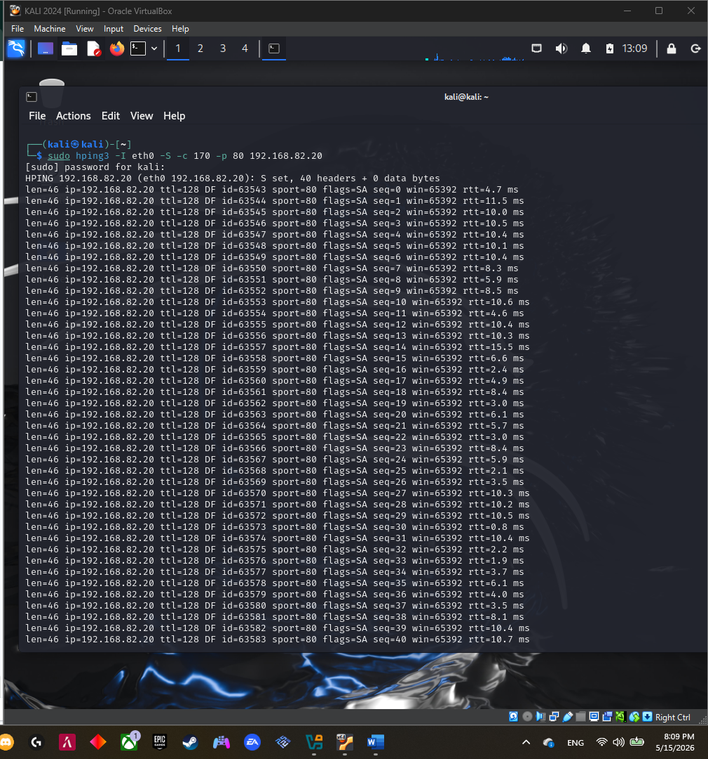
Figure 20: SYN Flood attack on Window Server 2022 at 192.168.82.20

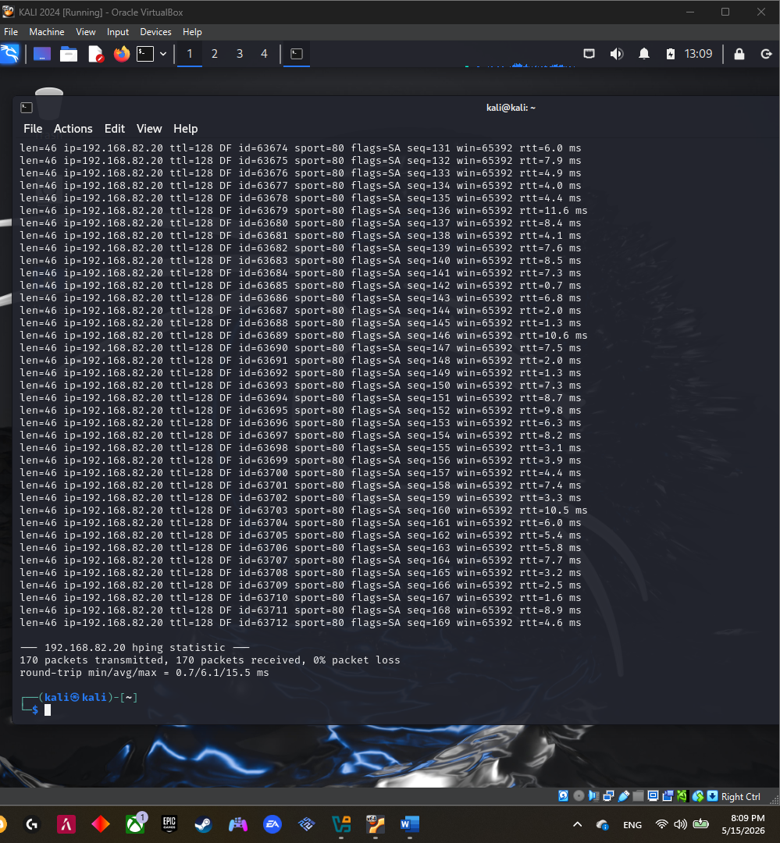
Figure 21: SYN Flood Successfully attacked Window Server 2022 at 192.168.82.20

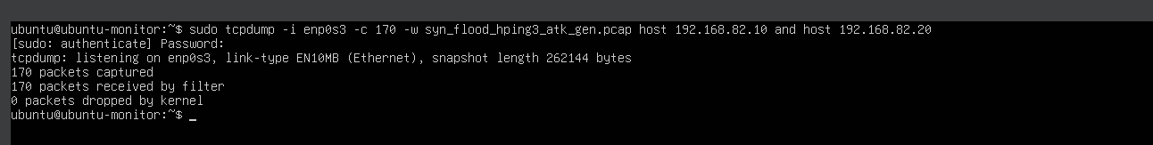
Figure 21: Tcpdump command to capture the SYN Flood packets and store it in a syn_flood_hping3_atk_gen.pcap

2.UDP Flood(170 packet):
The code below is used to conduct the UDP Flood attack:
sudo nping --udp -c 170 --rate 50 --dest-port 80 192.168.82.20
nping is the tool to generate packets.--udp sends UDP packets and specify the number of the sent packet in this case its 170 -c 170 a and the rate of packet sent per second which is 50 --rate 50 with it targets port --dest-port 80 and ip 192.168.82.20 (Attacking the web server)
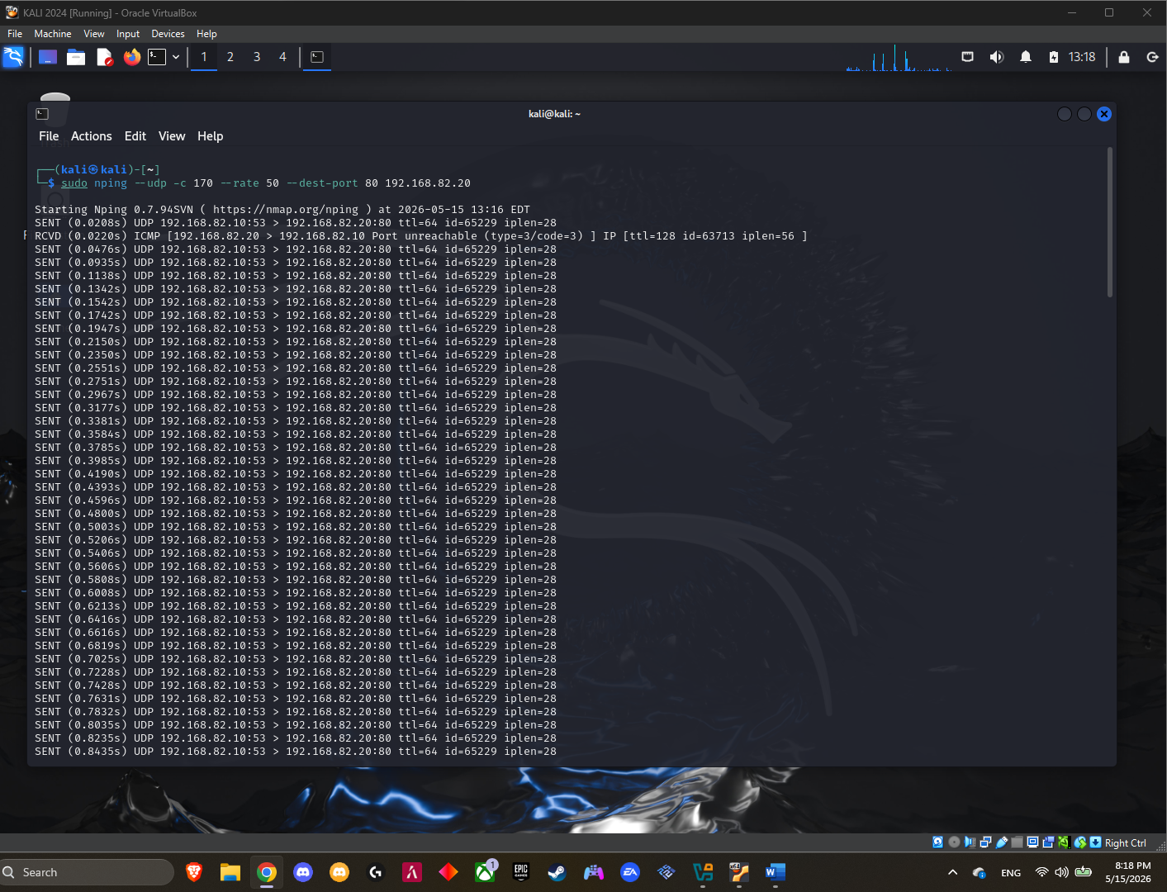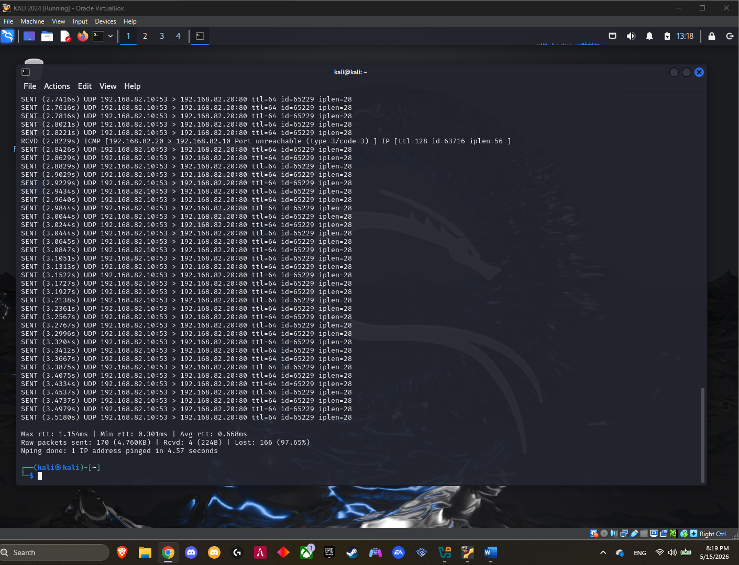
Figure 22: UDP Flood attack on Window Server 2022 at 192.168.82.20

Figure 23: UDP Flood Successfully attacked Window Server 2022 at 192.168.82.20

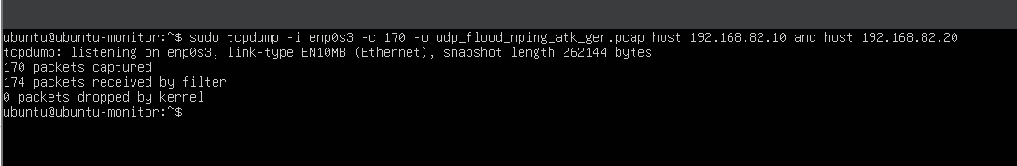
HTTP Flood (using curl):
Figure 24: Tcpdump command to capture the UDP Flood packets and store it in a udp_flood_nping_atk_gen.pcap

Attack used to replicate an application-layer HTTP Flood, by sending a large number of get requests to the server.
The code below is used to conduct the HTTP Flood attack:
for i in {1..500}; do curl -s -o /dev/null http://192.168.82.20/; done

Curl loop is used to send 500 HTTP GET request for i in {1..500}; do curl, in silent mode -s and let go of the output -o /dev/null and send the get request to Windows server 2022 (web server) http://192.168.82.20/;

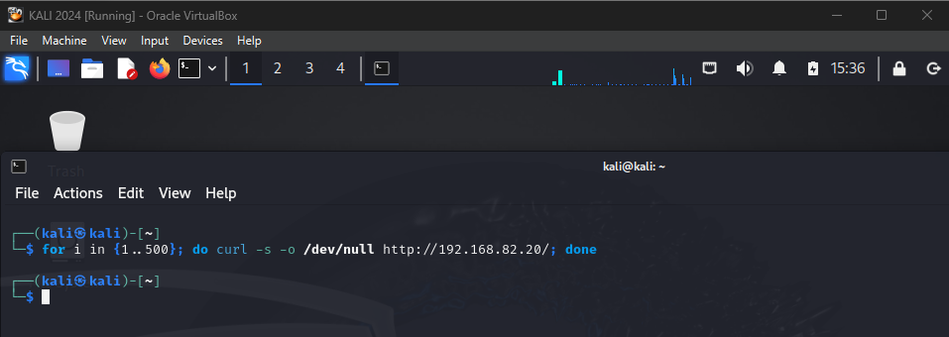
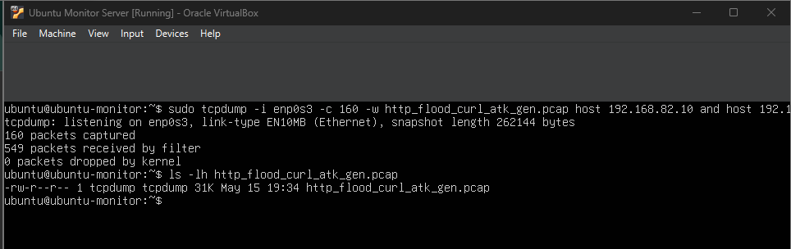
Figure 25: HTTP Flood attack on Window Server 2022 at 192.168.82.20

Figure 26: Tcpdump command to capture the HTTP Flood packets and store it in a http_flood_curl_atk_gen.pcap

Now all the PCAP files for the normal and attack traffic are generated in Ubuntu server and are ready to be viewed:
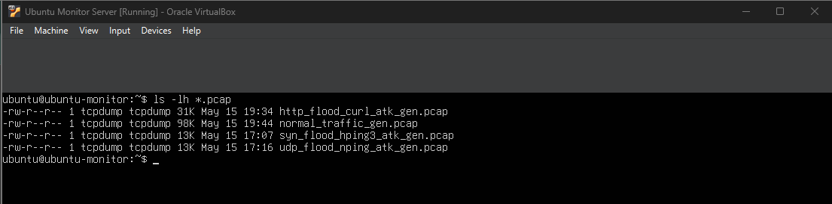
Figure 27: List of All PCAP files in Ubuntu Server (1000 packets)

The ML model requires a large dataset to attain a better prediction rate and accuracy. Thus, the entire process explained earlier was repeated, but instead of generating 1000, 100K packets were produced. The packets were divided equally between normal and attack traffic.
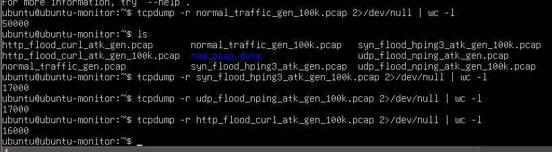
Figure 27: List of All PCAP files in Ubuntu Server (100,000 packets)

Feature Selection and Engineering
Data Preparation:
The raw PCAP files cannot be used for building machine learning algorithms. Hence, the collected PCAP files were converted to structured data through Python, Scapy, and pandas in Google Colab.

Using Scapy, we were able to capture packets from the PCAP files and extract relevant features at both packet level and flow level. The pandas library was used to format the extracted features in a tabular form and output the final dataset as a CSV file.
The resulting cleaned data was stored in the file name:
smartcity_clean_dataset_100k.csv
The cleaned dataset had the following dimensions:
100,000 rows
26 columns
These 26 columns were employed to represent packet information, flow behavior, traffic quantity, TCP flags, and labels. Having such a number of columns is justified for the IDS dataset due to multiple feature requirements for accurate representation of network traffic.

Selected Features
The dataset included both basic packet features and flow-based features.

Feature | Meaning | Why It Is Useful
timestamp | Time when the packet was captured | Helps analyze packet timing
datetime | Human-readable timestamp | Makes manual review easier
src_ip | Source IP address | Shows the sender machine
dst_ip | Destination IP address | Shows the receiving machine
src_port | Source port | Identifies the sender-side port
dst_port | Destination port | Shows the targeted service
protocol | TCP, UDP, ARP, or OTHER | Helps separate traffic types
packet_length | Total packet size | Helps detect repeated or abnormal packet sizes
payload_size | Actual data size inside the packet | Helps distinguish data packets from control packets
tcp_flags | TCP control flags | Important for detecting SYN Flood behavior
is_http | Identifies HTTP traffic on port 80 | Helps detect web-based traffic patterns

Basic Packet FeaturesFlow-Based Features
Feature | Meaning | Why It Is Useful
flow_packet_count | Number of packets in the same flow | Flood attacks usually generate many packets
flow_total_bytes | Total bytes in the flow | Shows traffic volume
flow_duration | Duration of the flow | Helps compare normal sessions with attack bursts
flow_avg_packet_size | Average packet size in the flow | Helps identify repeated packet patterns
flow_min_packet_size | Smallest packet size in the flow | Shows packet size range
flow_max_packet_size | Largest packet size in the flow | Shows packet size range
flow_packet_rate | Packets per second | Important for flood attack detection
flow_byte_rate | Bytes per second | Shows high-volume traffic behavior
flow_syn_count | Number of SYN packets | Important for SYN Flood detection
flow_ack_count | Number of ACK packets | Helps identify normal TCP communication
flow_rst_count | Number of reset packets | Can indicate failed or abnormal connections
flow_fin_count | Number of finish packets | Shows normal TCP connection closing
flow_udp_count | Number of UDP packets | Important for UDP Flood detection
flow_http_count | Number of HTTP packets | Important for HTTP Flood detection

Feature Selection Justification
The selected features were chosen because they describe important characteristics of network traffic behavior.
Packet-level features such as src_port, dst_port, protocol, packet_length, and payload_size provide basic information about each packet. These features are useful because normal and attack traffic often have different packet structures. For example, UDP Flood traffic uses UDP packets, while SYN Flood traffic uses TCP SYN packets.
TCP flag features were selected because TCP-based attacks can be identified through abnormal flag patterns. A SYN Flood attack sends many SYN packets without completing the normal TCP handshake. Therefore, flow_syn_count, flow_ack_count, flow_rst_count, and flow_fin_count help distinguish normal TCP sessions from suspicious traffic.
Flow-based features such as flow_packet_count, flow_total_bytes, flow_duration, flow_packet_rate, and flow_byte_rate were selected because flood attacks usually produce many packets in a short time. High packet rate and byte rate values can indicate abnormal traffic volume.
HTTP-related features were included because the target server was an IIS web server running on port 80. The is_http and flow_http_count features help identify web traffic and are useful for detecting HTTP Flood behavior.

Data Labeling Process
The labeling process was based on the source PCAP file. Since each PCAP file contained one known type of traffic, the labels were assigned during the feature extraction stage.
Two label columns were used:
label
attack_type
The label column was used for binary classification:
normal
attack
The attack_type column stored the detailed traffic category:
normal
syn_flood
udp_flood
http_flood
The labeling process was:
Source PCAP File | label | attack_type
normal_traffic_large.pcap | normal | normal
syn_flood_large.pcap | attack | syn_flood
udp_flood_large.pcap | attack | udp_flood
http_flood_large.pcap | attack | http_flood
Using this method of labeling enabled the models to concentrate on the primary objective of the IDS that entails identifying whether the traffic is benign or malicious. The attack_type variable remained for analytical purposes and to document the category of the attacks.

Final Dataset Summary
The final dataset contained 100,000 packet records.
Category | Count
Normal | 50,000
Attack | 50,000
Total | 100,000
The detailed traffic distribution was:
Traffic Type | Count
Normal | 50,000
SYN Flood | 17,000
UDP Flood | 17,000
HTTP Flood | 16,000
Total | 100,000
This final CSV dataset was then used for machine learning model training and evaluation.
Training ML Models & Evaluation:

Training ML Models and Evaluation Report

Overview
This section focuses on training and evaluating supervised machine learning models to classify smart city network traffic as either normal or attack traffic. The models were trained using the cleaned dataset generated from the captured PCAP files in the virtual lab environment. The purpose of this phase is to determine which machine learning algorithm provides the most accurate and reliable intrusion detection performance while avoiding overfitting and unrealistic prediction results.
The dataset contains approximately 100,000 network traffic records collected from both legitimate communication and simulated cyberattacks, including SYN Flood, UDP Flood, and HTTP Flood attacks. Each traffic record was labeled either as normal or attack, which became the target variable used during supervised learning.

Dataset Loading and Initial Analysis
The cleaned dataset was imported using the Python Pandas library. Before training the models, several verification checks were performed to ensure the quality and integrity of the dataset.
The following checks were completed:
- Dataset size and structure verification
- Binary label distribution analysis
- Attack category distribution analysis
- Missing value detection
- Duplicate row detection
The dataset included:
- Packet-level features
- Flow-based traffic characteristics
- Binary classification labels
The attribute labeled “label” was chosen to be the target variable for classification. The attribute called “attack_type” was purposefully left out from the modeling process since it clearly describes attack types which may cause data leakage.

Feature Selection Strategy
Even though there are 26 artificial attributes available in the data set, only some of the packet attributes have been chosen for the training process to avoid overfitting. This is mainly because it is important to ensure that the IDS simulation is more realistic in nature.
Specific attributes like:
IP addresses
Timestamps
Attack-specific labels
Flow identifiers
were not selected to ensure that the nature of traffic was not leaked accidentally and hence accuracy of model increased artificially.
The following real-life packet attributes were selected:
Feature | Description
src_port | Source-side communication port
dst_port | Destination service port
protocol | Protocol type such as TCP or UDP
packet_length | Total size of the packet
payload_size | Size of the actual packet payload
These features represent realistic information that an actual intrusion detection system can observe in real network environments.

Data Splitting
The data set was split into:
80% Training data
20% Testing data
Stratify parameter was used while splitting so that both data sets have the same proportion of normal and attack traffic data.

Data Pre-processing
As machine learning algorithms work with numeric data, some pre-processing techniques were employed before training models.

Encoding of Categorical Features
Protocol is a categorical feature with following values:
TCP
UDP
ARP
One-Hot encoding was used for converting categorical data into numeric form.

Numerical Feature Scaling
The numerical features:
- source port
- destination port
- packet length
- payload size
were normalized using StandardScaler to place all values within a similar range. This improves the performance of distance-based algorithms such as KNN and SVM.
A preprocessing pipeline was created to ensure that encoding and scaling were automatically applied during both training and testing.

Machine Learning Models Used
Five supervised machine learning classification algorithms were trained and evaluated.

1. Logistic Regression
Logistic Regression is a simple and interpretable linear classification algorithm commonly used for binary classification tasks.

Characteristics
- Fast training speed
- Easy interpretation
- Good baseline model

2. Decision Tree
Decision Tree creates hierarchical decision rules based on feature values to classify traffic records.

Characteristics
- Easy visualization
- Fast predictions
- Risk of overfitting if unrestricted
To reduce overfitting:
- maximum tree depth was limited
- minimum leaf sample count was increased
3. Random Forest

A Random Forest is formed by combining several decision trees into one model.

Features
High-quality classification results
Good generalization ability
Lower chances of overfitting than individual trees
4. K-Nearest Neighbors (KNN)

KNN classifies traffic by comparing each sample to the nearest neighboring samples in feature space.

Characteristics
Simple algorithm
Sensitive to feature scaling
Performance depends on neighbor count

A large neighbor count was selected to reduce noise sensitivity.

5. Support Vector Machine (SVM)
Linear Support Vector Machine attempts to separate normal and attack traffic using an optimal decision boundary.

Characteristics
- Effective in high-dimensional spaces
- Good classification capability
- Sensitive to scaling

Model Training Process
Each machine learning model was trained using a unified pipeline containing:
- Data preprocessing
- Feature encoding
- Feature scaling
- Model training
The pipeline ensures consistency and prevents preprocessing errors between training and testing phases.
After training:
- predictions were generated on the test dataset
- evaluation metrics were calculated
- confusion matrices were generated
The trained models were also stored for later use in the IDS deployment phase.
Metrics for Evaluation

For evaluating the models, different classification metrics have been used.

Name of Metric | Purpose
Accuracy | Determines total accuracy of prediction
Precision | Determines quality of positive prediction
Recall | Determines capacity of attack detection
F1-score | Tradeoff between precision and recall
Confusion Matrix | Demonstrates correctness and error of prediction

This gives us the complete picture of the effectiveness of each algorithm in detecting malicious data packets.

Results Comparison
After evaluation, the models were compared according to their overall classification performance.
The results demonstrated that:
- Random Forest achieved strong and stable performance
- SVM also performed effectively in separating attack traffic
- Logistic Regression provided reliable baseline results
- Decision Tree showed signs of slight overfitting
- KNN performed reasonably well but remained sensitive to scaling and neighbor selection
The use of limited packet-level features successfully prevented unrealistic 100% accuracy while maintaining meaningful intrusion detection capability.

Accuracy Visualization
A bar chart was generated using Matplotlib to visually compare the accuracy of all five machine learning models. This visualization clearly highlights the performance differences between the classifiers and assists in selecting the best model for IDS deployment.

Result Interpretation
The selected feature subset significantly improved the realism of the evaluation process by avoiding features that directly expose traffic classes. This approach better simulates real-world intrusion detection conditions where attack labels are unknown during prediction.
The evaluation demonstrates that machine learning can effectively classify smart city network traffic using only realistic packet-level information. Among all tested algorithms, Random Forest and Support Vector Machine provided the best balance between accuracy, stability, and generalization performance.
These findings support the use of machine learning-based intrusion detection systems in smart city environments to improve threat detection capabilities against denial-of-service and network flooding attacks.

IDS:
Real-Time IDS Development and Threat Detection
IDS Purpose
A simple Intrusion Detection System that runs in real time has been implemented to show how the machine learning algorithm can classify live traffic on the network as either normal traffic or malicious attacks.

The IDS helps the user in:
· Picking the network interface card
· Deciding on the number of packets to capture
· Capturing the live packets from the network
· Feature extraction
· Traffic classification
· Displaying the output

The IDS has been implemented to meet the project requirement of using a trained machine learning algorithm for real-time detection of threats.

2. IDS Machine
IDS installation and execution took place on the Ubuntu Monitor Server.
Ubuntu is the chosen platform for use in the isolated lab environment where it would be used to monitor and sniff packets.

The IP address of the Ubuntu Monitor Server is: 192.168.82.40
The network interface used to monitor packets is: enp0s3
It was used since it was attached to the isolated lab network: 192.168.82.0/24

3. IDS Files
Two important files that the IDS application employs are:
· ai_threat_detection_system.py
· it8520_model.pkl

The first file: ai_threat_detection_system.py
holds the real-time IDS Streamlit application code.

The second file: it8520_model.pkl
has the machine learning model with the best performance, exported from Google Colab.

These files were saved in the Ubuntu project folder: ~/ids_app

4. Trained Model Used by the IDS
The trained model was exported from Google Colab as: it8520_model.pkl

The above mentioned model file consists of:
· Preprocessing process
· Trained Machine Learning Classifier
It is significant since the IDS doesn't have to perform encoding or scaling of data manually; the above mentioned pipeline will take care of it.

The model was loaded into the IDS using: model = joblib.load("it8520_model.pkl")

5. IDS Features Used for Prediction
The IDS uses the same five features which were used for building the classifier model:
· src_port
· dst_port
· protocol
· packet_length
· payload_size
These features have been chosen as they can be derived from live packets in real-time.

Feature Description:
src_port
It is the port number through which the packet is being sent.
dst_port
It refers to the port of the service where the packet will be received. In this case, the port number 80 has significance as the Windows Server had an IIS web server running on port 80.

protocol
It denotes the protocol being used to transfer the packet.

packet_length
It is the total size of the packet obtained.

payload_size
It refers to the size of actual data within the packet.

6. IDS Application Tools
For creating real-time IDS, the above-mentioned software and libraries were used:
· Streamlit
· Scapy
· pandas
· joblib
· scikit-learn
· Streamlit

Streamlit: was used for designing the application’s UI.

Scapy: was used for capturing live packets from the chosen network interface.

Pandas: was used for storing packet characteristics in a tabular form before transferring them to the classifier model.

Joblib: was used to read the previously saved file with the machine learning model.

scikit-learn: was used due to the model creation process via scikit-learn library.

7. IDS Application Workflow
IDS operates using the steps below:
· Open the IDS Web Interface
· Load the pre-trained model using it8520_model.pkl
· Select the Network Interface
· Select Number of Packets
· Capture Live Packets from the selected Network Interface using Scapy
· Extract Features of Captured Packets
· Insert Feature into Pandas DataFrame
· Predict whether Each Packet is Normal or Attack using Trained Model
· Show Results Per Packets
· Show Detection Summary

8. Running of the IDS Application
The IDS Application was executed using the Ubuntu Monitor Server.
First step: Open project directory
cd ~/ids_app

Second step: Activate Python Virtual Environment
source venv/bin/activate

Third step: Start the IDS using the command below
sudo venv/bin/python -m streamlit run ai_threat_detection_system.py --server.address 0.0.0.0 --server.port 8501
Use of the sudo command was needed for the application to capture live packets.

9. Accessing the IDS Interface
Following the launching of the Streamlit app, the IDS web interface was then accessed via a web browser by entering the Streamlit URL.

Example:
http://192.168.100.237:8501
This Streamlit URL was just used to access the IDS web interface.

In the IDS app, the chosen capture interface was: enp0s3
since enp0s3 was connected to the isolated lab network and had the following IP address:192.168.82.40

10. IDS User Interface
The IDS user interface gives the user the ability to:
· Choose the network interface
· Select the number of packets to capture
· Capture packets
· Observe packet classification results
· Observe detection summary
· Observe threat status

It has a button labeled: Start Capture and Classify
Clicking on this button will commence live packet capture.

11. Real-Time Packet Classification
After the packets are captured, IDS will extract the necessary features from each packet.
The following features are extracted for every packet:
· src_port
· dst_port
· protocol
· packet_length
· payload_size

After extraction, the features are forwarded to the trained model.

The model classifies packets into either of the following two classes:
· normal
· attack
These classifications are presented in the IDS results table.

12. IDS Detection Summary
Once the classification process is over, IDS provides a summary that shows the number of packets that were classified as:
· normal
· attack
IDS also provides a threat status.

If the majority of the packets were classified as attack, then IDS provides:
· Threat Status: Malicious traffic detected

If the majority of the packets were classified as normal, then IDS provides:
· Threat Status: Traffic seems normal

13. IDS Demo Traffic
While performing the IDS demo, packet capturing and traffic generation were taking place concurrently.
Traffic for normal activity was created from Windows 10 by using the following command:
· for /L %i in (1,1,1000) do curl -s -o NUL http://192.168.82.20/

For the SYN Flood traffic creation from Kali, the following command was used:
· sudo hping3 -S -c 1000 -p 80 192.168.82.20

To create UDP Flood traffic, the following command was used:
· sudo nping --udp -c 1000 --rate 100 --dest-port 80 192.168.82.20

To create HTTP Flood traffic, the following command was used:
· for i in {1..1000};

14. IDS Report Explanation

The IDS can be described in the report as:
IDS implementation in real time was done with the use of Streamlit, Scapy, pandas, joblib, and scikit-learn packages. IDS works on the Ubuntu Monitor Server, enabling the selection of the network interface, setting up the number of packets to analyze, as well as classifying network traffic in either a normal way or an attack. Model for IDS analysis was created on the Google Colab platform, then saved as it8520_model.pkl file and uploaded to the IDS program. In turn, for each packet captured by the IDS, the following five features were obtained: source port, destination port, protocol, length of the packet, and payload. These characteristics are then fed into the model that predicts whether the traffic is either normal or malicious.

15. Completed IDS Components

The IDS portion included:
1. Exporting the trained model in the form of it8520_model.pkl.
2. Transfer of the model to the Ubuntu Monitor Server.
3. Development of Streamlit Interface for IDS.
4. Live packet capturing through Scapy.
5. Selecting the network interface.
6. Selecting the number of packets.
7. Feature extraction from the live packets.
8. Real-time prediction using the trained model.
9. Display of the results table.
10. Display of detection summary.
11. Display of threat status.

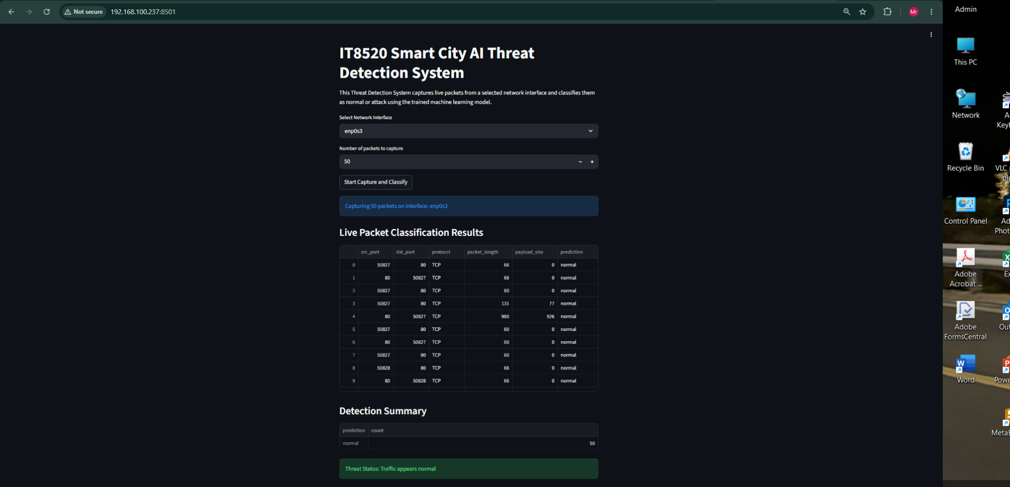
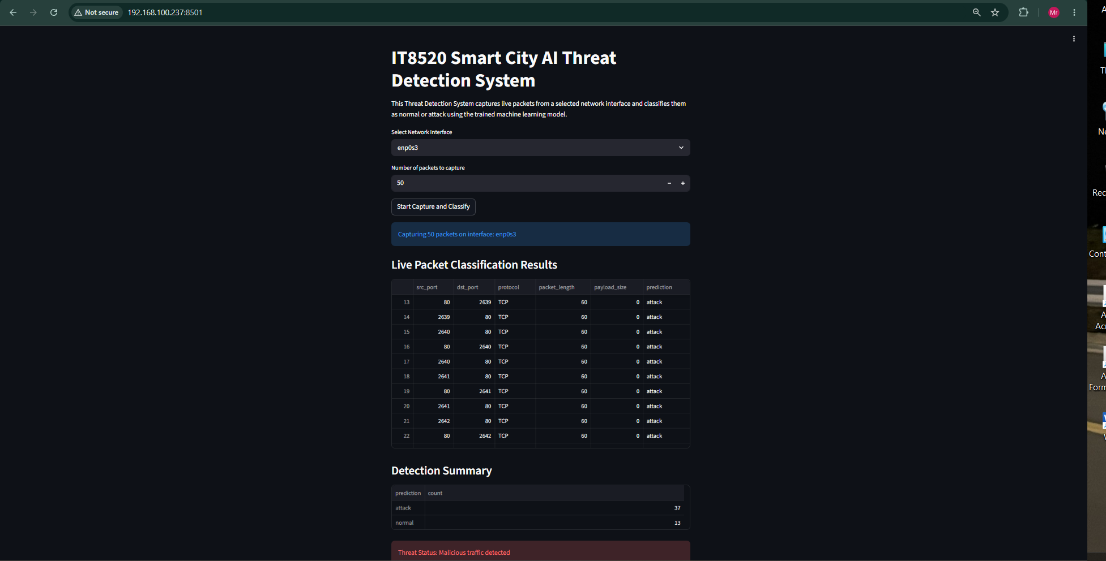

Performance Comparison
To come up with the most efficient machine learning algorithm in identifying network intrusion, five different classifiers have been selected for comparison based on several measures. The performance measures chosen include classification efficiency and computation efficiency. These classification models were Logistic Regression, Decision Tree, Random Forest, Support Vector Machine (SVM), and K-Nearest Neighbor (KNN).
The performance of these machine learning algorithms has been analyzed based on Accuracy, Precision, Recall, and F1-Score measures. Moreover, training time and space have also been examined.

1> Machine Learning Algorithm Comparisons
The Table below shows performance measures of all machine learning algorithms used in this research project.

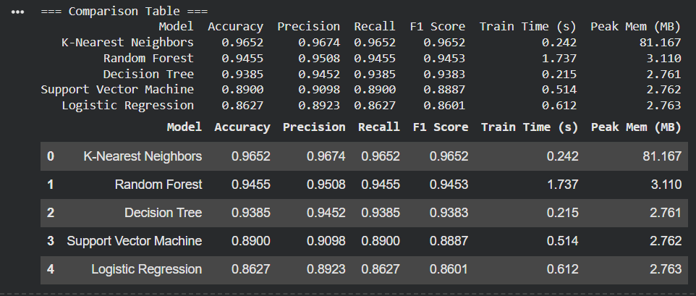

From the findings, it is evident that K-Nearest Neighbor obtained the highest accuracy of all the evaluated models. The worst performing model was the Logistic Regression model, whereas the Random Forest and Decision Trees models performed excellently.

2> F1 Score Evaluation
can be seen in this figure, which shows the comparison of F1 score in all the models under consideration.
F1 Score holds special significance in cybersecurity applications due to its balanced relationship between Precision and Recall measures.
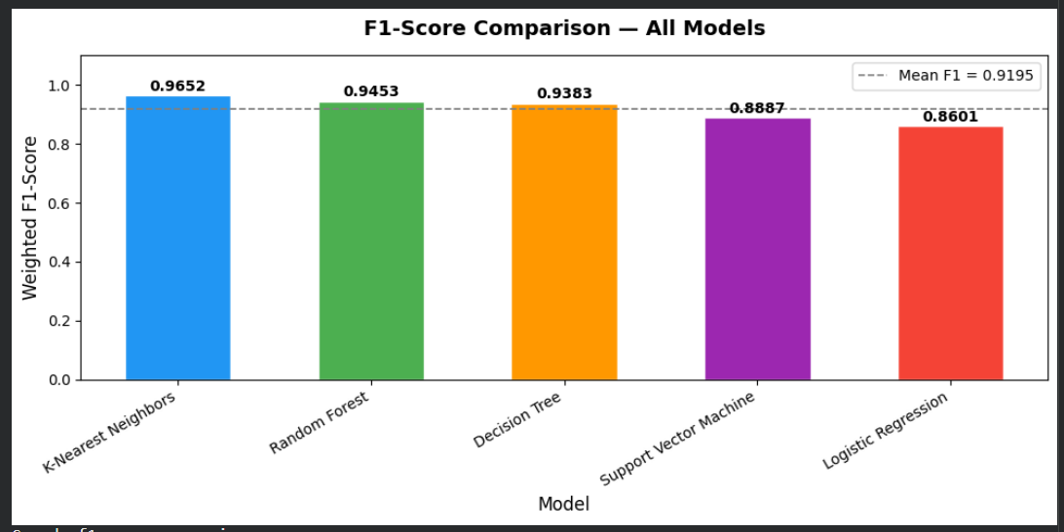

3> Multi-Metric Performance Analysis
The grouped performance comparison graph clearly shows that the K-Nearest Neighbor model outperformed all other models in terms of Accuracy, Precision, Recall, and F1-score

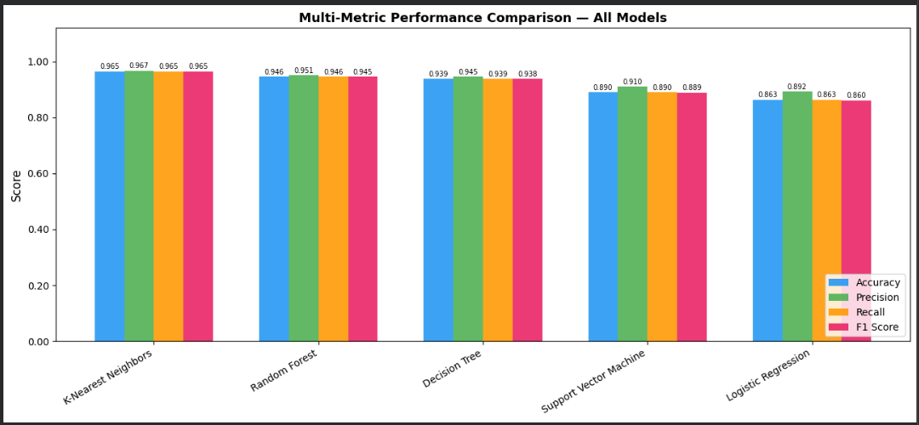

4> Computational Efficiency Evaluation
Not only the classification performance but also computational efficiency was considered by evaluating training time and maximum memory usage
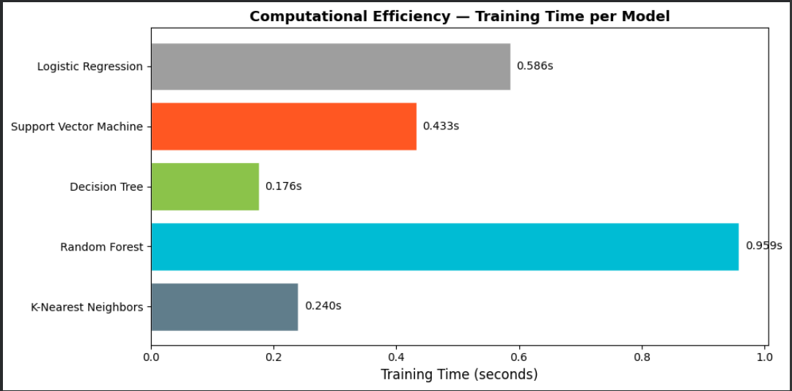

The Decision Tree took the least amount of training time of 0.176 seconds. KNN is also computationally efficient with only 0.240 seconds required for training. Random Forest
took the most time because it needed to create many decision trees.

5>Memory Usage Comparison

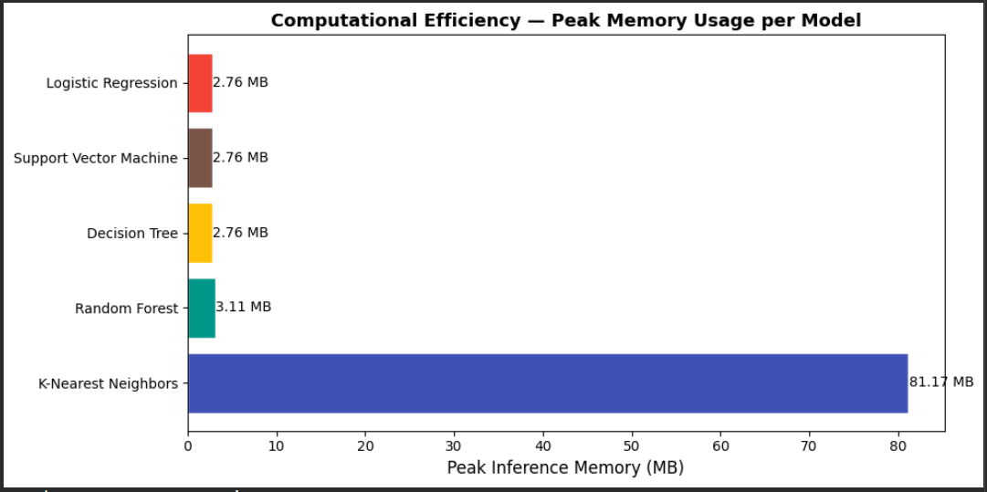

In terms of memory, it can be observed that there is a huge difference between the memory consumption of K-Nearest Neighbor classifier from all other classifiers. The memory usage for KNN was 81.167MB, which is much higher when compared to all other classifiers. On the contrary, the rest of the classifiers used less than 3 MB of memory.

6> Confusion Matrix Analysis
Confusion matrix analysis also serves to showcase the ability of each of the classifiers to distinguish between malicious and non-malicious traffic
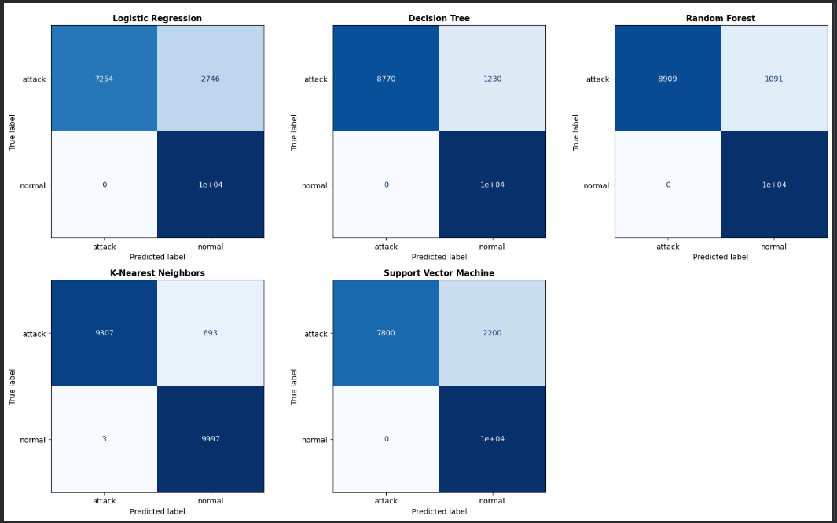

AI-Based Countermeasures for Smart City Networks
From the above IDS results, there are various measures that can be taken using AI techniques to enhance the smart city network security. First, one measure would involve implementing rate limiting. In the event that the IDS detects numerous packets emanating from one source or detecting flood activity, it would be wise to allow the traffic rate to be reduced from that source. As such, SYN Flood, UDP Flood, and HTTP Flood attacks would be minimized even before reaching their target servers.
A second strategy would be implementing adaptive firewall rule generation. Whenever the trained IDS system detects frequent malicious traffic from one particular source, it is wise to use that information to generate a firewall rule that would block or limit access to that particular source IP address.
Thirdly, there is traffic redirection. If some traffic appears to be suspicious, then instead of allowing this traffic into the critical services of the smart city, the traffic could be diverted into a monitoring server or a honey trap.

An effective countermeasure to use is automated alerts. In the case where malicious traffic is identified by the IDS, this information can be sent to the security staff using a dashboard, an email notification or logging the security logs.
Moreover, the IDS can be refined by constant retraining of the model used. New data regarding both normal traffic and attacks should be gathered and incorporated into the data set. It would help the model adjust to new trends and decrease the number of mistakes made during the detection process in the future.
These countermeasures improve the IDS by connecting detection results with practical response actions, which makes the system more suitable for smart city cybersecurity environments.

Conclusion
This study has effectively developed and deployed the intelligent IDS in a simulated smart city scenario through the use of machine learning algorithms. The simulation has been done in a secured virtual lab environment by making use of Oracle Virtualbox software, where legitimate and malicious network data were produced and captured. Various cybersecurity attacks such as SYN Flood, UDP Flood and HTTP Flood attacks have been performed for the generation of the dataset.
A few supervised machine learning algorithms have been trained and analyzed to predict whether the traffic is benign or malicious. It was found from analysis that machine learning techniques are able to effectively predict malicious traffic behavior based on real packet level features rather than unrealistic features such as the IP address. From the experiments' results, K-Nearest Neighbors performed well in all evaluation measures but consumed higher memory compared to other classifiers. Therefore, it might not be feasible for real-time IDS implementations where processing is expected to happen quickly without requiring large amounts of memory. In such cases, Random Forest and SVM would be better choices due to their balanced performance and efficiency.
Moreover, a real-time IDS software was successfully implemented by making use of tools such as Streamlit, Scapy, pandas, and scikit-learn. The IDS was able to perform the tasks of capturing live packets, extracting key features, and classifying the data in real-time using the machine learning model.
The overall significance of this project lies in demonstrating the necessity of coupling machine learning with IDS to create effective cybersecurity defenses for modern network attacks. The future scope includes incorporating deep learning into the IDS, adding more attack cases to the dataset, and deploying the IDS in a larger scale.

References
Buczak, A. L., & Guven, E. (2016). A survey of data mining and machine learning methods for cyber security intrusion detection. IEEE Communications Surveys & Tutorials, 18(2), 1153–1176. https://doi.org/10.1109/COMST.2015.2494502
Harris, C. R., Millman, K. J., van der Walt, S. J., Gommers, R., Virtanen, P., Cournapeau, D., Wieser, E., Taylor, J., Berg, S., Smith, N. J., Kern, R., Picus, M., Hoyer, S., van Kerkwijk, M. H., Brett, M., Haldane, A., del Río, J. F., Wiebe, M., Peterson, P., Gérard-Marchant, P., Sheppard, K., Reddy, T., Weckesser, W., Abbasi, H., Gohlke, C., & Oliphant, T. E. (2020). Array programming with NumPy. Nature, 585, 357–362. https://doi.org/10.1038/s41586-020-2649-2
Hunter, J. D. (2007). Matplotlib: A 2D graphics environment. Computing in Science & Engineering, 9(3), 90–95. https://doi.org/10.1109/MCSE.2007.55
Oracle. (2026). Oracle VM VirtualBox user manual: Internal networking. https://www.virtualbox.org/manual/ch06.html
pandas development team. (2026). pandas documentation. https://pandas.pydata.org/docs/
Pedregosa, F., Varoquaux, G., Gramfort, A., Michel, V., Thirion, B., Grisel, O., Blondel, M., Prettenhofer, P., Weiss, R., Dubourg, V., Vanderplas, J., Passos, A., Cournapeau, D., Brucher, M., Perrot, M., & Duchesnay, É. (2011). Scikit-learn: Machine learning in Python. Journal of Machine Learning Research, 12, 2825–2830. https://jmlr.org/papers/v12/pedregosa11a.html
Scapy Project. (2026). Scapy documentation. https://scapy.readthedocs.io/
Sharafaldin, I., Lashkari, A. H., & Ghorbani, A. A. (2018). Toward generating a new intrusion detection dataset and intrusion traffic characterization. Proceedings of the 4th International Conference on Information Systems Security and Privacy, 108–116. https://doi.org/10.5220/0006639801080116
Streamlit. (2026). Streamlit documentation. https://docs.streamlit.io/
The Tcpdump Group. (2026). tcpdump: A tool for network monitoring and data acquisition. https://github.com/the-tcpdump-group/tcpdump
University of New Brunswick Canadian Institute for Cybersecurity. (2017). Intrusion detection evaluation dataset: CIC-IDS2017. https://www.unb.ca/cic/datasets/ids-2017.html

Group Reflection & Peer Review Table

Student ID | Name | % of Workload Assigned | % of Assigned Workload Completed | Main Tasks Completed | Peer Review Remarks
202301225 | Salman Almomani | 20% | 100% | Lab Design & Topology, Data Generation Methodology, Report Structure, References | Completed assigned tasks on time with good technical contribution
202304613 | Abdulrahman Altairey | 20% | 100% | Feature Selection & Engineering Justification, IDS Development & Real-Time Detection, Report Structure, References | Strong implementation and testing contribution
202203262 | Abdulla Alfetaini | 20% | 100% | Performance Comparison, Data Preprocessing, Report Structure, References | Good documentation and preprocessing support
202203316 | Abdulla Almutawa | 20% | 100% | Model Training & Evaluation, Report Structure, References | Successfully trained and evaluated ML models
202203053 | Bader Aamer | 20% | 100% | Introduction & Objectives, AI Countermeasures, Conclusion & Future Work, Report Structure, References, Presentation Quality | Good analysis, comparison, and reporting contribution

