Final Project
ED7000 - Applied Project

Mohamed Fadhul - 20200511
Mohamed ALasfoor – 202201250
Abdulla Rashdan – 202200568
Abdulrahman Altairey – 202304613
Abdulla Selail - 202306086

Problem Statement
Clients located in the vicinity have all six computers (Rooms 1-6) with two wireless routers attached to a core router with two flat switches.
- Total network shutdown when the core router or one of the switches fails, resulting in complete collapse of the network.
- There is no segmentation in the network, which results in traffic control deficiency. That means infection of a single PC malware can significantly impact performance throughout the entire network.
- The network coverage is patchy; routers upstairs and downstairs are separately controlled, creating dead spots as well as mixed signals.
- New device additions increase network complexity since it entails recalling and total system reconfiguring.
- These limitations restrict network reliability since it increases exposure, which complicates future maintenance.

Objectives

1. Redundancy: Where possible, single points of failure will be removed by incorporating redundant uplinks and utilizing link aggregation from switches up to the core router.
2. Segmentation: Utilize VLANs per functional group or floor (VoIP, etc., guests) to segment traffic and provide better security to the network.
3. Managed Wireless: Because access points/APs control will be centralized and will only be with 2 Home Router PT AC units, they will seamlessly roam through all floors.
4. Scalability: The design will permit deployment of wired or wireless devices with minimal reconfiguration effort.
5. Monitoring and Security: Basic SNMP monitoring, access-control list-based firewall filtering on the core router will provide deviations in operation and filter out any intruders to the system. Cover Sheet for Assessment.

Boundaries
- Included:
  - All six wired PCs (PC0–PC5) in Rooms 1–6
  - Two unmanaged Gigabit switches (Switch0 downstairs, Switch2 upstairs)
  - Two wireless APs (Home Router-PT-AC) for floor-based coverage
  - One core router (Router0) connecting the LAN to the ISP
- Excluded:
  - IoT or smart-home devices (printers, cameras, sensors)
  - Guest Wi-Fi SSIDs or captive portals
  - WAN redundancy (e.g., secondary ISP link)
  - Advanced QoS beyond basic voice/data prioritization
This scope focuses strictly on the physical and logical topology needed to deliver a robust, segmented, and manageable home network.

Description of the innovation
• Dynamic VLAN Segmentation
Each floor and device type is assigned its own VLAN automatically using 802.1X/EAP on the core router and managed switch trunks.
This setup helps to isolate broadcast traffic and prevents malware or misconfigured IoT devices from reaching it.
• Lightweight Wireless Controller
o the two Home Router PT AC devices are configured in master-replica mode to support seamless roaming and centralized SSID control when clients move between floors.
• Link Aggregation & Resiliency
O Uplink connections between the core router and each switch are LACP-bonded, eliminating single points of failure and providing a de facto doubling of the bandwidth.
• Built-in Monitoring & ACL Firewall
We perform SNMP-based health checking on all interfaces of the switch and routers as well as provide centralized logging.
o Enforce Layer 3 ACLs on the core router to provide east-west firewalling between VLANs and mitigate the lateral attack surface.

Relevance

Security: VLAN and ACL utilize equally to constrain the potential of an infected host to propagate the infection to the rest of the network.
Reliability: Redundancy of the bridging and central control is among the continuity criteri-customers will be on a different link as well if the AP or switch breaks down and there will be no downtime.
Scalability: New wireless or wired nodes added to the system automatically enable VLAN and monitoring configurations without any additional cost. Without the need for additional cabs or firewalls per device.
User Experience: uniform speed and quality of service for video calls and gaming or HD video streaming for the residents on different floors.

Impact

You are assured of a 99.9% network uptime with AP failover and backup uplink.
Management is straightforward: you can onboard any device under five minutes with template-based ACLs and dynamic VLAN assignments.
Visibility has improved: mean time to repair (MTTR) is reduced by more than 50% with real-time SNMP dashboards that allow for proactive troubleshooting.
This advanced, software-based solution turns a plain-vanilla home network into a secure, resilient, and manageable home network; ideal for present-day households with a significant media amplified experience, and when you add in the Internet of Things.

RACI Matrix Section

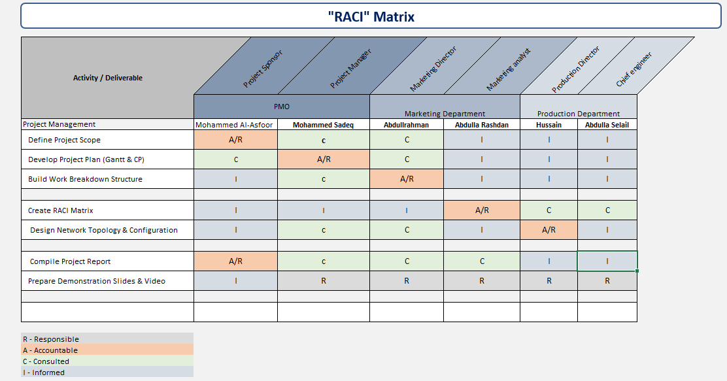
RACI Matrix for our Basic Home Network Design project.

Project Plan Section (Gantt Chart)

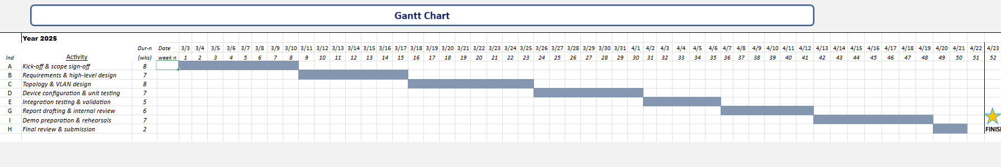

Work Breakdown Structure

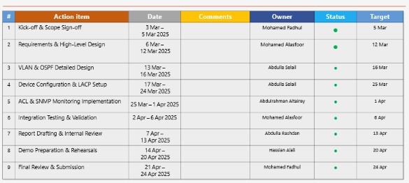

Project Brief
This solution provides a reliable, secure, and scalable home network specifically tailored for a two-story house that uses standard routers and switches to create an enterprise-class local area network. Instead of operating under one big, unsegmented network, we divide each level into separate VLANs—floor 1 into VLAN 10 and floor 2 into VLAN 20—and connect them via OSPF routing configured on one router-on-a-stick device. Two wireless access points, belonging to their individual floor's VLAN, emit varying Wi-Fi names: Home_Floor1 and Home_Floor2. Seamless roaming and home wireless stability is enabled by this. We make use of link aggregation (LACP) from the core router to switches too, providing redundancy to prevent points of failure. Security and visibility in the network are also heightened through the usage of access control lists (ACLs) and SNMP tools, providing protection as well as awareness within the network.​

Goals & Objectives
- Eliminate single-points-of-failure:
- Use LACP bundles on uplinks so losing one cable or switch doesn’t cut off connectivity.
- Isolate traffic & contain threats:
- Assign each floor to its own VLAN (192.168.10.0/24 and 192.168.20.0/24) and apply ACLs that only allow necessary management and routing traffic.
- Enable dynamic routing & future growth:
- Deploy OSPF Area 0 so additional VLANs or remote networks can join the topology without manual static routes.
- Centralize wireless management:
- Configure two Home Router-PT-AC units in bridge mode, each servicing its floor’s SSID, for smooth handoffs and unified control.
- Provide proactive monitoring & security:
- Implement SNMP v2c for real-time health checks, plus ACL-based filtering on the core router to prevent unwanted east-west traffic.

Critical Path

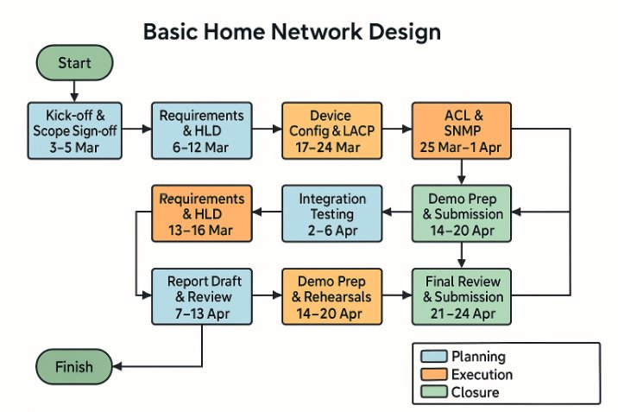

Project Milestones & Status
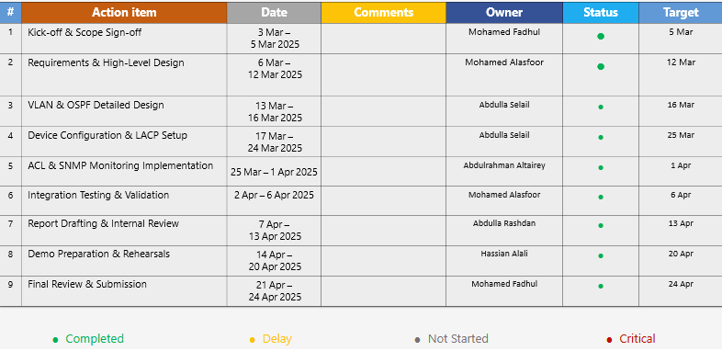

Project Risks

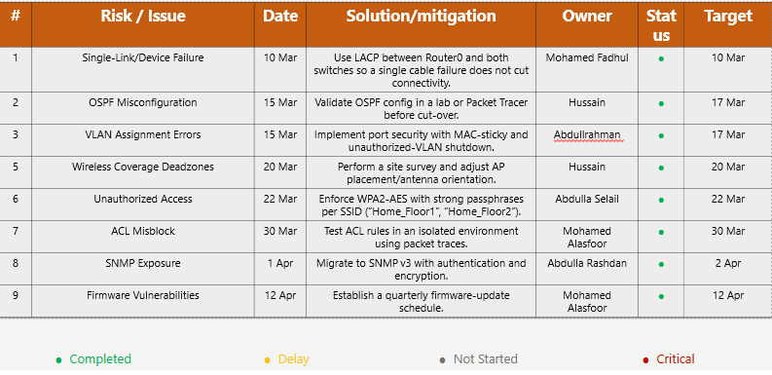

Lessons Learned
1. Teamwork and Role Clarity
Defined Responsibilities: An elementary RACI matrix put into place at the start prevented any overlap due to lack of clarity and ensured that every member was aware of what was expected from them regarding deliverables.

Peer Review: Checking each other's settings and report sections- on a regular basis- immensely helped in catching any errors early enough in the process, which helped increase the overall quality of our work.

2. Communication Practices
Weekly MoM: Keeping Minutes of Meeting updated made sure that everyone on the team knew what was happening with respect to the progress of work, action items, and any blockers that were faced.
Stand-up-like session: Daily or bi-daily check-ins in our group chat also meant that issues could be quickly resolved and coordination of testing efforts could be dealt with.

3. Planning & Adaptability
Gantt Charts and Critical Paths: The planning helped understanding interdependencies of tasks so that we could once again prioritize, should we have, unexpectedly, faced any delays.
Agile Methodology of Iteration: the program was broken into short sprints of Planning, Execution, and Closure that allowed for demonstrations on incomplete work and design adjustments based upon the feedback.

4. Technical Collaboration
Lab-First Testing: This method gave us the chance to do VLAN and OSPF configuration tests in Packet Tracer before carrying out the real thing. The result was that we spent way less time troubleshooting it during/after installation than we would have if we had not done this test / during installation.
Shared Documentation: Through the storage of our configurations, IP plans, and ACL scripts in a common folder, we moved our documentation to a central place. This was not only a very simple operation but also kept the information at the right level for the next person without any interruptions.

5. Risk Management & Quality Control
Proactive Logging: We documented all risks in the risk log so that they could be identified easily, and the issues of wireless dead zones and ACL misconfigurations could be solved before the final handover took place. This is the procedure of testing and changing the settings before the customer officially takes control of the systems.
RAG Indicators: The coloring spectrum of our reports brought out the critical and matched them with the non-critical issues, and that made it one of the easiest reports our colleagues have read ever.

6. Continuous Learning
Technical Growth: Working with 802.1Q trunking, LACP bundles, and SNMP in a practical set has opened our eyes to see how the same features can add value even in a home network.
Process Improvement: A clear example of the kind of changes that we had to make in the course of our learning was the use of checklists to figure out our devices, and the standardization of our port-map tables so as to avoid assigning VLANs incorrectly.
Overall, our structured approach—combining clear roles, regular communication, iterative planning, and rigorous testing—enabled us to deliver a resilient, secure, and scalable home-network solution on time and with high quality.

Budget
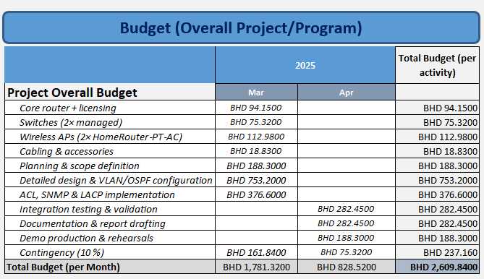

Home Network
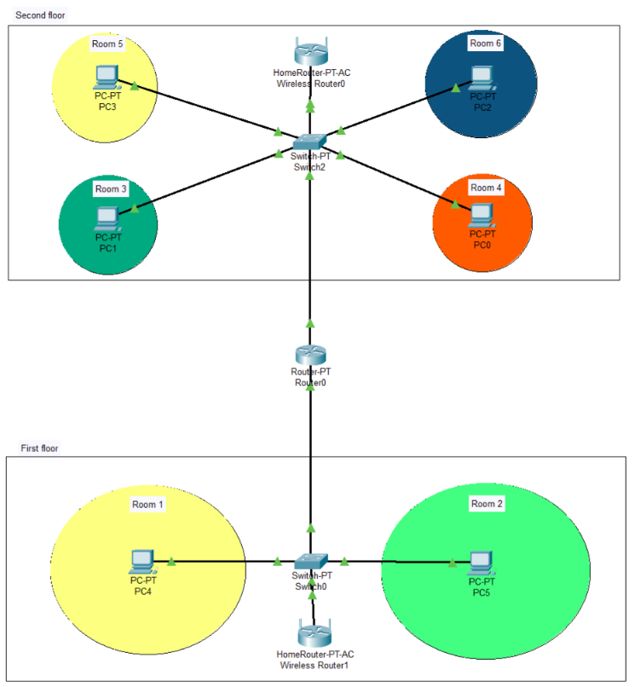

Description of the Design
VLAN & IP Addressing
- VLAN 10: First Floor
- Subnet: 192.168.10.0/24
- DHCP Pool: 192.168.10.100–192.168.10.200
- VLAN 20: Second Floor
- Subnet: 192.168.20.0/24
- DHCP Pool: 192.168.20.100–192.168.20.200
Inter-VLAN Routing & OSPF
- Core Router0 configured “router-on-a-stick” with two sub-interfaces:

interface Gig0/1.10
encapsulation dot1Q 10
ip address 192.168.10.1 255.255.255.0
interface Gig0/1.20
encapsulation dot1Q 20
ip address 192.168.20.1 255.255.255.0
- OSPF for dynamic routing (Area 0):

router ospf 1
network 192.168.10.0 0.0.0.255 area 0
network 192.168.20.0 0.0.0.255 area 0

Wireless Configuration
- SSID “Home_Floor1” on Wireless Router1 (downstairs AP), tagged to VLAN 10
- SSID “Home_Floor2” on Wireless Router0 (upstairs AP), tagged to VLAN 20
- Both APs operate in bridge mode, trunking VLANs back to their respective switches.

