

Assessment Cover Sheet
Assessment Title
Group Project
Assessment Type
Uncontrolled
Group
Not must-pass
Due Date
23 December 2025
Course Code
IT7301
Course Title
Ethical Hacking
Internal Moderator’s Name
Dr. Muhammed Tariq
External Examiner’s Name
Dr. James Egan
Instructions:
- This cover sheet must be completed (section in blue below) and attached to your assessment before submission in hard copy/soft copy.
- Submit the project report on Sunday, December 18, 2025, before 11:55 via Moodle.
- If an assessment is submitted late, the maximum result the student can achieve is 60% in that assessment. The cut-off time for submitting an assessment will be 3 calendar days after the assessment is due. After this, students will get 0%.
- Students will have to work in as a group project, and each group can have max four members.
- Each group must prepare a report and submit it on Moodle. Only the group leader is required to submit the report on behalf of the group.
Lecturer’s Name
Programme Title
Programme Code
Learner Name
Date Submitted
Learner ID

ik
Sehrish Shahid

Ethical Hacking
IT7301
Muhannad Alnooh
23/12/2025
202300678
By submitting this assessment for marking, I affirm that this assessment is my own work.

Learner Signature

Do not write beyond this line. For assessor use only.

Maks Obtained
Marking Date
Assessor’s Name
Comments:
Table of Contents
Introduction: 3
Task 1: Footprinting 4
Independent/ Researched Techniques 8
Task 2: Scanning 13
Independent/Researched Techniques 19
Task 3: Enumeration 24
Independent/ Researched Techniques 28
Task 4: Vulnerability Scanning 32
Task 5: Gaining access 43
Independent/Research Techniques 50
Task 6: Maintaining access: 59
Task 7: Covering tracks: 61
Task 8: Pentest Report and Security Policy: 63
Section A: pentest report: 64
Section B: security policy: 69
Task 9: Self-reflection: 77
Conclusion: 78
References: 79

Introduction:
This project will attempt to model a real-life penetration testing exercise in a controlled and ethically validated laboratory setting. The major aim is to use ethical hacking methodology throughout the entire attack lifecycle, which includes reconnaissance, scanning, enumeration, access, maintenance of access, track coverage and finally offer the mitigation measures and security policies. This process will show the project applied exploitation skills, vulnerability analysis, and creation of defensive controls that are in line with industry standards.

The main target system chosen in this project was the Metasploitable 2 which is a deliberately vulnerable Linux-based virtual machine used in practice of penetration testing. The reason as to why Metasploitable 2 was selected is because it offers a large variety of open services and has known vulnerabilities.

Lab environment- This was an environment based on a set of virtual machines on an Oracle VirtualBox, all connected using a NAT Network with an IP range of 192.168.109.0/24 enabling controlled internal communication between systems. The main attacker computer was Kali Linux as it was used to conduct reconnaissance, scanning, exploitation and post exploitation processes during the project, additional virtual machines were also present in the lab, including the Greenbone Enterprise, Windows 10, and other Linux based systems, but were only used to conduct some tasks where necessary, e.g. vulnerability assessment.

Task 1: Footprinting
Target name: demo OWASP juice shop, OWASP org
URL: https://demo.owasp-juice.shop, https://owasp.org
1.
Command: nslookup demo.owasp-juice.shop
Methodology:
The nslookup is a passive technique that avoids directs contact with a target, and this method was used to resolve the domain name of the target to an ip address, additionally this command also queries the target’s dns server and gets the ipv4 and ipv6 records tied to them. 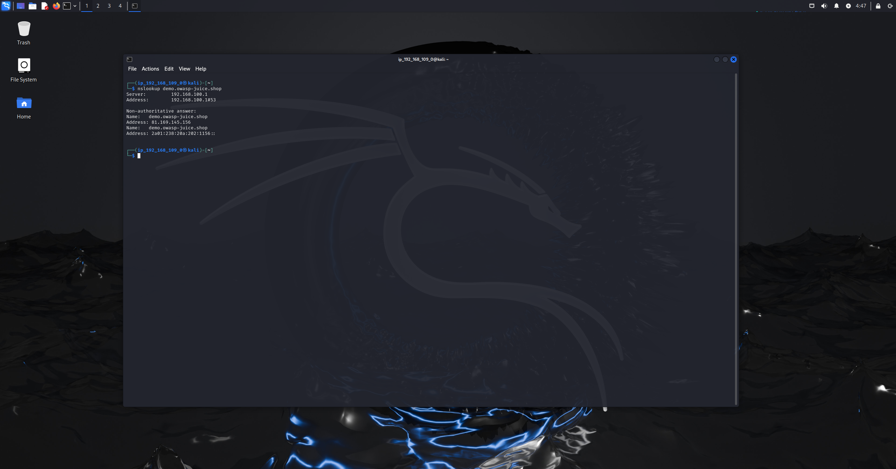
Figure 1.1: nslookup technique
Results:
- The domain successfully resolved to an IPv4 address (81.169.145.156)
- An IPv6 address was also identified
- DNS resolution confirms the target is internet-accessible and not hosted locally
- The DNS response was non-authoritative, indicating a third-party DNS resolver
2.
Command: wafw00f demo.owasp-juice.shop
Methodology:
The wafw00f tool is used to determine whether a website has protection from a web application firewall by checking the responses from the series of sent http requests to check if they contain any known WAF signatures. 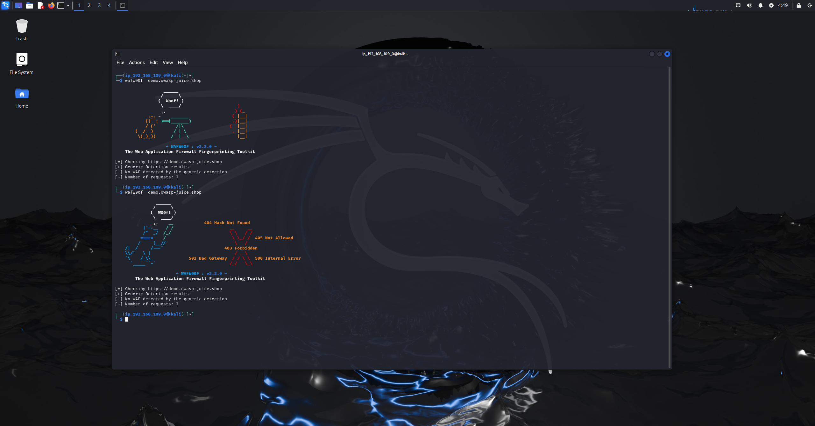
Figure 1.2: wafw00f technique
Results:
- No Web Application Firewall was detected
- Generic detection returned negative results
- The target does not appear to be protected by common WAF solutions
- This increases exposure to common web-based attacks in later phases

3.
Command: whatweb https://demo.owasp-juice.shop
Methodology: the whatweb tool is used identify the web technologies active on the target website, by analyzing the http responses header, server behavior and java script libraries this technique determines the security headers, platforms and frameworks on the target. 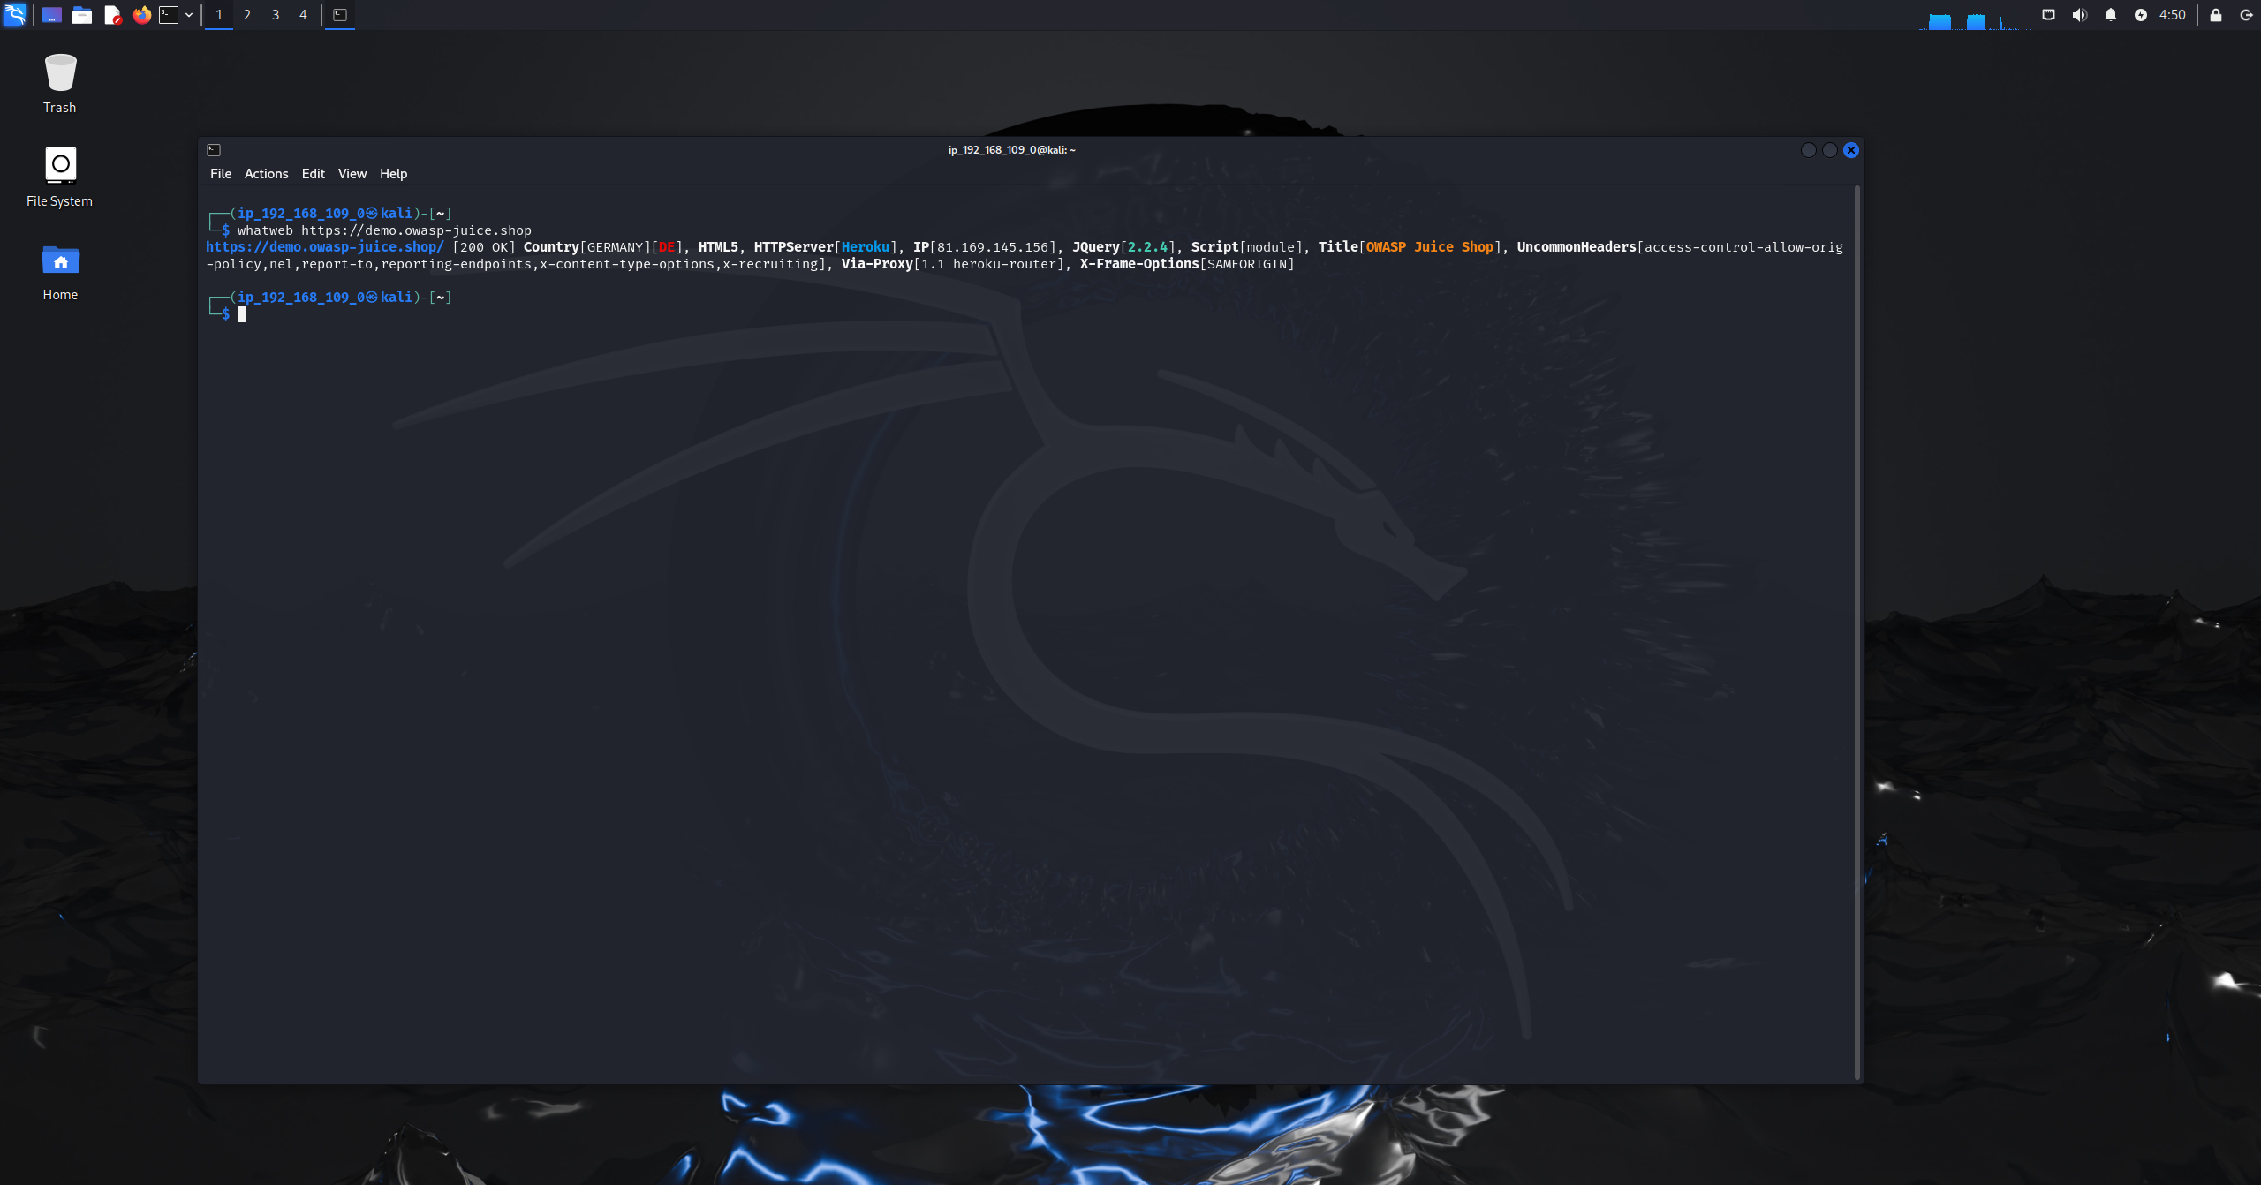
Figure 1.3: whatweb technique

Results:
- Web server: Heroku
- Hosting IP: 81.169.145.156
- JavaScript libraries: jQuery 2.2.4
- Page title: OWASP Juice Shop
- Security headers identified:
  - X-Frame-Options (SAMEORIGIN)
  - Content-Type options
- Confirms cloud-hosted deployment and modern web stack

4.
Command: whois owasp.org
Methodology: The whois tool is used to return the details of the domain registration about the target infrastructure like who is the owner, registrar and some dns infrastructure information. 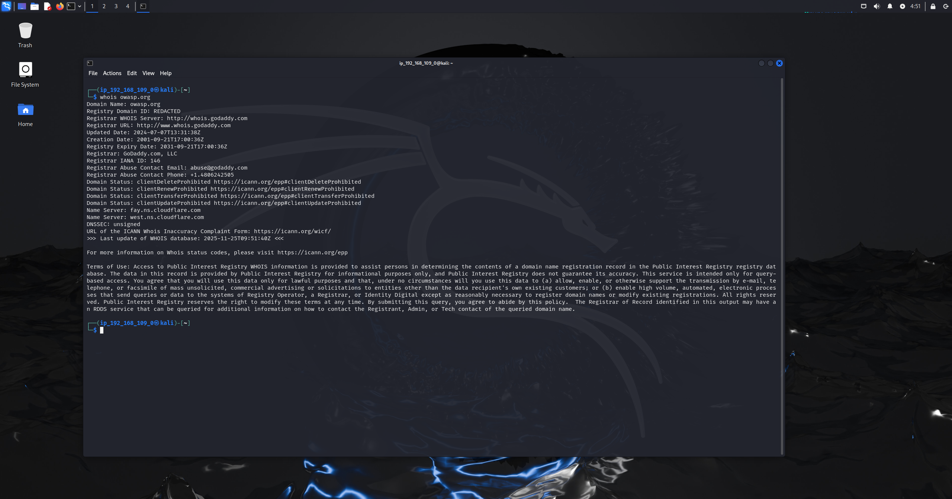
Figure 1.4: whois technique
Results:
- Registrar: GoDaddy.com, LLC
- Name servers: Cloudflare (ns.cloudflare.com)
- Domain status: Client transfer, update, and delete prohibited
- DNSSEC: Unsigned
- Organization: OWASP Foundation
- Confirms use of Cloudflare for DNS and infrastructure protection

Independent/ Researched Techniques
5.
Command: amass enum -passive -d owasp-juice.shop -oA juice -silent
Methodology: The amass tool was used in passive enumeration mode (-passive) to discover any dns related information about the (-d) target domain without any direct interaction while also suppressing any unnecessary outputs (-silent), after the operation is done the output is redirected to a text file in multiple formats (-oA). 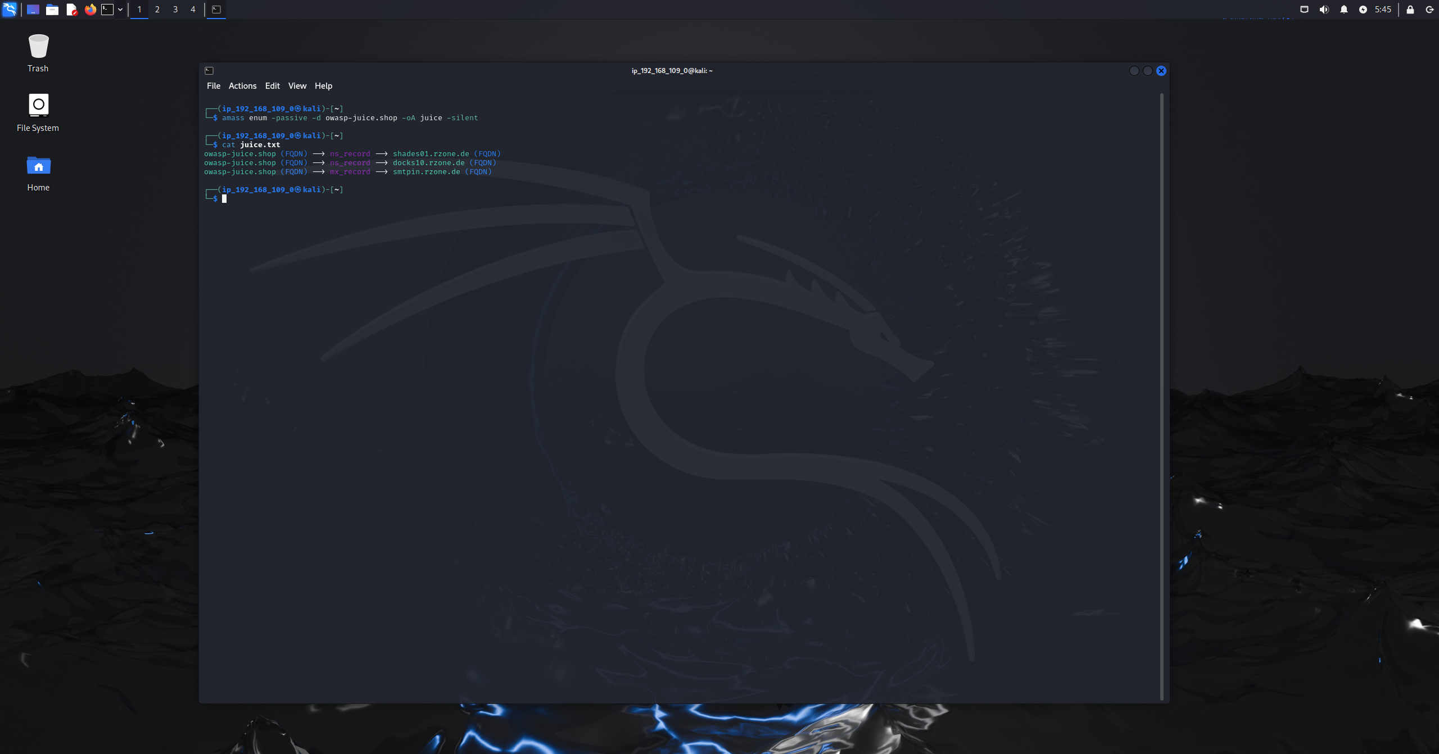
Figure 1.5: amass technique
Results:
- Multiple DNS records were identified for the domain
- NS records discovered:
  - shades01.rzone.de
  - docks10.rzone.de
- MX record identified:
  - smtpin.rzone.de
- These findings reveal:
  - External DNS hosting infrastructure
  - Third-party mail handling services
  - Supporting backend components beyond the main web application
6.
Command: https://crt.sh/?q=owasp-juice.shop
Methodology: The crt.sh technique was used to search in the certificate transparency logs for any ssl or tls certificates for the target domain, this helps in identifying the subdomains and the historical certificate usage while remaining passive. 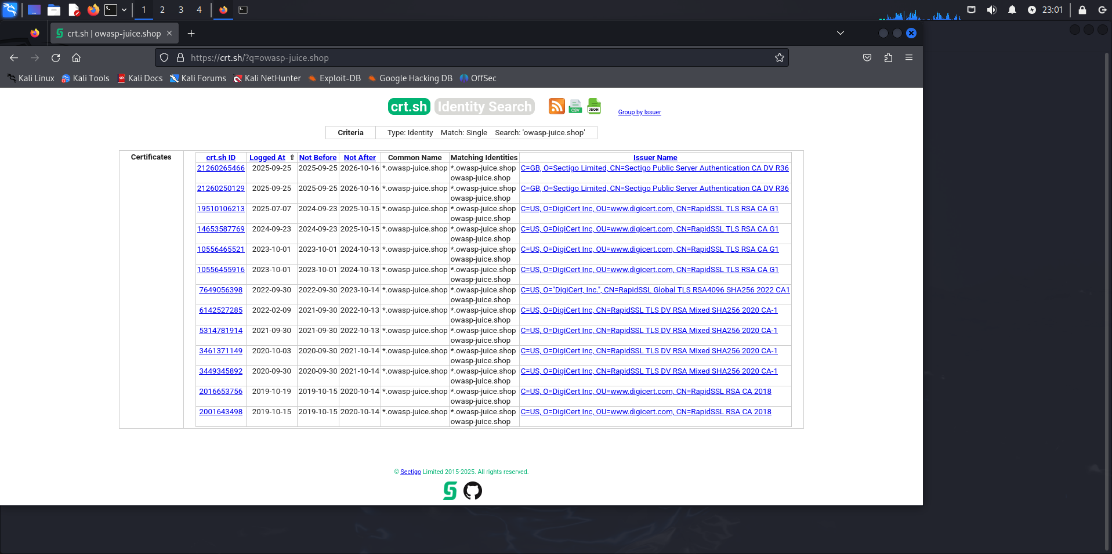
Figure 1.6: crt.sh website technique

Results:
- Multiple certificates were identified for:
  - *.owasp-juice.shop
  - owasp-juice.shop
- Certificates were issued by:
  - Sectigo
  - DigiCert
- Certificate validity periods revealed:
  - Historical certificate rotation
  - Ongoing maintenance of TLS infrastructure
- Confirms the use of wildcard certificates, indicating potential subdomains even if not publicly accessible

7.
Command: curl -I https://demo.owasp-juice.shop/
Methodology:
The curl technique is used to extract only the http response headers (-I) to avoid direct contact with the target, moreover this method reveals server, caching, and backend routing information. 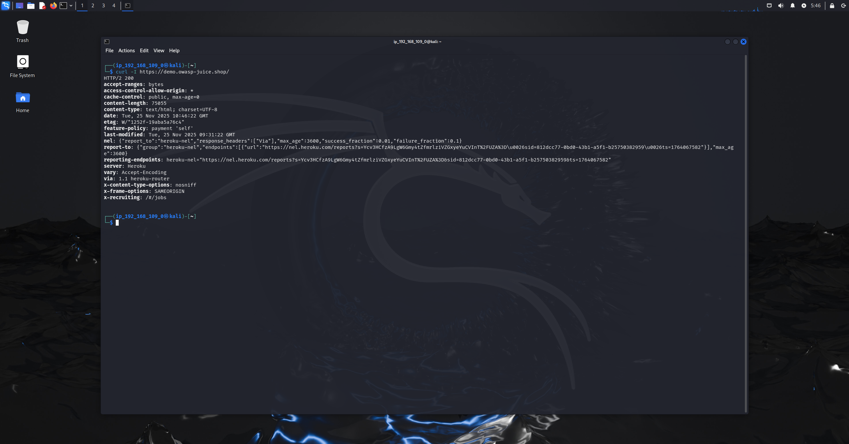
Figure 1.7: curl technique
Results:
The response headers revealed:
- HTTP version: HTTP/2 200 OK
- Server: Heroku
- Proxy: heroku-router
- Security headers present:
  - X-Frame-Options: SAMEORIGIN
  - X-Content-Type-Options: nosniff
- CORS policy: access-control-allow-origin: *
- Caching and reporting headers indicating cloud monitoring
- confirms cloud-based hosting and exposes security-related HTTP configurations
8.
Tool: Netlas (web-based ip intelligence platform)
Methodology: The netlas platform was used on the ipv4 address which was found from the nslookup command to gather external information about the target while avoiding active contact with them as this technique relies on third party scan data. 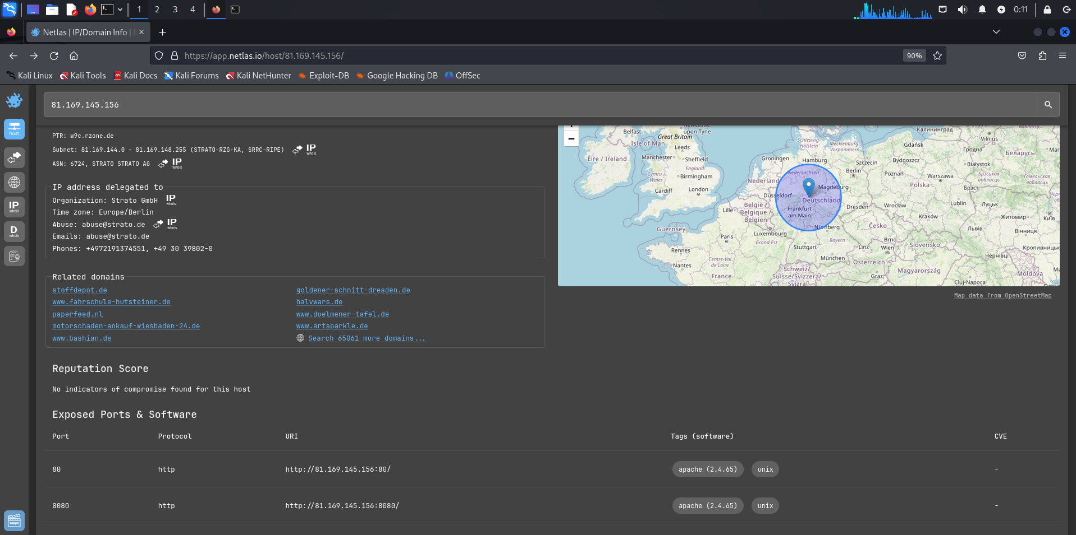
Figure 1.8: Netlas footprinting technique
Results:
- Organization: Strato GmbH
- ASN: AS6724 (STRATO AG)
- Geolocation: Germany (Europe/Berlin)
- PTR record: wgc.rzone.de
- Exposed services identified:
  - Port 80 (HTTP)
  - Port 8080 (HTTP)
- Detected software: Apache 2.4.65
- Reputation: No indicators of compromise found
- This confirms hosting provider, geographic location, and externally visible services.

Task 2: Scanning
Target system: Metaspoiltable2
Operating system: Linux
Ip address: 192.168.109.5
1.
Tool: Nmap
Command: sudo nmap -sA 192.168.109.5
Methodology:
The ack scan sends tcp ack packets to determine whether ports are filtered or unfiltered, if it is filtered the server does not give a response or an ICMP error message is displayed, if it is unfiltered the server responds with a RST packet, moreover It does not identify open ports, instead it maps firewall behavior.
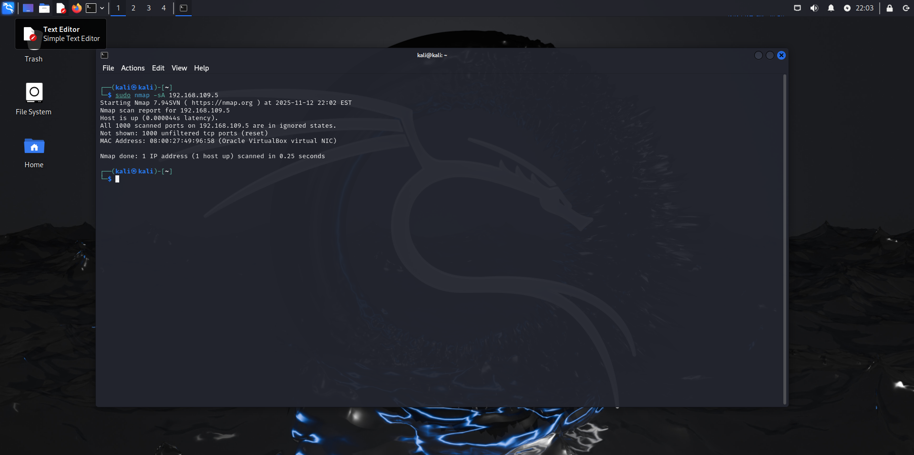
Figure 2.1: acknowledge nmap scan
Results:
- All 1000 scanned ports returned reset, meaning unfiltered
- No firewall is blocking ACK packets
- Confirms the host is directly reachable and not behind a stateful firewall
2.
Tool: Nmap
Command: sudo nmap --script http-enum -p80,443 192.168.109.5
Methodology:
The http-enum script scan enumerates the common web directories and files on the target http service as the script checks for known path, configuration files, and administrative interfaces that could reveal sensitive and critical information. 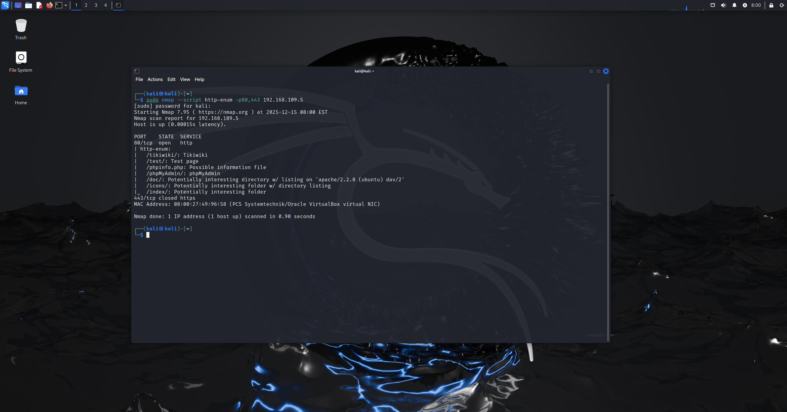
Figure 2.2: http enumeration script
Results:
- Port 80/tcp: Open (HTTP)
- Discovered resources:
- /tikiwiki/
- /test/
- /phpinfo.php
- /phpMyAdmin/
- /doc/ (directory listing enabled)
- /icons/
- /index/
- Port 443/tcp: Closed
- The presence of administrative and information files suggests potential misconfiguration and information disclosure.

3.
Tool: Nmap
Command: nmap --script ftp-anon -p21 192.168.109.5
Methodology:
The ftp-anon script scan usage is to test whether the ftp port allows anonymous authentication as the script attempts to log in using anonymous credentials without a password and prints if the access was allowed, this method validates the authentication behavior on the ftp service port. 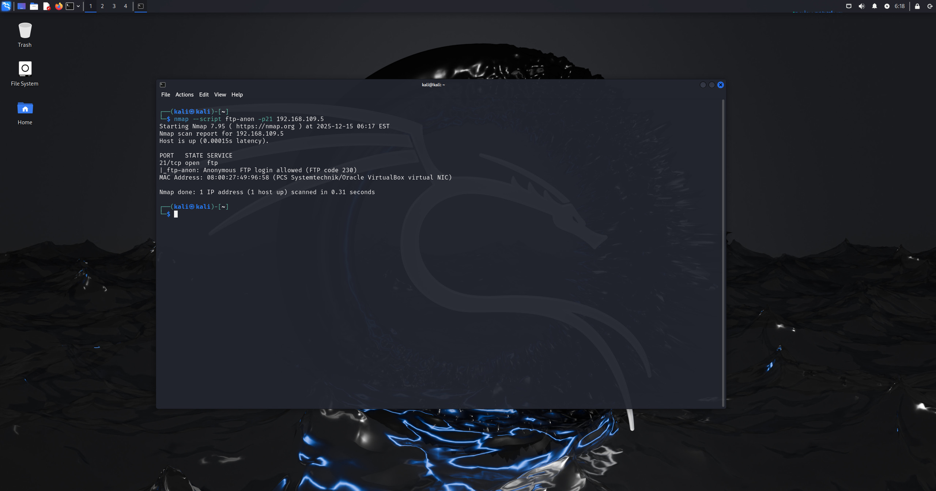
Figure 2.3: nmap ftp anonymous login script
Results:
- Port 21/tcp: Open
- Service: FTP
- Finding: Anonymous FTP login is allowed (FTP code 230)
- This indicates that the FTP service permits unauthenticated access, which may expose files or allow further abuse.

4.
Tool: Zenmap
Command: nmap --script http-title -p80,443 192.168.109.5
Methodology:
This scan used http-title script to get the html title of the web service active on the target machine, the script works by sending a http request and extracts the page title that reveals application names, environments, and system identifiers. 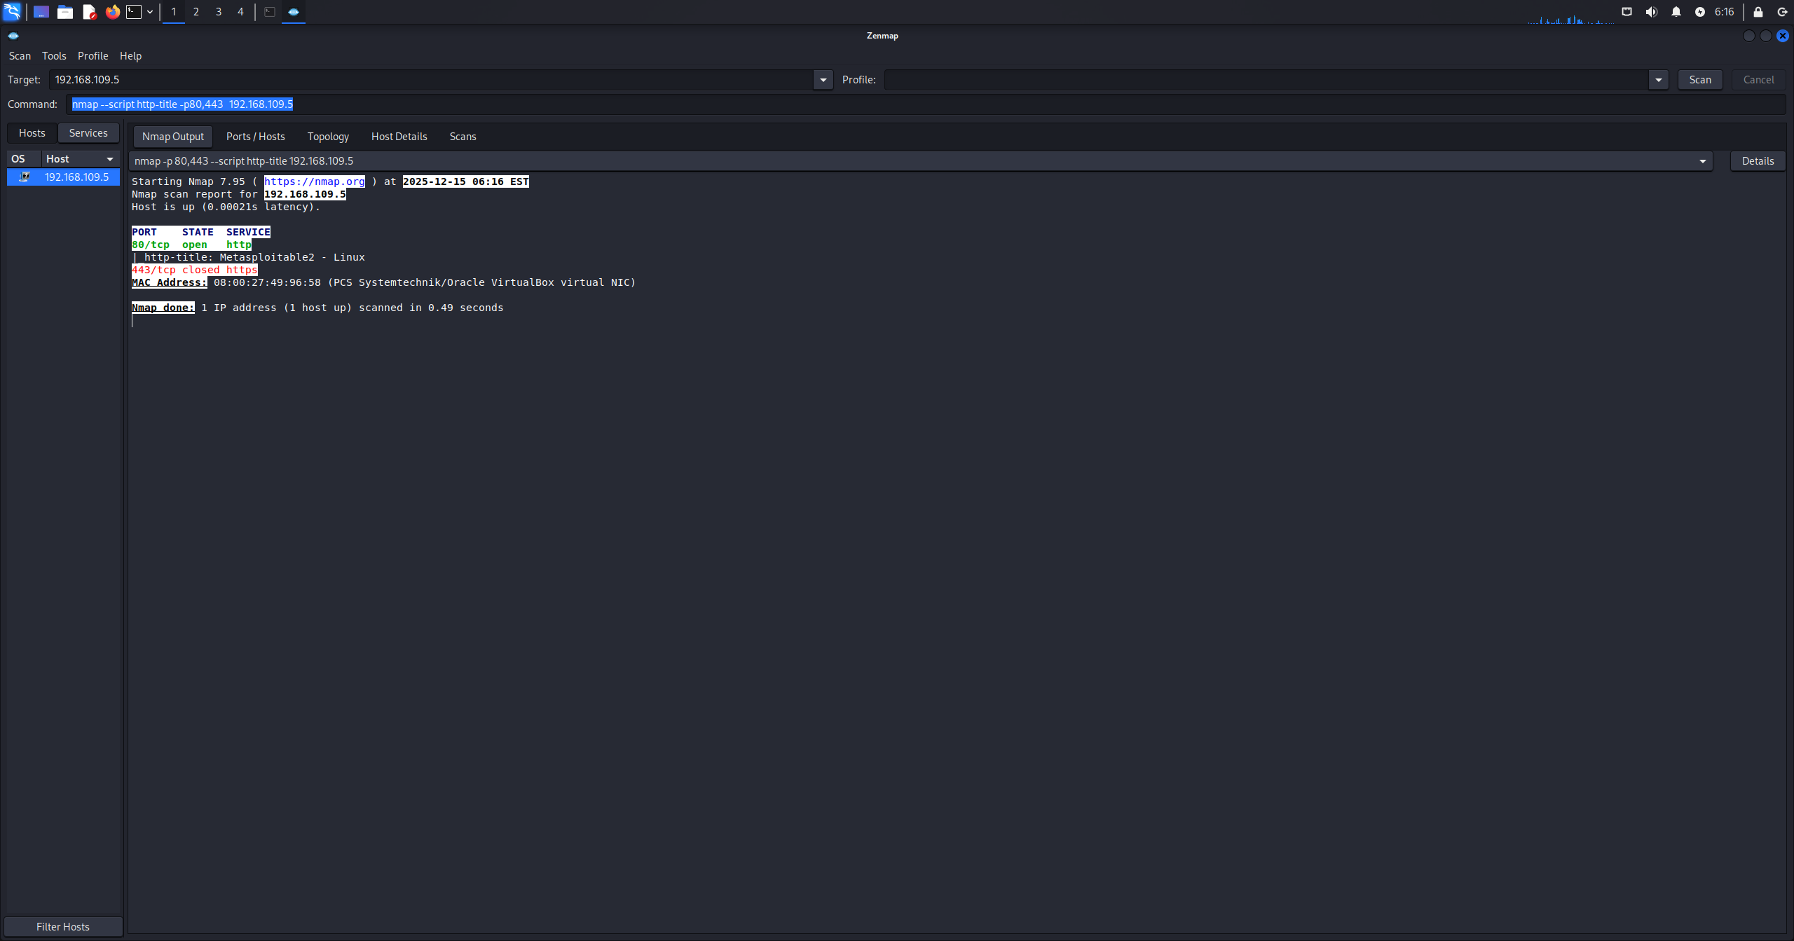
Figure 2.4: nmap http title script
Results:
- Port 80/tcp: Open (HTTP)
- HTTP Title: Metasploitable2 - Linux
- Port 443/tcp: Closed
- The page title directly reveals the system name and operating system, which aids attackers during reconnaissance and fingerprinting.

Independent/Researched Techniques
5.
Tool: angry ip scanner
Methodology:
The angry ip scanner was used to scan the entire subnet of 192.168.109.0/24 to identify any live hosts, the scan was configured to do ping checks and port detection as the default scanning settings were selected. 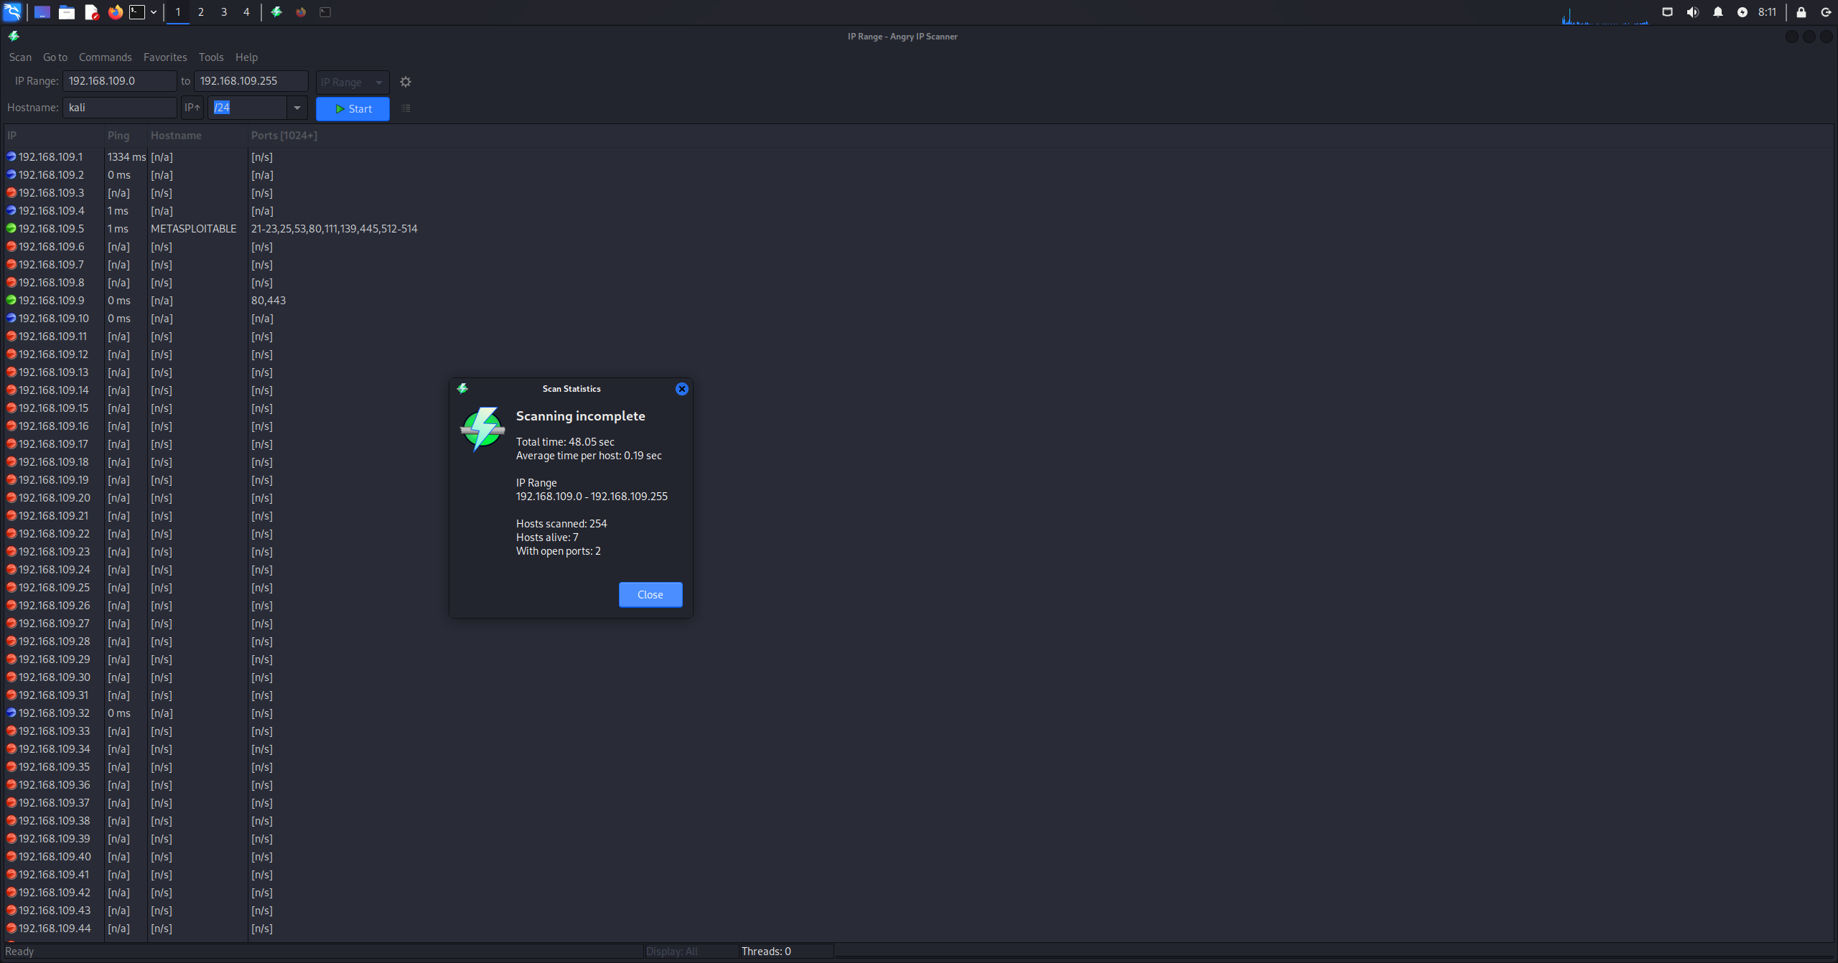
Figure 2.5: angry ip scanner result
Results:
- Total hosts scanned: 254
- Live hosts detected: 7
- Hosts with open ports: 2
- Metasploitable 2 was identified at 192.168.109.5 with multiple open ports.

6.
Tool: fping
Command: fping -a -g 192.168.109.0/24 2>/dev/null
Methodology:
The fping tool was used to do a quick icmp sweep across the subnet, additionally the -a syntax displays only alive hosts, while the -g syntax generates the ip range and the 2>/dev/null option hides the big load of error messages. 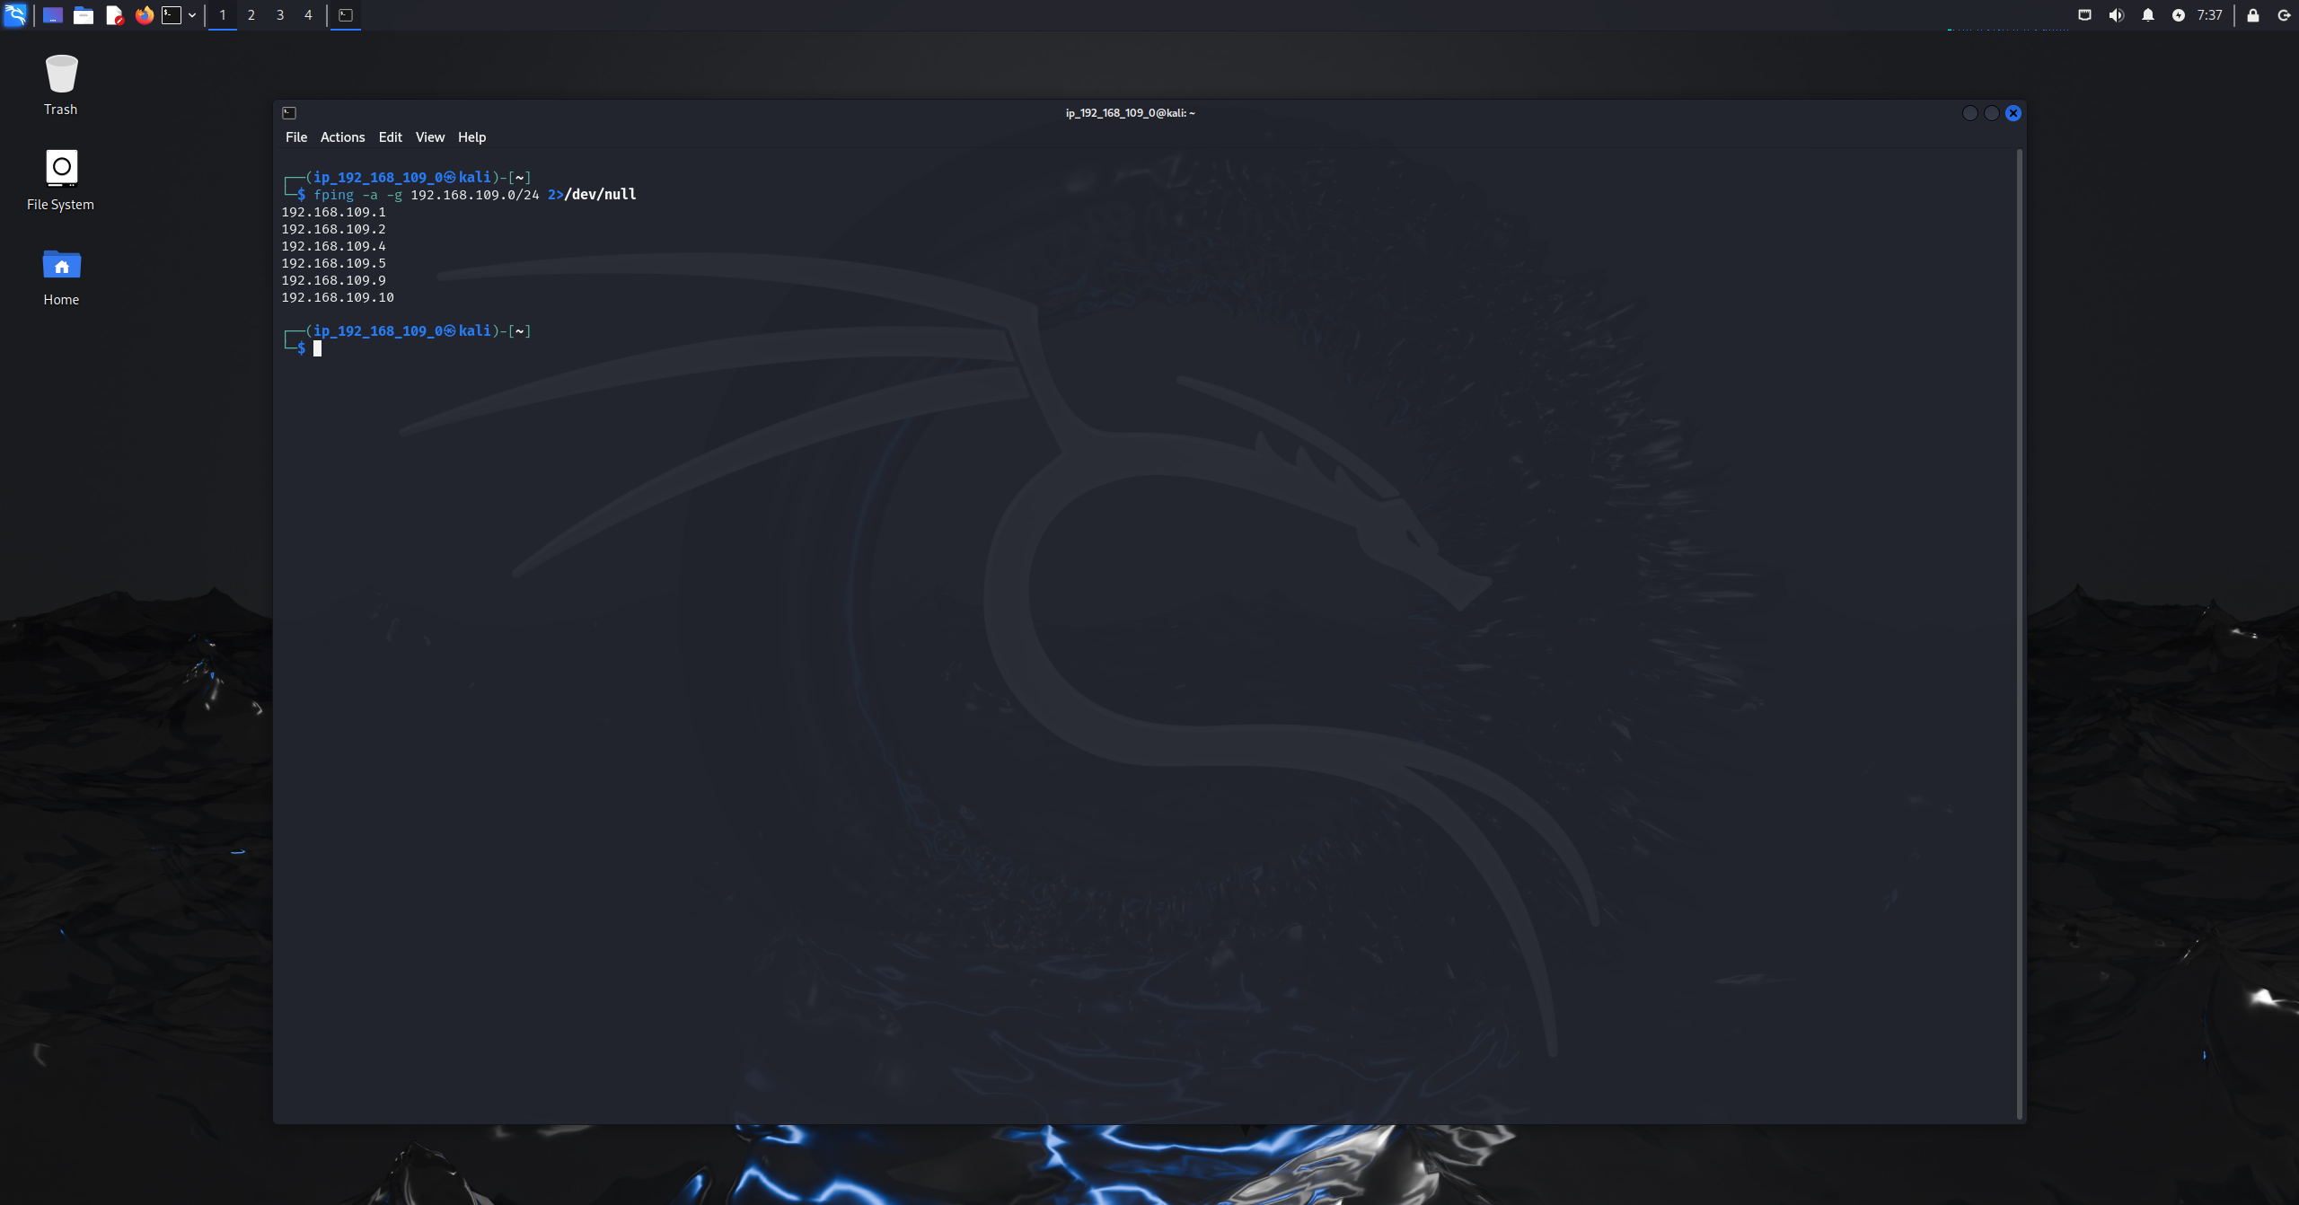
Figure 2.6: fping icmp sweep scan
Results:
Multiple hosts were found to be active in the subnet as they responded to the icmp requests:
- 192.168.109.1
- 192.168.109.2
- 192.168.109.4
- 192.168.109.5
- 192.168.109.9
- 192.168.109.10

7.
Tool: netcat
Command: nc -zv 192.168.109.5 1-65535
Methodology:
A netcat scan was performed on the target to find out the open ports without sending any data but only checks if a tcp connection can be made (-z) and displaying a detailed output (-v). 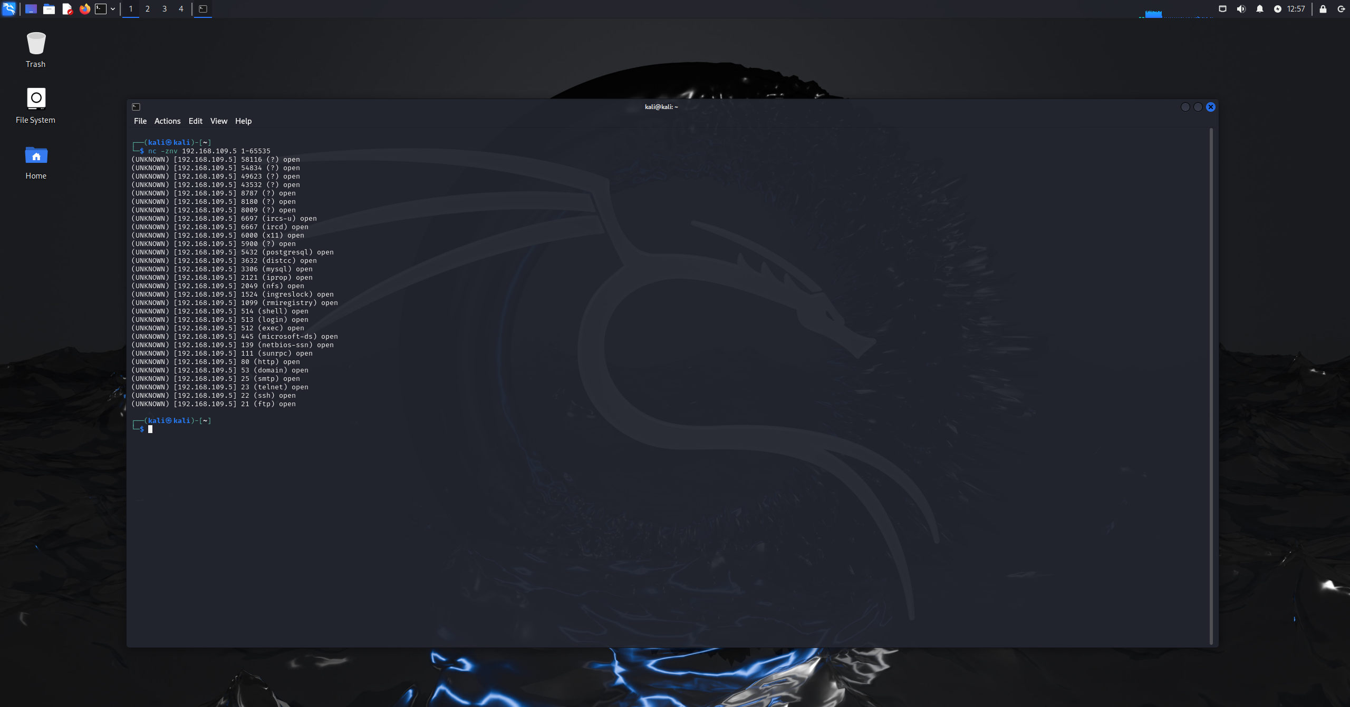
Figure 2.7: netcat tcp scan
Results:
Multiple open ports were identified on the target system:
- 21
- 22
- 23
- 25
- 80
- 139
- 445
8.
Tool: scapy
Command: for port in [21,22,23,25,80,111,139,445]:
resp = sr1(IP(dst="192.168.109.5")/TCP(dport=port, flags="S"), timeout=1, verbose=0)
if resp and resp.haslayer(TCP) and resp[TCP].flags == 18:
print(port, "OPEN")
else:
print(port, "CLOSED/FILTERED")
Methodology:
A scapy tcp scan was done on the target ip address on a selection of ports, for each port scapy sent a tcp packet with the syn flag, if the reply has a tcp layer and syn and ack the port would be considered open, but if there was no reply or a different response the port would be considered closed or filtered. 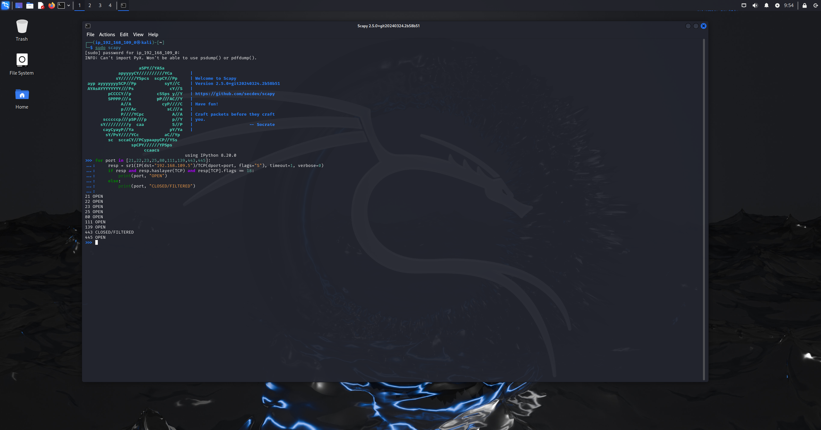
Figure 2.8: scapy loop scan
Results:
The port scan determined multiple ports as open, including the ports associated with the services of the likes of:
- ftp
- ssh
- http
- smtp
- smb
while one port was identified as closed/filtered.

Task 3: Enumeration
Target name: metasploitable 2
Operating system: Linux
Ip address: 192.168.109.5
- Complex technique
Command:
sudo msfconsole
search smtp_enum
use auxiliary/scanner/smtp/smtp_enum
set RHOSTS 192.168.109.5
run
Methodology:
The Metasploit framework was used to perform an user enumeration on smtp against the target, the Metasploit was opened using the sudo msfconsole on the kali terminal, then the technique was found by typing the search smtp_enum command to find it and then type the technique name with use at the beginning like use auxiliary/scanner/smtp/smtp_enum or you can just type use with the index number of the technique.
After the technique was chosen, the target ip address is configured using the set rhost command, moreover there is no need to alter or change anything else as the target port is by default on port 25.
When executed, the module connects to the smtp service and issues the VRFY and EXPN commands to test for valid users accounts as the server responses are analyzed to find out whether specific users exist in the target system.
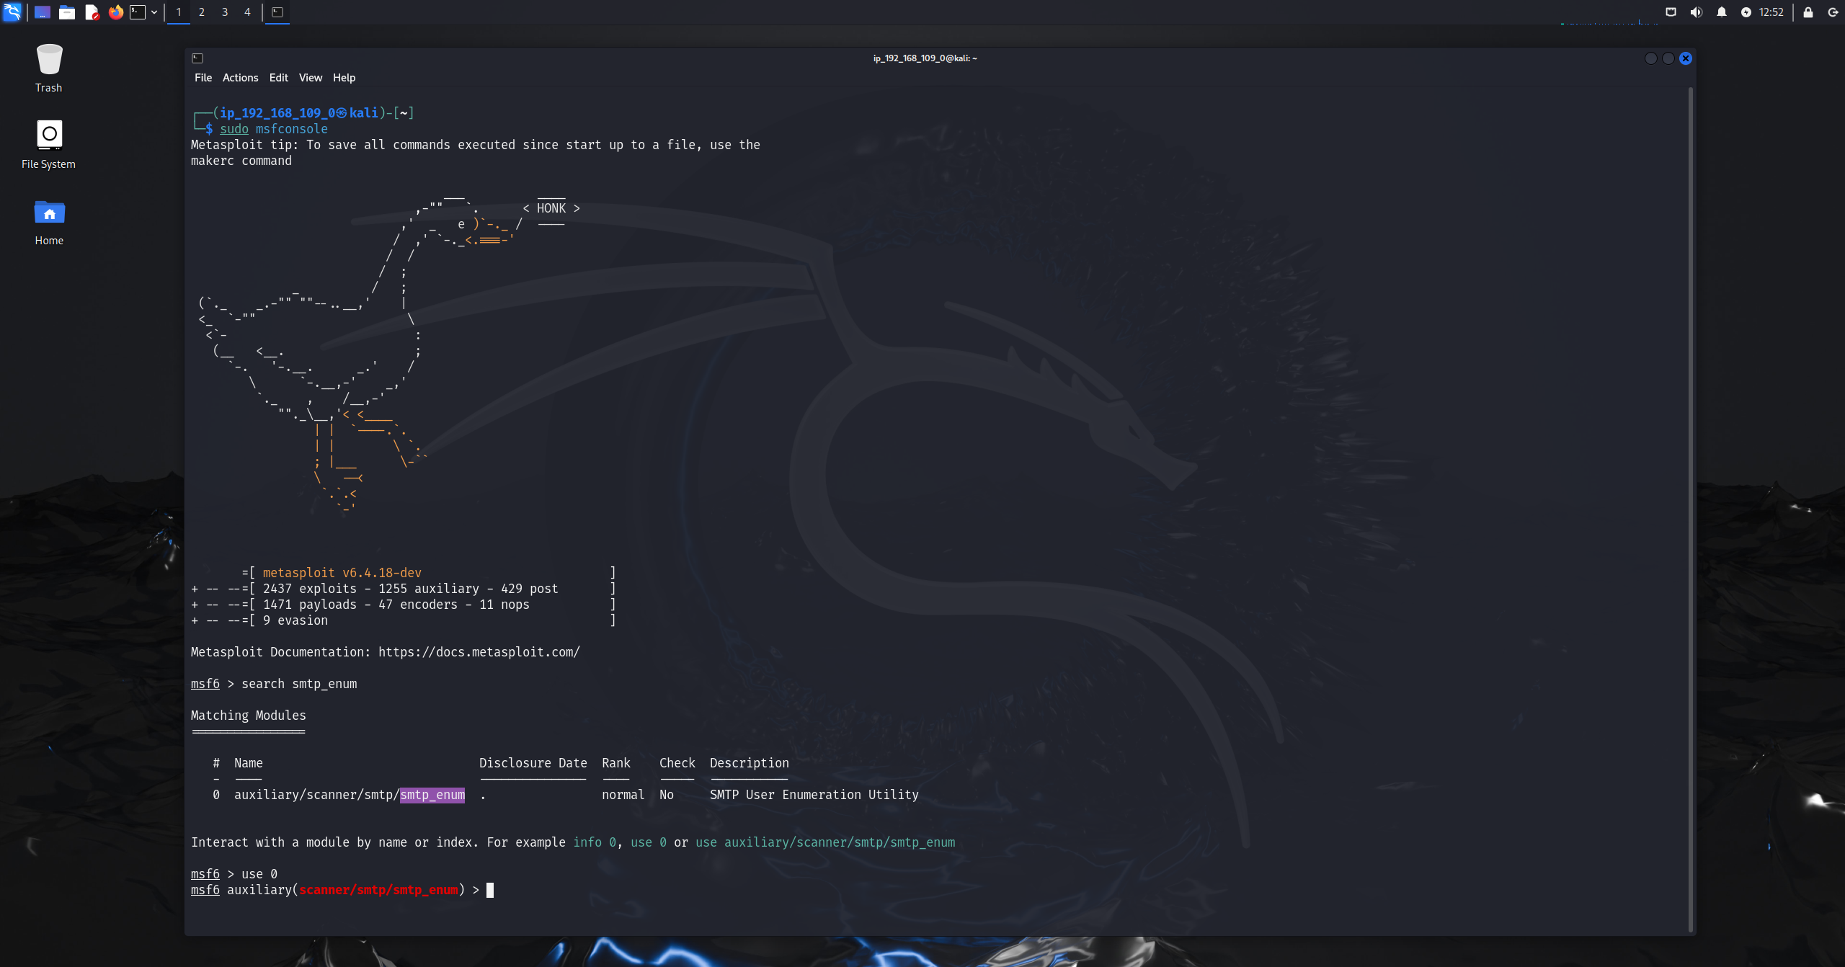
Figure 3.1A: starting Metasploit and selecting module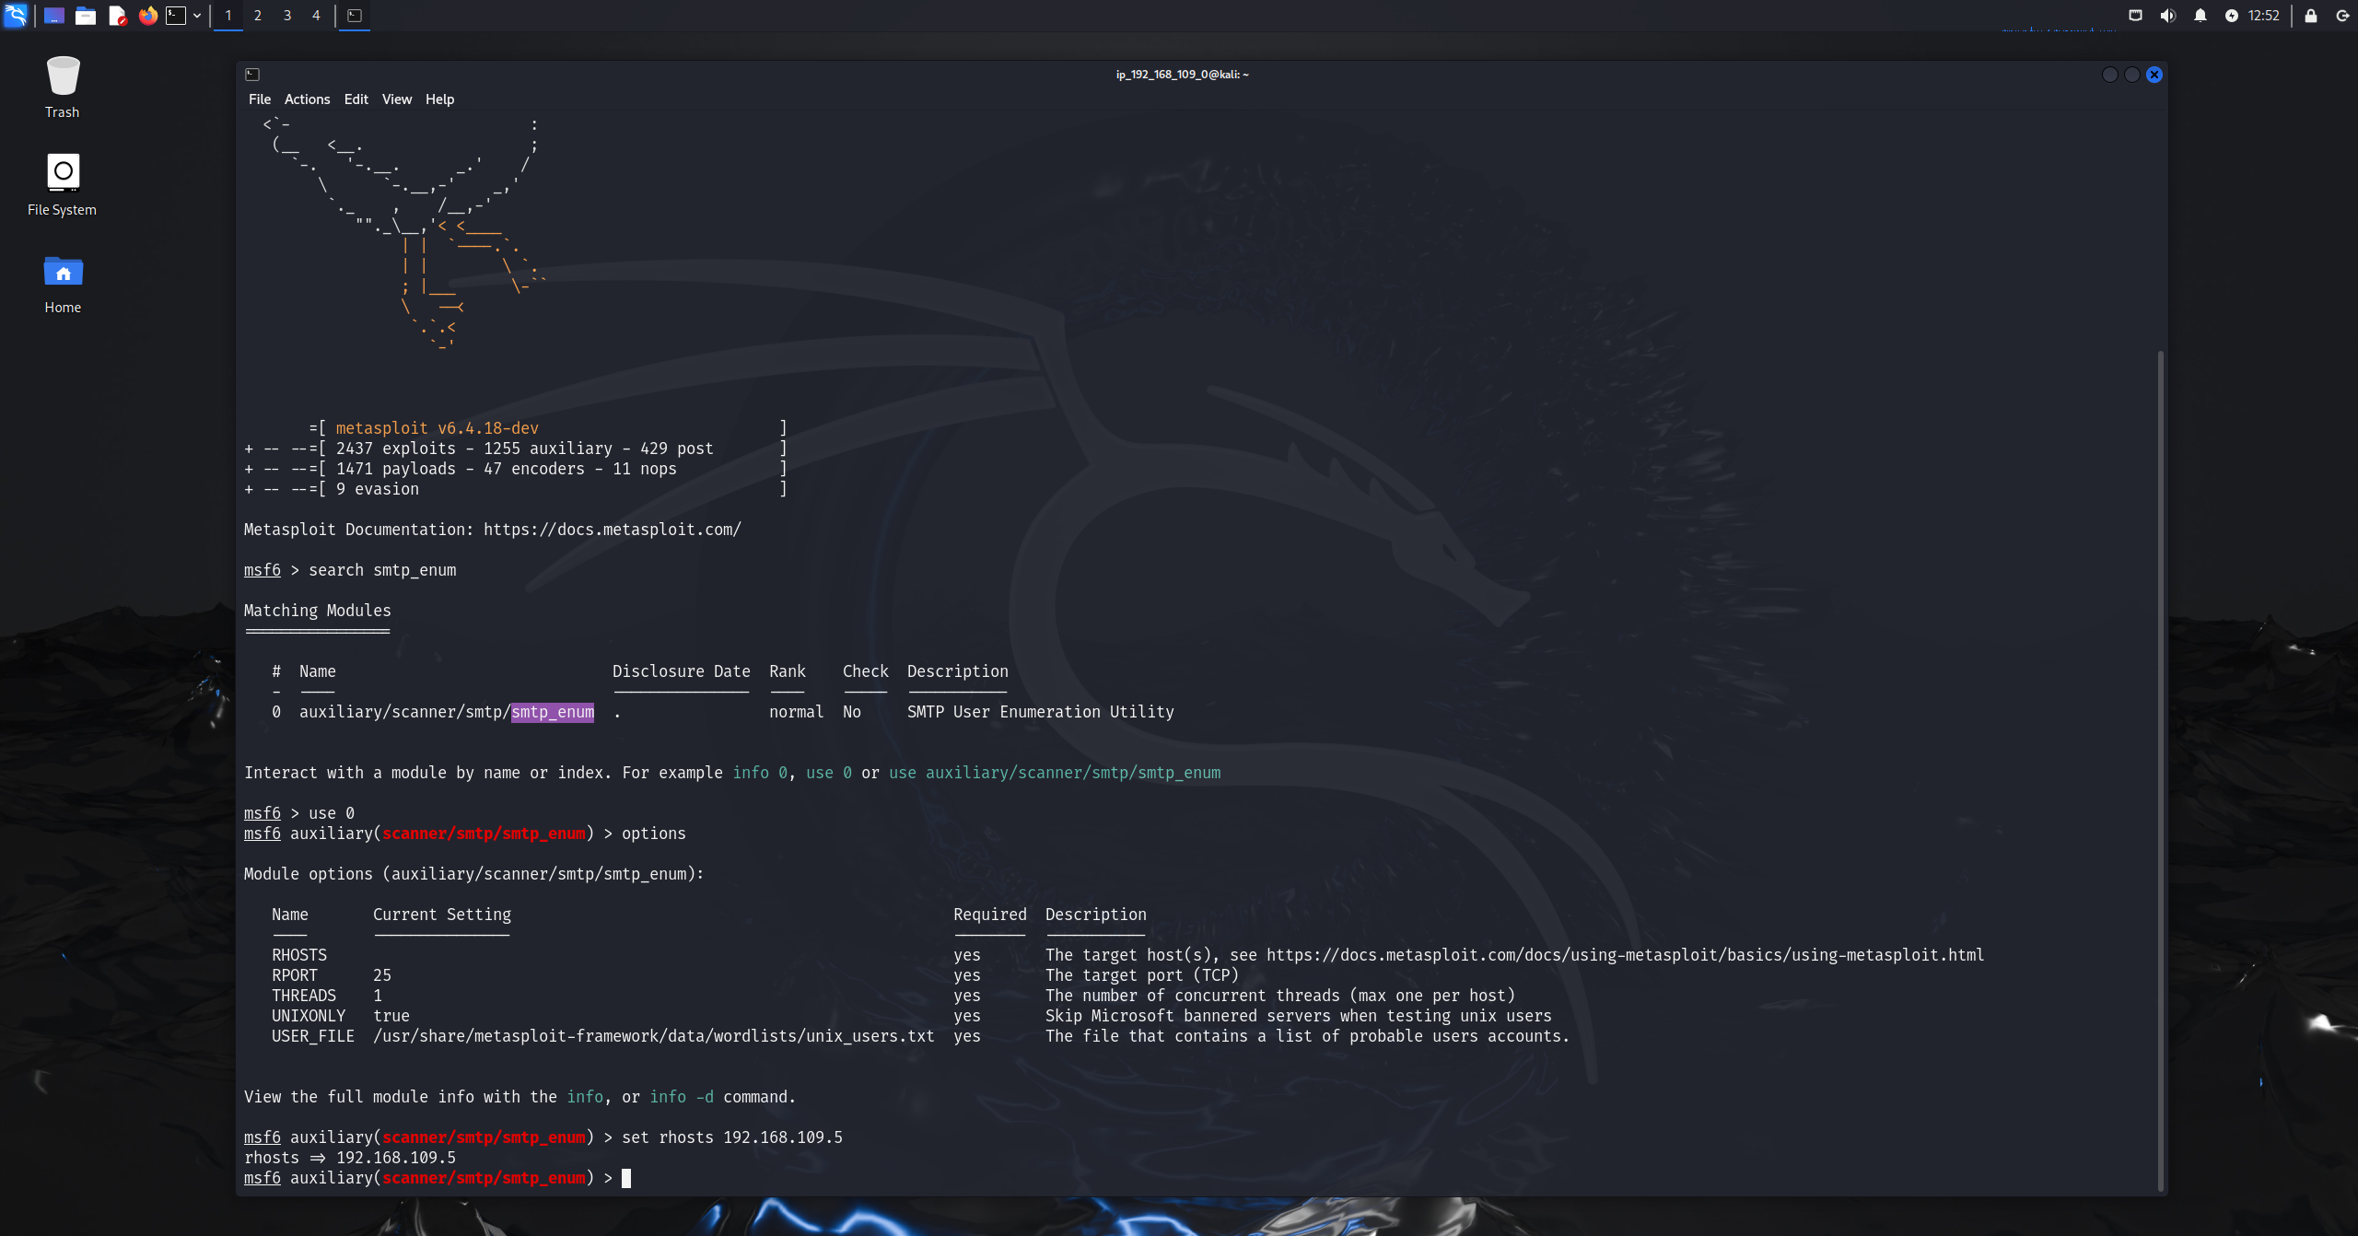
Figure 3.1B: viewing options and setting the target ip as rhosts
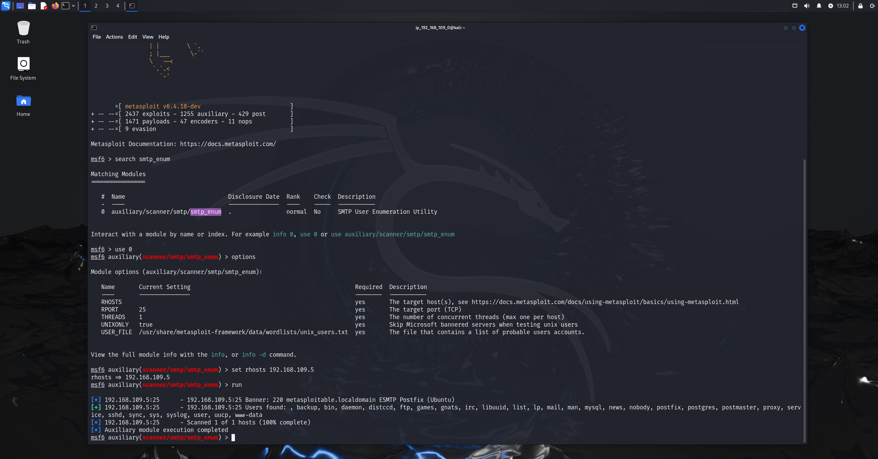
Figure 3.1C: module executed and output displayed

Results:
- The SMTP enumeration successfully identified multiple valid local user accounts on the target system. The SMTP service was confirmed to be Postfix (Ubuntu) running on port 25.
- The following valid user accounts were discovered:
backup, bin, daemon, distccd, ftp, games, gnats, irc, libuuid, list, lp, mail, man, mysql, news, nobody, postfix, postgres, postmaster, proxy, root, service, ssh, sync, sys, syslog, user, uucp, www-data
- The discovery of privileged and service-related accounts such as root, postgres, postfix, and www-data is particularly significant, as these accounts are commonly targeted during brute-force attacks, password reuse attempts, or privilege escalation in later exploitation phases.

Independent/ Researched Techniques
2. Complex smb commands
Command:
Smbclient -L //192.168.109.5/ -N
Nmap --script smb-enum-shares -p 445 192.168.109.5
Smbclient //192.168.109.5/tmp -N
Nmap –script smb-enum-users -p 445 192.168.109.5
Methodology:
Smb enumeration was used to identify any shared resources and any users exposed, first smbclient was used with the -L syntax to list all available smb shares while performing anonymous authentication (-N) which skips password prompts.
After confirming that anonymous access was allowed, a direct connection was made to the tmp share using smbclient, additionally basic directory listing and navigation like ls and cd were used to verify the read and write access and inspect the content of the share.
To get more smb information, nmap scripts were used like smb-enum-shares performed to retrieve detailed data about each shared resource, also the smb-enum-users script was used after to enumerate domain and local user accounts exposed by the smb service. 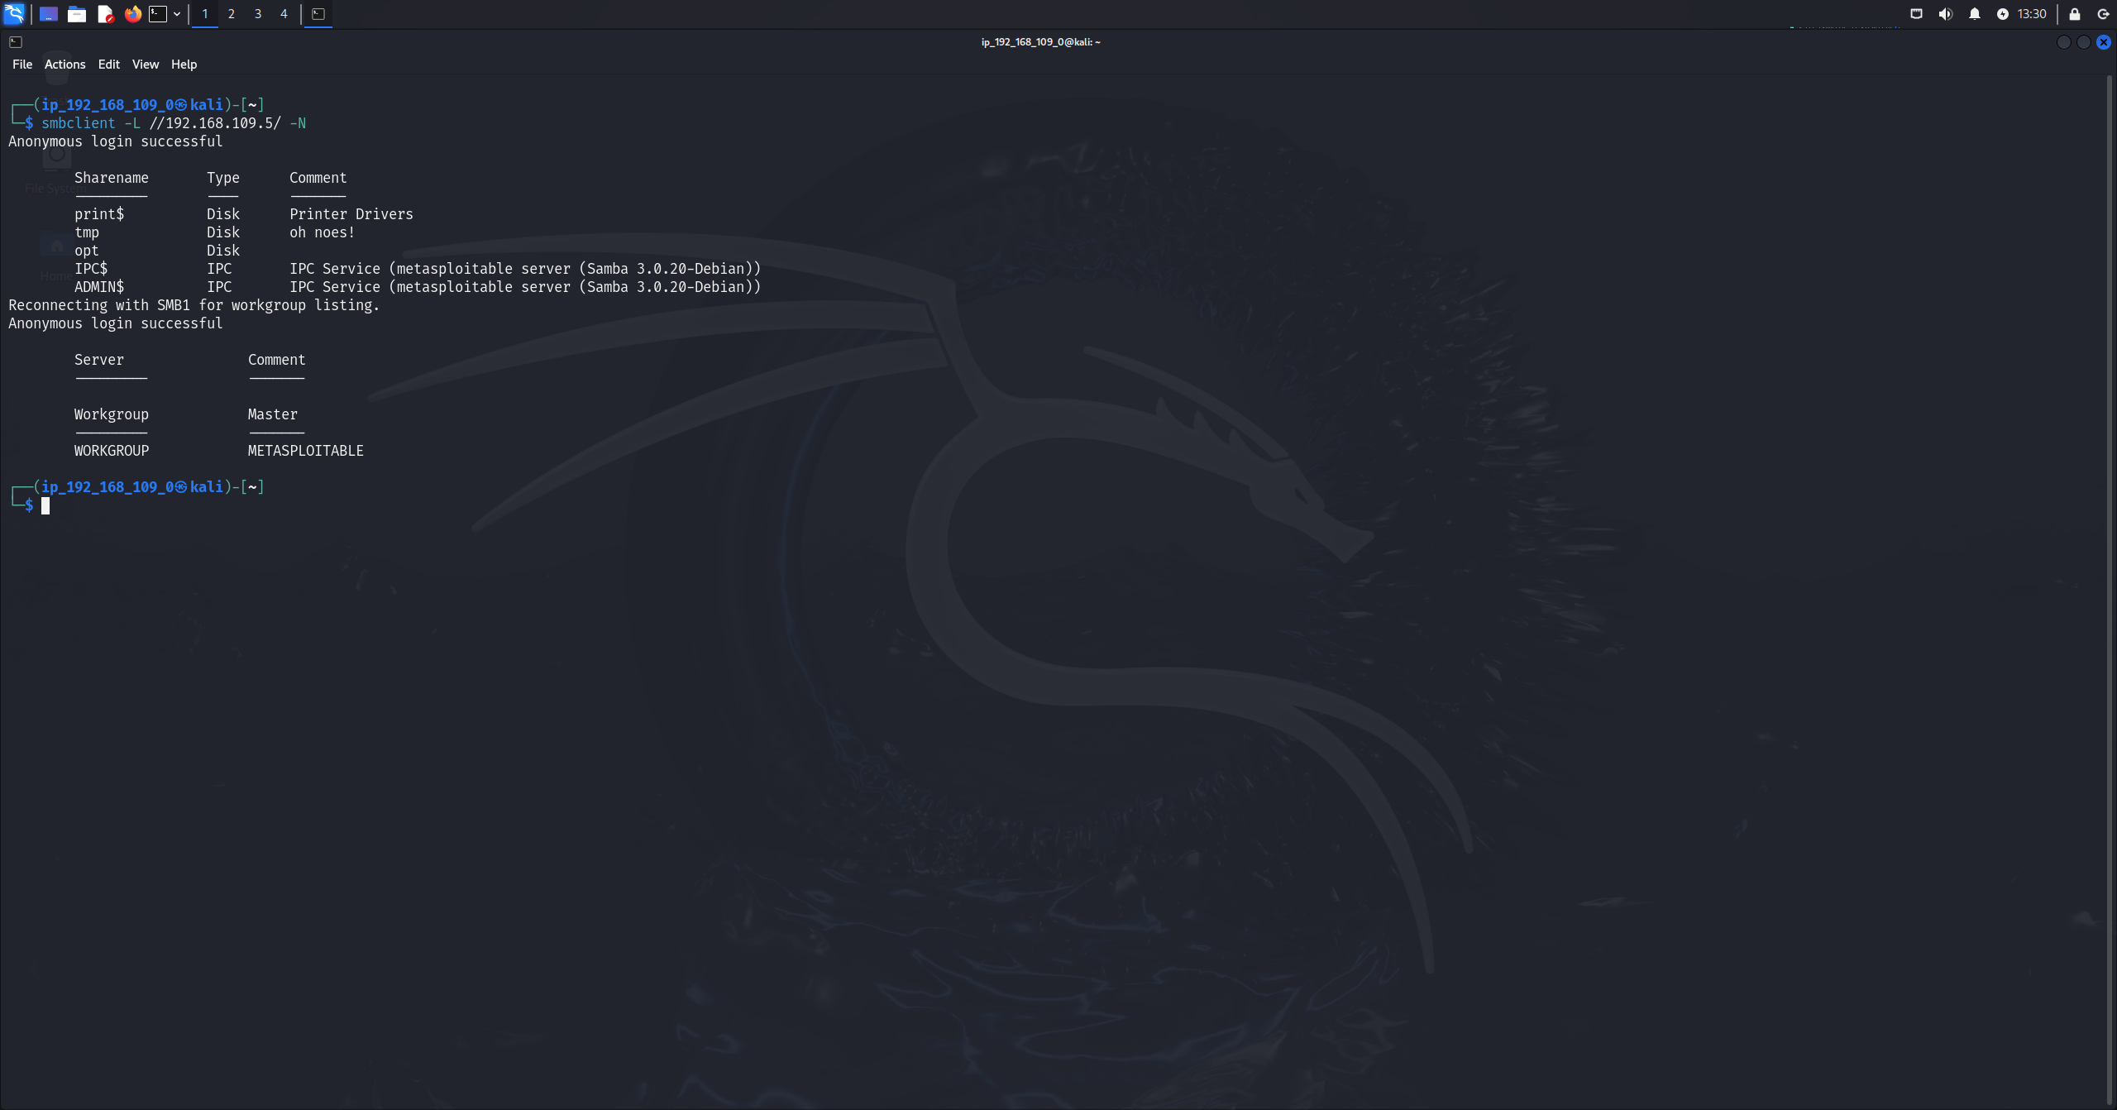Figure 3.2A: smbclient -L command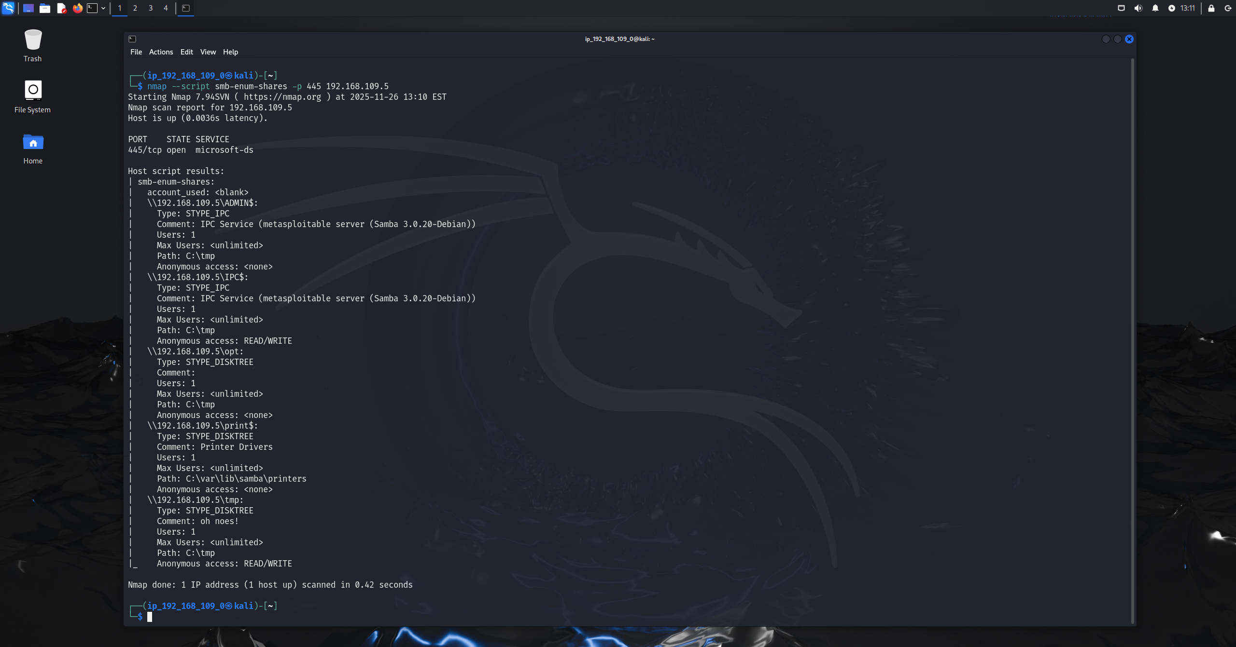 Figure 3.2B : nmap smb shares enumeration script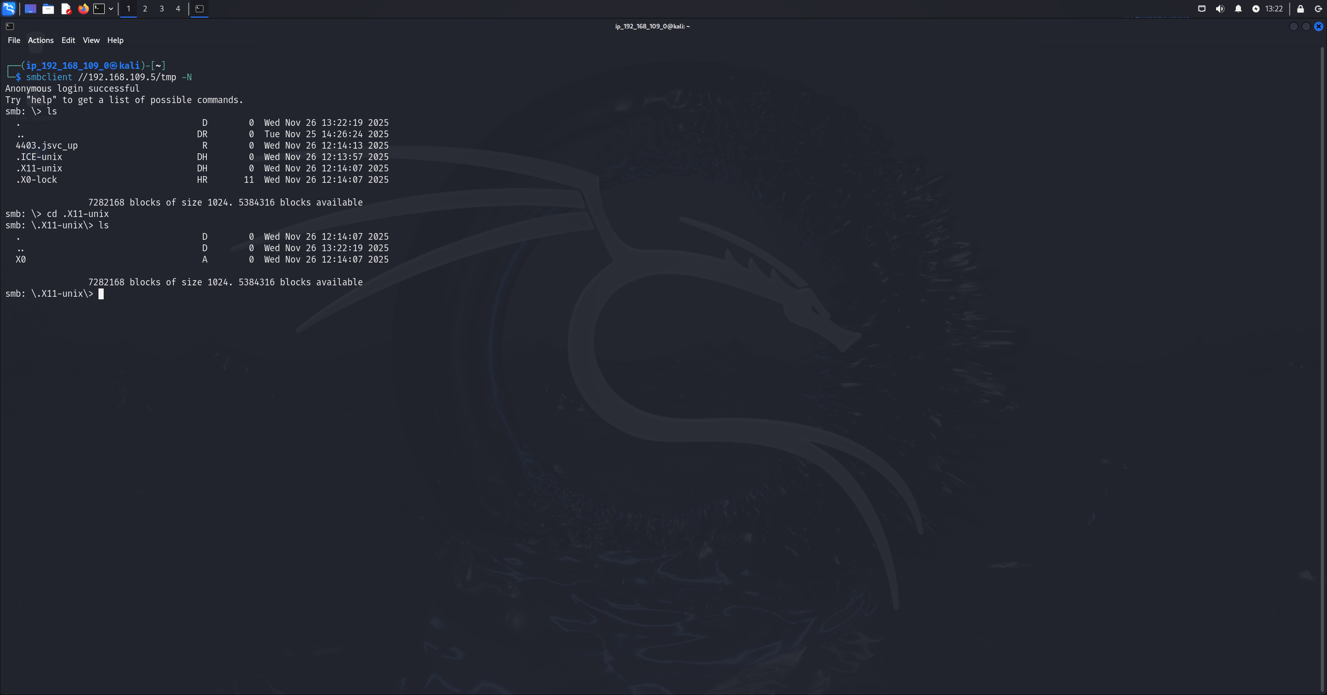 Figure 3.2C: smb client tmp command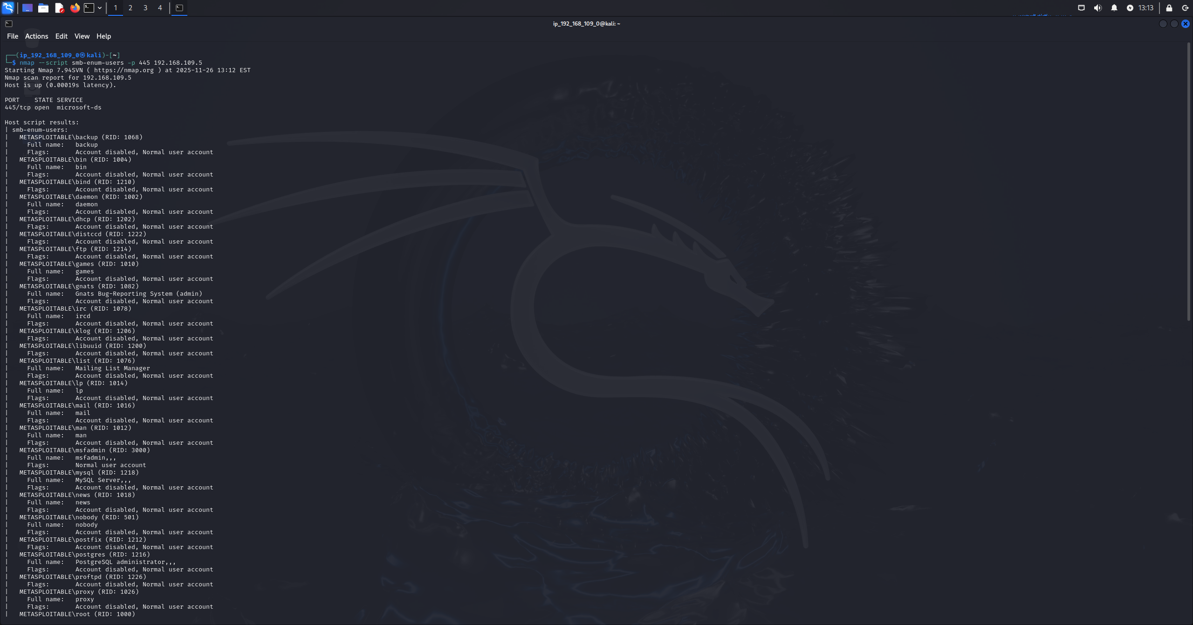 Figure 3.2D: smb enumeration users script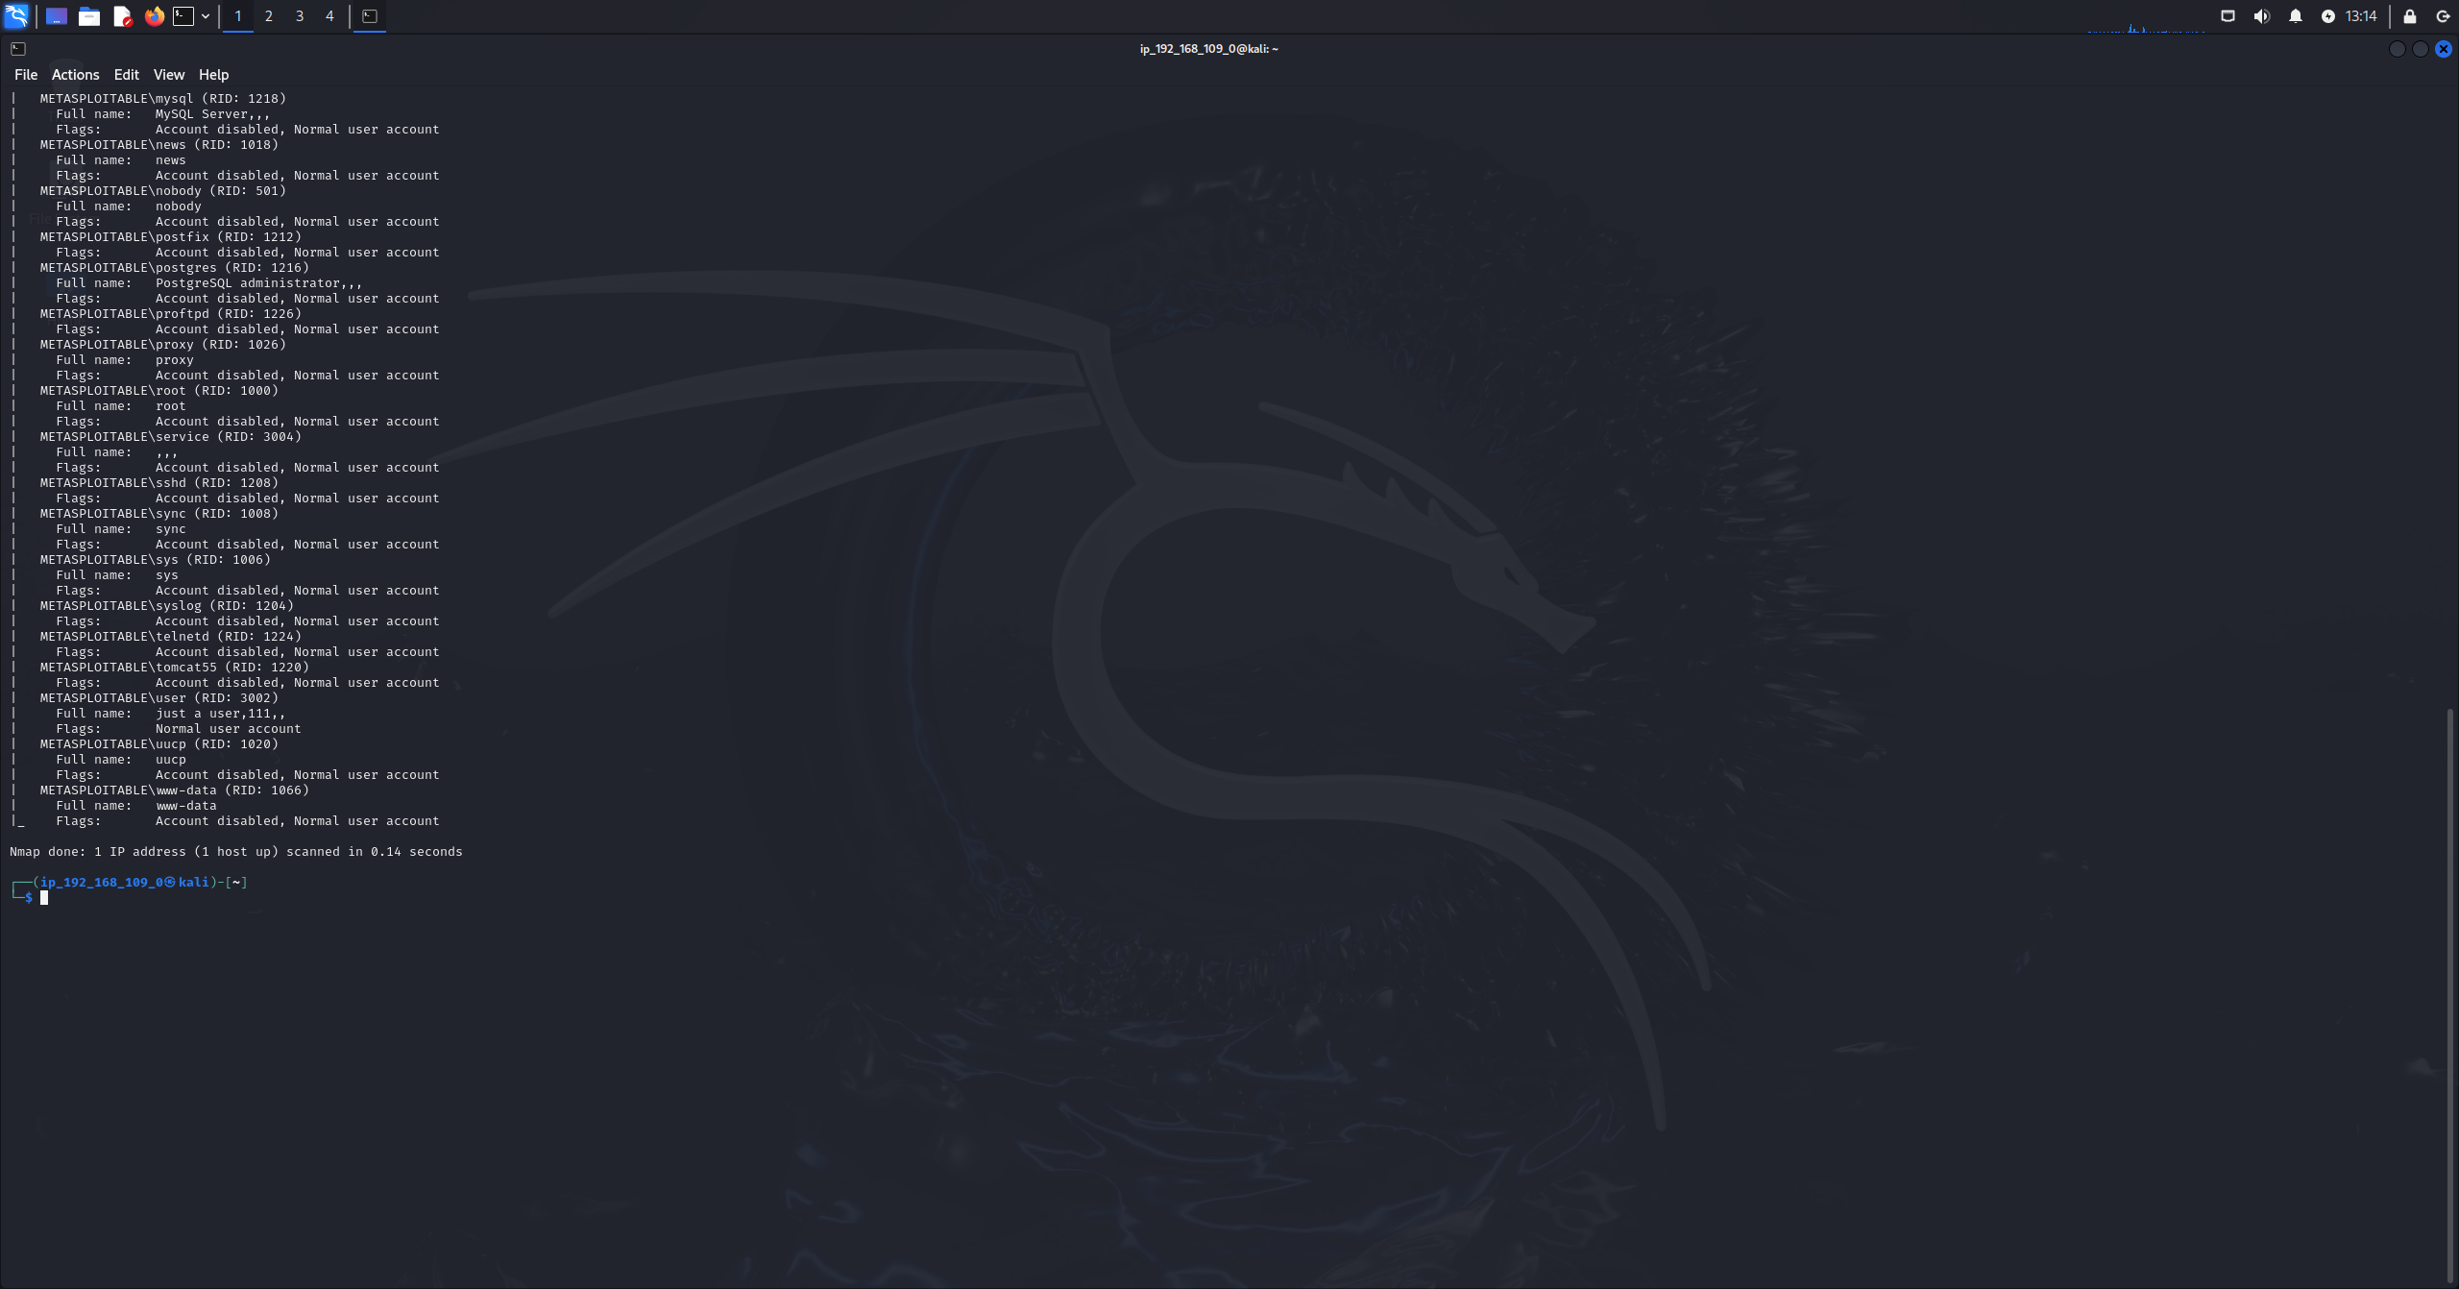
Figure 3.2E: smb enumeration users script output part 2
Results:
1.Smb shares
The following smb shares were identified by anonymous access:
Print$, tmp, opt, IPC$, ADMIN$
This concludes that:
- Anonymous login was successful
- The tmp share allowed READ/WRITE access
- The print$ share exposed printer driver storage
- IPC$ and ADMIN$ services confirmed Samba version:
  - Samba 3.0.20-Debian (Metasploitable server)

2.smb file system access:
The tmp share was accessed anonymously and directory contents were listed successfully as navigation into subdirectories confirmed that the file system interaction was possible without authentication, this indicates that the target has misconfigured smb permissions allowing unauthenticated users to access and interact with the shared directories.

3.smb user enumeration:
Using the script smb-enum-users, multiple valid user accounts were enumerated:
The following list of users were identified:
backup, bin, daemon, distccd, ftp, games, gnats, irc, libuuid, list, lp, mail, man, mysql, news, nobody, postfix, postgres, postmaster, proxy, root, service, ssh, sync, sys, syslog, telnetd, uucp, www-data.
Several accounts were identified as valid users:
- root
- mysql
- postgres
- www-data
- service

Task 4: Vulnerability Scanning

Target name: metasploitable 2
Operating system: linux
Ip address: 192.168.109.5
1.
Tool: Greenbone (OpenVAS)
Interface: Greenbone enterprise appliance
Methodology:
This vulnerability scan was performed using the greenbone enterprise appliance web interface, a new scan task was configured to use the openvas default scanner and the full and fast type which enables deep vulnerability checks while remaining in a reasonable scan time.
Also, while creating a new task a new scan target was created named meta2 with the target ip address with the default port list and alive test settings, and no authentication credentials which results in an unauthenticated vulnerability scan.
After the scan was finished, the generated report was reviewed using tabs like the results, hosts, ports etc..... 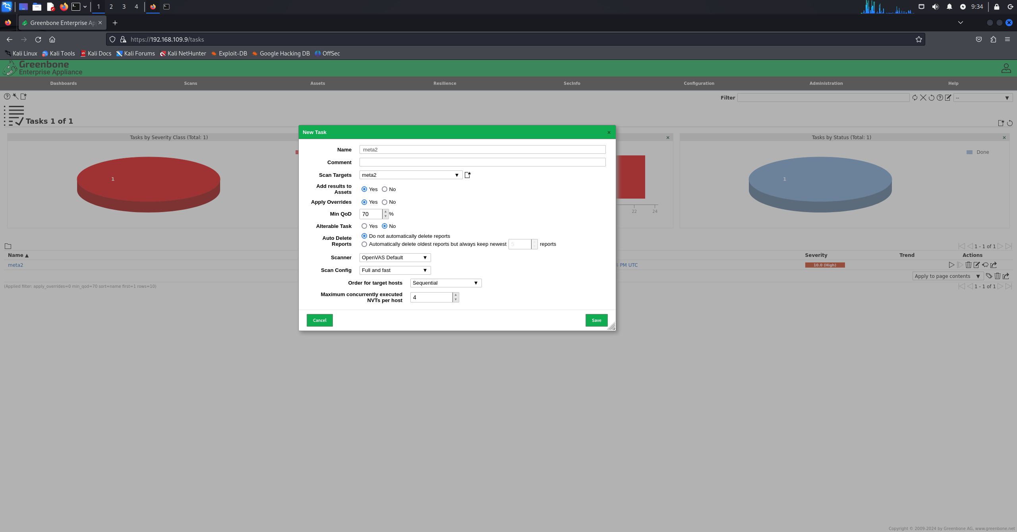 Figure 4.1A: configuring the scan 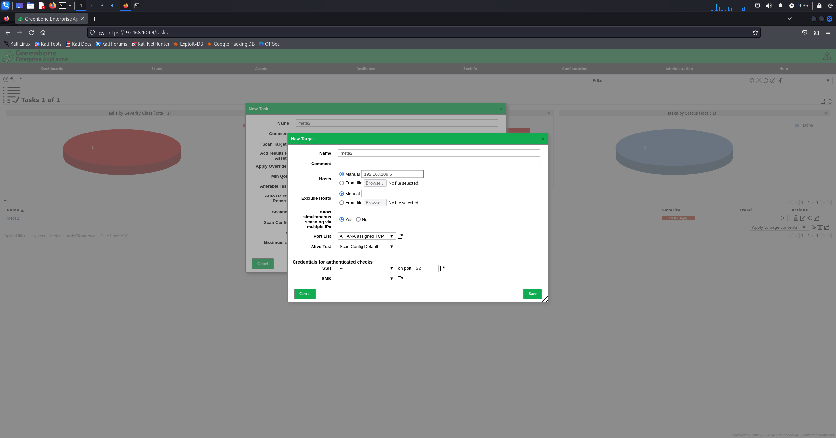 Figure 4.1B: configuring the target 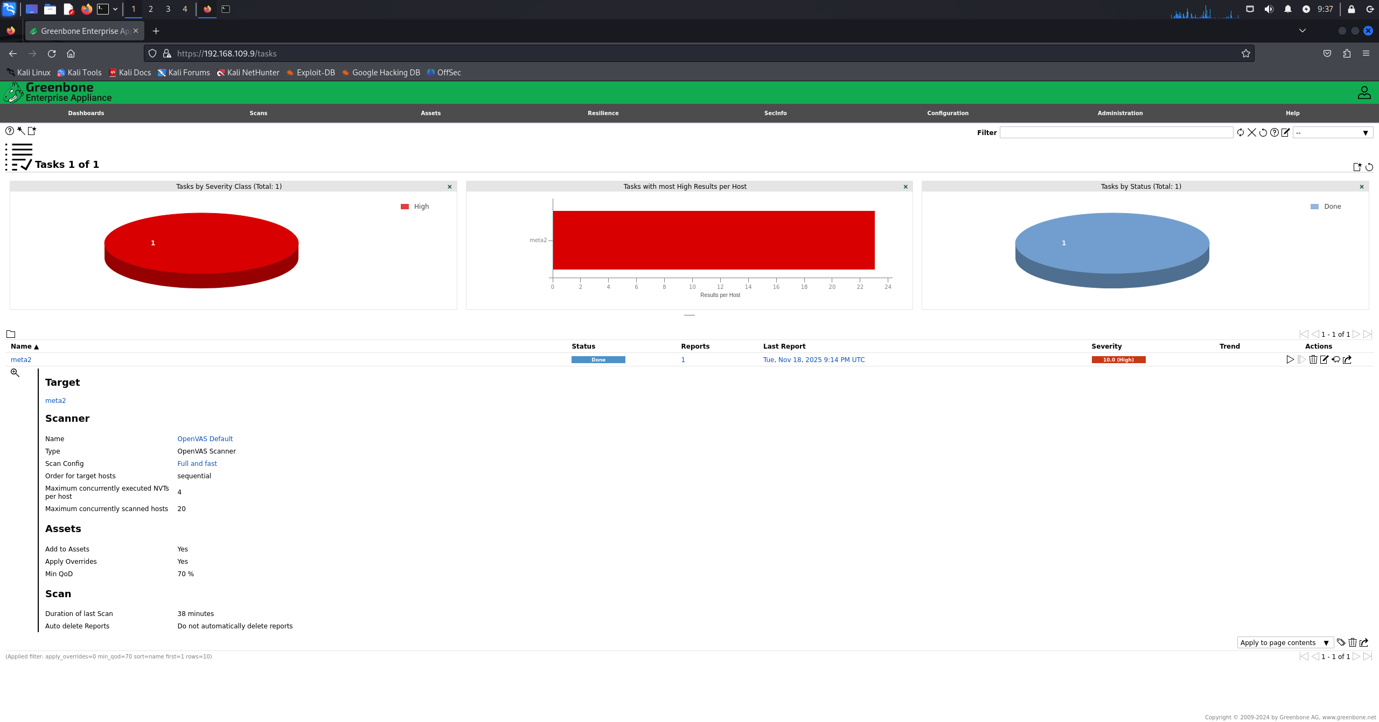 Figure 4.1C: scan done 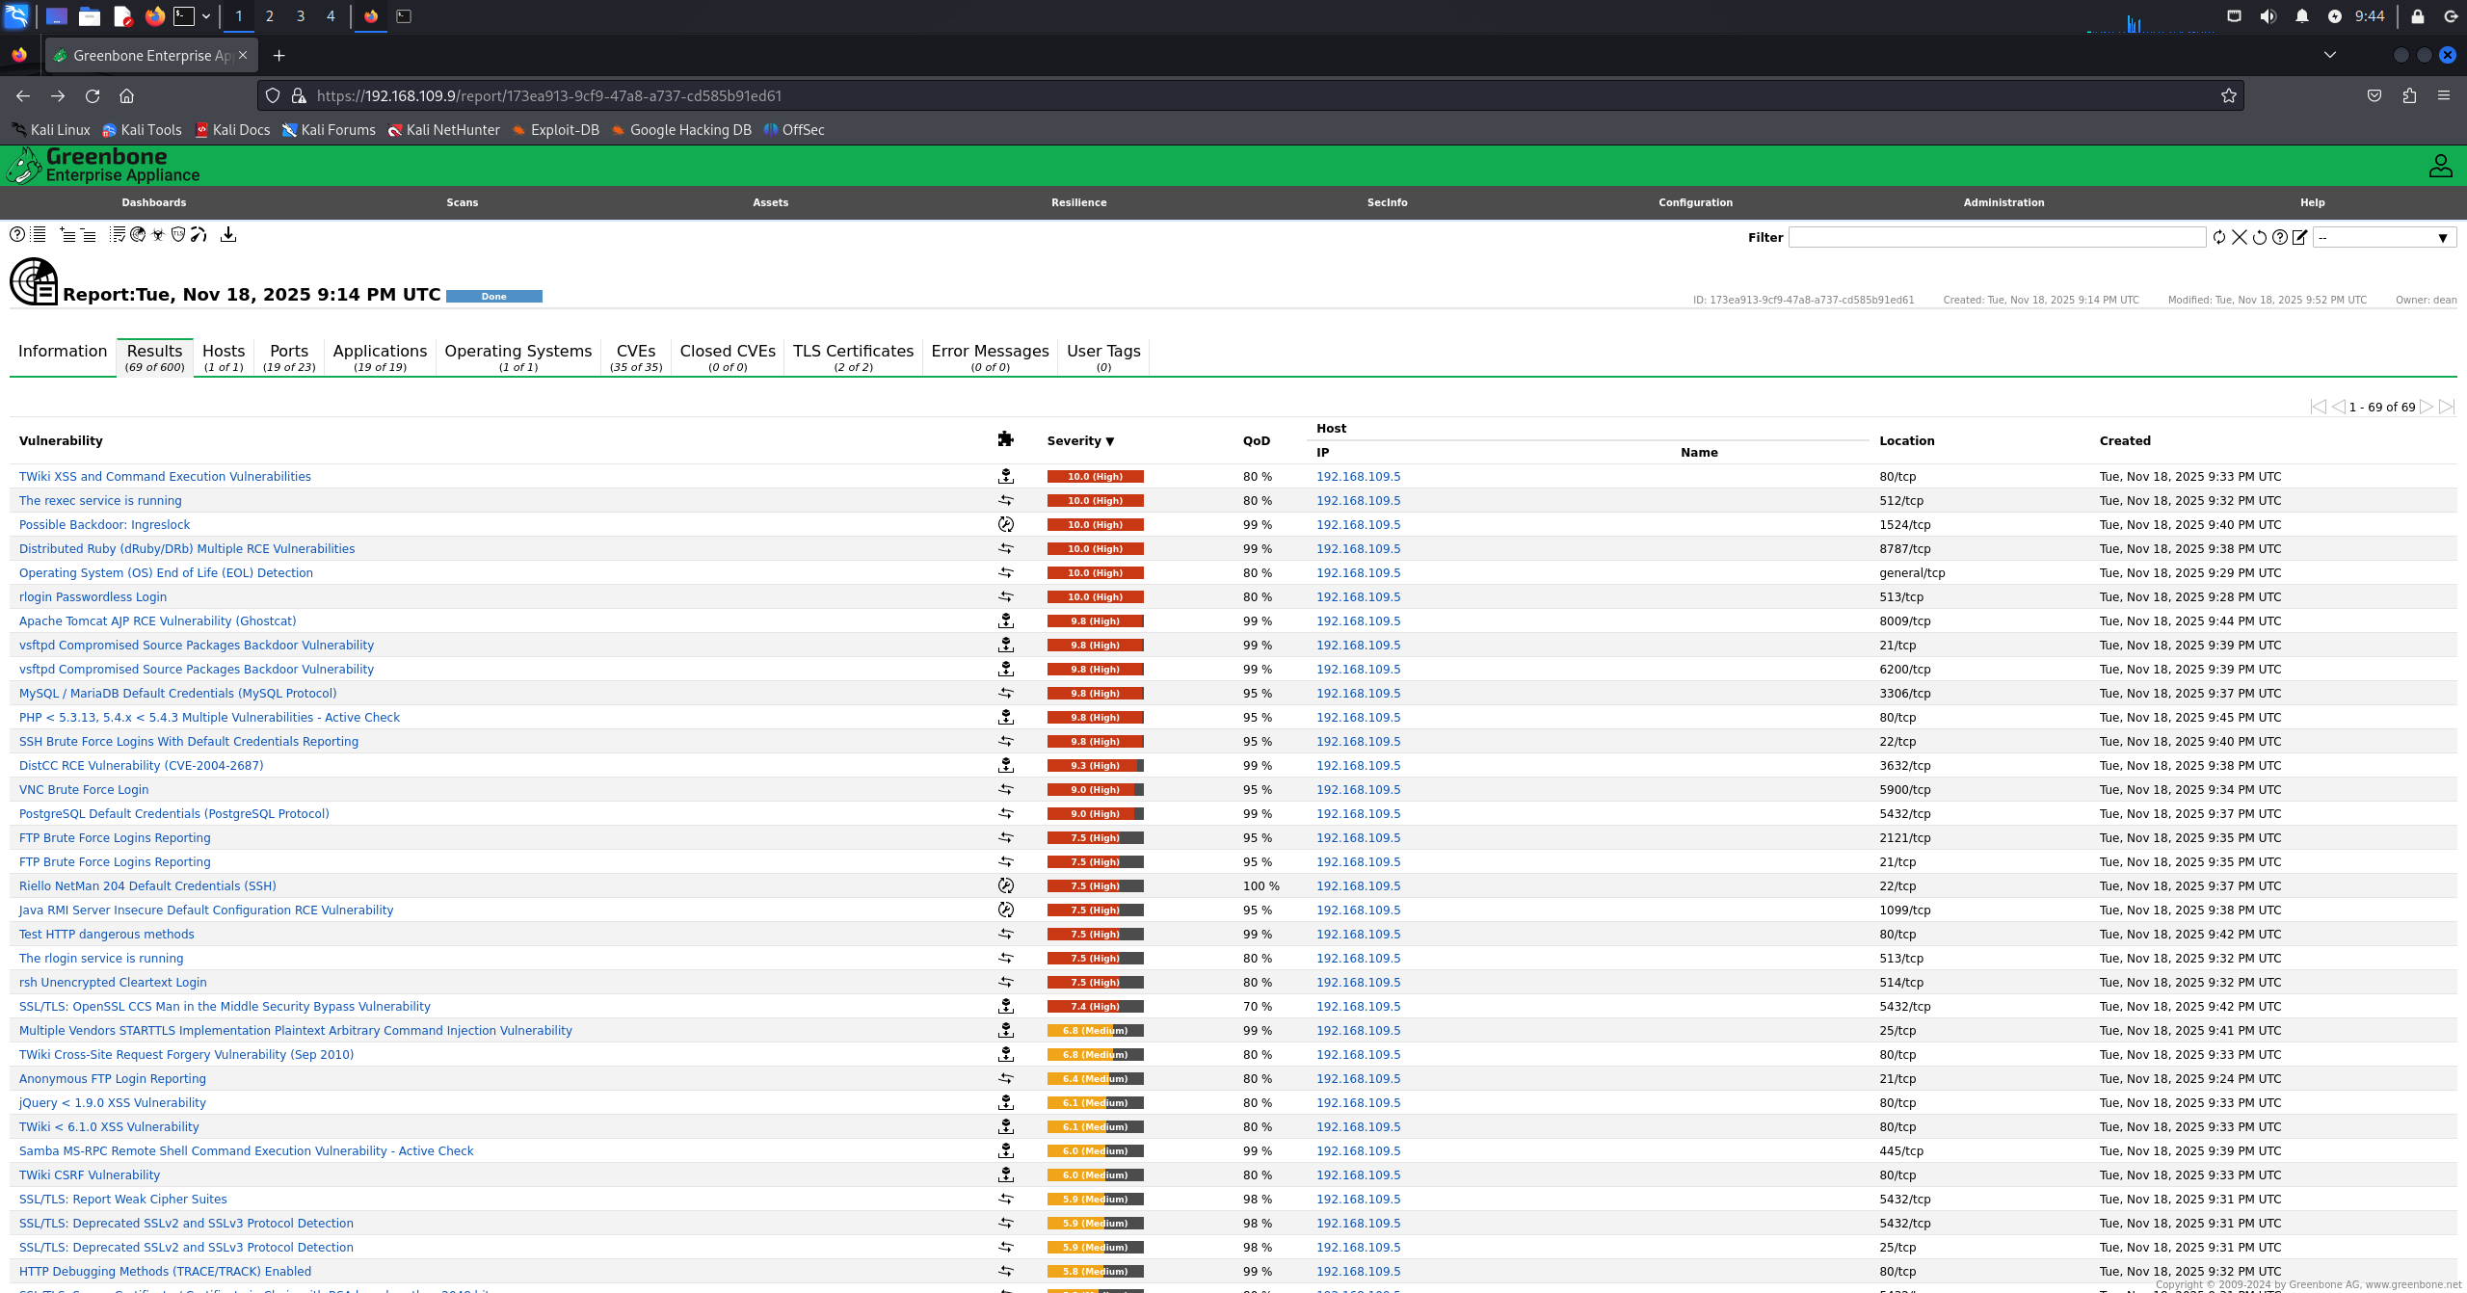 Figure 4.1D: the results tab 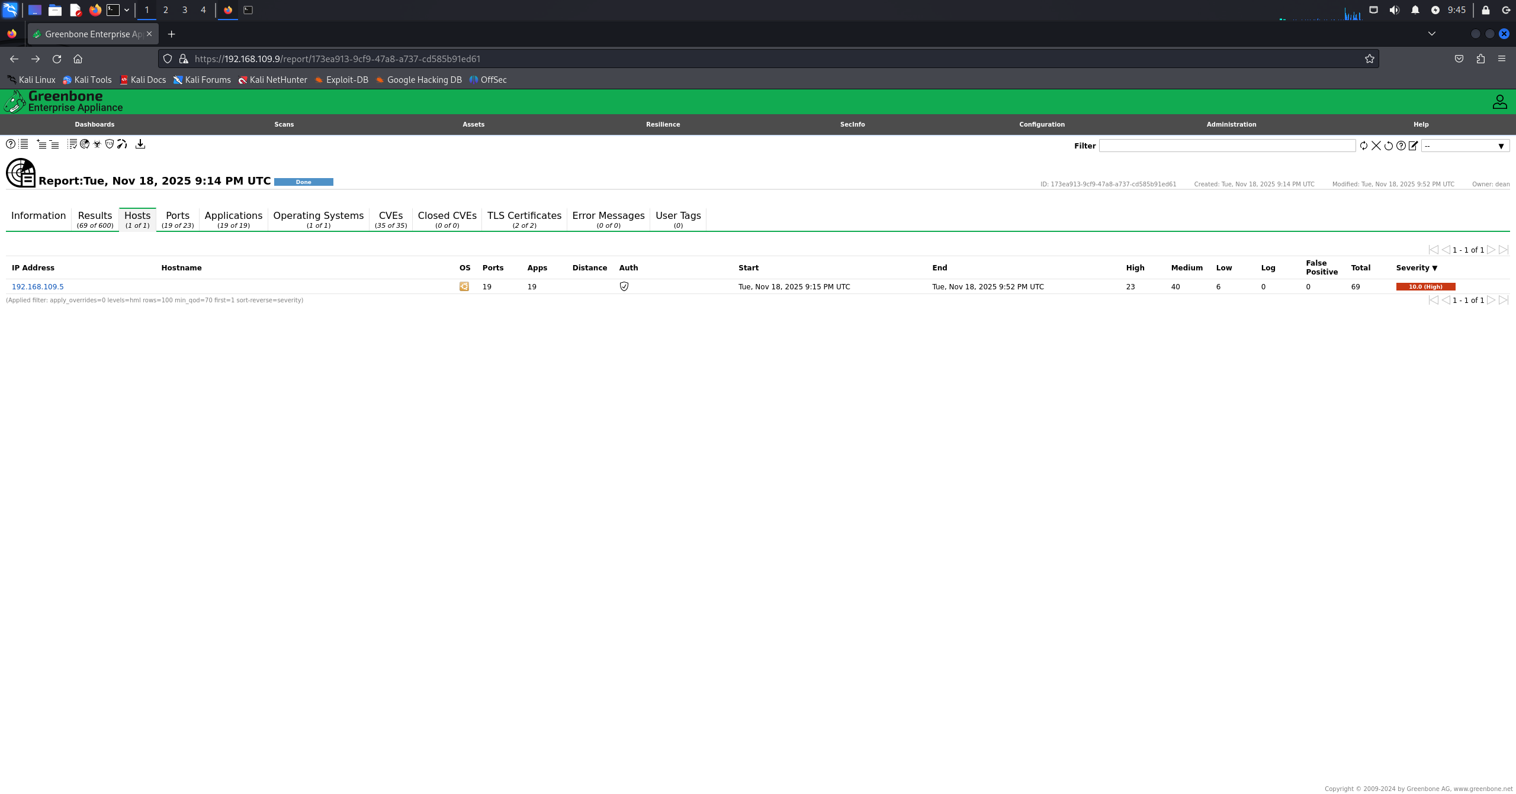 Figure 4.1E: the hosts tab 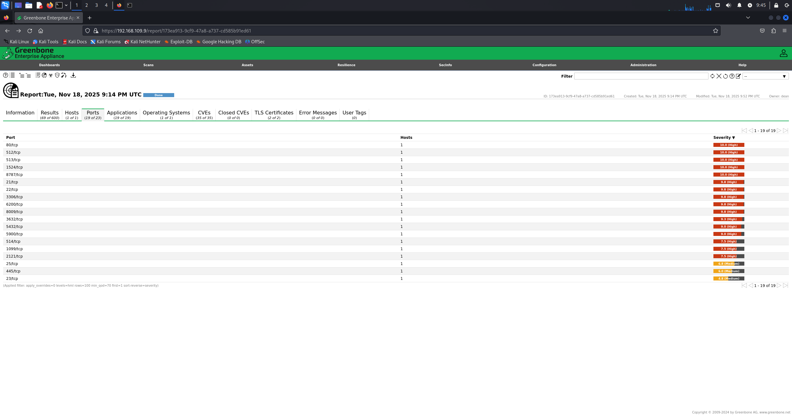 Figure 4.1F: the ports tab 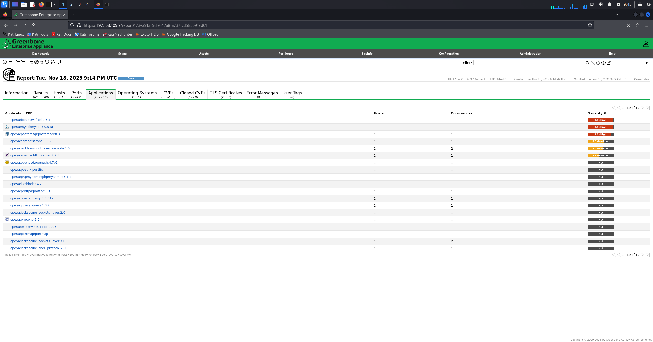 Figure 4.1G: the applications tab 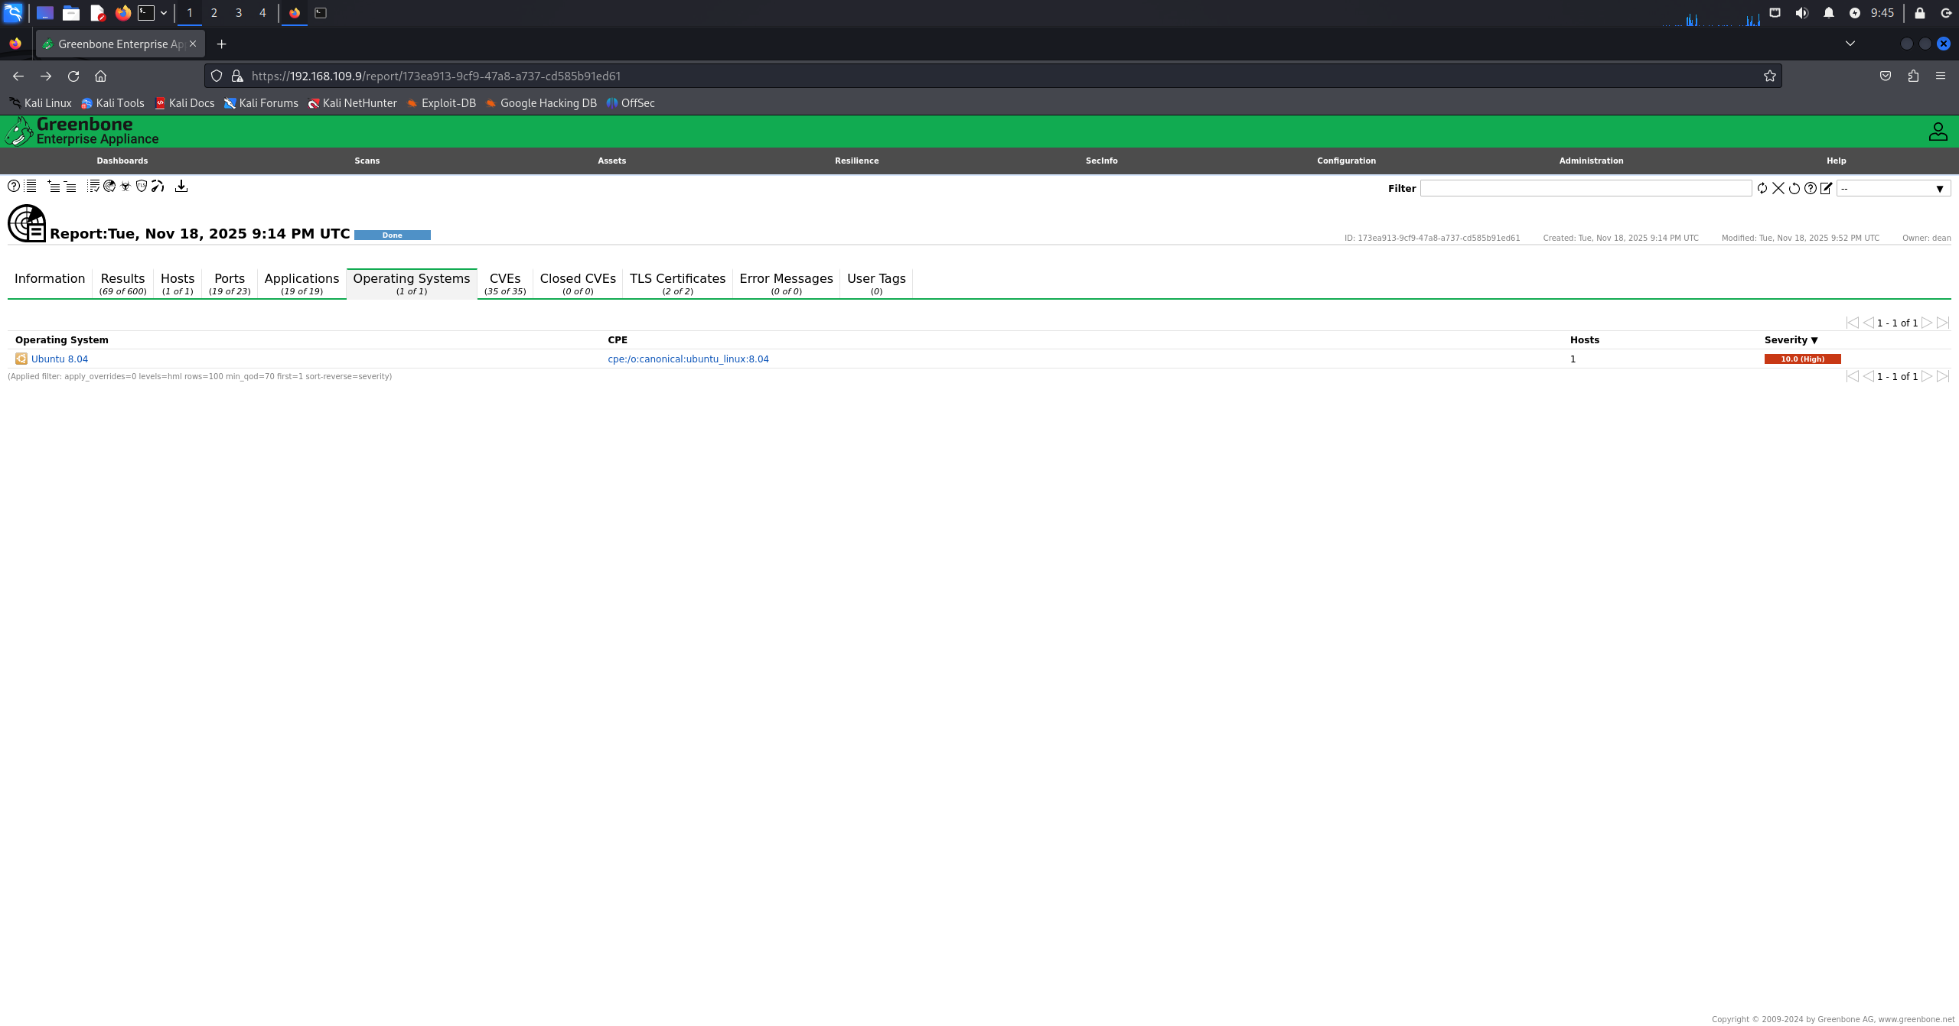 Figure 4.1H: Operating system tab 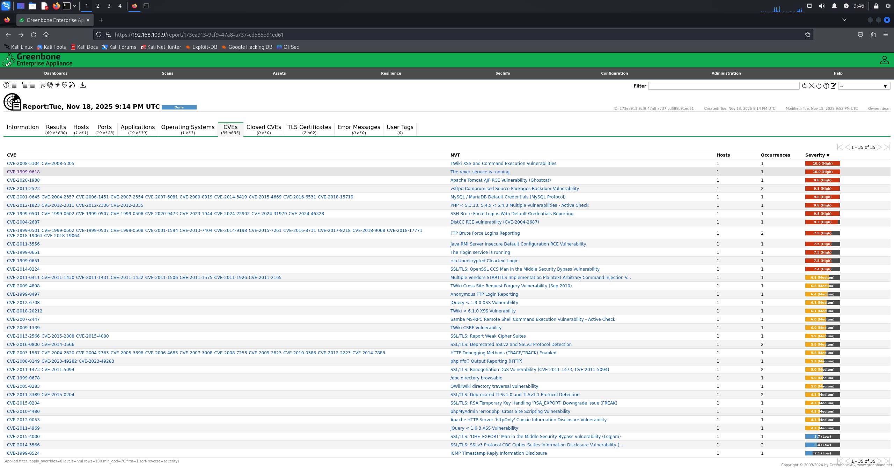 Figure 4.1I: CVE's tab 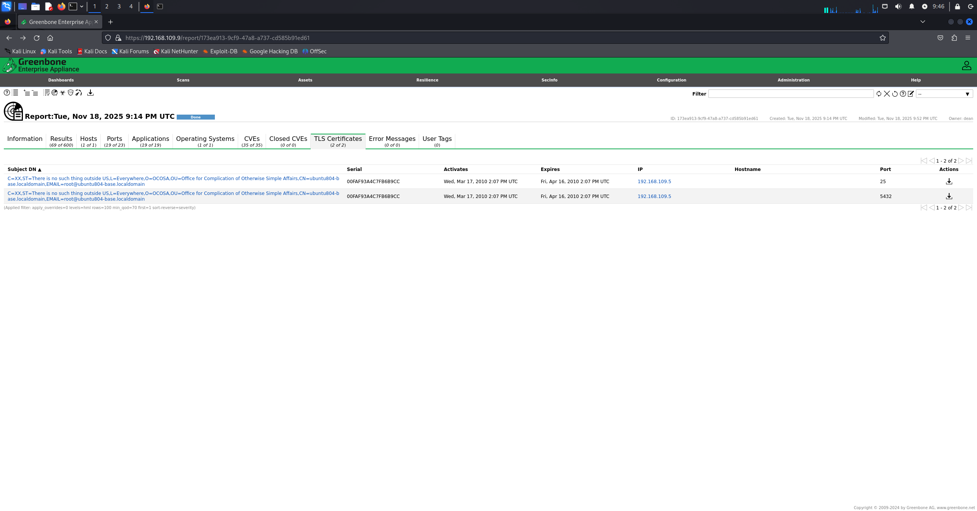 Figure 4.1J: TLS certificates tab

Results:
- Total vulnerabilities detected: 69
Vulnerability | Description | CVE ID | CWE Category | CVSS Score
TWiki XSS and Command Execution Vulnerabilities | TWiki installation is vulnerable to cross-site scripting (XSS) and command execution due to improper input sanitization, allowing attackers to inject scripts or execute commands. | CVE-2008-5304 | Not Applicable | 10.0
rexec Service Running | The rexec remote execution service is enabled, allowing remote command execution with credentials transmitted in cleartext. | CVE-1999-0618 | Not Applicable | 10.0
vsftpd Compromised Source Package Backdoor | The vsftpd FTP service contains a known backdoored version that opens a shell on a high port when triggered. | CVE-2011-2523 | Not Applicable | 9.8
DistCC Remote Code Execution | DistCC service allows execution of arbitrary commands remotely without authentication. | CVE-2004-2687 | Not Applicable | 9.3
rsh Unencrypted Cleartext Login | The rsh service allows remote shell access using unencrypted credentials, exposing authentication data. | CVE-1999-0651 | Not Applicable | 7.5

2.
Tool: Tenable nessus essentials
Interface: Nessus web interface
Methodology:
A basic network scan was created using nessus web interface with the target ip address manually configured and with the default discovery and assessment settings as no authentication credentials were provided resulting in an unauthenticated vulnerability scan using the built in plugin database of the tool.
After the nessus vulnerability scan was done, the results were analyzed using the hosts and the vulnerabilities tabs to review the severity and risk level of each of the vulnerabilities found. 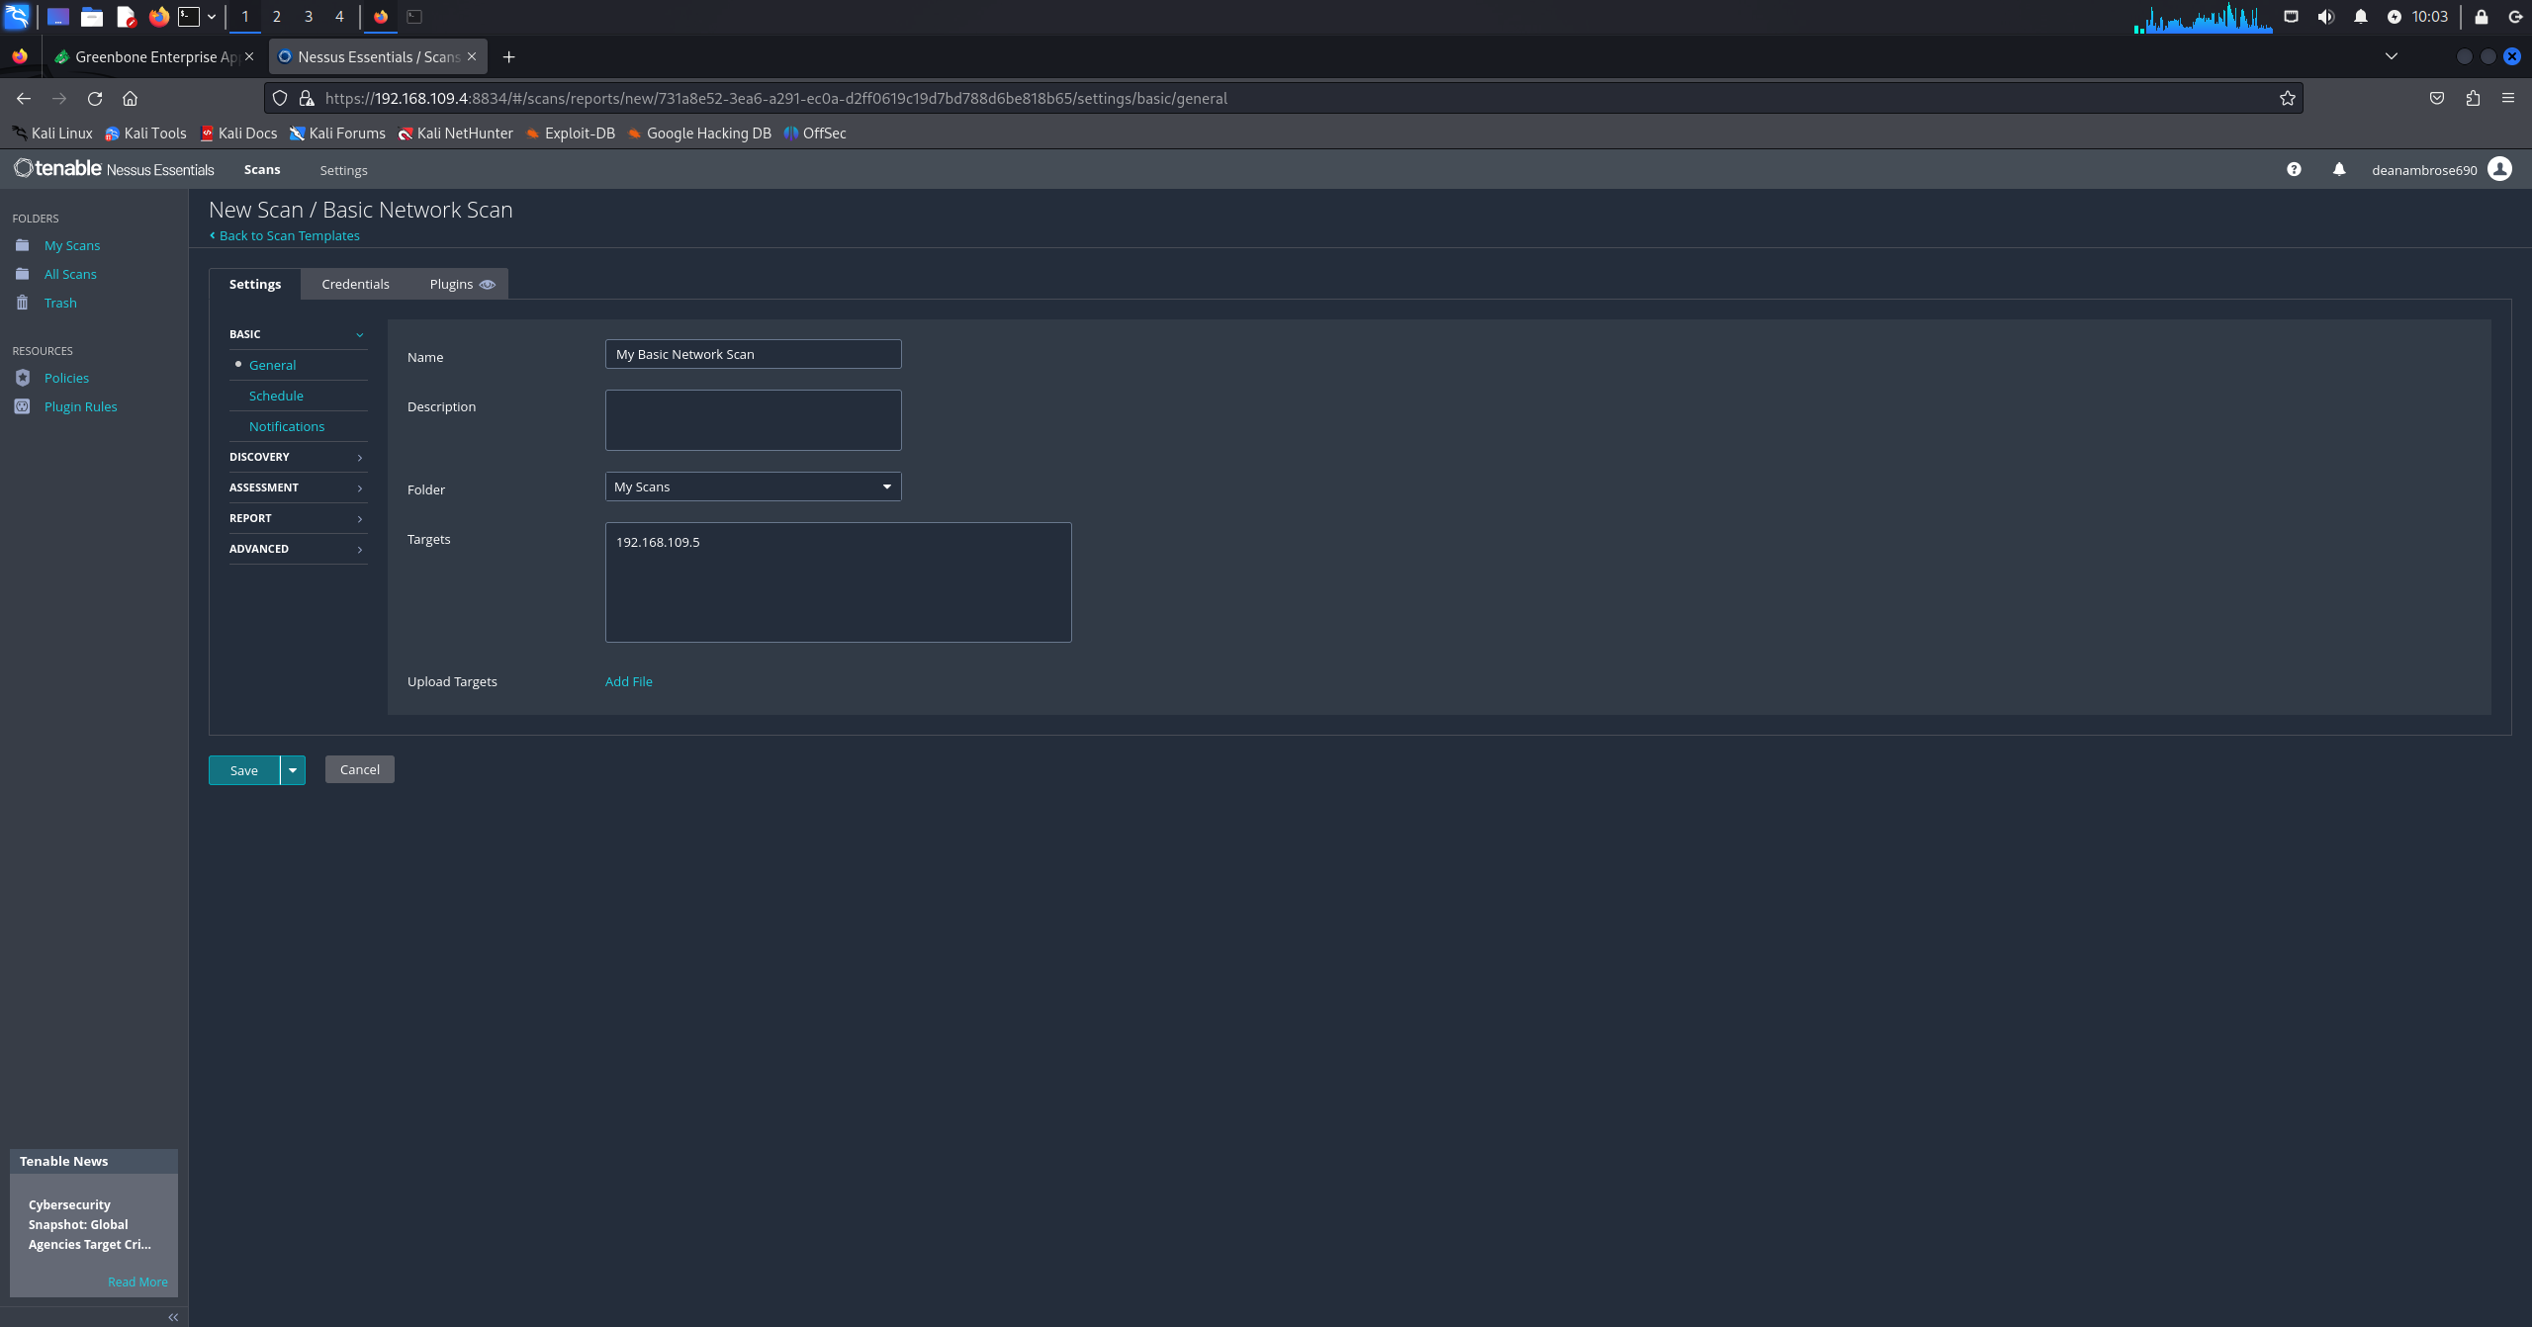 Figure 4.2A: configuring the scan and target 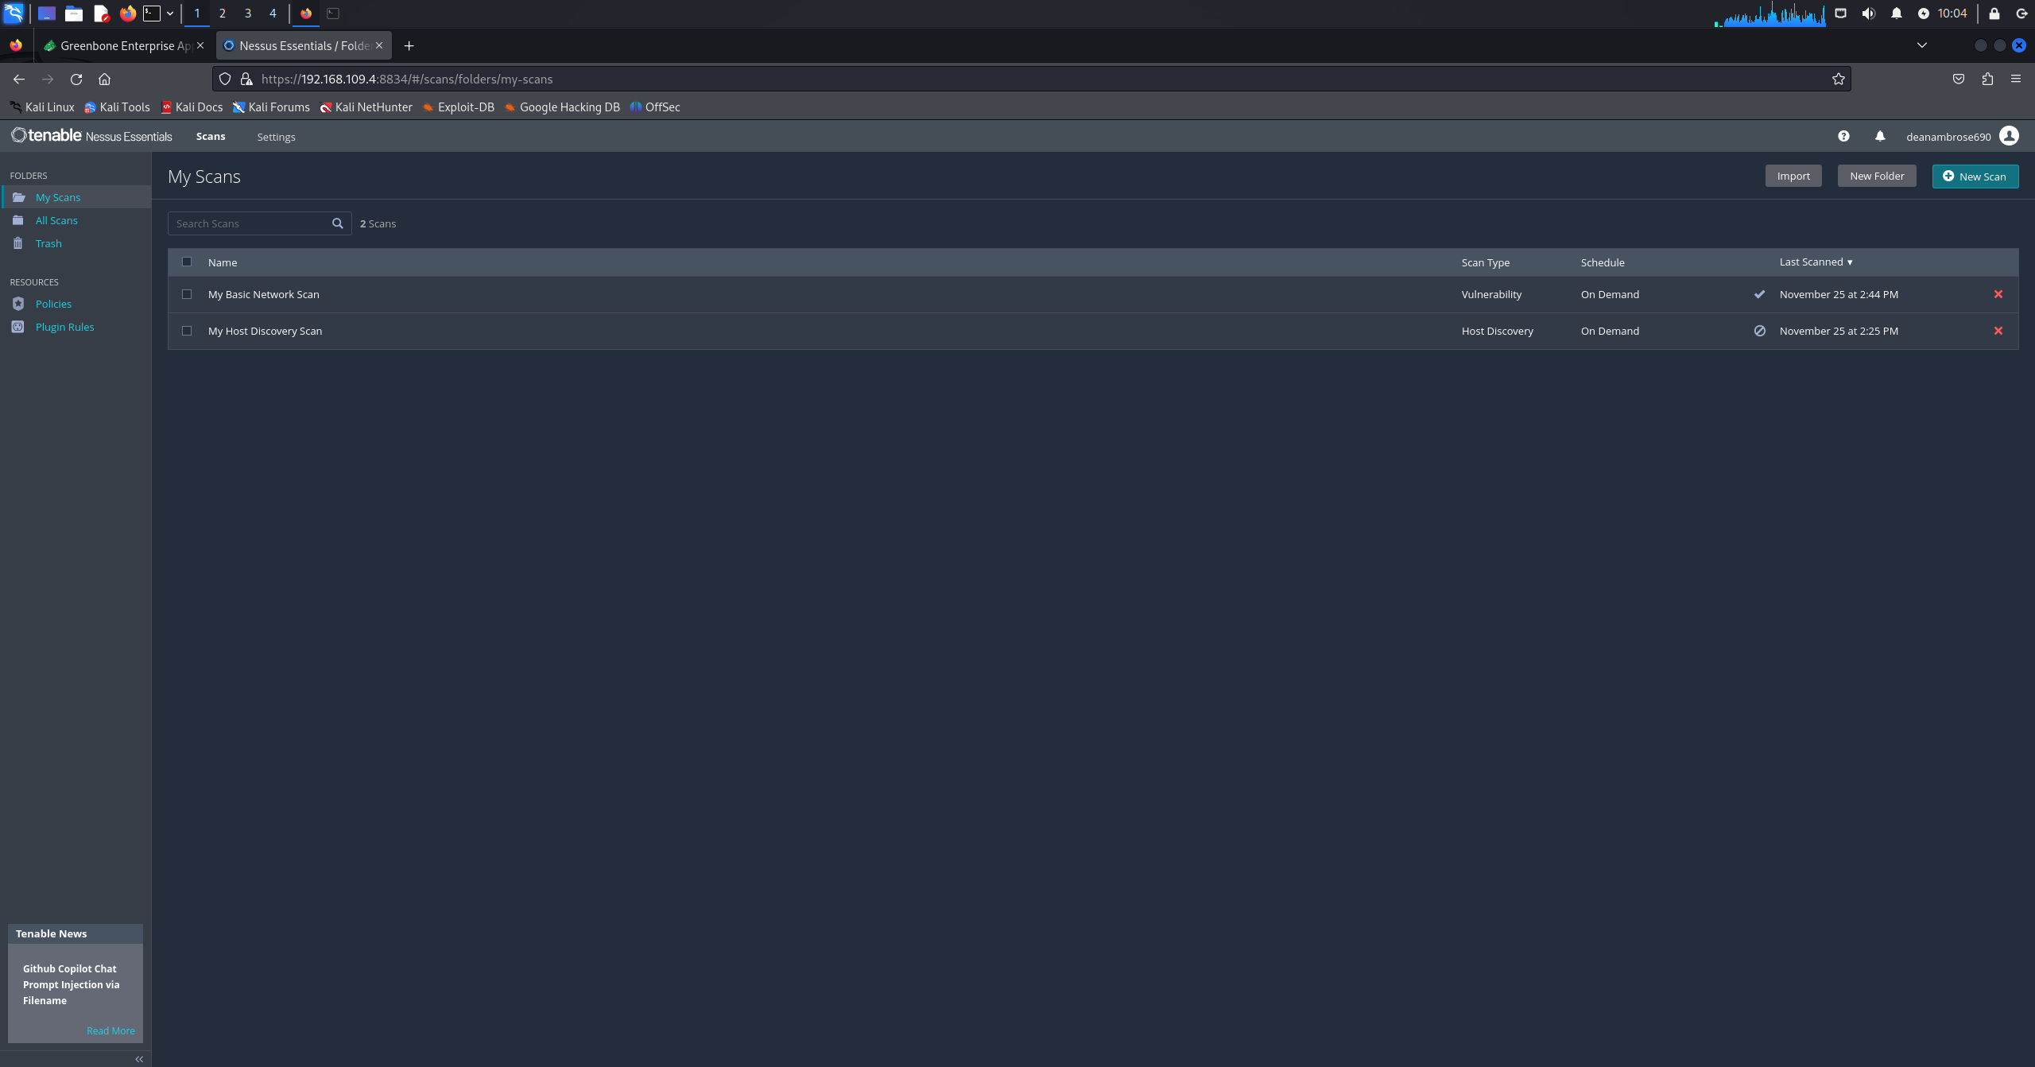 Figure 4.2B: scan done 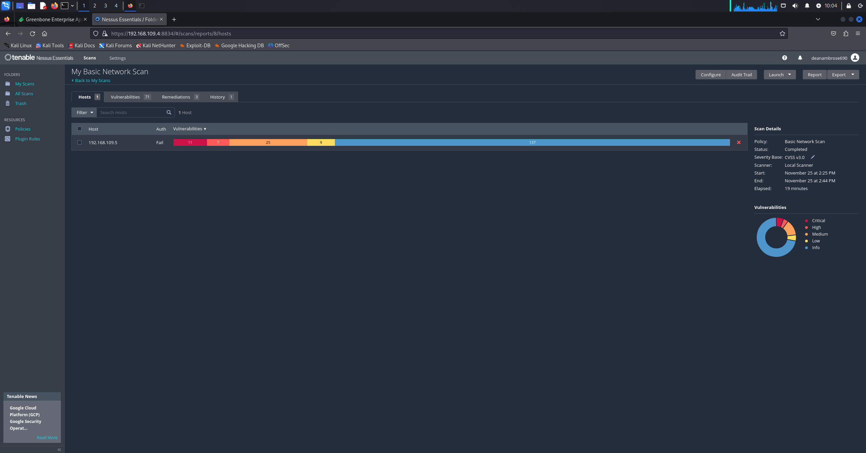Figure 4.2C: scan details 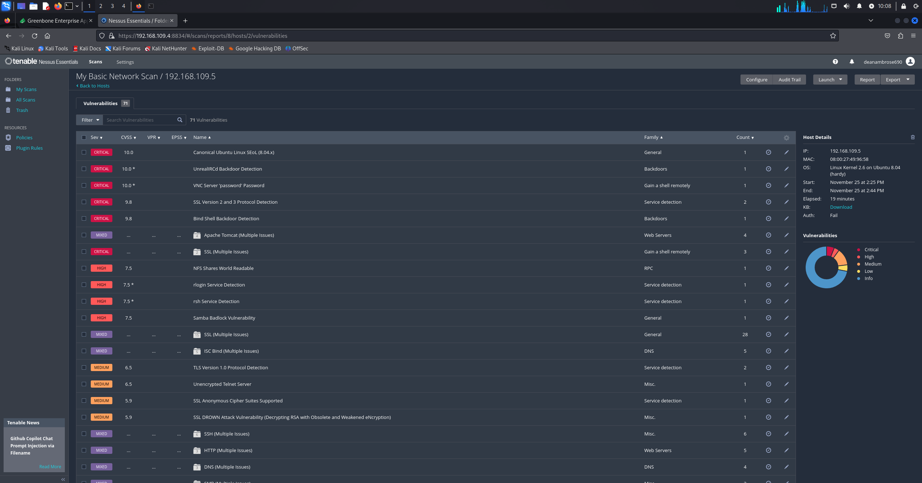 Figure 4.2D: vulnerabilities tab

Results:
- Total vulnerabilities detected: 71
Vulnerability | Description | CVE ID | CWE Category | CVSS Score
Canonical Ubuntu Linux EoL (8.04.x) | The target system is running Ubuntu Linux 8.04, which is end-of-life and no longer supported by the vendor, meaning no security patches are provided. | Not Applicable | Not Applicable | 10.0
UnrealIRCd Backdoor Detection | The UnrealIRCd service contains a backdoor that allows attackers to execute arbitrary codes on the affected host. | CVE-2010-2075 | Not Applicable | 10.0
VNC Server “password” Password | The VNC service is protected with a weak default password (“password”), allowing unauthenticated attackers to gain remote access. | Not Applicable | Not Applicable | 10.0
Bind Shell Backdoor Detection | A bind shell is listening on a remote port without authentication, allowing attackers to execute commands directly on the system. | Not Applicable | Not Applicable | 9.8
Debian OpenSSH/OpenSSL Random Number Generator Weakness | Cryptographic keys generated using a vulnerable OpenSSL implementation are predictable, enabling attackers to decrypt sessions or perform man-in-the-middle attacks. | CVE-2008-0166 | CWE-310 | 10.0

