Task 5: Gaining access
1. Medusa password crack
Target: metasploitable 2
Operating system: Linux
Ip: 192.168.109.5
Attack type: brute force
Command: medusa -U users.list -P pass.list -h 192.168.109.5 -M ssh
ssh -o HostKeyAlgorithms=+ssh-rsa -o PubkeyAcceptedAlgorithms=+ssh-rsa msfadmin@192.168.109.5
Methodology:
The attack started by targeting the ssh service on the target machine based on previous task results in the scanning phase, which displayed that the ssh service on port 22 was open and susceptible to an attack.
Medusa, a password cracking tool was used in this attack with predefined users and passwords list to run multiple authentication attempts on the ssh service by checking each user in the list with a password in the passwords list until it finds a success attempt.
After getting the valid credentials, a ssh connection was made where legacy ssh algorithms were enabled by specifying the HostKeyAlgorithms and PubkeyAcceptedAlgorithms options, this allowed the modern ssh client to accept the older ssh-rsa algorithm used by the target. 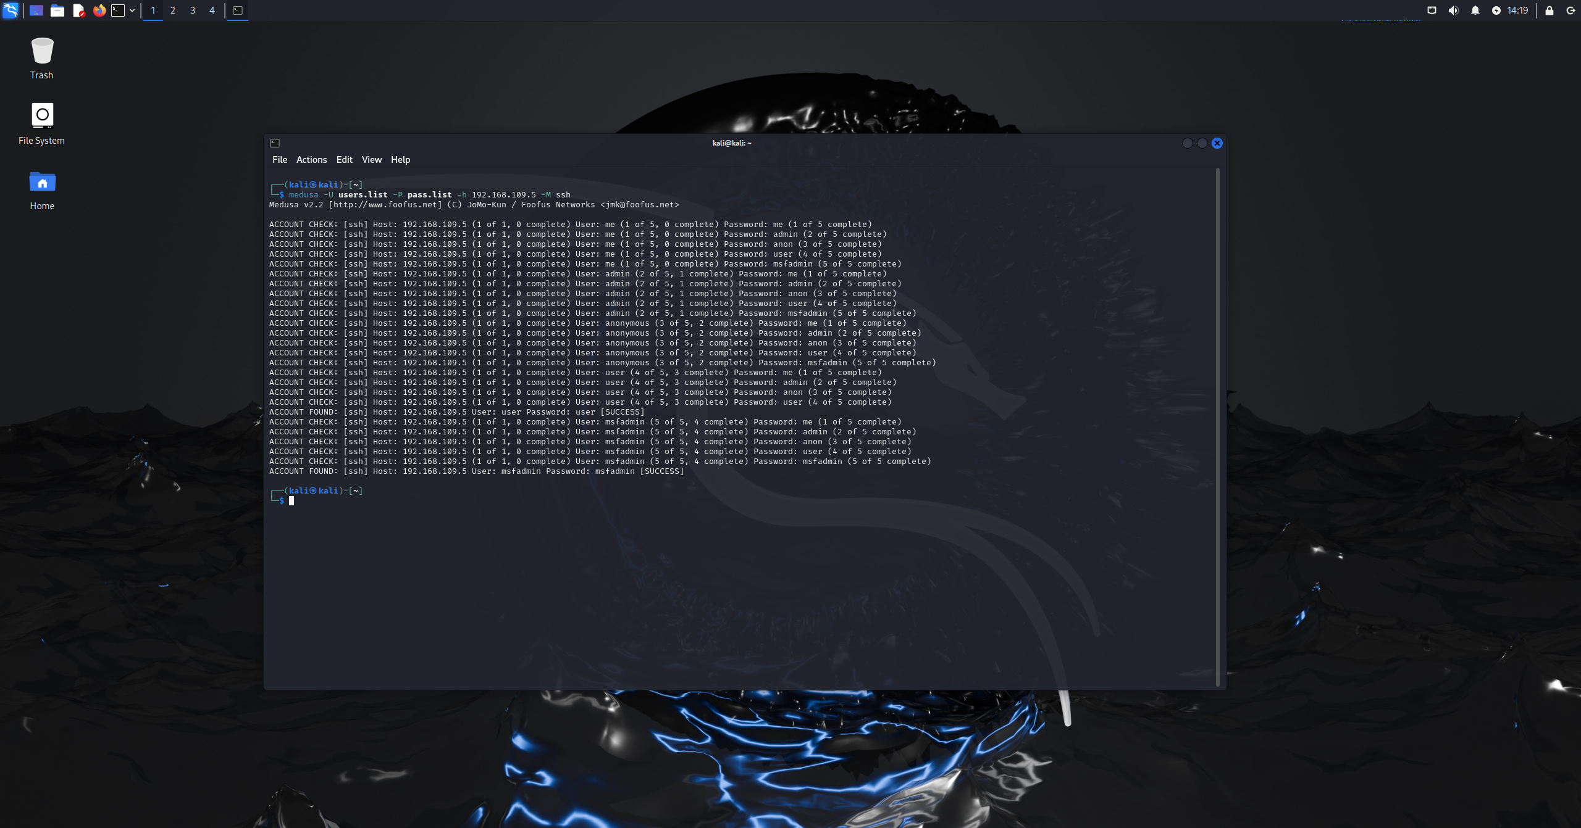 Figure 5.1A: medusa ssh password crack 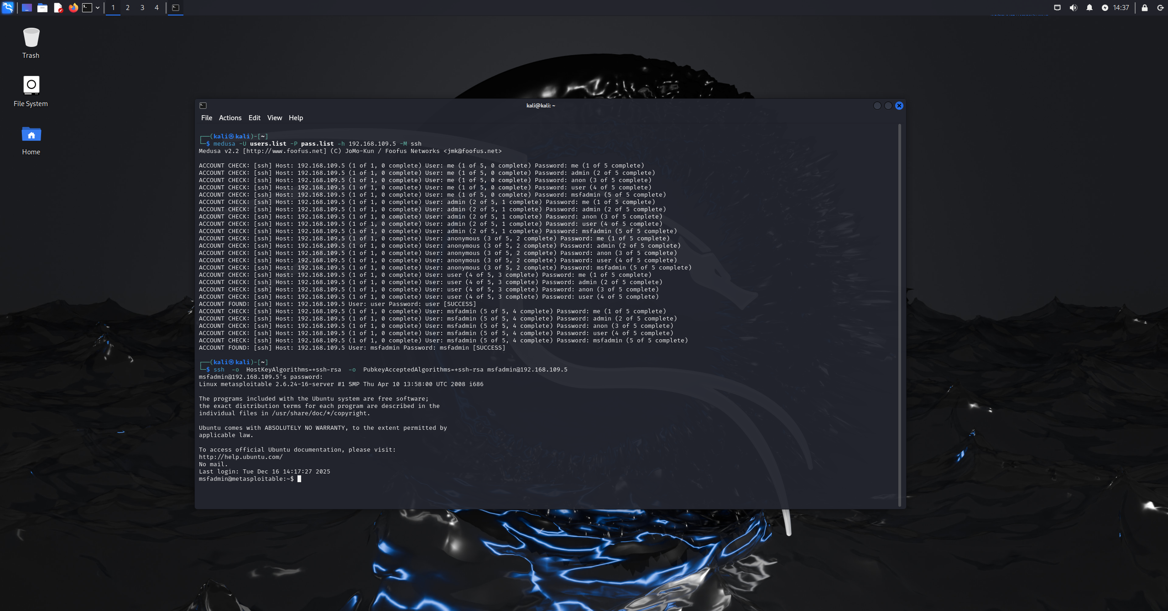 Figure 5.1B: obtain access through ssh
Results:
The ssh brute force attack was successful as medusa got two valid user credentials:
- msfadmin: msfadmin
- user: user
This confirmed unauthorized remote access to the system without exploiting software vulnerabilities, but relying instead on weak authentication practices and outdated configurations as the attacker gained cmd access as the msfadmin user.
Impact:
- Unauthenticated remote shell access
- Ability to execute system commands
- Confirmation of insecure default credentials
- Exposure of legacy SSH configuration weaknesses
Attack vulnerability:
- Ssh brute force logins with default credentials

2. vsftpd attack
Target: metasploitable 2
Operating system: Linux
Ip: 192.168.109.5
Attack type: backdoor exploitaion
Tool: Metasploit framework
exploit/unix/ftp/vsftpd_234_backdoor
Methodology:
First, the attacker obtained info in a previous task that the ftp services on the target machine was open and running the vsftpd version 2.3.4, which is known to contain a malicious backdoor.
After confirming the vulnerable service version, the attacker launched the Metasploit framework and selected the vsftpd backdoor exploit module and set the target ip address as the remote host.
Once configured, the exploit was run and the module took advantage of the backdoor present in the vsftpd 2.3.4, when triggered a command shell opened on a high port.
The exploit successfully spawned a remote command shell on the target without requiring valid credentials, after that some commands were run to confirm the access and privilege level.
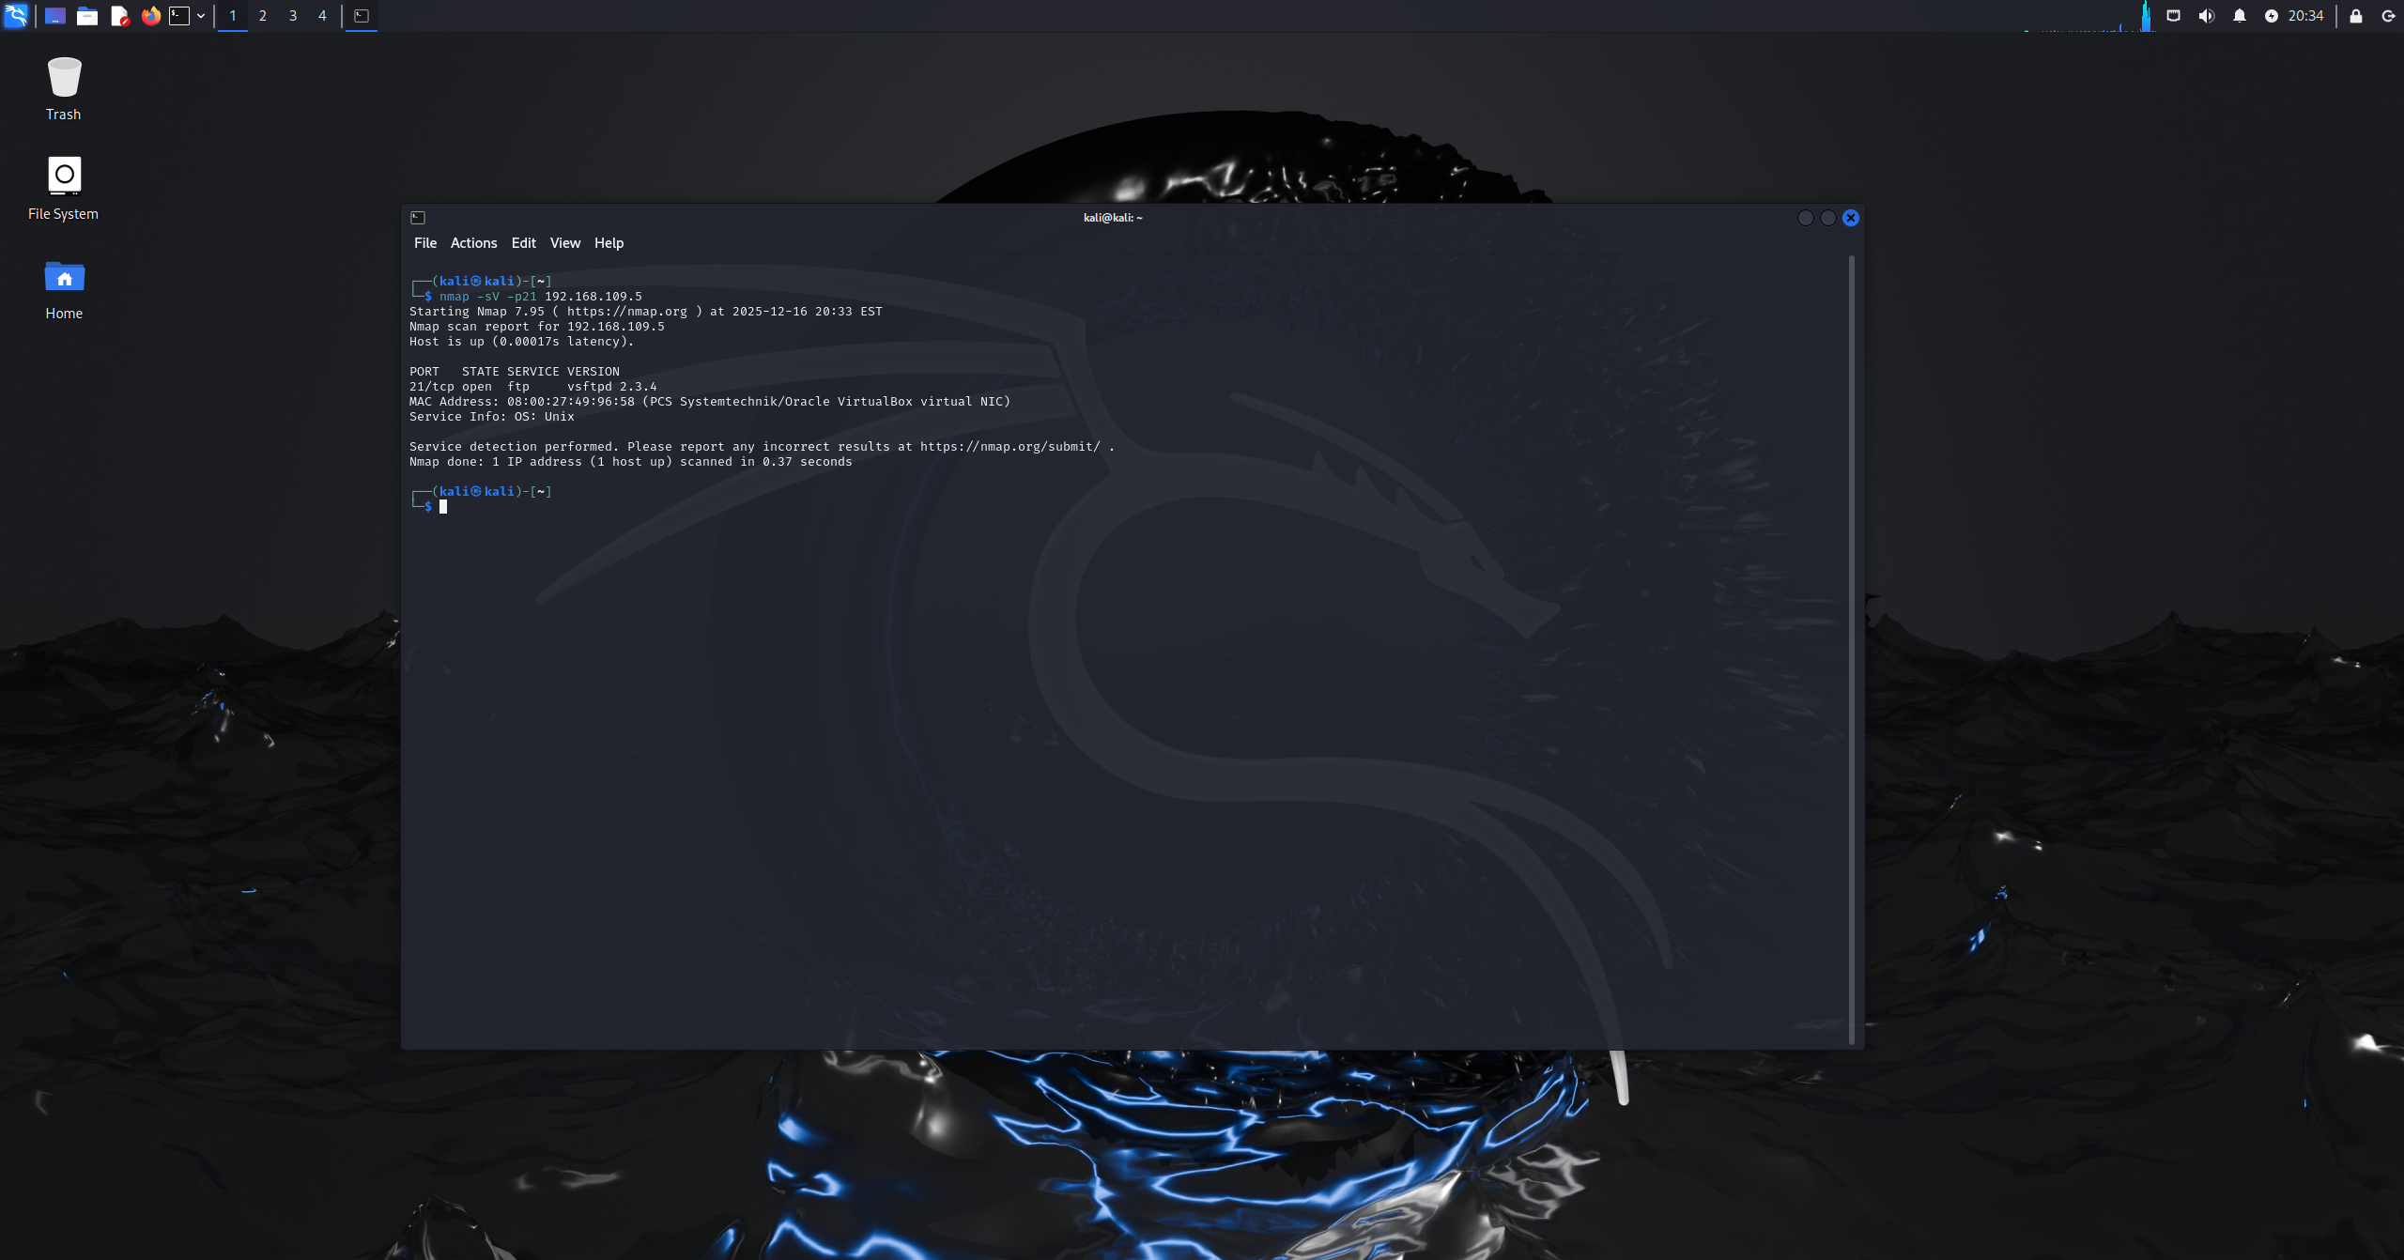 Figure 5.2A: checking ftp port state and version 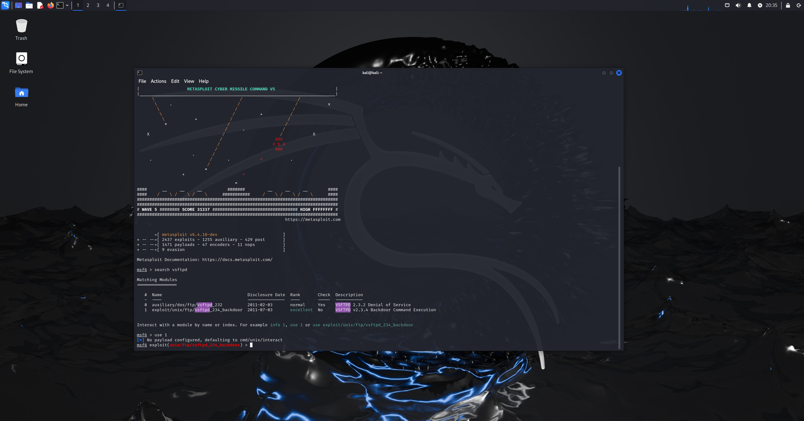 Figure 5.2B: starting Metasploit and selecting exploit 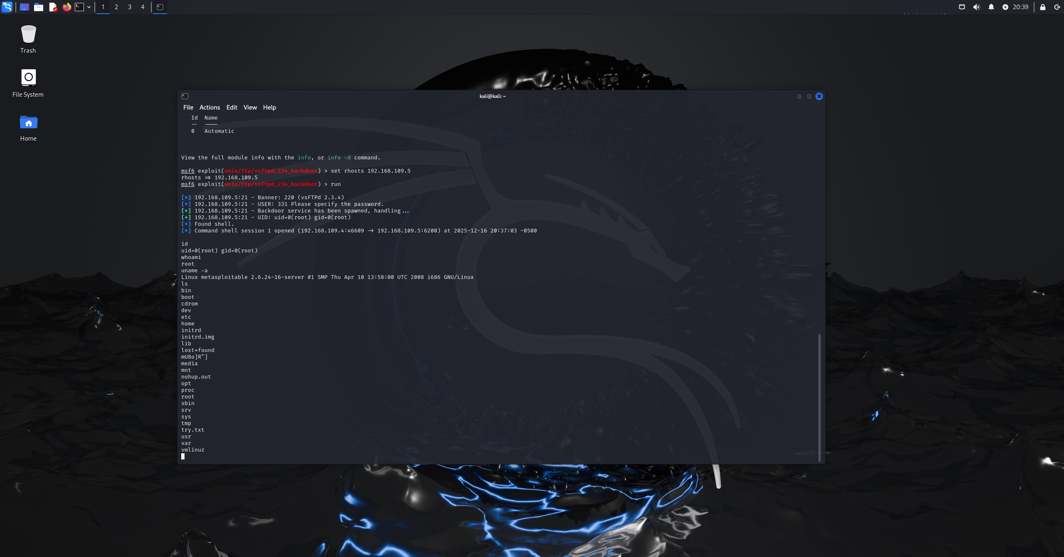 Figure 5.2C: setting target ip as rhost and running exploit

Results:
- Attack Outcome: Successful
- Impact:
A command shell was obtained with root privileges, allowing full control of the system, including file access and execution of administrative commands.
- Vulnerability that enabled the attack:
vsftpd Compromised Source Package Backdoor.
CVE-2011-2523

Independent/Research Techniques
3.
Target: metasploitable 2
Operating system: Linux
Ip: 192.168.109.5
Attack type: remote command execution
Tool: Metasploit framework
exploit/unix/misc/distcc_exec
Methodology:
Firstly, before beginning the attack, the attacker used nmap to scan the target port 3632 which revealed that the port was open and running the DistCC service whom is known to be vulnerable when exposed without correct access restrictions.
After getting confirmation about the port service, the Metasploit framework was used with the exploit module exploit/unix/misc/distcc_exec that targets insecure distcc configurations. Moreover, the target ip was as the rhost and the cmd/unix/reverse payload was selected.
Once the exploit was executed, Metasploit successfully triggered the vulnerability and established a reverse shell session from the target system back to the attacker machine. 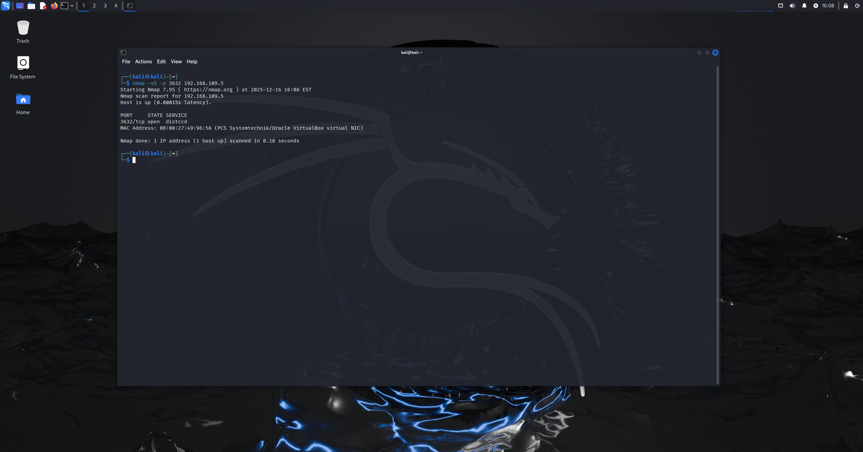 Figure 5.3A: checking distcc port state 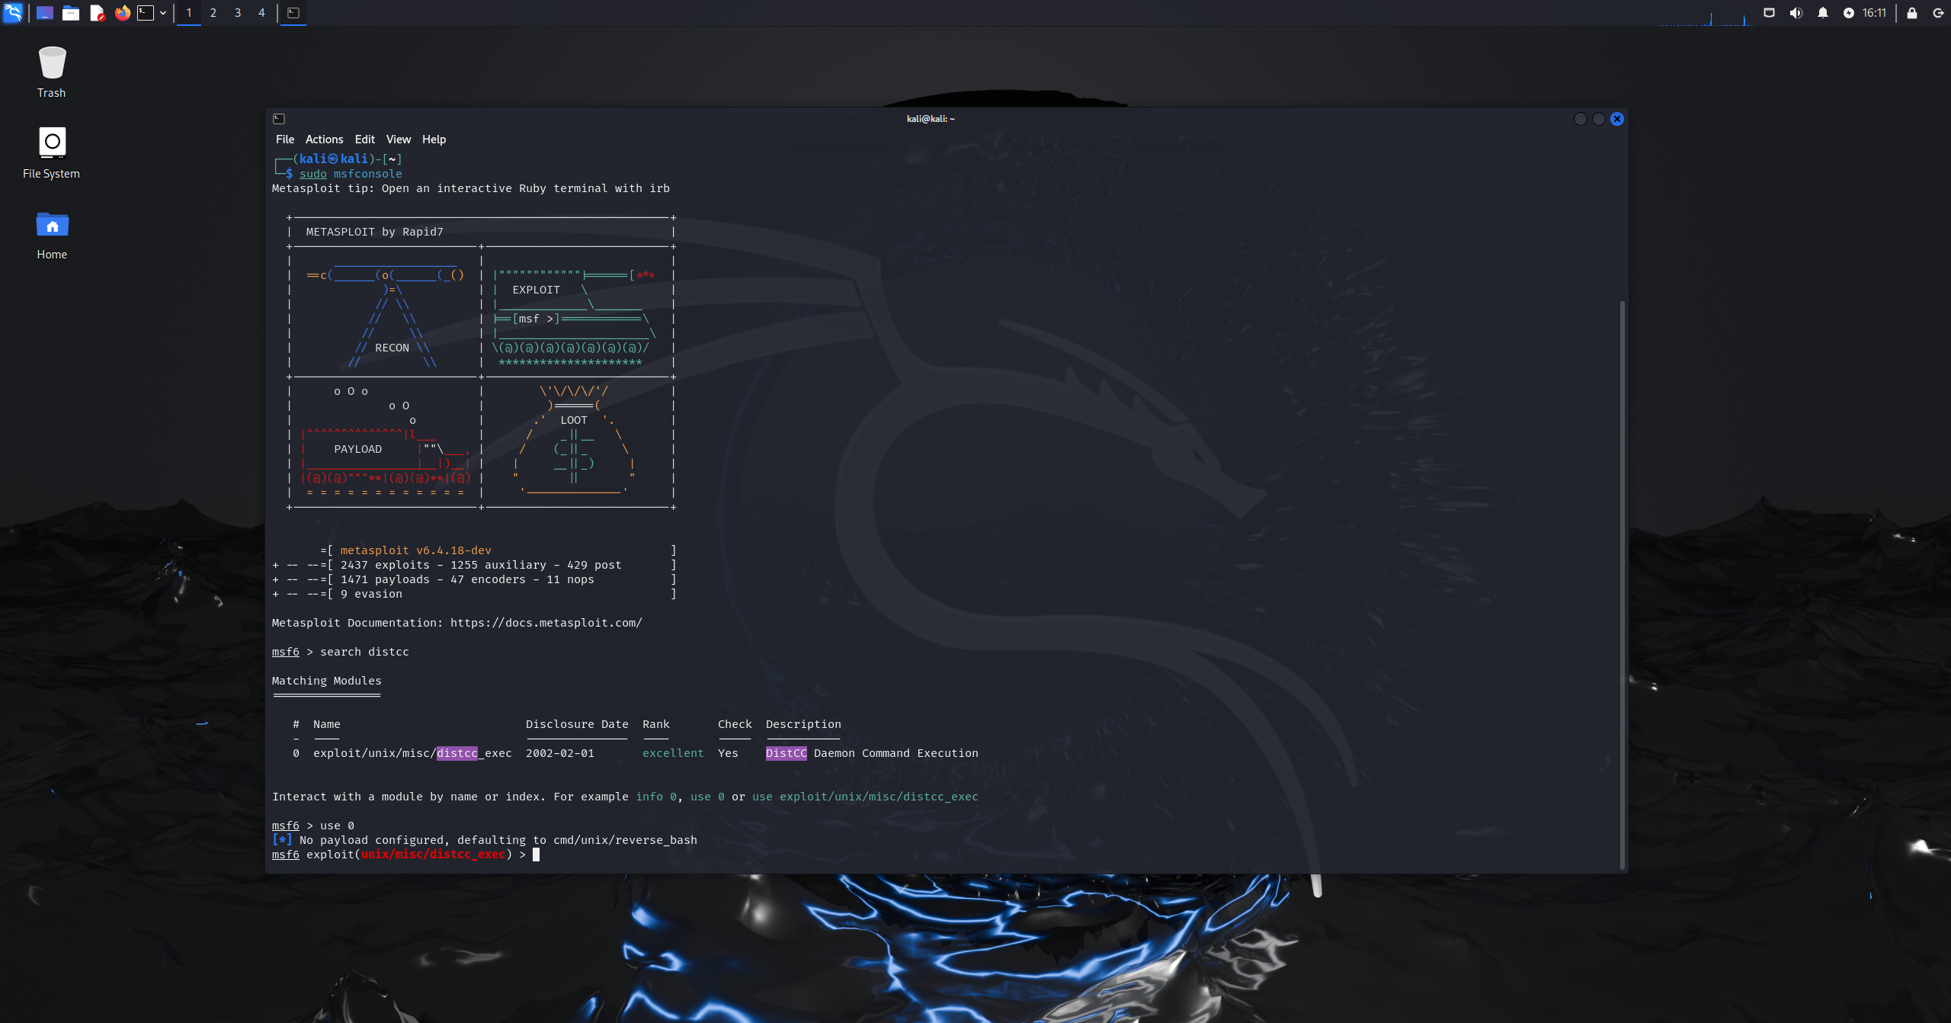 Figure 5.3B: starting Metasploit and selecting exploit 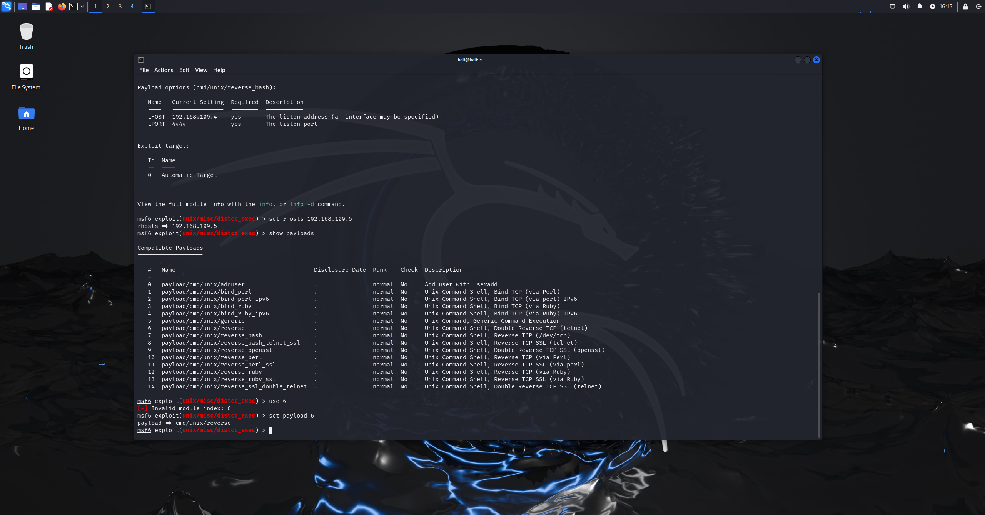 Figure 5.3C: setting target ip as rhost and selecting payload 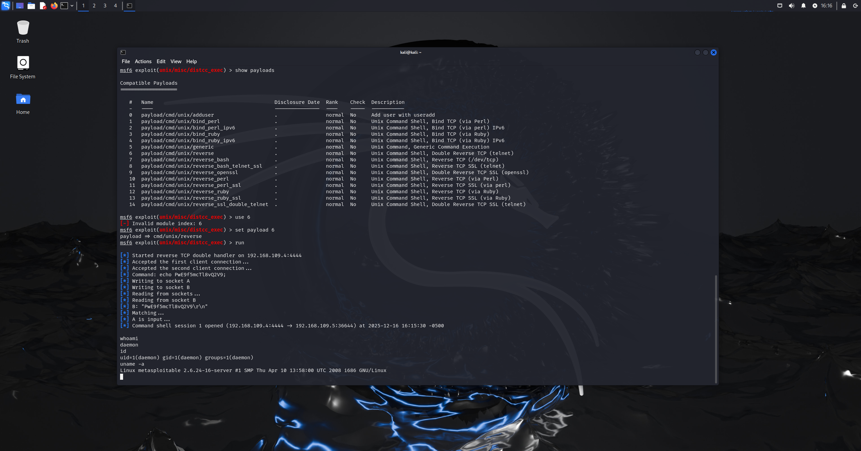 Figure 5.3D: running exploit and output displayed

Results:
The attack was successful as the exploitation of the distcc service resulted in remote command shell on the target system without needing any authentication credentials. Additionally, the shell was obtained under the daemon user, confirming unauthorized command execution on the host which
Impact:
- allows the attacker to run arbitrary system commands
- enumerate the operating system
- escalate privileges
Vulnerability that enabled the attack:
DistCC Remote Code Execution
CVE-2004-2687
4.
Target: metasploitable 2
Operating system: Linux
Ip: 192.168.109.5
Attack type: remote service exploitation
Tool: Metasploit framework
auxiliary/scanner/rservices/rsh_login
Methodology:
In the first step, the attacker scanned the target port 514 to check whether the port was open and what service it is running which is the RSH service on the open port 514, it is a legacy remote shell service known to be insecure when misconfigured.
After knowing the port state and what service it was running, the attacker used the auxiliary module auxiliary/scanner/rservices/rsh_login in the Metasploit framework to take advantage of this weakness as this module job is to test the authentication weakness in the rsh service.
The module was configured with the target ip and the username set to root and the blank password option was enabled as rsh trusts hosts and users without forcing authentication.
After execution, the scanner successfully authenticated as the root users without a password and opened a remote shell session, the session was accessed and verified by running the commands whoami, id, and uname -a confirming full root-level access on the target system. 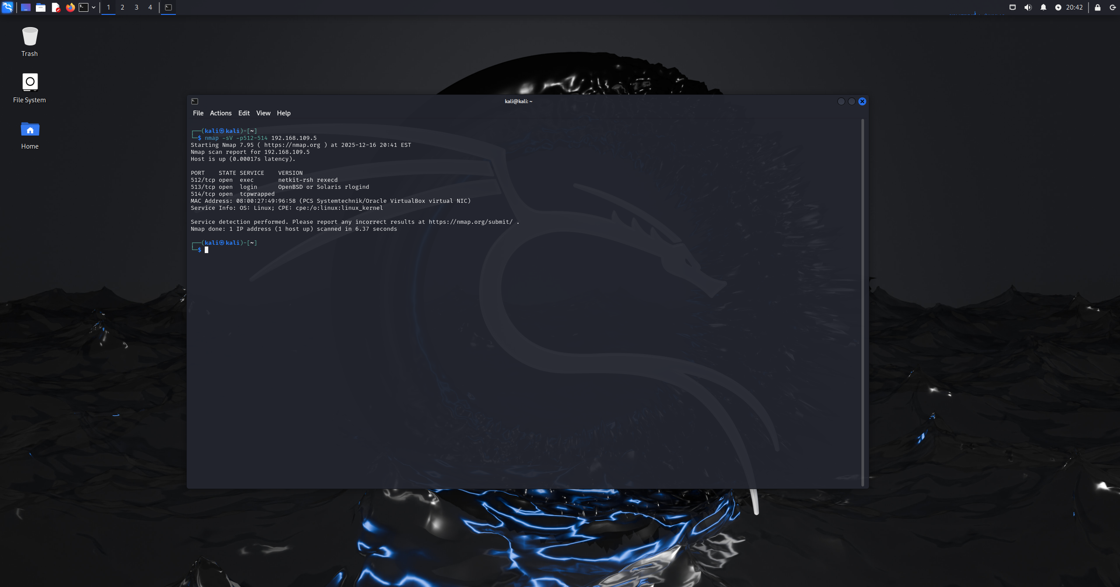 Figure 5.4A: checking ports state and version 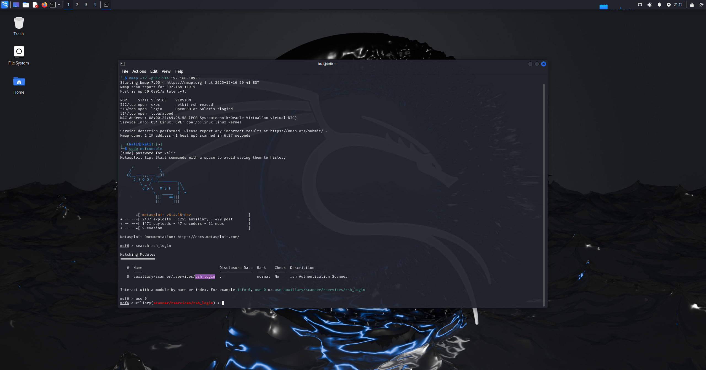 Figure 5.4B: starting Metasploit and selecting exploit 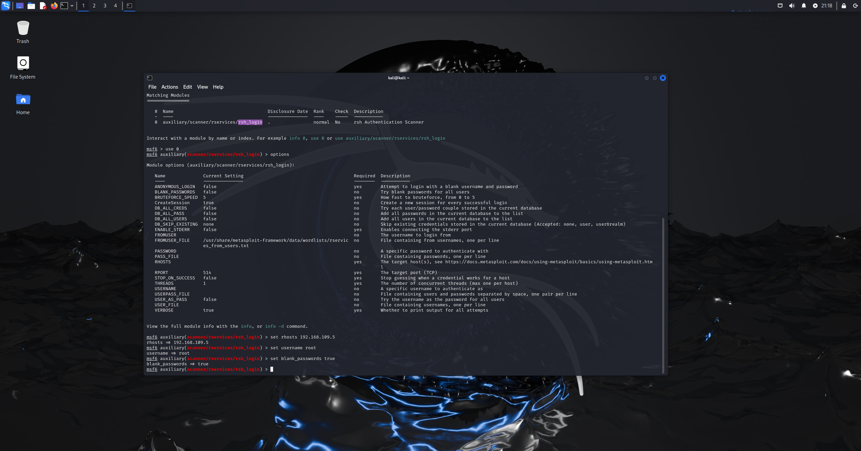 Figure 5.4C: setting target ip as rhost and setting username 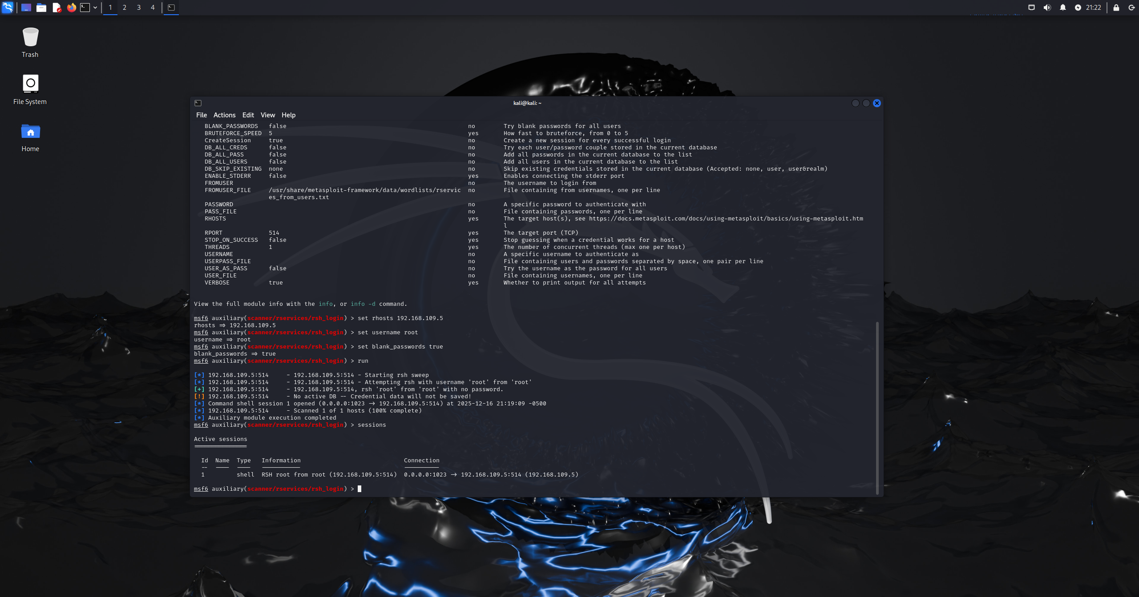 Figure 5.4D: running exploit and session opened 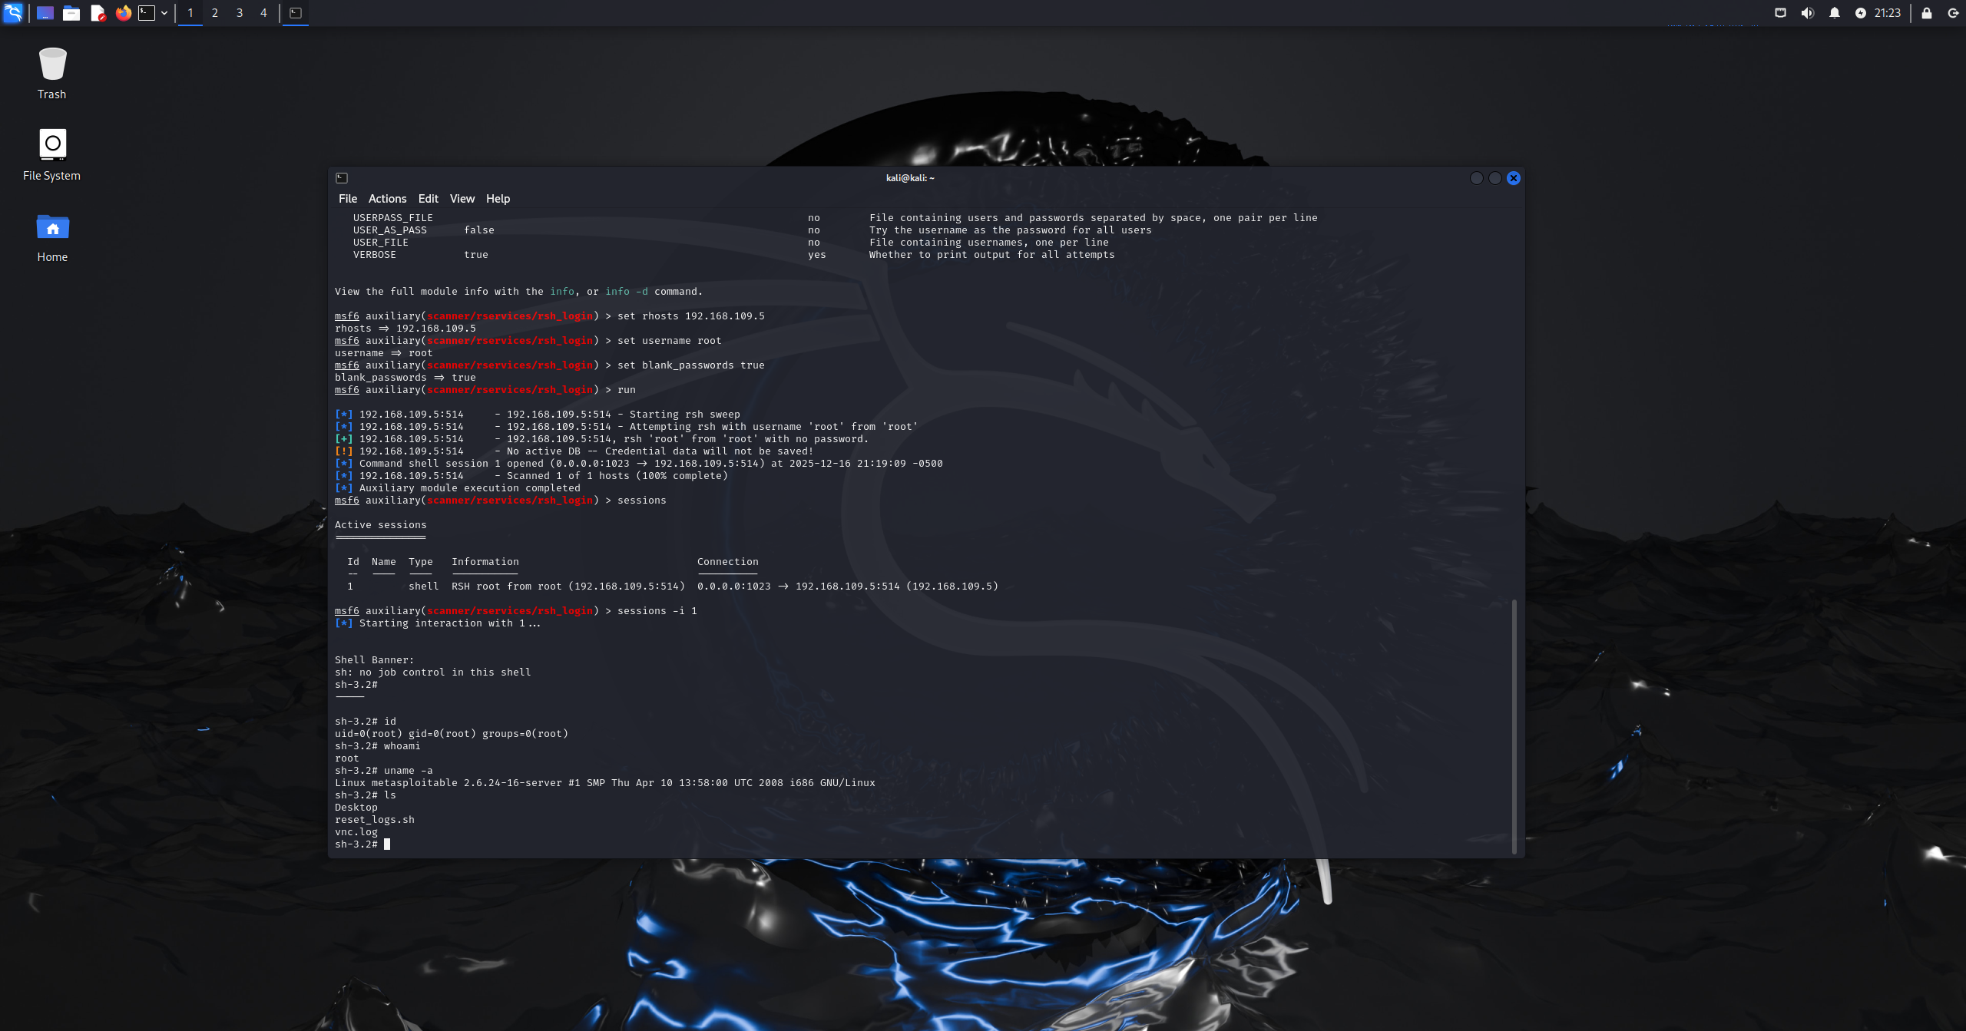 Figure 5.4E: opening session and verify 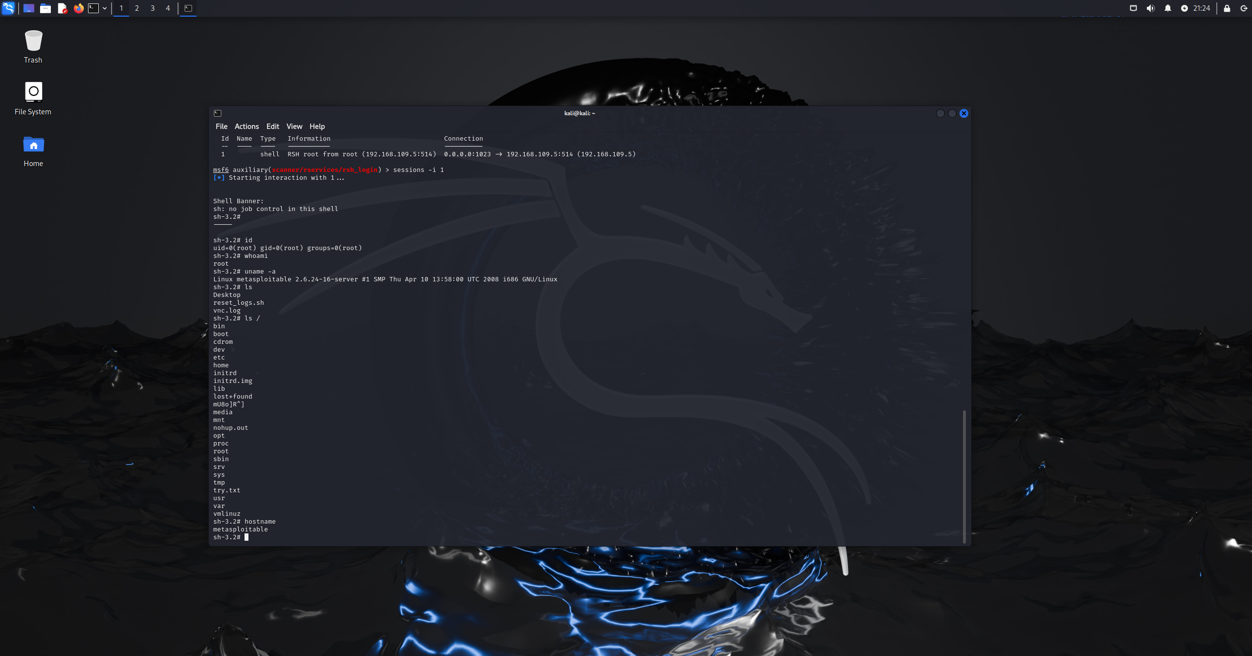 Figure 5.4F: opening session and verify part 2

Results:
The attack was successful as it resulted in unauthorized remote shell access without needing authenticated credentials, and due the insecure trust based configuration, a shell session was obtained directly as the root user.
Impact:
- Complete system compromise without credentials
- Ability to execute arbitrary commands remotely
Vulnerability that enabled the attack:
rsh Unencrypted Cleartext Login
CVE-1999-0651

Task 6: Maintaining access:
Command: sudo su
whoami
id
Methodology:
After gaining access to msfadmin user through the ssh service, post exploitation was performed to find out privilege levels and group memberships, with the whoami and id commands the current user and group privileges were revealed.
The msfadmin user was found to have sudo privileges but to escalate the privilege level and maintain administrative control, the sudo su command was run, and since the msfadmin user used default credentials and has sudo access, the system asked for the user’s password and granted root privileges on successful authentication.
Once root access was obtained, the attacker changed from a limited user shell to a root shell allowing unrestricted access to system files and enabling long-term control over the compromised system. 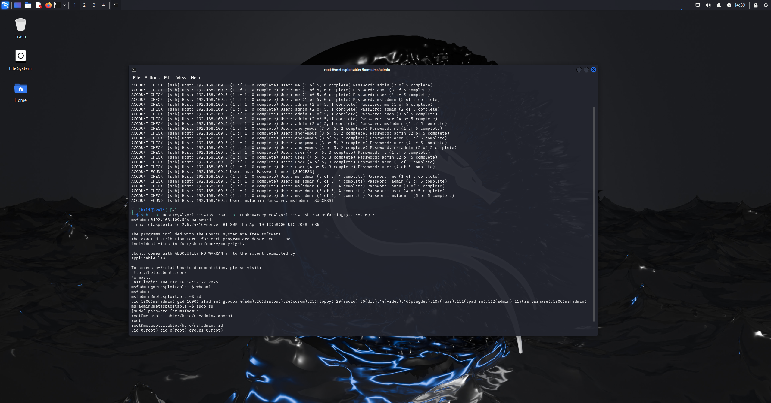 Figure 6.1: escalating privileges technique 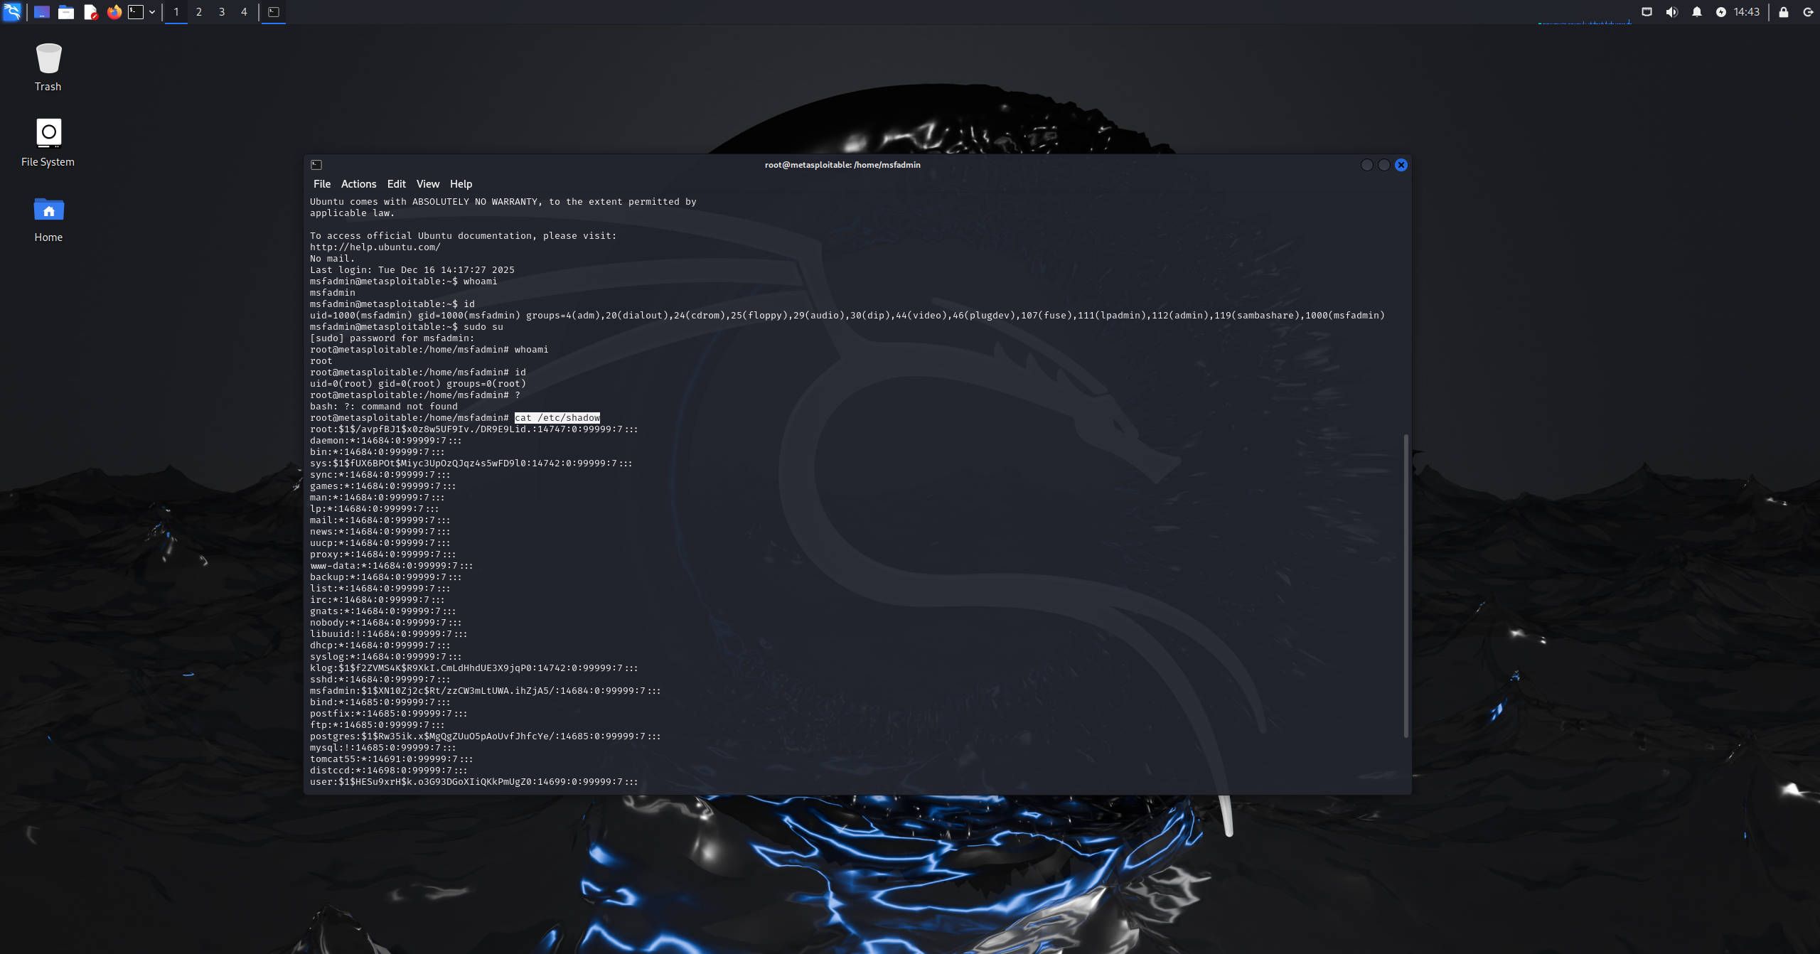 Figure 6.2: verifying privileges
Results:
The privilege escalation was successful, allowing the attacker to gain and retain root-level access to the system after the initial compromise, by escalating privileges through sudo, the attacker achieved persistent administrative control, enabling continued access even if the original user session were terminated.

Task 7: Covering tracks:
Command: history
rm ~/.bash_history
rm -f ~/.bash_history
history -c
Methodology:
After escalating the privileges to the root user in the previous task, a basic clearing log technique was applied to reduce or remove any trace of the attacker activity in the root user.
First, the command history was reviewed using the command history to reveal the previous commands which contain id,whoami,cat /etc/shadow, after confirming their presence the bash history file that stores persistent command history was deleted for the root user.
After deleting the file, the attacker cleared the in-memory command history for the active user session with the command history -c as the command itself will not be detected in the history. 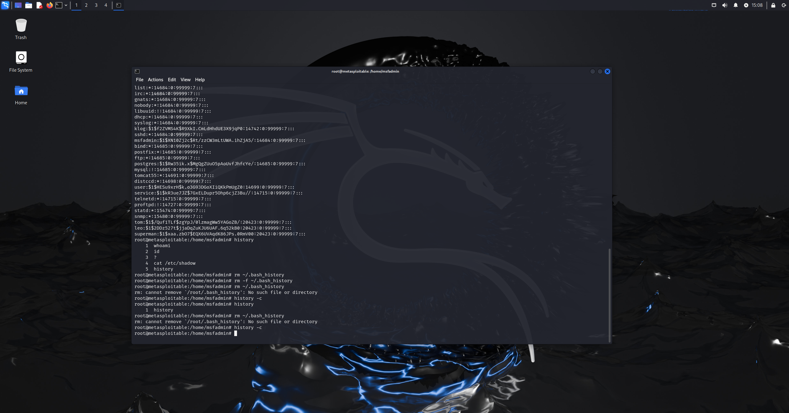 Figure 7.1: clearing history commands

Results:
The command history deletion technique successfully removed traces of executed commands from both the history file and the active shell session. This limits the ability of system administrators or forensic analysts to reconstruct attacker actions based solely on shell history artifacts.
Although simple, this technique demonstrates how attackers with root access can quickly erase valuable forensic evidence. It highlights the importance of centralized logging, real-time monitoring, and tamper-evident log storage, as relying solely on local shell history is insufficient for reliable incident investigation.

Task 8: Pentest Report and Security Policy:

Section A: pentest report:
1. Attack Summary
Attack performed: Remote shell (rsh) unauthorized access attack
Target System: Metasploitable 2
Operating System: Linux
Ip Address: 192.168.109.5
Attack Description:
The attack exploited a misconfigured remote shell service running on the target system, by using Metasploit authentication scanner the attacker took advantage of the insecure trust based authentication and blank password acceptance to get a remote shell session.
2. Vulnerability Analysis
Vulnerability Description:
The rsh service active on the target system allowed unencrypted remote shell access and heavily relied on weak trust based authentication. In addition, the service didn’t implement a secure credentials verification way, which opens the door for remote users to obtain shell access without authentication.
Why does this vulnerability exist:
This vulnerability exists because the rsh service uses legacy trust based authentication instead of secure credentials verification, as the service relies on trust between the host and user rather than enforcing password or any cryptographic authentication.
Impact:
Unauthorized remote command execution with administrative privileges, which can lead to full system compromise and exposure of confidential data.

Evidence:
Figure 8.1: starting Metasploit and selecting exploit Figure 8.2: setting target ip as rhost and setting username Figure 8.3: running exploit and session opened Figure 8.4: opening session and verify Figure 8.5: opening session and verify part 2
Identifiers:
CVE: CVE-1999-0651
CWE: Not Applicable
CVSS score: 7.5

3. Risk Assessment
Likelihood: High
Impact: High
Overall risk level: High
My own CVSS score: 8.5
4. Proposed Mitigation & Controls
  - Technical controls:
    - Disable and replace the rsh service on all systems with ssh.
    - Restrict access to legacy services using host-based firewalls
    - Harden system configurations by removing trust based authentication files
  - Procedural/ Administrative controls:
    - Enforce secure access policies that prohibit the use of unencrypted remote protocols
    - Conduct regular system hardening reviews
    - Maintain an asset and service inventory to track enabled services
  - Detective controls:
    - Perform periodic vulnerability scans to identify any misconfigured services before exploitation
    - Enable log monitoring to detect unauthorized access attempts
    - Deploy intrusion detection system rules to alert on any rsh traffic

5. Impact Summary
The selected controls would considerably harden the security by removing the usage of insecure legacy remote access practices and replacing rsh with ssh which guarantees secure communication, while getting rid of trust based authentication files reduces the attack surface and likelihood, they also help prevent any misconfigurations and makes sure that the insecure protocols are not reintroduced, moreover they provide continuous monitoring and early detection of unauthorized activity.
Although these mitigation controls help but they will not remove everything as there may still be remaining residue due to systems or applications dependent on the rsh service for compatibility.

Section B: security policy:
1-
Policy Title
Access Management Policy
Purpose
This policy is meant to provide secure control, authentication, and authorization over the access of the organizational systems. The other objective of this policy is to ensure that unauthorized access is prevented either by insecure or legacy authentication systems, including the existence of unencrypted remote shell services, and that secure access standards are met in all environments.
Scope
The policy has been applicable to all those users, the administrators, systems, servers, network devices that need authenticated access to the organization including internal, external, and remote access methods.
Policy Statements
AM-01: Secure and encrypted authentication protocols, which are approved by the organization, must be used in all access to the system.
AM-02: The legacy authentication services which lack encryption and robust authentication (e.g., rsh) are not allowed.
AM-03: There should be no use of default authentication, shared authentication or trust authentication.
AM-04: The principle of least privilege should guide the access privileges and they should be reviewed after some time.
AM-05: Root or administrative access should also be limited and should be logged in all the time.

Roles & Responsibilities
System Administrators: Set up and deploy secure access controls and turn off forbidden services.
IT Security Team: Check access setups and grant verification criteria.
End Users: Only authorized access mode should be used and the authentication measure implemented.
Enforcement & Exceptions
Breach of this policy could lead to the removal of access or disciplinary measures. Exceptions should be officially listed, documented, assessed in terms of risk, and accepted by the IT Security Manager.
Monitoring & Audit
The incentives to comply will be ensured by periodical reviews of access, authentication audit, and vulnerability scans.
Review Period
The review of this policy will either be on the annual basis or after a significant security incident.
References
ISO/IEC 27001:2022 – Information Security Management Systems (ISMS)
Relevant Annex A controls:
A.5.16 – Identity management
A.5.17 – Authentication information
A.8.2 – Privileged access rights
NIST SP 800-53 Rev. 5
Relevant control families:
AC-2: Account Management
AC-6: Least Privilege
AC-7: Unsuccessful Login Attempts
2-
Policy Title
Internal Access Control Policy.
Purpose
The policy specifies methods regarding access control of the internal network services to minimize the chances of unauthorized access by exposed or misconfigured services.
Scope
This policy is applicable to all the internal networks, servers, network services, and systems that can be accessed in the organizational set up.
Policy Statements
INAM-01: Internal systems can only be enabled to support network services that are business-justified.
INAM-02: The network services that are legacy and insecure have to be disabled or blocked on the network level.
INAM-03: Within a default configuration, host-based and network firewalls should only allow access to internal services.
INAM-04: Exposure in network services should be checked on a regular basis and documented.
Roles & Responsibilities
Network Administrators: Set up network access controls and firewalls.
IT Security Team: Authenticate network services exposure and perform evaluation.
System Owners: Make sure that they are only running the approved services on their systems.

Enforcement & Exceptions
Illegal services will be put off at once. Exceptions must be documented in terms of business justification and security approval.

Monitoring & Audit
Periodical scans and configuration audits will be performed pertaining to internal networks to check the compliance.
Review Period
Audited either on a yearly basis or when there are alterations in network architecture.
References
CIS Critical Security Controls v8:
Control 5 – Account Management
Control 6 – Access Control Management
ISO/IEC 27002:2022
ISO/IEC 27001:2022:
Annex A.5 – Identity and Access Management
Annex A.8.2 – Privileged Access Rights
3-
Policy Title
System Protection Management Policy.
Purpose
This policy introduces system hardening and protection requirements in order to avoid exploitation of insecure or poorly configured services in organizational systems.
Scope
Covers all the servers, workstations, virtual machines, and operating systems under the care of the organization.
Policy Statements
SPM-01: Systems should be hardened based on approved security baselines.
SPM-02: Unstable and old fashioned services should be eliminated or flipped.
SPM-03: Forbids any trust-based authentication files and settings.
SPM-04: The systems should be updated and reviewed on a regular basis to identify security weaknesses.
Roles & Responsibilities
System Administrators: Set hardening guidelines and uphold safe settings.
IT Security Team: Establish baseline settings and detect compliance.
Enforcement & Exceptions
Systems which do not comply can be taken out of the network until fixed. Exceptions should be officially accepted.
Monitoring & Audit
Compliance will be ensured through system configuration audits and vulnerability assessment.
Review Period
Appraised either on an annual basis or following a major change in the system.
References
NIST SP 800-53 Rev. 5
NIST SP 800-137
CIS Critical Security Controls v8:
Control 4 – Secure Configuration of Enterprise Assets and Software
Control 7 – Continuous Vulnerability Management
Control 10 – Malware Defenses

4-
Policy Title
Log Management Policy
Purpose
This policy guarantees that the logs of system and authentication are gathered, secured, and monitored to identify cases of unauthorized access and abuse of network services.
Scope
It is applicable to any system, server, and network equipment that produce security-relevant logs.
Policy Statements
LM-01: All access and remote access attempts are to be logged.
LM-02: The logs are not to be altered or destroyed by unauthorized persons.
LM-03: Security logs should be checked on a regular basis regarding suspicious activity.
LM-04: The attempt to get access without authorization or as an anomaly shall give a notification.
Roles & Responsibilities
IT Security Team: Survey logs and address notifications.
System Administrators: Make sure that logging is activated and it is configured correctly.
Enforcement & Exceptions
Unnecessary logging that is necessary to remain may lead to lock out in the system. Security has to be approved in exceptions.
Monitoring & Audit
Compliance will be ensured through log reviews, SIEM alerts, as well as audit trails.
Review Period
Reviewed either after every year or after logging incidents.

References
NIST SP 800-92
ISO 27001
CIS Security Controls v8

Task 9: Self-reflection:
Student ID | Name | % of Workload Assigned | % of Assigned Workload Completed | Main Tasks Completed | Peer Review Remarks
202300678 | Muhannad Alnooh | 25% | 100% | Footprinting Scanning  Maintaining access | Took lead in report
202304613 | Abdulrahman Altairey | 25% | 100% | Enumeration, Maintaining access, gaining access | On time
202300436 | Abdulelah Slais | 25% | 100% | Vulnerability Scanning, gaining access | On time
202300903 | Talal Aljamri | 25% | 100% | pentest report and security policy, gaining access, Covering tracks | On time
Total |  | 100%

Conclusion:
This project gave real life example of an ethical hacking life cycle, which starts with reconnaissance and enumeration going all the way to exploitation, mitigation, and security policy formulation. Covering every step under controlled conditions in the lab helped enforce the significance of the systematic penetration testing manner where the knowledge obtained on the initial stages directly informed success in exploitation. The experiment showed how improper settings and outdated services can result in a total compromise of the system in case they have been used successfully.

The major lessons were acquired regarding the way to be vulnerable to insecure services, poor authentication, and ancient protocols and allow an unauthorized person to enter. The activity of exploitation demonstrated how mechanisms of trust and misconfigured services might be spotted to obtain remote shells and elevated access. Another significant resolution that was mentioned as a result of the project is the necessity of defensive measures such as system hardening, service restriction, continuous monitoring, and clearly defined security policies to minimize attack surfaces and risk mitigation.

Ethical concerns were upheld in the project, and all of the testing was conducted only on established systems in an isolated laboratory setting. This underscored the need of ethical hackers to act within the law, within stipulated scopes and work towards enhancing security instead of incurring losses. On the whole, the project supported the idea that ethical hacking is important in discovering the threats and enhancing organizational countermeasures.

References:
Angry IP Scanner. (2024). Angry IP Scanner documentation. https://angryip.org/documentation/
Cisco Systems, Inc. (n.d.). Remote Shell (rsh) protocol security considerations. https://www.cisco.com/c/en/us/support/docs/security-vulnerabilities/remote-shell-rsh/
National Institute of Standards and Technology. (2012). Guide to computer security log management (NIST Special Publication 800-92). https://csrc.nist.gov/publications/detail/sp/800-92/final
National Institute of Standards and Technology. (2020). Security and privacy controls for information systems and organizations (NIST Special Publication 800-53, Rev. 5). https://csrc.nist.gov/publications/detail/sp/800-53/rev-5/final
Rapid7. (n.d.). DistCC exploit module. https://www.rapid7.com/db/modules/exploit/unix/misc/distcc_exec/
Rapid7. (n.d.). RSH login scanner. https://www.rapid7.com/db/modules/auxiliary/scanner/rservices/rsh_login/
SANS Institute. (2025). Access management policy template. https://www.sans.org/information-security-policy/access-management-policy/
SANS Institute. (2025). Log management policy template. https://www.sans.org/information-security-policy/log-management-policy/
SANS Institute. (2025). System protection management policy template. https://www.sans.org/information-security-policy/system-protection-management-policy/
SANS Institute. (2025). Internal network access management policy template. https://www.sans.org/information-security-policy/internal-network-access-management-policy/
Scapy Project. (n.d.). Scapy packet manipulation tool. https://scapy.net/

