
Assessment Cover Sheet

Due Date
21/05/2026
Course Code
IT8515
Assessment Title
Group Project

Course Title
Cybersecurity Compliance and Regulations
Internal Moderator’s Name
Dr. Faheem Masoodi
External Examiner’s Name
Dr. James Eagan

Not must-pass
Group
Uncontrolled
Assessment Type

Instructions:
- This cover sheet must be completed (section in blue below) and attached to your assessment before submission in hard copy/soft copy.
- The time allowed for this assessment is 74 days.
- This assessment carries 25% marks; assessing CILO 1, and CILO 2.
- The materials allowed for use in this assessment are XXX, XXX, and XXX.
- The use of generative AI tools is strictly prohibited.
- References consulted (if any) must be properly acknowledged and cited.
- The assessment has a total of 07 pages.

Programme Title
Learner ID
202304613

Date Submitted
24/5/2026

Learner Name
Cybersecurity Compliance and Regulations

IT8515

Abdulrahman Altairey, Abdulelah Slais, Khalid Alhariri, Abdullah Hoth

Programme Code
Lecturer’s Name
Mohamed Yasin

By submitting this assessment for marking, I affirm that this assessment is my own work.
Learner Signature
Abdulrahman Altairey

Do not write beyond this line. For assessor use only.
Assessor’s Name

Marking Date

Maks Obtained

Comments:

Table of Contents
1. Executive Summary 3
1.1 Project Objectives and Scope 3
Key Findings 3
2. Organization and Sector Context 3
2.1 Key Assumptions 3
3. Methodology and Lab Setup 4
4. Implementation Requirement Traceability 4
5. Eramba Implementation Evidence 5
5.1 Student 1 - Asset and Risk Lead 5
5.2 Student 2 - Policy and Control Lead 7
5.3 Student 3 - Compliance and Privacy Lead 10
5.4 Student 4 - Integration, Incident and Reporting Lead 12
5.5 Additional Cross-Module Evidence 14
6. Analysis and Discussion 17
6.1 Top Risk Interpretation 17
6.2 Compliance and Privacy Interpretation 18
6.3 Incident and Improvement Interpretation 18
7. Conclusion and Recommendations 18
Recommendations 18
8. Workload Contribution Table 18
9. References 19
Appendix A - Evidence Index 19
Appendix B - Final Readiness Checklist 20

1. Executive Summary
This report documents the design and implementation of a centralized Governance, Risk and Compliance (GRC) system in Eramba
for the Government Digital Services Authority in Eramba. The Authority provides services to citizens online, stores the citizen identities, holds employees' HR data, and runs infrastructures such as email and virtual server services. The current report is guided by IT8515 Eramba process in Labs 7 through 10 to form organizations, assets, risks, policies, internal controls, compliance mapping, privacy data, incidents, and improvement activities.
The current implementation project successfully completes all the core elements of Eramba that were identified in the project brief, such as organization definition, assets & risks management, policy management, internal controls, compliance management, data privacy management, incident management, dashboard, and risk treatment planning. The attached screenshots present evidence of the needed records and the traceability between assets, risks, internal controls, policies, compliance requirements, third parties, data flows, incidents, and improvement activities.

1.1 Project Objectives and Scope
The goal of this exercise will be to develop an end-to-end GRC solution for a Government Digital Services Authority, with the following in-scope components: creating business units, assets, risks, policies, controls, compliance mapping, privacy, incidents, treatments, projects, and dashboards. The GRC implementation will utilize NIST CSF 2.0 and a privacy/compliance package for the specific industry sector to showcase how governance, risk, compliance, data privacy, and incidents can be integrated into a single GRC solution.

Key Findings
- The primary initial risk exposure is unauthorized access to citizen information, which is countered using multifactor authentication, identity governance policy, and a related improvement initiative.
- Risks from ransomware and outages are controlled using backup/recovery measures, data resilience strategy, and improvements to recovery process.
- Risks of email phishing attacks are countered using email filtering control, email security policy, and a phishing protection improvement initiative.
- Compliance are covered using NIST CSF 2.0 standards and government/privacy regulations specific to the sector with requirements mapped to control,policy and risk.
- Privacy governance has been improved by identifying processing activities, data owner, DPO responsibility, processor roles, third parties, and GDPR fields for three privacy data assets.

2. Organization and Sector Context
The chosen sector is Government / Public Sector. The organization model chosen for analysis is a made-up Government Digital Services Authority offering citizens access via Internet to various government services, internal activities, and functions. This includes handling confidential information about citizens, information about authentication, information on employee HR, information on access logs, email services, information on documents management, and virtual servers infrastructure. Due to their confidential and public service nature, confidentiality, integrity, availability, and regulatory requirements have been the major drivers of classification.

2.1 Key Assumptions
- Personal information on citizens' identity and HR information of employees is sensitive information that requires adequate privacy and security measures.
- Citizen Services Department has possession of all citizen services-related information and data.
- The Human Resource Department has possession of all employee HR information and data.
- IT Operations Department manages government email services and virtual server infrastructure.
- This company utilizes external vendors for purposes of identity verification, cloud-based backups, and analytics on security monitoring.
- The Eramba solution is adopted as the central GRC repository for Risks, Controls, Policies, Compliance, Privacy, Incidents, and Projects.

3. Methodology and Lab Setup
Implementation was done in a secure laboratory environment using Eramba. An instance of Eramba using the browser was used to create and link entries in the Organization, Asset Management, Risk Management, Control Catalog, Compliance Management, Data Privacy, Security Operations, and Project Management modules. The process started following the class labs where Week 7 involved creating assets and risk, Week 8 involved policy management, Week 9 internal control management and compliance management, and finally, Week 10 for data privacy and incident response.
Implementation of the lab was performed using a browser-based Eramba instance on a secured project environment. The choice of NIST CSF 2.0 as the standard is due to its recognized framework for addressing cybersecurity in terms of identification, protection, detection, response, and recovery in case of any cyber risks. Additionally, a government/privacy compliance package was used since the chosen organization uses sensitive information related to citizens' identity, human resource information, and logs for services access.
Lab / Module | Implementation Purpose in This Project
Week 7 - Asset and Risk | Creation of business unit, asset, and liability driver; risk scoring model, risk appetite matrix, and asset risk register.
Week 8 - Policy Management | Creation of policies, definition of ownership, setting of publish flag configuration, and creation of review/evidence version.
Week 9 - Internal Control & Compliance | Creation of controls, audit, maintenance and compliance mapping for framework, policy, control, and risk.
Week 10 - Data Privacy and Incident Response | Creation of privacy data assets, processing activities, third parties, data flow, GDPR fields, incident stages, and incident response linkage.

4. Implementation Requirement Traceability
Project Requirement | Minimum | Implemented Evidence | Status
Business Units | 3 | Citizen Services Department, IT Operations Department, Human Resources Department | Completed
Assets | 5, at least 2 data assets | 5 key assets with 3 privacy-related data assets | Completed
Asset liabilities / classification drivers | 3 categories/types | Confidentiality, Integrity, Availability, Legal / Regulatory | Completed
Risks | 5 asset risks | 5 risks associated with assets and rated | Completed
Policies | 4 policies with reviews | Identity Governance, Data Resilience, Email Security, Incident Response | Completed
Internal Controls | 4 controls with audit & maintenance plans | MFA, Backup and Recovery, Email Filtering, Incident Reporting | Completed
Compliance Packages | 2 frameworks | NIST CSF 2.0 framework along with privacy/compliance packages | Completed
Compliance Requirements | 5 mapped | Mapped NIST framework and other sector standards to controls, policies, risks | Completed
Privacy Data Assets | 3 | Citizen Records, HR Records, Citizen Service Access Logs | Completed
Data Flows | 3 | Identity proofing, cloud backup, service logs analysis | Completed
Third Parties | 3 | Identity Gateway, Cloud Backup Provider, Security Monitoring Analytics Provider | Completed
Incidents | 4 | Unauthorized access, ransomware, phishing, virtual server outage | Completed
Risk Treatment Plans | 3 | Access control, ransomware recovery, phishing protection projects | Completed
Dashboard Widgets | 2 | Asset-based risk matrix and current compliance status | Completed

5. Eramba Implementation Evidence

5.1 Student 1 - Asset and Risk Lead
Student 1 created the foundation for the GRC system by defining the organizational structure, classifying assets, configuring the risk calculation method, creating the risk appetite matrix, and building the asset risk register. This section proves the organization setup and risk management requirements.
Area | Implemented Items
Business Units | Citizen Services Department, IT Operations Department, Human Resources Department
Core Assets | Citizen Records Database, Employee HR Records System, Government Email System, Document Management System, Virtual Server Infrastructure
Classification Drivers | Confidentiality, Integrity, Availability, Legal / Regulatory
Risk Scoring | Single Matrix - Multiplication using likelihood and impact
Asset Risks | Unauthorized Access to Citizen Records, Ransomware in HR Records System, Phishing Through Government Email System, Loss of Official Documents, Service Outage in Virtual Server Infrastructure

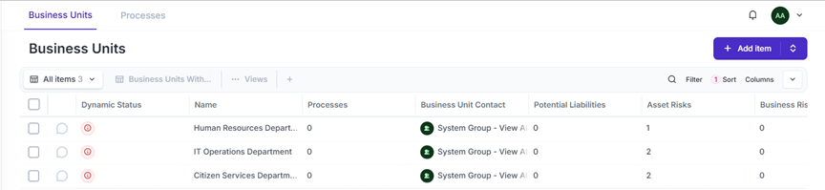
Figure 1: Organization’s business units configured in Eramba.
Relevance: The above figure shows that the organizational structure has been formed using number of three business units that are used for managing assets, risks, incidents, and flows.

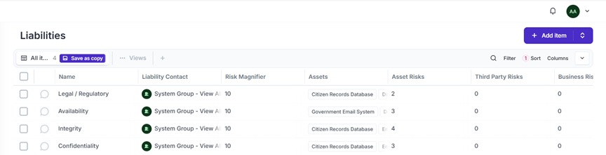
Figure 2: Asset liability and classification drivers configured in Eramba.
Relevance: This proves that confidentiality, integrity, availability, and legal/regulatory drivers were created and applied consistently to support risk scoring.

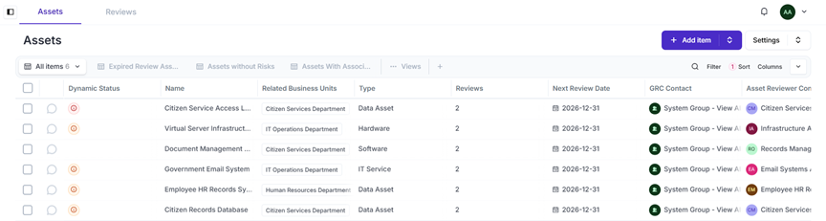
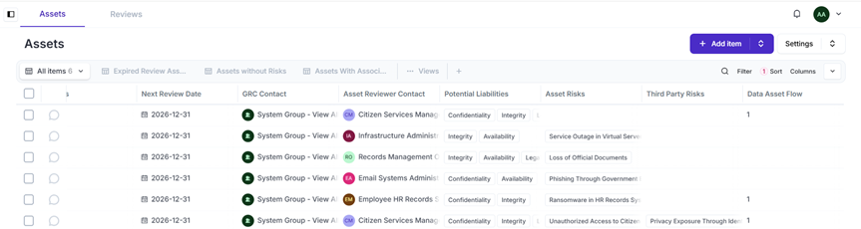
Figure 3: Asset inventory showing critical systems, business units, owners, review dates, and potential liabilities.
Relevance: This evidence confirms that the project includes at least five assets, including data assets, and that each asset has governance ownership and review accountability.

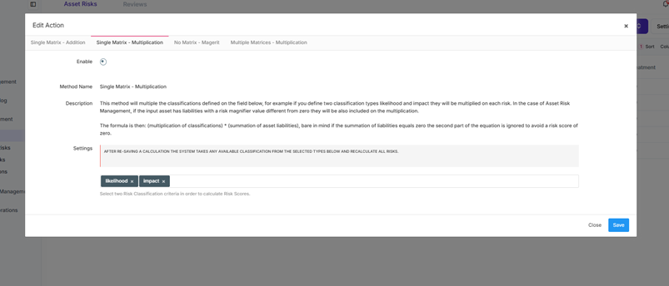
Figure 4: Risk calculation method configured as Single Matrix - Multiplication.
Relevance: This proves that Eramba calculates risk scores using likelihood and impact classifications and supports a consistent risk register.

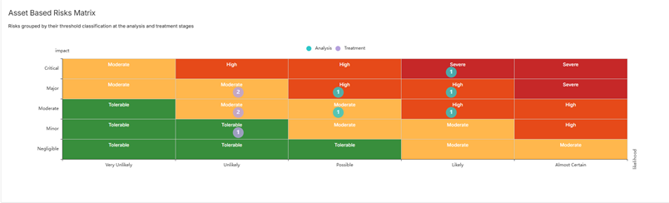
Figure 5: Dashboard asset-based risk matrix showing analysis and treatment stage risk positions.
Relevance: This validates the risk appetite matrix and demonstrates that risk treatment reduces several risks from higher analysis positions to lower residual positions.

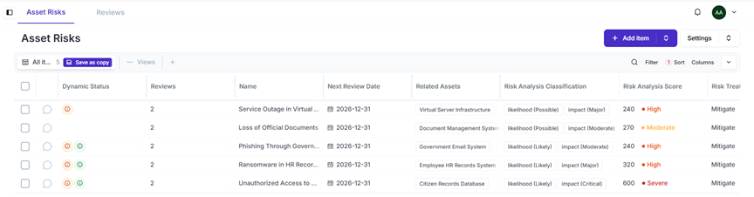
Figure 6: Asset risk register showing five risks linked to assets, scores, treatment, and residual scores.
Relevance: This proves the risk register requirement and shows that all risks were scored, assigned a treatment, and linked to assets.

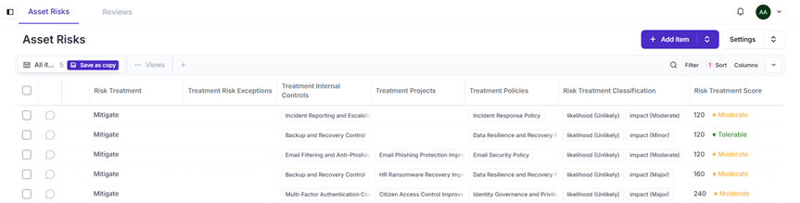
Figure 7: Risk treatment view showing internal controls, policies, projects, and residual treatment classifications.
Relevance: This proves cross-module linkage between risks, controls, policies, and improvement projects, which is required for integrated GRC reporting.

5.2 Student 2 - Policy and Control Lead
Student 2 created the policy and control layer of the GRC system. Policies define governance expectations, while internal controls show the practical security activities used to treat risks. Audit and maintenance records were created so that each control has evidence of testing and ongoing operation.
Policy / Control Area | Implemented Items
Policies | Identity Governance and Privileged Access Policy; Data Resilience and Recovery Policy; Email Security Policy; Incident Response Policy
Internal Controls | Multi-Factor Authentication Control; Backup and Recovery Control; Email Filtering and Anti-Phishing Control; Incident Reporting and Escalation Control
Audit Evidence | Audit records created for the controls with methodology, success criteria, planned dates, and audit ownership.
Maintenance Evidence | Maintenance records created for controls with planned maintenance tasks and ownership.
Linkage | Policies and controls were linked to asset risks, compliance requirements, and data flows.

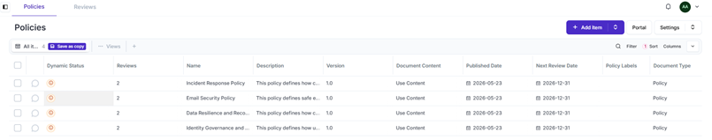
Figure 8: Policy library showing four published policies with review counts and next review dates.
Relevance: This proves that the minimum four-policy requirement was met and that policies were treated as active governance documents rather than simple text entries.

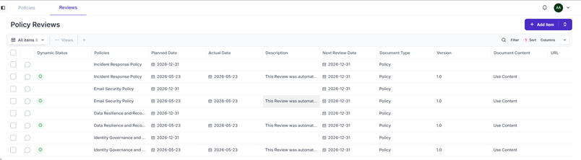
Figure 9: Policy review records showing version and planned review evidence for the created policies.
Relevance: This demonstrates policy lifecycle management, version history, and future review scheduling as required in the policy management workflow.

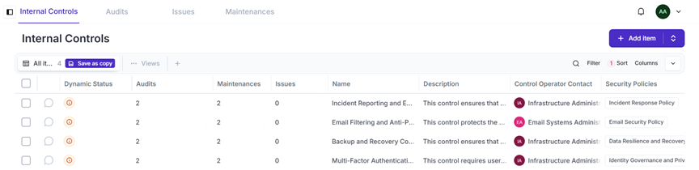
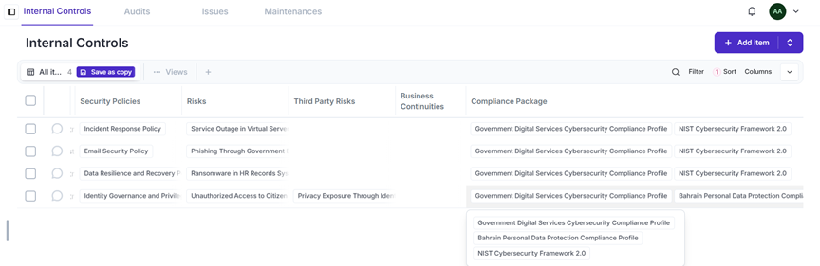
Figure 10: Internal controls list showing four controls with audit counts, maintenance counts, related policies, and linked risks.
Relevance: This proves that controls are operational solutions connected to policies and risks, not standalone entries.

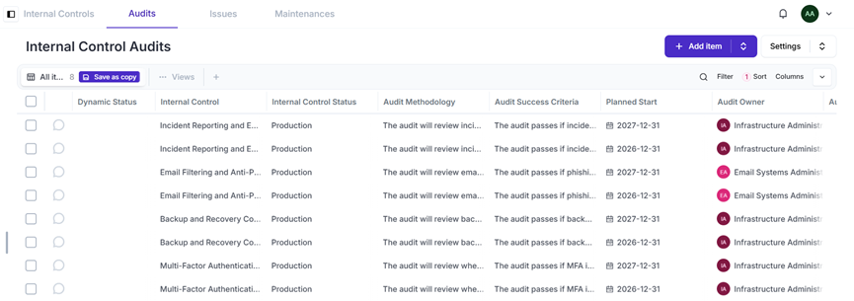
Figure 11: Internal control audit records created for the implemented controls.
Relevance: This provides testing evidence for the controls and supports audit readiness by showing methodology, success criteria, dates, and ownership.

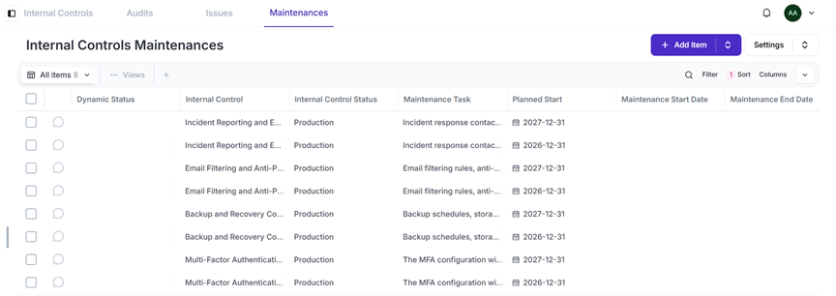
Figure 12: Internal control maintenance records showing planned maintenance activities for controls.
Relevance: This proves that controls are maintained over time and that Eramba is used to track ongoing control operation.

5.3 Student 3 - Compliance and Privacy Lead
Student 3 implemented the compliance and privacy requirements. NIST CSF 2.0 was imported as the main cybersecurity framework, and a sector-relevant compliance package was created for government digital services and privacy obligations. Privacy-focused data assets, processing activities, third parties, data flows, GDPR fields, and third-party risk evidence were also created.
Compliance / Privacy Area | Implemented Items
Frameworks | NIST CSF 2.0; Government Digital Services Cybersecurity Compliance Profile; Bahrain Personal Data Protection Compliance item
Mapped Requirements | Identity and access, backup/recovery, email/phishing, incident readiness, lawful processing/privacy
Privacy Data Assets | Citizen Records Database, Employee HR Records System, Citizen Service Access Logs
Third Parties | National Identity Verification Gateway, Secure Cloud Backup Provider, Security Monitoring Analytics Provider
Data Flows | Citizen Identity Verification Data Flow, Secure Cloud Backup Data Flow, Citizen Access Log Monitoring Data Flow
Third-Party Risk | Privacy Exposure Through Identity Verification Gateway

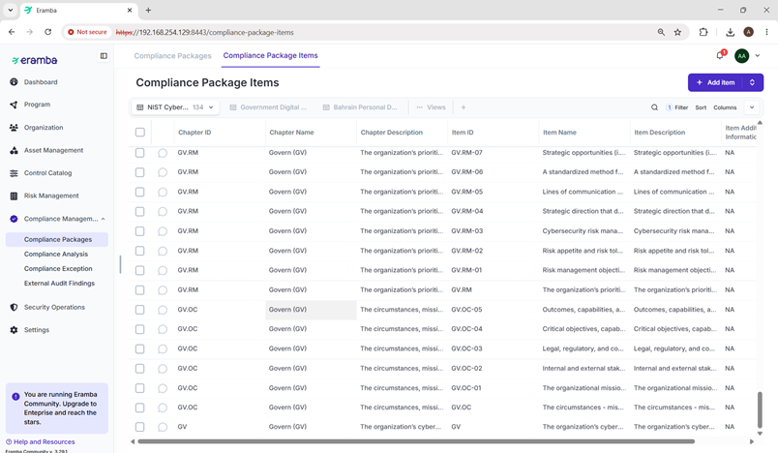
Figure 13: NIST Cybersecurity Framework 2.0 compliance package imported with 134 requirement items.
Relevance: This proves the NIST CSF 2.0 import requirement and creates the main framework repository for compliance analysis.

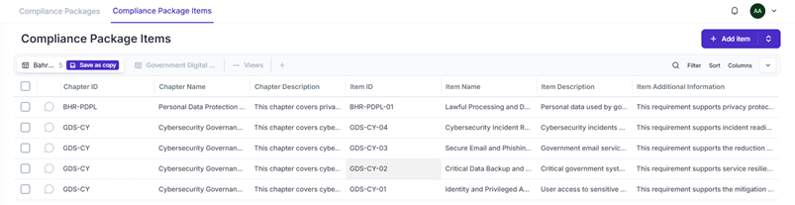
Figure 14: Sector-relevant compliance package items for government digital services and Bahrain privacy requirements.
Relevance: This proves that a second sector-relevant framework was created and mapped in addition to NIST CSF 2.0.

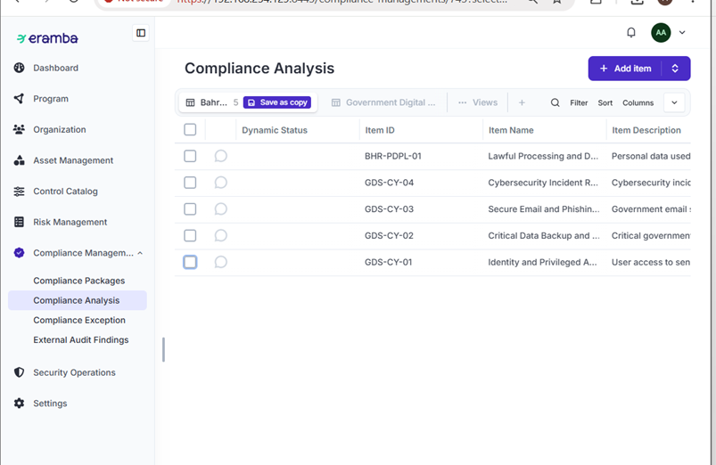
Figure 15: Compliance analysis list showing mapped requirements for the selected framework.
Relevance: This evidence confirms that compliance requirements were assessed and prepared for strategy, treatment, and risk mapping.

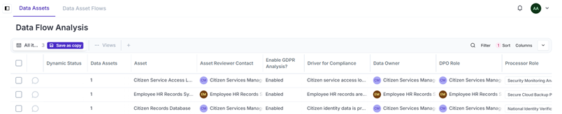
Figure 16: Data processing activities showing GDPR analysis enabled, compliance drivers, data owners, DPO roles, and processor roles.
Relevance: This closes the processing activity requirement by showing that the privacy-focused data assets have GDPR analysis enabled and ownership assigned.

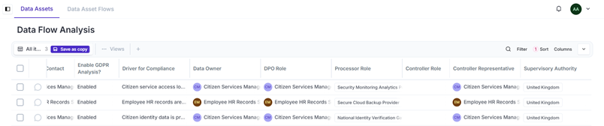
Figure 17: Processing activity GDPR role mapping showing processor roles, controller representatives, and supervisory authority.
Relevance: This supports privacy accountability by documenting processor roles, controller representative fields, and the available supervisory authority option in Eramba.

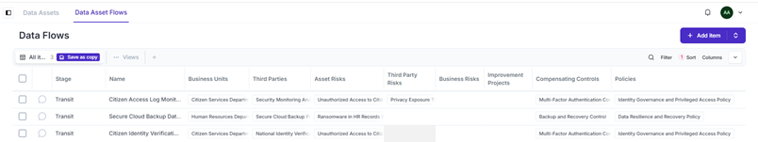
Figure 18: Data asset flows showing three privacy flows linked to business units, third parties, risks, controls, and policies.
Relevance: This proves the three-data-flow requirement and shows how privacy flows are linked to risk treatment and governance documents.

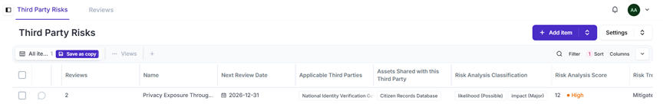
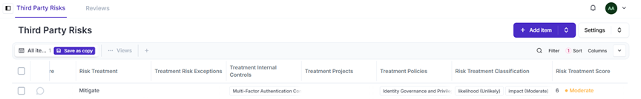
Figure 19: Third-party risk record showing treatment, internal control, policy linkage, and reduced residual score.
Relevance: This proves that third-party risk was assessed and treated through controls and policies, supporting the privacy and vendor-risk requirements.

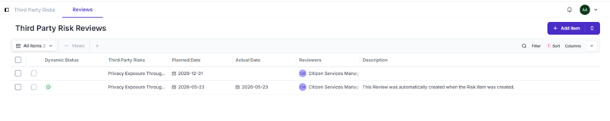
Figure 20: Third-party risk review records created for the privacy exposure risk.
Relevance: This shows that third-party risk is not only created but also scheduled for governance review.

5.4 Student 4 - Integration, Incident and Reporting Lead
Student 4 completed the integration, incident, and reporting layer. Four incidents were created and linked to known asset risks, affected controls, and affected assets. Incident stages were added and applied to each incident. Improvement projects and tasks were also created to represent treatment plans for priority risks, and dashboard screenshots were captured to support final reporting.
Incident / Reporting Area | Implemented Items
Incidents | Suspicious citizen account access, ransomware alert on HR records, phishing email reported, virtual server service outage
Incident Linkage | Known asset risk, affected internal control, affected asset, owner, status, and open date
Lifecycle Stages | Identification, Containment, Investigation, Recovery and Closure
Improvement Projects | Citizen Access Control Improvement Project, HR Ransomware Recovery Improvement Project, Email Phishing Protection Improvement Project
Tasks | One task created per project with owner, deadline, order, and completion rate
Dashboard Evidence | Asset-based risk matrix and current compliance status

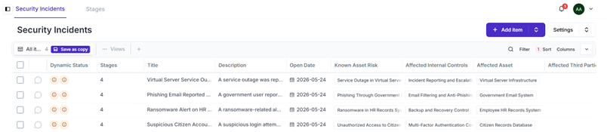
Figure 21: Security incidents list showing four incidents linked to asset risks, controls, and affected assets.
Relevance: This proves the incident management requirement and demonstrates that incidents were integrated with existing risk and control records.

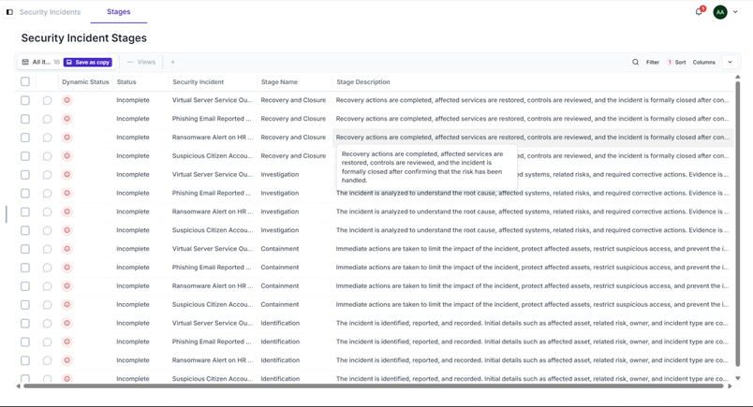
Figure 22: Incident lifecycle stages applied across security incidents.
Relevance: This shows that incidents were managed through a defined lifecycle, including identification, containment, investigation, and recovery/closure.

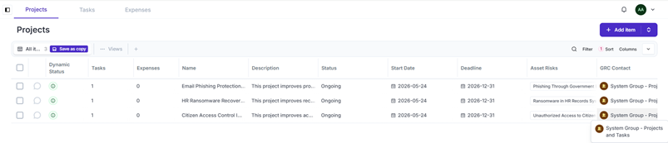
Figure 23: Improvement projects linked to priority asset risks with status, dates, and GRC ownership.
Relevance: This proves that three risk treatment projects were created and connected to priority risks.

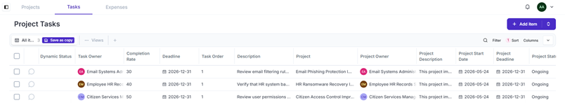
Figure 24: Project tasks showing owners, completion rates, deadlines, and project linkage.
Relevance: This shows that improvement projects have actionable tasks and measurable progress rather than being empty project records.

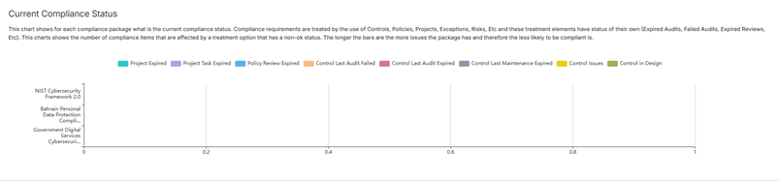
Figure 25: Dashboard current compliance status for NIST CSF 2.0, Bahrain privacy, and government digital services compliance packages.
Relevance: This proves the compliance dashboard widget requirement and shows monitoring of the implemented compliance packages.

5.5 Additional Cross-Module Evidence
The following updated screenshots were added to strengthen the final report evidence. They provide clearer proof of review cycles, cross-module linkages, compliance package ownership, and detailed compliance mapping across NIST CSF 2.0, government digital services, and Bahrain privacy requirements.
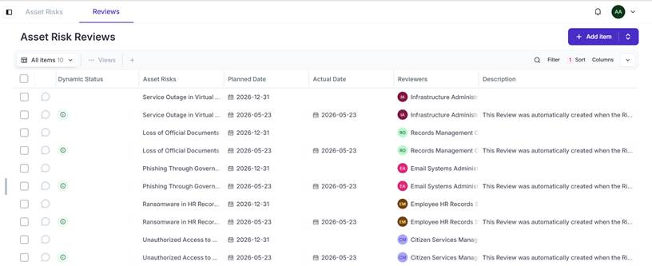
Figure 26: Asset risk review records showing planned and completed review dates for priority risks.
Relevance: This strengthens Student 1 evidence by showing that the asset risks were not only created, but also placed into a governance review cycle with assigned reviewers and planned review dates.
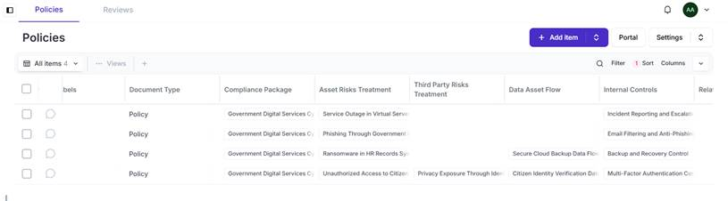
Figure 27: Policy library cross-module linkage view showing policies connected to compliance packages, risk treatments, data asset flows, and internal controls.
Relevance: This strengthens Student 2 evidence by proving that policies are linked to risks, controls, compliance packages, and privacy data flows instead of remaining standalone documents.
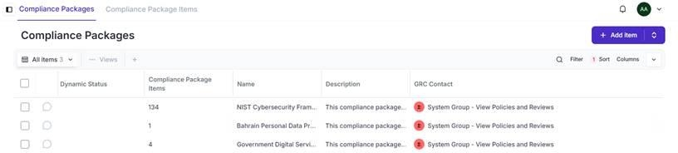
Figure 28: Compliance packages overview showing NIST CSF 2.0, Bahrain privacy, and government digital services packages with item counts and GRC contact ownership.
Relevance: This strengthens Student 3 evidence by clearly showing the required NIST CSF 2.0 framework and additional sector-relevant compliance packages in the compliance module.
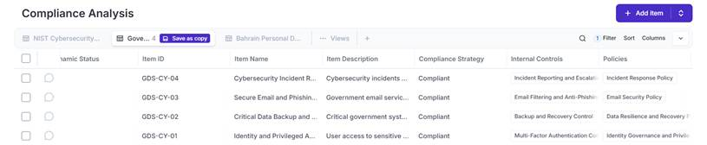
Figure 29: Government digital services compliance analysis showing four sector requirements marked as compliant and mapped to supporting controls and policies.
Relevance: This proves that sector-specific compliance requirements were mapped to real Eramba treatment evidence, including internal controls and policies.
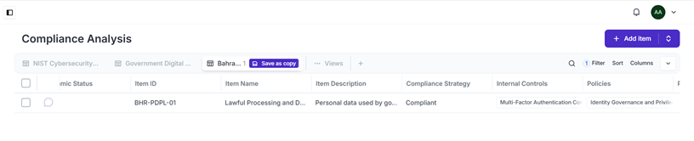
Figure 30: Bahrain personal data protection compliance analysis showing the lawful processing requirement marked as compliant and mapped to access control evidence.
Relevance: This supports the privacy and regulatory context by showing that the Bahrain privacy requirement was assessed and mapped to the identity governance policy and MFA control.
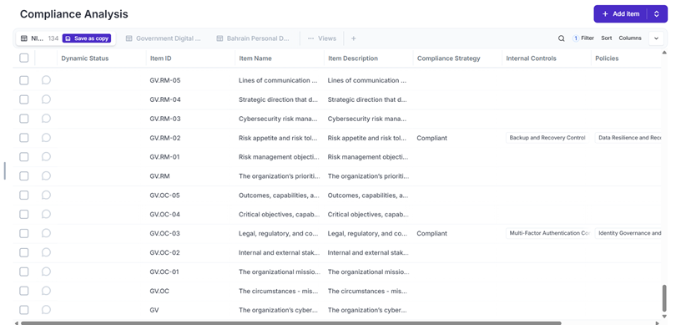
Figure 31: NIST CSF 2.0 compliance analysis showing governance requirements mapped to controls and policies.
Relevance: This strengthens the compliance mapping evidence by showing NIST governance requirements with compliant strategy values and supporting treatment links.
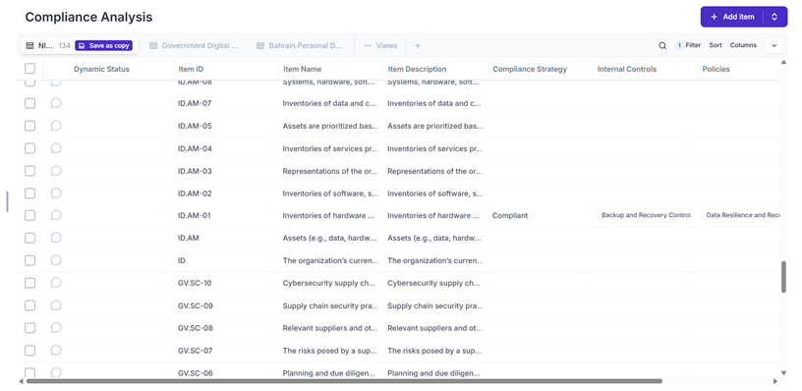
Figure 32: NIST CSF 2.0 asset management requirement mapping linked to backup and recovery treatment evidence.
Relevance: This shows that asset inventory and recovery-related requirements were connected to the Backup and Recovery Control and Data Resilience and Recovery Policy.
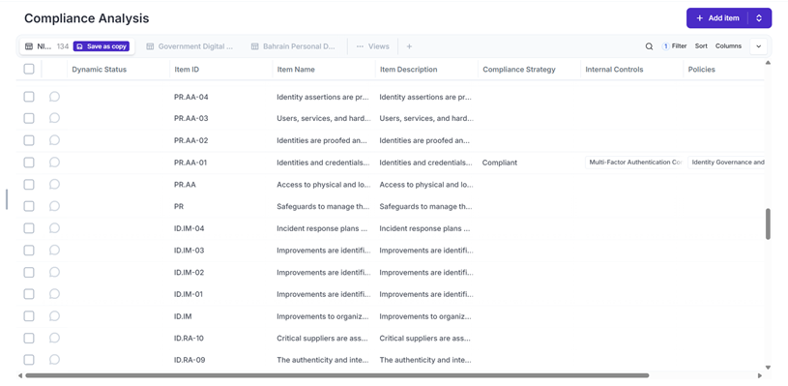
Figure 33: NIST CSF 2.0 identity and access requirement mapping linked to MFA and identity governance evidence.
Relevance: This directly supports the access control compliance requirement by showing PR.AA-01 marked compliant and mapped to the Multi-Factor Authentication Control and Identity Governance policy.
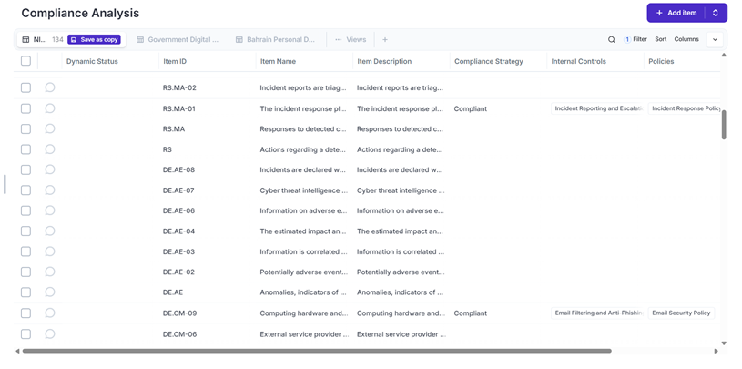
Figure 34: NIST CSF 2.0 detection and response mappings linked to incident reporting and email security controls.
Relevance: This confirms that response and monitoring requirements were mapped to the Incident Reporting and Escalation Control, Incident Response Policy, Email Filtering control, and Email Security Policy.

6. Analysis and Discussion

6.1 Top Risk Interpretation
In the Risk Matrix, it is evident that there were some risks that were initially classified as High and Severe risks. Some of the risks include the risk of access to citizens' data without authorization and risks related to HR data and governmental services. In the treatment indicators, it is evident that the residual risks have been reduced through mitigation strategies.
Priority Risk | Main Impact | Treatment Approach
Unauthorized Access to Citizen Records | Privacy breach, identity misuse, legal/regulatory impact | MFA Control, Identity Governance Policy, access control improvement project
Ransomware in HR Records System | Loss of employee records, service disruption, recovery cost | Backup and Recovery Control, Data Resilience Policy, ransomware recovery project
Phishing Through Government Email System | Credential compromise and unauthorized access | Email Filtering Control, Email Security Policy, phishing protection project
Service Outage in Virtual Server Infrastructure | Availability impact to government digital services | Incident Reporting and Escalation Control, Incident Response Policy

6.2 Compliance and Privacy Interpretation
The evidence for compliance includes mapping NIST CSF 2.0 and governmental/privacy compliance requirements. The extra compliance screenshots further substantiate this evidence through providing several mappings for governmental digital service compliance, Bahrain privacy compliance, and NIST CSF 2.0, including control and policy treatments. The reason this is critical is that the auditors require an ability to map the requirements to evidence of governance provided by the organization. Privacy-related evidence suggests that the organization has determined types of personal information processed; purpose, use, owner, data processors; and relevant control and policy treatments of data flows.

6.3 Incident and Improvement Interpretation
Incidents records have shown that there is an integration of the security operation with the GRC system where each incident has some relationship with certain risks and assets or controls involved. The improvements are carried out through risk treatment to improve remediation activities. They involve having owners, deadlines, and progress rates towards completion.

7. Conclusion and Recommendations
The Eramba implementation successfully demonstrates a complete GRC system for a government digital services organization. The system documents business units, assets, risk classifications, risks, policies, controls, audits, maintenances, compliance frameworks, privacy records, third parties, data flows, incidents, projects, and dashboard reporting. The evidence shows that the required modules were implemented and that the records are connected across Eramba modules.

Recommendations
- Complete periodic review cycles for all policies, controls, risks, and privacy records before each audit period.
- Use the dashboard regularly to monitor high and severe risks and verify that treatment projects are reducing residual exposure.
- Continue expanding compliance mapping beyond the minimum five requirements so management can see broader framework coverage.
- Test incident response stages using tabletop exercises and record the outcome in Eramba as evidence.
- Review third-party contracts and ensure processors support reporting, privacy requests, and secure data handling requirements.
In general, this implementation proves that Eramba is capable of integrating the various functions such as governance, risk management, compliance analysis, privacy management, and incident response all into one trackable system.

8. Workload Contribution Table
Student | Role | Assigned Workload | Completed Workload | Main Tasks Completed | Peer Review Remarks
Student 1: Abdulrahman Altairey 202304613 | Asset and Risk Lead | 25% | 100% | Business units, assets, liabilities, risk scoring, appetite matrix, asset risk register | Completed assigned tasks and evidence.
Student 2: Abdulelah Slais 202300436 | Policy and Control Lead | 25% | 100% | Policies, versions/reviews, internal controls, audits, maintenances, risk-control-policy linkage | Completed assigned tasks and evidence.
Student 3: khalid Alhariri 202302473 | Compliance and Privacy Lead | 25% | 100% | NIST import, additional framework, compliance mappings, privacy data assets, processing activities, third parties, data flows | Completed assigned tasks and evidence.
Student 4: Abdullah Hoth 202302552 | Integration, Incident and Reporting Lead | 25% | 100% | Incidents, incident stages, improvement projects, project tasks, dashboard screenshots, evidence organization | Completed assigned tasks and final integration.

9. References
Bahrain Polytechnic. (2026). IT8515 course project brief: Real-time GRC system design and implementation using Eramba platform.
Bahrain Polytechnic. (2026). Week 7 lab: Asset and risk — Identifying and creating risks in Eramba.
Bahrain Polytechnic. (2026). Week 8 lab: Policies — Creating and managing policies in Eramba.
Bahrain Polytechnic. (2026). Week 9 lab — Part 1: Mapping controls in Eramba.
Bahrain Polytechnic. (2026). Week 9 lab — Part 2: Performing compliance analysis in Eramba.
Bahrain Polytechnic. (2026). Week 10 lab: Data privacy — Managing data privacy using Eramba.
National Institute of Standards and Technology. (2024). The NIST Cybersecurity Framework (CSF) 2.0. U.S. Department of Commerce. https://www.nist.gov/cyberframework
Kingdom of Bahrain. (2018). Law No. 30 of 2018 with respect to Personal Data Protection Law. Personal Data Protection Authority. https://www.pdp.gov.bh/
Eramba. (n.d.). Eramba GRC platform documentation. Retrieved May 24, 2026, from https://www.eramba.org/

Appendix A - Evidence Index
Figure | Section | Evidence Description
Figure 1 | Student 1 | Business units configured in Eramba for the government digital services organization.
Figure 2 | Student 1 | Asset liability and classification drivers configured in Eramba.
Figure 3 | Student 1 | Asset inventory showing critical systems, business units, owners, review dates, and potential liabilities.
Figure 4 | Student 1 | Risk calculation method configured as Single Matrix - Multiplication.
Figure 5 | Student 1 / Student 4 | Dashboard asset-based risk matrix showing analysis and treatment stage risk positions.
Figure 6 | Student 1 | Asset risk register showing five risks linked to assets, scores, treatment, and residual scores.
Figure 7 | Student 1 / Student 4 | Risk treatment view showing internal controls, policies, projects, and residual treatment classifications.
Figure 8 | Student 2 | Policy library showing four published policies with review counts and next review dates.
Figure 9 | Student 2 | Policy review records showing version and planned review evidence for the created policies.
Figure 10 | Student 2 | Internal controls list showing four controls with audit counts, maintenance counts, related policies, and linked risks.
Figure 11 | Student 2 | Internal control audit records created for the implemented controls.
Figure 12 | Student 2 | Internal control maintenance records showing planned maintenance activities for controls.
Figure 13 | Student 3 | NIST Cybersecurity Framework 2.0 compliance package imported with 134 requirement items.
Figure 14 | Student 3 | Sector-relevant compliance package items for government digital services and Bahrain privacy requirements.
Figure 15 | Student 3 | Compliance analysis list showing mapped requirements for the selected framework.
Figure 16 | Student 3 | Data processing activities showing GDPR analysis enabled, compliance drivers, data owners, DPO roles, and processor roles.
Figure 17 | Student 3 | Processing activity GDPR role mapping showing processor roles, controller representatives, and supervisory authority.
Figure 18 | Student 3 | Data asset flows showing three privacy flows linked to business units, third parties, risks, controls, and policies.
Figure 19 | Student 3 | Third-party risk record showing treatment, internal control, policy linkage, and reduced residual score.
Figure 20 | Student 3 | Third-party risk review records created for the privacy exposure risk.
Figure 21 | Student 4 | Security incidents list showing four incidents linked to asset risks, controls, and affected assets.
Figure 22 | Student 4 | Incident lifecycle stages applied across security incidents.
Figure 23 | Student 4 | Improvement projects linked to priority asset risks with status, dates, and GRC ownership.
Figure 24 | Student 4 | Project tasks showing owners, completion rates, deadlines, and project linkage.
Figure 25 | Student 4 | Dashboard current compliance status for NIST CSF 2.0, Bahrain privacy, and government digital services compliance packages.
Figure 26 | Student 1 | Asset risk review records showing planned and completed risk reviews for priority risks.
Figure 27 | Student 2 | Policy cross-module linkage showing policy relationships with risks, compliance packages, data flows, and internal controls.
Figure 28 | Student 3 | Compliance package overview showing NIST CSF 2.0, Bahrain privacy, and government digital services compliance packages.
Figure 29 | Student 3 | Government digital services compliance analysis showing mapped controls and policies.
Figure 30 | Student 3 | Bahrain privacy compliance analysis showing lawful processing mapped to treatment evidence.
Figure 31 | Student 3 | NIST CSF governance requirement mappings linked to controls and policies.
Figure 32 | Student 3 | NIST CSF asset management mapping linked to backup and data resilience treatment evidence.
Figure 33 | Student 3 | NIST CSF identity and access mapping linked to MFA and identity governance evidence.
Figure 34 | Student 3 | NIST CSF detection and response mappings linked to incident response and email security controls.

Appendix B - Final Readiness Checklist
Checklist Item | Status
All minimum Eramba modules implemented | Completed
Each screenshot has a figure number and caption | Completed
Each screenshot has a relevance explanation | Completed
Workload contribution table included | Completed
References included | Completed
Student names/IDs completed and reviewed by group before submission | Completed
Additional compliance mapping screenshots included | Completed

