THE APPLICATION OF BLOCKCHAIN IN HIGH-SECURITY PERSONAL HEALTH SYSTEM

**Group :** FreeRider

**Supervisor :** Jackey Cheung

**Group Members :** Li Ka Kit 12631206

Chong Wan Si 12534001

You Zhihao 11957546

Pan Yichang 12530407

**Table of Content**

**Chapter 1. Problem Definition** **3**

Introduction 3

Project Aim 3

Discussion: 3

Project Objectives 4

Value Propositions 5

**Chapter 2. Background or Literature Review** **6**

Problem Discussion and Analysis 6

Network attacks 6

Easy to modify data maliciously 6

High Cost 6

Review of Existing or Related Solutions for the Problem (Existing How) 6

Related Supporting Technologies (Existing How) 8

Use Case diagram 8

Use Case and Function List 9

Use Case Descriptions 10

UC-001 Read Health Information 10

UC-002 Read Medical Record 12

UC-003 Modify Medical Record 14

UC-004 Add Medical Record 16

UC-005 Set Patient Information 18

UC-006 Set Attending Medical Personnel 19

UC-007 Register Patient Account 20

UC-008 View Base Account Information 21

UC-009 Modify User Permission 22

UC-010 Add Medical Personnel Account 23

UC-011 Add Health Information 23

Functional and Non-Functional requirements 24

Functional requirements 24

Modify Medical Record 24

Add Medical Record 24

Read Medical Record 24

Read Health Information 24

Add Health Information 24

Add Medical Personnel Account 24

Modify Permission 24

Non-Functional requirements 25

Performance 25

security 25

Security of added data 25

Data confidentiality 25

Security of delete data 25

Compatibility 25

Reliability 25

List of essential technologies 26

Conclusion 26

**Chapter 3. Preliminary Methodology** **27**

Overview of Methodologies 27

Requirements and Key Technologies 27

Higher Level Design 28

*system architecture* *28*

Component Diagram 29

Information Flow 30

**References** **31**

**Appendix A. Project Plan** **32**

Gantt Chart 32

**Appendix B. Members’ Roles and Responsibilities** **32**

**Appendix C. Meeting Minutes** **33**

# Chapter 1. Problem Definition

## Introduction

In order to further provide better medical services, medical organizations need more patient information for more accurate diagnoses. To this end, they began to build an electronic medical record system for patients.

Now, many medical record systems have some problems. About security, detailed information, and insecure storage and link data. In cost, the volume of transactions and the burden on the healthcare ecosystem are hugely challenging to manage. In user needs, many system patients cannot search their medical history quickly and easily.

## Project Aim

This project aims to use BlockChain technology to create a high-security database to store medical history/records which reduces the risk of data leakage and maliciously changing data.

### Discussion:

Besides adding the medical history to the database, other information such as medical consultation history and family medical history data will also be added. This additional information can be regarded as the reference of the patients while they are looking for medical treatment. The database with BlockChain technology offers query and management services for patients in a safer way.

## Project Objectives

To achieve the aim, the project has defined several sub-objectives which are based on Wang et al. (2020) as follows:

Develop a decentralized system by using Blockchain to store patient data

Design a structure containing the corresponding patient, the ID of the doctor, medical instructions, and time. The patients who are assigned to the specific doctor grant access to their own medical instructions.

Develop a system that let user can faster via Interplanetary File System (IPFS) to patient data transferring from one computer to another

Develop a system that can connect IoT devices to collect and save patient data Let doctors be able to find the user-health problem

## Value Propositions

First of all, over the past few years, there has been a massive spurt of Research on Blockchain technologies and several attempts at incorporating them into the medical system.

Nowadays Many companies with Blochian technology are using Blockchain technology to help the medical system of many hospitals because blockchain makes people trust and can disrupt the digital ecosystem by providing an alternative to centralized storage and management of the data. Therefore, blockchain technology helps busy healthcare systems reduce costs and maximize benefits.

Furthermore, when using the blockchain system, these technologies can bring us a new model of data storage, transparency, tracking, and payment system, amongst other advantages. For example, using blockchain, this new technology, the medical staff will know about the patient — this new decentralized participatory governance model for the evolution of next-generation digital platforms and multi-stakeholder business interaction.

However, while some value propositions are easier to integrate with existing digital platforms, more disruptive value propositions such as business automation and governance models present more significant challenges and lead to innovation at the technical level and the transformation of existing social, economic, and governance models.

# 

# Chapter 2. Background or Literature Review

## Problem Discussion and Analysis

### Network attacks

A study (Martin, G., Martin, P., Hankin, C., Darzi, A., & Kinross, J. 2017) showed that attacks on the medical system have increased significantly in recent years.

Since the traditional system is a centralized system, once the server is compromised, data leakage and system failure will result. Since the new system does not only rely on a centralized server, but hackers must also attack all nodes at the same time, which will greatly increase the difficulty of intrusion and attack cost.

### Easy to modify data maliciously

In normal circumstances, medical records will not be modified or deleted in most cases. There may be cases where the medical records are revised, and the reason is that the medical staff made mistakes and wanted to conceal their mistakes, such as misdiagnosis.

Therefore, the patient's medical records will be changed. Currently, the modifiability of the traditional database becomes the main disadvantage. On the contrary, the immutability of the blockchain and the unique feature of deleting data can avoid this situation.

## High Cost

In a traditional centralized system, Maintaining the normal operation of the system will need a high cost for maintenance server and high data transfer costs.

## Review of Existing or Related Solutions for the Problem (Existing How)

### Using a centralized system

The connection method is designed in a safer approach, while the user connects to the system via a dedicated leased line or Virtual Private Network(VPN) connection.

### Use authentication

A static IP address or a registered security module is used for connecting to the system. Users must log in using these two technologies with their name and password and user-selected second-factor authentication.

### Comprehensive auditing of data activities

Detailed records of sensitive data are accessed, including access from external network users and business operators, especially auditing bulk access, auditing of unauthorized operations, and auditing the original data affected by changes and deletions.

### Encryption

A common approach to sharing medical data is to index and encrypt the data before uploading it to the public or cloud. Data can be encrypted by using traditional symmetric key encryption and then outsourcing the encrypted data to some decentralized file storage network, such as Interstar File System (IPFS).

## 

## Related Supporting Technologies (Existing How)

### Use Case diagram

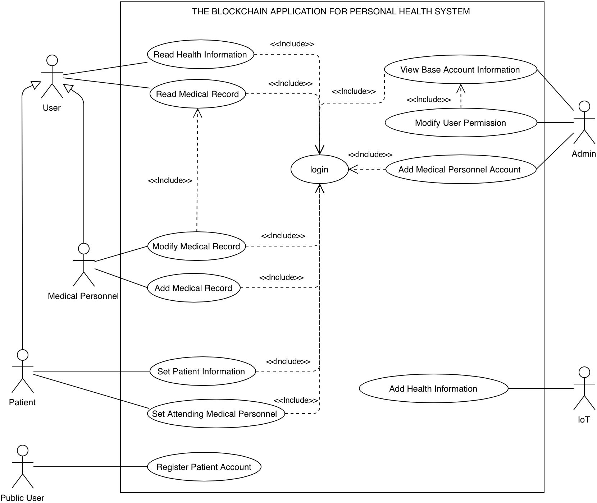

#### 

#### Use Case and Function List

|  |  |  |  |
| --- | --- | --- | --- |
| Type | Actor | Description | Use Case and Function |
| Primary Actors | Public User | People who don't have an account but want to register | 1. Register Patient Account |
| User | A user who has registered in the system. If authorized, the user can read medical records and Health Information. | 1. Read Medical Record 2. Read Health Information |
| Medical Personnel | Medical personnel is authorized to use this system. | 1. Read Medical Record 2. Read Health Information 3. Modify Medical Record 4. Add Medical Record |
| Patient | A user who has registered as a patient | 1. Read Medical Record 2. Read Health Information 3. Set patient information 4. Set attending medical personnel |
| Admin | System Operation Manager | 1. Add Medical Personnel Account 2. Modify User Permission 3. View Base Account Information |
| Secondary Actor | IoT | An external entity that can be used to record the physical condition of a patient.  it will send back patient health information to the system. | 1. Add Health Information |

### 

### 

### Use Case Descriptions

#### UC-001 Read Health Information

|  |  |
| --- | --- |
| Actor(s): | User, Medical Personnel, Patient |
| Brief description: | * Medical Personnel can read Patient Health Records for medical use. * Patients can read their Health records to understand one's physical condition |
| User Stories: | * As a Medical Personnel, I want to read patients' health information, so I need patient health information for medical use. * As a patient, I went to read patients' health information, so that I could know my health information. |
| Preconditions: | Medical personnel have the relevant authority. |
| The flow of events: | Medical Personnel:  1. Medical Personnel login to the system  2. The system will show the list of patients that the medical staff is responsible for.  3. Select patient  4. System displays patient’s health information    Patient:  1. Patient login to the system  2. System shows health information |
| Postconditions: | Successfully show health information. |
| Alternative flows  and exceptions: | If the system does not have any patient health information, the system shows that “Patient health information is empty”. |

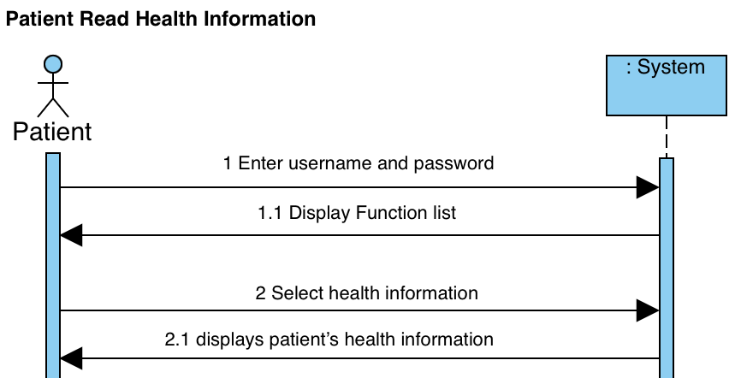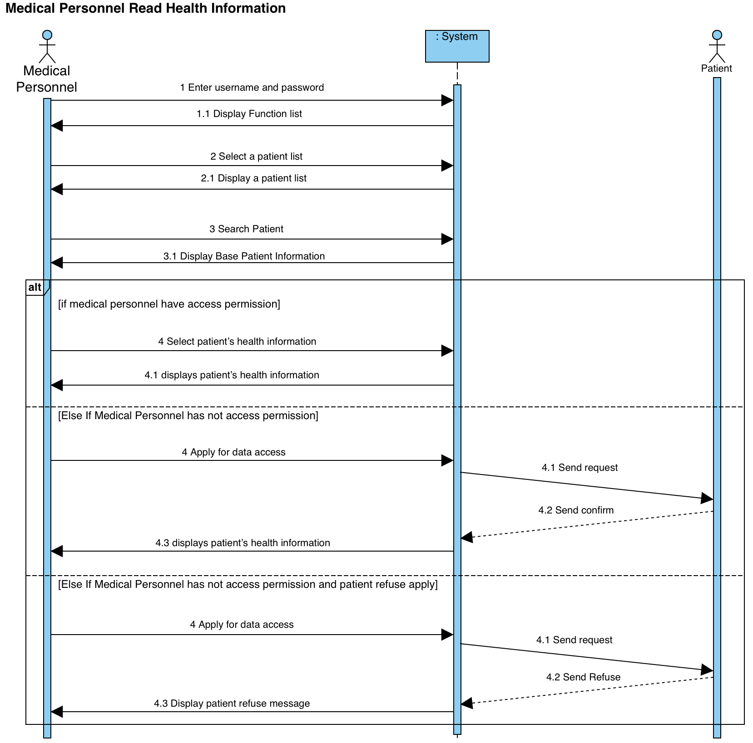

#### UC-002 Read Medical Record

|  |  |
| --- | --- |
| Actor(s): | User, Medical Personnel, Patient |
| Brief description: | Medical Personnel can read patient medical Records for medical use.  Patients can read their medical records to understand one's physical condition. |
| User Stories: | As medical personnel, I want to read patients’ medical records, so I need patient health information for medical use.  As a patient, I want to read my medical record, so that I could know my health information. |
| Preconditions: | Medical personnel have the relevant authority |
| The flow of events: | Medical Personnel:   1. Medical Personnel login to the system 2. The system will show the list of patients that the medical staff is responsible for. 3. Select patient 4. System displays more patient information   Patient:   1. Patient login to the system 2. System shows medical record |
| Postconditions: | Successfully show medical record |
| Alternative flows  and exceptions: | If the system does not have any patient medical records, the system shows that “Patient medical record is empty”. |

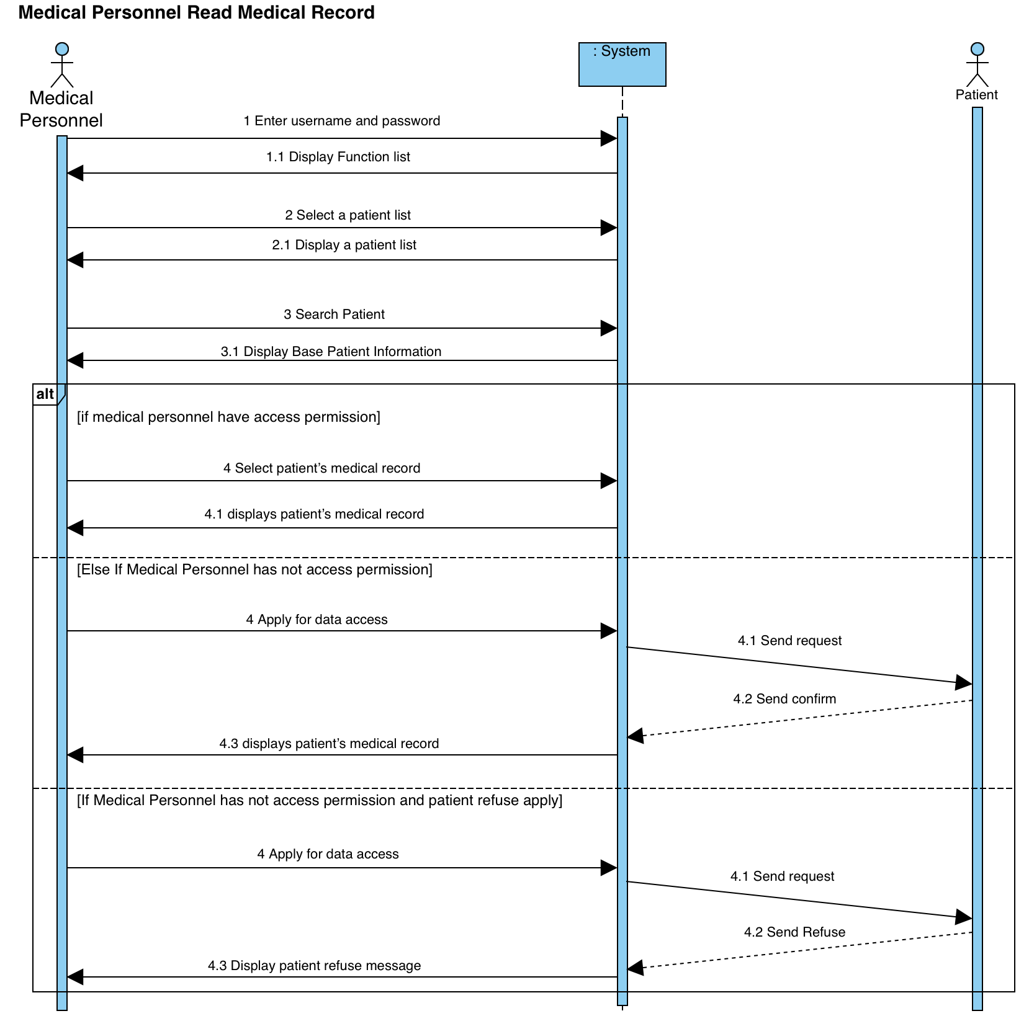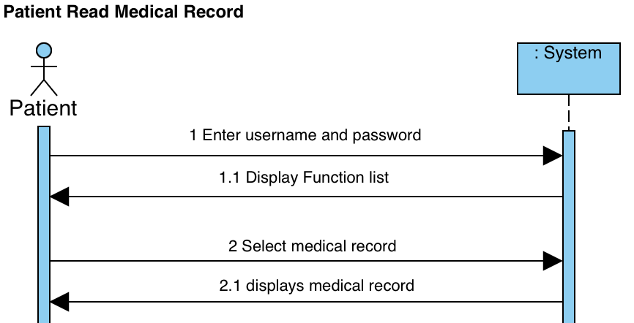

#### UC-003 Modify Medical Record

|  |  |
| --- | --- |
| Actor(s): | Medical Personnel |
| Brief description: | Add a new block to indicate what data was wrong before and which data shall prevail. Use this method to correct and update information. |
| User Stories: | As medical personnel, I want to modify medical records, so that I can more easily provide better medical service. |
| Preconditions: | Medical personnel have relevant authority,  The system stores the data that the user wants to change |
| The flow of events: | 1. Medical Personnel login to the system 2. The system will show the list of patients that the medical staff is responsible for. 3. Select patient 4. System displays more patient information 5. Medical Personnel click update medical record 6. System update and show the result of updated medical record |
| Postconditions: | Successfully Modify Medical Record |
| Alternative flows  and exceptions: | If medical personnel do not have permission, the system shows that “you do not have enough permission”. |

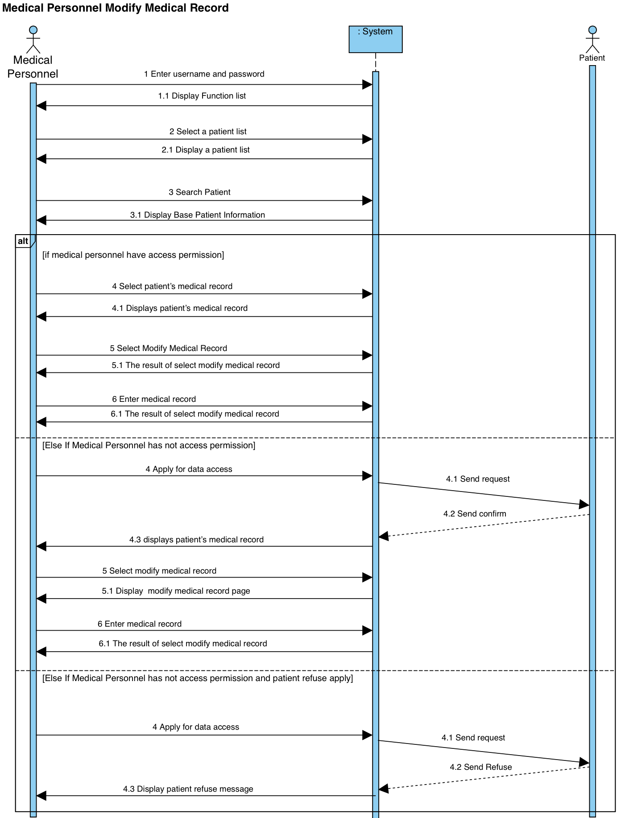

#### UC-004 Add Medical Record

|  |  |
| --- | --- |
| Actor(s): | Medical Personnel |
| Brief description: | Medical staff can add medical records for patients |
| User Stories: | As a Medical Personnel, I add medical records, so that I can more easily service patients. |
| Preconditions: | Medical personnel have the relevant authority |
| The flow of events: | 1. Medical Personnel login to the system 2. The system will show the list of patients that the medical staff is responsible for. 3. Select patient 4. System displays more patient information 5. Medical Personnel click add a medical record 6. System add and show the result of add medical record |
| Postconditions: | Successfully add the medical record |
| Alternative flows  and exceptions: | If medical personnel enter has a mistake, the system shows an “Input Error”. |

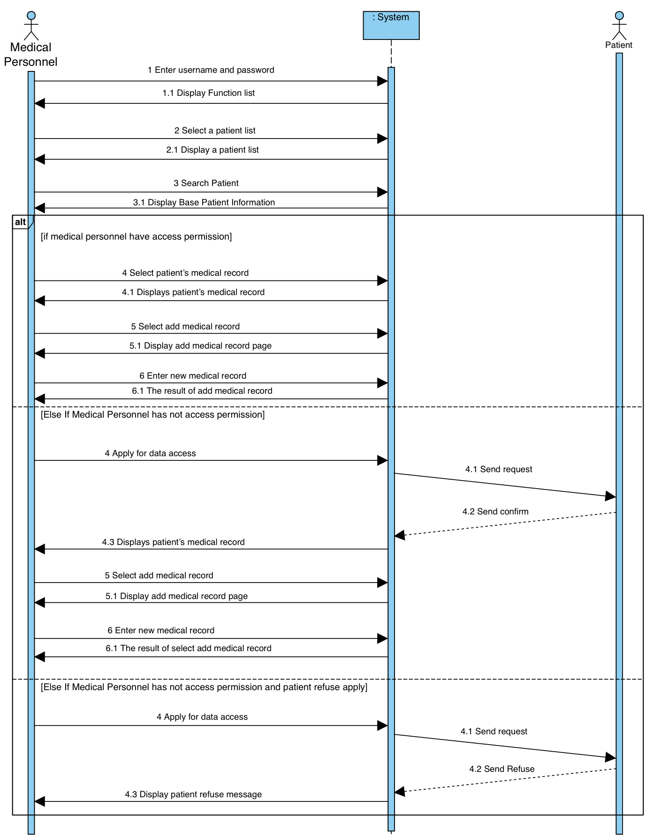

#### UC-005 Set Patient Information

|  |  |
| --- | --- |
| Actor(s): | Patient |
| Brief description: | Patients can set their personal information to the system. |
| User Stories: | As a patient, I want to set personal information to the system, so that I can use this information to see a doctor more conveniently. |
| Preconditions: | Patient has a account in the system |
| The flow of events: | 1. Patient login to the system 2. Patients enter personal information 3. System shows the result of Set Patient Information |
| Postconditions: | Successfully Set Patient Information |
| Alternative flows  and exceptions: | If a patient enters with a mistake, the system shows an “Input Error”. |

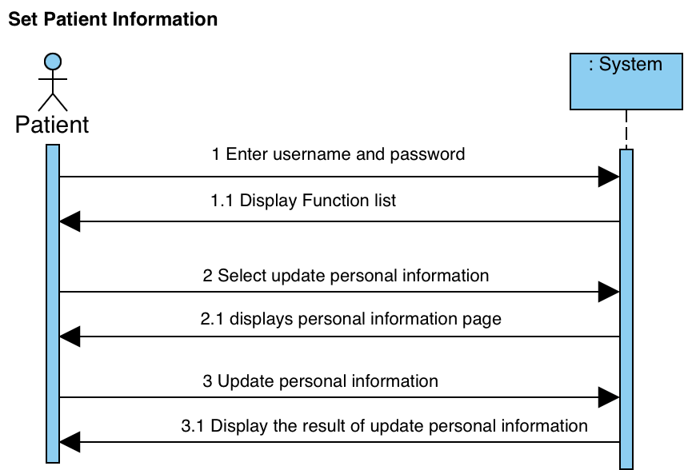

#### UC-006 Set Attending Medical Personnel

|  |  |
| --- | --- |
| Actor(s): | Patient |
| Brief description: | The patient can set which medical personnel to let them access my medical records and health information |
| User Stories: | As a patient, I want to attend medical personnel, so that can enjoy better medical services more conveniently. |
| Preconditions: | Medical personnel have an account in the system |
| The flow of events: | 1. Patient login to the system 2. The patient enters medical personnel information 3. The system shows the result of Set Attending Medical Personnel |
| Postconditions: | Successfully Set Attending Medical Personnel |
| Alternative flows  and exceptions: | If medical personnel do not have an account in the system, the system shows an “In the system, we do not have this medical personnel”. |

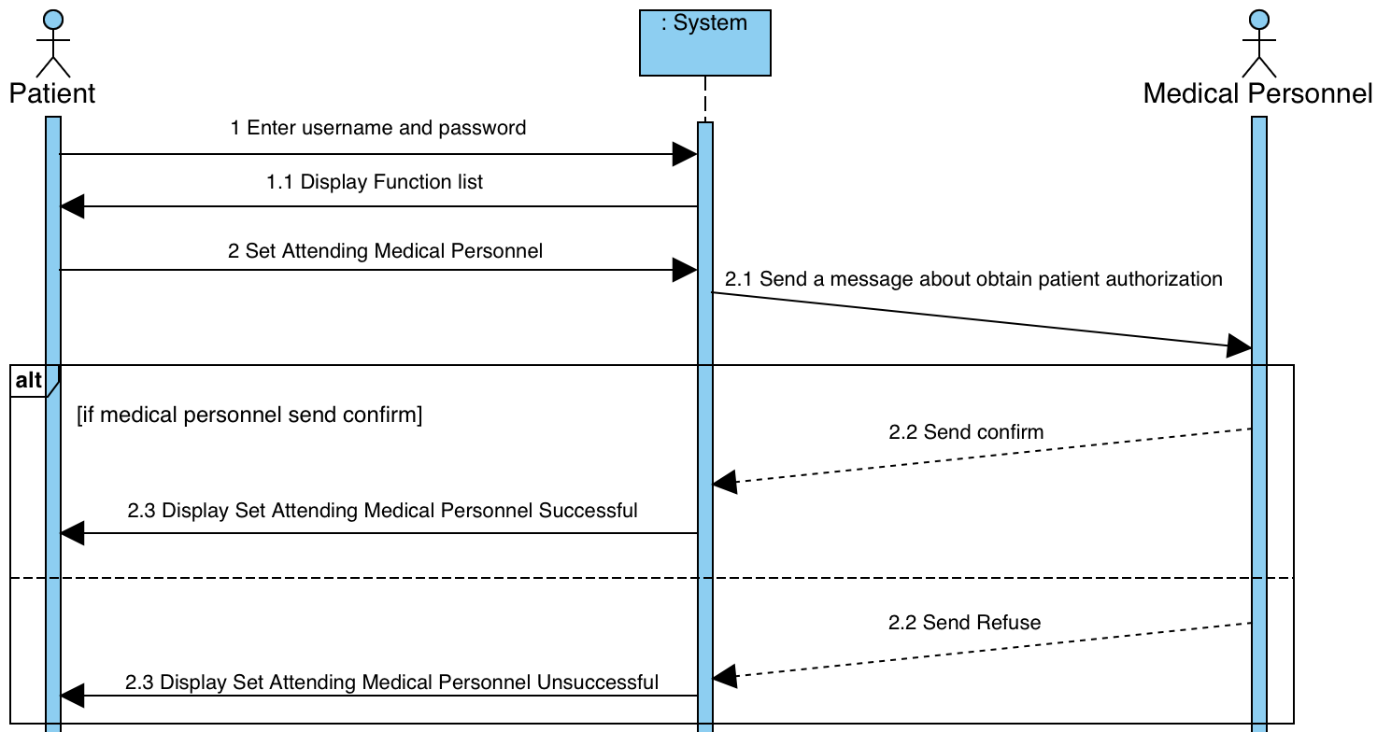

#### UC-007 Register Patient Account

|  |  |
| --- | --- |
| Actor(s): | Public User |
| Brief description: | A public user provides an email address, password to register a new patient account |
| User Stories: | As a public user, I want to register a patient account, so that I can use this system. |
| Preconditions: | Public users do not have an account in the system. |
| The flow of events: | 1. The public user enters an email address and password 2. The system creates a new patient account and confirms the patient through email |
| Postconditions: | A new patient account is created. |
| Alternative flows  and exceptions: | If a public user’s email has an error, the system shows a “Please re-enter your email, the email has a mistake”. |

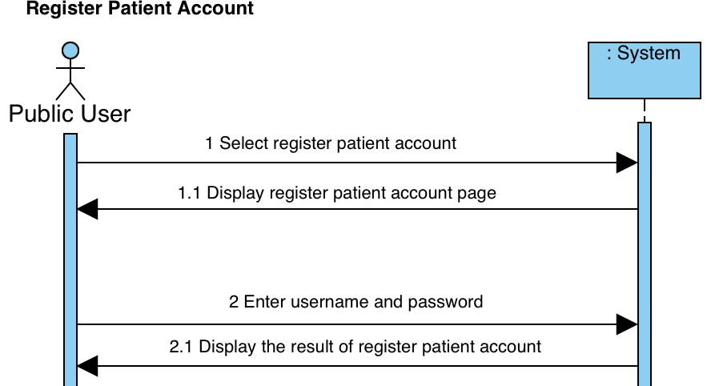

#### UC-008 View Base Account Information

|  |  |
| --- | --- |
| Actor(s): | Admin |
| Brief description: | Admin can view base account information |
| User Stories: | As an admin, I want to view base account information, so that I can more easily manage accounts. |
| Preconditions: | The system has an account that the administrator wants to view |
| The flow of events: | 1. Admin login to the system 2. The system displays a list of account 3. Admin select account 4. System displays base account information |
| Postconditions: | Successfully display base account information |
| Alternative flows  and exceptions: | If the system has not any account, the system shows that “The system has not any account”. |

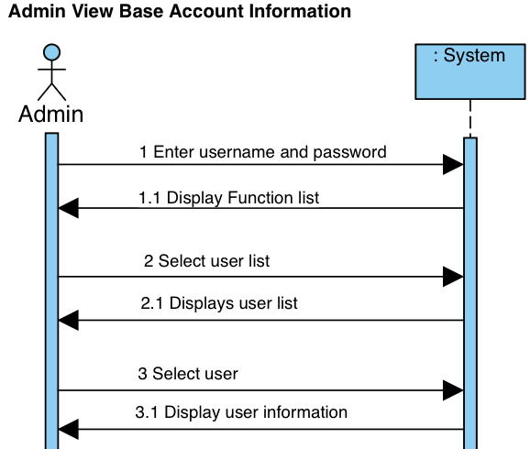

#### UC-009 Modify User Permission

|  |  |
| --- | --- |
| Actor(s): | Admin |
| Brief description: | Admin can modify user permission |
| User Stories: | As an admin, I want to modify user permission, so that I can more easily manage accounts. |
| Preconditions: | The system has an account that the administrator wants to modify |
| The flow of events: | 1. Admin login to the system 2. The system displays a list of account 3. Admin select account 4. System display more detail of the account 5. Admins modify permission 6. The system displays the result of modifying permission |
| Postconditions: | Successfully modified user permission |
| Alternative flows  and exceptions: | If the system has not any account, the system shows that “The system has not any account”. |

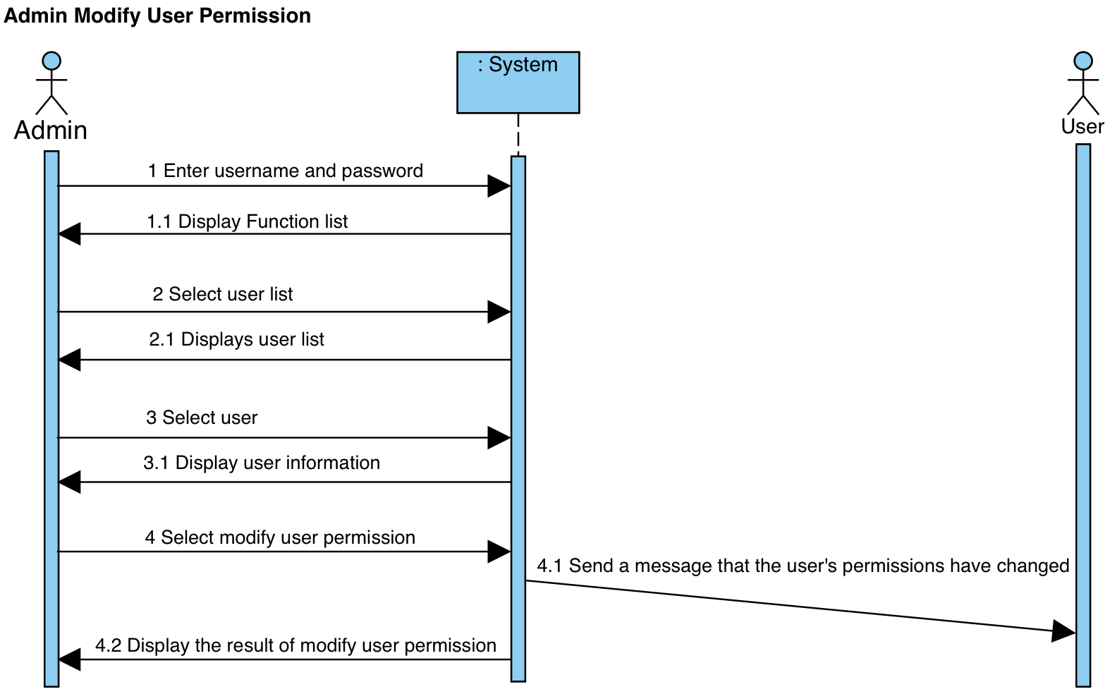

#### UC-010 Add Medical Personnel Account

|  |  |
| --- | --- |
| Actor(s): | Admin |
| Brief description: | Admin can add medical personnel account |
| User Stories: | As an admin, I want to add a Medical Personnel Account, so that I can more easily manage accounts. |
| Preconditions: | The medical personnel have no account in the system. |
| The flow of events: | 1. Admin login to the system 2. Admin add Medical Personnel Account 3. The system displays the result of adding a new Medical Personnel Account |
| Postconditions: | Successfully add Medical Personnel Account |
| Alternative flows  and exceptions: | If the admin enters new account information and has a data error, the system shows that “Please check new account information”. |

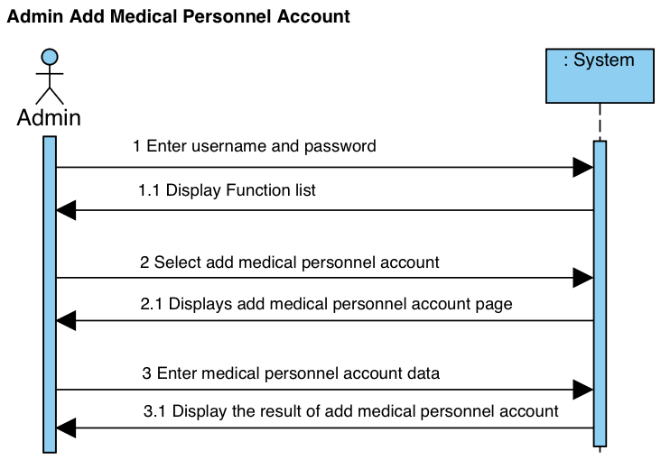

#### UC-011 Add Health Information

|  |  |
| --- | --- |
| Actor(s): | iot |
| Brief description: | The IoT device will write the recorded patient data into the system. |
| Preconditions: | The IoT device has connected to the system. |
| Postconditions: | Successfully add Health Information |

### 

### Functional and Non-Functional requirements

#### Functional requirements

##### Modify Medical Record

Adding a new block indicates what data was wrong before and which data shall prevail. Use this method to correct and update the information.

##### Add Medical Record

Authorized users can add new medical records and record writers.

##### Read Medical Record

Authorized users can read the medical record. Patients can read their own medical records.

##### Read Health Information

Authorized users can read health information. Patients can read their own health information.

##### Add Health Information

The IoT equipment that has been connected to the system can write the recorded user information to the system.

##### Add Medical Personnel Account

Admin can add a user account.

##### Modify Permission

Admin can modify user permission. In order to protect the privacy of patients, it only has the permission to remove users from reading patient data and remove the permissions to add users' medical data.

#### Non-Functional requirements

##### Performance

##### When the user reads unprocessed data, the system returns results in 10s. **Compatibility**

Users can use iOS, android, web to read and add information to the system.

##### **Reliability**

The system has 90 percent reliability for an hour, in normal use, the system only has a 10% chance to experience critical failure.

##### security

###### Security of added data

Unauthorized persons are not allowed to publish data on the blockchain, so medical information and patient privacy must be encrypted.

###### Data confidentiality

Unauthorized persons are not allowed to read the patient information and medical resources.

###### Security of delete data

Users cannot delete data at will, and cannot read digitally deleted data.

##### Compatibility

Users can use ios, android, web to read and add information to the system.

##### Reliability

The system has 90 percent reliability for an hour, in normal use, the system only has a 10% chance to experience critical failure.

### 

### List of essential technologies

In order to build and maintain our blockchain project, we decided to use Python, it became clear that it is the best choice for our needs. Python has plenty of features that make it a great tool for developers. Its command-line tool also provided us with a stable framework to handle the influx of requests.

## Conclusion

The modifiability of traditional databases is an advantage under normal circumstances. But not when it comes to storing medical records and medical information.

Because medical records will not be modified or deleted in most cases. There may be cases where the medical records are revised, and the life is because the medical staff made a mistake and wanted to conceal their mistakes, such as a misdiagnosis. Therefore, the patient's medical records will be changed.

Currently, the modifiability of the traditional database becomes the main disadvantage. On the contrary, the non-modifiable nature of the blockchain and the special feature of deleting data can avoid this situation.

# 

# Chapter 3. Preliminary Methodology

## Overview of Methodologies

In this project, we would like to deploy a system to store personal health data. Regarding system and version control, we will use GitHub. Making all code to sync using GitHub which combines different versions and what we do in coding. Our team is supposed to use JavaScript which installs a library for crypto to implement the hash of blockchain. To prevent tampering, implementing Proof-of-Work in JavaScript can decide which block can be corrected and make sure it is a non-tamper block.  
  
Regarding the supporting technologies for stability and durability, we design the web server on AWS EC2 using a docker container. Docker can handle many requests for high availability and stability. Its main benefit is to allow package applications in the instance (EC2). When it comes to Auto Scaling group, it depends on the number of instances that you set as the desired capacity. According to Auto Scaling groups - AWS Documentation by 2021, Amazon Web Services, Inc. It can adjust its size to meet demand, either manually or by using automatic scaling.

An Auto Scaling group starts by launching enough instances to meet its desired capacity.

In terms of datastore, we suggest using Amazon DynamoDB Database for our blockchain data.  
It is a fast and flexible non-relational database service for any scale. Saving blockchain JSON and hash.  
  
We will use waterfall Development project management. Without a shadow of a doubt, we hope that we can predict the time needed on schedule

## Requirements and Key Technologies

|  |  |  |
| --- | --- | --- |
| Elements | Description | Remarks |
| Use-cases | Show the interaction between the user and the system | Necessary, show different kinds of users and use cases of the system |
| Functional requirements | List the function and the aim of the function | Necessary |
| Non-functional requirements | the performance and quality requirements of function | Non-Compulsory |

## 

## Higher Level Design

### system architecture

### Component Diagram

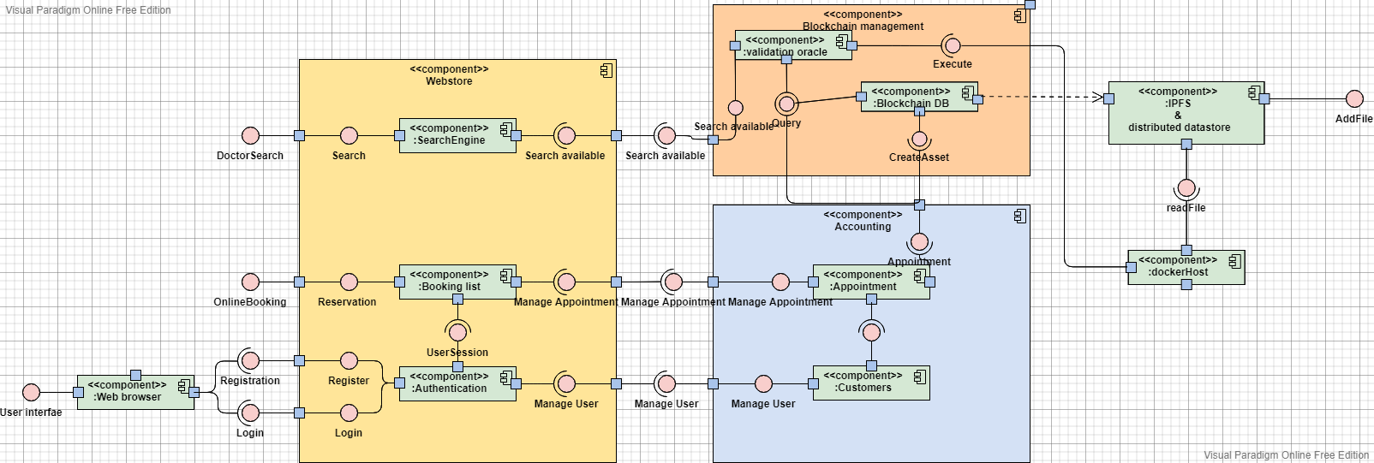

### 

### Information Flow

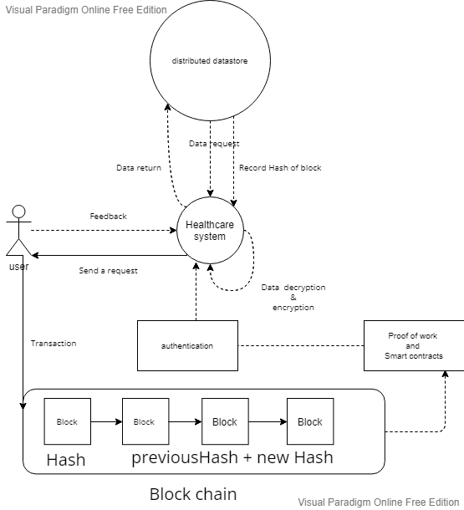

# 

# References

Martin, G., Martin, P., Hankin, C., Darzi, A., & Kinross, J. (2017). Cybersecurity and healthcare: how safe are we?. Bmj, 358. Retrieved from

<https://www.bmj.com/content/358/bmj.j3179.full>

Banerjee, M., Lee, J., & Choo, K. K. R. A blockchain future to Internet of Things security: A position paper, Digital Communications and Networks (2017). Retrieved from: <https://www.sciencedirect.com/science/article/pii/S2352864817302900>

Electronic Health Record Office. (2004). eHealth. Retrieved from <https://www.ehealth.gov.hk/en/index.html>

Stefano Tempesta.(2018). Decentralized Applications with Azure Blockchain as a Service. Retrieved from <https://docs.microsoft.com/en-us/archive/msdn-magazine/2018/july/blockchain-decentralized-applications-with-azure-blockchain-as-a-service>

Wang,J., Han, K., Alexandridis, A.,Chen, Z., Zilic, Z.,Pang, Y., ... Piccialli, F. (2020). A blockchain-based eHealthcare system interoperating with WBANs, Future Generation Computer Systems. Retrieved from <https://www.sciencedirect.com/science/article/pii/S0167739X19321247>

Li, H., Zhu, L., Shen, M. et al. (2018). Blockchain-Based Data Preservation System for Medical Data. J Med Syst 42, 141. Retrieved from <https://doi-org.ezproxy.lib.hkmu.edu.hk/10.1007/s10916-018-0997-3>

Matthias Mettler,M.A.HSG, Boydak Strategy Consulting AG, Freienbach, Switzerland , IEEE(2016)  
Blockchain technology in healthcare: The revolution starts here.Retrieved from <https://ieeexplore.ieee.org/abstract/document/7749510/authors#authors>  
  
Peng Zhang ,Douglas C.Schmidt , Jules White , Gunther Lenz (2018)  
Blockchain Technology Use Cases in Healthcare.Retrieved from   
<https://www.sciencedirect.com/science/article/abs/pii/S0065245818300196?via%3Dihub>  
  
 2021, Amazon Web Services, Inc. or its affiliates. All rights reserved.  
Auto Scaling groups - AWS Documentation  
<https://docs.aws.amazon.com/autoscaling/ec2/userguide/AutoScalingGroup.html>

# 

# Appendix A. Project Plan

## Gantt Chart

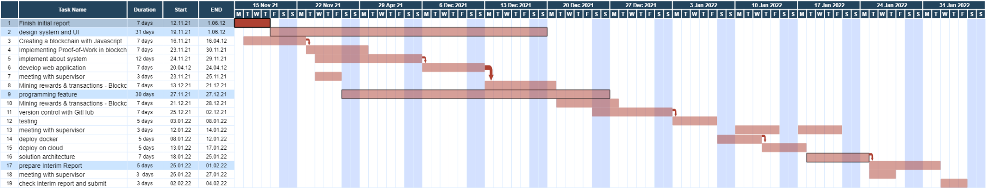

# Appendix B. Members’ Roles and Responsibilities

|  |  |  |
| --- | --- | --- |
| **Roles** | **Member(s)** | **Remarks** |
| iOS Programmer | Chong Wan Si | include apple watch app |
| Android Programmer | You Zhihao | include android watch app |
| Web Programmer | Pan Yichang |  |
| Cloud Server | Li Ka Kit |  |
| System Analyst & Designer | Li Ka Kit  Chong Wan Si  You Zhihao  Pan Yichang |  |
| Tester and Evaluator |  |
| Database Management |  |

|  |  |  |
| --- | --- | --- |
| **Tasks** | **Responsible Member(s)** | **Target Date** |
| Android Application & android watch | You Zhihao | Dec 2021 |
| iOS Application & Apple watch | Chong Wan Si | Dec 2021 |
| Web Application | Pan Yichang | Dec 2021 |
| Cloud Server Setup and Maintenance | Li Ka Kit | Dec 2021 |
| Questionnaire Design | Li Ka Kit  Chong Wan Si  You Zhihao  Pan Yichang | Feb 2022 |
| Experiment Setup and Coordination | Feb 2022 |
| Experimental Data Analysis | Feb 2022 |

# 

# Appendix C. Meeting Minutes

|  |  |  |  |  |  |
| --- | --- | --- | --- | --- | --- |
| **Date, time** | **place** | **Members present at the meeting** | **Decisions made** | **Actions need to be taken** | **by whom** |
| 8/10 | School Study room | all team members | Project main party and division of labor | initial collect basic information on the project subject | All member |
| 15/10 | ou cafe | all team members | Preliminary divide the work of the first screening presentation | Each carry out their own assigned work |
| 12/11 | School Study room | all team members | Preliminary divide the work of the initial report |

**The Open University of Hong Kong**

**Final Year Project in Computing and CIE 2021/2022 (Group and Individual)**

**Author's Declaration (Initial Report)**

*This part should be completed by the author(s)*

I/we certify that the work is original and I/we have utilized guidance of my/our supervisor in completing this project, and that any content which is not my/our own has been attributed and referenced appropriately. I/we have reviewed the report against the checklist below and found the report in good order. I/we have retained a copy of this submission (where written or electronic). The number of words is (2983).

|  |  |  |  |  |
| --- | --- | --- | --- | --- |
|  | Member #1 | Member #2 | Member #3 | Member #4 |
| Name | Li Ka Kit | Chong Wan Si | You Zhihao | Pan Yichang |
| SID | 12631206 | 12534001 | 11957546 | 12530407 |

**Reviewer’s Checklist**

*This part should be completed by the reviewer (who comes from another team)*

|  |  |
| --- | --- |
|  | Checked by Reviewer  ( if satisfactory) |
| A New Project Title | ✓ |
| Chapter 1: Aim and Objectives | ✓ |
| Chapter 2: Literature Review | ✓ |
| Chapter 3: Preliminary Methodology | ✓ |
| Appendix: Project Plan | ✓ |
| Appendix: Roles & Responsibility (group project) | ✓ |
| At least 6 citations from academic literature | ✓ |
| Cover Page (*Name, OUID, Supervisors, Title)* | ✓ |
| Page Number *(Each page has a page number)* | ✓ |
| The Report is generally Readable | ✓ |

I certify that I have reviewed this report and the above items indicated by check symbols are found to be satisfactory.

|  |  |
| --- | --- |
| Reviewer’s Name | Cheung Chung Yin |
| Reviewer’s SID | 12613249 |
| Date of Review | 17/11/21 |