# Start Guide

1. Power
   1. Big for the computer
   2. Small for the motors
   3. 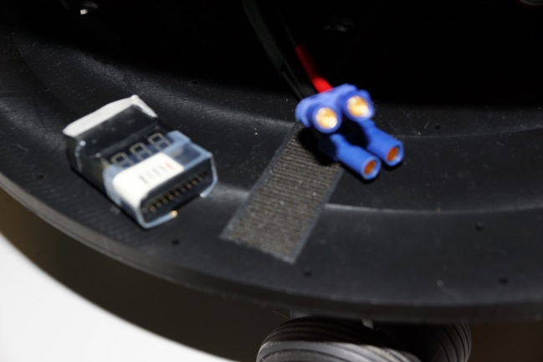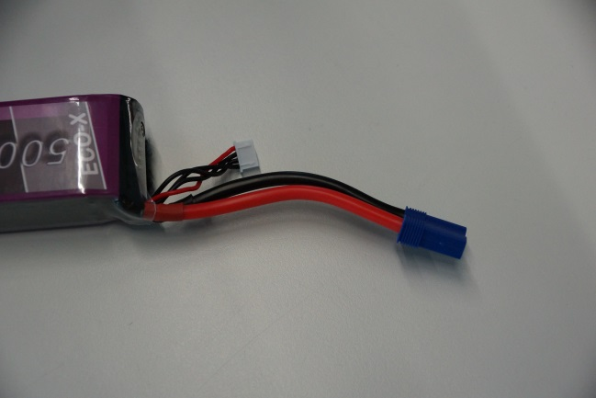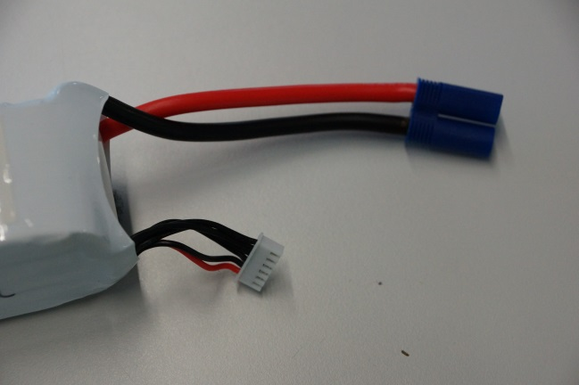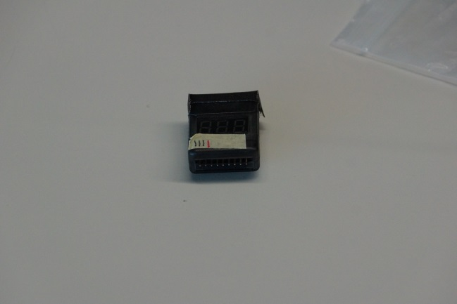plugin a power cable to the box
2. Connecting
   1. Connect the Oculus and start it
   2. 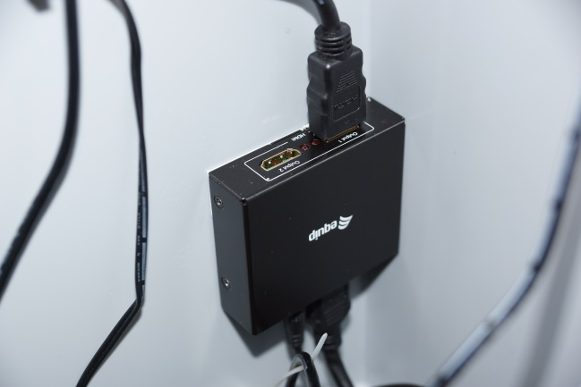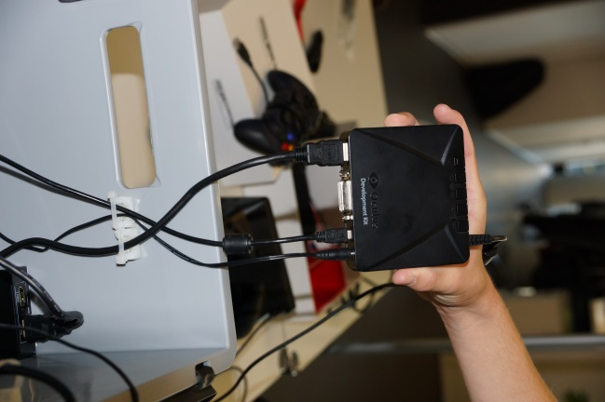Connect the controller
   3. 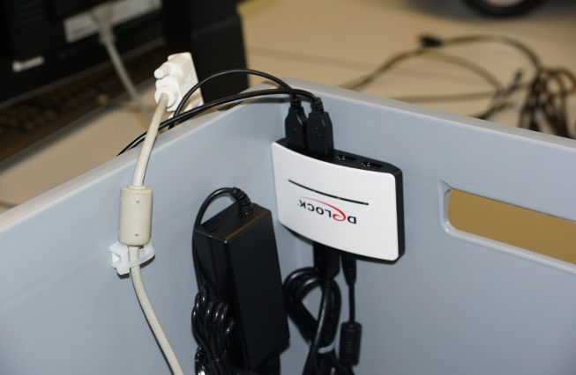Connect the headphones
3. Starting
4. Activate the motors on the roboter
5. 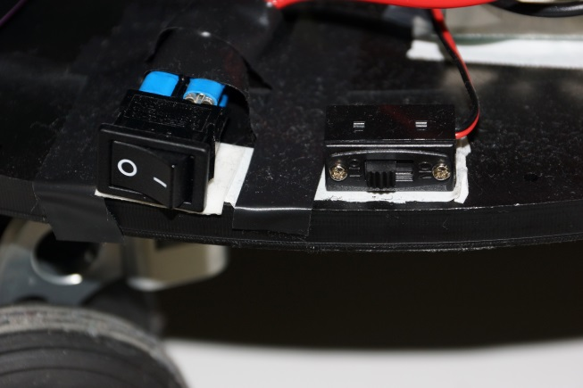Start the computer on the roboter
6. Start the computer in the box