Use Case Diagram
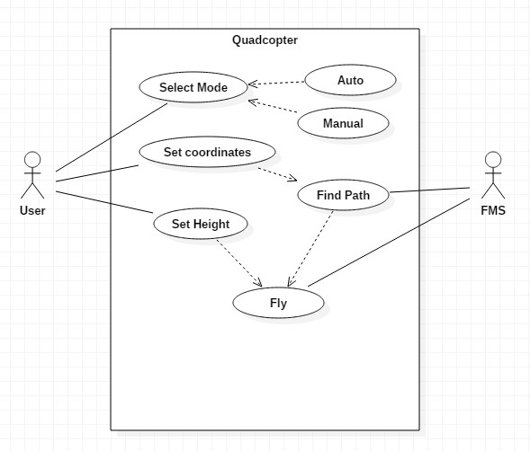

Use Case Templates
Use Case ID: | 1
Use Case Name: | Select Mode

Actor: | User
Description: | Select the mode in which the quadcopter has to fly (auto/manual)
Preconditions: | -
Postconditions: | -
Priority: | High
Frequency of Use: | Once in a flight
Normal Course of Events: | First event
Alternative Courses: | -
Exceptions: | -
Includes: | Mode A (manual), Mode B (Auto)
Special Requirements: | -
Assumptions: | The quadcopter has just started and is waiting for first instructions from user
Notes and Issues: | -

Use Case ID: | 2
Use Case Name: | Set Coordinates

Actor: | User
Description: | Set the latitude and longitude of destination
Preconditions: | Mode should be auto
Postconditions: | -
Priority: | High
Frequency of Use: | Once in a flight
Normal Course of Events: | Mode(Auto) -> Set Coordinates
Alternative Courses: | -
Exceptions: | -
Includes: | -
Special Requirements: | -
Assumptions: | The Quadcopter has been set to auto mode and is waiting for instructions from user
Notes and Issues: | -

Use Case ID: | 3
Use Case Name: | Set Height

Actor: | User
Description: | Select the height at which the quadcopter has to fly (max 3m)
Preconditions: | -
Postconditions: | -
Priority: | Low
Frequency of Use: | Once in a flight
Normal Course of Events: | Mode(Auto) -> Set Coordinates -> Set Height
Alternative Courses: | -
Exceptions: | -
Includes: | -
Special Requirements: | -
Assumptions: | -
Notes and Issues: | -

Use Case ID: | 4
Use Case Name: | Integrate with Google Maps

Actor: | Flight Management System
Description: | Find path which it has to follow
Preconditions: | Coordinates must have been set and mode should be auto
Postconditions: | -
Priority: | Medium
Frequency of Use: | Once in a flight
Normal Course of Events: | Mode(Auto) -> Set Coordinates -> Set Height (Optional) -> Integrate with Google Maps
Alternative Courses: | -
Exceptions: | -
Includes: | -
Special Requirements: | Coordinates must have been set and mode should be auto
Assumptions: | -
Notes and Issues: | -

Use Case ID: | 5
Use Case Name: | Fly

Actor: | Flight Management System
Description: | Fly with the given instructions
Preconditions: | Coordinates must have been set if mode is auto
Postconditions: | -
Priority: | High
Frequency of Use: | Continuous
Normal Course of Events: | Mode(Auto) -> Set Coordinates -> Set Height (Optional) -> Integrate with Google Maps -> Fly
Alternative Courses: | Mode (manual) -> Fly
Exceptions: | -
Includes: | -
Special Requirements: | Coordinates must have been set if mode is auto
Assumptions: | Default height is 3m
Notes and Issues: | -

Tasks and Subtasks
- Initial assembly of Quadcopter
  - Basic design and weight
  - Assembling motors with ESC and interfacing with quadcopter
  - Assembling flight management system
    - Establishing connect with PC
    - Interfacing sensor
      - Gyro and accelerometer
      - Pressure sensor for height
      - GPS for positioning

- Establishing point to point movement
  - Develop interface to accept GPS coordinates
  - Program the FMS to move between the point

- Establishing object detection
  - Interfacing camera image using phone
  - Use PC to process the image
  - Develop a program to send signal to FMS
  - Program the FMS to receive signal

Activity/Swimlane Diagram
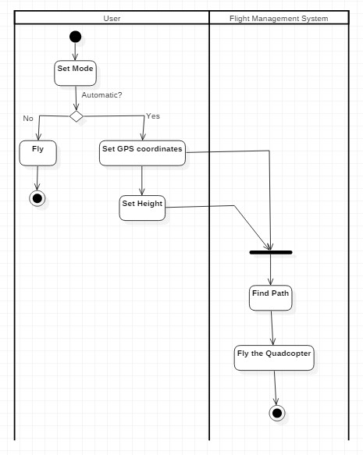

Work Breakdown Structure
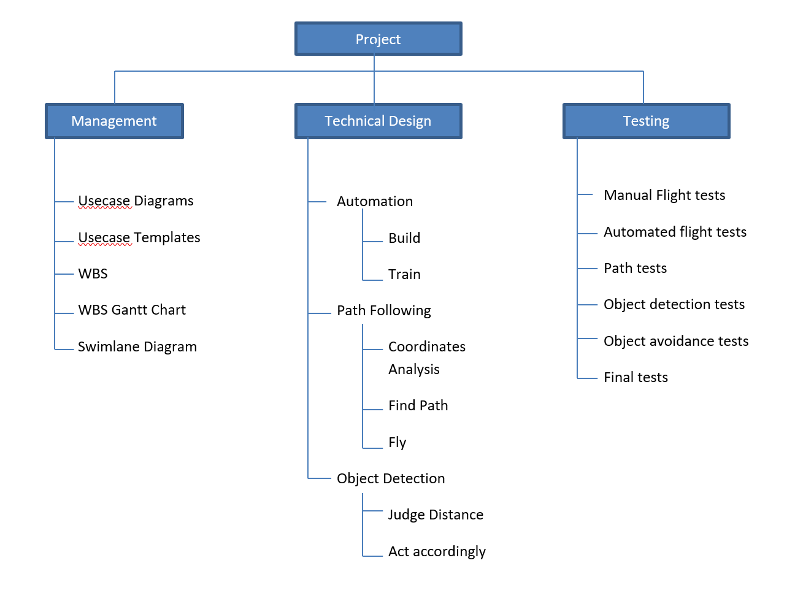

WBS Gantt Chart
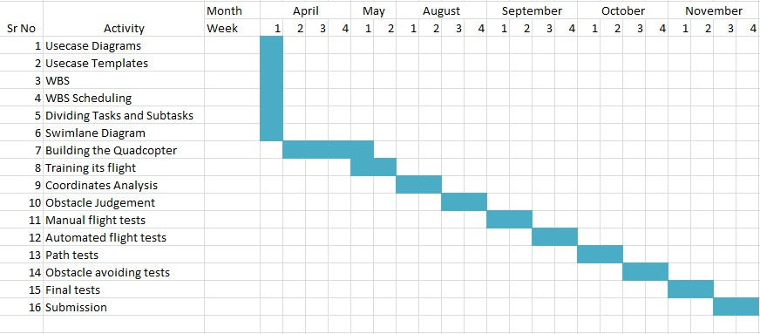

Requirements
- Functional Requirements
  - To build a quadcopter
  - To establish stabilization using sensors
  - To establish point to point movement using GPS and Google Maps
  - To use image processing to avoid obstacles
- Non-Functional Requirements
  - To have a minimum Response time
  - To have an interactive interface to control the Quadcopter

