**Parts for Input and Output**

**Inputs:**

* measurement_type
* measurement_range_lower
* measurement_range_upper
* MT_1
* MT_2

**Output:**

* Distance
* Error informations

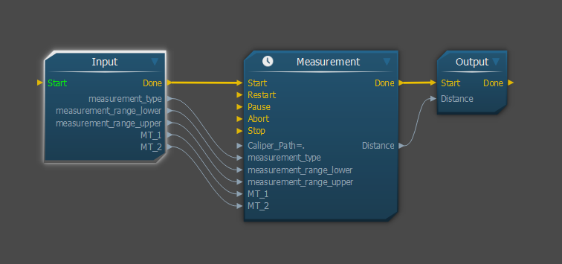

**Caliper:**

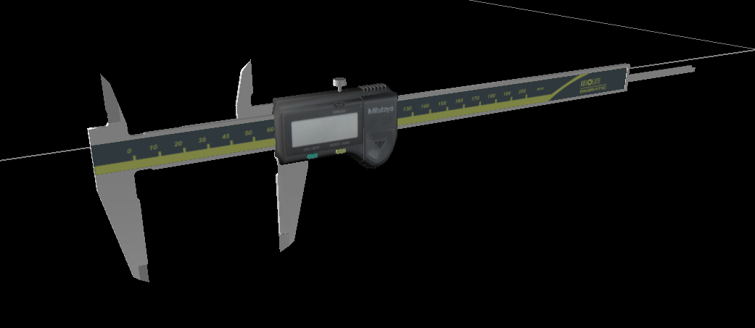

**MT_1**

**MT_2**

***measurement_range_lower=0***

***measurement_range_upper=…(depends)***

**measurement_type: *Caliper_Outside***



**measurement_type: *Caliper_Inside***



**measurement_type: *Caliper_Shoulder***



**measurement_type: *Caliper_Depth***



**Micro Meter:**

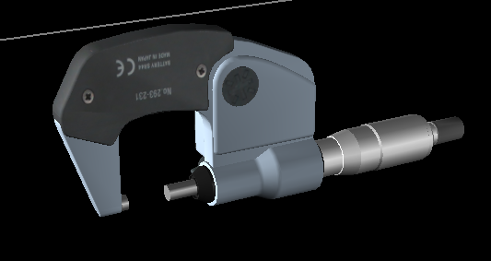

**MT_1**

**MT_2**

***measurement_range_lower=…(depends)***

***measurement_range_upper=…(depends)***

**measurement_type: *MicroMeter***



**Dial Indicator:**

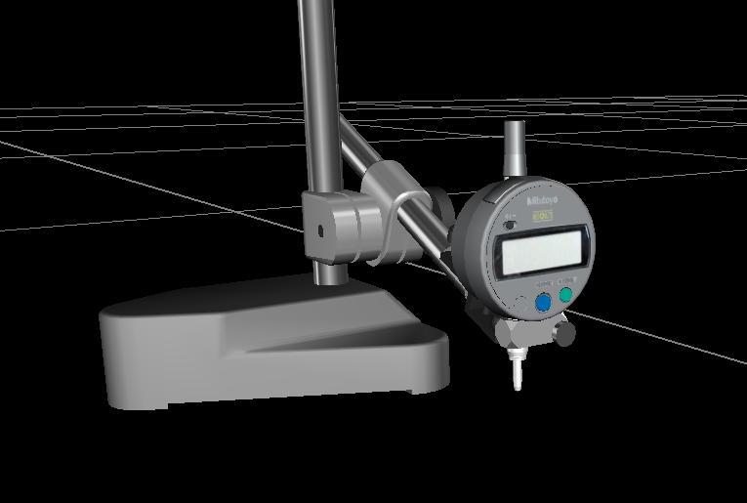

**MT_2**

***measurement_range_lower=0***

***measurement_range_upper=…(depends)***

**measurement_type: *DialIndicator***

