**Al Imam Mohammad Ibn Saud Islamic University**

**College of Computer and Information Sciences**

**Computer Science Department**

**CS151 Final Project**

CS151 - Object-Oriented Programming

Second semester 1440-1441

|  |  |
| --- | --- |
| **Section:** .............376.......... | |
| **Group:** ..................6..... | |
| **Group members’ names** | **Students IDs** |
|  |  |
| حنان المطيري |  |
|  |  |

Contents

UML 3

Inheritance issues 4

Output 5

Screenshots 5

Additional Features (if any) 6

Screenshots 6

# UML

**Note:**

* Put your correct UML for each class in your work.
* Your UML shows classes name with all relations only, without showing attribute and method sections.
* You can use MS Word directly or any tool for drawing.

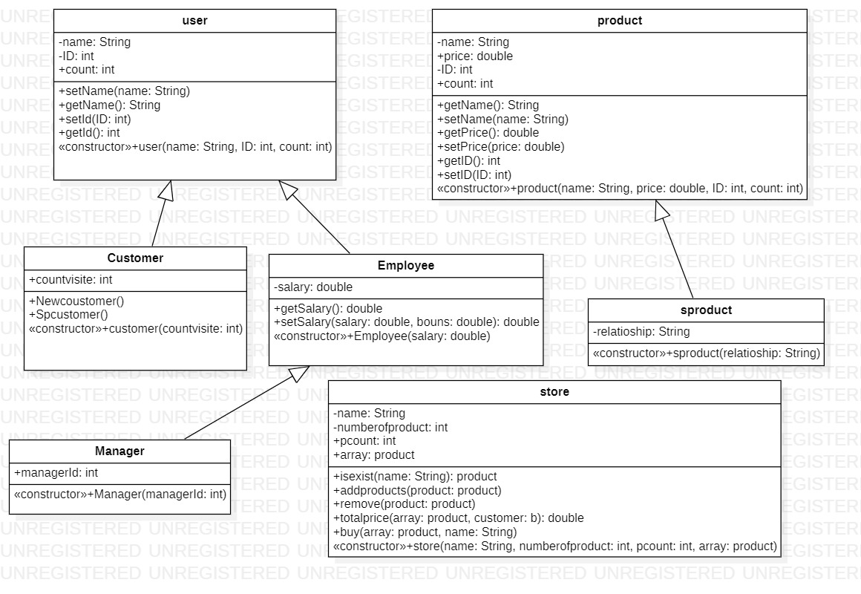

# Inheritance issues

-when the attribute are arranged incorrectly a constructor error occurs, Another problem that we faced

It is a problem of linking the classes

On the one hand, what are the appropriate classes that are inherited from another class ? and The right properties for it ,And super problems on the one hand I have to use all its properties.

# Output

Put the outputs for each operation in your classes, e.g., Test1: add salary for an employee.

* Test1: …create objects…
* Test2: …update the employee…
* Test3: …Add a product …
* Test4:Two lists of special products……
* Test5: remove an existed product for mangers only

## Screenshots

Insert your output showing test1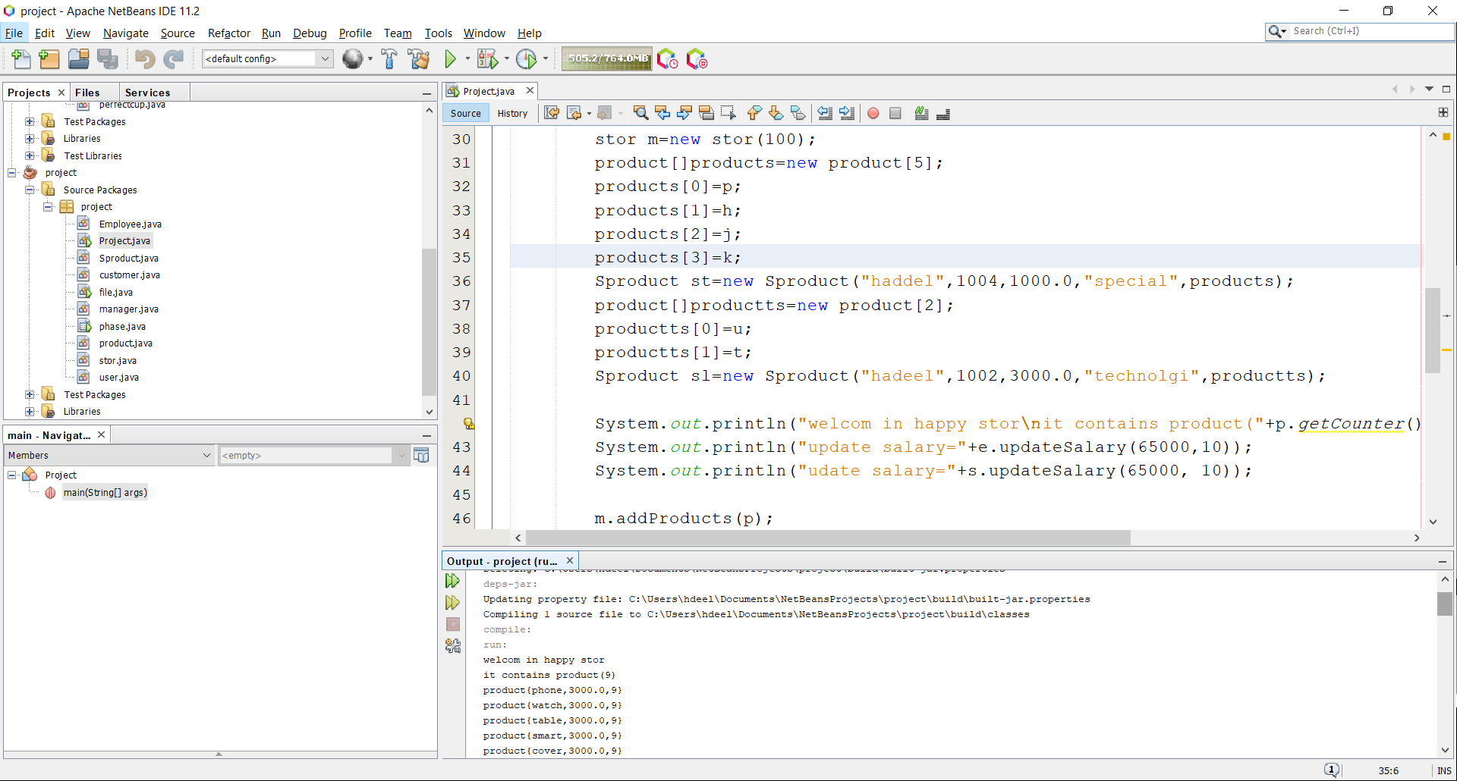

Insert your output showing test2

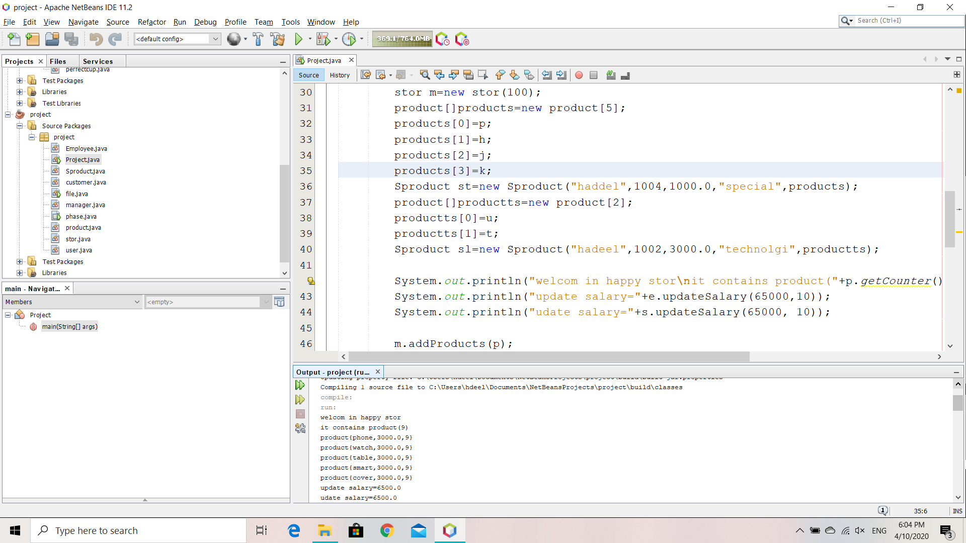

Insert your output showing test3



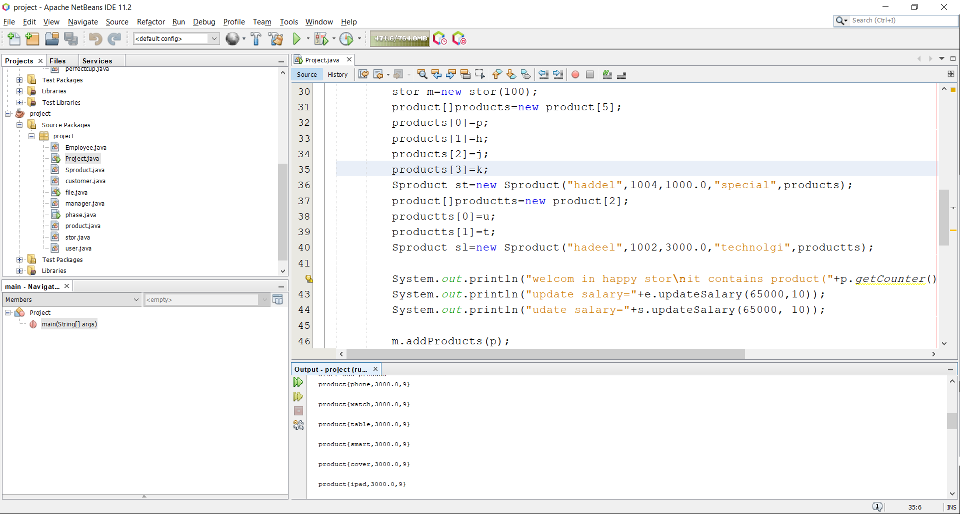

Insert your output showing test4

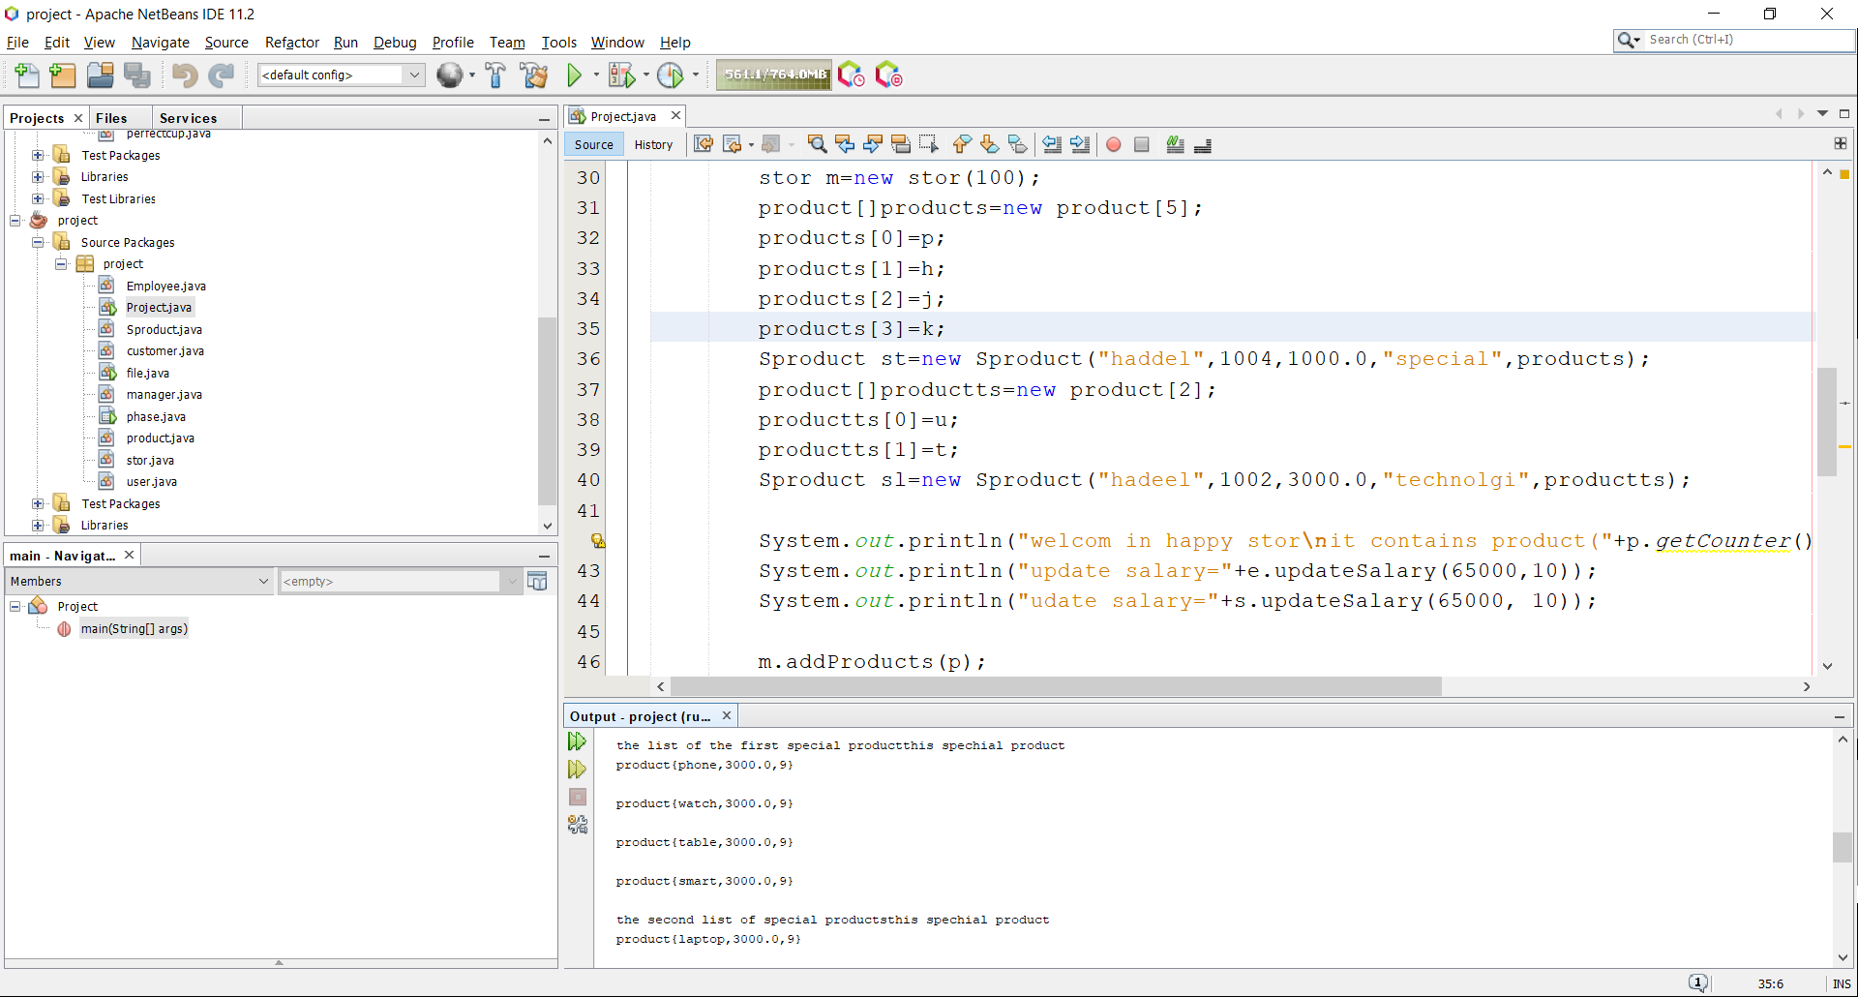

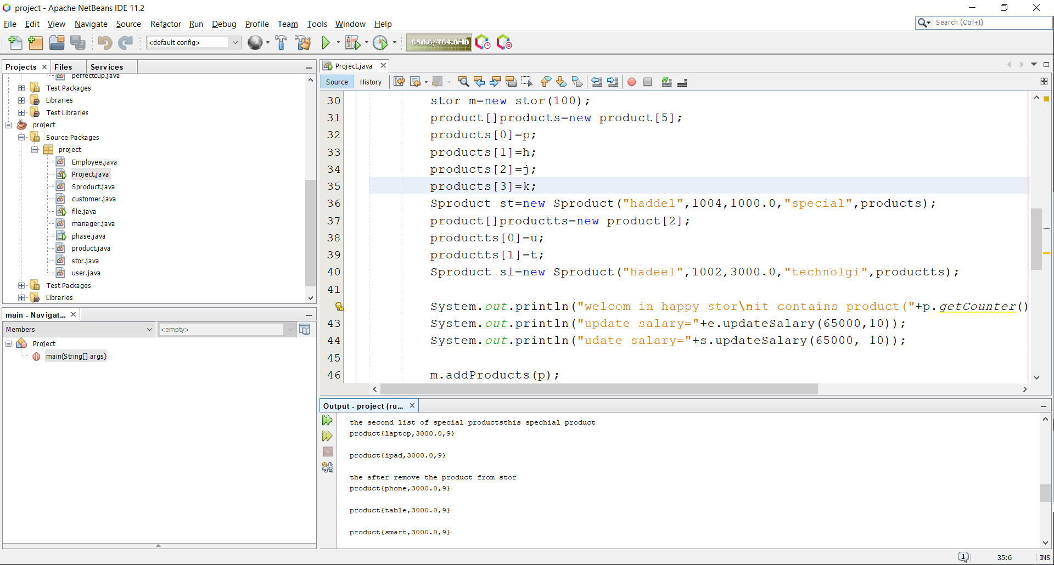

# 

Insert your output showing test5







# Additional Features (if any)

Describe the features that you chose. Put the output for each feature. Make sure, if your description is not clear, you cannot get the mark.

* Feature 1: ……
* Feature 2: ……
* Feature 3: ……

## Screenshots

Insert your output showing feature1

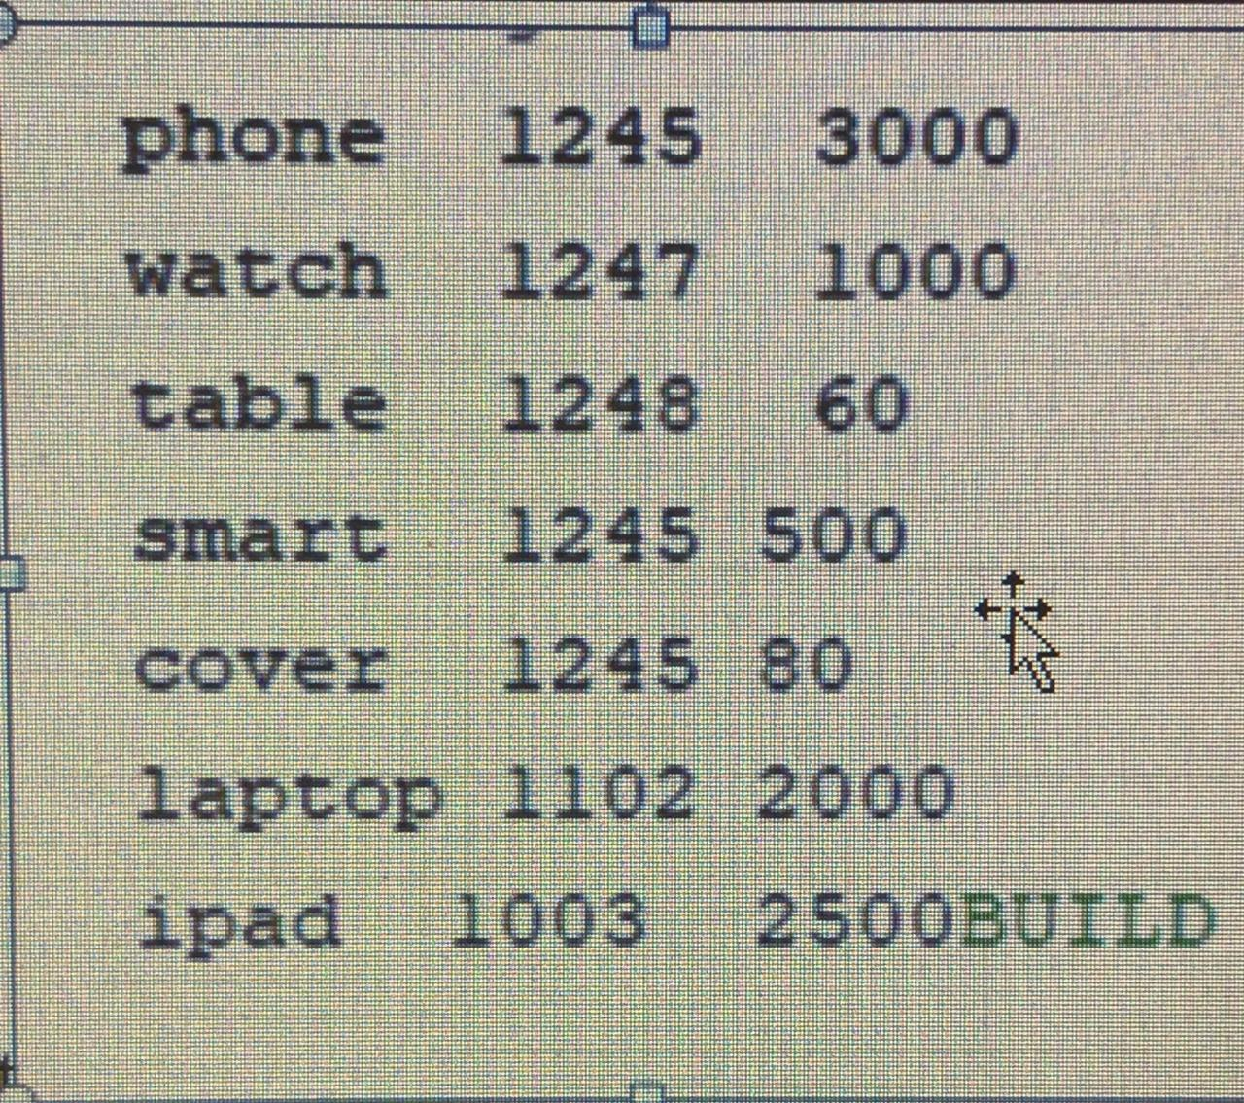

Insert your output showing feature2

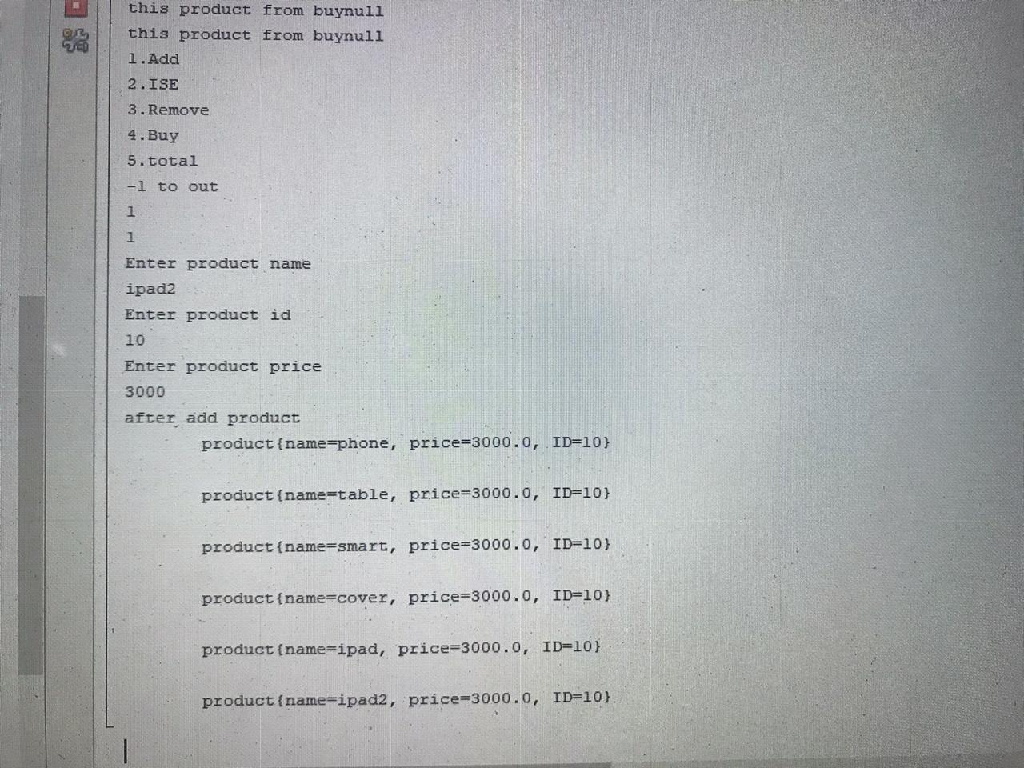

Insert your output showing feature3