======== S/4 log-on =======================

user:ZHANGJ

pasword:1998xh1998XH

====== Configure outbound iDoc =============================

1)BD54: define logical system

2)SALE: create a distribution model and message type

3)STRUST: Add certificates(root, ca, ci)

4)SM59: RFC connection to Cloud Integration

5)WE21: create Port for iDoc processing

6)WE20: create a partner profile

7)Seletion program test iDoc transaction (SE38)

BD10/RBDSEMAT: material

BD12/RBDSEDEB: customer

BD14/RBDSECRE: vendor

Material: IMC_750, IMC_690, SP001, RM129

8)WE02/WE05: verify

1)MM01: create material

2)SE11: search table

000000000000000001 (MARA, MAKT, MARC, MARD)

3)BD54/SALE (table: TBDLS/TBDLST): logical sytem

4)SCC4/SALE: assign logical sytem to source?????

5)SM59/SALE: crate RFC destination

6)WE21: maintain port

7)WE81: create distrubution model and message type

**BD54**: define logical system

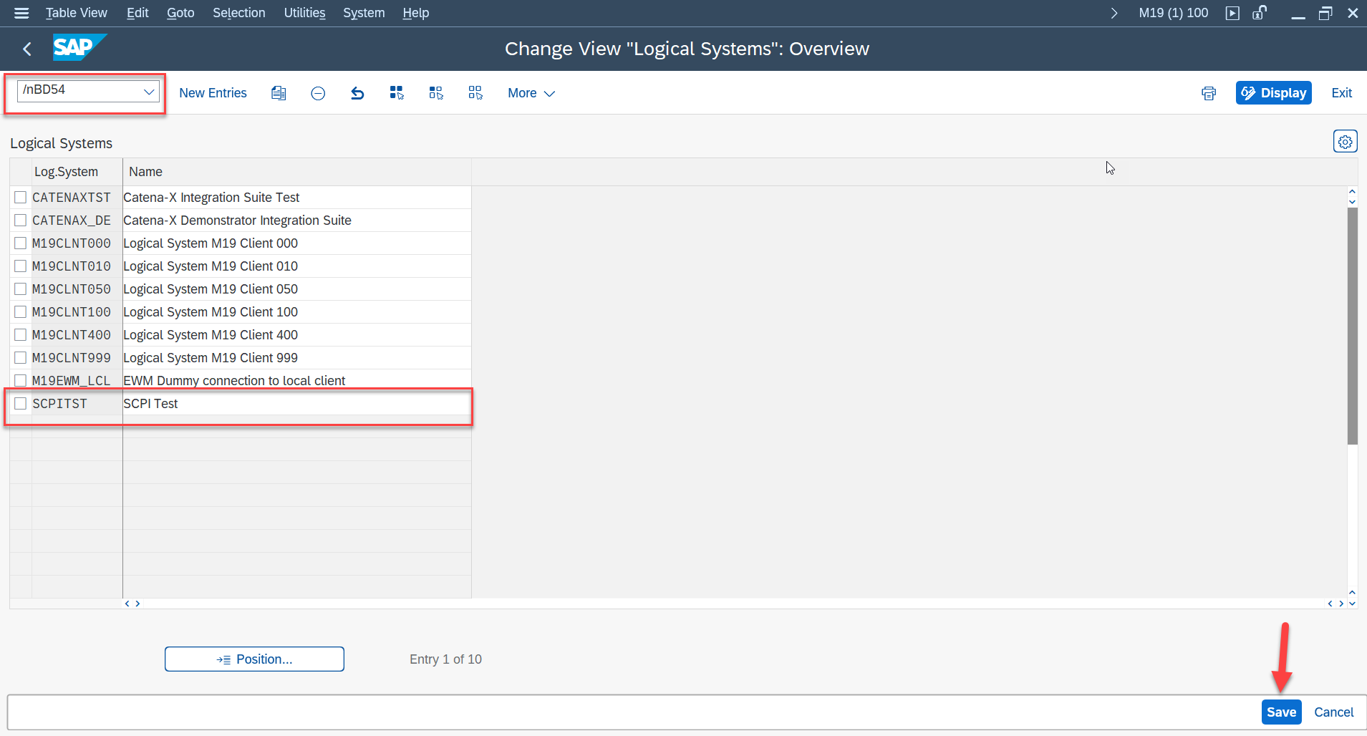

**SALE**: create distribution model and message type

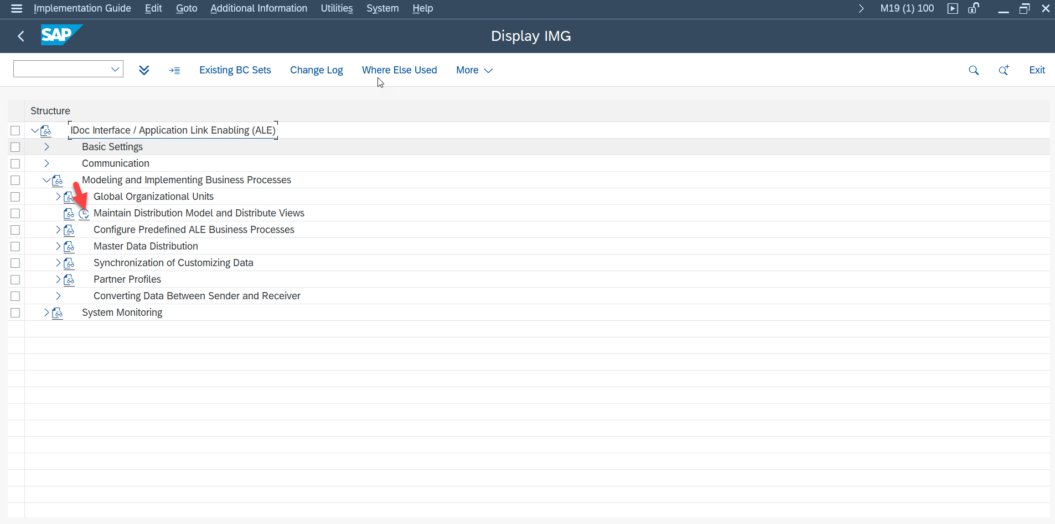



First create the model, then create a message type.

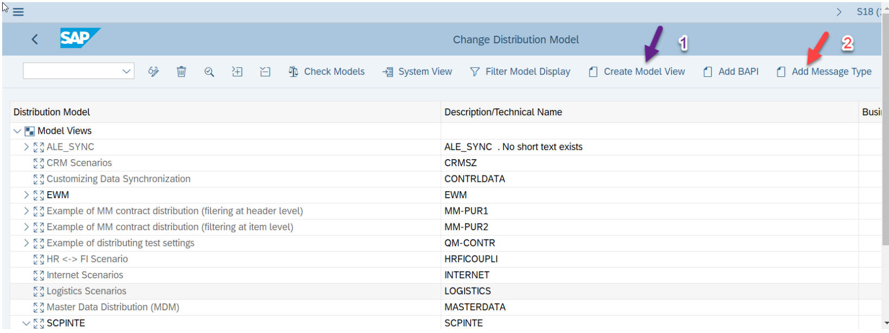

Message Type:

MATMAS (material)

DEBMAS(customer)

CREMAS(vendor)

Sender: current S/4 HANA system

Receiver: logical system we defined above

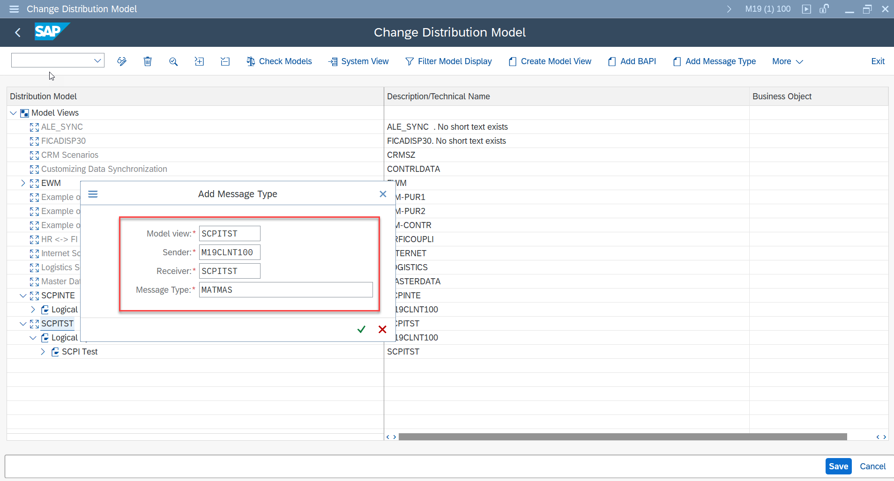

In Integration Suite, download 3 levels certificates using Base64 encoding to file:

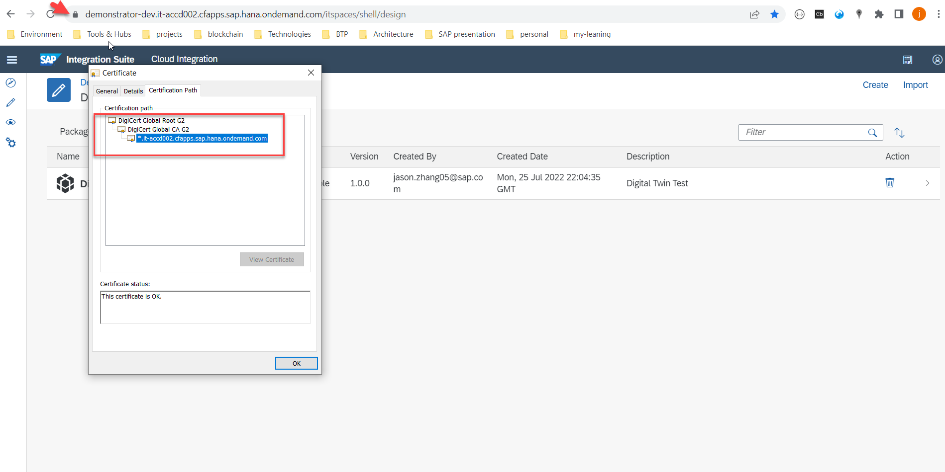

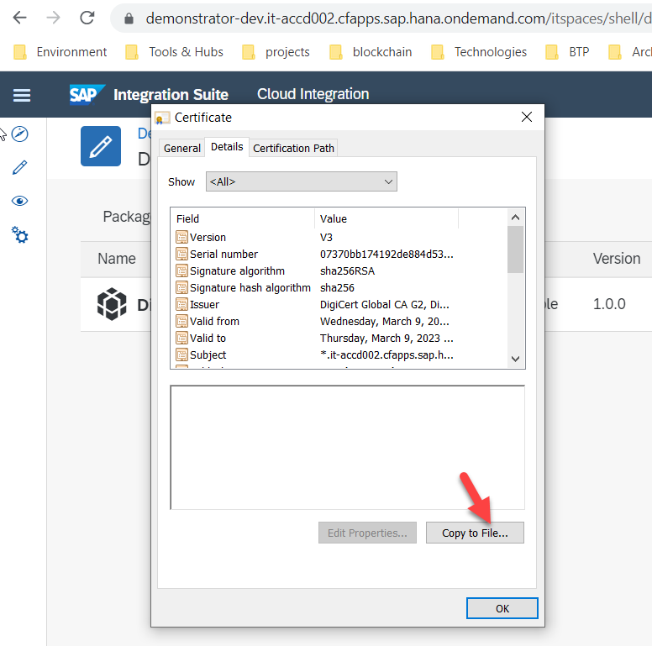

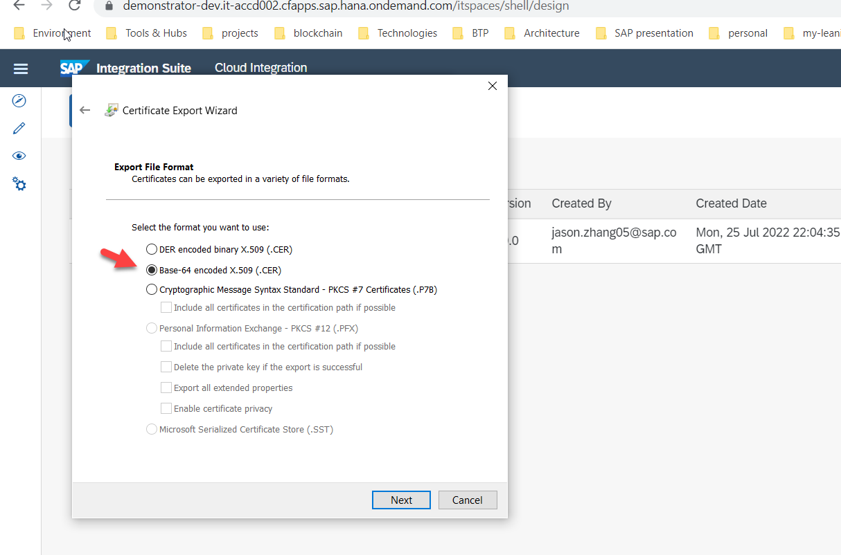

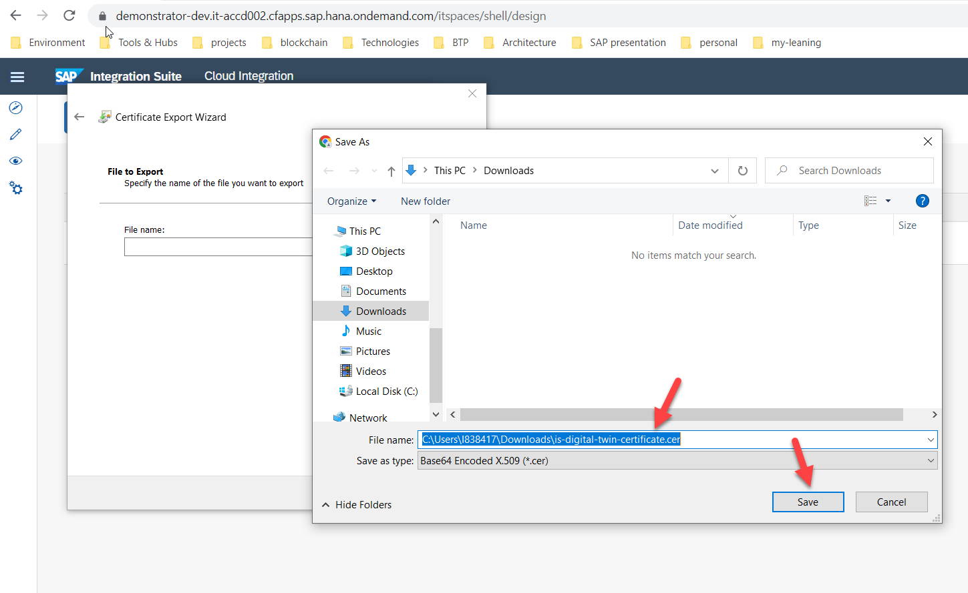

Generate CA certificate:

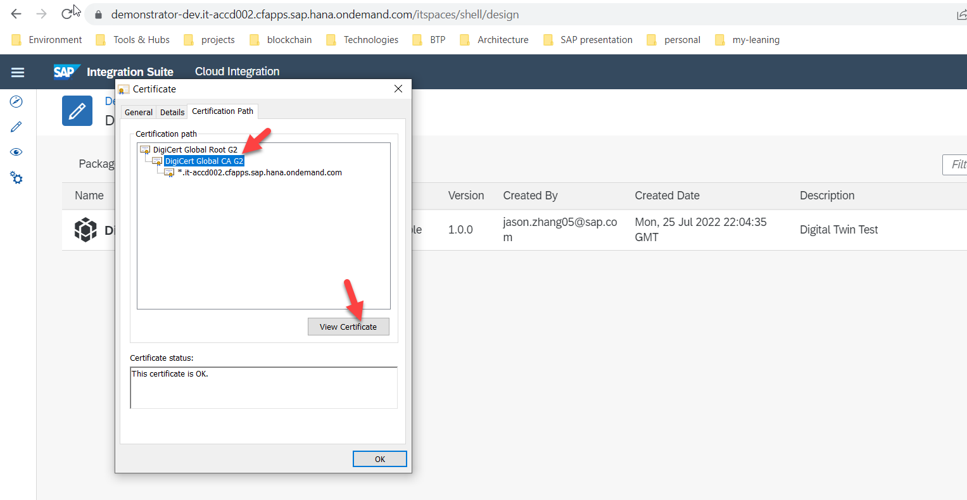

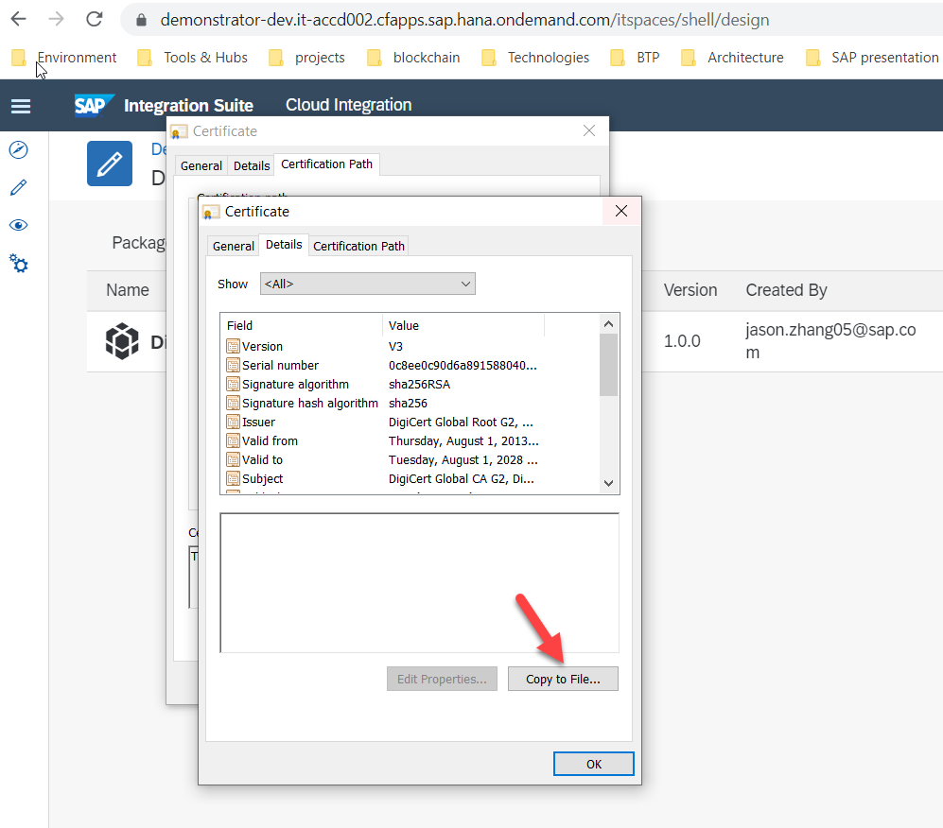

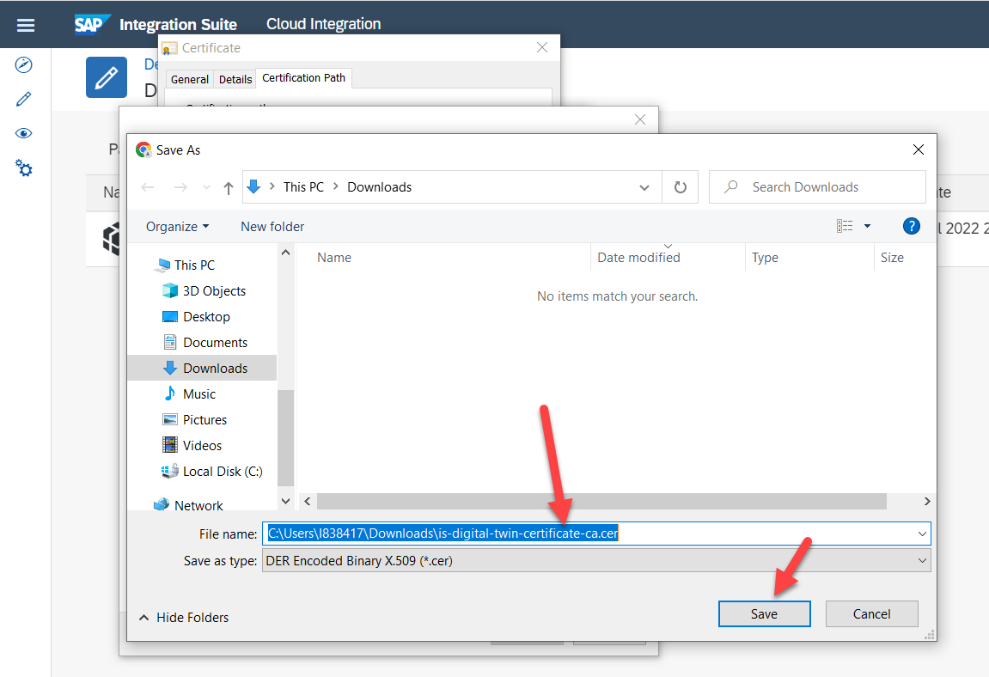

Generate Root certificate:

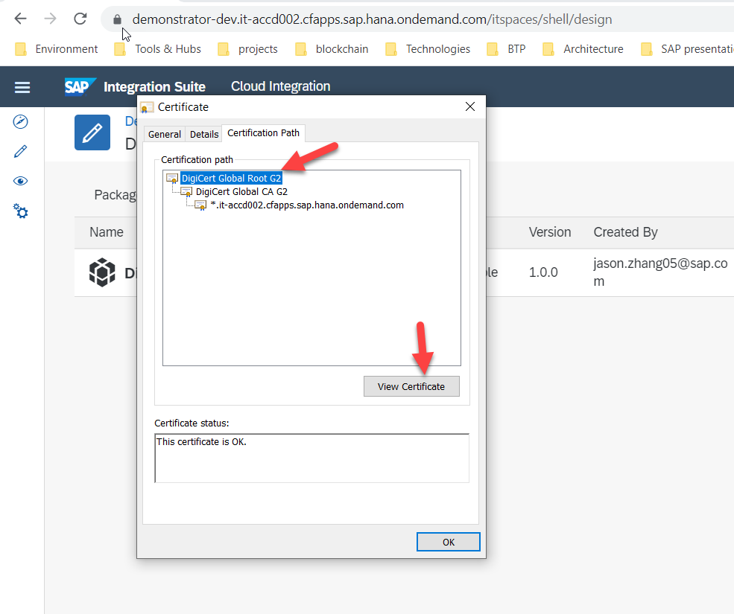

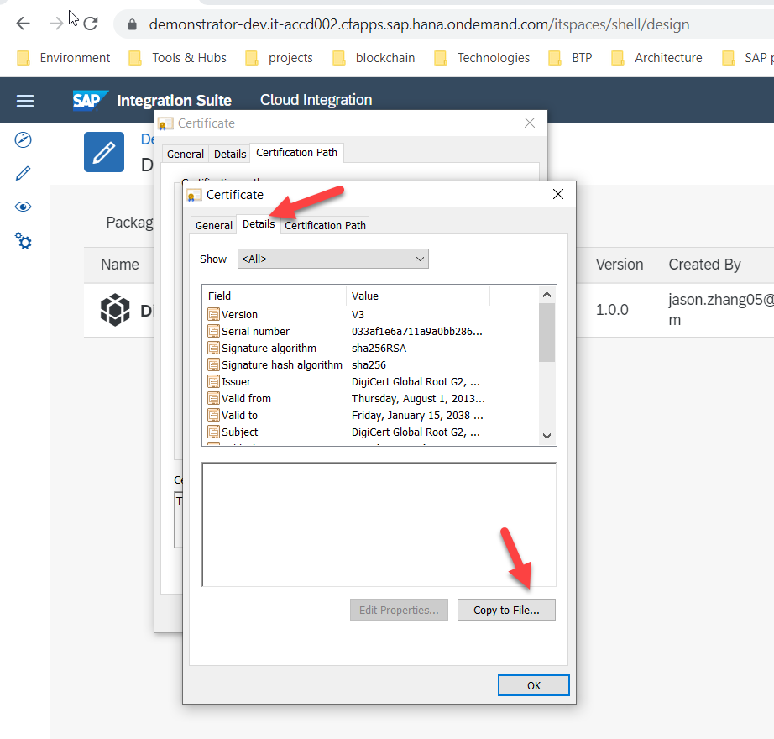

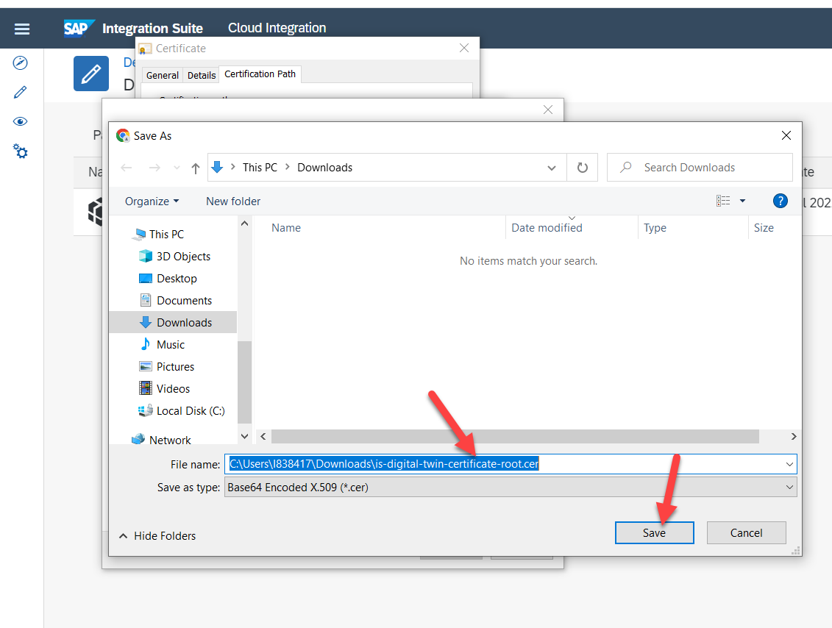

3 level certificates generated:

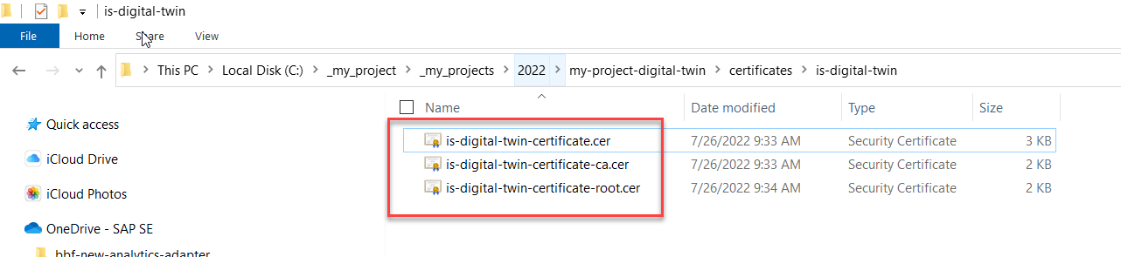

**STRUST**:

Click on SSL Client Anonymous, import the 3 certificates, one by one and each add them to the certificate list.

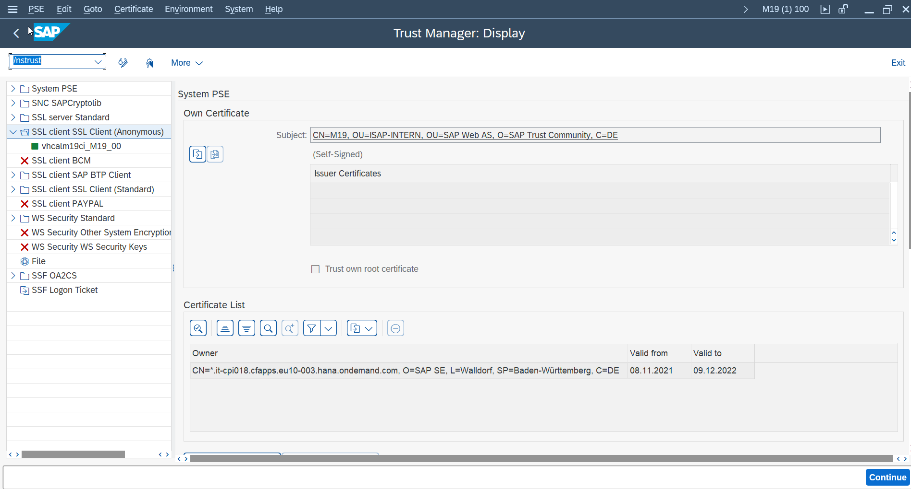

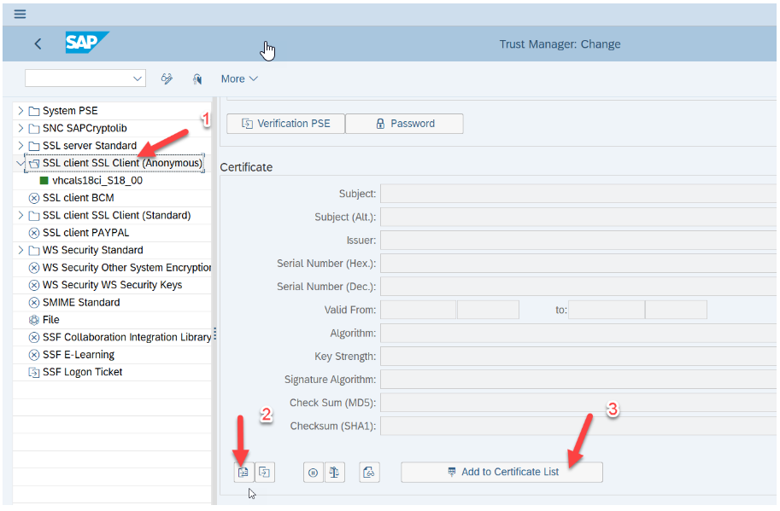

**SM59: c**onfigure RFC Connection to SCPI, create a new one in HTTP Connections to External Server

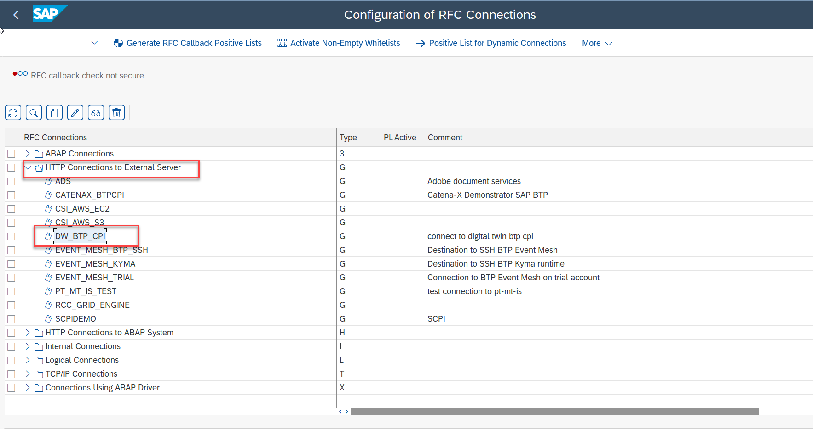

Host: demonstrator-dev.it-accd002-rt.cfapps.sap.hana.ondemand.com

Port: 443

Path Prefix: /cxf/idoc

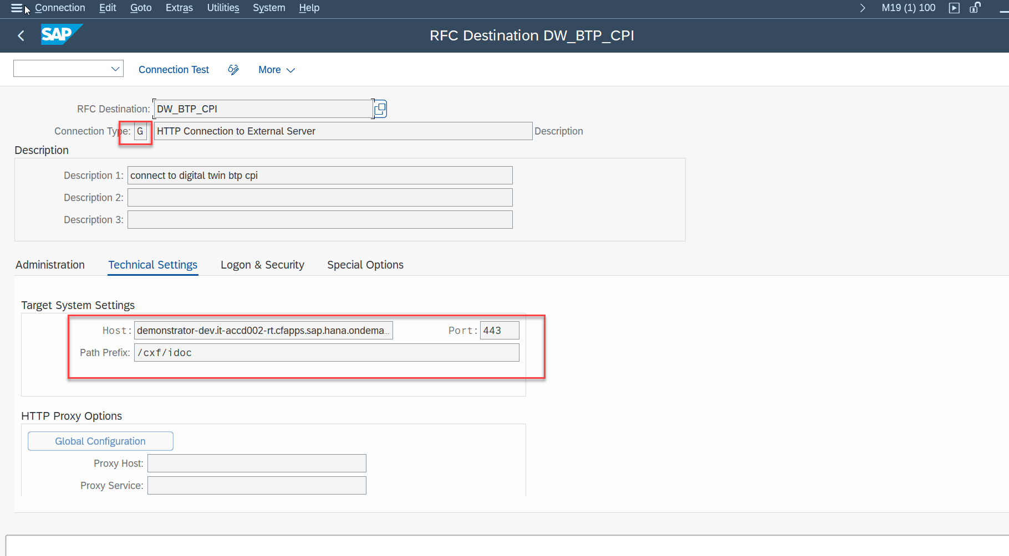

In the Logon & Security Tab, define your authentication method and also select anonymous SSL for secure protocol :

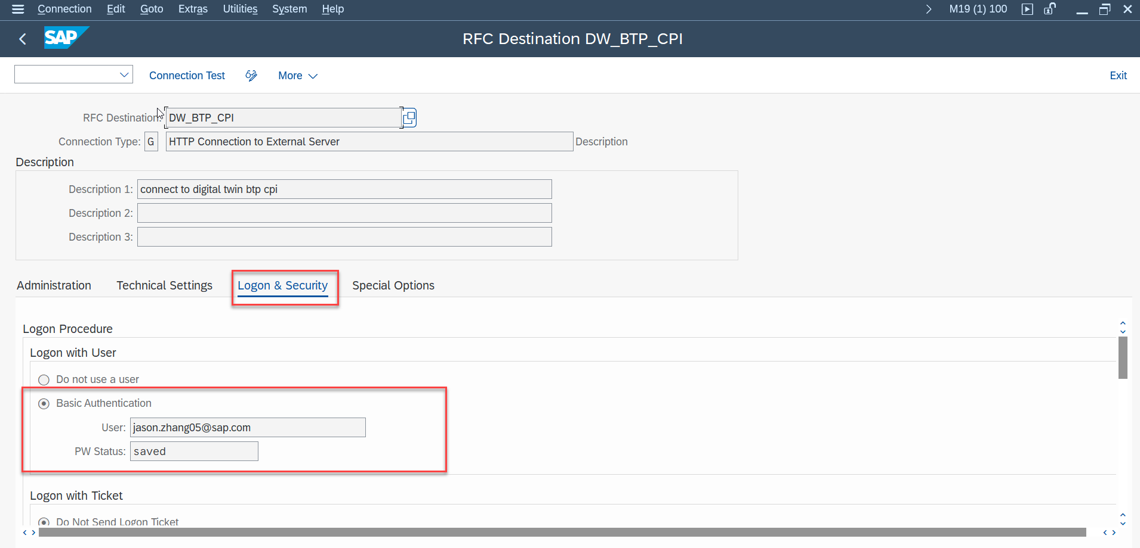

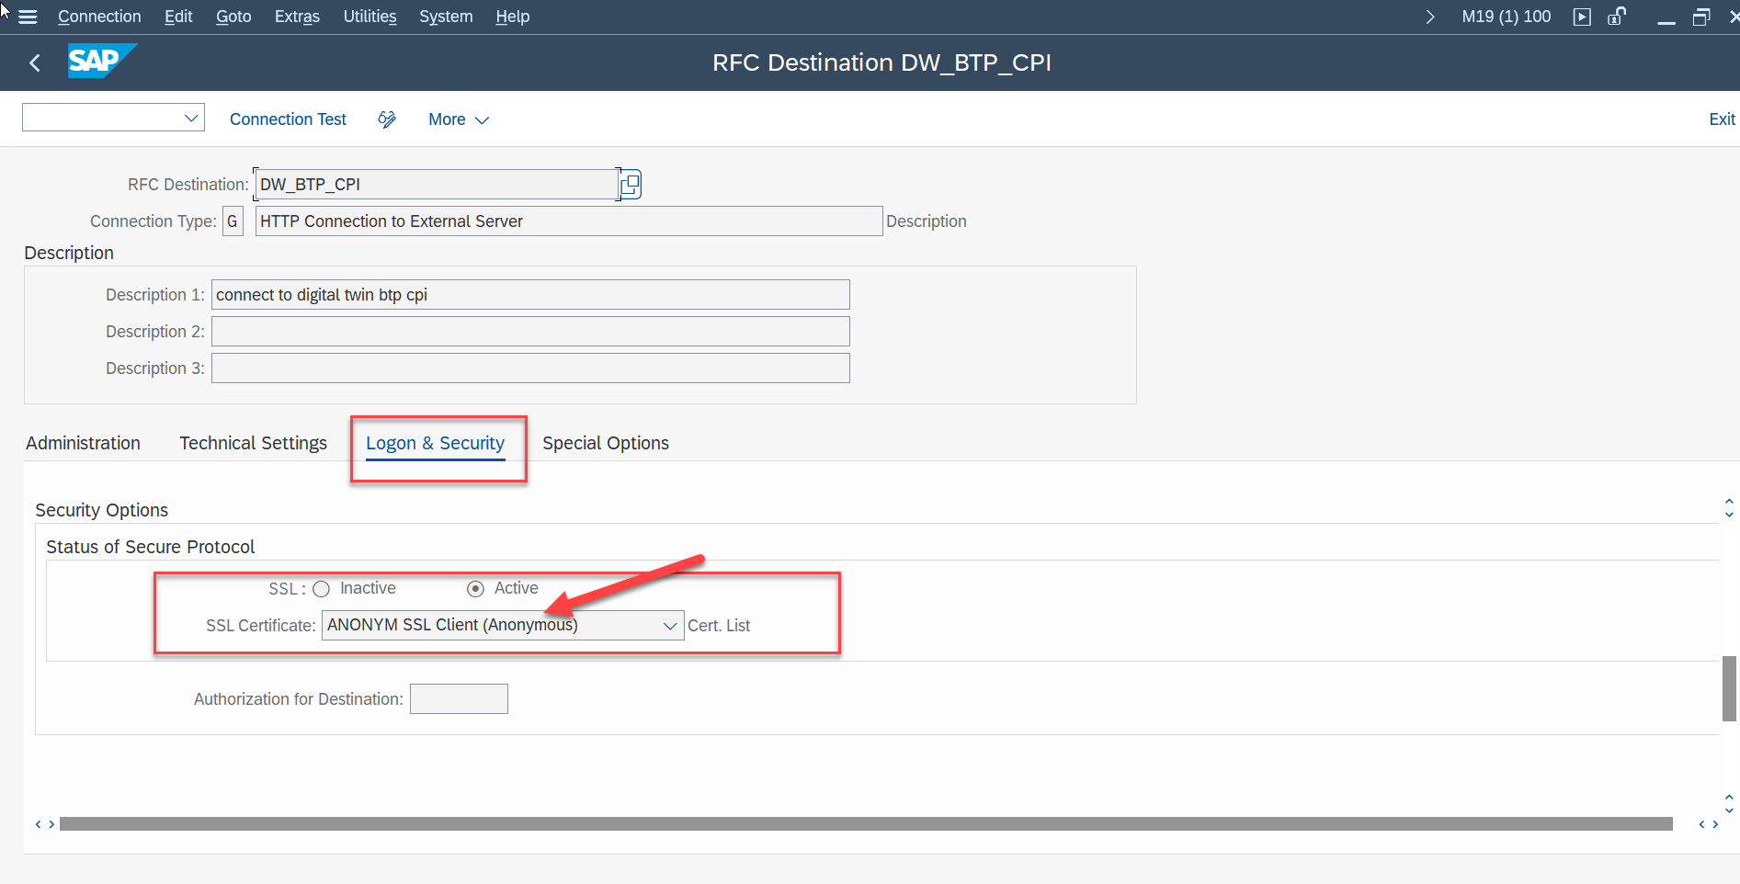

**WE21:** create the Port for our iDoc processing, click on XML HTTP and create a new port. Use the settings in the following screenshot.

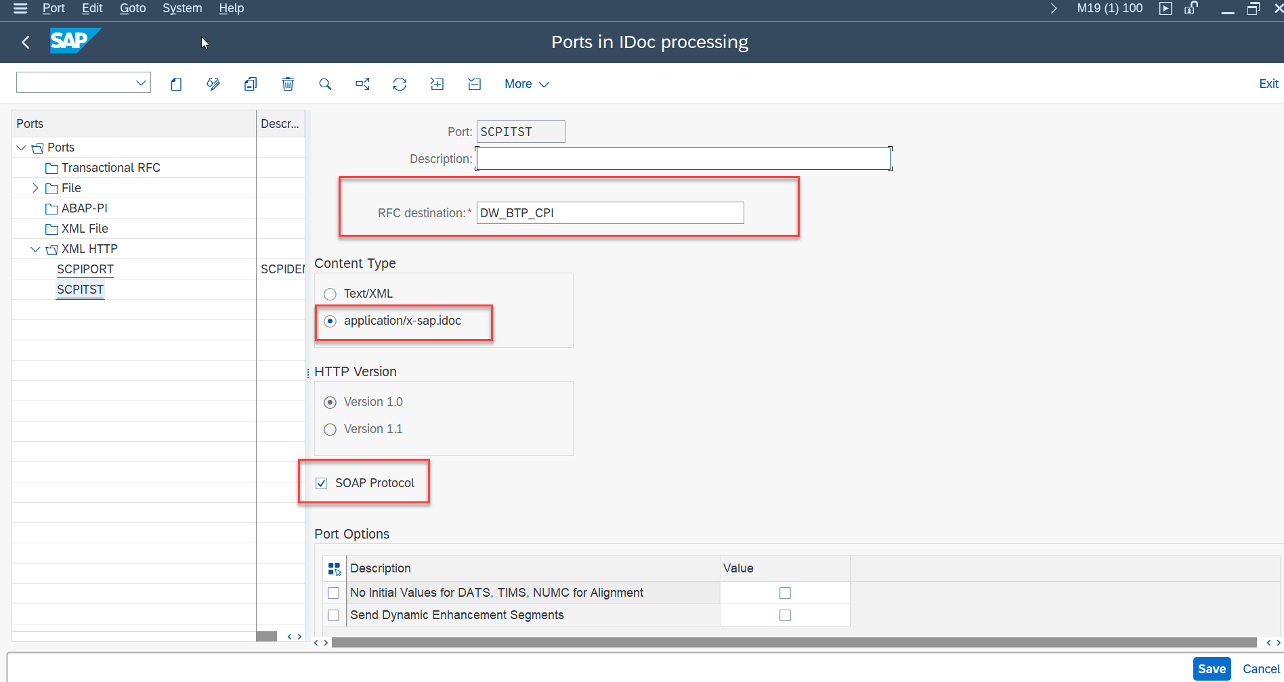

**WE20:** create a partner profile

click on Type LS and create a new profile. Give it a name. Define an agent and then add an Outbound Message by clicking the add button for outbound parameter.

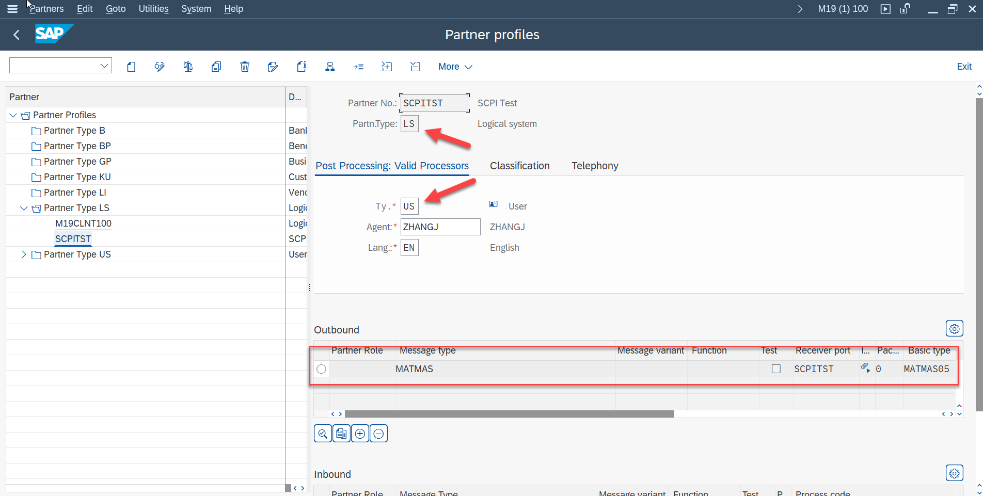

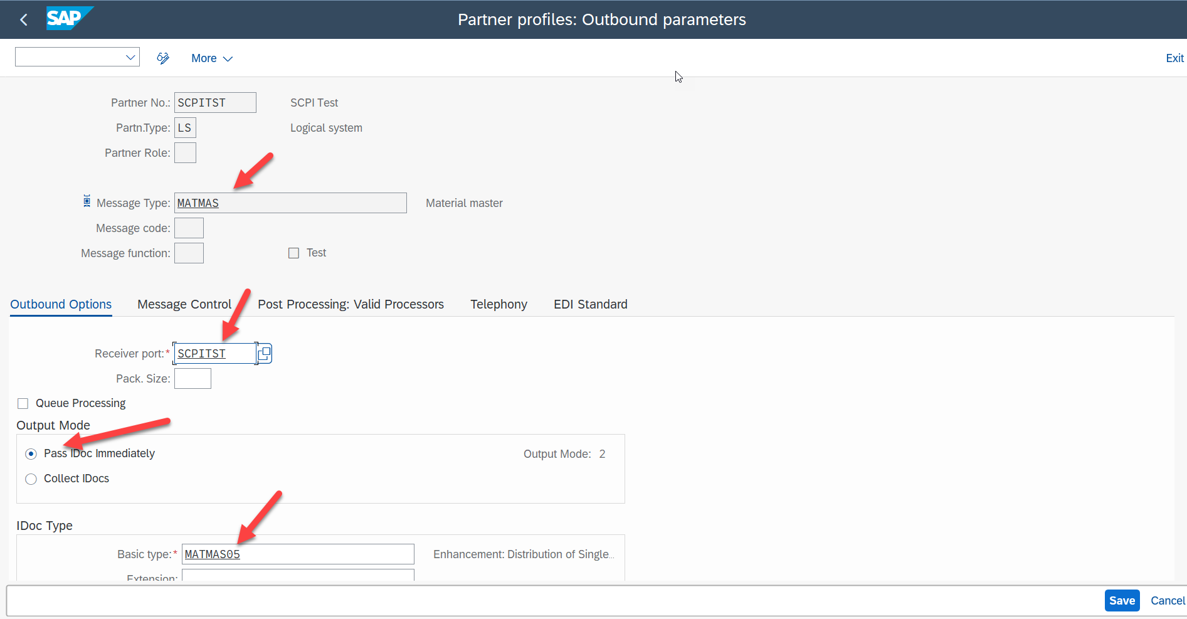

**BD10:** test material

**BD12:** test customer

**BD14:** test vendor

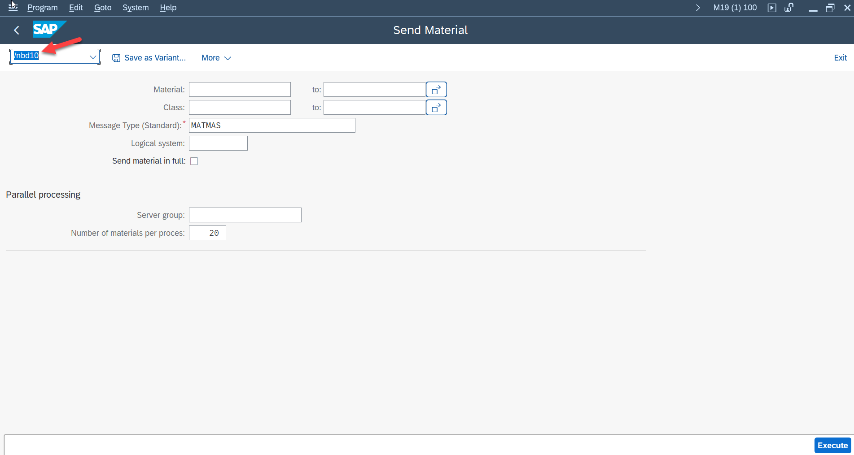

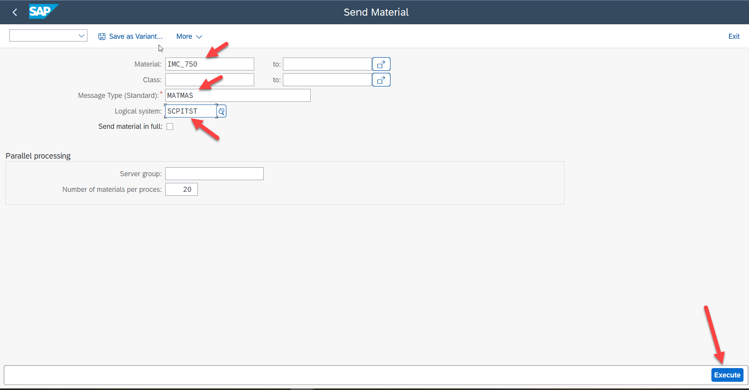

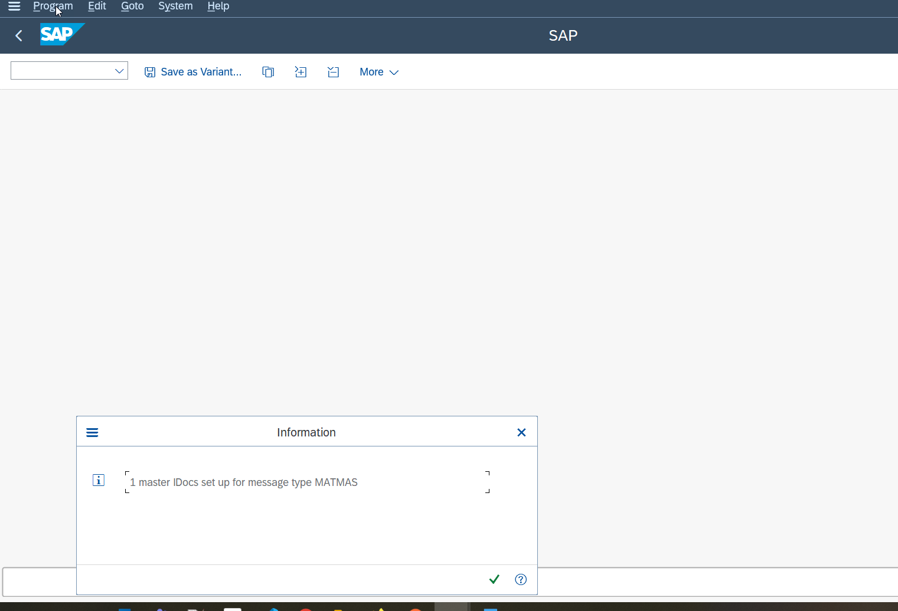

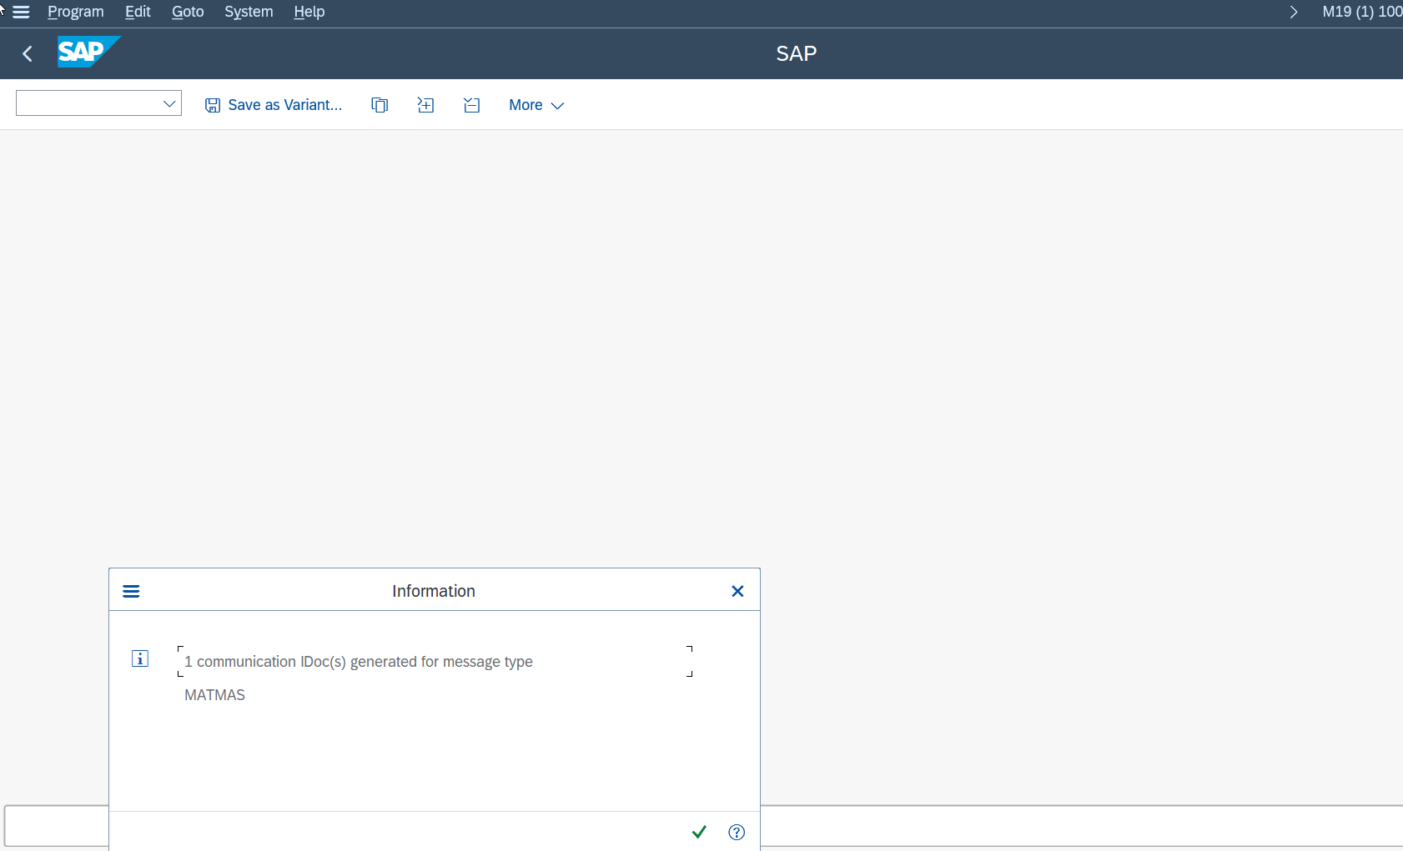

**SE38**: selection program

BD10/RBDSEMAT: material

BD12/RBDSEDEB: customer

BD14/RBDSECRE: vendor

Material: IMC_750, IMC_690, SP001, RM129

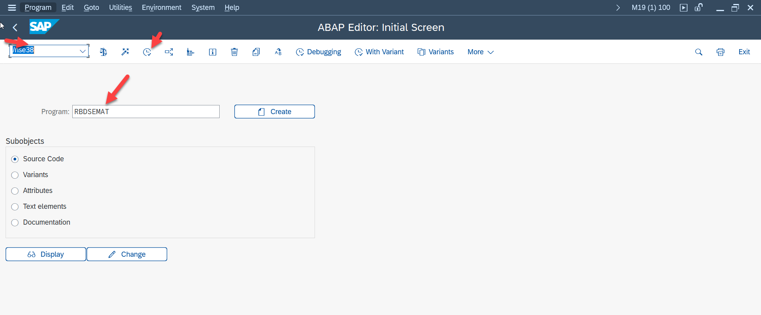

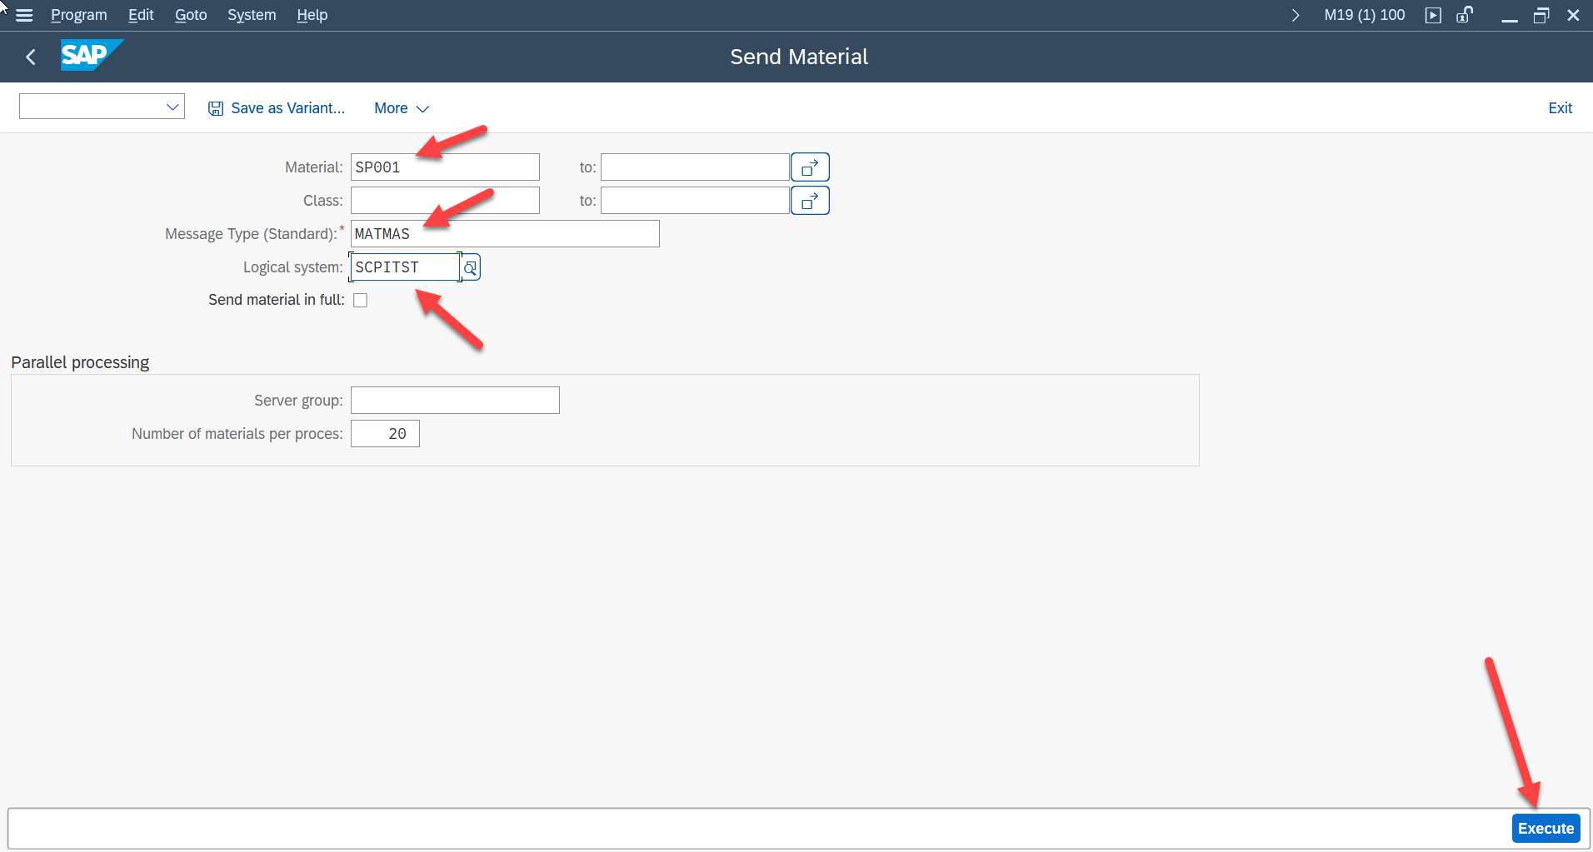

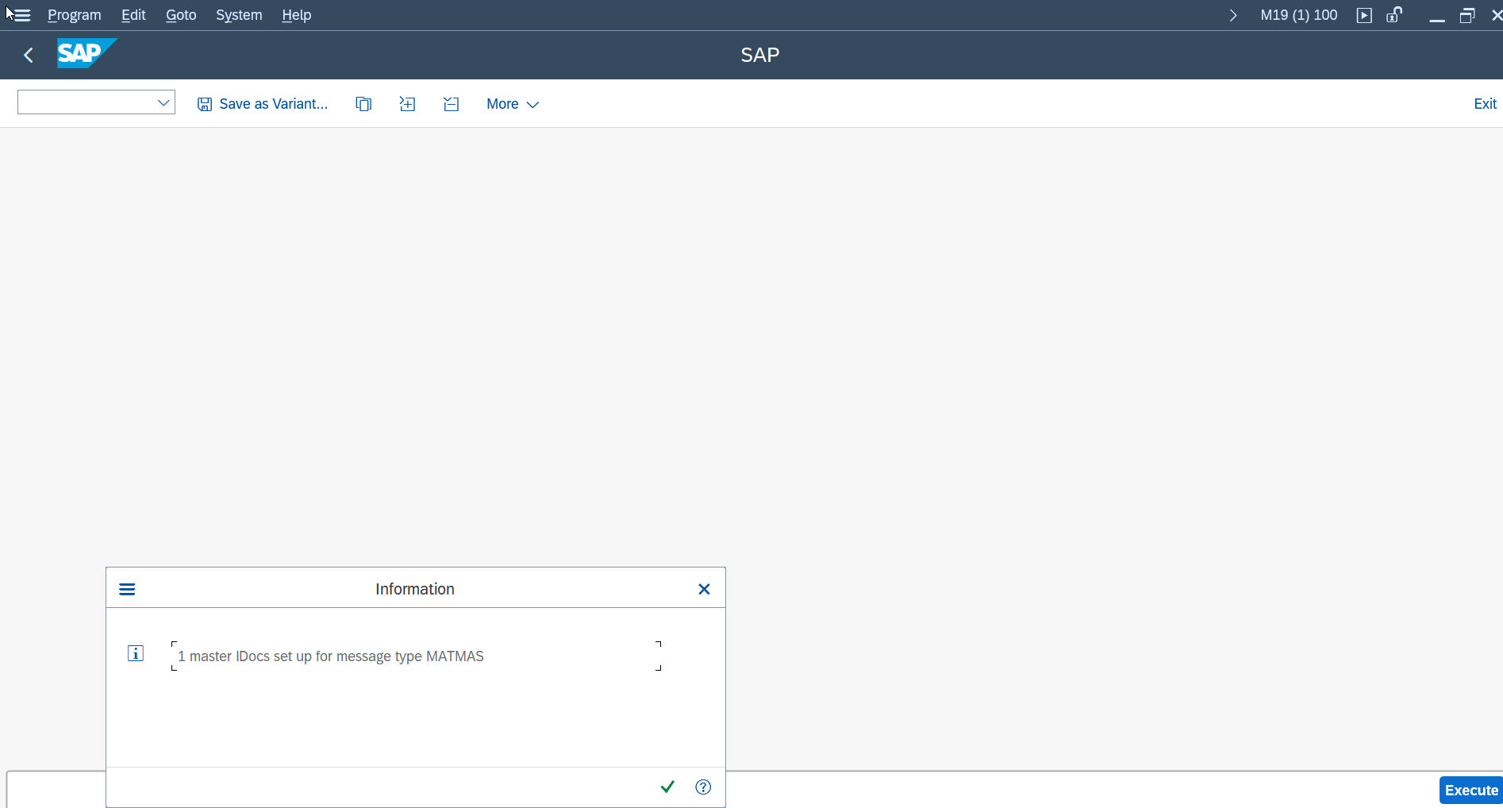

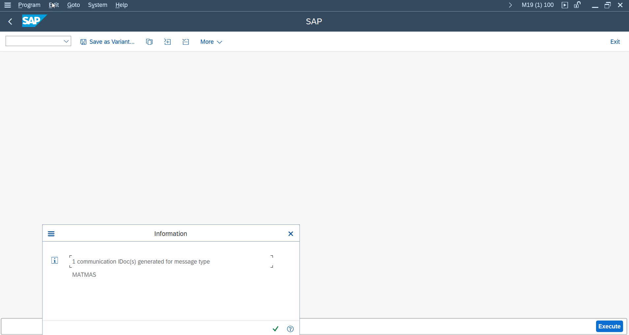



**WE02**: verify material

**WE05**: verify customer

