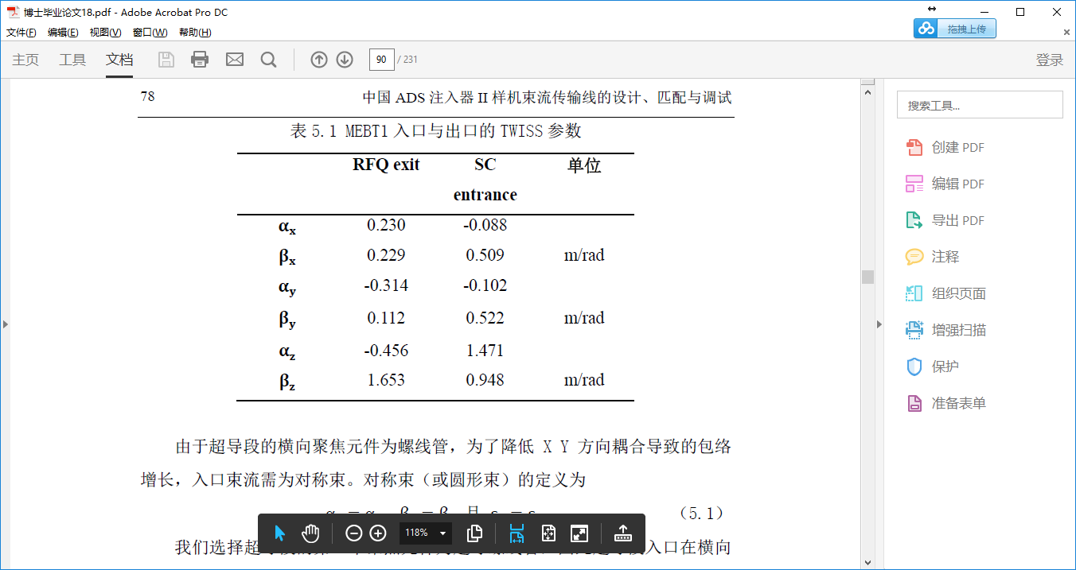

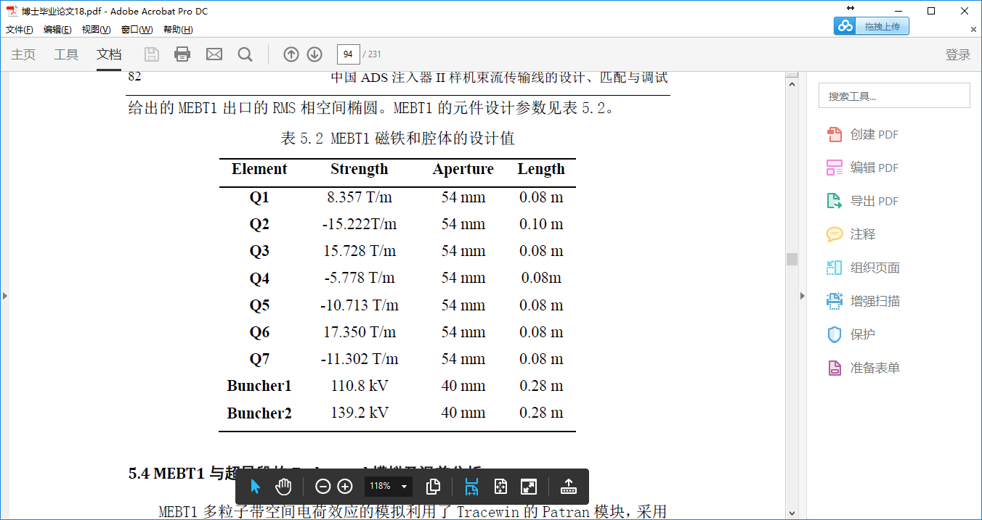

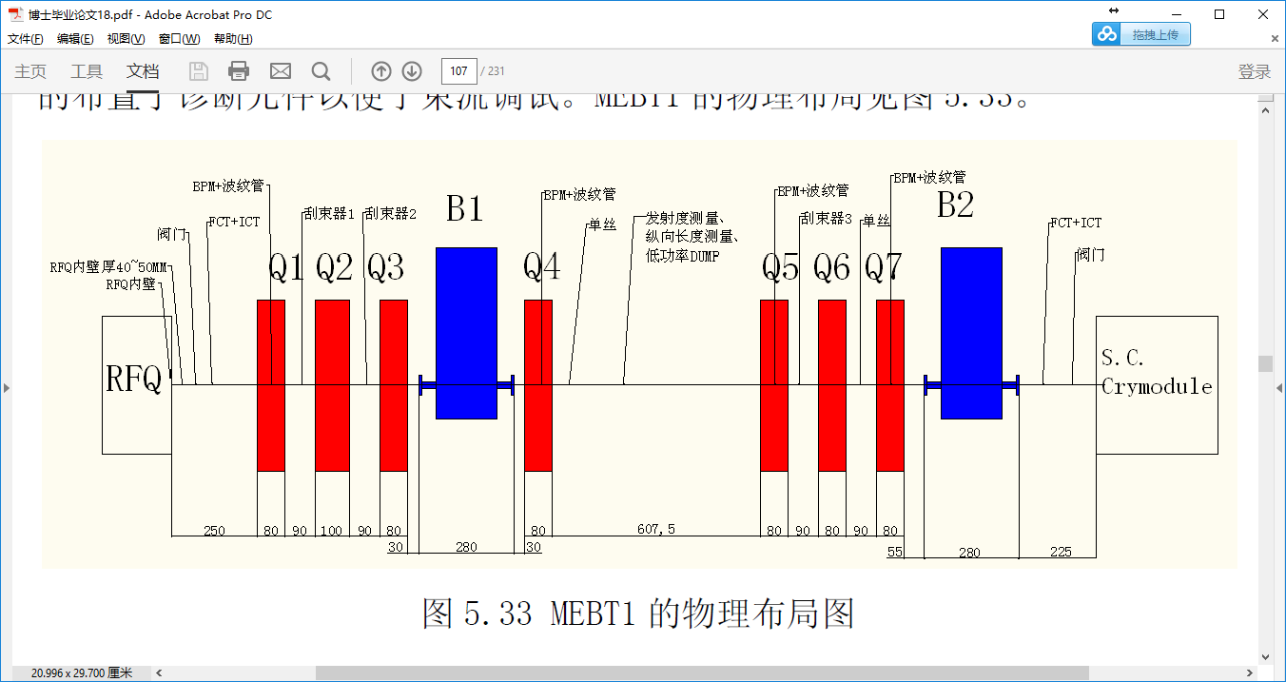

|  |  |  |  |
| --- | --- | --- | --- |
| D | 250 |  |  |
| Q1 | 80 | 8.357 | 6.6856 |
| D | 90 |  |  |
| Q2 | 100 | -15.222 | -15.222 |
| D | 90 |  |  |
| Q3 | 80 | 15.728 | 12.5824 |
| D | 340 |  |  |
| Q4 | 80 | -5.778 | -4.6224 |
| D | 607.5 |  |  |
| Q5 | 80 | -10.713 | -8.5704 |
| D | 90 |  |  |
| Q6 | 80 | 17.350 | 13.88 |
| D | 90 |  |  |
| Q7 | 80 | -11.302 | -9.0416 |
| D | 560 / 500 |  |  |

