MT-Hub Drupal Module User Guide

v1.0



User guide for the MT-Hub Drupal module to connect to the MT-Hub Platform.

## Table of Contents

Table of Contents 1

Introduction 2

Installation 3

Drupal Module Installation 3

Prerequisite Modules 3

Configuration 5

Authorisation 5

Multilingual Site Configuration 6

Add languages to site 6

Add Methods of Detecting and Selecting Language 6

Enable Content Type Translation 7

Enable Field Translation 8

Translating: Content 9

Translation Management 9

Translation 9

Post Editing 10

Exporting 10

Importing 10

Troubleshooting 11

Known Bugs/Limitations 11

Site language selected 11

# Introduction

This guide contains installation and basic use instructions for the MT-Hub Drupal Module. The plugin will facilitate the translation of sites created in the Drupal CMS using the MT-Hub platform.

# Installation

Installation steps for the MT-Hub Module.

## Drupal Module Installation

To install a new module to a Drupal site just simply download the code for the module. Put the folder containing the module code into the site directory “<your_site>/sites/all/modules”. Then the options to enable the module will appear in the Drupal modules list.

## Prerequisite Modules

The MT-Hub module requires the following Drupal projects:

* [Entity Translation](https://www.drupal.org/project/entity_translation)
* [Entity](https://www.drupal.org/project/entity)
* [I18n](https://www.drupal.org/project/i18n)
* [Variable](https://www.drupal.org/project/variable)

The follow modules are to be enabled:

* Locale
* Entity Translation
* Entity Translation Menu
* Entity Translation Upgrade
* Internationalization
* Variable
* Menu translation
* String translation
* Translation sets
* Entity API
* Content Translation
* Field Translation

# Configuration

The configuration page for the MT-Hub module can be found by two ways:

1. Go to “Modules” and select “Configure” beside the MT-Hub module.
2. Go to “Configuration” and under the heading “Regional and Language” select “MT-Hub”.

The URL endpoint is “admin/config/regional/mt_hub”.

## Authorisation

The MT-Hub module authenticates itself to the users account on the MT-Hub platform by and API token. This token can be found on your account at <https://app.mt-hub.eu>.

To authenticate your MT-Hub module just simply enter your MT-Hub Consumer API token in the API Token field on the module settings page and click “Save configuration”.

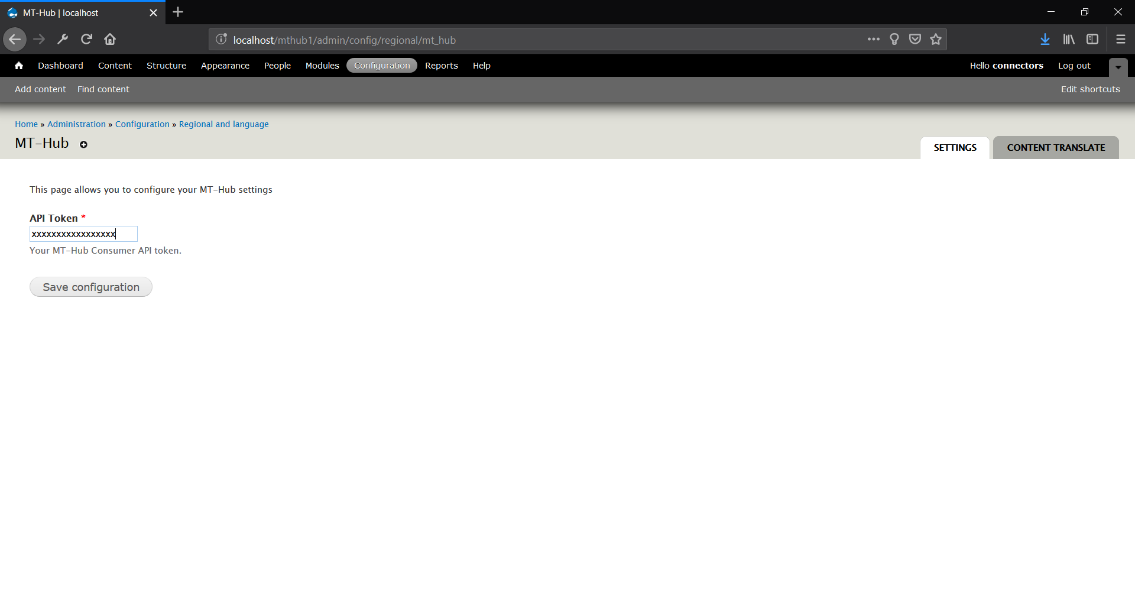

# Multilingual Site Configuration

## Add languages to site

Go to “Home > Administration > Configuration > Regional and language > languages” and add as many languages as you require. (“admin/config/regional/language”)

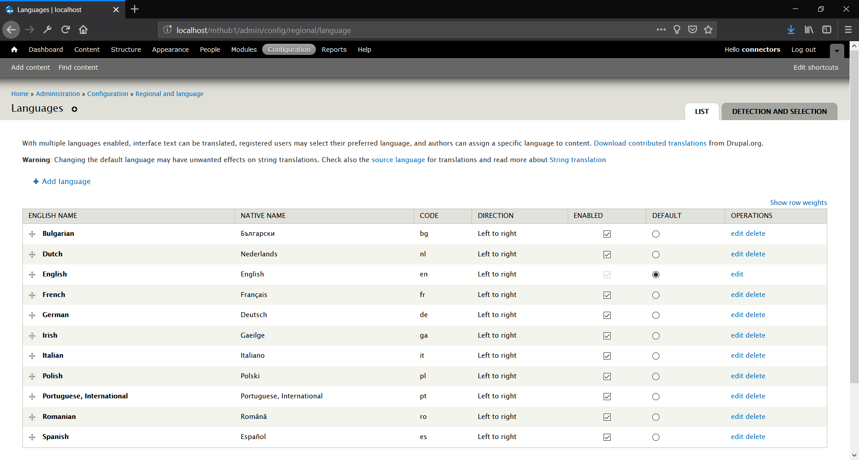

## Add Methods of Detecting and Selecting Language

Add a method for selecting and detecting languages for the site at “[Home](http://localhost/iadaatpad1/) > [Administration](http://localhost/iadaatpad1/admin) > [Configuration](http://localhost/iadaatpad1/admin/config) > [Regional and language](http://localhost/iadaatpad1/admin/config/regional) > [Languages](http://localhost/iadaatpad1/admin/config/regional/language)”. (“admin/config/regional/language/configure”)

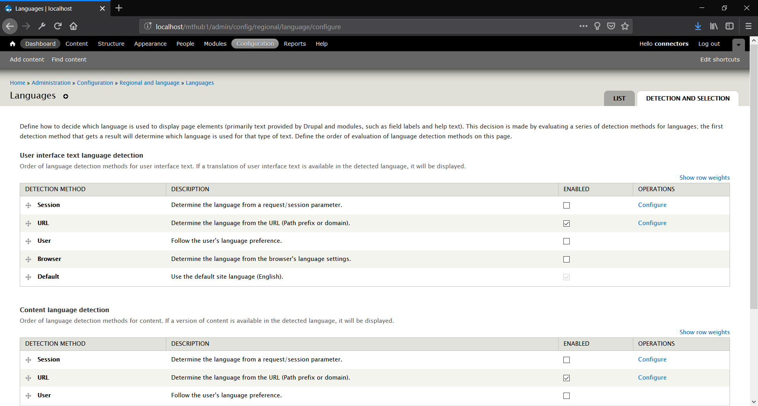

## Enable Content Type Translation

To enable translation for content types, go to “Structure > Content Types > Basic Page > edit > Publishing Options > Multilingual support” and select “Enabled, with Field Translation”. (“admin/structure/types/manage/page”)

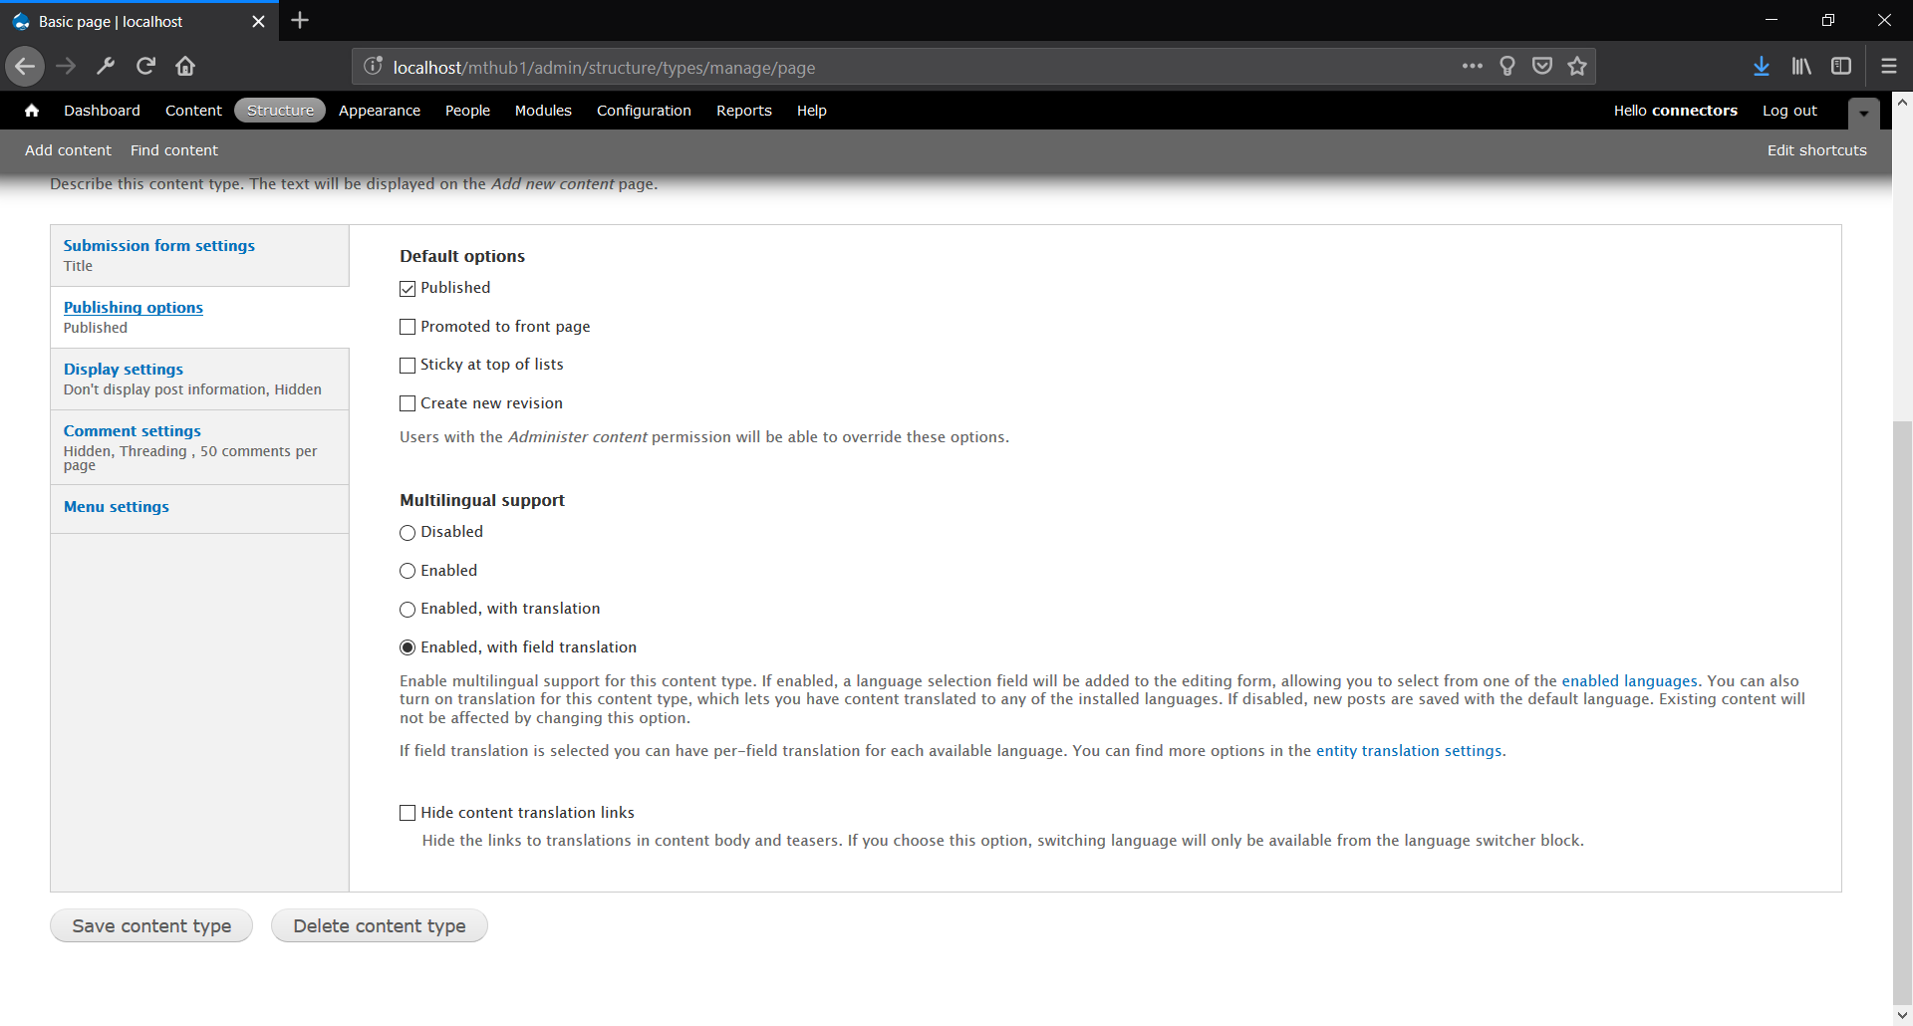

To disable the language selector links below content types check the “Hide content translation links” box on each content type edit page.

## Enable Field Translation

To enable fields to be translated you must edit the field settings. For example, to enable the “body” field, check the option found at “Structure > Content Types > Basic Page > Manage Fields > edit > Body field settings” called “Field Translation”. (“admin/structure/types/manage/page/fields/body”)

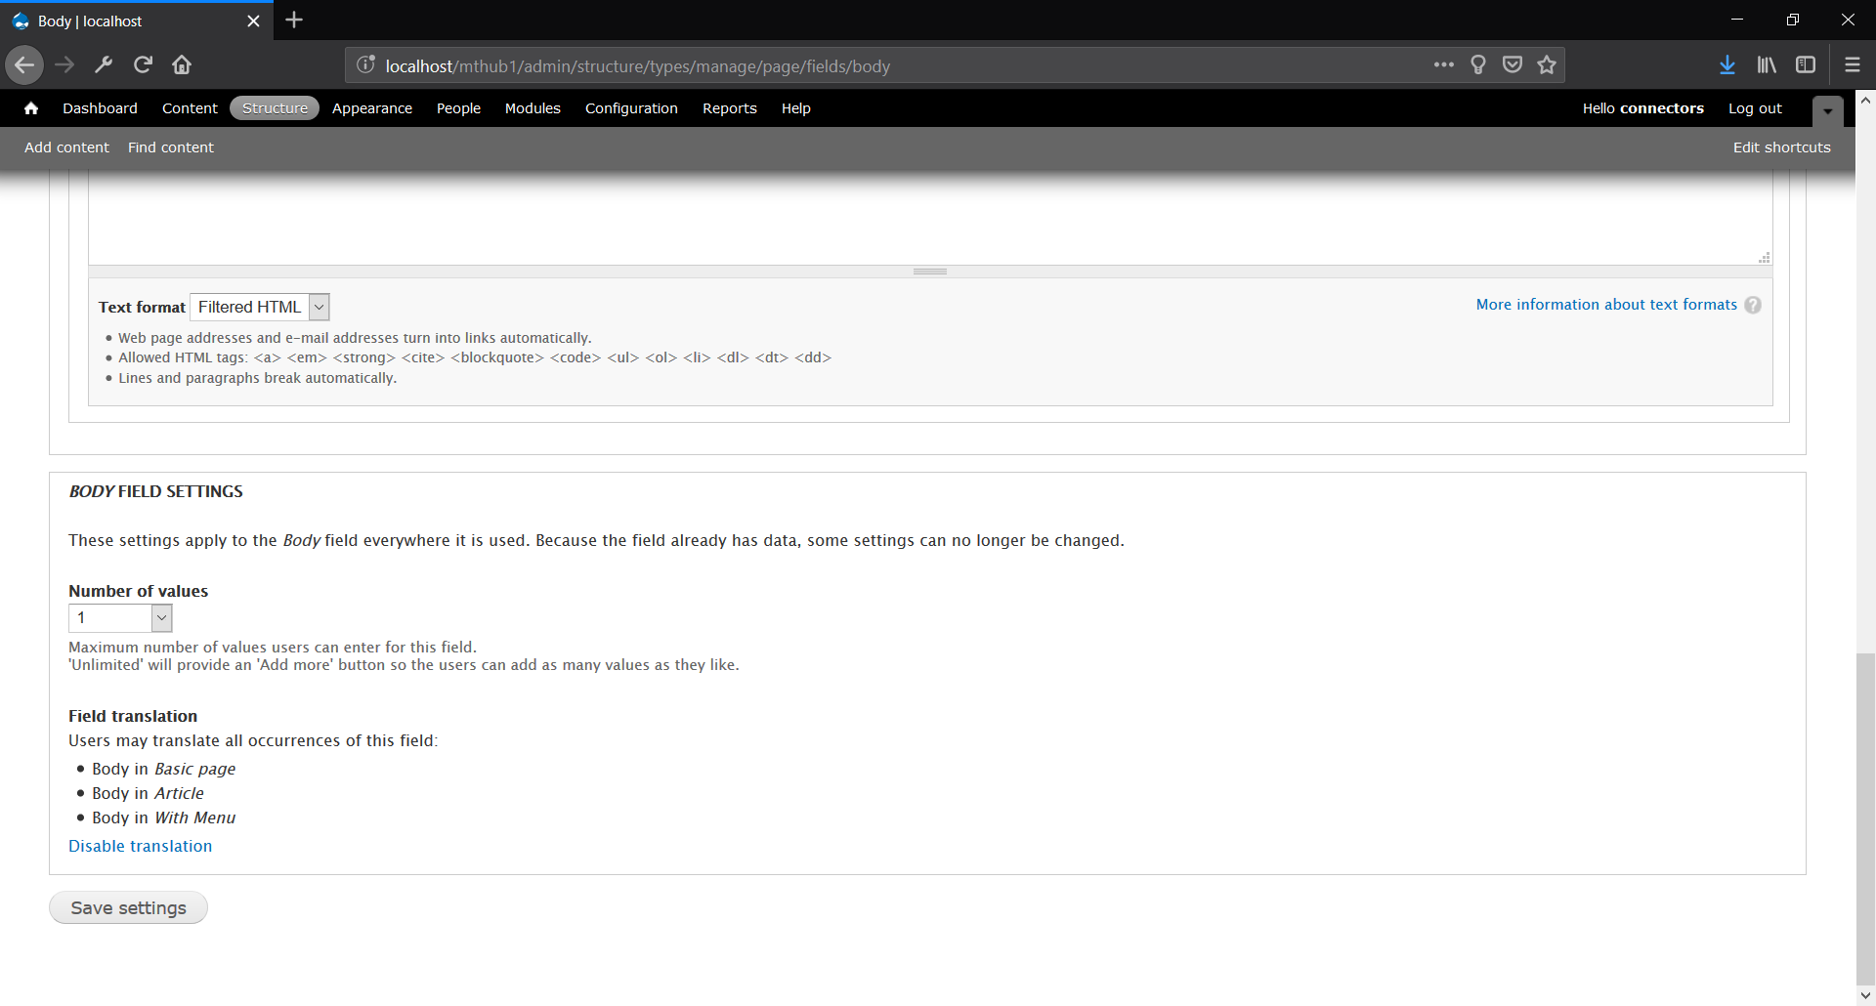

For further documentation please refer to the [Entity Translation module official documentation](https://www.drupal.org/docs/7/modules/entity-translation).

# Translating: Content

## Translation Management

Translating content is managed on the MT-Hub configuration page under the “Content Translate” tab. (“admin/config/regional/mt_hub/content”)

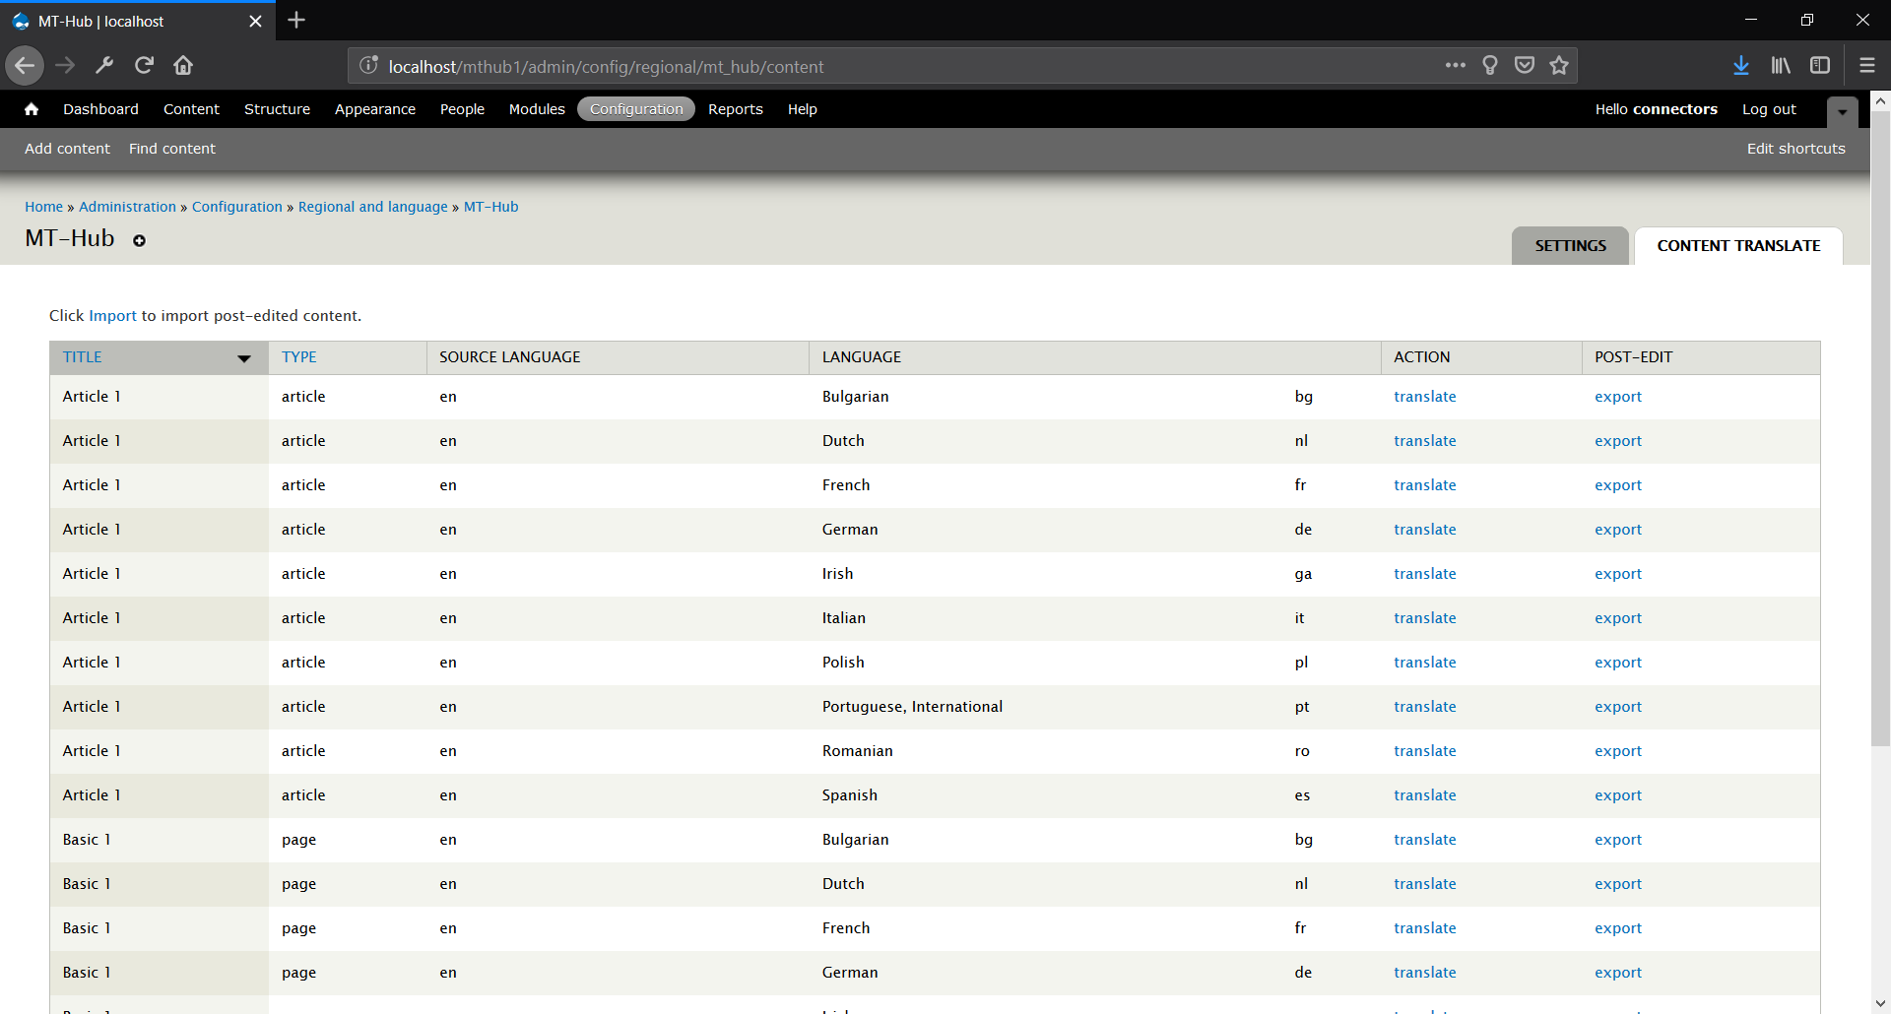

## Translation

A content type is selected for translation by clicking the “translate” button in the “ACTION” column. When a content type is selected for translation it’s body and other text containing fields are found in their relevant tables in the database and sent for translation.

Content types are translated synchronously. While a content type is translating the status column in the data table will show a progress bar to show the translation is in progress.

The translated content type is then stored in the database in the relevant tables for each content field type.

Any content which was created before the entity translation module was installed may not have the default site language set i.e. it will be Language Neutral “und”. To update the language on any content simply go to the edit page for the content and update the language to the desired default language e.g. English “en”. 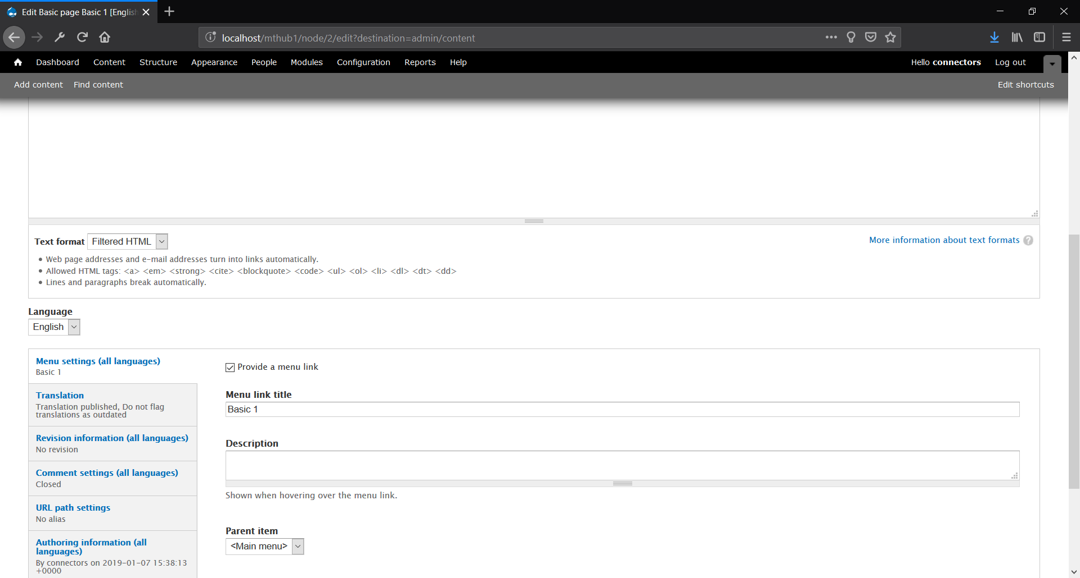

Note: If there is a “try again later” result for an attempt at translating a content type then that means there was an issue in the API such as the MT engine not being online. In most cases attempting the translation again in 5-10 minutes should result in a successful translation.

## Post Editing

### Exporting

To export the translated content for post editing select the “export” button in the “POST-EDIT” column. This option will export the translation pair in an XLIFF file.

The XLIFF file can then be imported to a CAT tool for post editing.

### Importing

To import the translated the content after post editing select the “import” link above the Content Translate table. This will open up an upload file window to select the post edited XLIFF file to update the translated content.

# Troubleshooting

## Known Bugs/Limitations

### Site language selected

Some multilingual actions such as postediting are affected by the language that is selected on the website, so it is advised to only use the MT-Hub module while the original site language is selected e.g. if your sites original language is English, do not have another language selected on the site such as French or Spanish while performing admin actions with the MT-Hub module.