Article
Genome scale metabolic model of Ustilago maydis shows metabolic adjustment at the strain level
Alphabetic Order Surname: Lars M. Blank ¹, Daniel Kaplan ¹, Ulf W. Liebal ¹, Christian Lieven ², Lena Ullmann, Daniel Wibberg ³, Thiemo Zambanini ¹⁴,
Citation: Lastname, F.; Lastname, F.; Lastname, F. Title. J. Fungi 2021, 7, x. https://doi.org/10.3390/xxxxx
Academic Editor: Firstname Lastname
Received: date
Accepted: date
Published: date
Publisher’s Note: MDPI stays neutral with regard to jurisdictional claims in published maps and institutional affiliations.

Copyright: © 2021 by the authors. Submitted for possible open access publication under the terms and conditions of the Creative Commons Attribution (CC BY) license (https://creativecommons.org/licenses/by/4.0/).
¹ Affiliation 1; e-mail@e-mail.com
² Affiliation 2; e-mail@e-mail.com
* Correspondence: e-mail@e-mail.com; Tel.: (optional; include country code; if there are multiple corresponding authors, add author initials)
Abstract: Ustilago maydis is an important plant pest and is being developed as an effective biotechnological production host. In particular, the ability to secrete high amounts of itaconate is interesting from the perspective of communal evolution and genetic engineering. However, the absence of a comprehensive metabolic overview hinders a full understanding of the adaptation and a full use of the metabolic potential. Here, we report the first genome scale metabolic model (GSMM) of Ustilago maydis 521 (iUma22) for the simulation of metabolic activities. iUma22 was reconstructed from sequencing and annotation using PathwayTools, the biomass equation was derived from literature values and from the codon composition. The growth capacity of Ustilago maydis was assessed by BIOLOG-Phenotype arrays to improve iUma22 performance. Growth rate predictions were validated based on exponential batch cultivations. A pan-genome of four different U. maydis strains highlights the evolutionary developments within the xx Mio years of divergent evolution. We find that the majority of metabolic differences between U. maydis and the pan-genome occurs in the starch metabolic pathways. This highlights the adaptation towards a particular host. The new model allows the study of metabolic adjustments in different conditions in the wild as well as for biotechnological applications.
Keywords: Ustilago maydis; Genome Scale Metabolic Model; Constraint Based Model; Biotechnology; COBRA; FBA; Metabolism; Itaconate

1. Introduction
The ecological role of U. maydis paragraph.
Biotechnological success of U. maydis. Tehrani et al. (2019)
The advantages of GSMM. Nies et al. (2020)
Outline of the manuscript

The introduction should briefly place the study in a broad context and highlight why it is important. It should define the purpose of the work and its significance. The current state of the research field should be carefully reviewed and key publications cited. Please highlight controversial and diverging hypotheses when necessary. Finally, briefly mention the main aim of the work and highlight the principal conclusions. As far as possible, please keep the introduction comprehensible to scientists outside your particular field of research. References should be numbered in order of appearance and indicated by a numeral or numerals in square brackets—e.g., [1] or [2,3], or [4–6]. See the end of the document for further details on references.

2. Materials and Methods

2.1. Draft GSMM from Pathway Tools
The genomic DNA sequence of Ustilago maydis (Strain 521 FGSC 9021) (Kämper et al. 2006) was obtained from NCBI's RefSeq project (Tatusova et al. 2014). A corresponding annotation file (Mannhaupt et al. 2013) was then exported from the MIPS Ustilago Maydis Database via the PEDANT Interface (Frishman et al. 2001). Using the PathoLogic Tool (Karp et al. 2011), the sequence and annotation files were parsed and in combinationwith MetaCyc reactions database a new Pathway/Genome Database (PGDB) was created. During pathway cleaning reactions from other taxa are pruned, unless there are enzymes matching to all of the reactions. Additional metabolic activity was identified using the ‘Pathway Hole Filler’ function and sequence information of isoenzymes was used to query the proteome of U. maydis via pBlast. Protein sequences were queried on PEDANT, MUMDB, MetaCyc or KEGG and manually curated while inconclusive polypeptides as well as those that are involved in signaling and other non-metabolic pathways were discarded.

2.2 Strains sequenced, pan-genome, KEGG pathway enrichment
To identify metabolic differences of the strain 521 within the U. maydis strain family, a pan-genome consisting of five Ustilago maydis strains was assembled. In addition to strain 521 the following U. maydis strains were sequenced: 198, 482, 485, 512. What sequencing technique? How many contigs? How did the annotation happen? The KEGG pathway annotation was performed by comparison of E.C. numbers in the pan-genome annotation and E.C. numbers in the reaction description of iUma22. The comparison resulted in three lists, E.C. numbers only present in iUma22 (iUmaNOTpan), present in the pan-genome and iUma (iUmaANDpan), and only present in pan-genome (panNOTiUma). The panNOTiUma list was exported as fasta-file and KAAS was used to enrich the list with pathway information.

2.3 Biomass equation and growth/non-growth maintenance
The composition of proteins, RNA and DNA was estimated based on the protein and genome sequence respectively, whereas the composition of lipids and the cell wall were results mined from scientific articles(Hernandez et al. 1997; Ruiz-Herrera et al. 1996). The exact biomass composition of U. maydis (proteins, DNA, RNA, lipids, cell wall components) is not available, however, the specific elemental composition (Klement et al. 2012) and the biomass composition for fungi in general (Griffin 1994) was used as a starting point and linear programming was applied to approximate the total biomass composition (Table S1). The composition values of each monomer were then converted into stoichiometric values (Thiele & Palsson 2010). For example, for the AA composition, the absolute amount of each AA codon was counted (CDN_{AA}) and divided by the sum of all codons to calculate the molar percentage (MP)(Eq. 1). To calculate the stoichiometric factor of an AA (SF_{AA}) the molar percentage (MP) is multiplied with the fractional protein mass per biomass (X) (Eq. 2).
MP_{AA} [g_{AA}/g_{Prot}] = CDN_{AA}/Σι=_{AA} CDN_{i} | (1)
SF_{AA} [g_{AA}/g_{Prot}] = MP_{AA}[g_{AA}/g_{Prot}]•X[g_{Prot}/g_{CDW}]•1000 | (2)
The fraction of protein on total biomass (X) was determined by linear optimization. The average elemental composition of each macromolecule (protein, DNA., RNA, lipid, cell wall) was determined by summing up the products of the absolute amount of each element. For each macromolecule the C-mole content was calculated by division with the carbon elemental composition [Klement et al. (2012)]. Phosphorous and Sulfur were added from the elemental composition of S. cerevisiae, which was assumed to have a similar content. The linear optimization follows the general formula:

A•X = b | (3)
subject to: x_{lbi} ≤ x_{i} ≤ x_{ubi} | (4)

The rows of matrix A correspond to the six individual elements C, H, O, N, P, S whereas the columns correspond to the five types of macromolecules (protein, DNA, RNA, lipids, cell wall). The vector b represents the measured elemental biomass C, H, O, N supplemented by the elemental content of P and S of S. cerevisiae. The equation was solved for vector X, the biomass fractions of each of the macromolecules. The lower (x_{lb}) and upper (x_{ub}) boundary values are provided in Supp. Table 2. The ATP-associated maintenance values were set to 46.3 molATP/gCDW and 1.9 molATP /gCDW/h for GAM and NGAM, respectively.

Biolog experiments and analysis

Growth experiments
The Materials and Methods should be described with sufficient details to allow others to replicate and build on the published results. Please note that the publication of your manuscript implicates that you must make all materials, data, computer code, and protocols associated with the publication available to readers. Please disclose at the submission stage any restrictions on the availability of materials or information. New methods and protocols should be described in detail while well-established methods can be briefly described and appropriately cited.
Research manuscripts reporting large datasets that are deposited in a publicly available database should specify where the data have been deposited and provide the relevant accession numbers. If the accession numbers have not yet been obtained at the time of submission, please state that they will be provided during review. They must be provided prior to publication.
Interventionary studies involving animals or humans, and other studies that require ethical approval, must list the authority that provided approval and the corresponding ethical approval code.

3. Results
This section may be divided by subheadings. It should provide a concise and precise description of the experimental results, their interpretation, as well as the experimental conclusions that can be drawn.

3.1. Description of iUma22
Number of genes, reactions, metabolites
Table 1. This is a table. Tables should be placed in the main text near to the first time they are cited.
Component | iUma22 | Yeast 8…
Genes | 1079
Metabolites | 1987
Reactions | 2218
¹ Tables may have a footer.

Presentation of special properties of the model, comparison of biomass composition and maintenance cost with yeast.

3.2. U. maydis Pan-Genome
What are special KEGG enrichments?
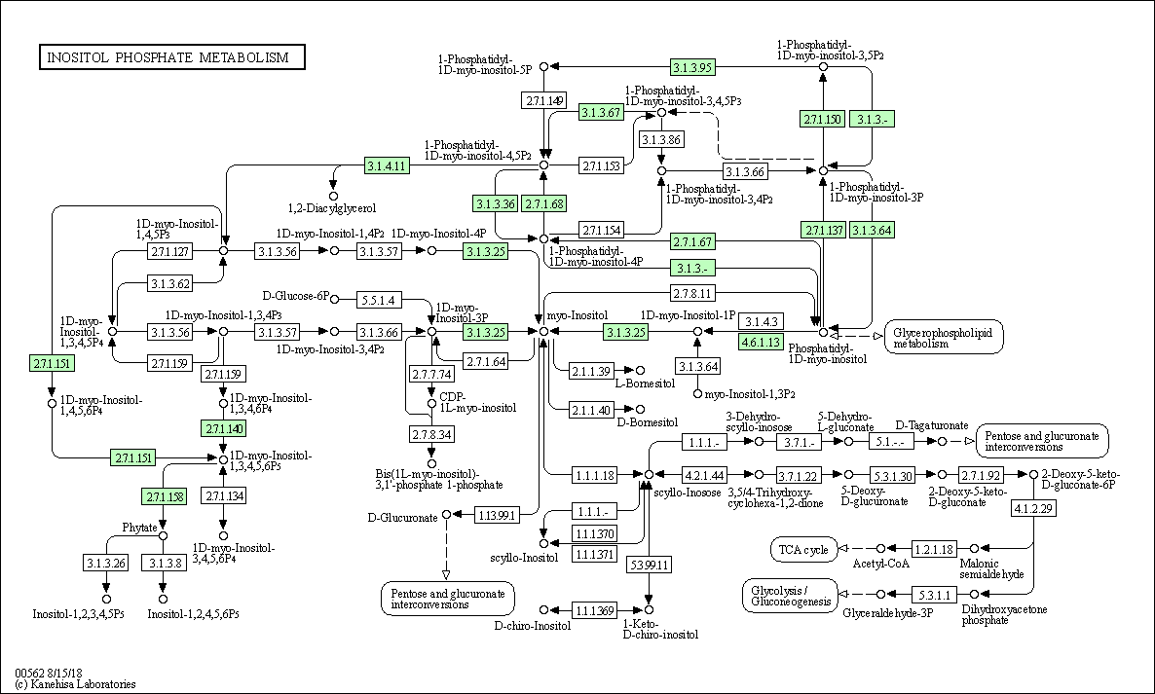
Figure 1. KEGG enrichment of reactions not present in iUma22 but in the pan-genome.

3.2. Carbon Substrate tests with BIOLOG Phenotype arrays
The text continues here.
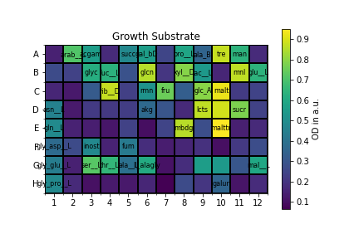 | 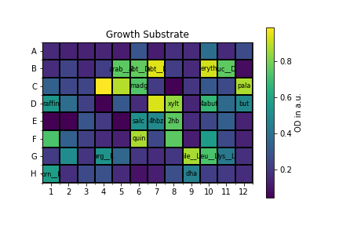
(c) | (d)
Figure 2. BIOLOG phenotype experiments with carbon sources from PM1 and PM2A. The final OD is measured after 144h for PM1 (a) and 288h for PM2A. The cutoff for growth is set at 0.35 a.u. at OD600 based on a histogram of all OD values.
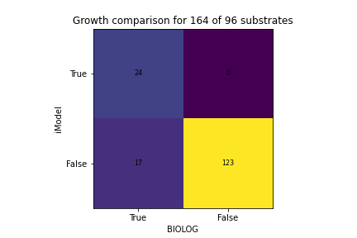
Figure 3. Confusion table of the overlap between model prediction and BIOLOG growth result.

3.3. Growth rate correlation
All figures and tables should be cited in the main text as Figure 1, Table 1, etc.
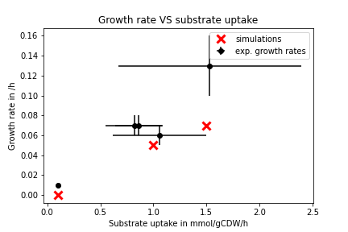
Figure 4. Growth correlation of iUma22 with batch cultures.

Table 2. This is a table. Tables should be placed in the main text near to the first time they are cited.
Title 1 | Title 2 | Title 3 | Title 4
entry 1 | data | data | data
entry 1 | data | data | data
entry 1 | data | data | data
entry 2 | data | data | data
entry 2 | data | data | data
entry 3 | data | data | data
entry 3 | data | data | data
entry 3 | data | data | data
entry 3 | data | data | data
entry 4 | data | data | data
entry 4 | data | data | data

3.3. Formatting of Mathematical Components
This is example 1 of an equation:
a = 1, | (1)
the text following an equation need not be a new paragraph. Please punctuate equations as regular text.
This is example 2 of an equation:
a = b + c + d + e + f + g + h + i + j + k + l + m + n + o + p + q + r + s + t + u + v + w + x + y + z | (2)
the text following an equation need not be a new paragraph. Please punctuate equations as regular text.
Theorem-type environments (including propositions, lemmas, corollaries etc.) can be formatted as follows:
Theorem 1. Example text of a theorem. Theorems, propositions, lemmas, etc. should be numbered sequentially (i.e., Proposition 2 follows Theorem 1). Examples or Remarks use the same formatting, but should be numbered separately, so a document may contain Theorem 1, Remark 1 and Example 1.
The text continues here. Proofs must be formatted as follows:
Proof of Theorem 1. Text of the proof. Note that the phrase “of Theorem 1” is optional if it is clear which theorem is being referred to. Always finish a proof with the following symbol. □
The text continues here.

4. Discussion
Authors should discuss the results and how they can be interpreted from the perspective of previous studies and of the working hypotheses. The findings and their implications should be discussed in the broadest context possible. Future research directions may also be highlighted.

5. Conclusions
This section is not mandatory but can be added to the manuscript if the discussion is unusually long or complex.

6. Patents
This section is not mandatory but may be added if there are patents resulting from the work reported in this manuscript.
Supplementary Materials: The following are available online at www.mdpi.com/xxx/s1, Figure S1: title, Table S1: title, Video S1: title.
Author Contributions: For research articles with several authors, a short paragraph specifying their individual contributions must be provided. The following statements should be used “Conceptualization, X.X. and Y.Y.; methodology, X.X.; software, X.X.; validation, X.X., Y.Y. and Z.Z.; formal analysis, X.X.; investigation, X.X.; resources, X.X.; data curation, X.X.; writing—original draft preparation, X.X.; writing—review and editing, X.X.; visualization, X.X.; supervision, X.X.; project administration, X.X.; funding acquisition, Y.Y. All authors have read and agreed to the published version of the manuscript.” Please turn to the CRediT taxonomy for the term explanation. Authorship must be limited to those who have contributed substantially to the work reported.
Funding: Please add: “This research received no external funding” or “This research was funded by NAME OF FUNDER, grant number XXX” and “The APC was funded by XXX”. Check carefully that the details given are accurate and use the standard spelling of funding agency names at https://search.crossref.org/funding. Any errors may affect your future funding.
Institutional Review Board Statement: In this section, please add the Institutional Review Board Statement and approval number for studies involving humans or animals. Please note that the Editorial Office might ask you for further information. Please add “The study was conducted according to the guidelines of the Declaration of Helsinki, and approved by the Institutional Review Board (or Ethics Committee) of NAME OF INSTITUTE (protocol code XXX and date of approval).” OR “Ethical review and approval were waived for this study, due to REASON (please provide a detailed justification).” OR “Not applicable.” for studies not involving humans or animals. You might also choose to exclude this statement if the study did not involve humans or animals.
Informed Consent Statement: Any research article describing a study involving humans should contain this statement. Please add “Informed consent was obtained from all subjects involved in the study.” OR “Patient consent was waived due to REASON (please provide a detailed justification).” OR “Not applicable.” for studies not involving humans. You might also choose to exclude this statement if the study did not involve humans.
Written informed consent for publication must be obtained from participating patients who can be identified (including by the patients themselves). Please state “Written informed consent has been obtained from the patient(s) to publish this paper” if applicable.
Data Availability Statement: In this section, please provide details regarding where data supporting reported results can be found, including links to publicly archived datasets analyzed or generated during the study. Please refer to suggested Data Availability Statements in section “MDPI Research Data Policies” at https://www.mdpi.com/ethics. You might choose to exclude this statement if the study did not report any data.
Acknowledgments:
We are grateful to Jennifer Scheuplein and Brigida Fabry for support at pathway visualization.
In this section, you can acknowledge any support given which is not covered by the author contribution or funding sections. This may include administrative and technical support, or donations in kind (e.g., materials used for experiments).
Conflicts of Interest: Declare conflicts of interest or state “The authors declare no conflict of interest.” Authors must identify and declare any personal circumstances or interest that may be perceived as inappropriately influencing the representation or interpretation of reported research results. Any role of the funders in the design of the study; in the collection, analyses or interpretation of data; in the writing of the manuscript, or in the decision to publish the results must be declared in this section. If there is no role, please state “The funders had no role in the design of the study; in the collection, analyses, or interpretation of data; in the writing of the manuscript, or in the decision to publish the results”.
Appendix A
The appendix is an optional section that can contain details and data supplemental to the main text—for example, explanations of experimental details that would disrupt the flow of the main text but nonetheless remain crucial to understanding and reproducing the research shown; figures of replicates for experiments of which representative data is shown in the main text can be added here if brief, or as Supplementary data. Mathematical proofs of results not central to the paper can be added as an appendix.
Appendix B
All appendix sections must be cited in the main text. In the appendices, Figures, Tables, etc. should be labeled starting with “A”—e.g., Figure A1, Figure A2, etc.

References
References must be numbered in order of appearance in the text (including citations in tables and legends) and listed individually at the end of the manuscript. We recommend preparing the references with a bibliography software package, such as EndNote, ReferenceManager or Zotero to avoid typing mistakes and duplicated references. Include the digital object identifier (DOI) for all references where available.

Citations and references in the Supplementary Materials are permitted provided that they also appear in the reference list here.

In the text, reference numbers should be placed in square brackets [ ] and placed before the punctuation; for example [1], [1–3] or [1,3]. For embedded citations in the text with pagination, use both parentheses and brackets to indicate the reference number and page numbers; for example [5] (p. 10), or [6] (pp. 101–105).

- Author 1, A.B.; Author 2, C.D. Title of the article. Abbreviated Journal Name Year, Volume, page range.
- Author 1, A.; Author 2, B. Title of the chapter. In Book Title, 2nd ed.; Editor 1, A., Editor 2, B., Eds.; Publisher: Publisher Location, Country, 2007; Volume 3, pp. 154–196.
- Author 1, A.; Author 2, B. Book Title, 3rd ed.; Publisher: Publisher Location, Country, 2008; pp. 154–196.
- Author 1, A.B.; Author 2, C. Title of Unpublished Work. Abbreviated Journal Name stage of publication (under review; accepted; in press).
- Author 1, A.B. (University, City, State, Country); Author 2, C. (Institute, City, State, Country). Personal communication, 2012.
- Author 1, A.B.; Author 2, C.D.; Author 3, E.F. Title of Presentation. In Title of the Collected Work (if available), Proceedings of the Name of the Conference, Location of Conference, Country, Date of Conference; Editor 1, Editor 2, Eds. (if available); Publisher: City, Country, Year (if available); Abstract Number (optional), Pagination (optional).
- Author 1, A.B. Title of Thesis. Level of Thesis, Degree-Granting University, Location of University, Date of Completion.
- Title of Site. Available online: URL (accessed on Day Month Year).

