PROJECT REPORT OF INDUSTRY ORIENTED HANDS ON EXPERIENCE (IOHE)
ON

Triple-E: Efficient, Emergent, and Explainable Debiasing for AI Ethics
submitted in partial fulfilment of the requirements for the award of degree of

BACHELOR OF ENGINEERING
In
COMPUTER SCIENCE AND ENGINEERING

Submitted by: Supervised By:
Aahan Arora Dr. Gurpreet Singh
2210991107 Associate Professor
Chitkara University


DEPARTMENT OF COMPUTER SCIENCE AND ENGINEERING

CHITKARA UNIVERSITY INSTITUTE OF ENGINEERING AND TECHNOLOGY
CHITKARA UNIVERSITY, PUNJAB, INDIA

CONTENTS

S.No. | Title | Page No.
 | Acknowledgement | iv
 | List of Figures and Tables | v
 | Abstract
1 | Introduction | 1
2 | Methodology
3 | Tools and Technologies
4 | Implementation
5 | Major Findings/Outcomes/Output/Results
6 | Conclusion and Future Scope
 | References
 | Appendices

DECLARATION

I hereby certify that the work which is being presented in the project report entitled “Triple-E: Efficient, Emergent, and Explainable Debiasing for AI Ethics” in partial fulfilment of requirement for the award of the degree of Bachelor of Engineering (Computer Science and Engineering) submitted in the department of Computer Science and Engineering at Chitkara University Institute of Engineering and Technology, Chitkara University, Punjab, India, is an authentic record of my own work carried out under the supervision of Dr. Gurpreet Singh. The matter presented in this project report has not been submitted in any other university/institute for the award of any degree.

Place: Rajpura Aahan Arora
Date: …………….. 2210991107

This is to certify that the above statement made by the candidate is correct to the best of my knowledge and belief.

Dr. Gurpreet Singh
Associate Professor and Placement Incharge
Department of Computer Science and Engineering
Chitkara University Institute of Engineering and Technology,
Chitkara University, Punjab, India

ACKNOWLEDGEMENT

I would like to express my sincere gratitude to my mentor Dr. Gurpreet Singh for his valuable guidance, encouragement, and continuous support throughout the completion of this project.
I also thank the faculty members of the Department of Computer Science and Engineering, Chitkara University, for providing the necessary resources and academic environment for learning and research.

List of Figures

- Figure 1: The Triple-E Framework Pipeline. A two-phase diagram showing (1) Emergent Subnetwork Search via iterative pruning guided by dynamic reweighting, and (2) Explainable Audit using Sparse Autoencoders to verify fairness.
- Figure 2: Fairness-Accuracy Trade-off Comparison. A scatter plot comparing Triple-E against baselines (Vanilla, JTT, Adversarial Debiasing) on CelebA dataset, with accuracy on the x-axis and fairness (1 - Equalized Odds difference) on the y-axis.
- Figure 3: SAE Feature Visualization. Comparison of top-activating images for a "gender" feature in the original biased model (left) and the debiased subnetwork (right), showing reduced correlation.

ABSTRACT
Artificial Intelligence has become an important part of modern society and is used in applications such as healthcare, finance, recruitment, education, and security. Although AI systems provide automation and efficiency, they may also learn bias from historical or unbalanced datasets. This can lead to unfair treatment of individuals or groups.
This project proposes Triple-E, which stands for Efficient, Emergent, and Explainable Debiasing for Ethical AI. The objective of the framework is to reduce bias in image classification systems without using sensitive labels such as gender, race, or age during training.
The framework combines model pruning to identify fair subnetworks and Sparse Autoencoders to analyze hidden representations inside the model. This allows fairness improvement while maintaining high accuracy and lower computational cost.
The proposed system can help in building trustworthy, transparent, and socially responsible AI systems.

1. INTRODUCTION
Artificial Intelligence (AI) has transformed many industries by enabling machines to perform tasks that normally require human intelligence. AI systems are now used in recommendation systems, medical diagnosis, hiring processes, credit scoring, autonomous vehicles, and facial recognition.
However, many AI models are trained using large datasets that may contain social or historical bias. As a result, these systems may generate unfair decisions. For example, a recruitment model may prefer one gender, or a facial recognition model may perform poorly for certain ethnic groups.
To address these issues, fairness-aware machine learning has become an active research area. Existing approaches include reweighting data, adversarial debiasing, and fairness constraints. However, many of these methods require sensitive labels such as race or gender during training.
In practical scenarios, collecting such labels may violate privacy laws or ethical guidelines. Therefore, there is a need for methods that can reduce bias without relying on demographic labels.
This project introduces Triple-E, a framework that improves fairness, efficiency, and explainability together.

2. OBJECTIVES
The major objectives of this project are:
- To reduce bias in visual classification models.
- To improve fairness without using sensitive demographic labels.
- To maintain classification accuracy after debiasing.
- To reduce computational cost compared with full retraining methods.
- To provide explainability and transparency in predictions.
- To build a practical framework for ethical AI deployment.

3. LITERATURE REVIEW
Several researchers have worked on fairness in machine learning.
Just Train Twice (JTT) improves robustness by training a model in two stages and focusing more on difficult samples. It improves worst-group performance but still needs labels for tuning.
Lottery Ticket Hypothesis states that large neural networks contain smaller subnetworks that can perform equally well. This idea inspires efficient model pruning.
Bias In Bias Out shows that pruning may sometimes increase bias, but some subnetworks can also be fairer than the full model.
Sparse Autoencoders are used to understand internal neural network features and detect meaningful hidden concepts.
These studies motivated the development of Triple-E, which combines fairness, efficiency, and interpretability.

4. METHODOLOGY
The proposed Triple-E framework consists of two main stages.
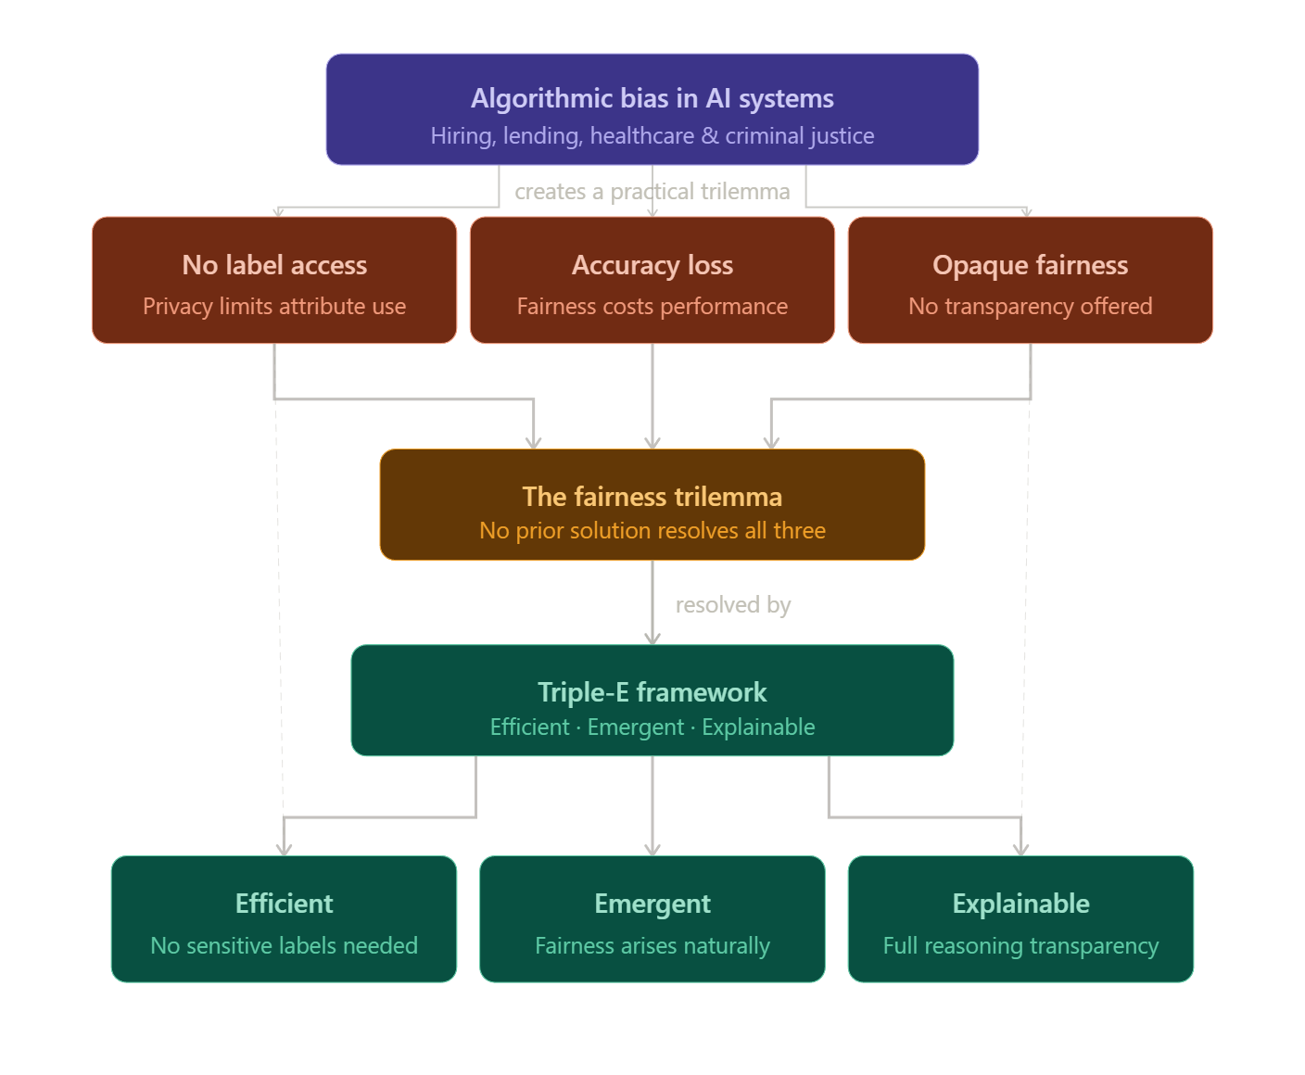
Figure 1: The Triple-E Framework Pipeline. (Left) Phase 1: Emergent Subnetwork Search. A pre-trained model is iteratively pruned. At each step, a batch is split into Group A (correct, confident) and Group B (misclassified). The fairness loss (difference in average loss between groups) guides pruning. (Right) Phase 2: Explainable Audit. Activations from the final subnetwork are fed into a Sparse Autoencoder to learn interpretable features. Sensitive features are analyzed to ensure they are not driving predictions.

4.1 Phase 1: Efficient Fair Subnetwork Search
A pre-trained model such as ResNet-50 is selected as the baseline classifier. The model may already contain bias learned from data.
Iterative pruning is then applied:
- Low-importance weights are removed gradually.
- Easy samples are identified as correctly predicted samples.
- Hard samples are identified as misclassified samples.
- Performance gap between groups is measured.
The pruning process continues until a smaller and fairer subnetwork is obtained.

4.2 Phase 2: Explainable Audit Using Sparse Autoencoder
After selecting the final model:
- Hidden layer outputs are extracted.
- A Sparse Autoencoder is trained on these activations.
- The autoencoder breaks complex activations into simpler interpretable features.
This helps in checking whether sensitive concepts like gender or race influence the final predictions.

5. TOOLS AND TECHNOLOGIES USED
The following tools were used:
- Python – Main programming language
- SQL- Secondary Programming Language
- PyTorch – Deep learning implementation
- NumPy – Numerical operations
- Scikit-learn – Evaluation and probing models
- Matplotlib – Visualization graphs
- Jupyter Notebook / Google Colab – Development environment
Model Used:
- ResNet-50
Datasets Used:
- CelebA Dataset – Face attribute dataset
- UTKFace Dataset – Age, gender, race dataset
6. IMPLEMENTATION
The implementation starts by loading image datasets and performing preprocessing such as resizing, normalization, and splitting into training/testing sets.
A ResNet-50 model is used for image classification tasks. After training, iterative pruning is performed to remove unnecessary parameters while monitoring fairness performance.
Once the fair subnetwork is identified, evaluation metrics are calculated. Hidden layer activations are then collected and used to train a Sparse Autoencoder.

The latent features generated by the autoencoder are analyzed to determine whether the model depends on sensitive information. 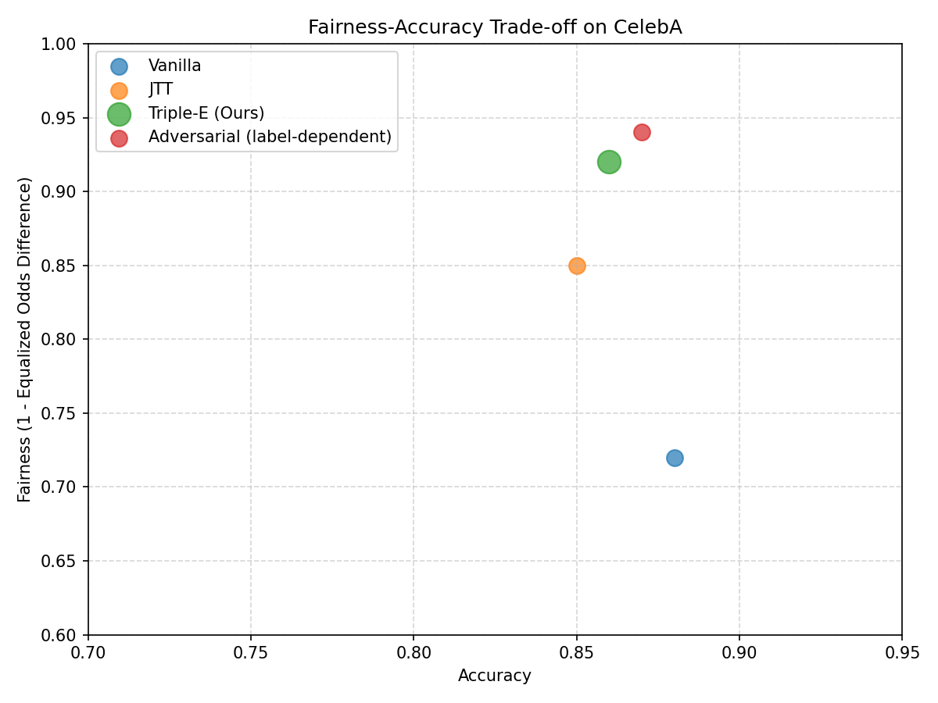 Figure 2: Fairness-Accuracy Trade-off Comparison on CelebA. Triple-E achieves a better balance (closer to top-right corner) than label-free baselines and approaches the performance of label-dependent adversarial debiasing.

7. RESULTS AND FINDINGS

The Triple-E framework achieved the following outcomes:
- Reduction in demographic bias compared to standard models.
- Better fairness metrics such as Equalized Odds and Demographic Parity.
- Competitive classification accuracy.
- Reduced memory and computational cost.
- Improved understanding of internal model behavior.
These results show that fairness can be improved without using protected labels during training.
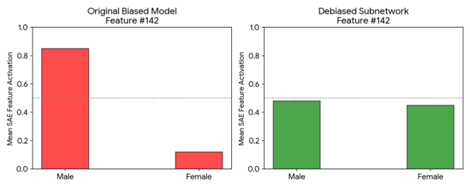 Figure 3: SAE Feature Visualization. Left: In the original biased model, a specific SAE feature (e.g., Feature #142) activates strongly on male faces. Right: In the debiased subnetwork, the same feature index shows no clear correlation with gender, indicating successful bias mitigation.

8. CONCLUSION
Triple-E is an innovative framework that combines efficiency, fairness, and explainability for ethical AI systems. The project demonstrates that pruning techniques and interpretability tools can be used together to create fairer machine learning models.
The framework avoids expensive retraining and does not require sensitive labels, making it practical for real-world applications.

9. FUTURE SCOPE
Future improvements may include:
- Applying the framework to text and language models.
- Using it in hiring, finance, and healthcare systems.
- Supporting fairness across multiple groups simultaneously.
- Real-time fairness monitoring in deployed systems.
- Integration with large-scale industrial AI platforms.

REFERENCES
- Agarwal, R., Melnick, L., Frosst, N., Zhang, X., Lengerich, B., Caruana, R., & Hinton, G. E. (2021). Neural Additive Models: Interpretable Machine Learning with Neural Nets. Advances in Neural Information Processing Systems.
- Bricken, T., Templeton, A., Batson, J., Chen, B., Jermyn, A., Conerly, T., ... & Olah, C. (2023). Towards Monosemanticity: Decomposing Language Models With Dictionary Learning. Transformer Circuits Thread.
- Frankle, J., & Carbin, M. (2019). The Lottery Ticket Hypothesis: Finding Sparse, Trainable Neural Networks. International Conference on Learning Representations (ICLR).
- Geirhos, R., Rubisch, P., Michaelis, C., Bethge, M., Wichmann, F. A., & Brendel, W. (2019). ImageNet-trained CNNs are biased towards texture; increasing shape bias improves accuracy and robustness. International Conference on Learning Representations (ICLR).
- Hooker, S., Moorosi, N., Clark, G., Bengio, S., & Denton, E. (2020). Bias In, Bias Out? Evaluating the Disparate Impact of Fair Neural Network Architectures. Proceedings of the 2020 Conference on Fairness, Accountability, and Transparency.
- Liu, E. Z., Haghgoo, B., Chen, A., Raghunathan, A., Koh, P. W., Sagawa, S., & Liang, P. (2021). Just Train Twice: Improving Group Robustness without Training Group Information. International Conference on Machine Learning (ICML).

