Apps.js is using few variables for calculations which are defined in demo.js
Reference won’t work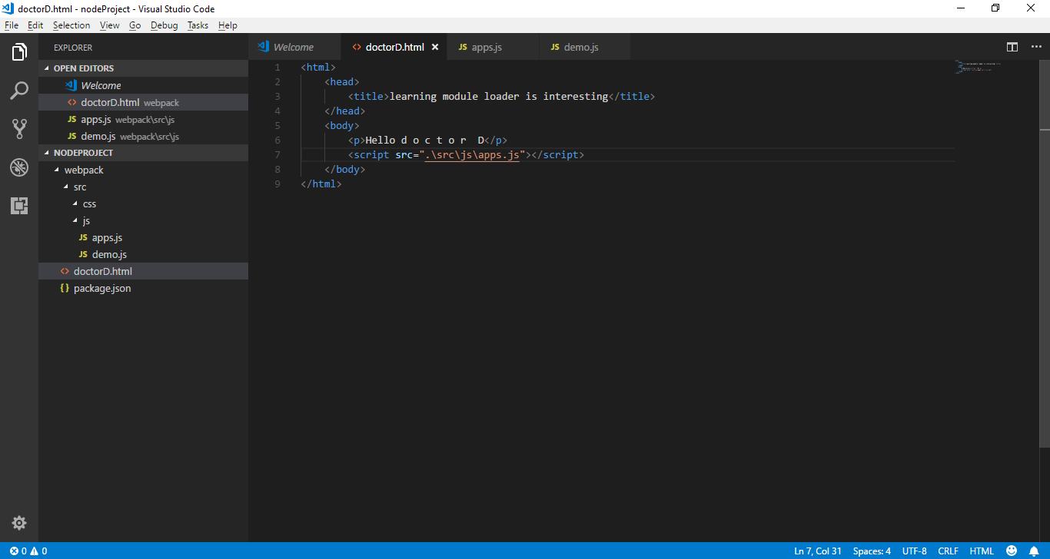
Reference won’t work
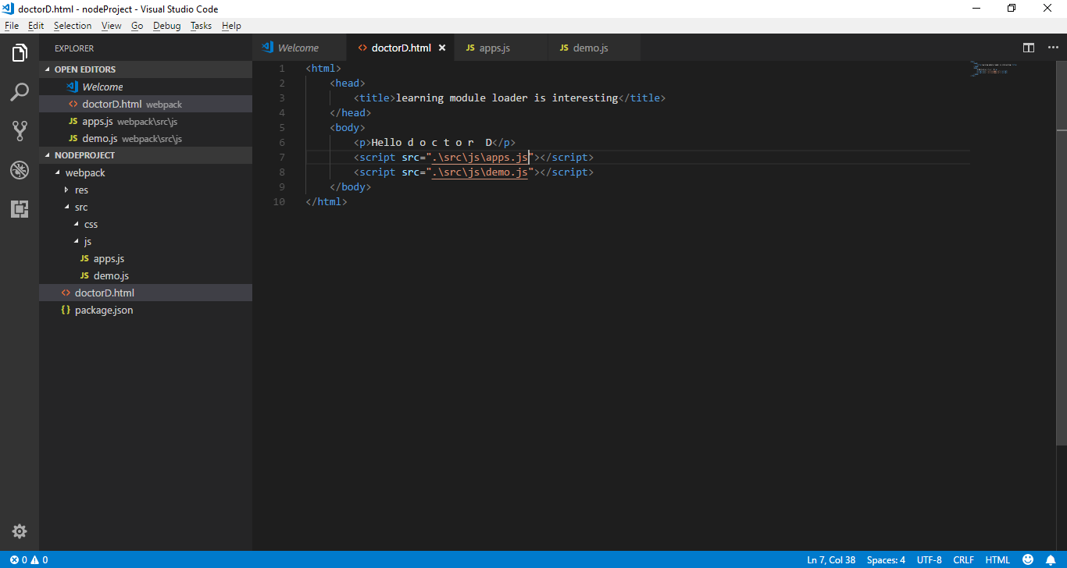
The reference error is coming inside the html page as demo.js is no loaded in html
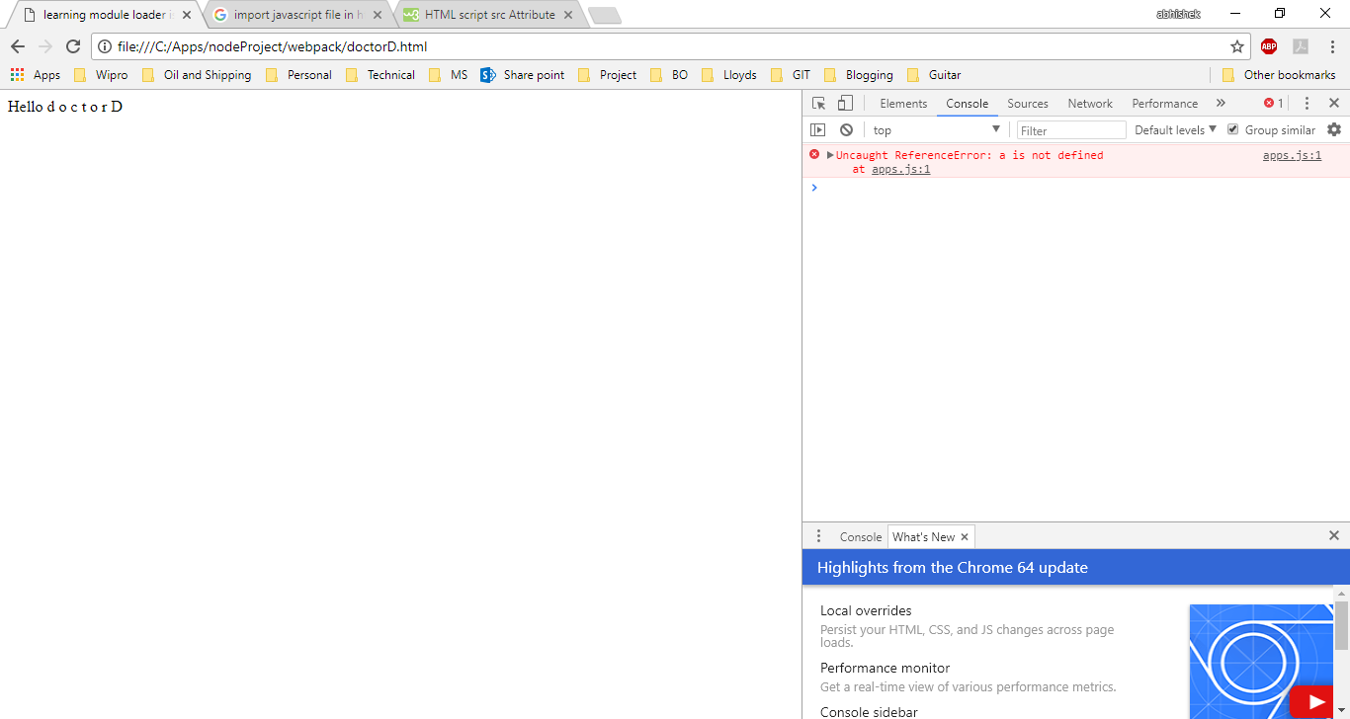
Webpack-cli node module is used to create
