

**THE UNIVERSITY OF TEXAS AT ARLINGTON, TEXAS  
DEPARTMENT OF ELECTRICAL ENGINEERING**

**EE 5322 - 002**

**INTELLIGENT CONTROL SYSTEMS**

**HW # 4**

**ASSIGNMENT**

**by**

**SOUTRIK PRASAD MAITI**

**1001569883**

**Presented to**

**Dr. Frank Lewis**

**Oct 31, 2017**

**EE 5322 Intelligent Control**

**Fall 2015**

**Homework Pledge of Honor**

On all homeworks in this class - YOU MUST WORK ALONE.

***Any cheating or collusion will be severely punished.***

***It is very easy to compare your software code and determine if you worked together***

***It does not matter if you change the variable names.***

Please sign this form and include it as the first page of all of your submitted homeworks.

.......................................................………………………………………………………………........

Typed Name: Soutrik Maiti

***Pledge of honor:***

"On my honor I have neither given nor received aid on this homework.”

e-Signature: Soutrik Maiti

**EE 5322 Homework 4**

**Problem 1:**

**MATLAB CODE –**

close all;

clear all;

%Matrices A,B,C,D

a=[0 1;-25 -2];

b=[0;1];

c=[1 0];

d=0;

%Finding the poles and the transfer function

[n,d]=ss2tf(a,b,c,d);

sysTF=tf(n,d) %Transfer Function

sysPoles=pole(sysTF) %Poles

%Simulating system with unit step function for 10s

x0=[0;0]; %Initial conditions

t=0:0.01:10; %Total time of simulation

u=ones(length(t),1); %Unit step function

plot(t,lsim(sysTF,u,t,x0))

***System Transfer function and poles:***

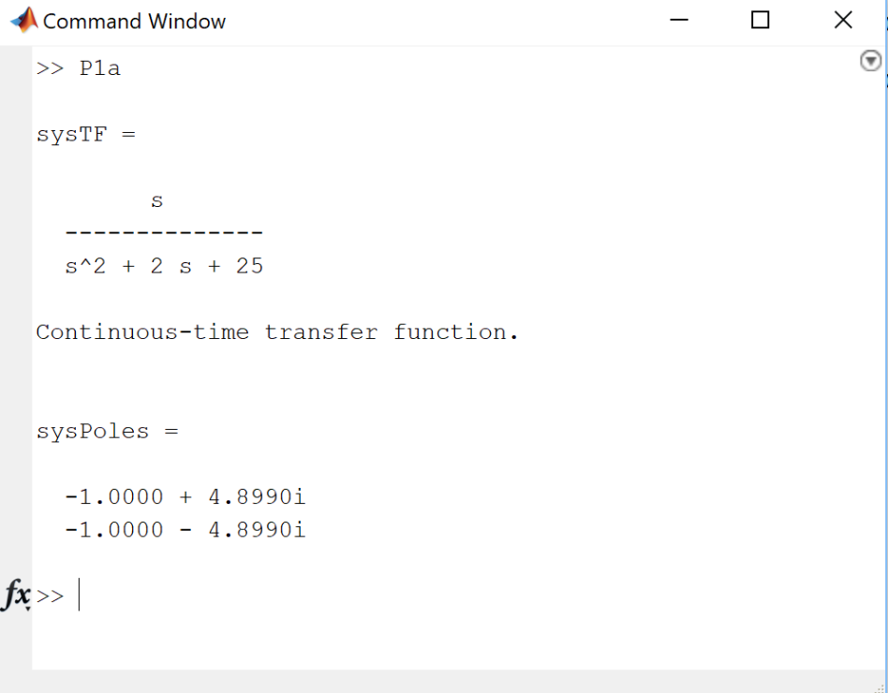

Fig1: System Transfer function and poles

***Unit step response of the system:***

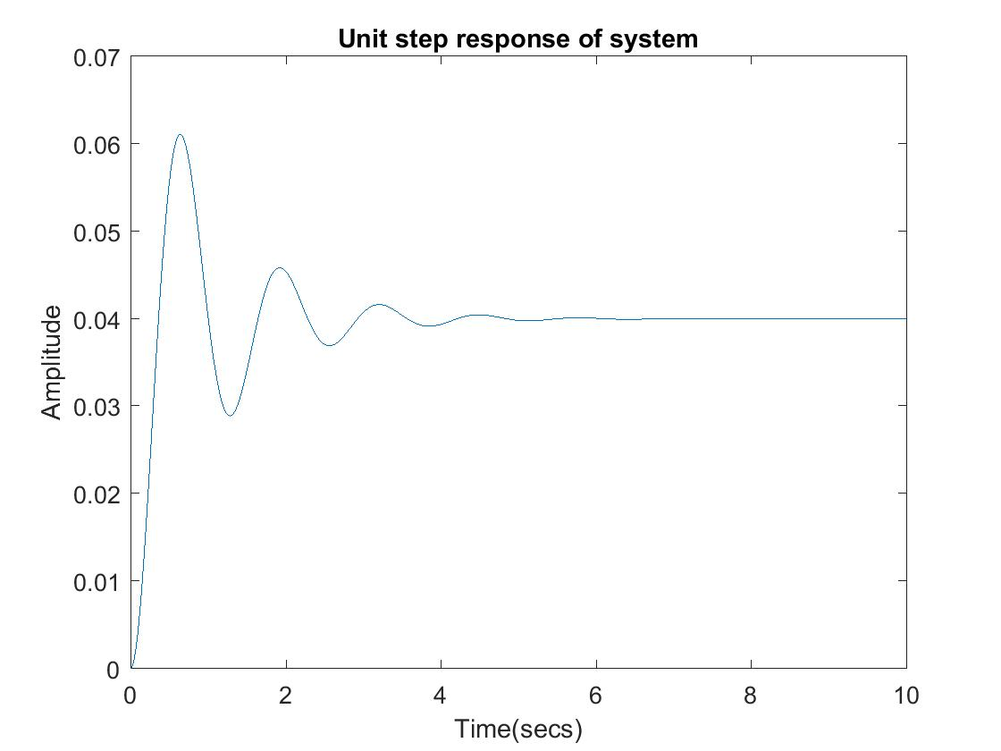

Fig2: Unit step response of the system

**Problem 2:**

**MATLAB CODE –**

function AC=AC(t,s)

%The states of the plant

y=s(1);

ydot=s(2);

%The states of adaptive Controller

a1=s(3);

a2=s(4);

%The plant system matrices

a=[0 1;-25 -2];

b=[0;1];

%The unit step input

yd=5;

e=yd-y; %Error

edot=-ydot;

lam=4; %Lamda

r=edot+lam*e; %sliding error

wT=[a1 a2]; %The unknown weights

phi=[y;ydot]; %The regression matrix

f=wT*phi;

F=50;

dw=F*phi*transpose(r); %Adapted Parameters

k=60;

v=f+k*r;

u=v+lam*edot; %Input to the plant

dx= (a*phi)+(b*u); %Output of the plant

AC=[dx;dw];

end

clc;

clear all;

ini=[0;0;1;1]; %Initial Conditions

tin=0:0.1:10; %Time of the simulation

[t,s]=ode45(@AC,tin,ini) %simulating the adaptive controller

plot(t,s(:,1))

*It can be seen from the Adaptive controller dynamics that the controller makes the plant follow the input signal from Fig3.*

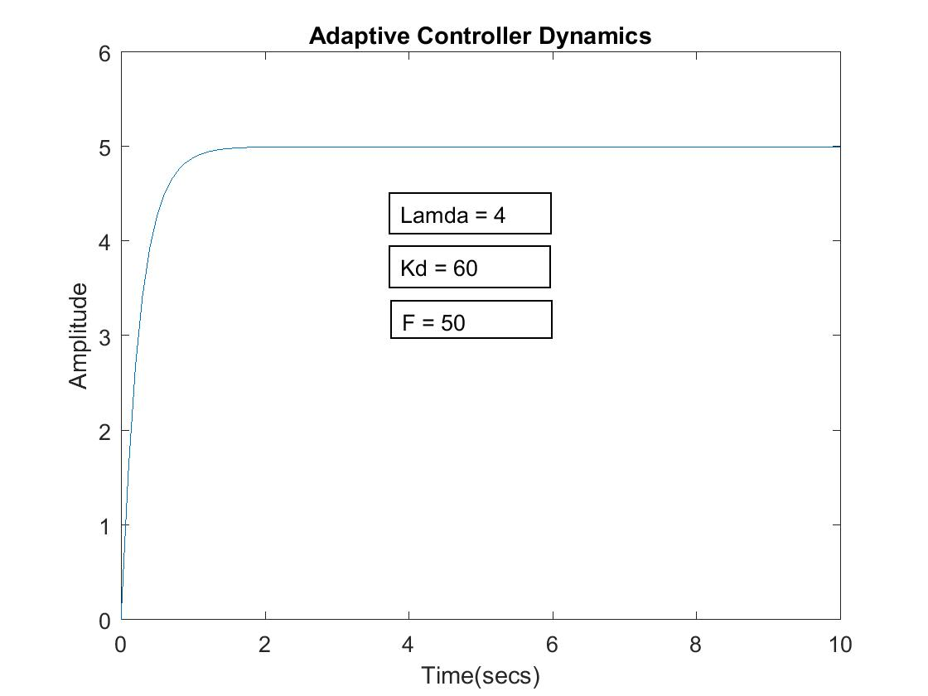

Fig 3 – Adaptive Controller dynamics

**Problem 3:**

**MATLAB CODE –**

function StateEstimate=robust(t,s)

%states for robust control

y=s(1);

ydot=s(2);

%The state matrices of the known plant

a=[0 1;-25 -2];

b=[0;1];

E=0.33; %Choosing value for epsilon

yd=5; %Unit step input

e=yd-y; %Error

edot=-ydot;

lam=8; %Lamda value

r=edot+lam*e; %The sliding error

wT=[1 20]; %The known weights

phi=[y;ydot]; %The regression matrix

f=wT*phi; %Activation function

F=[1 50]*phi;

k=70;

%Under norm bound

if norm(r)<E

v=-r*(F/E);

else

v=-r*(F/norm(r));

end

tau=f+k*r-v; %Plant Input

u=tau+lam*edot;

dx= (a*phi)+(b*u); %Plant Output

StateEstimate=[dx(1);dx(2)];

end

clc;

clear all;

ini=[0;0]; %Initial conditions for robust controller

[t,s]=ode45(@robust,[0:0.1:10],ini) %Simulating robust controller

plot(t,s(:,1))

*It can be seen from the robust controller dynamics that the controller does not actually reach the input but stays close to it.(Fig 4)*

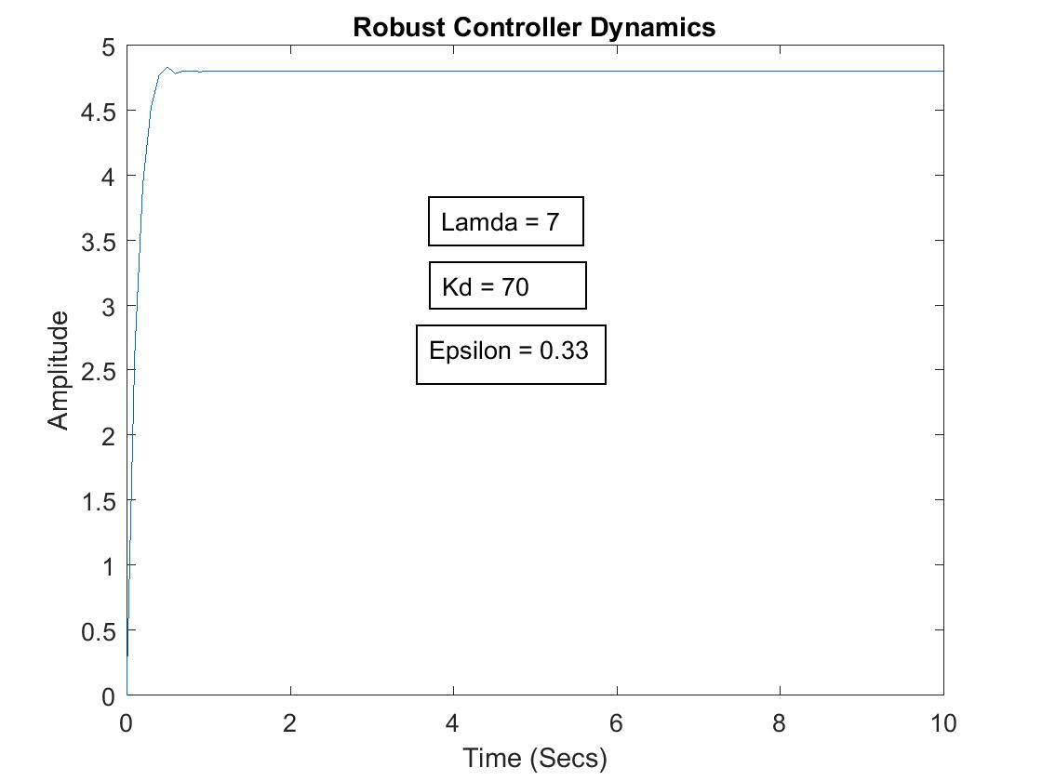

Fig 4- Robust Controller Dynamics