

**THE UNIVERSITY OF TEXAS AT ARLINGTON, TEXAS  
DEPARTMENT OF ELECTRICAL ENGINEERING**

**EE 5321 - 001**

**OPTIMAL CONTROL**

**HW # 2**

**ASSIGNMENT**

**by**

**SOUTRIK MAITI**

**1001569883**

**Presented to**

**Prof. Michael Niestroy**

**Feb 8,2018**

**Problem 1:**

1. Computing the first derivative of the given function:

MATLAB CODE:

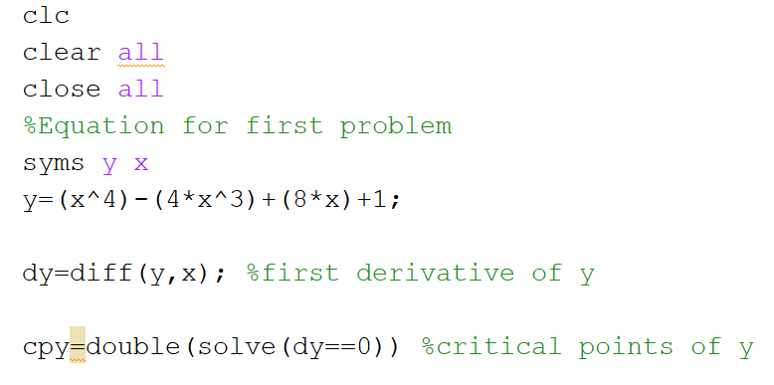

Result: The critical points of the function are as follows-

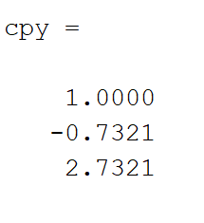

1. Computing the second derivative of the given function and determining the nature of the critical points:

MATLAB CODE:

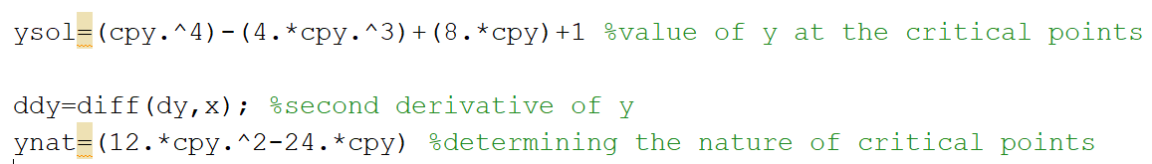

Result:

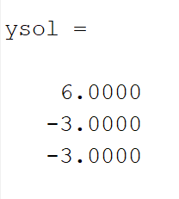 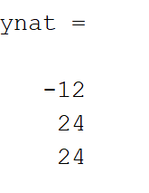

From the above results we can say that the maxima occur at 1 and the minima occur at –0.7321.

The **global minima** from the second derivative is determined to be at -0.7321.

The local maxima occur at 1.

1. Plotting the function:

MATLAB CODE:

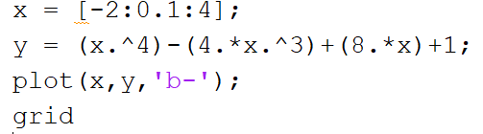

Result:

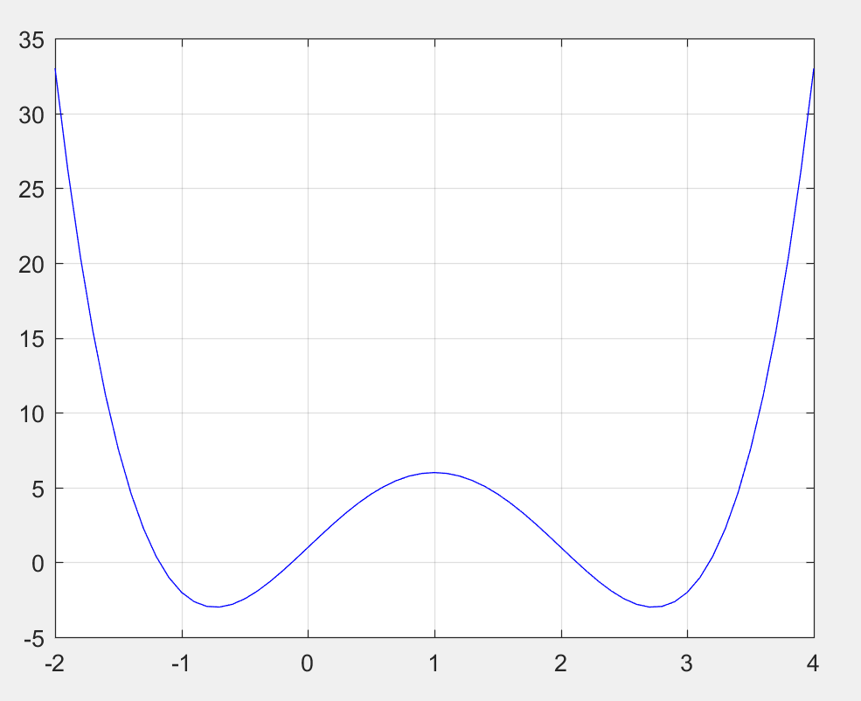

1. MATLAB CODE:

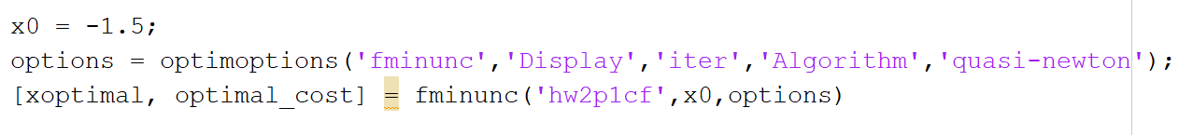

Cost function:

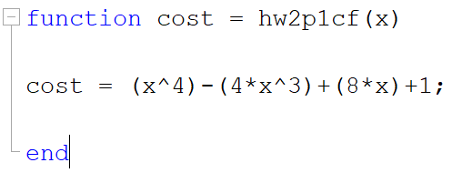

Result:

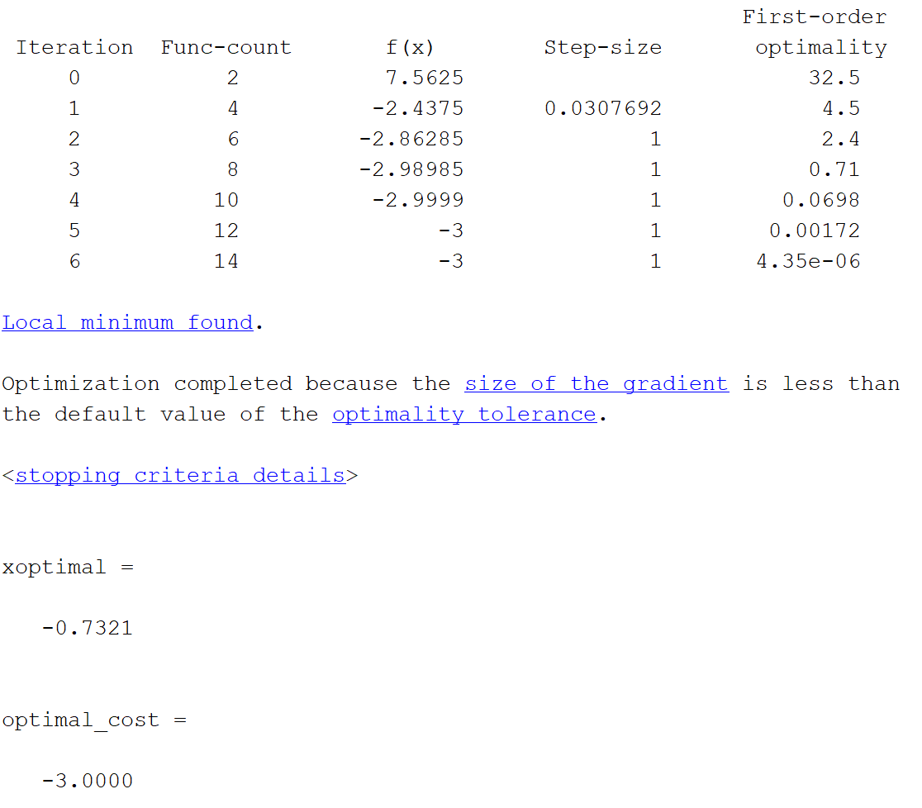

The number of iterations required to calculate is 5 and the **global minima** is -0.732 from the previous part of the problem and it matches with the results from this code. Therefore, our algorithm worked correctly, and the optimal cost of the function is -3.0000.

1. When x0=1.1

MATLAB CODE:

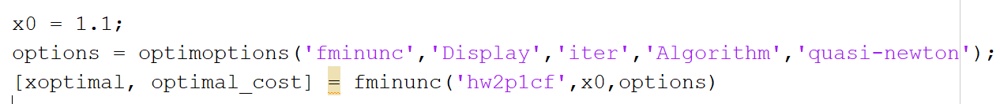

Result: The number of iterations decrease as the value of x is selected near the local maxima. The same code with x=1.1 took 3 iterations.

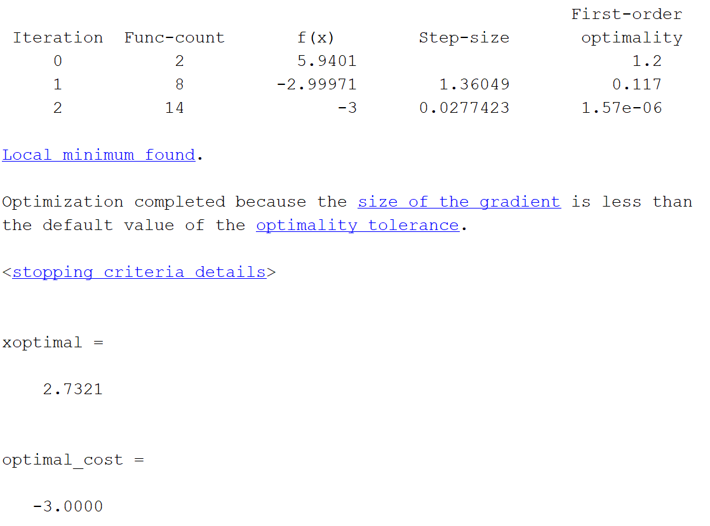

1. When x=1.0, using the same code as above

Result: The number of iterations is just 1 as the value of x is exactly the critical point which is the local maxima.

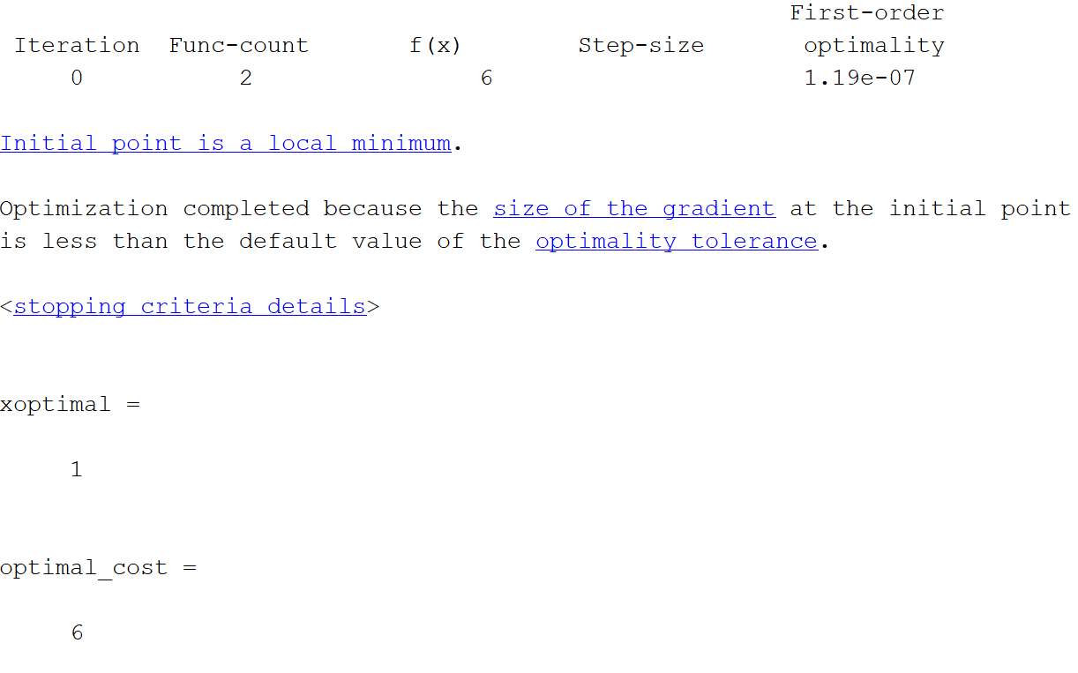

**Problem 2:**

1. MATLAB CODE:

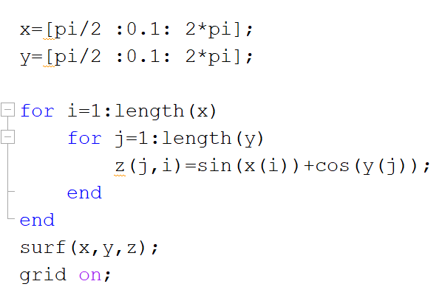

Result:

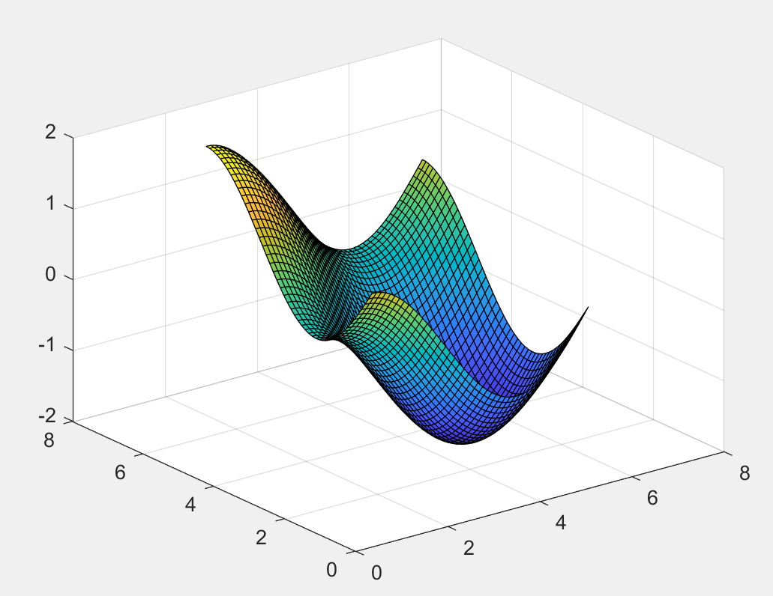

1. MATLAB CODE:

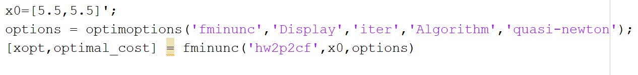

Result:

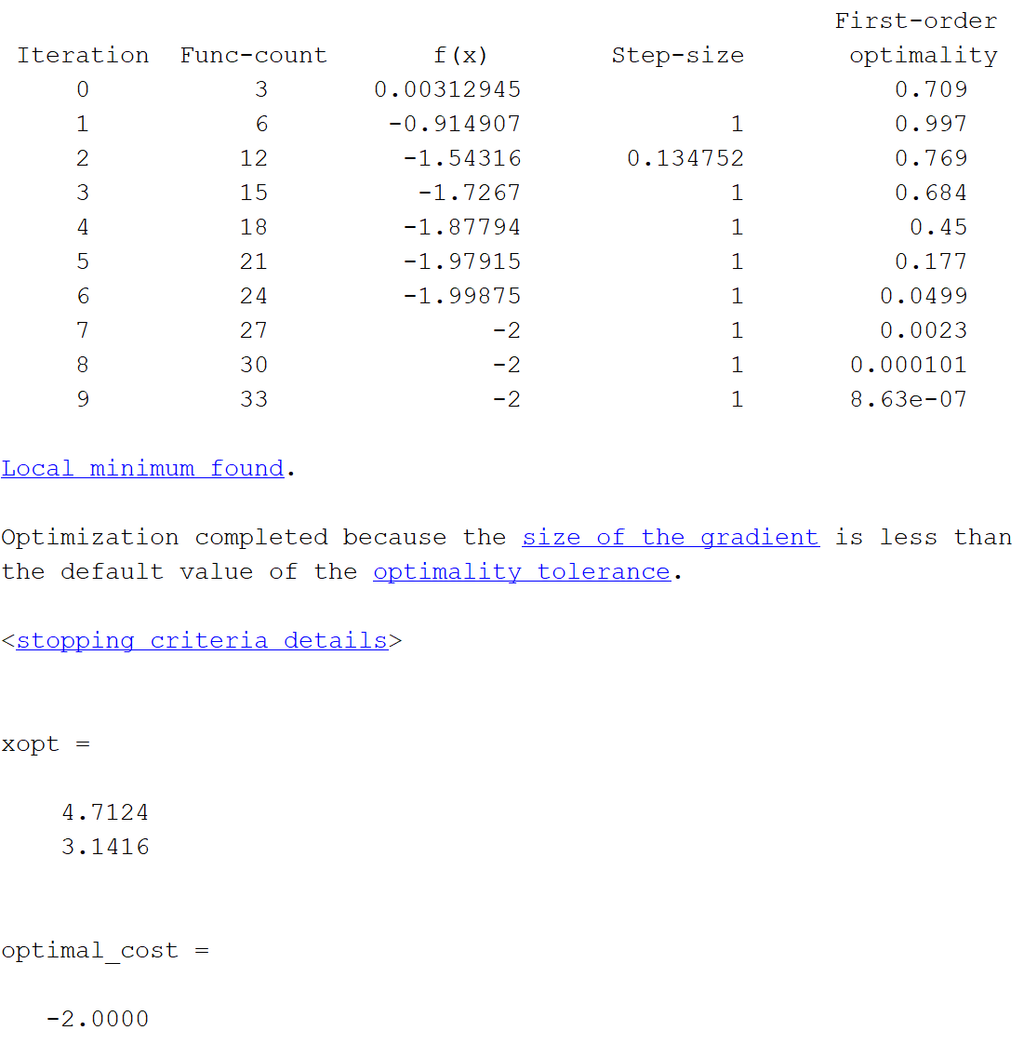

**Problem 3:**

1. MATLAB CODE:

*Cost function:*

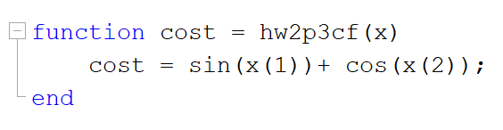

*Constraint function:*

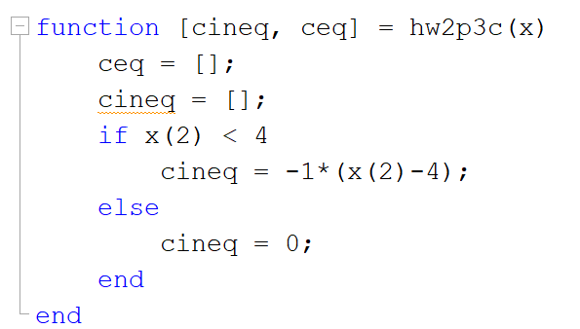

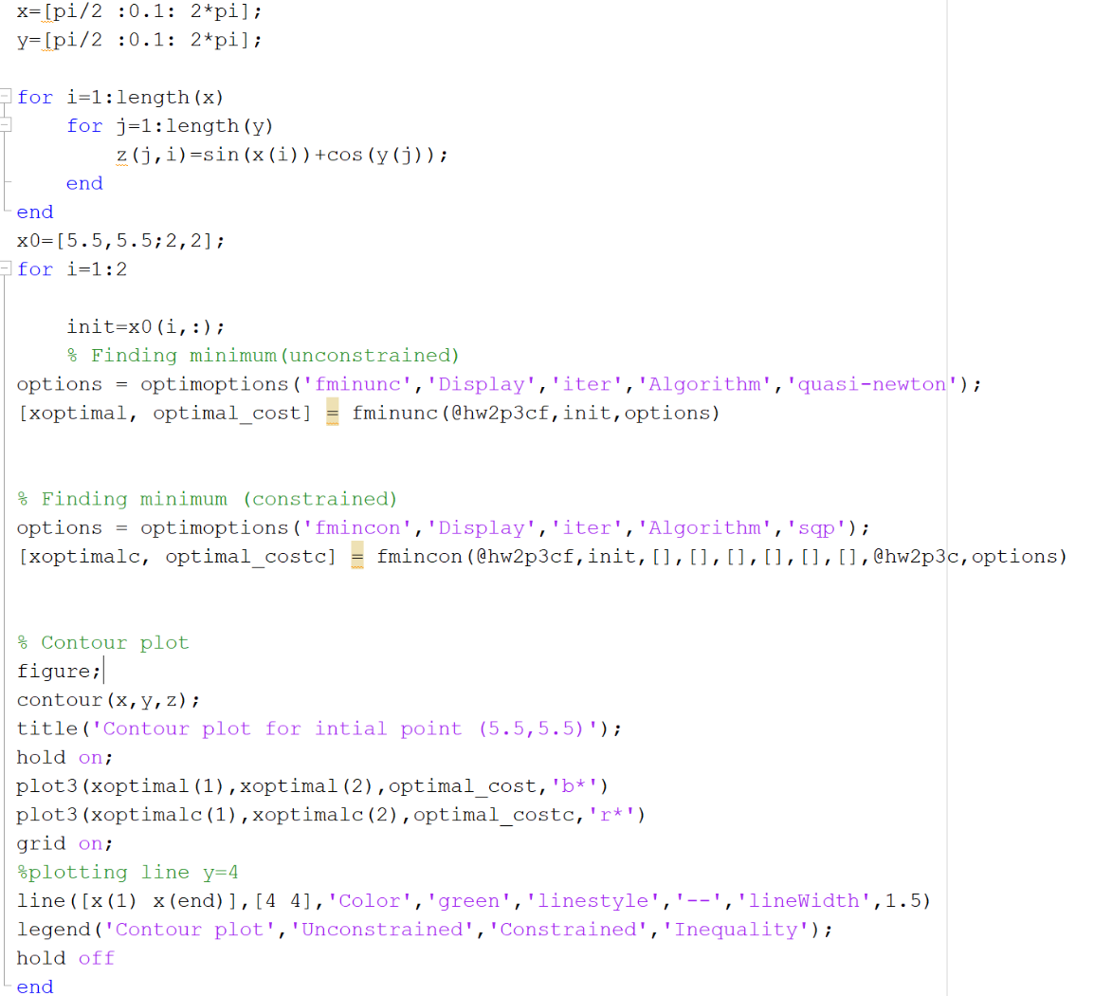

Results:

When x0=[5.5,5.5]

*The unconstrained minimum*

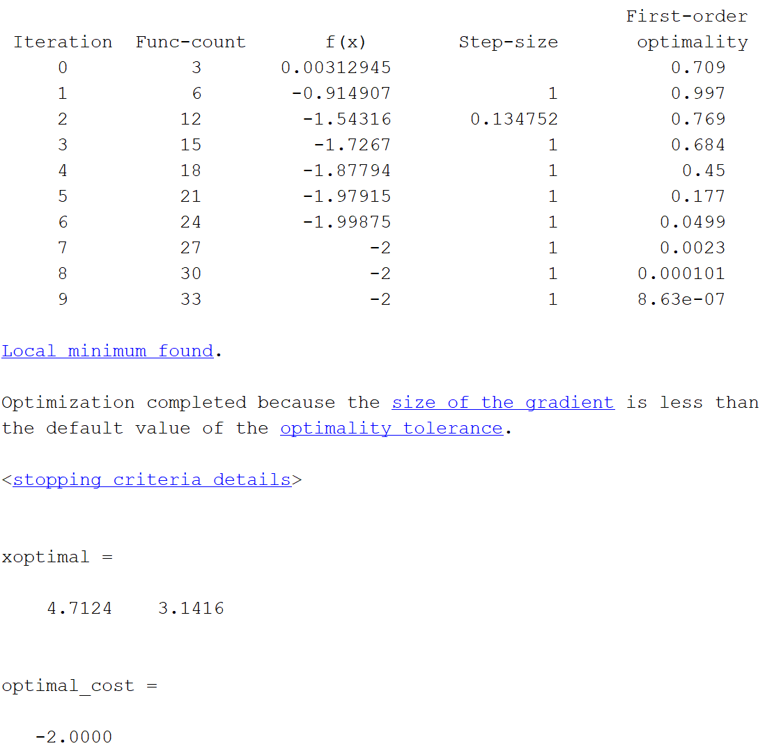

*The constrained minimum*

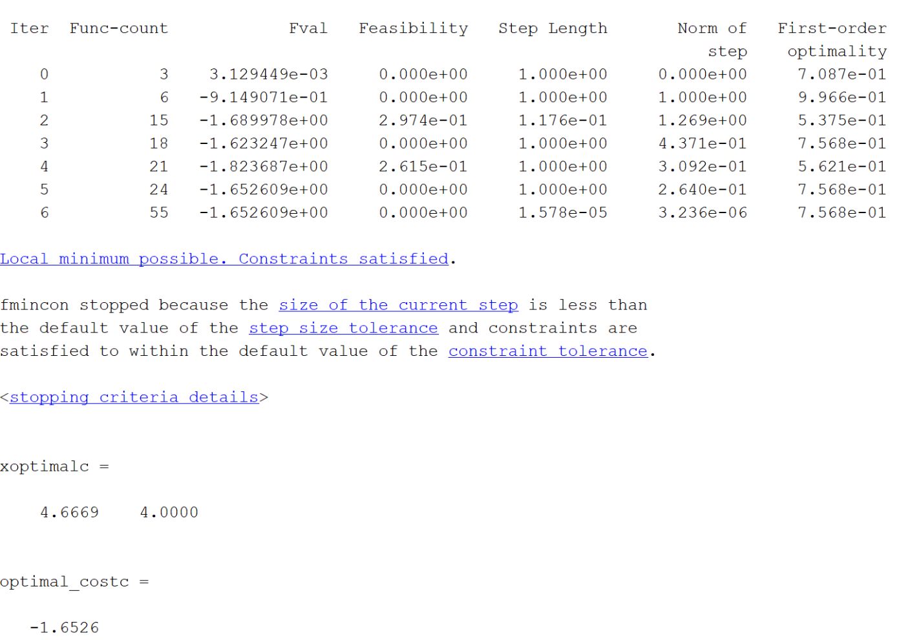

When x0=[2,2]

*The unconstrained minima*

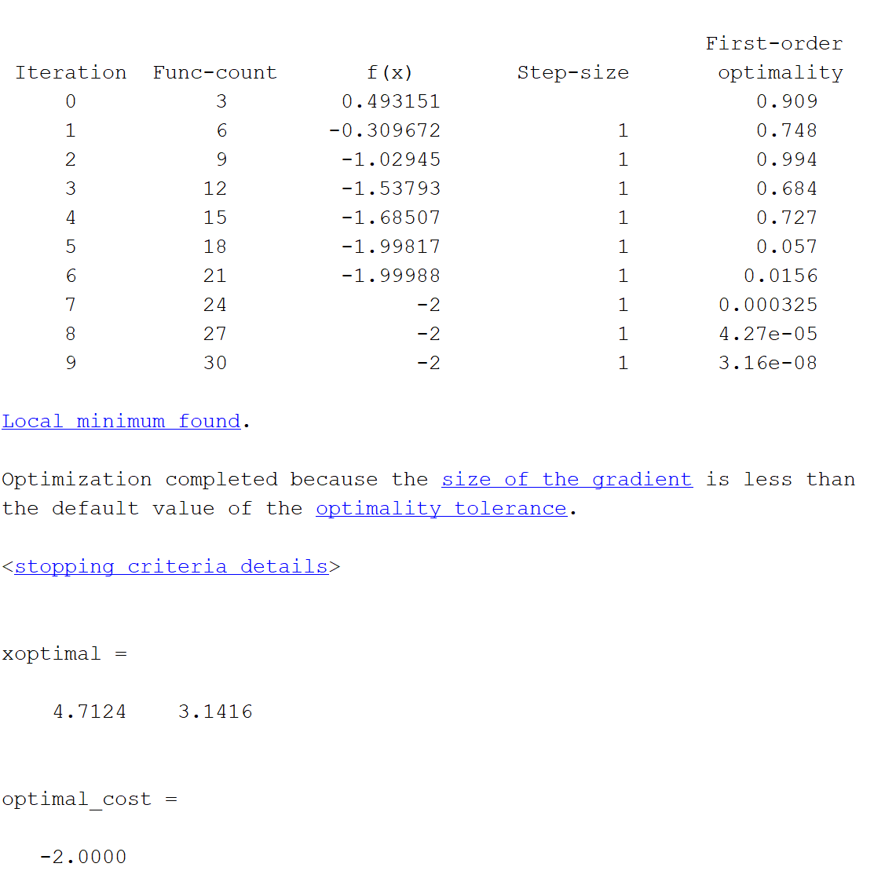

*The constrained minima*

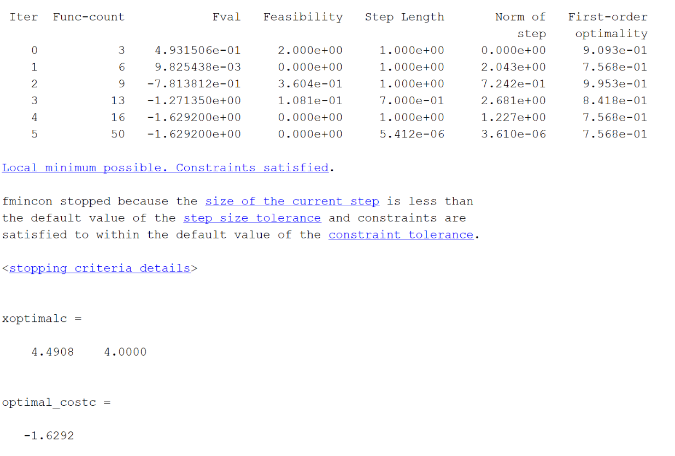

Contour Plot:

