Please Go through readme.md or github

1. Login Page

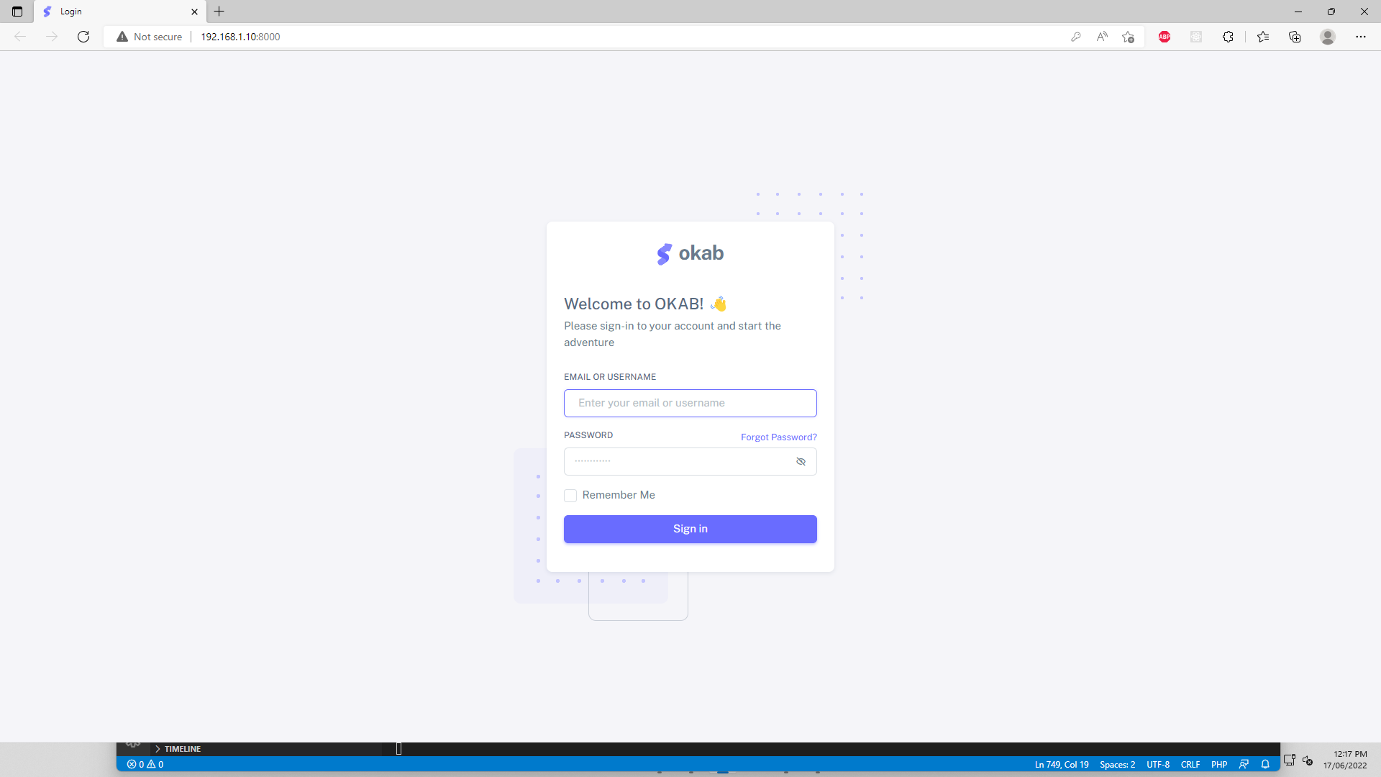

If DB migrated then you can login through

User Name: [admin@gmail.com](mailto:admin@gmail.com)

Password: password

And

User Name: [manager@gmail.com](mailto:manager@gmail.com)

Password: password

1. After Login

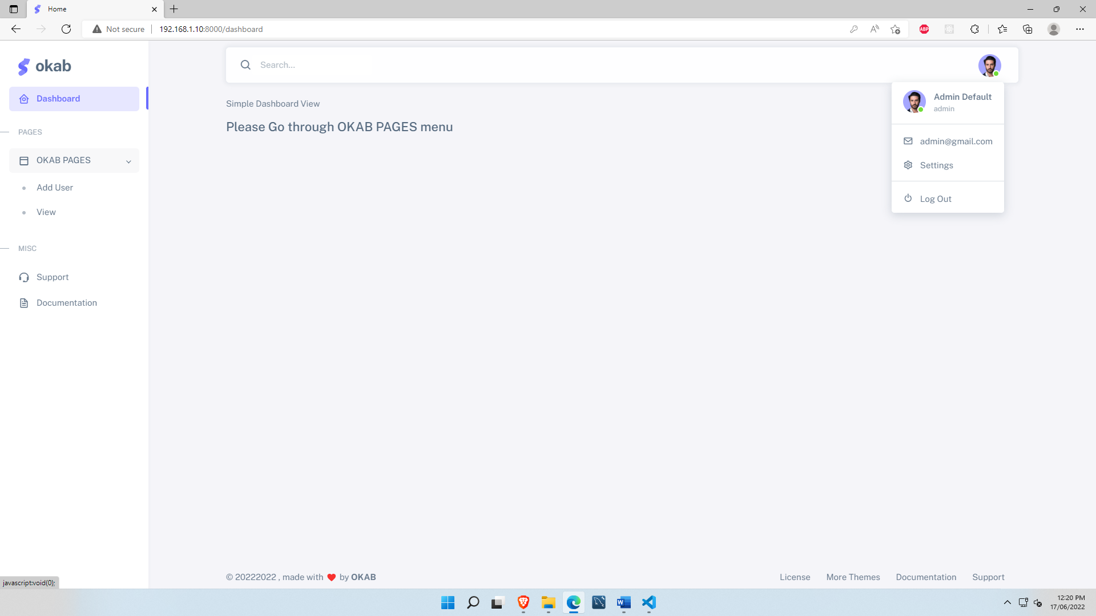

1. Add User Page

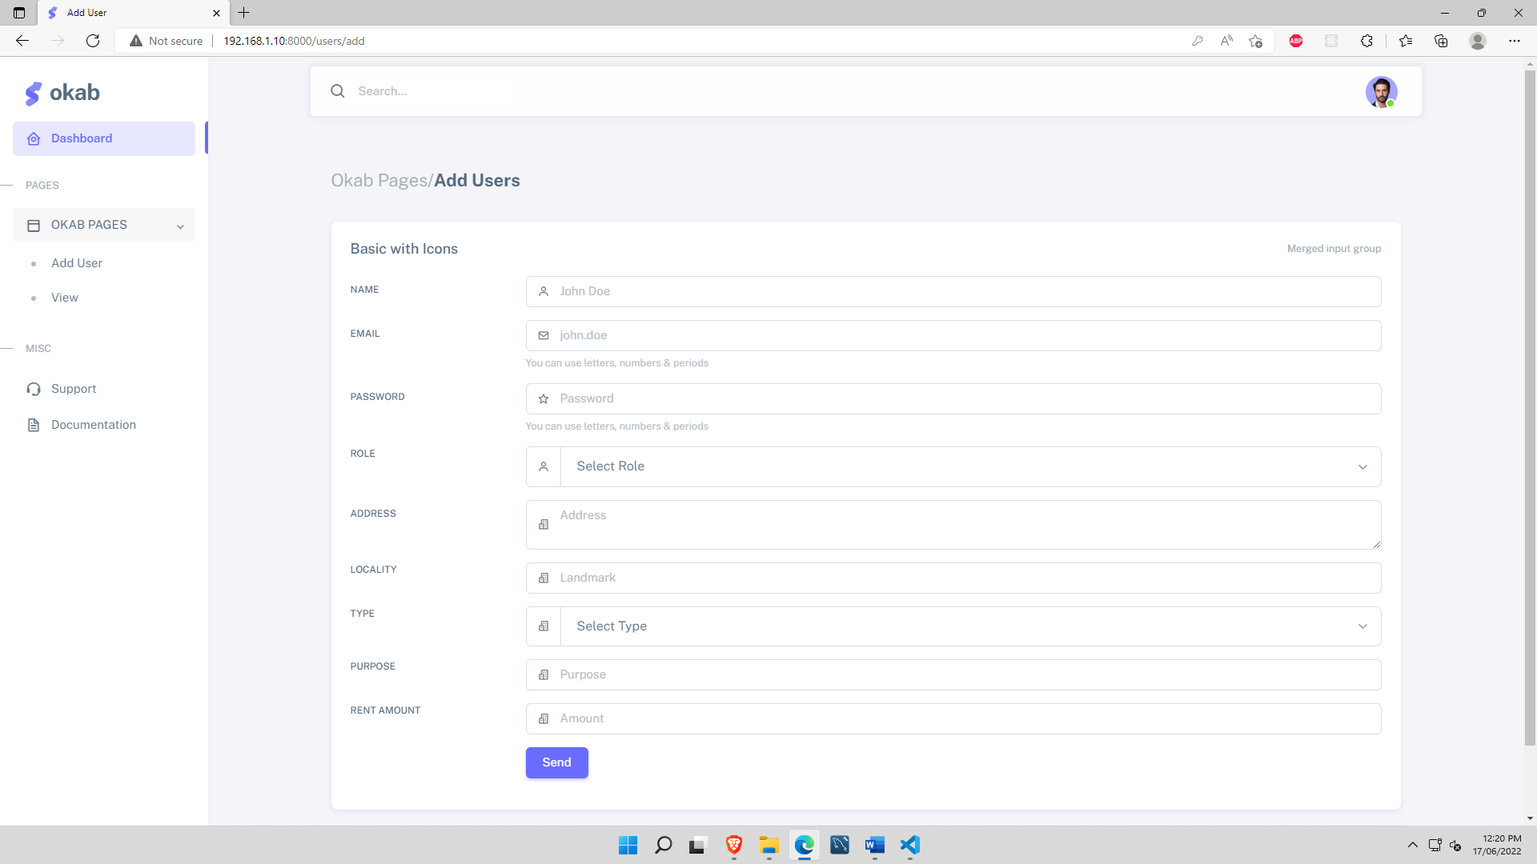

1. List View Page , With edit / Update action – based on logged in user role

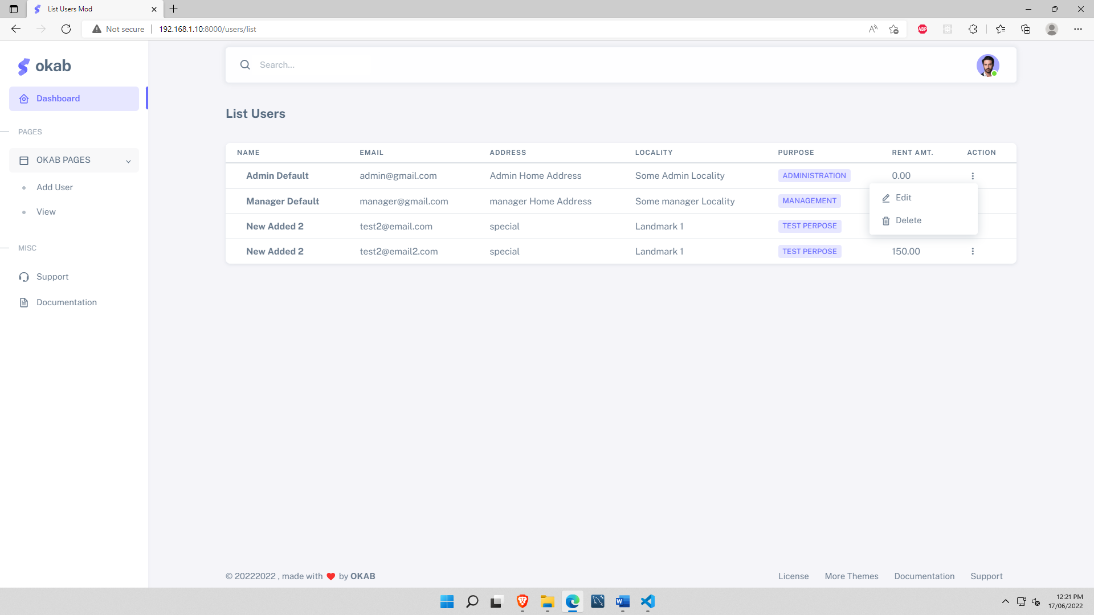

1. Search page Type in search box then Hit enter

