DESIGN AND IMPLEMENTATION OF A POUTRY MANAGEMENT SYSTEM

FATIMA HUSSAIN HUSSAIN

A PROJECT SUBMITTED TO THE DEPARTMENT OF COMPUTER SCIENCE, FEDERAL UNIVERSITY DUTSE IN PARTIAL FULFILMENT OF THE REQUIREMENTS FOR THE AWARD OF THE DEGREE OF BACHELOR OF SCIENCE (B.Sc. Hons.) IN COMPUTER SCIENCE.

DESIGN AND IMPLEMENTATION OF A POUTRY MANAGEMENT SYSTEM

FATIMA HUSSAIN HUSSAIN

A PROJECT SUBMITTED TO THE DEPARTMENT OF COMPUTER SCIENCE, FEDERAL UNIVERSITY DUTSE IN PARTIAL FULFILMENT OF THE REQUIREMENTS FOR THE AWARD OF THE DEGREE OF BACHELOR OF SCIENCE (B.Sc. Hons.) IN COMPUTER SCIENCE.

# CERTIFICATION

This project entitled “Design and implementation of a poultry management system” by Fatima Hussain Hussain with registration FSC/CSC/14/0024 meets the requirements governing the award of the degree of Bachelor of Science in Computer Science and is approved for its contribution to knowledge and literary representation

…………………………. ………………………….

Abdulazeez Yusuf Date

Supervisor

…………………………………….. ………………………….

Dr. Zaharadden Sufyan Date

Head of Department

…………………………………….. …………………………. (Name of the External Examiner) Date External Examiner

# DEDICATION

To my parents for their support, guidance and sacrifice

# ACKNOWLEDGEMENTS

First of all I would like to thank Allah the Almighty for having given me strength and enabled me to do research and write this research work in sound mind and good health

Secondly I thank my members for their endless love, care, prayers and encouragement with full of moral support.

Thirdly special thanks goes to my Project Supervisor Malam Abdulazeez Yusuf for his ideas, guidance and support with full of wide experience and endless dedication to see that I finish my BSc project.

I will finally like to thank all the lecturers, staffs and Students of department of computer science for the effort they made in my undergraduate study.

# TABLE OF CONTENT

Contents

CERTIFICATION iii

DEDICATION iv

ACKNOWLEDGEMENTS v

TABLE OF CONTENT vi

ABSTRACT vii

CHAPTER ONE 1

INTRODUCTION 1

1.1 Background of the Study 2

1.2 Statement of the Problem 2

1.3 Aim and Objectives of the Study 2

1.4 Scope of the Study 3

1.5 Significance of the Study 3

CHAPTER TWO 4

2.0 LITERATURE REVIEW 4

2.1 Birds Production 5

2.2 Constraints of Poultry Birds Production 5

2.2.1 Climatic Constraint 5

2.2.2 Economic Constraint 5

2.2.3 Technical Constraint 6

2.3 Birds Breeder Managements 6

2.3.1 Temperature Management 7

2.3.2 Ventilation Management 7

2.3.3 Poultry Information System 8

CHAPTER THREE 9

RESEARCH METHODOLOGY 9

3.0 Introduction 9

3.1 Software Development Life Cycle (SDLC) 9

SDLC stands for software development life cycle. A software development life cycle is essentially a series of steps or phases that provide a model for the development and life cycle management of an application or piece of software. The methodology within the SDLC process can vary across industries and organizations, but standards such as ISO/IEC 12207 represent processes that establish a life cycle for software and provide a mode for the development, acquisition, and configuration of software systems. 9

3.1.1 Chosen Methodology 9

The chosen methodology for development of this system is the Water-Fall . Model which is the oldest and the most widely used paradigm for software engineering. This model provides a systematic and sequential approach to software development. It is very useful where the requirements are well understood. This model is chosen because of the reasons stated below: 9

3.1.1.1 Requirement analysis and specification phase 10

3.2 Tools used for the system development 14

3.3 Justification for the tools used 15

3.4 ANALYSIS OF THE EXISTING SYSTEM. 16

3.5 PROBLEMS OF THE EXISTING SYSTEM. 16

3.6 JUSTIFICATION OF THE NEW SYSTEM 17

CHAPTER FOUR 18

RESULTS AND DISCUSSION 18

4.0 INTRODUCTION 18

4.1 Features of the system 18

4.1.1 Home Page 18

4.1.2 Login page 20

4.1.3 Users 20

4.1.4: Birds Types 21

4.1.5 Birds 22

4.1.6 Casualties 22

4..1.7 Doctor Visits 23

4.1.8: Employees 24

4.1.9: Feed 24

4.1.9: Medical Report 25

4.1.10: Purchase 26

4.2 Limitations of the system 27

CHAPTER FIVE 28

SUMMARY CONCLUSION AND RECOMMENDATION 28

5.1 Introduction 28

5.2 Summary 28

5.3 Conclusion 28

5.4 Recommendation 28

REFERNCES 31

# ABSTRACT

*The need for use and benefits of information for farm decision making has drawn the attention of farmers, researchers and policymakers over the years. Information is data that has been transformed into a form that is meaningful and useful for decision-making with data distinguished as raw facts,* ***Farmers use to keep records of their poultry using the traditional manual system of book keeping, which is time consuming and error prone. The document also lacks consistency and may be damaged or loss.*** *This project is concerned with computerizing a poultry farm but the focus is in general stock keeping and other activities that will be done easily and effectively by computers. It is worthy to note that a poultry farmer who engages a large scale production encounters a lot of problems; this problem may include stock keeping proper account of their daily activities and also keeping tracks on feeding the birds. This project will see the design of a system using a water fall model of software development that will serve as a guide to poultry farmers on how to keep proper stocks and the system of feeding their birds to avoid stunted growth.*

# ****CHAPTER ONE****

# ****INTRODUCTION****

A poultry management information system is a system that can be used to record needed or relevant information pertaining a poultry farm. The system is needed because of the importance associated with adequately monitoring the activities in a poultry farm.

Poultry production is a very important source of livelihoods for most rural communities because it provides ready cash for emergency needs, supplies the fast-growing human population with high quality protein, contributes significantly to food security, poverty alleviation and ecologically sounds management of natural resources. Since there is a continuing rise in the cost of production of cattle, sheep and goat meat, consumer preferences have shifted now for poultry meat (white meat) given the ecological, economic, social and health advantages it has over the other types of meat (red meat) (Adedeji *et al.,* (2014). The poultry is the most commercialized (capitalized) of all the Nigerian livestock agriculture. The types of poultry that are commonly reared in Nigeria are chickens, ducks, guinea fowls, turkeys, pigeons and more recently ostriches. Those that are of commercial or economic importance are chicken, guinea fowls and turkeys Atteh (2011). Poultry production in the past was not counted as an important occupation. Poultry management system in Nigeria is of three types which are intensive, extensive and semi-intensive, they are differentiated on the basis of their flock size and input and output relationship. Flock size in intensive production are in thousands, whereas semi-intensive production system flock size range from 50-200 birds and keeping of big flock size in as a result of research development in artificial incubation, nutritional requirement and disease control. Poultry birds mature earlier than most breeds of livestock, they bring economic return within relatively short periods of about 10-12 weeks, poultry eggs and meat play a very important role in bridging the protein gap in Nigeria and they are generally accepted (Weaver, 2010)

This projects is concerned with computerizing a poultry farm but the focus is in general stock keeping and other activities that will be done easily and effectively by computers. It is worthy to note that a poultry farmer who engages a large scale production encounters a lot of problems, these problem may include stock keeping proper account of their daily activities and also keeping tracks on feeding the birds.

This project will see the design of a system that will take care of the above mentioned problems. Above all, it will serve as a guide to poultry farmers on how to keep proper stocks and the system of feeding their birds to avoid stunted growth.

# ****1.1 Background of the Study****

**Farmers use to keep records of their poultry using the traditional manual system. which is time consuming and error prone. The document also lacks consistency and may be damaged or losed.**

The need for, use and benefits of information for farm decision making has engaged the attention of farmers, researchers and policymakers over the years. Information is data that has been transformed into a form that is meaningful and useful for decision-making with data distinguished as raw facts, figures, objects et cetera. The ‘system’ about information relates to the connection or integration of components of collection, processing, storage, and distribution of information to support decision-making (Laudon & Laudon 2012). By extension of this non-farm definition, farm information systems (FIS), then, can be appreciated as a tool to assist farms in forward planning, risk management, and by the use of information. Poultry production enterprises require good information systems to ensure success.

# ****1.2 Statement of the Problem****

Many poultry farmers still make use of the manual approach of keeping farm records. The consequence of this approach is it is time consuming, needed information may easily be misplaced, un-organized and inefficient. Also, needed reports concerning different aspects of the farm cannot be easily retrieved when needed. This situation makes it difficult to monitor the state of the birds in the poultry and other relevant information. To overcome these problems there is need for an information system for proper management of the poultry farm.

# ****1.3 Aim and Objectives of the Study****

The aim of the study is to develop poultry information management system.

The following are the objectives of the study:

* To automate the manual means of recording poultry farm records
* To develop a database application that can be used to maintain and provide information about the livestock.
* To provide a system that can facilitate the update of poultry farm records
* To develop a system that will aid the presentation of reports pertaining the poultry farm

# ****1.4 Scope of the Study****

This research work covers Design and Implementation of a poultry information management system. It is restricted to recording information concerning the birds (feeding and medication). And also sales and purchase

# ****1.5 Significance of the Study****

The significance of the study is that it will provide useful information and means to enable the management of the poultry farm, automate their record keeping process for better updating and presentation of reports. It will also serve as a useful reference material to other researchers that need related information.

# ****CHAPTER TWO****

# LITERATURE REVIEW

The magical impact of computer has made enormous contribution to all aspects of the society; people can now do things easily unlike in the past. Computers have lessen human activities (effort) in their day to day life, by reducing both human labor and time in solving their problem which are both numerous / unlimited. The introduction of the magical machine has led to the further growth of Agricultural products. The technological knowhow and scientific research reveals that a lot of work can be carried out by the computer in agriculture and help in the growth. It therefore deems imperative that computers should also be employed and utilized in farms. This project centers how computer systems can be useful in a large scale poultry farm, keeping of general stock of the birds, weight of individual birds and finally the accountability of the farm. Computerized system has been designed to take care of all the mentioned activities in a modern poultry farm. The activities will be carried out solely by the computer and any odd actions taken should be notified by the computer.

Nigeria has the highest number of poultry farms in Africa, despite the great numbers of farms in Nigeria, a parallel record from Poultry Association of Nigeria (PAN) indicates that Nigeria produces presently above 553million tons of egg and 708million tons of birds meat per year, despite this volume Nigeria is far from meeting her domestic demands in birds production (FAO, 2010).

Many poultry farmers still make use of the manual approach of keeping farm records. The consequences of this approach are, it is time consuming, needed information may easily be misplaced, un-organized and inefficient. Also needed report concerning different aspects of the farm cannot be easily retrieved when needed. this situation makes it to monitor the state of the birds in the poultry and other relevant information. To overcome these problems there is need for an information system for proper management of the poultry farm.

This project is concerned with computerizing a poultry farm but the focus is in general stock keeping and other activities that will be done easily and effectively by computers. It is worthy to note that a poultry farmer who engages a large scale production encounters a lot of problems, these problems may include stock keeping proper account of their daily activities and also keeping tracks on feeding the birds.

# 2.1 Birds Production

The world poultry industry has been a very dynamic industry because of the nature of birds birds. Atteh (2011) stated that birdsbirds has been typified with unprecedented growth, in his research he further explained the trends of growth in birds production in the world. He depicts that world produced 6.5 billion in 1961,in 1990 over 27 billion,35.3 billion in 1999 while over 60 billion in 2012.FAO, (2010) reported that birds production in the world has been growing faster than any other meat production in the world, especially in the developed countries that are active players in birds production. Since the 1960s, the global production of birds meat has been on

# 2.2 Constraints of Poultry Birds Production

# 2.2.1 Climatic Constraint

FAO(2012) reported that one of the factors that inhibit birds production development in Nigeria is the climate. Some of the bird’s breeds are imported into the country from temperate region, most of these birds performed below optimal level due to differences in climatic conditions.

Climate exerts constraining influences on livestock production through its associative effects of humidity, temperature, precipitation and air movement, and its indirect influences Although, all livestock are subject to environmental stress in the tropics, poultry appear to be less susceptible than mammals. Previous comparative records between the temperate and tropical environments indicated that poultry show the most comparative performance between the two environments than any other class of livestock, yet their performance not up to standard as a result of climatic influence,(FAO,2012).

# 2.2.2 Economic Constraint

According to Bell and Weaver (2010) the most important socio-economic constraints affecting birds production in Nigeria include inadequate of capital, illiteracy and lack of technical experience. The amount of capital in birds production is to some extent, a major determinant of the size of the operating units because birds farmers with enough working capital are usually better in employing other factors of production, hence enlarging their holding than relatively poor farmers. However, most birds farmers in Nigeria do not have adequate capital to invest in large scale production (FAO, 2014). The scarcity of farm credit has been blamed in part for the low agricultural production in the country. Even with the establishment of more agricultural and commercial banks in the country, most of the birds farmers are still handicapped in obtaining adequate credits not only from lack of acceptable collateral and the general uncertainty and heavy risks associated with birds production.

# 2.2.3 Technical Constraint

According to Bell and Weaver( 2010) the capacity to developed technical technology consistent with environmental and economic conditions, is the single most important which explained the growth of birds production in Nigeria. He stressed further that a continuous stream of new technical knowledge and a flow of inputs in which the new knowledge is embodied represents a necessary condition for modern birds production .A further breakdown in his study identified other constraints that affect birds production, these include inadequate of capital, poor management, inadequate of technical knowhow and poor diseases control

The continual challenges to the bird’s breeder producer are provision of highest quality products for sale at a price competitive with other food sources. Over the past two decades the industry has become very successful by incorporating technical advances in genetic selection, nutrition and diseases control into their management scheme. Another critical factors for efficient management of reproduction of birds, birds has not been changed since the inception of the industry, recent advances in artificial insemination technique now provide alternative methods for use within the primary breeder segment of the industry.

# 2.3 Birds Breeder Managements

The aim of management information system for the poultry farm is to provide the conditions that ensure optimum performance of the birds (Bell and Weaver, 2010).Given reasonable conditions, broody hens are very successful at hatching their chicks, but good hatching using artificial incubation (both large and small) relies on good management with respect to temperature, humidity, ventilation, feeding and vaccination. It is necessary to ensure that appropriate brooding, growing and laying conditions are given. It is also important to ensure that recommended vaccinations are given and appropriate feeding programmed are used. In developing countries like Nigeria it is often difficult to achieve optimum performance from birds owing to less than optimal housing conditions and lack of quality feed, vaccines and trained staff (Weaver, 2010). High genetic hybrid is often used in the developing countries, but is not well suited to tropical environments. Diseases transmission in poultry birds could either be horizontally from sick bird to healthy one or vertically by passing the causative pathogen from the hen to the chicks through the eggs. Horizontal spread may be by contact between birds, air, contaminated litter, feed or water in contact with sick birds (Atteh, 2011). Most of the important poultry diseases include Coccidiosis, Fowl Pox, Newcastle Diseases, Infectious Bronchitis, Infection Bursa Diseases, Fowl pox, Salmonella Infections and Marek's Diseases etc. To avoid diseases outbreak in bird’s production proper management, sanitation as well as essential vaccination schedule should be complied with (Hogue and Morris, 2013).

# 2.3.1 Temperature Management

Farmers need to compensate for undesirable climatic conditions by manipulating control systems or modifying the house to ensure that the welfare and environmental needs of the birds are satisfied. Environmental extremes (heat and cold stress, excessive or inadequate ventilation, poor air quality) can be managed if the design of the poultry house is appropriate for conditions. Birds require adequate space, sufficient feed to meet their nutritional requirements. The heat requirements of birds change with age, and recommended ambient temperatures may be lower than birds would prefer early in life when stocking densities are low. The risk of cold stress is low once the thermoregulatory ability is fully developed in birds. The risk of heat stress increases with age and with stocking density as heat production increases and as space between birds (and hence their ability to lose heat) decreases, (Hogue and Morris, 2013).

# 2.3.2 Ventilation Management

All birds houses need some form of ventilation to ensure an adequate supply of oxygen, removing carbon dioxide, other waste gases and dust. In commercial operations, minimum ventilation is often practiced in colder climates, but not generally in tropical ones (Atteh, 2004).In large scale automated operations, correct air distribution can be achieved using a negative pressure ventilation system. Due to the nature of birds adequate ventilation is very crucial to them, when chicks are very young or in cooler climate the air from the inlets should be directed towards the roof to mixed with the warm air there and circulate throughout the shed. With older birds and in warmer temperatures, the incoming air are directed towards the birds and helps to keep them cool (Atteh, 2011). Tunnel ventilation is the most effective ventilation for large houses in hot weather, this system is popular in hot climates, exhaust fans are placed at one end of the or the middle of the shed and air is drawn through the length of the house removing heat moisture and dust.

# 2.3.3 Poultry Information System

Poultry farm information systems (PIS), then, can be appreciated as a tool to assist farms in forward planning, risk management, and by the use of information. Poultry production enterprises require good information systems to ensure success. The need for, use and benefits of information for farm decision making has engaged the attention of farmers, researchers and policymakers over the years.

# CHAPTER THREE

# RESEARCH METHODOLOGY

# 3.0 Introduction

This chapter shows how the research methods used in carrying out the research in line with the research procedure. The aim is find out the appropriate design for poultry management system. And establish what methods employers, recruiters and organizations use during verification of certificates

The information obtained from the review was used to influence in the development of the system for certificate verification.

# 3.1 Software Development Life Cycle (SDLC)

## SDLC stands for software development life cycle. A software development life cycle is essentially a series of steps or phases that provide a model for the development and life cycle management of an application or piece of software. The methodology within the SDLC process can vary across industries and organizations, but standards such as ISO/IEC 12207 represent processes that establish a life cycle for software and provide a mode for the development, acquisition, and configuration of software systems.

# 3.1.1 Chosen Methodology

## The chosen methodology for development of this system is the Water-Fall . Model which is the oldest and the most widely used paradigm for software engineering. This model provides a systematic and sequential approach to software development. It is very useful where the requirements are well understood. This model is chosen because of the reasons stated below:

* easy to explain to the users
* Structured approach.
* Stages and activities are well defined.
* Helps to plan and schedule the project.
* Verification at each stage ensures early detection of errors/misunderstanding.

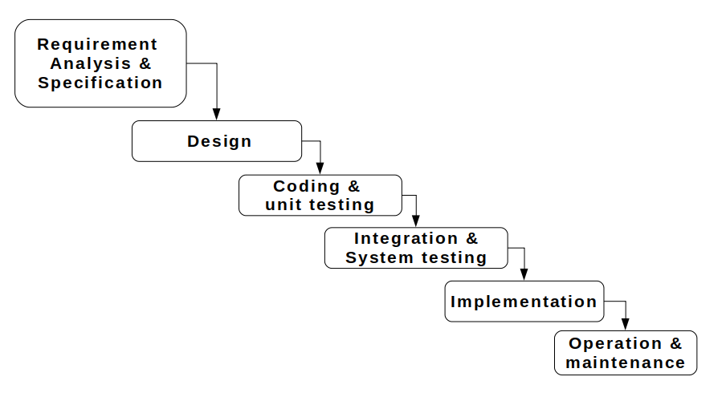**Figure 3.1**: waterfall model

# 3.1.1.1 Requirement analysis and specification phase

The goal of this phase is to understand the exact requirements of a proposed system and to document them properly. This activity is usually executed together with the client, as the goal is to document all functions, performance and interfacing requirements for the software. The requirements describe the “what” of a system not the “how”. This phase produces a large document, written in natural language, contains a description of what the system will do without describing how it will be done. The resultant document is known as software requirement specification (SRS) document.

**Method of Data Collection**

During this project research work, data needed for the project was gathered from the various sources. In gathering and collecting necessary data and information needed for the successful completion of this project, two major fact-finding techniques were used in this work and they are:

**Primary source**

This refers to empirical approach; the form of collecting data was made in form of interviews conducted in ECWA farms, and Alheri Polutry. ECWA and Alheri farms undergoes a manual system of record management in the farm whereby all the activities of the farm are recorded in paper.

**Secondary Source**

The secondary data were obtained through reviews from journals and the internet.

1. **Design phase:** when the SRS document is produced in the previous phase, which contains the exact requirements of the proposed system. The goal of this phase is to transform the requirements specification into a structure that is suitable for implementation in some programming language. Here, overall software architecture is defined, and the high level and detailed design work is performed. This work is documented and known as software design description (SDD) document. The information contained in the SDD should be sufficient to begin the coding phase. Several tools and techniques were used for designing. The tools and techniques includes: Flowchart and Use Case Diagram etc.

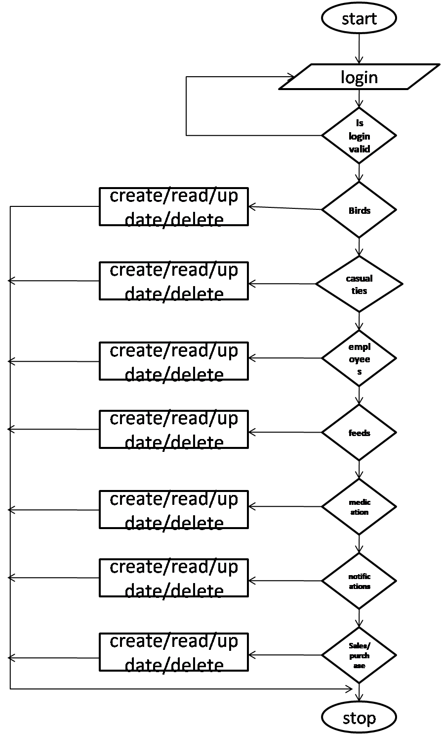

**Figure 3.2:** Flow chart of the system

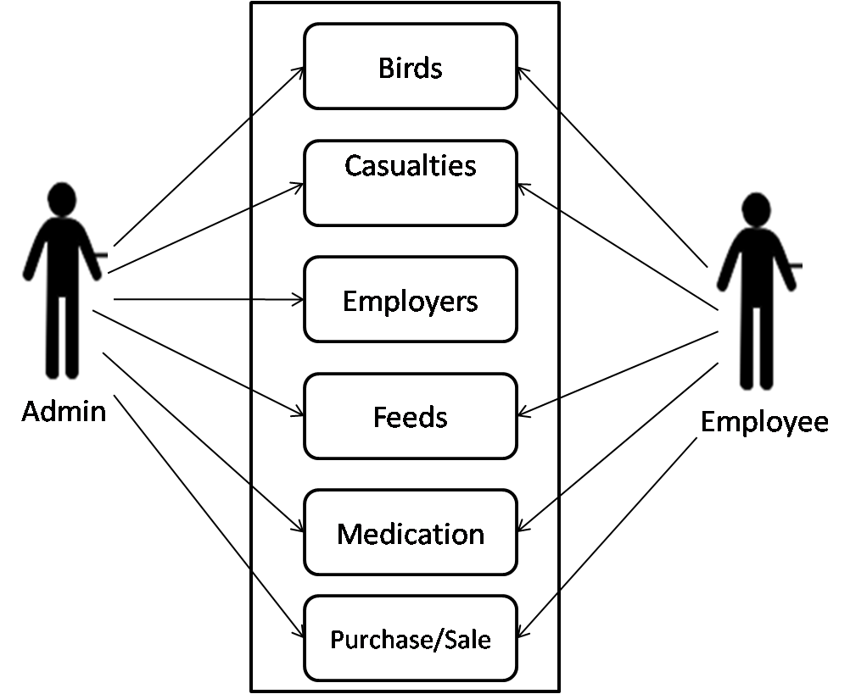

**Figure 3.3:** Use Case Diagram of the System

1. **Coding and Unit testing:** During this phase coding proceeds smoothly because all the information needed by the software development is contained in the SDD. The main purpose of this phase of waterfall model is to translate the software design into source code. The end product of this phase is a set of program modules.
2. **Integration and system testing:** This is very important phase. Effective testing will contribute to the delivery of higher quality software products, more satisfied users, lower maintenance costs and more accurate and reliable results. During this phase individual program units or programs are integrated and tested as a complete system to ensure that software requirements have been met. After system testing, the software is delivered to the customer.
3. **Implementation:** This is the process in which the developed system is handed over to the client.
4. **Operation and maintenance:** Software maintenance is a task that every development group has to face, when the software is delivered, installed and is made operational. Therefore, release of software inaugurates the operation and maintenance phase of the life cycle. The time spent and effort required keeping the software operational after release is very significant. Despite the fact that it is a very important and challenging phase.

# 3.2 Tools used for the system development

**Python:** is an interpreter, high-level, general-purpose programming language. Created by Guido van Rossum and first released in 1991

**PostgreSQL:** also known as Postgres, is a free and open-source relational database management system (RDBMS) emphasizing extensibility and technical standards compliance. It is designed to handle a range of workloads, from single machines to data warehouses or Web services with many concurrent users.

**Django:** is a high-level Python Web framework that encourages rapid development and clean, pragmatic design.

**ORM:** Object-Relational Mapping is a technique that lets you query and manipulate data from a database using an object-oriented paradigm

**HTML:** is the standard markup language for creating Web pages. HTMLstands for Hyper Text Markup Language. HTMLdescribes the structure of a Web page.

**CSS:** stands for Cascading Style Sheet. Is a style sheet language that describes the presentation of an HTML document. CSS describes how elements must be rendered on screen, on paper, or in other media.

**JavaScript: JavaScript is the programming language of HTML and the Web it** is a lightweight interpreted or just-in-time compiled programming language with first-class functions

**Bootstrap:** it is a free and open-source HTML and CSS framework directed at responsive, mobile-first front-end web development. It contains HTML and CSS based design templates for typography, forms, buttons, navigation and other interface components

**Heroku**: is a container-based cloud Platform as a Service (PaaS). Developers use Heroku to deploy, manage, and scale modern apps

# 3.3 Justification for the tools used

The system as a whole is composed of three (3) parts – the user interface, the application and the database. All of which are integrated and worked together to achieve the specified goal. The hosting platform chosen is Heroku for deploying the system.

The user interface is what the user sees and interacts with the system. The tools used in this part are HTML, CSS, JavaScript and Bootstrap. HTML is used in creating the web pages and the components. CSS is used in styling and positioning the components, and JavaScript is used in handling actions and interactions. Bootstrap is a user interface framework that comprises of HTML, CSS and Bootstrap there by making it simpler in designing the user interface. The tools chosen are the only and best for designing the user interface.

The application is the part that takes the action of all the system operations between the user interface and the database. Therefore it sits in between the two and acts like a middle-man in query the database and sending the response to the user interface. Django is the framework that is chosen for this part, which is based on the python programming language. Python is a high level programming language that is known for its general-purpose use. Django as a framework is known for its security and scalability.

PostgreSQL is a very powerful database system that is based on relational database systems. Relational database systems are the best kinds of system used for handling multiple records in a database. PostgreSQL is also known for its security and the ability to accommodate large records.

For a system to be online and accessible on the World Wide Web, it has to first be deployed. Considerations of the ease of use and cost of deployment make Heroku to be chosen.

# 3.4 Analysis Of The Existing System.

the existing system that has been used or in operation in the farm is a manual system, a lots of records have been missing, some intentionally damage and others are damage due to improper information management system. A lot of challenges are been face by the management in keeping proper records of the farm.

The need arise of a computerized management information system that will help keep and provide proper records of all the birds, feeds, eggs, staff and track all records of sales in the farm. Management information system remains the system that aim at providing information for the management on a regular basis.

Management always aim at reading the climax in the decision performance fort attainment of organizational objectives but the existing system could not attract such performance due to the lack of effective information tool which can provide the management with quality and needed information and at needed time.

This system always results to information over local which actually decreases the decision performance in any management.

# 3.5 Problems Of The Existing System.

They say information is power. Quality information is very vital do check in organization. Many poultry farmers still make use of the manual approach of keeping farm records. The consequence of this approach is it is time consuming, needed information may easily be misplaced, un-organized and inefficient. Also, needed reports concerning different aspects of the farm cannot be easily retrieved when needed.

This situation makes it to monitor the state of the birds in the poultry, income and expenses and other relevant information. To overcome these problems there is need for an information system for proper management of the poultry farm.

the only information that can accelerate the management decision performance is the information that process the good quality of information. the problems of the existing system are

1. Accuracy
2. Reliability
3. Relevance
4. Completeness
5. Timeliness

Due to the show mentioned problems and errors associated with the existing system, an alternative system is suggested which is a computerized system.

# 3.6 Justification Of The New System

1. To automate the manual means of recording poultry farm records.
2. To develop a database application that can be used to maintain and provide information about the livestock and financial information aspect of the poultry farm
3. To provide a system that can facilitate the update of poultry farm records
4. To develop a system that will aid the presentation of reports pertaining the poultry farm
5. To facilitate in fast decision making in the farm.

# CHAPTER FOUR

# RESULTS AND DISCUSSION

# 4.0 Introduction

Software documentation is a written text that accompanies computer software. It explains how the software operates and how to use the system. Types of documentation include:

**User** documentation, it is intended to help the users of the system, it explains how to start / stop the system, how to use the features of the system. The users are usually **non-technical** people such as students and supervisors, who don't need to know how the system works. They just need to know **how to use it**.

The technical documentation is intended to help the **maintainers** of the system (the people who need to keep the system running smoothly, fix problems, etc.). The maintainers are usually **technical** people, who need to know exactly **how the system works**. In this system, they are the project coordinators.

# 4.1 Features of the system

# 4.1.1 Home Page

This page is the first page of the system consisting of the title of the software. The specific aims of the page are to:

1. Introduce user to the software.
2. To signify the start of the system.

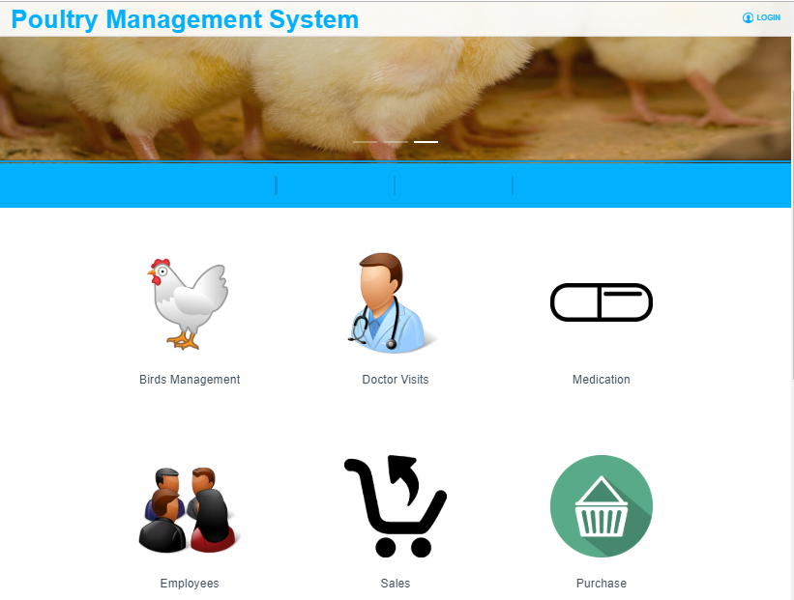

Figure 4.1: Home page

# 4.1.2 Login page

The login provides a mechanism for authenticating the user in the system, user has to login with his username and password before gaining access to the system

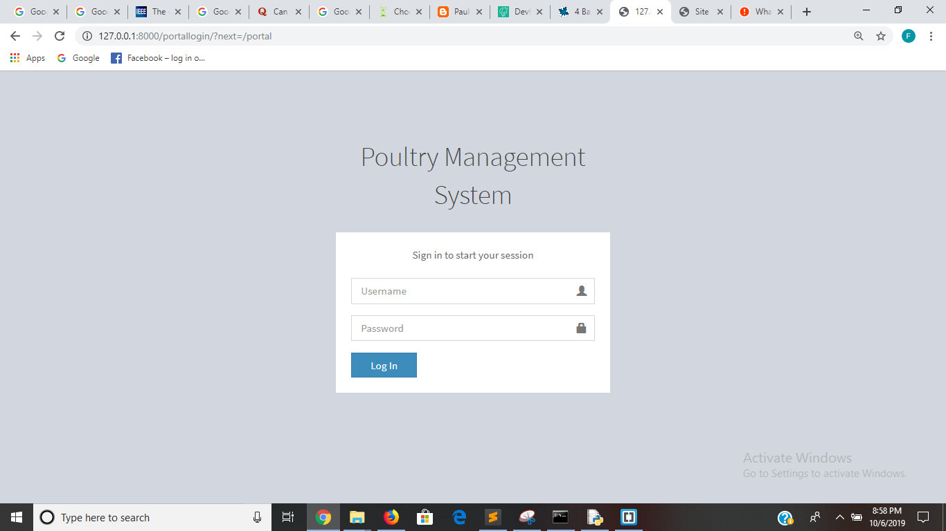

Figure 4.2: Login page

# 4.1.3 Users

The system has an administrator that has the all the controls of the system. The administrator can add other users and set their roles and permissions for read and write the system.

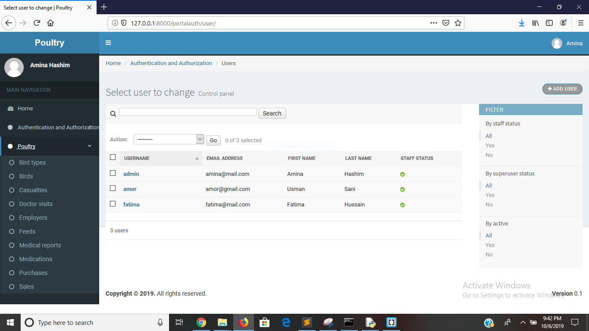

Figure 4.3: users of the system

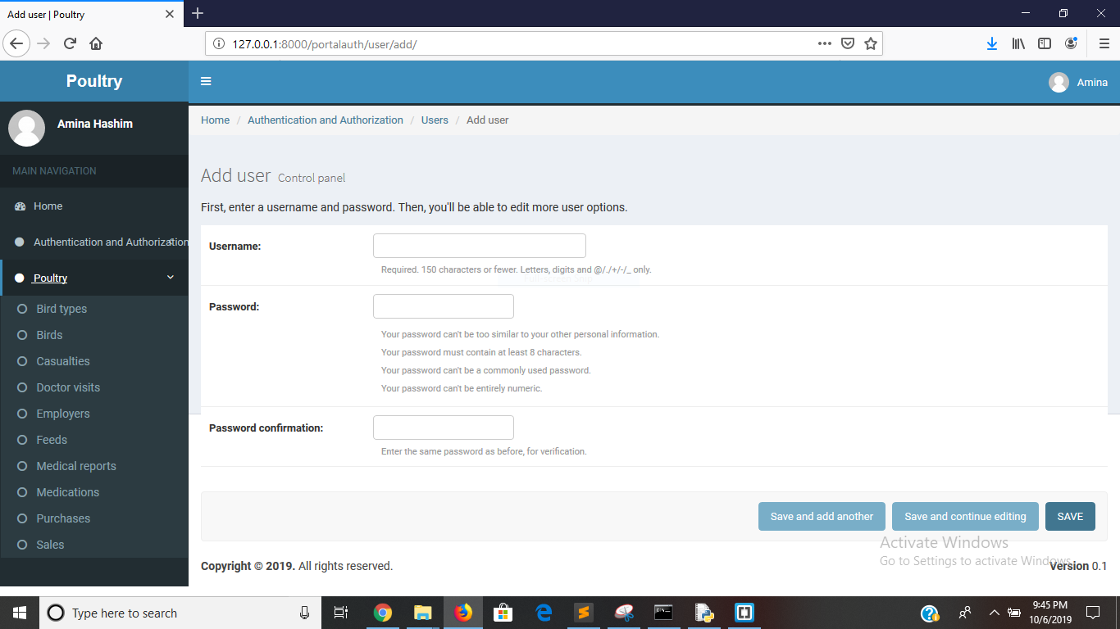

Figure 4.4: user add form

# 4.1.4: Birds Types

This module enables the management of the different categories of the birds in the system.

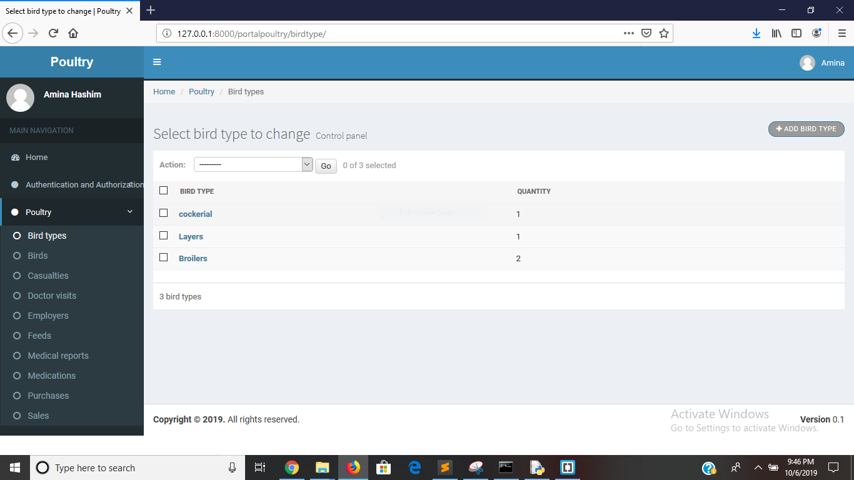

Figure 4.5: Bird Types

# 4.1.5 Birds

This module enables the management of the different birds in the system.

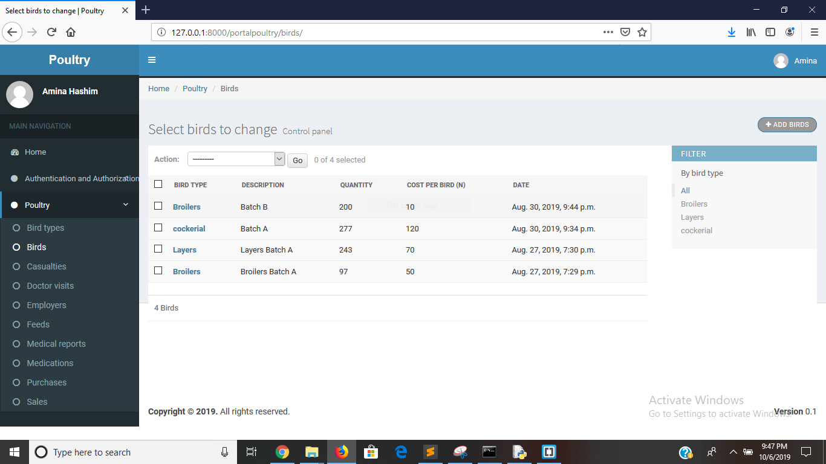

Figure 4.6: Birds in the system

# 4.1.6 Casualties

This module enables the management of the casualties that affects the birds, which may be death or damage

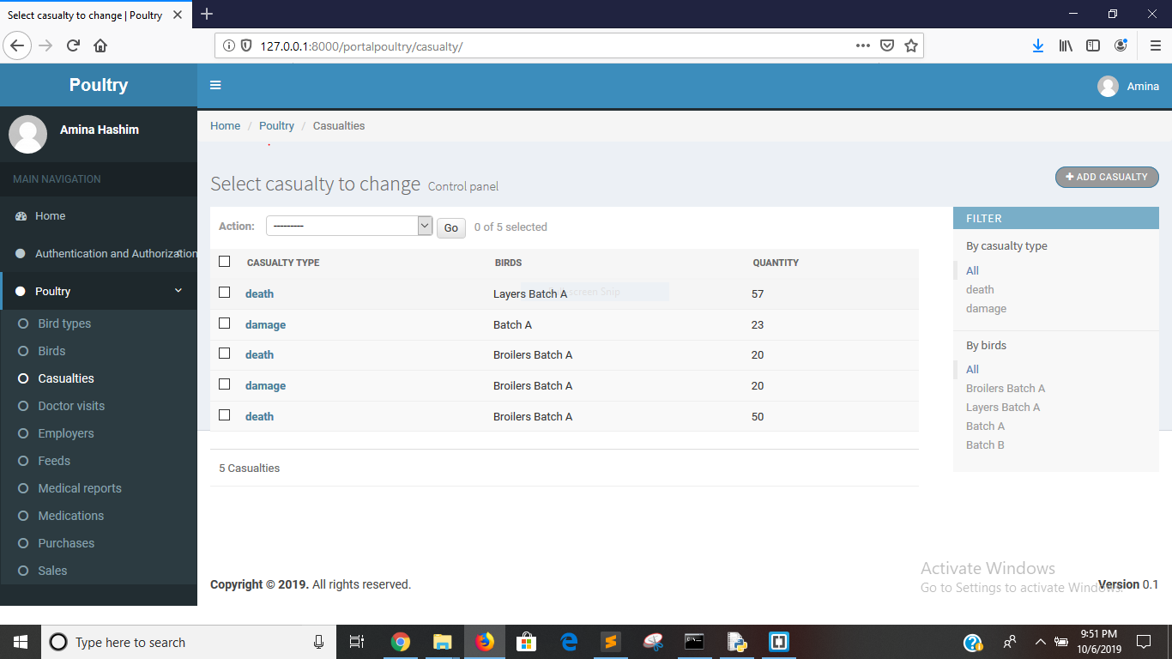

Figure 4.7: casualties

# 4..1.7 Doctor Visits

This module enables the management of the doctor visits to the poultry

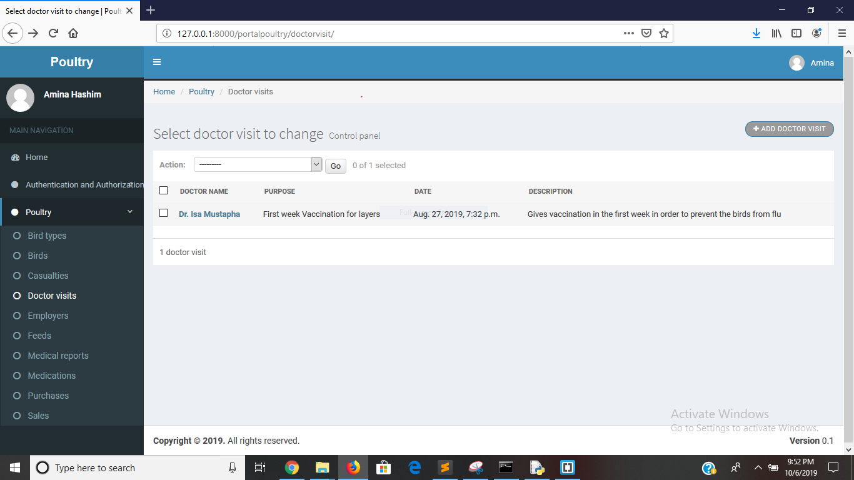

Figure 4.8: doctor visits

# 4.1.8: Employees

This module enables the management of the employees of the poultry

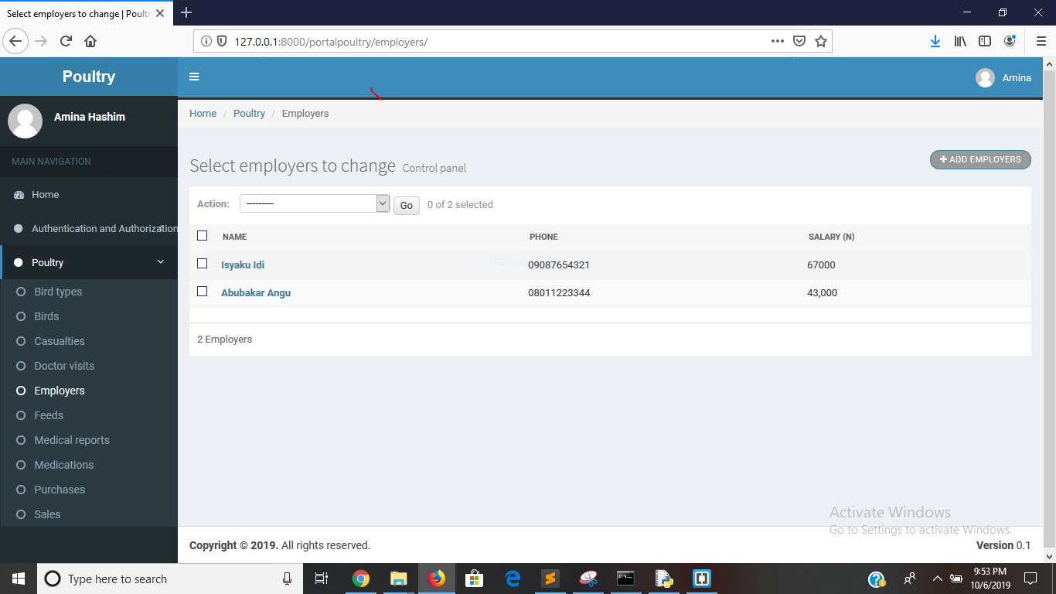

Figure 4.9: employees

# 4.1.9: Feed

This module enables the management of the employees

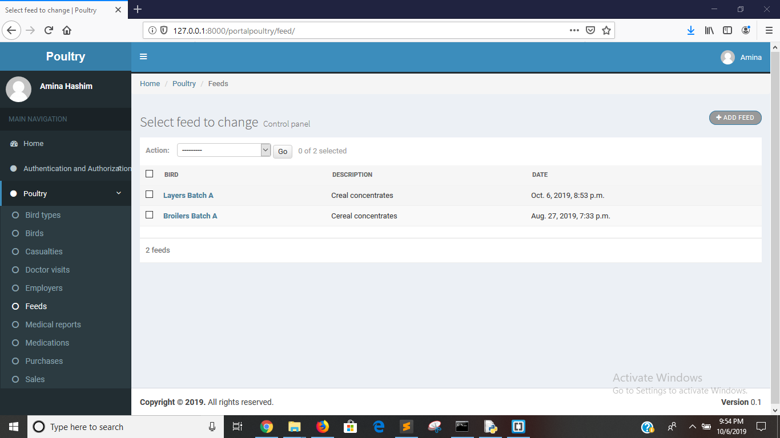

Figure 4.9: Feeds

# 4.1.9: Medical Report

This module enables the management of the medical reports of the birds

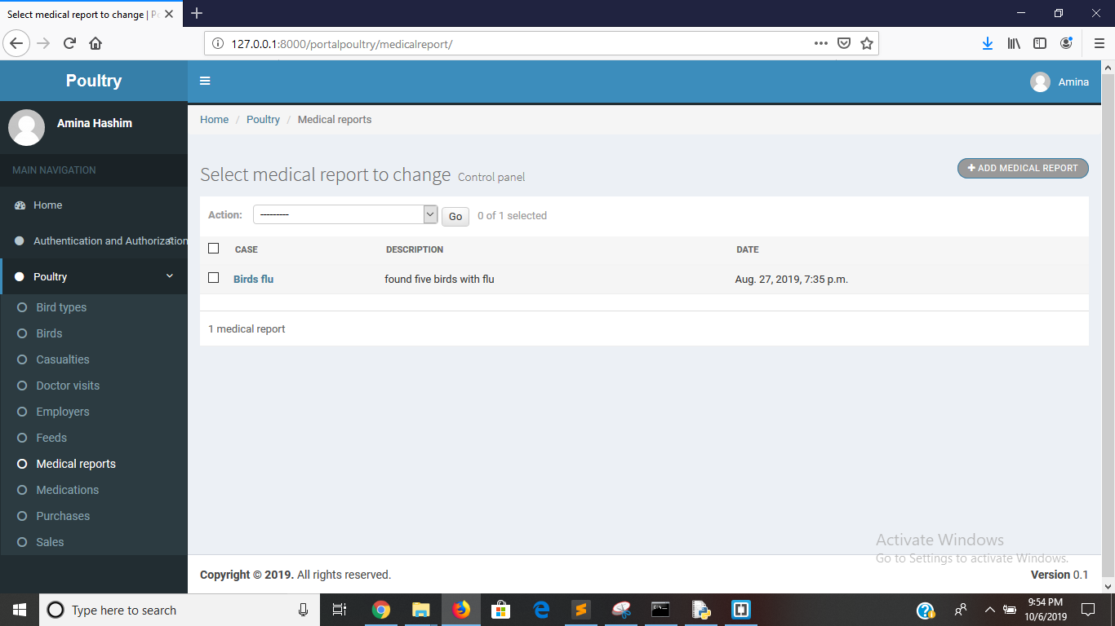

Figure 4.9: medical report

# 4.1.10: Purchase

This module enables the management of the purchases made in the poultry

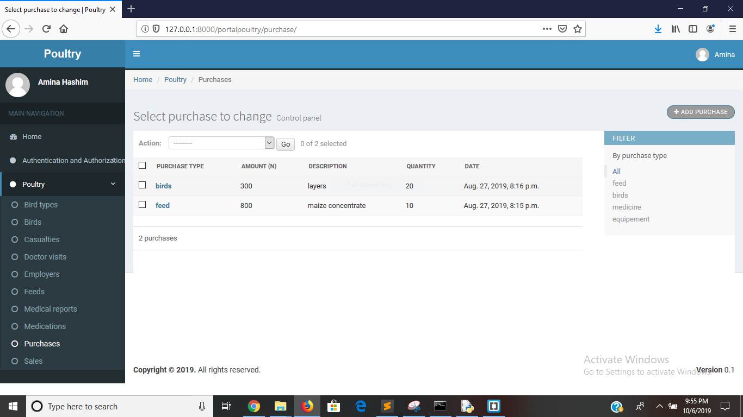

Figure 4.10: purchase

**4.1.11: Sales**

This module enables the management of the sales made in the poultry

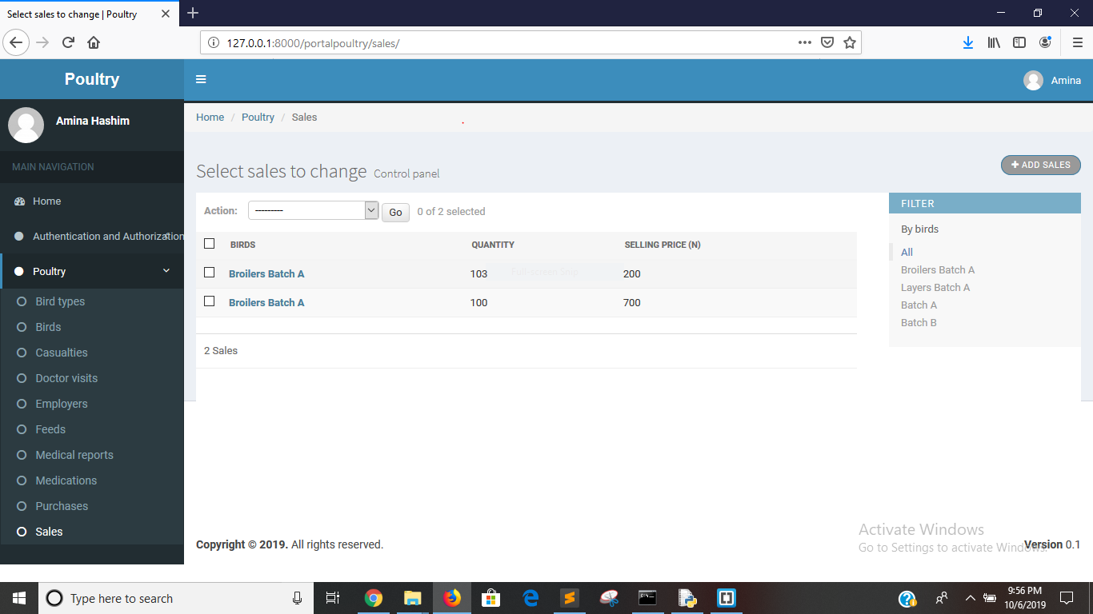

Figure 4.11: sales

# 4.2 Limitations of the system

1. Doesn’t support pictures of the birds
2. Limited to only birds that are uploaded in the system
3. Limited to only birds

# CHAPTER FIVE

# SUMMARY CONCLUSION AND RECOMMENDATION

# 5.1 Introduction

This chapter gives a summary of each of the preceding chapters; hence it summarizes the entire research work. It gives recommendations and draws conclusions based on the summary of the entire work.

# 5.2 Summary

The project developed a poultry management system. It is target to help and ease the way people keeps their poultry records in a more efficient way. It provides a much more credible and cost effective way with guarantee of providing accurate information to aid in making better decisions. It also benefits the poultry owners access the system anytime and anywhere so long as there is internet connectivity. The methodology used to develop this project is water fall Model in the Software Development Life Cycle. This project provides a web application as well as database to have this information and to record easier in this aspect. The tools used include Hypertext Markup Language (HTML), Python and Django, SQL (Structured Query Language) ,Bootstrap and PosgreSQL database. The system a user role mode of authentication, in which the usrers of the system has some specific roles in the system.

# 5.3 Conclusion

Manual method of record keeping has become a very tedious and inefficient way of keeping records in poultries. Because poultry owners uses the traditional book method which is vulnerable to loss and damage. However the system developed as part of this project will overcome the issue of the traditional method by providing a more efficient and consistent way of poultry records.

# 5.4 Recommendation

Based on the in-depth study on this topic, the following recommendations have been put forward:

1. It is recommended that there should contain analysis tools like graphs and charts to present information about farms and farming activities.
2. An Android application will be friendlier to use though the system is responsive to any device, and it target more users of the system.

**REFERNCES**

Adedeji OS, Ajayi JA, Amao SR, Aiyedun JO; Extent of commercial poultry production in Saki West local government area of Oyo State. Transnational Journal of Science and Technology, 2013 3(5): 68-81.

Atteh, J.O 2011. Romancing the chicken 68th Inaugural lecture, University of Ilorin. Published by Unilorin Press

FAO (2010). Small-Scale Poultry Production. FAO Corporate Document Repository, 2002. FAO

Animal Production and Health Paper, No. 35, Rome

Fontana E.A., W.D. Weaver, B.A. Watkins, and D.M. Denbow, 2010. Effect of early feed restriction on growth, feed conversion and mortality in broiler chickens. Poult. Sci., 71: 1296-1305

Laudon KC, Laudon JP; Management Information Systems, Pearson Education, Inc. 2012, Upper Saddle River, New Jersey

Lewis, P. & Morris, T. 2013. Poultry lighting: the theory and practical.Nottingham, UK, Nottingham University Press. ISBN 0-9552104-0-2

Reiter K. and W. Bessei, 2011. Behaviour of broilers in dependence on group size and stocking density. In: Volume I, Proceedings of the 9th European Poultry Conference, Glasgow, UK, August 7- 12th 1994: 294-295